**PRACTICAL NO 6**

**AIM: To study of PL/SQL concepts like Programming Language, IF Statements and Loop.**

**Theory:**

PL/SQL is a combination of SQL along with the procedural features of programming languages. It was developed by Oracle Corporation in the early 90's to enhance the capabilities of SQL. PL/SQL is one of three key programming languages embedded in the Oracle Database, along with SQL itself and Java. This tutorial will give you great understanding on PL/SQL to proceed with Oracle database and other advanced RDBMS concepts. Every PL/SQL statement ends with a semicolon (;). PL/SQL blocks can be nested within other PL/SQL blocks using BEGIN and END. Following is the basic structure of a PL/SQL block:

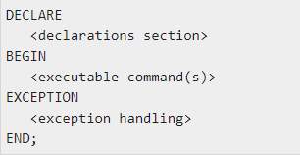

**1) PL/SQL variables:** PL/SQL variables must be declared in the declaration section or in a package as a global variable. When you declare a variable, PL/SQL allocates memory for the variable's value and the storage location is identified by the variable name.The syntax for declaring a variable is:

variable_name [CONSTANT] datatype [NOT NULL] [: = | DEFAULT initial_value]

**2) PL/SQL identifiers:** PL/SQL identifiers are constants, variables, exceptions, procedures, cursors, and reserved words. It consists of a letter optionally followed by more letters, numerals, dollar signs, underscores, and number signs and should not exceed 30 characters.

**3) PL/SQL Comments:** Program comments are explanatory statements that can be included in the PL/SQL code that you write and helps anyone reading its source code. All programming languages allow some form of comments. The PL/SQL single-line comments start with the delimiter -- (double hyphen) and multi-line comments are enclosed by /* and */.

**4)** **PL/SQL IF Statements:** Decision-making structures require that the programmer specify one or more conditions to be evaluated or tested by the program, along with a statement or statements to be executed if the condition is determined to be true, and optionally, other statements to be executed if the condition is determined to be false. PL/SQL programming language provides following types of decision-making statements. They are Simple IF Statements, Compound IF

Statements IF-THEN-ELSE Statements.

**5) Loop:** A loop statement allows us to execute a statement or group of statements multiple times. PL/SQL provides the following types of loop to handle the looping requirements. They are Basic Loop, For Loop, and While loop.

**1. Write a PL/SQL block containing a variable with value "Hello Welcome to PL SQL Programing!" and print it.**

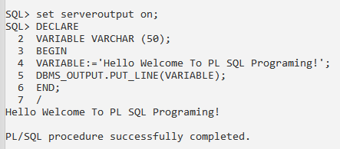

**2. Write a PL/SQL block containing a variable with value 'Welcome to PL/SQL block.' and display the message 'Hello! Welcome to PL/SQL block.' using concatenation operator.**

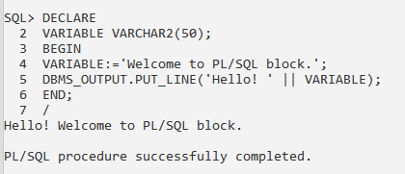

**3. Write PL/SQL blocks to show the declaration of variables.**

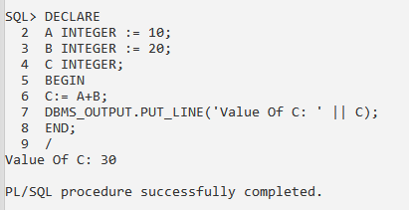

**4. Write a PL/SQL block containing two variables with some values and perform arithmetic**

**operator’s addition, subtraction, multiplication and division.**

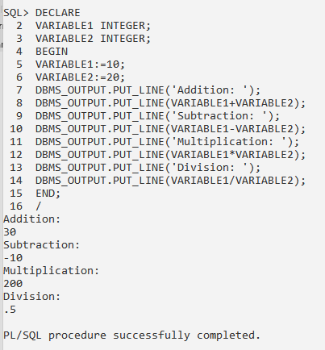

**5. Write a PL/SQL block to calculate circumference and area of circle by accepting value of radius from user.**

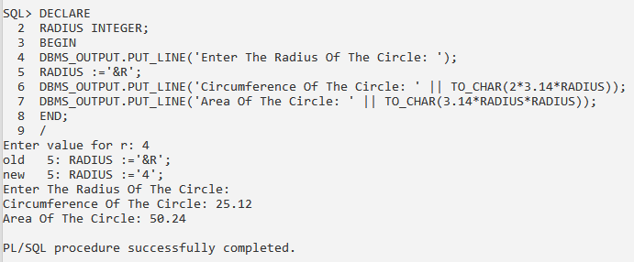

**6. Write a PL/SQL block to calculate perimeter of a rectangle.**

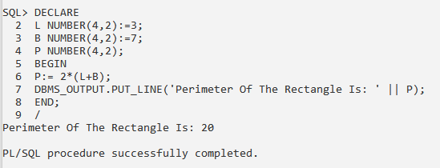

**7. Write a PL/SQL block convert temperature degree Celsius to degree Fahrenheit.**

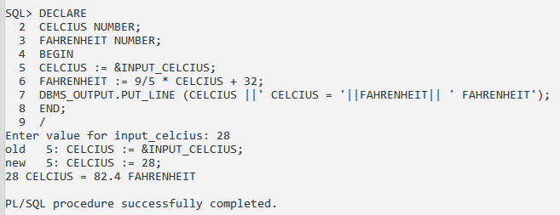

**8. Write a PL/SQL block to find the greatest among the four numbers.**

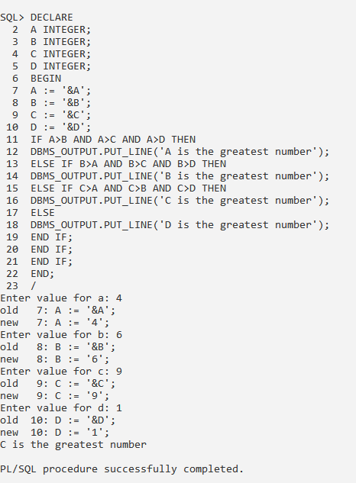

**9. Write a PL/SQL block to test whether given number is prime or not.**

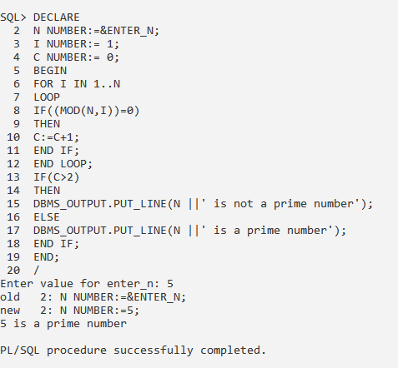

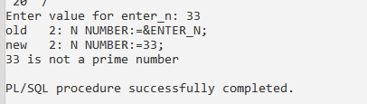

**10. Write a PL/SQL block which accepts grade from user and prints the following remark using case statement**

**'O' - Outstanding**

**'A' - Excellent**

**'B' - Very Good**

**'C' - Good**

**'D' - Satisfactory**

**'P' - Pass**

**'F' - Fail**

**default - Invalid Input**

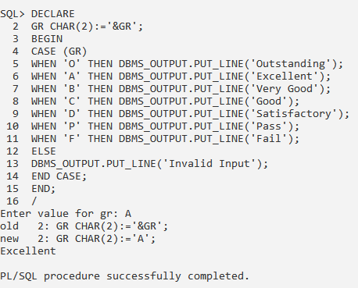

**11. Write a PL/SQL block to get the sum of first five numbers using for loop.**

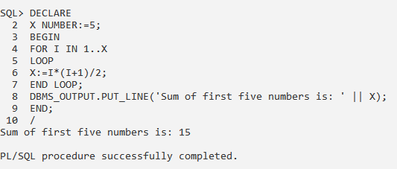

**12. Write a PL/SQL block reverse a 3-digit numbers.**

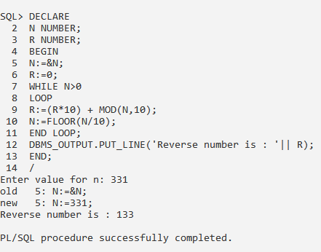

**CONCLUSION:** We have studied the PL/SQL concepts like Programming Language, IF Statements and Loop in details.