**PRACTICAL NO 8**

**AIM: To study of Functions, Procedures and Packages.**

**Theory:**

**Functions:** SQL Server has many built-in functions. This reference contains string, numeric, date, conversion, and some advanced functions in SQL Server.

**String Functions:** ASCII, CHAR, CONCAT, FORMAT, NCHAR, SPACE, STR, TRANSLATE.

**Math/Numeric Functions:** ABS, ACOS, ASIN, ATAN, COUNT.

**Date Functions:** CURRENT_TIMESTAMP, DATEADD, DATEDIFF, MONTH.

**Advanced Functions:** CAST, CONVERT, ISNUMERIC, ISNULL, SYSTEM_USER, USER_NAME.

**Procedure:** A program that performs one or more actions and is called as an executable PL/SQL statement. You can pass information into and out of a procedure through its parameter list. A subprogram can be created at the schema level, Inside a package and Inside a PL/SQL block. At the schema level, subprogram is a standalone subprogram. It is stored in the database and can be deleted only when the package is deleted with the DROP PACKAGE statement. PL/SQL provides two kinds of subprograms Functions and Procedure. A procedure is created with the CREATE OR REPLACE PROCEDURE statement. The simplified syntax for the CREATE OR REPLACE PROCEDURE statement is as follows:

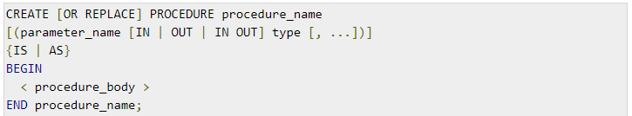

**Package:** A named collection of procedures, functions, types, and variables. A package is not really a module (it’s more of a meta-module), but it is so closely related that I mention it here. The specification is the interface to the package. It just DECLARES the types, variables, constants, exceptions, cursors, and subprograms that can be referenced from outside the package. In other words, it contains all information about the content of the package, but excludes the code for the subprograms. All objects placed in the specification are called public objects. Any subprogram not in the package specification but coded in the package body is called a private object. The following code snippet shows a package specification having a single procedure. You can have many global variables defined and multiple procedures or functions inside a package.

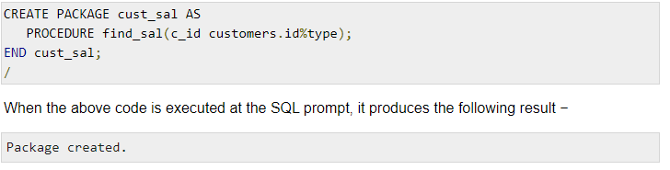

**Working with Functions**

**1. Function that computes and returns the maximum of three values.**

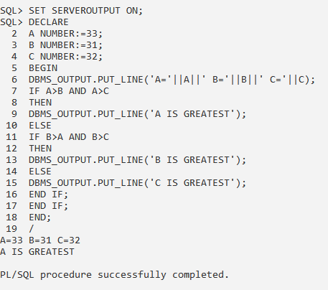

**Working with Procedure**

**1. Write a procedure to find max of two.**

**CREATING PROCEDURE:**

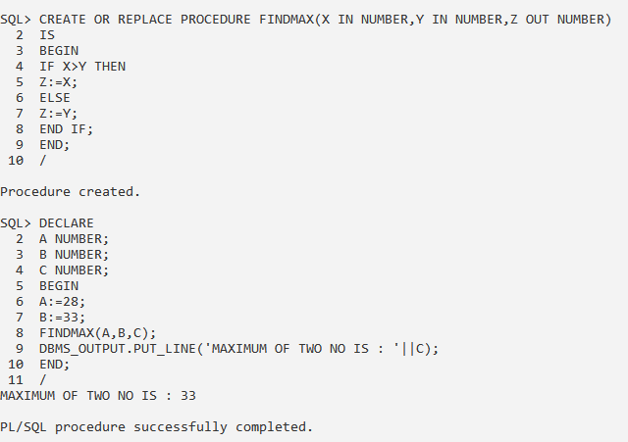

**CALLING PROCEDURE:**



**2. Write a procedure to update a table.**

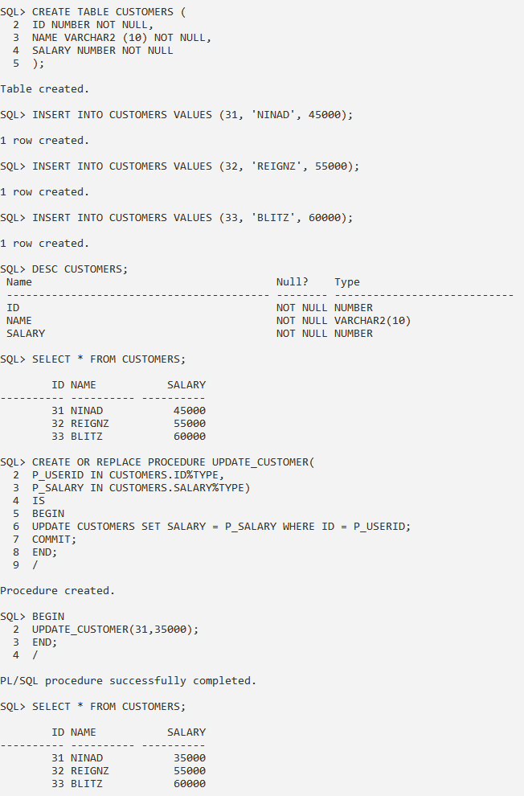

**Working with Package**

**1. Write a PL/SQL Block to specify, create and us a package**

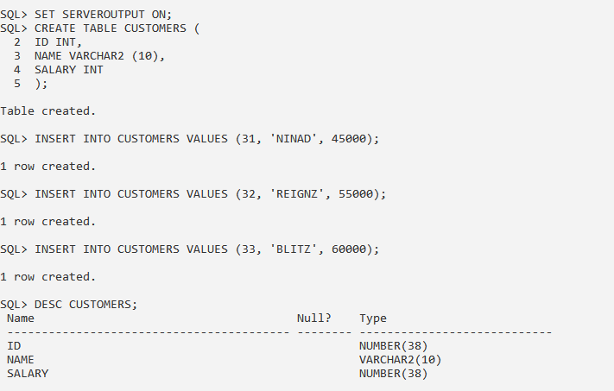

**CREATING A PACKAGE:**

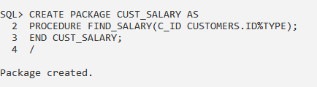

**CREATING BODY OF PACKAGE:**

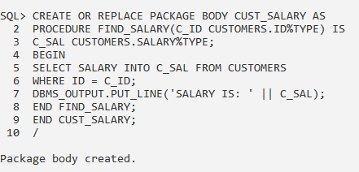

**RUNNING PACKAGE:**

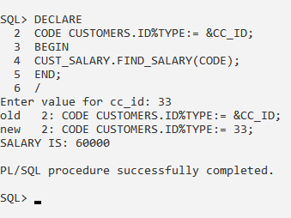

**CONCLUSION:** We have studied the functions, procedures and packages in details.