**Practical No 10**

**A) To implement an online Exam or Shopping Cart application using swings and JDBC Type 1 Driver.**

**Aim: Write a program to implement an online Exam application using swings and JDBC Type 1 Driver.**

**Description:**

JDBC drivers are client-side adapters that convert requests from Java programs to a protocol that the DBMS can understand. There are 4 types of JDBC drivers they are:

Type 1: JDBC-ODBC Bridge driver (Bridge)

Type 2: Native-API/partly Java driver (Native)

Type 3: All Java/Net-protocol driver (Middleware)

Type 4: All Java/Native-protocol driver (Pure)

**Type 1 JDBC Driver : JDBC-ODBC Bridge driver**

The Type 1 driver translates all JDBC calls into ODBC calls and sends them to the ODBC driver. ODBC is a generic API. The JDBC-ODBC Bridge driver is recommended only for experimental use or when no other alternative is available.

In this program we used Type J JDBC driver and imported all the required libraries and then we have created mcq type exam form for a single user and then we use username which is already fixed and then we use the marks to show the marks obtained by the students based on correct mcq. Once you submitted the exam form the scores will show and display on the screen to the user and same will update in the database.

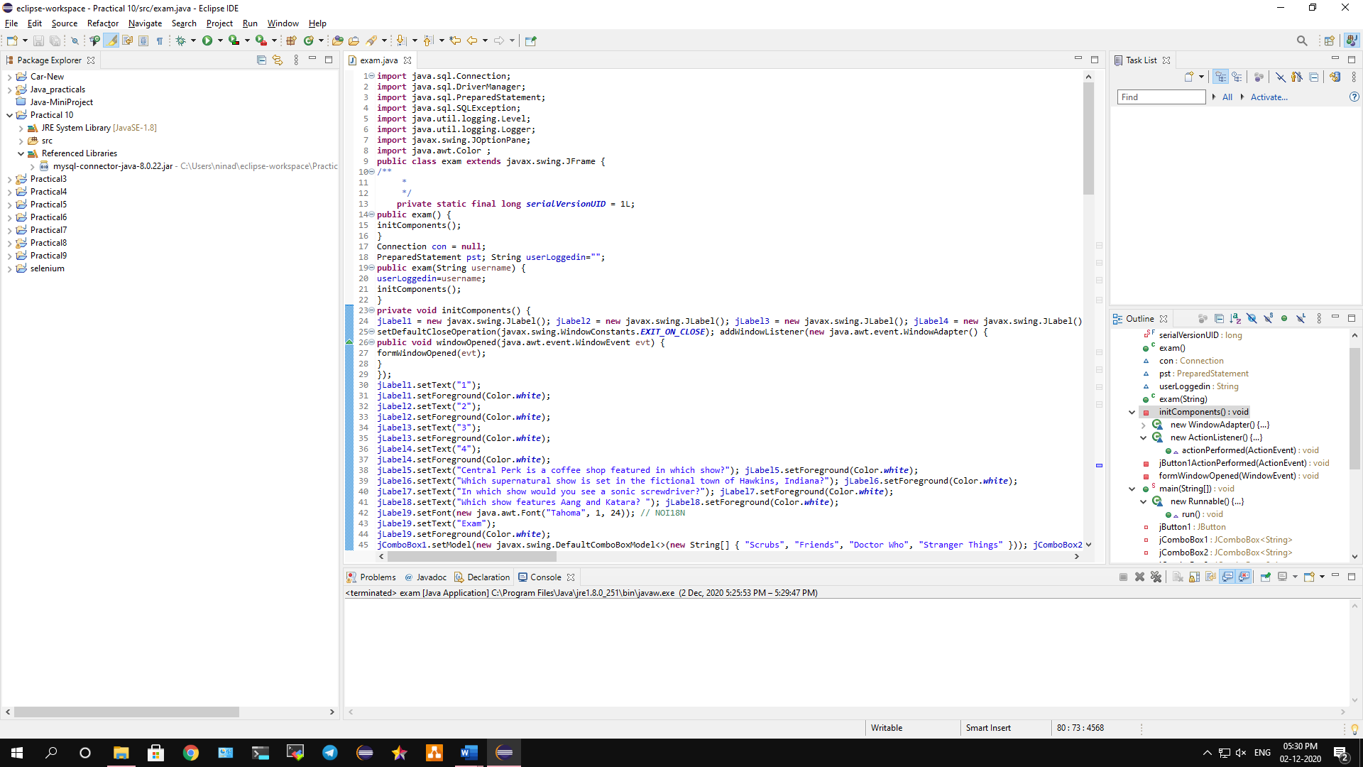

**Conclusion: We have implemented an online Exam application using swings and JDBC Type 1 Driver.**

**Code:**

**import** java.sql.Connection;

**import** java.sql.DriverManager;

**import** java.sql.PreparedStatement;

**import** java.sql.SQLException;

**import** java.util.logging.Level;

**import** java.util.logging.Logger;

**import** javax.swing.JOptionPane;

**import** java.awt.Color ;

**public** **class** exam **extends** javax.swing.JFrame {

**private** **static** **final** **long** ***serialVersionUID*** = 1L;

**public** exam() {

initComponents();

}

Connection con = **null**;

PreparedStatement pst; String userLoggedin="";

**public** exam(String username) {

userLoggedin=username;

initComponents();

}

**private** **void** initComponents() {

jLabel1 = **new** javax.swing.JLabel(); jLabel2 = **new** javax.swing.JLabel(); jLabel3 = **new** javax.swing.JLabel(); jLabel4 = **new** javax.swing.JLabel(); jLabel5 = **new** javax.swing.JLabel(); jLabel6 = **new** javax.swing.JLabel(); jLabel7 = **new** javax.swing.JLabel(); jLabel8 = **new** javax.swing.JLabel(); jLabel9 = **new** javax.swing.JLabel(); jComboBox1 = **new** javax.swing.JComboBox<>(); jComboBox2 = **new** javax.swing.JComboBox<>(); jComboBox3 = **new** javax.swing.JComboBox<>(); jComboBox4 = **new** javax.swing.JComboBox<>(); jButton1 = **new** javax.swing.JButton(); jLabel10 = **new** javax.swing.JLabel();

setDefaultCloseOperation(javax.swing.WindowConstants.***EXIT_ON_CLOSE***); addWindowListener(**new** java.awt.event.WindowAdapter() {

**public** **void** windowOpened(java.awt.event.WindowEvent evt) {

formWindowOpened(evt);

}

});

jLabel1.setText("1");

jLabel1.setForeground(Color.***white***);

jLabel2.setText("2");

jLabel2.setForeground(Color.***white***);

jLabel3.setText("3");

jLabel3.setForeground(Color.***white***);

jLabel4.setText("4");

jLabel4.setForeground(Color.***white***);

jLabel5.setText("Central Perk is a coffee shop featured in which show?"); jLabel5.setForeground(Color.***white***);

jLabel6.setText("Which supernatural show is set in the fictional town of Hawkins, Indiana?"); jLabel6.setForeground(Color.***white***);

jLabel7.setText("In which show would you see a sonic screwdriver?"); jLabel7.setForeground(Color.***white***);

jLabel8.setText("Which show features Aang and Katara? "); jLabel8.setForeground(Color.***white***);

jLabel9.setFont(**new** java.awt.Font("Tahoma", 1, 24)); // NOI18N

jLabel9.setText("Exam");

jLabel9.setForeground(Color.***white***);

jComboBox1.setModel(**new** javax.swing.DefaultComboBoxModel<>(**new** String[] { "Scrubs", "Friends", "Doctor Who", "Stranger Things" }));

jComboBox2.setModel(**new** javax.swing.DefaultComboBoxModel<>(**new** String[] { "Doctor Who", "Scrubs","Friends", "Stranger Things" }));

jComboBox3.setModel(**new** javax.swing.DefaultComboBoxModel<>(**new** String[] { "Stranger Things", "Doctor Who", "Scrubs", "Friends" }));

jComboBox4.setModel(**new** javax.swing.DefaultComboBoxModel<>(**new** String[] { "Friends","Doctor Who", "Scrubs", "Avatar - the last Airbender" })); jButton1.setText("SUBMIT");

jButton1.addActionListener(**new** java.awt.event.ActionListener() {

**public** **void** actionPerformed(java.awt.event.ActionEvent evt) {

jButton1ActionPerformed(evt);

}

});

jLabel10.setFont(**new** java.awt.Font("Tahoma", 1, 36)); jLabel10.setText("jLabel10");

javax.swing.GroupLayout layout = **new** javax.swing.GroupLayout(getContentPane()); getContentPane().setBackground( **new** Color(90, 113, 148));

getContentPane().setLayout(layout); layout.setHorizontalGroup( layout.createParallelGroup(javax.swing.GroupLayout.Alignment.***LEADING***)

.addGroup(layout.createSequentialGroup()

.addGroup(layout.createParallelGroup(javax.swing.GroupLayout.Alignment.***LEADING***)

.addGroup(layout.createSequentialGroup()

.addGap(35, 35, 35)

.addGroup(layout.createParallelGroup(javax.swing.GroupLayout.Alignment.***LEADING***)

.addGroup(layout.createSequentialGroup()

.addComponent(jLabel1)

.addGap(18, 18, 18)

.addGroup(layout.createParallelGroup(javax.swing.GroupLayout.Alignment.***LEADING***)

.addComponent(jComboBox1, javax.swing.GroupLayout.***PREFERRED_SIZE***,

javax.swing.GroupLayout.***DEFAULT_SIZE***, javax.swing.GroupLayout.***PREFERRED_SIZE***)

.addComponent(jLabel5)))

.addGroup(layout.createSequentialGroup()

.addComponent(jLabel2)

.addGap(18, 18,

18) .addGroup(layout.createParallelGroup(javax.swing.GroupLayout.Alignment.***LEADING***)

.addComponent(jComboBox2, javax.swing.GroupLayout.***PREFERRED_SIZE***,

javax.swing.GroupLayout.***DEFAULT_SIZE***, javax.swing.GroupLayout.***PREFERRED_SIZE***)

.addComponent(jLabel6)))

.addGroup(layout.createSequentialGroup()

.addComponent(jLabel3)

.addGap(18, 18, 18)

.addGroup(layout.createParallelGroup(javax.swing.GroupLayout.Alignment.***LEADING***)

.addComponent(jComboBox3, javax.swing.GroupLayout.***PREFERRED_SIZE***,

javax.swing.GroupLayout.***DEFAULT_SIZE***, javax.swing.GroupLayout.***PREFERRED_SIZE***)

.addComponent(jLabel7)))

.addGroup(layout.createParallelGroup(javax.swing.GroupLayout.Alignment.***TRAILING***)

.addComponent(jButton1)

.addGroup(layout.createSequentialGroup()

.addComponent(jLabel4)

.addGap(18, 18, 18)

.addGroup(layout.createParallelGroup(javax.swing.GroupLayout.Alignment.***LEADING***)

.addComponent(jComboBox4, javax.swing.GroupLayout.***PREFERRED_SIZE***,

javax.swing.GroupLayout.***DEFAULT_SIZE***, javax.swing.GroupLayout.***PREFERRED_SIZE***)

.addComponent(jLabel8))))))

.addGroup(layout.createSequentialGroup()

.addGap(212, 212, 212)

.addComponent(jLabel9))

.addGroup(layout.createSequentialGroup()

.addGap(196, 196, 196)

.addComponent(jLabel10)))

.addContainerGap(75, Short.***MAX_VALUE***))

);

layout.setVerticalGroup( layout.createParallelGroup(javax.swing.GroupLayout.Alignment.***LEADING***)

.addGroup(layout.createSequentialGroup()

.addContainerGap()

.addComponent(jLabel10)

.addGap(26, 26, 26)

.addComponent(jLabel9)

.addGap(18, 18, 18)

.addGroup(layout.createParallelGroup(javax.swing.GroupLayout.Alignment.***BASELINE***) .addComponent(jLabel1)

.addComponent(jLabel5))

.addGap(18, 18, 18)

.addComponent(jComboBox1, javax.swing.GroupLayout.***PREFERRED_SIZE***,

javax.swing.GroupLayout.***DEFAULT_SIZE***, javax.swing.GroupLayout.***PREFERRED_SIZE***)

.addGap(27, 27, 27)

.addGroup(layout.createParallelGroup(javax.swing.GroupLayout.Alignment.***BASELINE***)

.addComponent(jLabel2)

.addComponent(jLabel6))

.addGap(14, 14, 14)

.addComponent(jComboBox2, javax.swing.GroupLayout.***PREFERRED_SIZE***,

javax.swing.GroupLayout.***DEFAULT_SIZE***, javax.swing.GroupLayout.***PREFERRED_SIZE***)

.addGap(18, 18, 18)

.addGroup(layout.createParallelGroup(javax.swing.GroupLayout.Alignment.***BASELINE***)

.addComponent(jLabel3)

.addComponent(jLabel7))

.addGap(18, 18, 18)

.addComponent(jComboBox3, javax.swing.GroupLayout.***PREFERRED_SIZE***,

javax.swing.GroupLayout.***DEFAULT_SIZE***, javax.swing.GroupLayout.***PREFERRED_SIZE***)

.addGap(31, 31, 31)

.addGroup(layout.createParallelGroup(javax.swing.GroupLayout.Alignment.***BASELINE***)

.addComponent(jLabel4)

.addComponent(jLabel8))

.addGap(18, 18, 18)

.addComponent(jComboBox4, javax.swing.GroupLayout.***PREFERRED_SIZE***,

javax.swing.GroupLayout.***DEFAULT_SIZE***, javax.swing.GroupLayout.***PREFERRED_SIZE***)

.addGap(18, 18, 18)

.addComponent(jButton1)

.addContainerGap(javax.swing.GroupLayout.***DEFAULT_SIZE***, Short.***MAX_VALUE***))

);

pack();

setLocationRelativeTo(**null**);

}

**private** **void** jButton1ActionPerformed(java.awt.event.ActionEvent evt) {

String answer1,answer2,answer3,answer4; **int** score=0;

answer1 = jComboBox1.getSelectedItem().toString(); answer2 = jComboBox2.getSelectedItem().toString(); answer3 = jComboBox3.getSelectedItem().toString(); answer4 = jComboBox4.getSelectedItem().toString(); **if**(answer1.equals("Friends")){

score++;

}

**if**(answer2.equals("Stranger Things")){

score++;

}

**if**(answer3.equals("Doctor Who")){

score++;

}

**if**(answer4.equals("Avatar - the last Airbender")){

score++;

}

JOptionPane.*showMessageDialog*(**this**,userLoggedin+" your score is : "+score); **try** {

Class.*forName*("com.mysql.cj.jdbc.Driver");

con = DriverManager.*getConnection*("jdbc:mysql://****/SAC?useSSL=false&serverTimezone=UTC", "***", "***");

String query="update user set score = ? where username=?"; pst = con.prepareStatement(query); pst.setInt(1,score); pst.setString(2,userLoggedin); **int** r=pst.executeUpdate();

**if**(r==1){

JOptionPane.*showMessageDialog*(**null**, "Value has been updated");

}**else**

JOptionPane.*showMessageDialog*(**null**, "DB connection issue");

} **catch** (ClassNotFoundException | SQLException ex) {

Logger.*getLogger*(exam.**class**.getName()).log(Level.***SEVERE***, **null**, ex);

}}

**private** **void** formWindowOpened(java.awt.event.WindowEvent evt) { jLabel10.setText(userLoggedin);

}**public** **static** **void** main(String args[]) { **try** {

**for** (javax.swing.UIManager.LookAndFeelInfo info : javax.swing.UIManager.*getInstalledLookAndFeels*()) {

**if** ("Nimbus".equals(info.getName())) {

javax.swing.UIManager.*setLookAndFeel*(info.getClassName()); **break**;

}}

} **catch** (ClassNotFoundException ex) { java.util.logging.Logger.*getLogger*(exam.**class**.getName()).log(java.util.logging.Level.***SEVERE***, **null**, ex);

} **catch** (InstantiationException ex) { java.util.logging.Logger.*getLogger*(exam.**class**.getName()).log(java.util.logging.Level.***SEVERE***, **null**, ex);

} **catch** (IllegalAccessException ex) { java.util.logging.Logger.*getLogger*(exam.**class**.getName()).log(java.util.logging.Level.***SEVERE***, **null**, ex);

} **catch** (javax.swing.UnsupportedLookAndFeelException ex) { java.util.logging.Logger.*getLogger*(exam.**class**.getName()).log(java.util.logging.Level.***SEVERE***, **null**, ex);

}

java.awt.EventQueue.*invokeLater*(**new** Runnable() {

**public** **void** run() {

**new** exam().setVisible(**true**);

}

});

}

**private** javax.swing.JButton jButton1;

**private** javax.swing.JComboBox<String> jComboBox1; **private** javax.swing.JComboBox<String> jComboBox2; **private** javax.swing.JComboBox<String> jComboBox3; **private** javax.swing.JComboBox<String> jComboBox4; **private** javax.swing.JLabel jLabel1; **private** javax.swing.JLabel jLabel10; **private** javax.swing.JLabel jLabel2; **private** javax.swing.JLabel jLabel3; **private** javax.swing.JLabel jLabel4; **private** javax.swing.JLabel jLabel5; **private** javax.swing.JLabel jLabel6; **private** javax.swing.JLabel jLabel7; **private** javax.swing.JLabel jLabel8; **private** javax.swing.JLabel jLabel9;

}

**Output:**

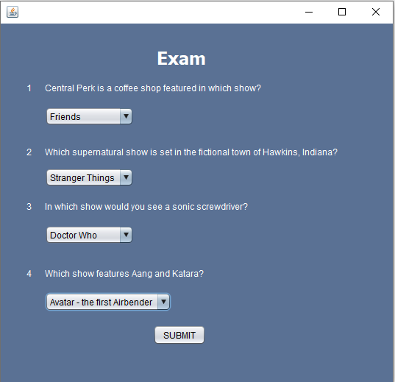

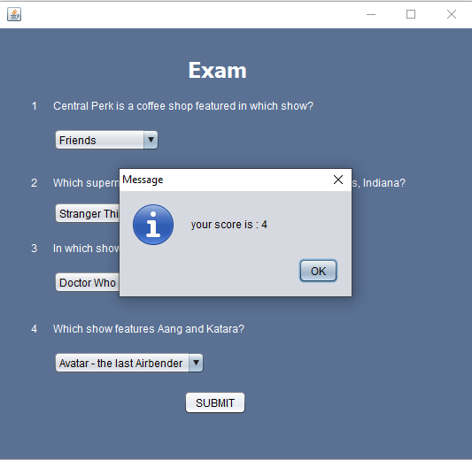

**B) To implement a program using JDBC Type 4 driver and mysql connector.**

**Aim: Write a program to implement a program using JDBC Type 4 driver and mysql connector.**

**Description:**

JDBC drivers are client-side adapters that convert requests from Java programs to a protocol that the DBMS can understand. There are 4 types of JDBC drivers they are:

Type 1: JDBC-ODBC Bridge driver (Bridge)

Type 2: Native-API/partly Java driver (Native)

Type 3: All Java/Net-protocol driver (Middleware)

Type 4: All Java/Native-protocol driver (Pure)

**Type 4 JDBC Driver : All Java/Native-protocol driver (Pure)**

The Type 4 JDBC Driver uses java networking libraries to communicate directly with the database server. In this program we imported Type 4 JDBC driver and all its required libraries and then we have created a window where all the major database operations are performed. Then we have used the insert button function in which it will insert the id and the username in the database, where the select button will show the username for the id we have inserted. Then we have defined the update button which will update the inserted id and then delete button will delete the records from the database.

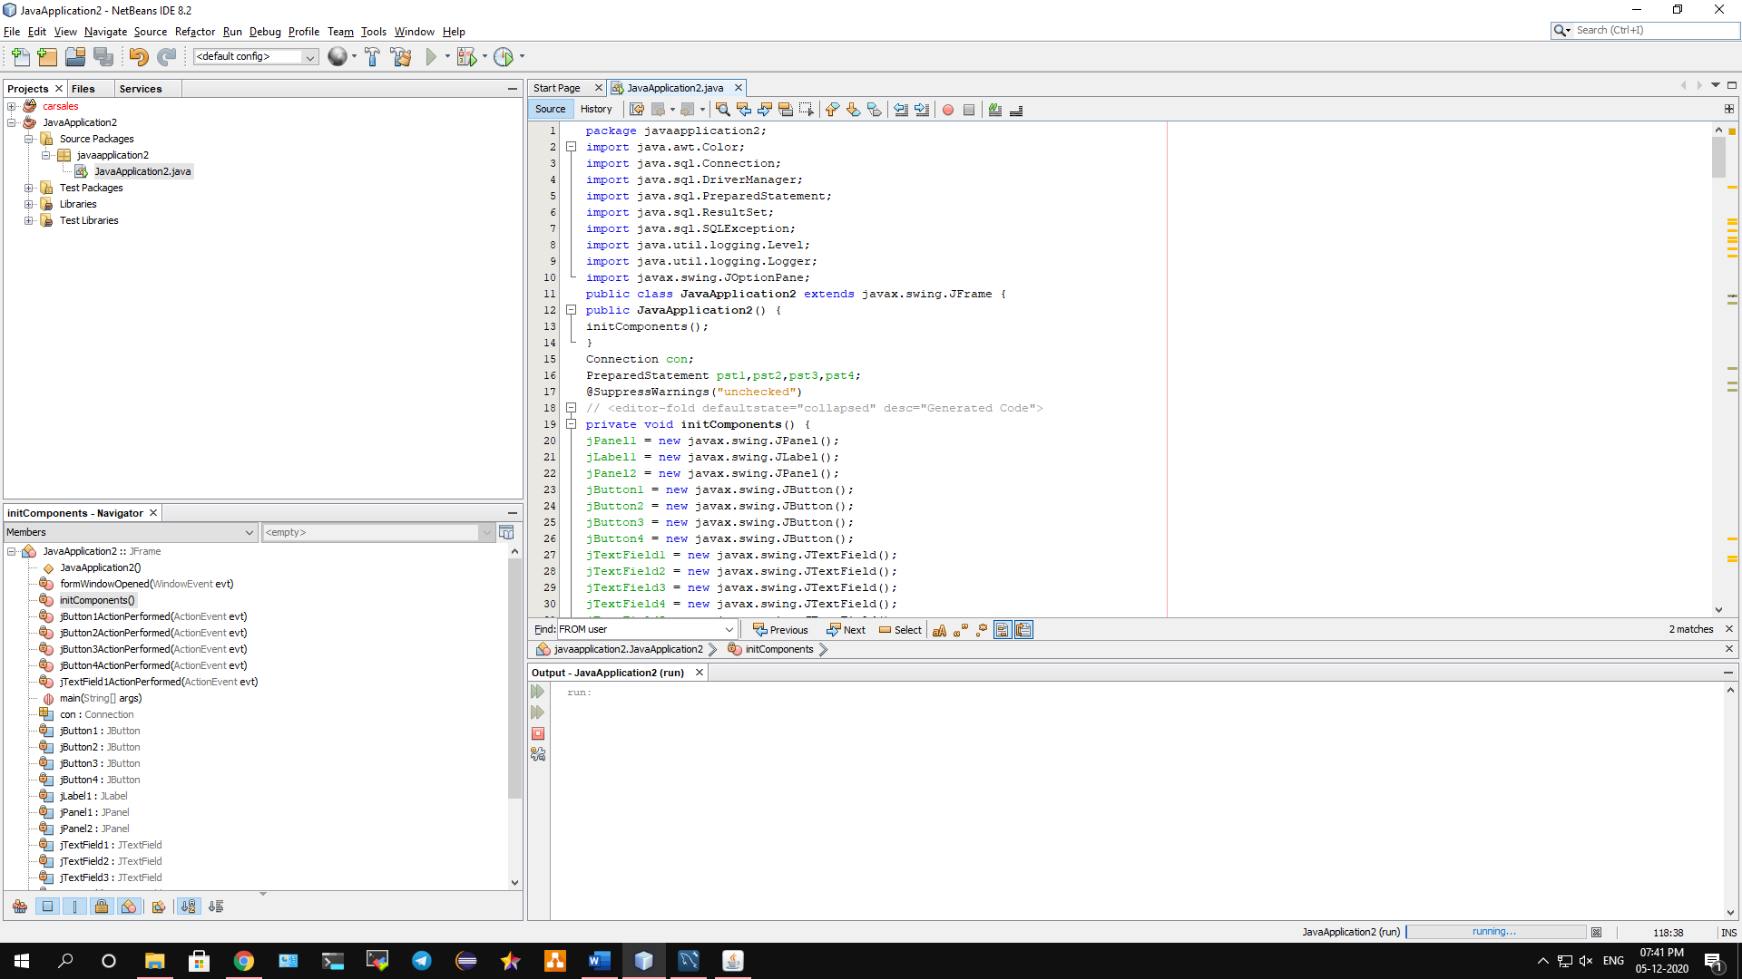

**Conclusion: We have implemented a program using JDBC Type 4 driver and mysql connector.**

**Code:**

package javadb;

import java.awt.Color;

import java.sql.Connection;

import java.sql.DriverManager;

import java.sql.PreparedStatement;

import java.sql.ResultSet;

import java.sql.SQLException;

import java.util.logging.Level;

import java.util.logging.Logger;

import javax.swing.JOptionPane;

public class javadb extends javax.swing.JFrame {

private static final long *serialVersionUID* = 1L;

public javadb() {

initComponents(); }

Connection con;

PreparedStatement pst1,pst2,pst3,pst4;

private void initComponents() {

jPanel1 = new javax.swing.JPanel();

jLabel1 = new javax.swing.JLabel();

jPanel2 = new javax.swing.JPanel();

jButton1 = new javax.swing.JButton();

jButton2 = new javax.swing.JButton();

jButton3 = new javax.swing.JButton();

jButton4 = new javax.swing.JButton();

jTextField1 = new javax.swing.JTextField();

jTextField2 = new javax.swing.JTextField();

jTextField3 = new javax.swing.JTextField();

jTextField4 = new javax.swing.JTextField();

jTextField5 = new javax.swing.JTextField();

jTextField6 = new javax.swing.JTextField();

setDefaultCloseOperation(javax.swing.WindowConstants.*EXIT_ON_CLOSE*);

addWindowListener(new java.awt.event.WindowAdapter() {

@Override

public void windowOpened(java.awt.event.WindowEvent evt)

{ formWindowOpened(evt); }

});

jLabel1.setFont(new java.awt.Font("Tahoma", 1, 28));

jLabel1.setText("DATABASE OPERATIONS");

jLabel1.setForeground(Color.*darkGray*);

javax.swing.GroupLayout jPanel1Layout = new javax.swing.GroupLayout(jPanel1);

jPanel1.setLayout(jPanel1Layout);

jPanel1Layout.setHorizontalGroup(

jPanel1Layout.createParallelGroup(javax.swing.GroupLayout.Alignment.*LEADING*)

.addGroup(jPanel1Layout.createSequentialGroup()

.addGap(76, 76, 76)

.addComponent(jLabel1)

.addContainerGap(javax.swing.GroupLayout.*DEFAULT_SIZE*, Short.*MAX_VALUE*)));

jPanel1Layout.setVerticalGroup(

jPanel1Layout.createParallelGroup(javax.swing.GroupLayout.Alignment.*LEADING*)

.addGroup(jPanel1Layout.createSequentialGroup()

.addContainerGap()

.addComponent(jLabel1)

.addContainerGap(javax.swing.GroupLayout.*DEFAULT_SIZE*, Short.*MAX_VALUE*))

);

jButton1.setText("SELECT");

jButton1.addActionListener((java.awt.event.ActionEvent evt) -> {

jButton1ActionPerformed(evt);

});

jButton2.setText("UPDATE");

jButton2.addActionListener((java.awt.event.ActionEvent evt) -> {

jButton2ActionPerformed(evt);

});

jButton3.setText("DELETE");

jButton3.addActionListener((java.awt.event.ActionEvent evt) -> {

jButton3ActionPerformed(evt);

});

jButton4.setText("INSERT");

jButton4.addActionListener((java.awt.event.ActionEvent evt) -> {

jButton4ActionPerformed(evt);

});

jTextField1.setText("Please enter the id for name");

jTextField1.addActionListener((java.awt.event.ActionEvent evt) -> {

jTextField1ActionPerformed(evt);

});

jTextField2.setText("Please enter id");

jTextField3.setText("Please enter the id to be deleted");

jTextField4.setText("Name to be updated");

jTextField5.setText("Enter the id");

jTextField6.setText("Enter the username");

javax.swing.GroupLayout jPanel2Layout = new javax.swing.GroupLayout(jPanel2);

jPanel2.setLayout(jPanel2Layout);

jPanel2Layout.setHorizontalGroup(

jPanel2Layout.createParallelGroup(javax.swing.GroupLayout.Alignment.*LEADING*)

.addGroup(jPanel2Layout.createSequentialGroup()

.addGap(44, 44, 44)

.addGroup(jPanel2Layout.createParallelGroup(javax.swing.GroupLayout.Alignment.*LEADING*)

.addComponent(jButton1)

.addComponent(jButton2)

.addGroup(jPanel2Layout.createParallelGroup(javax.swing.GroupLayout.Alignment.*TRAILING*,false)

.addComponent(jButton4, javax.swing.GroupLayout.Alignment.*LEADING*,

javax.swing.GroupLayout.*DEFAULT_SIZE*, javax.swing.GroupLayout.*DEFAULT_SIZE*,

Short.*MAX_VALUE*)

.addComponent(jButton3, javax.swing.GroupLayout.Alignment.*LEADING*,

javax.swing.GroupLayout.*DEFAULT_SIZE*, javax.swing.GroupLayout.*DEFAULT_SIZE*,

Short.*MAX_VALUE*)))

.addGap(24, 24, 24)

.addGroup(jPanel2Layout.createParallelGroup(javax.swing.GroupLayout.Alignment.*LEADING*)

.addComponent(jTextField1)

.addComponent(jTextField3)

.addGroup(jPanel2Layout.createSequentialGroup()

.addComponent(jTextField2, javax.swing.GroupLayout.*PREFERRED_SIZE*,

javax.swing.GroupLayout.*DEFAULT_SIZE*,

javax.swing.GroupLayout.*PREFERRED_SIZE*)

.addPreferredGap(javax.swing.LayoutStyle.ComponentPlacement.*UNRELATED*)

.addComponent(jTextField4))

.addGroup(jPanel2Layout.createSequentialGroup()

.addComponent(jTextField5, javax.swing.GroupLayout.*PREFERRED_SIZE*,

javax.swing.GroupLayout.*DEFAULT_SIZE*,

javax.swing.GroupLayout.*PREFERRED_SIZE*)

.addPreferredGap(javax.swing.LayoutStyle.ComponentPlacement.*UNRELATED*)

.addComponent(jTextField6))

)));

jPanel2Layout.setVerticalGroup(

jPanel2Layout.createParallelGroup(javax.swing.GroupLayout.Alignment.*LEADING*)

.addGroup(jPanel2Layout.createSequentialGroup()

.addGap(43, 43, 43)

.addGroup(jPanel2Layout.createParallelGroup(javax.swing.GroupLayout.Alignment.*BASELINE*)

.addComponent(jButton1)

.addComponent(jTextField1, javax.swing.GroupLayout.*PREFERRED_SIZE*,

javax.swing.GroupLayout.*DEFAULT_SIZE*,

javax.swing.GroupLayout.*PREFERRED_SIZE*))

.addGap(18, 18, 18)

.addGroup(jPanel2Layout.createParallelGroup(javax.swing.GroupLayout.Alignment.*BASELINE*)

.addComponent(jButton2)

.addComponent(jTextField2, javax.swing.GroupLayout.*PREFERRED_SIZE*,

javax.swing.GroupLayout.*DEFAULT_SIZE*,

javax.swing.GroupLayout.*PREFERRED_SIZE*)

.addComponent(jTextField4, javax.swing.GroupLayout.*PREFERRED_SIZE*,

javax.swing.GroupLayout.*DEFAULT_SIZE*,

javax.swing.GroupLayout.*PREFERRED_SIZE*))

.addGap(18, 18, 18)

.addGroup(jPanel2Layout.createParallelGroup(javax.swing.GroupLayout.Alignment.*BASELINE*)

.addComponent(jButton3)

.addComponent(jTextField3, javax.swing.GroupLayout.*PREFERRED_SIZE*,

javax.swing.GroupLayout.*DEFAULT_SIZE*,

javax.swing.GroupLayout.*PREFERRED_SIZE*))

.addGap(18, 18, 18)

.addGroup(jPanel2Layout.createParallelGroup(javax.swing.GroupLayout.Alignment.*BASELINE*)

.addComponent(jButton4)

.addComponent(jTextField5, javax.swing.GroupLayout.*PREFERRED_SIZE*,

javax.swing.GroupLayout.*DEFAULT_SIZE*,

javax.swing.GroupLayout.*PREFERRED_SIZE*)

.addComponent(jTextField6, javax.swing.GroupLayout.*PREFERRED_SIZE*,

javax.swing.GroupLayout.*DEFAULT_SIZE*,

javax.swing.GroupLayout.*PREFERRED_SIZE*))

.addContainerGap(32, Short.*MAX_VALUE*))

);

javax.swing.GroupLayout layout = new javax.swing.GroupLayout(getContentPane());

getContentPane().setLayout(layout);

layout.setHorizontalGroup(

layout.createParallelGroup(javax.swing.GroupLayout.Alignment.*LEADING*)

.addGroup(layout.createSequentialGroup()

.addContainerGap()

.addGroup(layout.createParallelGroup(javax.swing.GroupLayout.Alignment.*LEADING*)

.addGroup(layout.createSequentialGroup()

.addComponent(jPanel2, javax.swing.GroupLayout.*PREFERRED_SIZE*,

javax.swing.GroupLayout.*DEFAULT_SIZE*,

javax.swing.GroupLayout.*PREFERRED_SIZE*)

.addGap(0, 0, Short.*MAX_VALUE*))

.addComponent(jPanel1, javax.swing.GroupLayout.*DEFAULT_SIZE*,

javax.swing.GroupLayout.*DEFAULT_SIZE*, Short.*MAX_VALUE*))

.addContainerGap())

);

layout.setVerticalGroup(

layout.createParallelGroup(javax.swing.GroupLayout.Alignment.*LEADING*)

.addGroup(layout.createSequentialGroup()

.addComponent(jPanel1, javax.swing.GroupLayout.*PREFERRED_SIZE*,

javax.swing.GroupLayout.*DEFAULT_SIZE*,

javax.swing.GroupLayout.*PREFERRED_SIZE*)

.addPreferredGap(javax.swing.LayoutStyle.ComponentPlacement.*UNRELATED*)

.addComponent(jPanel2, javax.swing.GroupLayout.*PREFERRED_SIZE*,

javax.swing.GroupLayout.*DEFAULT_SIZE*,

javax.swing.GroupLayout.*PREFERRED_SIZE*) .addContainerGap(19,

Short.*MAX_VALUE*)));

pack();

setLocationRelativeTo(null); }

private void jButton3ActionPerformed(java.awt.event.ActionEvent evt)

{ try { int id=Integer.*parseInt*(jTextField3.getText());

Class.*forName*("com.mysql.cj.jdbc.Driver");

con = DriverManager.*getConnection*("jdbc:mysql://localhost:3306/practical10?serverTimezone=UTC","root","");

String query3="DELETE FROM users WHERE id = ?";

pst3 = con.prepareStatement(query3);

pst3.setInt(1,id);

int r3=pst3.executeUpdate();

if(r3==1){

JOptionPane.*showMessageDialog*(null,"The details have been deleted"); }

else

JOptionPane.*showMessageDialog*(null,"Some connection issue"); }

catch (ClassNotFoundException | SQLException ex)

{

Logger.*getLogger*(javadb.class.getName()).log(Level.*SEVERE*, null, ex); } }

private void jTextField1ActionPerformed(java.awt.event.ActionEvent evt) {}

private void jButton1ActionPerformed(java.awt.event.ActionEvent evt)

{ try {

int id=Integer.*parseInt*(jTextField1.getText());

Class.*forName*("com.mysql.cj.jdbc.Driver");

con = DriverManager.*getConnection*("jdbc:mysql://localhost:3306/practical10?serverTimezone=UTC","root","");

String query="select username from users where id = ?";

pst1 = con.prepareStatement(query);

pst1.setInt(1,id);

ResultSet r=pst1.executeQuery();

while(r.next()){

JOptionPane.*showMessageDialog*(null,"The username of id : "+id+" is : "+r.getString(1)); } }

catch (ClassNotFoundException | SQLException ex)

{

Logger.*getLogger*(javadb.class.getName()).log(Level.*SEVERE*, null, ex); } }

private void jButton2ActionPerformed(java.awt.event.ActionEvent evt)

{

try {

int id=Integer.*parseInt*(jTextField2.getText());

String updatedName=jTextField4.getText();

Class.*forName*("com.mysql.cj.jdbc.Driver");

con = DriverManager.*getConnection*("jdbc:mysql://localhost:3306/practical10?serverTimezone=UTC","root","");

String query2="update users set username = ? where id = ?";

pst2 = con.prepareStatement(query2);

pst2.setInt(2,id);

pst2.setString(1,updatedName);

int r1=pst2.executeUpdate();

if(r1==1){

JOptionPane.*showMessageDialog*(null,"Username has been updated");

}

else

JOptionPane.*showMessageDialog*(null,"Some connection issue");

}

catch (ClassNotFoundException | SQLException ex) {

Logger.*getLogger*(javadb.class.getName()).log(Level.*SEVERE*, null, ex);

}

}

private void formWindowOpened(java.awt.event.WindowEvent evt) {}

private void jButton4ActionPerformed(java.awt.event.ActionEvent evt)

{

try {

int ID=Integer.*parseInt*(jTextField5.getText());

String name=jTextField6.getText();

Class.*forName*("com.mysql.cj.jdbc.Driver");

con = DriverManager.*getConnection*("jdbc:mysql://localhost:3306/practical10?serverTimezone=UTC","root","");

String query2="INSERT INTO users VALUES(" + ID + ",'" + name + "')";

pst4 = con.prepareStatement(query2);

int r1=pst4.executeUpdate();

if(r1==1){

JOptionPane.*showMessageDialog*(null,"Records inserted"); }

else

JOptionPane.*showMessageDialog*(null,"Some connection issue"); }

catch (ClassNotFoundException | SQLException ex) {

Logger.*getLogger*(javadb.class.getName()).log(Level.*SEVERE*, null, ex); } }

public static void main(String args[])

{ try {

for (javax.swing.UIManager.LookAndFeelInfo info :

javax.swing.UIManager.*getInstalledLookAndFeels*())

{

if ("Nimbus".equals(info.getName()))

{ javax.swing.UIManager.*setLookAndFeel*(info.getClassName());

break; } } }

catch (ClassNotFoundException | InstantiationException | IllegalAccessException | javax.swing.UnsupportedLookAndFeelException ex)

{

java.util.logging.Logger.*getLogger*(javadb.class.getName()).log(java.util.logging.Level.*SEVERE*, null, ex);

}

java.awt.EventQueue.*invokeLater*(() -> {

new javadb().setVisible(true);

});

}

private javax.swing.JButton jButton1;

private javax.swing.JButton jButton2;

private javax.swing.JButton jButton3;

private javax.swing.JButton jButton4;

private javax.swing.JLabel jLabel1;

private javax.swing.JPanel jPanel1;

private javax.swing.JPanel jPanel2;

private javax.swing.JTextField jTextField1;

private javax.swing.JTextField jTextField2;

private javax.swing.JTextField jTextField3;

private javax.swing.JTextField jTextField4;

private javax.swing.JTextField jTextField5;

private javax.swing.JTextField jTextField6;

}

**Output:**

