**Practical No 11**

**A) To design a simple web-based interface to a currency converter application. The interface should consist of a title, suitable instructions, and a form for entering the amount to be converted and an optional currency rate. Use text fields for entering the amount and rate. Use the POST method to submit the form.**

**Aim: Write a program to design a simple web-based interface to a currency converter application.**

**Description:**

Java Web Application is used to create dynamic websites. Java provides support for web applications through Servlets and JSPs. We can create a website with static HTML pages but when we want information to be dynamic, we need web application. In the following program we designed a simple web-based interface for converting currency. We defined the main functionality of html and java. We first imported java.io and then the java servlet package which helps in building this application then we extended the jdbc class with httpsservlet class. Then we defined the public void as doget and throw exceptions which will throw an exception if the program fails to run. Then we use index.html which contains mains html functions as head body and then we use a script which helps in displaying the webpage.

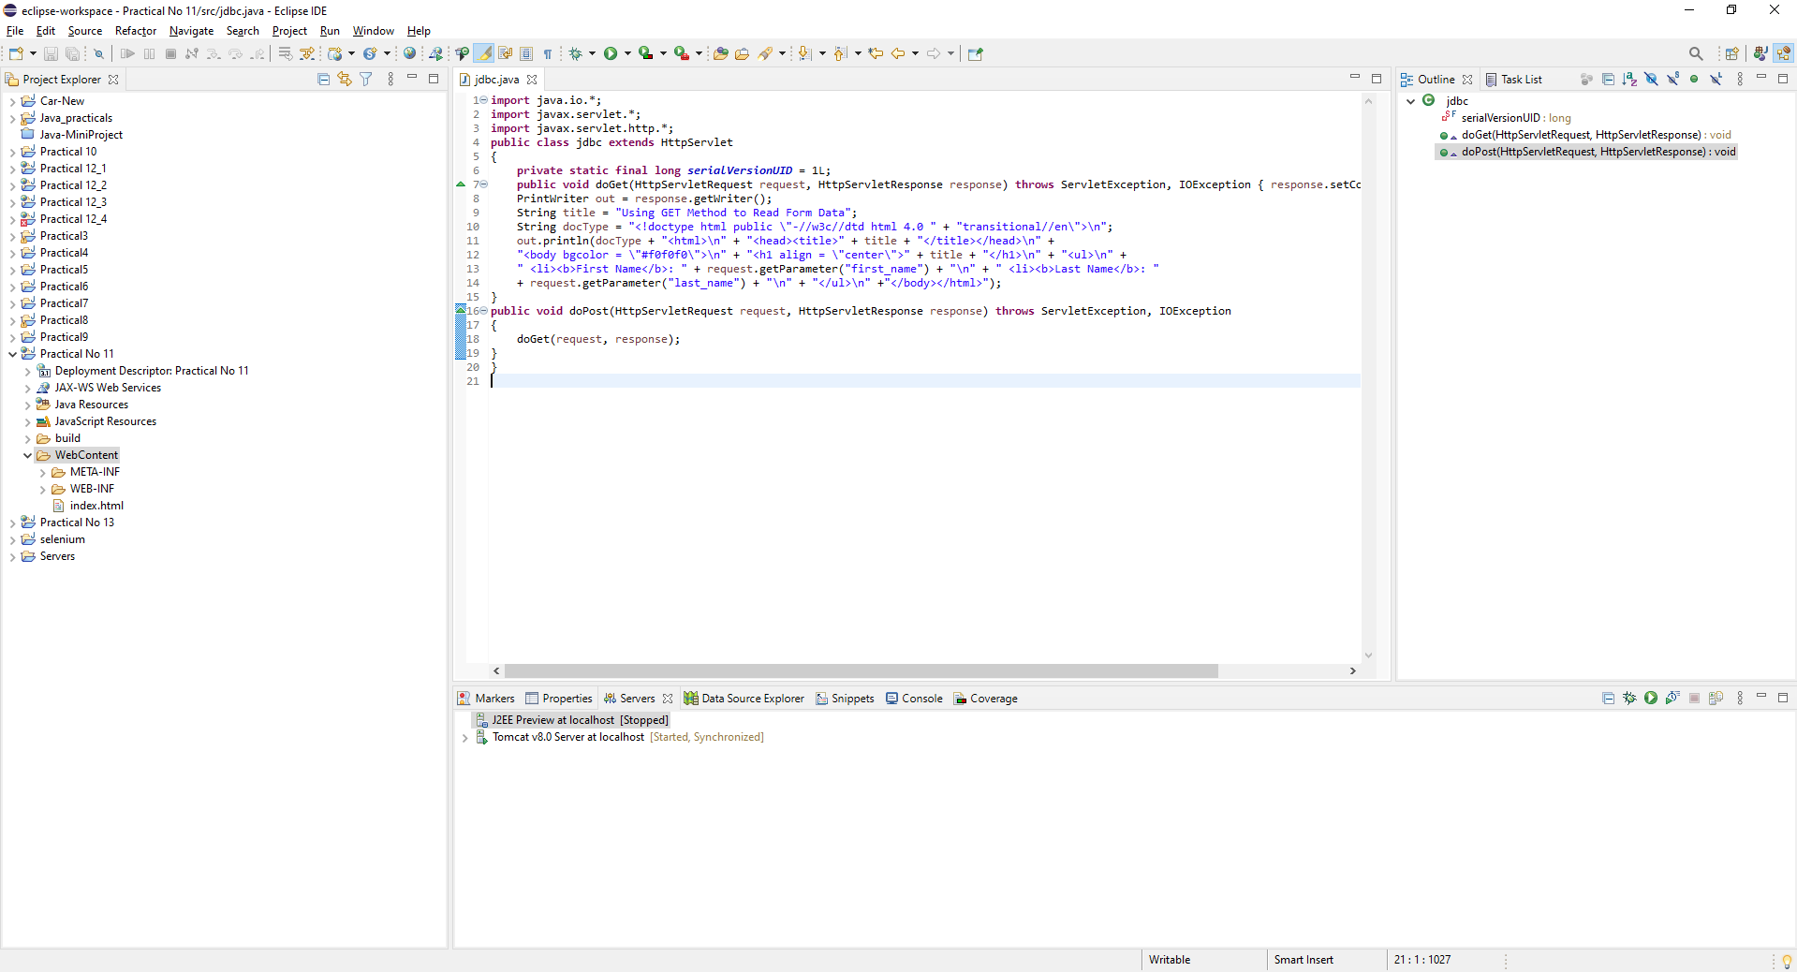

**Conclusion: We have designed a simple web-based interface to a currency converter application.**

**Code:**

**jdbc.java**

**import** java.io.*;

**import** javax.servlet.*;

**import** javax.servlet.http.*;

**public** **class** jdbc **extends** HttpServlet

{

**private** **static** **final** **long** ***serialVersionUID*** = 1L;

**public** **void** doGet(HttpServletRequest request, HttpServletResponse response) **throws** ServletException, IOException { response.setContentType("text/html");

PrintWriter out = response.getWriter();

String title = "Using GET Method to Read Form Data";

String docType = "<!doctype html public \"-//w3c//dtd html 4.0 " + "transitional//en\">\n";

out.println(docType + "<html>\n" + "<head><title>" + title + "</title></head>\n" +

"<body bgcolor = \"#f0f0f0\">\n" + "<h1 align = \"center\">" + title + "</h1>\n" + "<ul>\n" +

" <li><b>First Name</b>: " + request.getParameter("first_name") + "\n" + " <li><b>Last Name</b>: "

+ request.getParameter("last_name") + "\n" + "</ul>\n" +"</body></html>");

}

**public** **void** doPost(HttpServletRequest request, HttpServletResponse response) **throws** ServletException, IOException

{

doGet(request, response);

}

}

**Index.html**

<!DOCTYPE html>

<html>

<head>

<meta charset=*"ISO-8859-1"*>

<title>Currency Converter</title>

</head>

<body>

<h3>Currency Converter</h3>

<h3>Rates for Conversion</h3>

<h2>Dollar : 74.12</h2>

<h2>Egyption Pound: 4.29</h2>

<h2>Qatari Rial : 20.36</h2>

<p>Type amount in RS to convert the amount:</p>

<p><label>Rupees</label>

<input id=*"input_RS"* type=*"number"* placeholder=*"Insert Amount in RS"* oninput=*"CurrencyConverter(this.value)"* onchange=*"CurrencyConverter(this.value)"*>

<p>Dollars : <span id=*"USDollar"*></span></p>

<script>

**function** CurrencyConverter(valNum)

{

document.getElementById("USDollar").innerHTML=valNum*74.12;

}

**function** CurrencyConverter1(valNum1)

{

document.getElementById("Egyption_Pound").innerHTML=valNum1*4.29;

}

**function** CurrencyConverter2(valNum2)

{

document.getElementById("Qatari_Rial").innerHTML=valNum2*20.36;

}

</script>

</body>

</html>

**Output:**

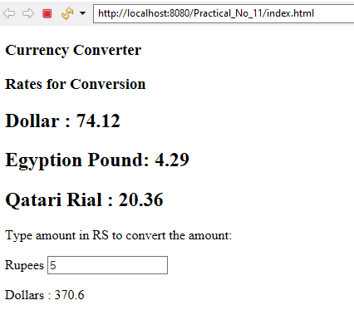

**B) To implement a program to count the no of visits made to the site using cookies in servlet.**

**Aim: Write a program to count the no of visits made to the site using cookies in servlet.**

**Description:**

A servlet is a Java programming language class that is used to extend the capabilities of servers that host applications accessed by means of a request-response programming model. Although servlets can respond to any type of request, they are commonly used to extend the applications hosted by web servers. In this program we have imported all the servlet classes then we defined the public class as cookies which extends servlet class. Then we define the integer to count the numbers of hits. Then we use the html functions for string title and doctype. The xml file is generated along with code. The output has been displayed.

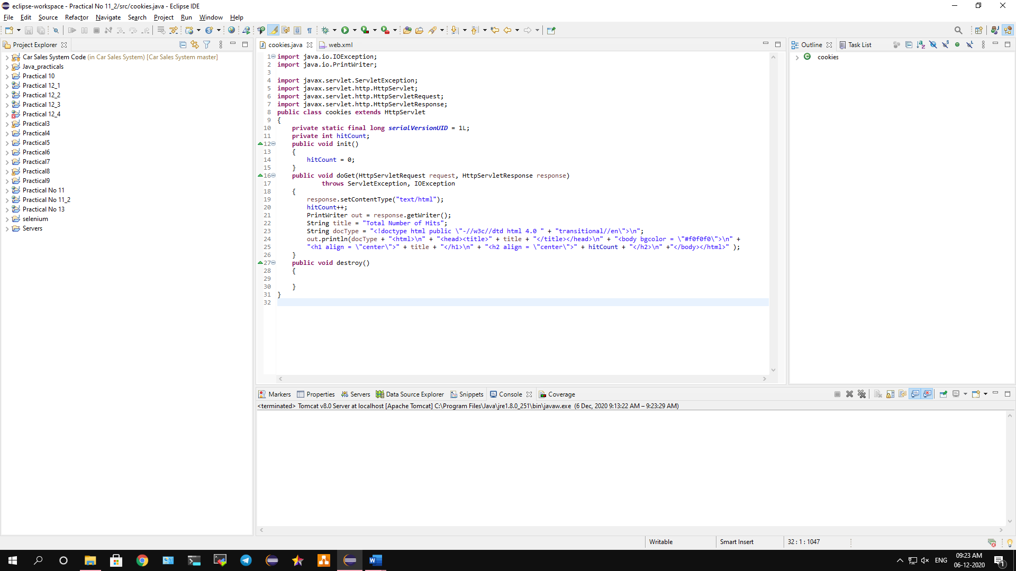

**Conclusion: We have implemented program to count the no of visits made to the site using cookies in servlet.**

**Code:**

**cookies.java**

**import** java.io.IOException;

**import** java.io.PrintWriter;

**import** javax.servlet.ServletException;

**import** javax.servlet.http.HttpServlet;

**import** javax.servlet.http.HttpServletRequest;

**import** javax.servlet.http.HttpServletResponse;

**public** **class** cookies **extends** HttpServlet

{

**private** **static** **final** **long** ***serialVersionUID*** = 1L;

**private** **int** hitCount;

**public** **void** init()

{

hitCount = 0;

}

**public** **void** doGet(HttpServletRequest request, HttpServletResponse response)

**throws** ServletException, IOException

{

response.setContentType("text/html");

hitCount++;

PrintWriter out = response.getWriter();

String title = "Total Number of Hits";

String docType = "<!doctype html public \"-//w3c//dtd html 4.0 " + "transitional//en\">\n";

out.println(docType + "<html>\n" + "<head><title>" + title + "</title></head>\n" + "<body bgcolor = \"#f0f0f0\">\n" +

"<h1 align = \"center\">" + title + "</h1>\n" + "<h2 align = \"center\">" + hitCount + "</h2>\n" +"</body></html>" );

}

**public** **void** destroy()

{

}

}

**servlet.xml**

<?xml version="1.0" encoding="UTF-8"?>

<web-app xmlns:xsi="http://www.w3.org/2001/XMLSchema-instance" xmlns="http://xmlns.jcp.org/xml/ns/javaee" xsi:schemaLocation="http://xmlns.jcp.org/xml/ns/javaee http://xmlns.jcp.org/xml/ns/javaee/web-app_3_1.xsd" id="WebApp_ID" version="3.1">

<display-name>Practical No 11_2</display-name>

<servlet>

<servlet-name>visitCounter</servlet-name>

<servlet-class>visitCounter</servlet-class>

</servlet>

<servlet-mapping>

<servlet-name>visitCounter</servlet-name>

<url-pattern>/visitCounter</url-pattern>

</servlet-mapping>

</web-app>

**Output:**

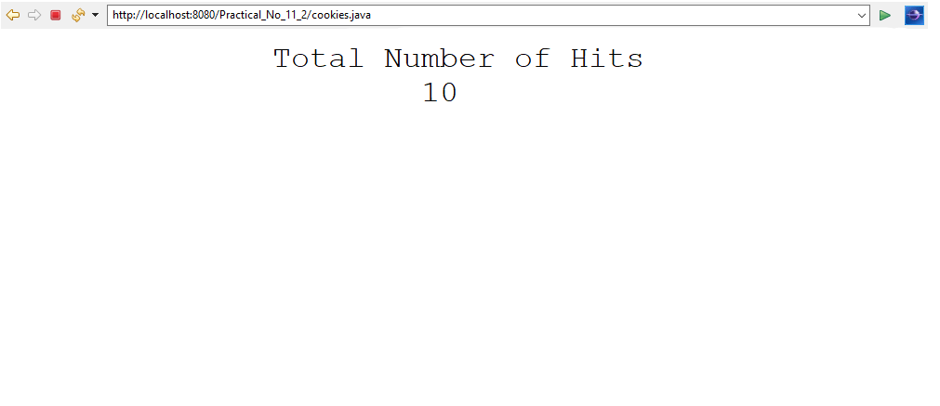

**C) To implement a program for Session management in servlet where the session in maintain under username.**

**Aim: Write a program to implement Session management in servlet.**

**Description:**

A Cookie is a small piece of data that is exchanged between a server and a client. Whenever a client sends a request, the server will send a cookie containing the required data and the client can send back the cookie with its next request. In session management, Tomcat creates a session id whenever client’s first request gets to the server (However, other servlet containers may behave differently). Then it inserts this session id into a cookie with a name JSESSIONID and sends along with the response. After receiving the response with the cookie, the client can send the received cookie in its next request so that the server will identify the session using session id that resides in the JSESSIONID cookie. In this program we created 2 files as cookies.java and session.java. We imported all the sessions and defied it main functions then we created a public class that will extends servlet class. Then we used form method to defined users and password. Once we type the username and password and if the username is correct it will display the output, if the password is not correct it will display as wrong password.

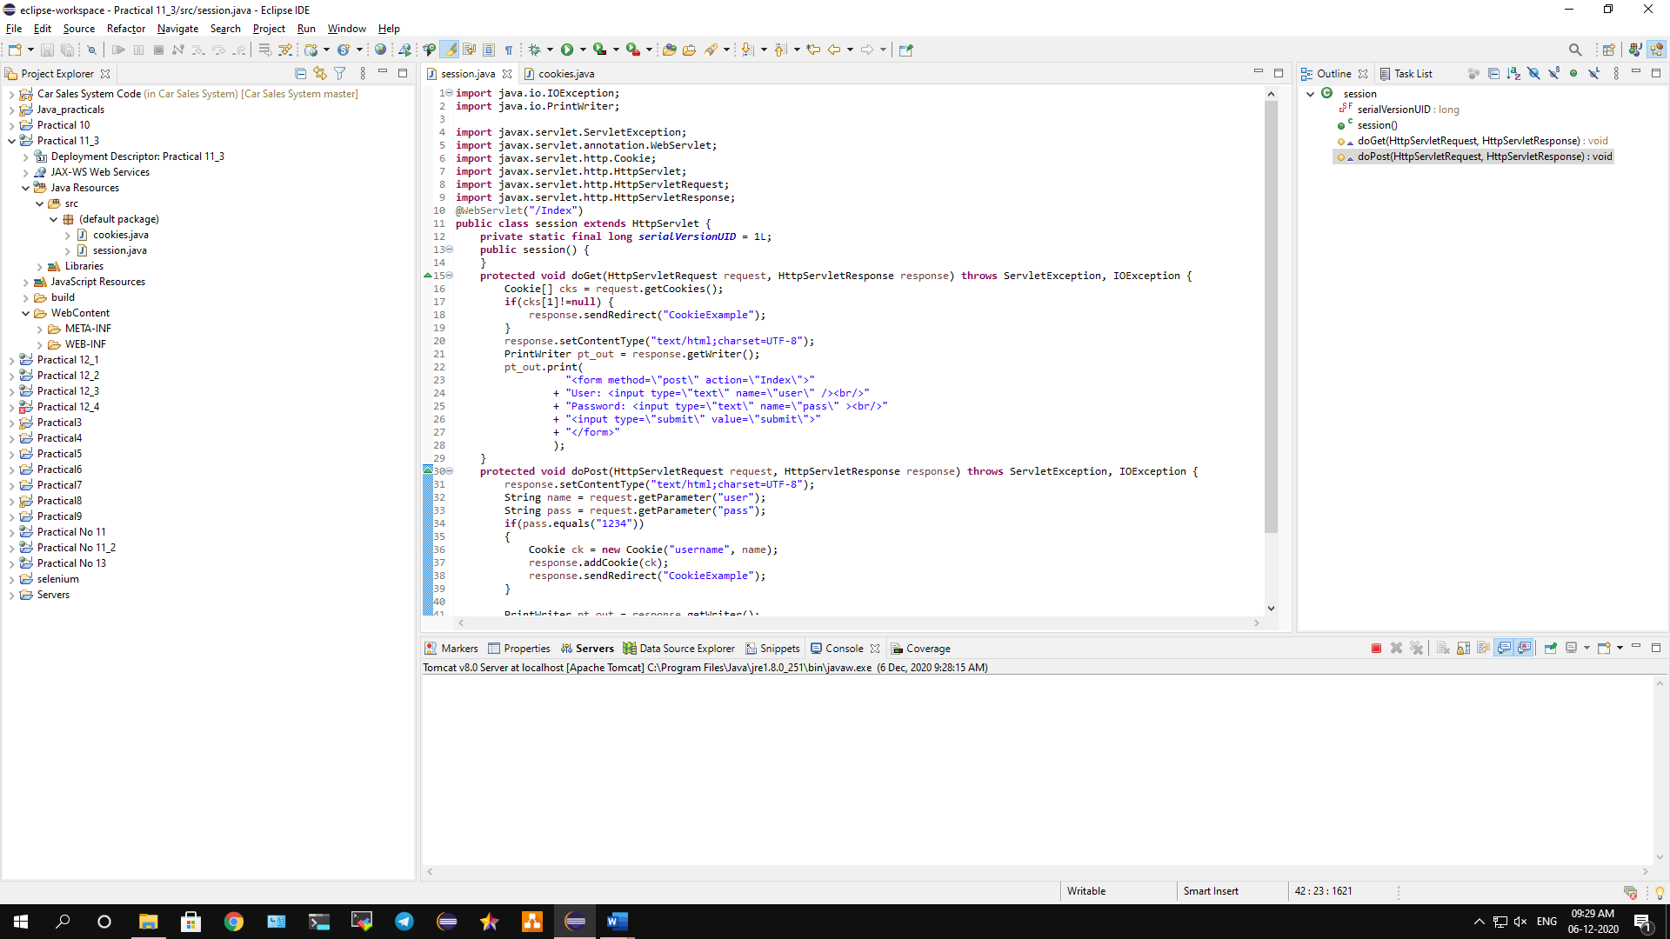

**Conclusion: We have implemented a program for Session management in servlet where the session in maintain under username.**

**Code:**

**session.java**

**import** java.io.IOException;

**import** java.io.PrintWriter;

**import** javax.servlet.ServletException;

**import** javax.servlet.annotation.WebServlet;

**import** javax.servlet.http.Cookie;

**import** javax.servlet.http.HttpServlet;

**import** javax.servlet.http.HttpServletRequest;

**import** javax.servlet.http.HttpServletResponse;

@WebServlet("/Index")

**public** **class** session **extends** HttpServlet {

**private** **static** **final** **long** ***serialVersionUID*** = 1L;

**public** session() {

}

**protected** **void** doGet(HttpServletRequest request, HttpServletResponse response) **throws** ServletException, IOException {

Cookie[] cks = request.getCookies();

**if**(cks[1]!=**null**) {

response.sendRedirect("CookieExample");

}

response.setContentType("text/html;charset=UTF-8");

PrintWriter pt_out = response.getWriter();

pt_out.print(

"<form method=\"post\" action=\"Index\">"

+ "User: <input type=\"text\" name=\"user\" /><br/>"

+ "Password: <input type=\"text\" name=\"pass\" ><br/>"

+ "<input type=\"submit\" value=\"submit\">"

+ "</form>"

);

}

**protected** **void** doPost(HttpServletRequest request, HttpServletResponse response) **throws** ServletException, IOException {

response.setContentType("text/html;charset=UTF-8");

String name = request.getParameter("user");

String pass = request.getParameter("pass");

**if**(pass.equals("1234"))

{

Cookie ck = **new** Cookie("username", name);

response.addCookie(ck);

response.sendRedirect("CookieExample");

}

PrintWriter pt_out = response.getWriter();

pt_out.append(

"<h3>Wrong password buddy!!!</h3>"

);

}

}

**cookies.java**

**import** java.io.IOException;

**import** java.io.PrintWriter;

**import** javax.servlet.ServletException;

**import** javax.servlet.annotation.WebServlet;

**import** javax.servlet.http.Cookie;

**import** javax.servlet.http.HttpServlet;

**import** javax.servlet.http.HttpServletRequest;

**import** javax.servlet.http.HttpServletResponse;

@WebServlet("/CookieExample")

**public** **class** cookies **extends** HttpServlet {

**private** **static** **final** **long** ***serialVersionUID*** = 1L;

**public** cookies() {

**super**();

}

**protected** **void** doGet(HttpServletRequest request, HttpServletResponse response) **throws** ServletException, IOException {

response.setContentType("text/html;charset=UTF-8");

PrintWriter out = response.getWriter();

Cookie[] cks = request.getCookies();

out.println("Welcome "+ cks[1].getValue());

}

**protected** **void** doPost(HttpServletRequest request, HttpServletResponse response) **throws** ServletException, IOException {

doGet(request, response);

}

}

**Output:**

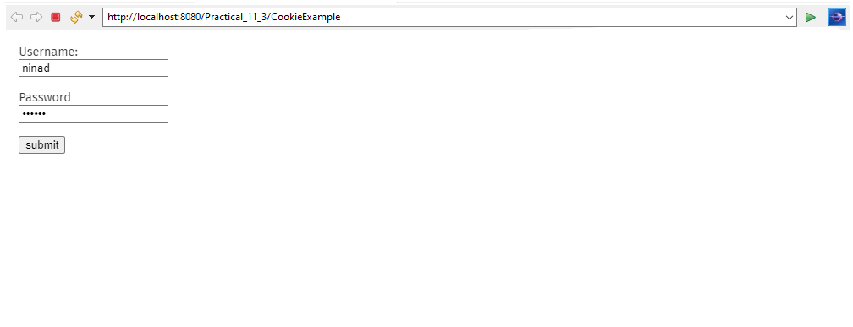

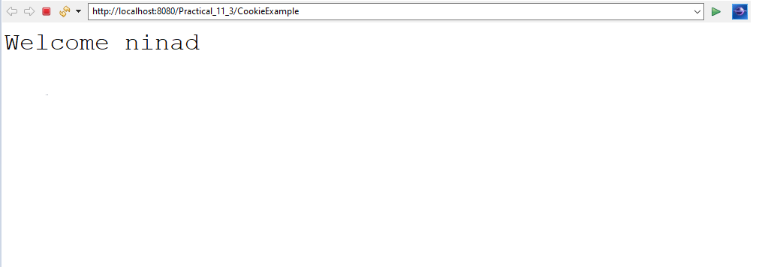

**D) To implement a sample program to handle post method in servlet.**

**Aim: Write a program to implement a sample program to handle post method in servlet.**

**Description:**

A servlet is a Java programming language class that is used to extend the capabilities of servers that host applications accessed by means of a request-response programming model. Although servlets can respond to any type of request, they are commonly used to extend the applications hosted by web servers. In this program we have imported the servlet classes and the we define the servlet path using @webserlet method then we defined the public class and the we use form function. Then we defined protected function and then the output is displayed.

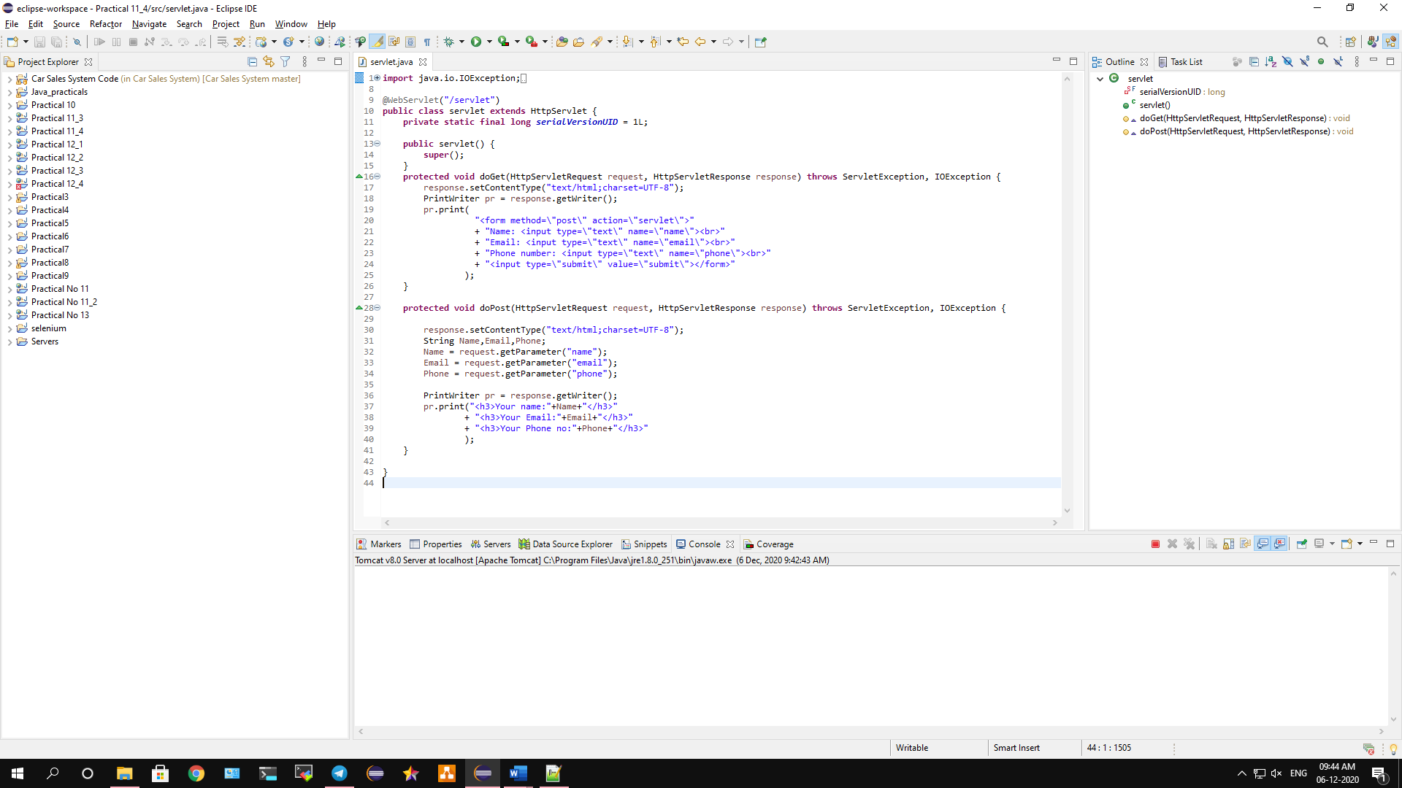

**Conclusion: We have implemented a sample program to handle post method in servlet.**

**Code:**

**import java.io.IOException;**

**import java.io.PrintWriter;**

**import javax.servlet.ServletException;**

**import javax.servlet.annotation.WebServlet;**

**import javax.servlet.http.HttpServlet;**

**import javax.servlet.http.HttpServletRequest;**

**import javax.servlet.http.HttpServletResponse;**

**@WebServlet("/servlet")**

**public class servlet extends HttpServlet {**

**private static final long serialVersionUID = 1L;**

**public servlet() {**

**super();**

**}**

**protected void doGet(HttpServletRequest request, HttpServletResponse response) throws ServletException, IOException {**

**response.setContentType("text/html;charset=UTF-8");**

**PrintWriter pr = response.getWriter();**

**pr.print(**

**"<form method=\"post\" action=\"servlet\">"**

**+ "Name: <input type=\"text\" name=\"name\"><br>"**

**+ "Email: <input type=\"text\" name=\"email\"><br>"**

**+ "Phone number: <input type=\"text\" name=\"phone\"><br>"**

**+ "<input type=\"submit\" value=\"submit\"></form>"**

**);**

**}**

**protected void doPost(HttpServletRequest request, HttpServletResponse response) throws ServletException, IOException {**

**response.setContentType("text/html;charset=UTF-8");**

**String Name,Email,Phone;**

**Name = request.getParameter("name");**

**Email = request.getParameter("email");**

**Phone = request.getParameter("phone");**

**PrintWriter pr = response.getWriter();**

**pr.print("<h3>Your name:"+Name+"</h3>"**

**+ "<h3>Your Email:"+Email+"</h3>"**

**+ "<h3>Your Phone no:"+Phone+"</h3>"**

**);**

**}**

**}**

**Output:**

