**Practical No 12**

**A) To design a form and use of JSP Scripting Element and JSP Directive. Display Grade of a student by accepting marks in five subjects.**

**Aim: Write a program to design a form and use of JSP Scripting Element and JSP Directive. Display Grade of a student by accepting marks in five subjects.**

**Description:**

JSP scripting allows you to insert Java code into Java Servlet generated from JSP page. These are the scripting elements: comment, expression, scriptlet, declaration and expression language. A JSP directive affects the overall structure of the servlet class. Directives can have a number of attributes which you can list down as key-value pairs and separated by commas.

In the following program we have defined the html functions along with forms and input type in index.html file. Then we have defined directive and scripting element in marks.jsp file which start with int subject name defines the subject for and integer so it will read the integer and get the output. Once we input the marks for a particular subject it will read and calculate the total marks and then it will show the grade based on the average of marks and then it will display the grade on the screen.

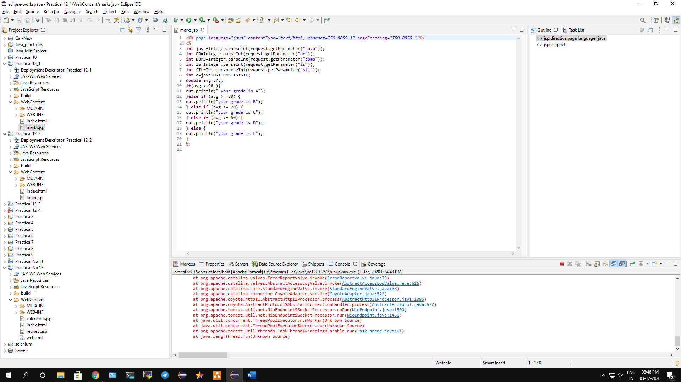

**Conclusion: We have designed a form and use of JSP Scripting Element and JSP Directive. Display Grade of a student by accepting marks in five subjects.**

**Code:**

**marks.jsp**

<%@ page language=*"java"* contentType=*"text/html; charset=ISO-8859-1"* pageEncoding=*"ISO-8859-1"*%>

<%

**int** java=Integer.parseInt(request.getParameter("java"));

**int** OR=Integer.parseInt(request.getParameter("or"));

**int** DBMS=Integer.parseInt(request.getParameter("dbms"));

**int** IS=Integer.parseInt(request.getParameter("is"));

**int** STL=Integer.parseInt(request.getParameter("stl"));

**int** c=java+OR+DBMS+IS+STL;

**double** avg=c/5;

**if**(avg > 90 ){

out.println(" your grade is A");

}**else** **if** (avg >= 80) {

out.println("your grade is B");

} **else** **if** (avg >= 70) {

out.println("your grade is C");

} **else** **if** (avg >= 60) {

out.println("your grade is D");

} **else** {

out.println("your grade is E");

}

%>

**index.html**

<!DOCTYPE html PUBLIC "-//W3C//DTD HTML 4.01 Transitional//EN" "http://www.w3.org/TR/html4/loose.dtd">

<html>

<head>

<meta http-equiv=*"Content-Type"* content=*"text/html; charset=ISO-8859-1"*>

</head>

<body>

<form action=*"marks.jsp"* method=*"get"*>

Enter Java Marks : <input type=*"text"* name=*"java"*> <br><br>

Enter OR Marks : <input type=*"text"* name=*"or"*><br><br>

Enter DBMS Marks :<input type=*"text"* name=*"dbms"*><br><br>

Enter IS Marks :<input type=*"text"* name=*"is"*><br><br>

Enter STL Marks :<input type=*"text"* name=*"stl"*><br><br>

<input type=*"submit"*>

</form>

</body>

</html>

**Output:**

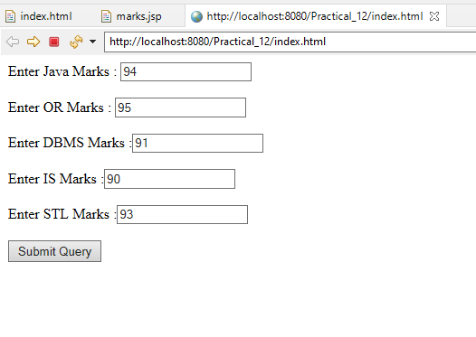

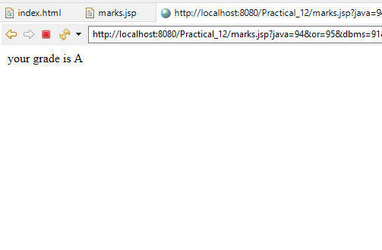

**B) To implement error and error Objects.**

**Aim: Write a program to implement error and error Objects.**

**Description:**

In the given program we have defined the jsp directive function and the we defined string user and pwd to get request if user enter then password it will login and if user failed then it will throw error as throw keyword is defined which display as mandatory parameter missing. In index.html we have defined the html function and then we use form action as login.jsp and then we use input function to get username and password field which will input username and password and then the output will be displayed.

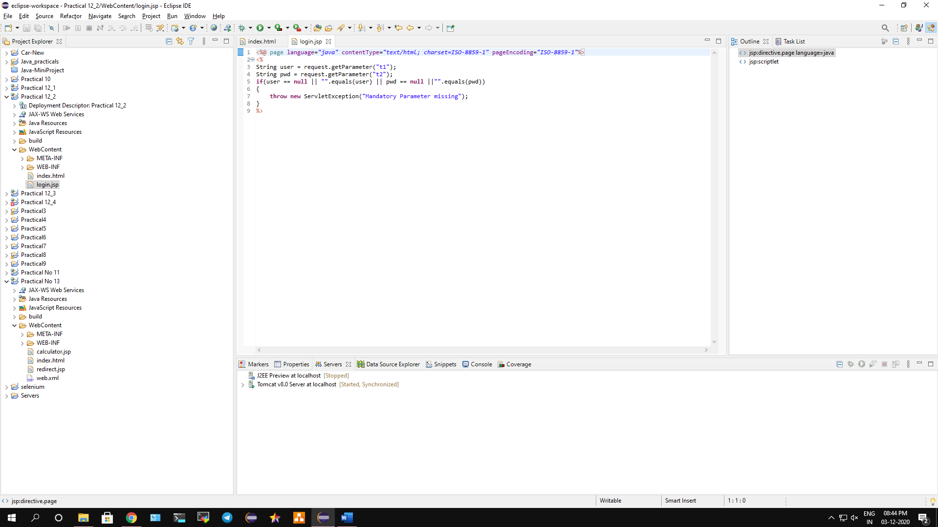

**Conclusion: We have implemented error and error Objects.**

**Code:**

**login.jsp**

<%@ page language=*"java"* contentType=*"text/html; charset=ISO-8859-1"* pageEncoding=*"ISO-8859-1"*%>

<%

String user = request.getParameter("t1");

String pwd = request.getParameter("t2");

**if**(user == **null** || "".equals(user) || pwd == **null** ||"".equals(pwd))

{

**throw** **new** ServletException("Mandatory Parameter missing");

}

%>

**index.html**

<!DOCTYPE html>

<html>

<body>

<form action=*"login.jsp"* method=*"post"*>

Enter user name:<input type=*"text"* name=*"t1"*><br><br>

Enter Password: <input type=*"password"* name=*"t2"*><br><br>

<input type=*"submit"* name=*"s1"*><br><br>

</form>

</body>

</html>

**Output:**

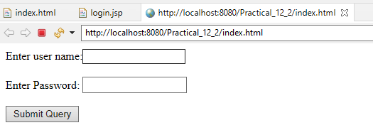

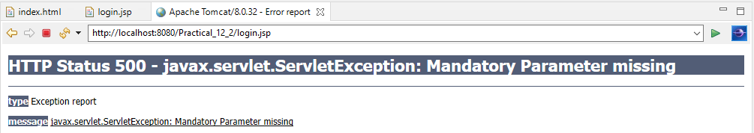

**C) To implement a program to create a Visitor Log that reports the IP Address of each User, and the time they visited the page.**

**Aim: Write a program to implement a program to create a Visitor Log that reports the IP Address of each User, and the time they visited the page.**

**Description:**

In this program we used the html functions with form such as enter username and submit button. Then we imported all the java utils for logging the users. Then we defined calendar function with integer hours and mins to get hours and minute of the day. Then we defined string to get username and display user message. Then the output will display once the user logged in and the ip address will also show on the output.

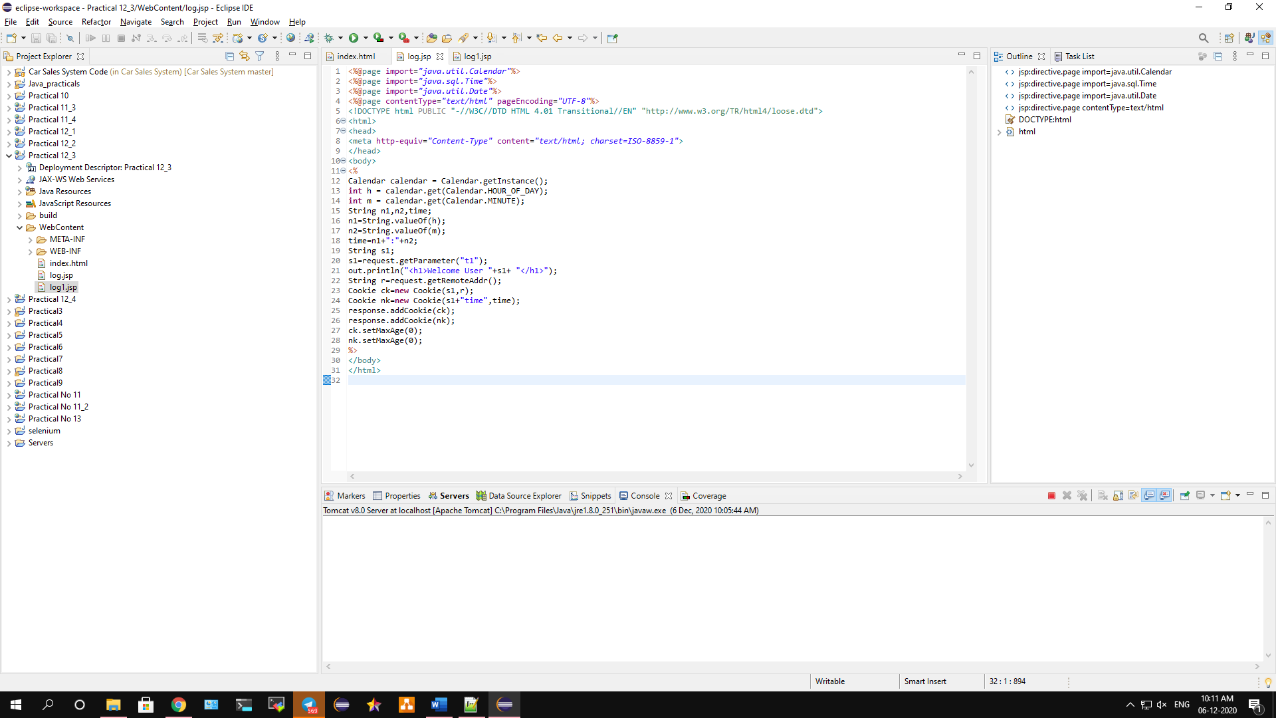

**Conclusion: We have implemented a program to create a Visitor Log that reports the IP Address of each User, and the time they visited the page.**

**Code:**

**index.html**

<!DOCTYPE html>

<html>

<head>

<meta charset=*"ISO-8859-1"*>

</head>

<body>

<form method=*"post"* action=*"log1.jsp"*>

Enter user name:<input type=*"text"* name=*"t1"*><br><br>

<input type=*"submit"* name=*"s1"*><br><br>

</form>

</body>

</html>

**log.jsp**

<%@page import=*"java.util.Calendar"*%>

<%@page import=*"java.sql.Time"*%>

<%@page import=*"java.util.Date"*%>

<%@page contentType=*"text/html"* pageEncoding=*"UTF-8"*%>

<!DOCTYPE html PUBLIC "-//W3C//DTD HTML 4.01 Transitional//EN" "http://www.w3.org/TR/html4/loose.dtd">

<html>

<head>

<meta http-equiv=*"Content-Type"* content=*"text/html; charset=ISO-8859-1"*>

</head>

<body>

<%

Calendar calendar = Calendar.getInstance();

**int** h = calendar.get(Calendar.HOUR_OF_DAY);

**int** m = calendar.get(Calendar.MINUTE);

String n1,n2,time;

n1=String.valueOf(h);

n2=String.valueOf(m);

time=n1+":"+n2;

String s1;

s1=request.getParameter("t1");

out.println("<h1>Welcome User "+s1+ "</h1>");

String r=request.getRemoteAddr();

Cookie ck=**new** Cookie(s1,r);

Cookie nk=**new** Cookie(s1+"time",time);

response.addCookie(ck);

response.addCookie(nk);

ck.setMaxAge(0);

nk.setMaxAge(0);

%>

</body>

</html>

**log1.jsp**

<% Cookie nk[]=request.getCookies();

Cookie ck[]=request.getCookies();

String[] name = **new** String[10];

String[] ip = **new** String[10];

String[] t = **new** String[10];

**int** c=1; %>

<table border=*"1"*>

<tr><th>User</th>

<th>IPaddress</th>

<th>Time</th> </tr>

<% **for**(**int** i=1;i<ck.length;i++){

**if**(!nk[i].getName().contains("time")){

name[c]= ck[i].getName();

ip[c] = ck[i].getValue();

c++; }}

c=1;

**for**(**int** i=1;i<nk.length;i++){

**if**(nk[i].getName().contains("time")){

t[c] = nk[i].getValue();

c++; }}

**for**(**int** i=1;i<c;i++){

out.println("<tr>");

out.println("<td>"+name[i]+"</td><td>"+ip[i]+"</td><td>"+t[i]

+"</td>");

out.println("</tr>");} %></table>

**Output:**

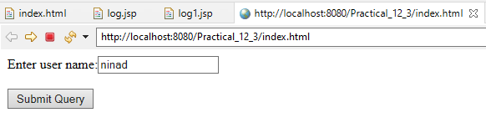

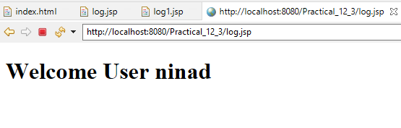

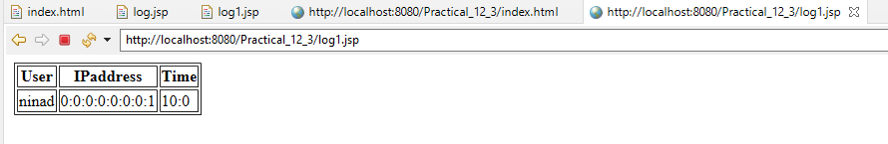

**D) To implement a program for Session management in JSP for Shopping cart Application.**

**Aim: Write a program to implement a program for Session management in JSP for Shopping cart Application.**

**Description:**

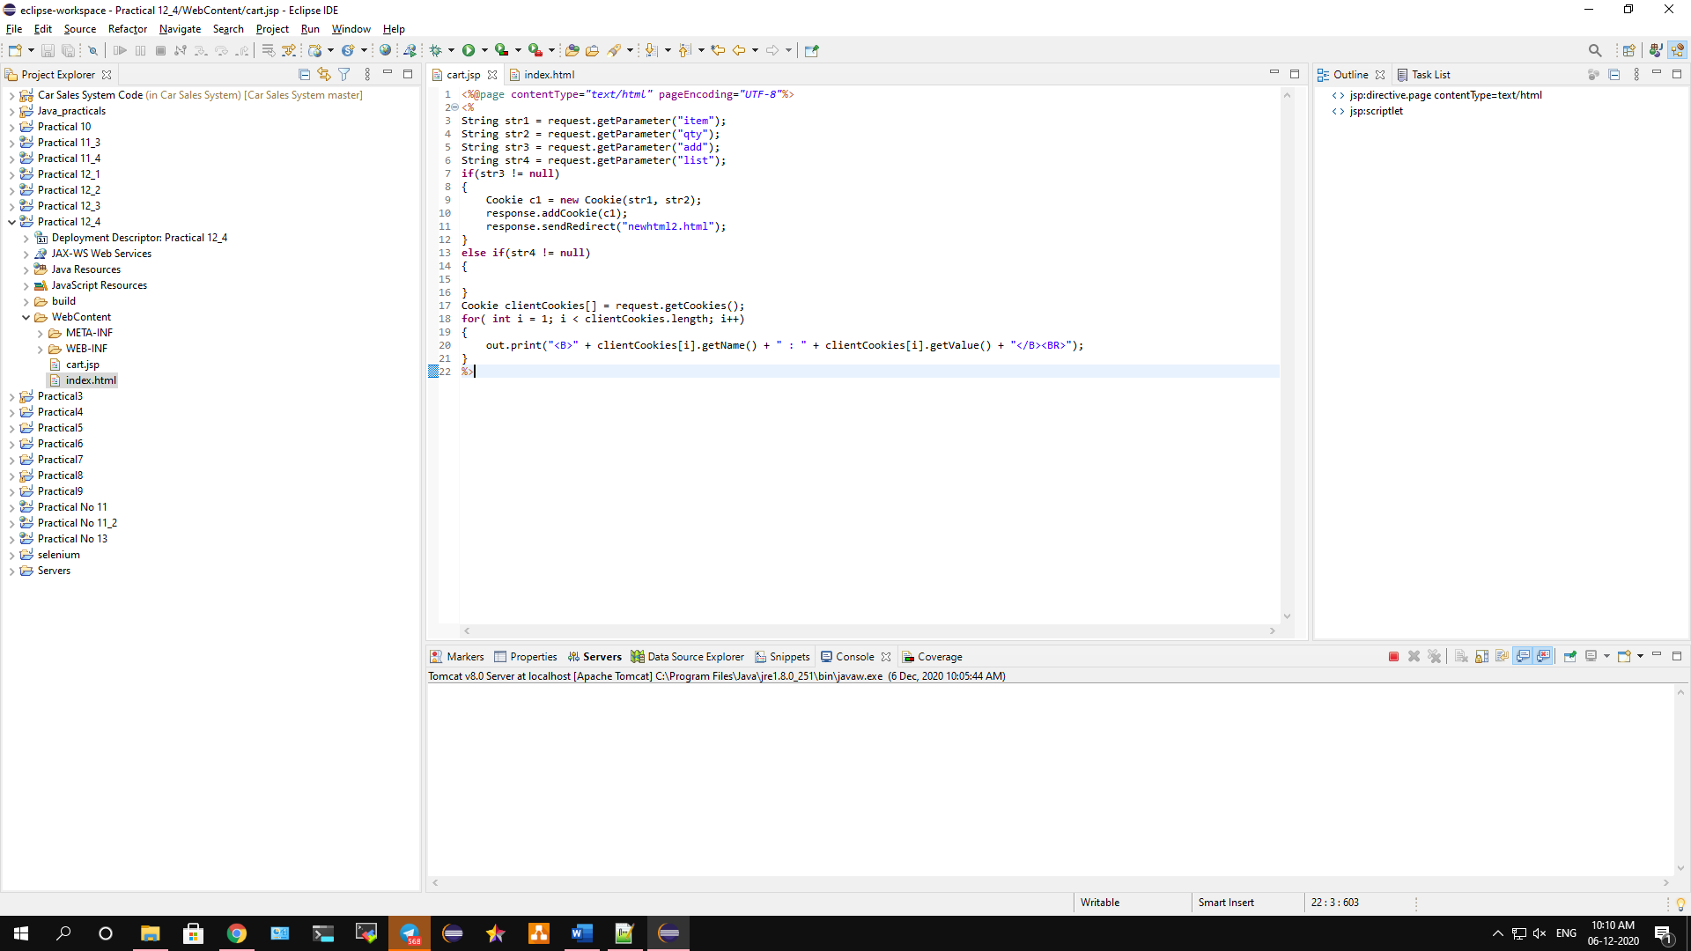

**Conclusion: We have implemented a program for Session management in JSP for Shopping cart Application.**

**Code:**

**index.html**

<!DOCTYPE html>

<html>

<head>

<meta charset=*"ISO-8859-1"*>

</head>

<body>

<form method=*"post"* action=*"cart.jsp"*>

Enter Item Name <input type=*"text"* name=*"item"*><br><br>

Enter Item Quantity <input type=*"text"* name=*"qty"*><br><br>

<input type=*"submit"* value=*"Add Cookie"* name=*"add"*>

<input type=*"submit"* value=*"List Cookies"* name=*"list"*>

</form>

</body>

</html>

**cart.jsp**

<%@page contentType=*"text/html"* pageEncoding=*"UTF-8"*%>

<%

String str1 = request.getParameter("item");

String str2 = request.getParameter("qty");

String str3 = request.getParameter("add");

String str4 = request.getParameter("list");

**if**(str3 != **null**)

{

Cookie c1 = **new** Cookie(str1, str2);

response.addCookie(c1);

response.sendRedirect("newhtml2.html");

}

**else** **if**(str4 != **null**)

{

}

Cookie clientCookies[] = request.getCookies();

**for**( **int** i = 1; i < clientCookies.length; i++)

{

out.print("<B>" + clientCookies[i].getName() + " : " + clientCookies[i].getValue() + "</B><BR>");

}

%>

**Output:**

