**Practical No 13**

**To implement basic program on Spring Framework.**

**Aim: Write a program to implement basic program on spring framework.**

**Description:**

Spring is the most popular application development framework for enterprise Java. Millions of developers around the world use Spring Framework to create high performing, easily testable, and reusable code. Spring framework is an open source Java platform. It was initially written by Rod Johnson and was first released under the Apache 2.0 license in June 2003. Spring is lightweight when it comes to size and transparency. The basic version of Spring framework is around 2MB. So, in this program we first created a file name called calculator.jsp and then we use the html body and then defined the page language as java, then we defined the int functions and string operators for requesting parameter as arithmetic operations. Then we define the if else if functions for operators and then we created another file call index.html in which all the html related functions are stored such as form actions, radio buttons and input type. Then we created redirect.jsp file which will redirect the index.html file for showing the response once we clicked the submit button. Then in web.xml it consists of all the manifest of the current project.

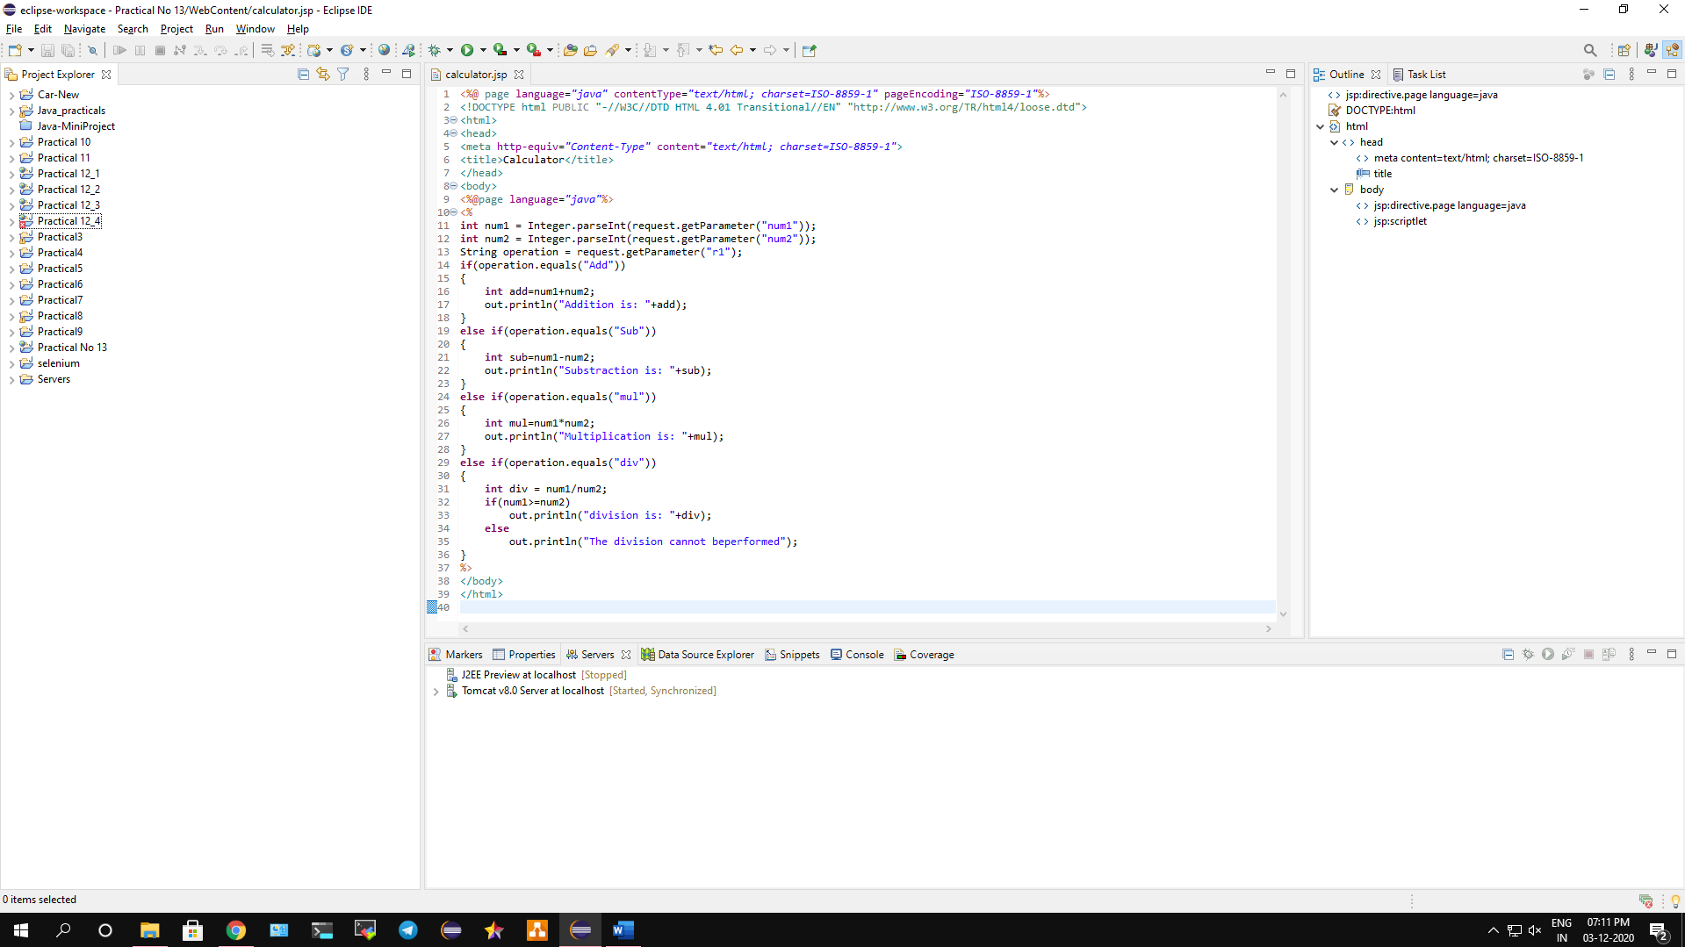

**Conclusion: We have implemented a basic program on spring framework.**

**Code:**

**Index.html**

<!DOCTYPE html>

<html>

<head>

<meta http-equiv=*"Content-Type"* content=*"text/html;charset=UTF-8"*>

<title>Welcome to Spring Web MVC project</title>

</head>

<body>

<form action=*"calculator.jsp"* method=*"get"*>

<label for=*"num1"*><b>VALUE 1</b></label>

<input type=*"text"* name =*"num1"*><br><br>

<label for = *"num2"*><b>VALUE 2</b></label>

<input type=*"text"* name=*"num2"*><br><br>

<input type =*"radio"* name = *"r1"* value=*"Add"*>ADD

<input type = *"radio"* name = *"r1"* value=*"Sub"*>SUB

<input type=*"radio"* name=*"r1"* value =*"mul"*>MUL

<input type = *"radio"* name=*"r1"* value=*"div"*>DIV

<br><br><input type=*"submit"* value=*"ANSWER"*>

</form>

</body>

</html>

**calculator.jsp**

<%@ page language=*"java"* contentType=*"text/html; charset=ISO-8859-1"* pageEncoding=*"ISO-8859-1"*%>

<!DOCTYPE html PUBLIC "-//W3C//DTD HTML 4.01 Transitional//EN" "http://www.w3.org/TR/html4/loose.dtd">

<html>

<head>

<meta http-equiv=*"Content-Type"* content=*"text/html; charset=ISO-8859-1"*>

<title>Calculator</title>

</head>

<body>

<%@page language=*"java"*%>

<%

**int** num1 = Integer.parseInt(request.getParameter("num1"));

**int** num2 = Integer.parseInt(request.getParameter("num2"));

String operation = request.getParameter("r1");

**if**(operation.equals("Add"))

{

**int** add=num1+num2;

out.println("Addition is: "+add);

}

**else** **if**(operation.equals("Sub"))

{

**int** sub=num1-num2;

out.println("Substraction is: "+sub);

}

**else** **if**(operation.equals("mul"))

{

**int** mul=num1*num2;

out.println("Multiplication is: "+mul);

}

**else** **if**(operation.equals("div"))

{

**int** div = num1/num2;

**if**(num1>=num2)

out.println("division is: "+div);

**else**

out.println("The division cannot beperformed");

}

%>

</body>

</html>

**redirect.jsp**

<%@ page language=*"java"* contentType=*"text/html; charset=ISO-8859-1"* pageEncoding=*"ISO-8859-1"*%>

<%@page contentType=*"text/html"* pageEncoding=*"UTF-8"*%>

<%

response.sendRedirect("index.html");

%>

**web.xml**

<?xml version=*"1.0"* encoding=*"UTF-8"*?>

<web-app version=*"3.1"*

xmlns=*"http://xmlns.jcp.org/xml/ns/javaee"*

xmlns:xsi=*"http://www.w3.org/2001/XMLSchema-instance"*

xsi:schemaLocation=*"http://xmlns.jcp.org/xml/ns/javaee*

*http://xmlns.jcp.org/xml/ns/javaee/web-app_3_1.xsd"*>

<context-param>

<param-name>contextConfigLocation</param-name>

<param-value>/WEB-INF/applicationContext.xml</param-value>

</context-param>

<listener>

<listener-class>org.springframework.web.context.ContextLoaderListener</listener-class>

</listener>

<servlet>

<servlet-name>dispatcher</servlet-name>

<servlet-class>org.springframework.web.servlet.DispatcherServlet

</servlet-class>

<load-on-startup>2</load-on-startup>

</servlet>

<servlet-mapping>

<servlet-name>dispatcher</servlet-name>

<url-pattern>*.htm</url-pattern>

</servlet-mapping>

<session-config>

<session-timeout>30</session-timeout>

</session-config>

<welcome-file-list>

<welcome-file>redirect.jsp</welcome-file>

</welcome-file-list>

</web-app>

**Output:**

