1. **PASS COMPLEX NUMBER AS PARAMETER**

**INPUT**

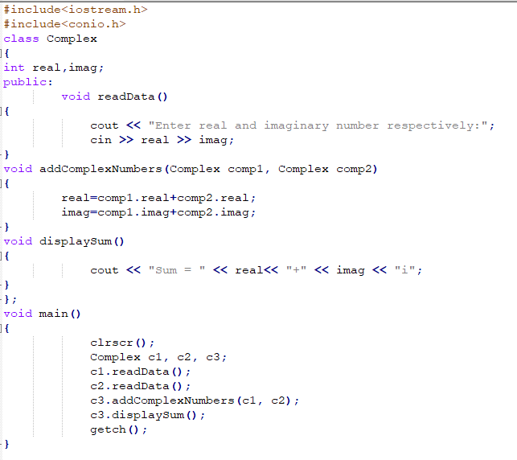

**OUTPUT**

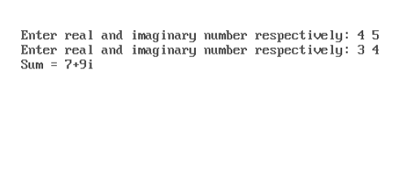

1. **RETURN COMPLEX NUMBER AS OBJECT**

**INPUT**

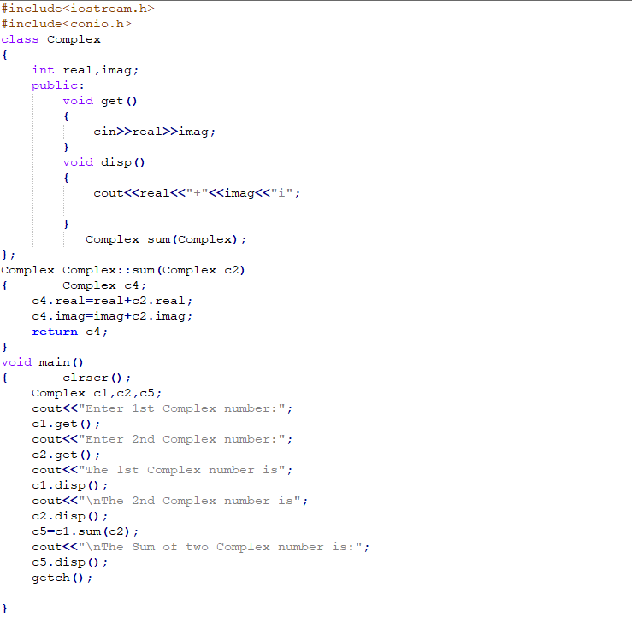

**OUTPUT**

