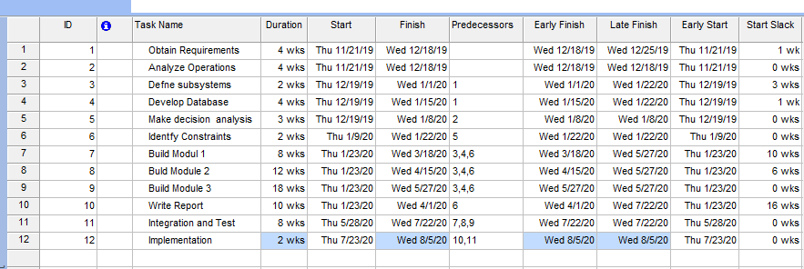**Gantt Chart:**

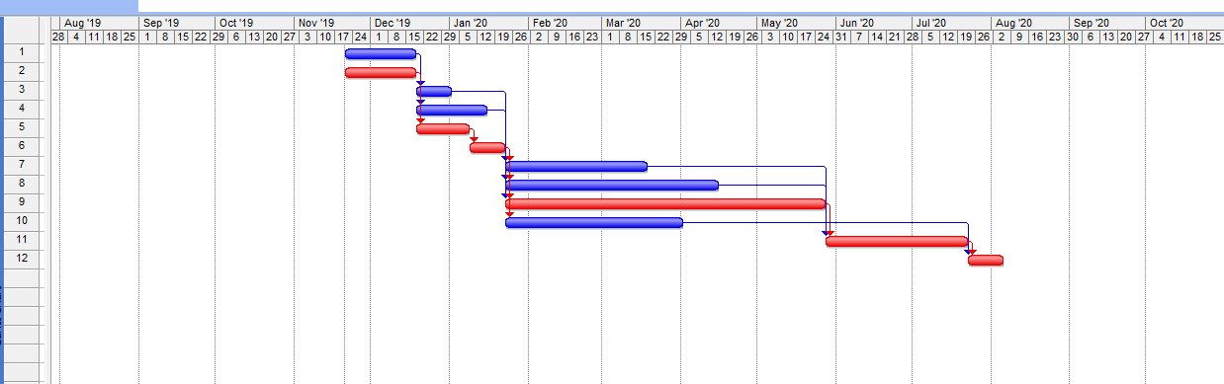

**Network Diagram:**

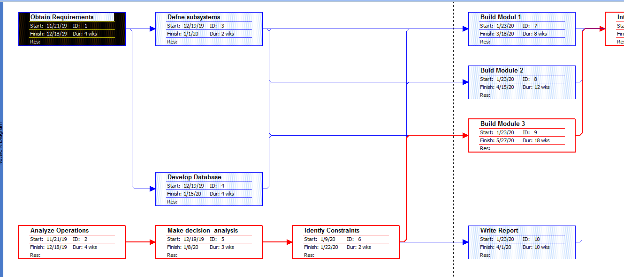

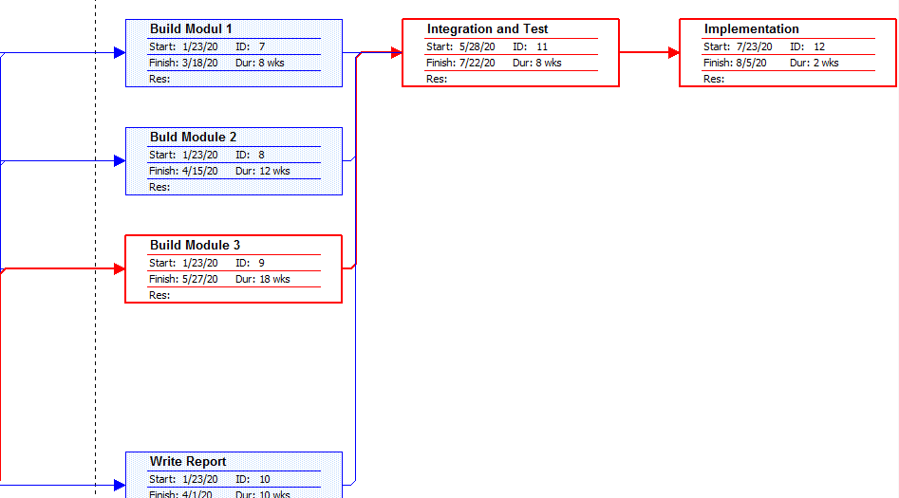

**//Q.3 To add and Multiple Matrices:**

#include<stdio>

void Matrix_Display(int a[][20],int n)

{

int i,j;

for(i=0; i<n; i++)

{

for(j=0; j<n; j++)

{

printf(" %d",a[i][j]);

}

printf("\n");

}

}

int main()

{

int n,i,j,k;

int a[20][20];

int b[20][20];

int c[20][20];

printf("\n Enter the dimensions of the 2 Square matrices: ");

scanf("%d",&n);

printf("\n Enter elements of Matrix A: ");

for(i=0; i<n; i++)

for(j=0; j<n; j++)

scanf("%d",&a[i][j]);

printf("\n Enter elements of Matrix B: ");

for(i=0; i<n; i++)

for(j=0; j<n; j++)

scanf("%d",&b[i][j]);

printf("\n Matrix A: \n");

Matrix_Display(a,n);

printf("\n\n Matrix B: \n");

Matrix_Display(b,n);

for(i=0; i<n; i++)

for(j=0; j<n; j++)

c[i][j]=a[i][j]+b[i][j];

printf("\n\n Addition of A and B gives: \n");

Matrix_Display(c,n);

//Multiplication

for(i=0; i<n; i++)

for(j=0; j<n; j++)

{

c[i][j]=0;

for(k=0; k<n; k++)

c[i][j]+=a[i][k]*b[k][j];

}

printf("\n\n Multiplication of A and B gives: \n");

Matrix_Display(c,n);

}

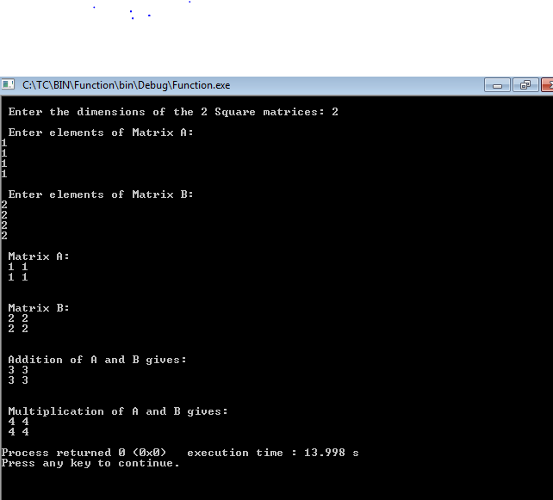

**Q.2 Area of Circle and Rectangle**

#include<iostream>

using namespace std;

int area(int);

int area(int,int);

float area(float);

float area(float,float);

int main()

{

int s,l,b;

float r,bs,ht;

cout<<"Enter side of a square:";

cin>>s;

cout<<"Enter length and breadth of rectangle:";

cin>>l>>b;

cout<<"Enter radius of circle:";

cin>>r;

cout<<"Enter base and height of triangle:";

cin>>bs>>ht;

cout<<"Area of square is"<<area(s);

cout<<"\nArea of rectangle is "<<area(l,b);

cout<<"\nArea of circle is "<<area(r);

cout<<"\nArea of triangle is "<<area(bs,ht);

}

int area(int s)

{

return(s*s);

}

int area(int l,int b)

{

return(l*b);

}

float area(float r)

{

return(3.14*r*r);

}

float area(float bs,float ht)

{

return((bs*ht)/2);

}

