**MINI PROJECT**

**CAR SALES SYSTEM**

**USE CASE DIAGRAM**

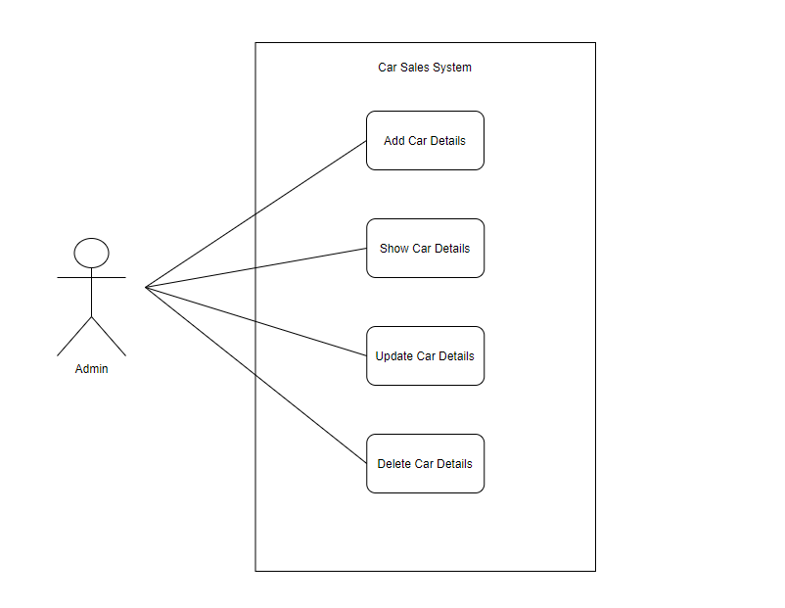

**CLASS DIAGRAM**

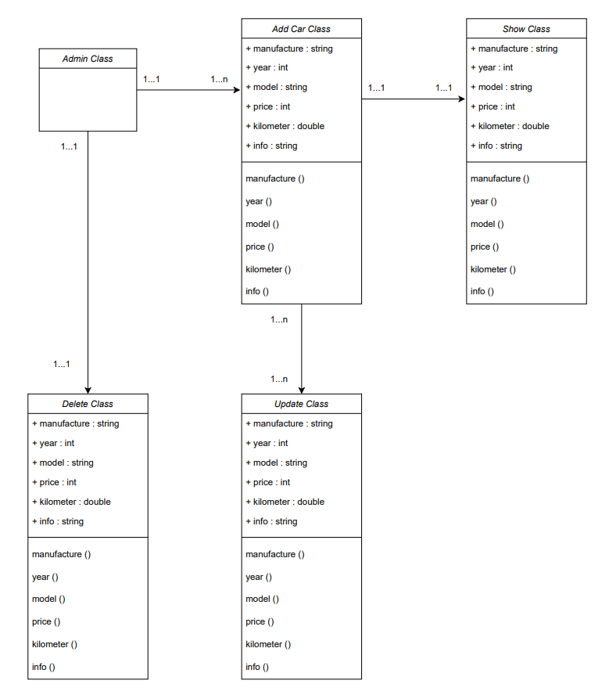

**ACTIVITY DIAGRAM**

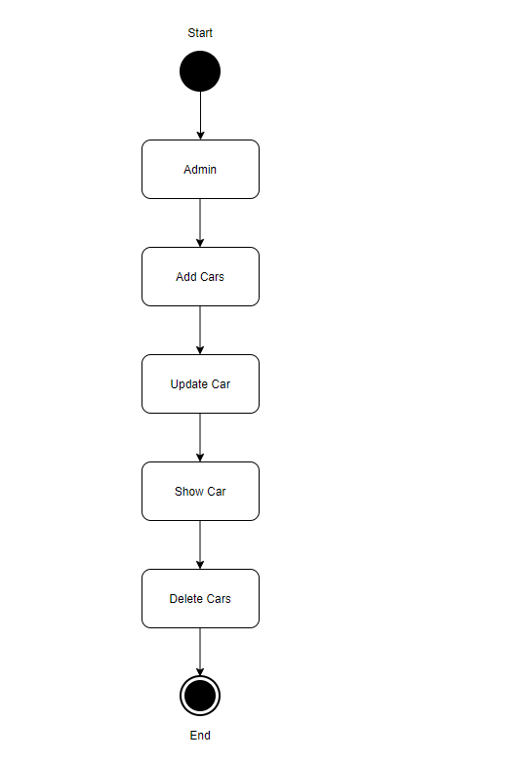

**OBJECT DIAGRAM**

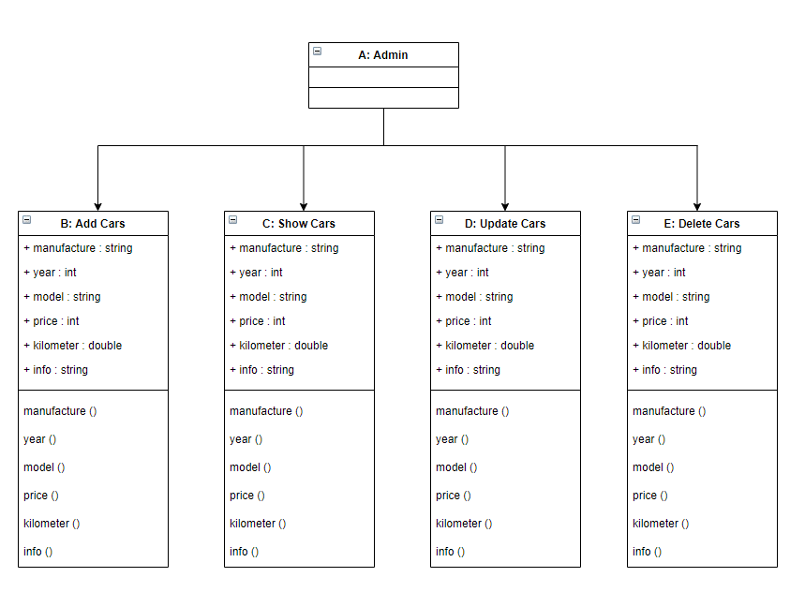

**COMPONENT DIAGRAM**

