

Master of Management (MM)

8542 RESEARCH METHODS
Term-2603

RESEARCH PROPOSAL
Lecturer Name: Dr Blake Bai

First Name | Nimanka Sulochani
Last Name | De Silva
Student ID | 108539
Student’s Signature | N/A for digital submissions via Canvas
Submission Date | 14.06.2026

Student Declaration

By submitting this assessment you acknowledge that:
- I have read and understood this assessment fully including the sections HOW TO SUBMIT ASSIGNMENTS and the ICL ASSESSMENT INSTRUCTIONS.
- I understand that my submission to Canvas is my official submission and that handing in an assignment by any other method does not count as an official submission.
- I confirm that all work completed for this assessment is my own work and has been produced without assistance from anyone else.
I confirm that this assignment has not, in whole or in part, been submitted for assessment in any other subject or course of study at ICL Business School, or at any other educational institution.

Table of Contents

Student Declaration ii
1. Introduction 2
1.1 Background 2
1.2 Objectives 3
1.3 Research Questions 4
1.4 The significance of this Research. 4
2. Literature Review 6
2.1 General Literature 6
2.2 Specific Literature 7
2.3 Research Gap 8
3. Methodology and Research Design 10
3.1 Methodology 10
3.2 Data and Data Collection 11
3.2.1 Data 11
3.2.2 Sampling and Sample Size 12
3.2.3 Data Collection Tools 12
3.2.4 Data Collection Method 13
3.2.5 Data Collection Procedure 13
3.3 Ethical Considerations 13
3.4 Timeline and Resources 14
References 17

List of Figures

Figure 1: The Research Onion Framework 11
Figure 2: Research Timeline - Gantt Chart (15 Weeks) 15

Research Proposal
on

The Impact of Digital Payment Systems on Consumer Spending Behaviour in New Zealand

1. Introduction

In the last decade, financial transaction systems have dramatically changed, facilitated by the convergence of mobile technology, digital infrastructure and changing consumer tastes. The uptake of cashless payments in New Zealand is faster than many other similar economies. The use of contactless cards, mobile apps, and especially Buy Now Pay Later has changed the way people pay for their everyday purchases, but it's also changed the way that they perceive paying for their purchases. The friction of handing over funds is significantly diminished and as the growing literature demonstrates, that friction can have measurable implications for how much money consumers spend and what they buy, all while the consumer taps a card or phone against a terminal. This study explores what that change might be and how much it is, recognising that the change is likely to occur on a particular backdrop of socio-economic and regulatory structures, and that this backdrop is distinct to New Zealand, and therefore the study's findings have limited applicability elsewhere.

1.1 Background

New Zealand offers an interesting country to study digital payment behaviour. Nearly nine in ten consumers (aged 18 and over) surveyed in 2024 had used ‘contactless’ payment options in the past year, according to Payments NZ (2024a), the national body for the payment infrastructure, and mobile wallet payments (which includes Apple Pay, Google Pay and similar options) had moved from 10 to 15 percent of everyday purchases between 2022 and 2024. Statista (2024) also reported its own findings, stating that the penetration rate for mobile payments at point-of-sale in New Zealand had more than trebled from 12% to 34% between 2019 and 2023, with this rate of adoption occurring before and during the upheaval of the global pandemic.

Commercial change has been reflected in regulatory responses. The Reserve Bank of New Zealand (2024a) embarked on a new initiative called the Future of Money programme in order to understand the potential of a central bank digital currency, and to acknowledge that the structure of everyday payments is evolving and is in need of a more robust framework to manage it. At the same time the Government has introduced legislation to safeguard those who use Buy Now Pay Later (BNPL) products: the Ministry of Business, Innovation and Employment (2024) released evidence that BNPL use among adults in New Zealand has risen by thirty-six percent in one year, with half of all New Zealand adults using the products by 2024. The regulatory actions indicate that the impact of digital payment systems on consumers' financial actions is serious and that policy makers are taking action – albeit, somewhat later – to learn more and support their decisions.

1.2 Objectives

The study is guided by four research objectives which address the central research problem that this study is guided by; these objectives are as follows;

- Objective 1: To examine the relationship between digital payment system adoption and changes in consumer spending volume among adult residents of New Zealand.

- Objective 2: To identify the demographic and behavioural factors that moderate the association between preferred digital payment method and impulse purchasing behaviour.

- Objective 3: To assess the extent to which consumer perceptions of usefulness, ease of use, security, and trust shape the frequency with which digital payment platforms are used.

- Objective 4: To determine how digital payment adoption behaviour and its spending outcomes differ across age groups and gender within the New Zealand adult population.

1.3 Research Questions

The main research question for this study is:

To what extent do digital payment systems shape consumer spending behaviour among adult consumers in New Zealand, and which factors moderate this relationship?

This is the main question, which is broken down into three subsidiary questions. The first question is whether people who believe that digital payment methods are more useful are more likely to spend more overall in New Zealand than people who do not believe that they are more useful.The first question is about whether if an adult in New Zealand believes that a digital payment method is more useful, they are more likely to spend more than if they do not believe that it is more useful. The second question is, “Is perceived ease of use positively correlated with unplanned/impulse buying behaviour? The third question is whether age and gender are important moderating factors in the relationship between the adoption of digital payments and spending effects? All the questions combine to create a testable deductive programme, which is tested using a validated quantitative instrument that is given to a representative sample of New Zealand consumers.

1.4 The significance of this Research.

This study has three levels of significance. At the academic level, it fills a documented gap; the adoption and consequences of digital payment have been predominantly studied in Asian and European markets, where there are unique regulatory, demographic and technological conditions, leaving New Zealand as a small open and technologically advanced economy with unique regulatory, demographic and technological conditions without an empirical basis. This study is an original contribution in several ways because it is the first to generate primary data with an extended TAM framework that is specific to the nation, instead of the general. The results at policy level will provide Payments NZ, the Reserve Bank of New Zealand and the Ministry of Business, Innovation and Employment with evidence-based insights that will help them develop policy responses to the rapidly changing digital payments landscape. From the commercial side, banks, retailers, and fintech companies will be able to leverage empirical evidence on the impact of payment modality on consumer purchasing to better design their products and customer engagement approaches, and therefore adapt to evolving consumer preferences.

2. Literature Review

2.1 General Literature

The theoretical underpinning of this study is Davis's (1989) Technology Acceptance Model (TAM), which has become the foundation of many studies and models in the Information Systems (IS) and Consumer Behaviour (CB) literature because of its ability to predict intention to adopt two simple constructs, perceived usefulness and perceived ease of use. Davis (1989) identified perceived usefulness as the extent to which a person believes that using a specific technology will improve performance of a task and perceived ease of use as the ease with which a person can use a specific technology. The key is that the TAM was not created as a descriptive model but as a predictive model; the real use of the TAM is to predict what cognitive factors will lead to adoption behaviour before it happens. This predictive utility is particularly important in the context of digital payment systems, since the adoption of the payment system is itself inseparable from the behaviour that it makes possible - the payments behaviour.

The most significant recent contribution of TAM theory into digital payment contexts is the theory of Spendception by Faraz and Anjum (2025) which incorporated a phenomenon that Davis' (1989) theory did not foresee: the systematic reduction of the psychological discomfort felt when making financial payments online as opposed to face-to-face. Indeed, Faraz and Anjum (2025), using SEM, found that this reduces the pain of paying acts as a mediating mechanism between digital payment adoption and increased impulse purchasing propensity in a sample of 1,162 respondents, which directly affects the conceptualization and measurement of the dependent variables of this study. Importantly, their analysis also revealed that gender influences the nature of this pathway, such that women consumers are much more prone to the Spendception effect. This moderating relationship is not a demographic curiosity, but rather an argument for taking a closer look at the demographics of New Zealand, and how the impacts of digital payment adoption are experienced at the micro-level of people's payments.

This study was guided by two bodies of scholarship.The variable selection for the present study and the measurement approach was guided by two bodies of scholarship. Tian and Chan (2024) further modified the TAM by adding trust and self-efficacy as additional predictors of mobile payment adoption and determined that the influence of trust was the most significant independent variable in their cross-national analysis, which is contrary to the two construct model that Davis (1989) presented and was therefore deemed to be worthy of its own independent variable. Daragmeh, Lentner and Sági (2021) complied with that by showing that the COVID-19 pandemic acted as a structural shock on payment behavior, fostering the use of contactless payments that lasted well after the pandemic had started. This is important for the current research because it provides evidence that digital payment methods that are driven by external pressures, tend to become self reinforcing and can trigger lasting changes in consumer payment behavior. Moreover, Wijaya et al. (2021) showed perceived security concerns as a strong obstacle for mobile wallet adoption as a psychological counterweight to the adoption impulse of Davis (1989) and Faraz and Anjum (2025).

2.2 Specific Literature

The literature reviewed globally above, although well supported and effective in theory, can not be directly applied without challenge in the New Zealand context. The international scholarship provides evidence for the presence of causal mechanisms (reduced pain of paying, trust driven adoption, security barriers) but not their scale or extent in a given national context. New Zealand offers a unique context for structural conditions, a context which has not been extensively explored. By 2024, the typical adult consumer was using contactless payment 88 percent of the time, making New Zealand one of the most cashless economies in the world and suggesting that the theoretical processes identified in markets in earlier stages of digital payment may be different - or more pronounced - when the norm of payment is digital rather than an emerging alternative.

The most analytically noteworthy NZ contribution to this field has been by Gilbert and Scott (2023) who surveyed 705 adults aged 18 to 34 using the Auckland University of Technology Centre for Applied Research in Finance. Their findings showed that not only was BNPL being used by half of adults by 2024 (according to the Ministry of Business, Innovation and Employment, 2024), but that understanding of what BNPL was as a financial product was shockingly low with one in five people not recognising BNPL as a debt product and one in four having fallen into BNPL repayment arrears. The consequences of this misclassification are significant. It is important to note that, if consumers do not identify a spending mechanism as debt, then the psychological constraints which would normally moderate borrowing behaviour are removed and the Spendception effect described by Faraz and Anjum (2025) is likely to be magnified rather than mitigated. This is a unique risk profile which is not covered in the international literature and is offered to this study as a way of examining this issue more generally across the adult age range. The findings of this study start to fill in the empirical evidence of consumer behaviour in the BNPL space, even as these two institutional actors have highlighted this intersection as one of policy priority by developing a central bank digital currency framework (Reserve Bank of New Zealand, 2024a, 2024b) and introducing the BNPL law (Ministry of Business, Innovation and Employment, 2024).

2.3 Research Gap

The above review shows that there is a structural disconnect between digital payment adoption research and studies of consumer behaviour in NZ. The theoretical mechanisms by which adoption of digital payments affects spending behaviour have been documented in the literature, but mostly in national settings where the levels of digital payment infrastructure maturity, regulatory frameworks, and financial literacy of consumers are significantly different from those of New Zealand. The New Zealand literature has described the market and regulatory environment in great detail, but has not conducted a peer-reviewed quantitative study of the link between the adoption of digital payments and its impacts on spending patterns across the entire adult population that has been measured using a theoretically validated instrument.

This is no trifling matter, but a significant one. New Zealand's policy makers at the Ministry of Business, Innovation and Employment and the Reserve Bank are creating policy solutions to a behaviour of consumers which is not empirically characterised at the national level. Retailers and banks are creating digital payment products with impacts on spending that are extrapolated from the evidence of other countries with limited applicability. There is no academic paper that has examined whether the TAM derived mechanisms which have been documented in other countries, function equally as strongly in New Zealand's particularly ripe cashless economy. The present study therefore aims to fill this gap by collecting primary data from 150 New Zealand adults across a diverse range of demographic groups, using an extended TAM model, which has been developed and tested with the latest and most relevant literature, and exploring the moderating impact of age and sex as identified in the literature but yet to be assessed in New Zealand.

3. Methodology and Research Design

3.1 Methodology

The approach used in this study is quantitative research with a positivist approach in which the data obtained is of the type that can be obtained from the quantitative aspect. In positivism, the idea is that the social world follows observable regularities which can be measured and tested by objective, empirical research (independent of researcher's subjective interpretation) (Saunders, Lewis and Thornhill, 2019). This philosophy is congruent with deductive approach to the research in which the hypotheses established based on the extended TAM were tested with the primary data which are analyzed statistically. The investigation is based on three hypotheses:

- H1: suggests that perceived usefulness of digital payment systems is positively related to increased volume of consumer spending,
- H2: suggests that perceived ease of use is positively related to impulse purchasing behaviour, and
- H3: suggests that age and gender mediate the relationship between digital payment adoption and consumer spending outcomes.

The variables that have been selected for the study are the independent variables such as perceived usefulness, perceived ease of use, perceived security, and trust. The dependent variables are spending volume and impulse purchasing behaviour and the moderating variables are age and gender. The research approach selected is a cross-sectional online survey as this allows for standardised data collection from a geographically spread out national sample, without the need to access any host organization (Saunders et al, 2019).

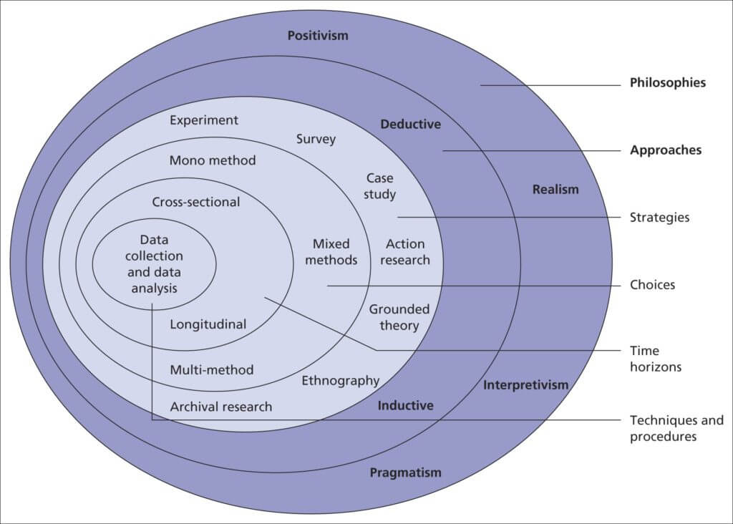

Figure 1: The Research Onion Framework
(Source: Saunders, Lewis and Thornhill, 2019)

3.2 Data and Data Collection

3.2.1 Data
This study uses primary data, gathered from adults, by means of a specially designed self-report questionnaire. No transactional databases, administrative or organisation records will be accessed. The literature review uses contextual statistical data from Payments NZ (2024a and 2024b) and the Reserve Bank of New Zealand (2024a and 2024b) to contextualise the research problem but is not included in the analysis. The use of exclusive self-report primary data guarantees that perceptual and behavioural constructs such as perceived usefulness, trust, impulse buying propensity are captured as perceived by consumers and not surmised from third party administrative data sources.

3.2.2 Sampling and Sample Size
A non-probability purposive method of sampling is used. The eligibility criterion is: All participants are New Zealand adults aged 18 years and over who have used at least one of the three digital payment methods (EFTPOS, contactless card, mobile wallet, BNPL service, in the past 12 months before the data collection. The recruitment process is convenience sampling with the goal of reaching participants through social media and community sites on the internet that are readily available to the researcher and where they are posted. This integrated method is consistent with Tian and Chan (2024), and has been proven for quantitative online survey research by Saunders et al. (2019). The sample size is 150 which is the number of people that are needed and is statistically supported by Green (1991) with the formula of N ≥ 50 + 8m. The minimum sample size statistically adequate when 6 predictor variables are used is 98; when it's expected that 150 cases will be obtained, there's a buffer of 52 cases which will give enough statistical power for multiple regression analysis and moderation testing in addition to providing for incomplete responses.

3.2.3 Data Collection Tools
The main data collection tools are a structured 28 item questionnaire using Google Forms. The instrument is made up of six sections. The moderating variable is operationalised in Section A, which includes the following demographic characteristics: age group (18–34, 35–44, 45–50, 51 and above), gender, education level, household income bracket and region of residence. Section B focuses on the patterns of digital payments. For all questions in Section C through F, the five-point Likert scale from strongly disagree to strongly agree was used, which are validated instruments: perceived usefulness and ease of use (5 items each), perceived security and trust (5 items), spending volume (4 items) and impulse purchasing behaviour (5 items) from Davis (1989), Tian and Chan (2024), Faraz and Anjum (2025) respectively. Construct validity and comparability with existing literature is achieved when published validated scales are used.

3.2.4 Data Collection Method
The questionnaire will be promoted via community groups in New Zealand on Facebook and professional networking sites. The survey will be open for 14-days with a reminder sent at the 7-day mark to minimize non-response bias. If completed responses are less than one hundred by the end of the first period, there will be a second distribution of responses through university student networks and data collection will be continued for an additional seven days. A qualifying question is asked at the beginning of the survey to verify whether the respondents have used any digital payment system within the past year: If they do not meet the condition, they are automatically directed out of the survey.

3.2.5 Data Collection Procedure
The data collection process is carried out in a sequential way, consisting of five stages. The ten participants in the pilot test provide preliminary estimates of scale reliability, identify ambiguous items and provide an estimate of completion time; this is the first stage. Appropriate revisions are made to be distributed after full distribution. In the second phase, the completed questionnaire is published and sent to specific channels. In the third stage, raw data from Google Forms are cleaned in Microsoft Excel by eliminating the answers of incomplete or ineligible. The final step is to import the cleaned data into IBM SPSS Statistics (stage 4). The three hypotheses are tested sequentially by descriptive statistics, Cronbach's alpha reliability coefficients (r ≥ 0.70), Pearson correlation analysis, and multiple linear regression. Subgroup analysis and the use of interaction terms in the regression models explore moderating effects of gender and age. In the fifth stage, results are analyzed and included in the applied project report.

3.3 Ethical Considerations

Data collection and management is conducted in an ethical manner. There is no incentive for participation and no penalty for not participating or withdrawal at any time. No names, email addresses or other personally identifiable information are requested in the questionnaire. At the start of the project, an informed consent statement is provided that tells the purpose of the research, that participation is voluntary and anonymous, that participation is not required first to be submitted, and how data will be stored and disposed of at the end of the project. All response data will be stored only on a password protected device that can only be accessed by the researcher and will be destroyed after submission of the final applied project. There are no vulnerable groups included, no deception, and no personal disclosures other than normal demographic data. Therefore, the study does not need the approval of formal ethics committee other than obtaining approval from the institution, following the principles of Saunders et al. (2019).

3.4 Timeline and Resources

The research programme comprises a 15-week plan, ranging from a research intensive literature review to the final submission of the applied project. A one-week contingency buffer is built in during the revision phase for the possibility of delays in the feedback turnaround by supervisors or lower than expected survey response rates. The first draft of the applied project will be handed in to the designated supervisor at least 4 weeks prior to the due date for the completed applied project, according to the ICL Graduate Business School applied project regulations. Figure 1 is a Gantt chart that shows week-by-week research activities for the entire fifteen weeks.
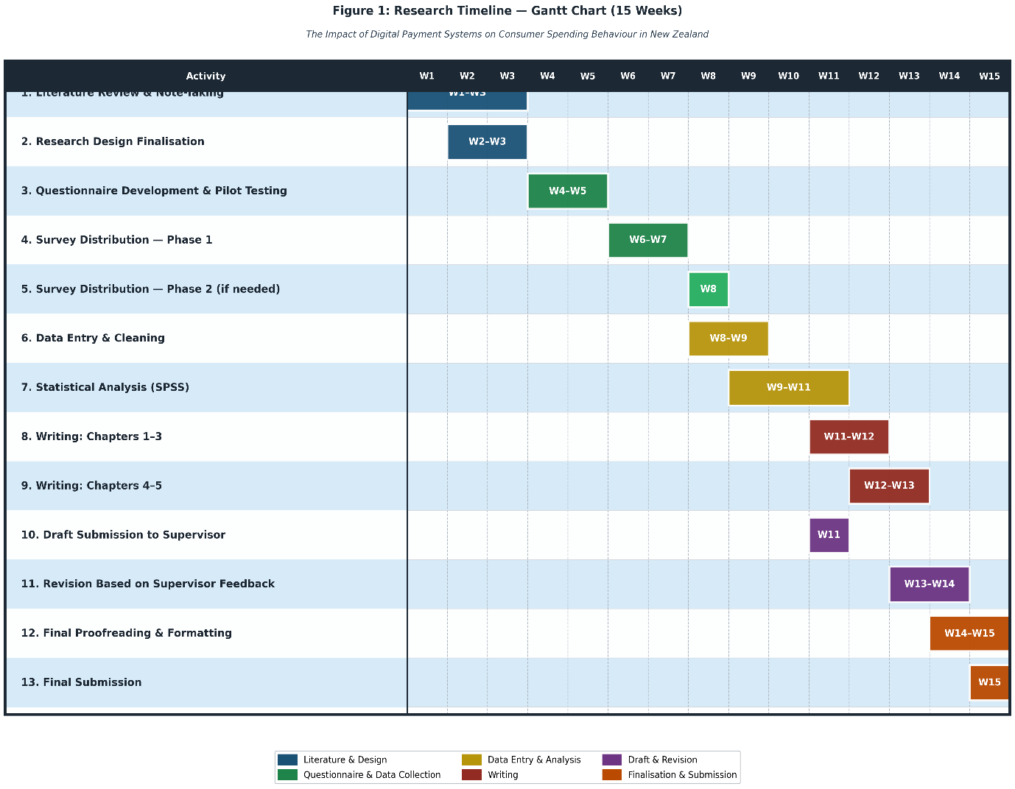
Figure 2: Research Timeline - Gantt Chart (15 Weeks)
(Source :Developed by the Researcher)

The requirement for resources is low and the researcher can easily meet it. Google Forms is a free resource that streamlines the process of where users can capture response data and compile datasets, without requiring financial resources or manual data entry. The ICL Graduate Business School has an institutional software licence for IBM SPSS Statistics, which can be used for free. There is no need to come to the field, travel or have access to any organisation, all data collection is done remotely via public online platforms. No research assistant or transcription assistance required. The researcher already has skills in SPSS, such as: Descriptive statistics, Pearson correlation, Cronbach's alpha and multiple linear regression which can be applied in all planned analytical processes, so no additional skills have to be learned during the 15-week period. It is therefore expected that the study will be complete, on time and without resource limitations that would potentially affect the quality/integrity of the research work. The overall design has been developed in an attempt to maximize analytical rigor as a single researcher applied project in the realistic confines of a postgraduate study.

References

Davis, F. D. (1989). Perceived usefulness, perceived ease of use, and user acceptance of information technology. MIS Quarterly, 13(3), 319–340. https://doi.org/10.2307/249008

Daragmeh, A., Lentner, C., & Sági, J. (2021). FinTech payments in the era of COVID-19: Factors influencing behavioral intentions of 'contactless' payments. Journal of Behavioral and Experimental Finance, 32, 100574. https://doi.org/10.1016/j.jbef.2021.100574

Faraz, N., & Anjum, A. (2025). Spendception: The psychological impact of digital payments on consumer purchase behavior and impulse buying. Behavioral Sciences, 15(3), 387. https://doi.org/10.3390/bs15030387

Gilbert, A., & Scott, A. (2023). Problem debt, buy now pay later (BNPL) and young adults in New Zealand. Auckland University of Technology, Centre for Applied Research in Finance.

Green, S. B. (1991). How many subjects does it take to do a regression analysis? Multivariate Behavioral Research, 26(3), 499–510. https://doi.org/10.1207/s15327906mbr2603_7

Ismail, M., Hamid, R. A., Abdullah, A., & Ismail, M. D. (2021). Mobile wallet adoption: A systematic review of factors influencing adoption. Journal of Academic Research in Economics, 13(2), 200–220.

Ministry of Business, Innovation and Employment. (2024). Buy now pay later. New Zealand Government. https://www.mbie.govt.nz/business-and-employment/consumer-protection/buy-now-pay-later

Payments NZ. (2024a). Consumer research 2024: Cards still on top but digital options gaining ground. Payments New Zealand.

https://www.paymentsnz.co.nz/resources/articles/consumer-research-cards-still-on-top-but-digital-options-gaining-ground/

Payments NZ. (2024b). 2024 year in review. Payments New Zealand. https://www.paymentsnz.co.nz/our-work/company-updates/2024-report/

Quist, E. A., Acquaye, R., & Fiagbe, A. (2023). Using a technology acceptance model to determine factors influencing continued usage of mobile money service transactions in Ghana. Journal of Innovation and Entrepreneurship, 12, 34. https://doi.org/10.1186/s13731-023-00301-3

Reserve Bank of New Zealand. (2024a). Central bank digital currency strategic design insights dossier. Te Pūtea Matua. https://consultations.rbnz.govt.nz/money-and-cash/digital-cash-in-new-zealand/

Reserve Bank of New Zealand. (2024b). Digital cash in New Zealand. Te Pūtea Matua. https://www.rbnz.govt.nz/money-and-cash/digital-cash

Saunders, M. N. K., Lewis, P., & Thornhill, A. (2019). Research methods for business students (8th ed.). Pearson Education.

Statista. (2024). Mobile payment use in POS in New Zealand 2019–2024. https://www.statista.com/statistics/1448511/mobile-payments-adoption-in-pos-in-new-zealand/

Tian, Y., & Chan, T. J. (2024). Predictors of mobile payment use applications from the extended technology acceptance model: Does self-efficacy and trust matter? SAGE Open, 14(4). https://doi.org/10.1177/21582440241292525

Wijaya, T., Wahdiniwaty, R., Priadana, S., & Basri, H. (2021). Mobile wallets: Key drivers and deterrents of consumers' intention to adopt. Journal of Financial Services Marketing, 27(3), 182–210. https://doi.org/10.1080/09593969.2021.1879208

