ACADEMIC TECHNICAL REPORT
Architecture, Design Patterns, and Generative AI Integration of the Smart Student Planner Mobile Application
Course Title: Mobile Application Development (PLO 6.5 Module)
Prepared by: Shaakir (Student Planner Project Lead)
Institution: Department of Computer Science & Software Engineering
Date: June 2026

1. Introduction and Project Scope
Modern university environments require students to self-manage overlapping timelines, including assignments, examinations, laboratory milestones, and group coursework. The Smart Student Planner is a cross-platform mobile application developed in React Native and Expo, integrated with Firebase Cloud services and Google Gemini AI. The project aims to minimize the cognitive overhead associated with student organization, providing offline-first caching, real-time sync, dynamic custom module categorizations, and automated AI task decomposition. This document outlines the system architecture, design patterns, step-by-step implementation, database layouts, and screenshots representing key navigation flows.

2. System Architecture & Architectural Patterns
To achieve scalability, offline resilience, and ease of maintainability, the application utilizes the Model-View-ViewModel (MVVM) pattern alongside a Client-Server architecture. This enforces separation of concerns between raw data modeling, state managers, and UI components.

2.1 Model-View-ViewModel (MVVM) Pattern
The application layers are organized as follows:
• Model: Represents the schema validation layers (ValidationService.js) and Firestore data structures. Contains the raw values and properties of task documents (title, module, dueDate, priority, subTasks, completed).
• View: Handles UI rendering and user gestures. Component-based architecture in React Native (e.g., TaskDetailScreen.js, SettingsScreen.js) designed with the custom style system.
• ViewModel: Implemented via TaskContext.js. Listens to Firestore snapshots, holds active states (sorting, filtering, loader variables), and executes tasks operations (addTask, editTask, deleteTask). This acts as the state mediator for Views.

2.2 Client-Server & Generative AI Layout
The system coordinates three main architectural nodes:
1. React Native App Client: The mobile client built on Expo SDK. Keeps local configurations using AsyncStorage and uses firestore client adapters to fetch data.
2. Firebase Firestore & Auth: Cloud database store. Serves collection queries in real-time. Automatically isolates tasks under individual user identifiers (userId).
3. Google Gemini API Gateway: External API queried over HTTP to analyze task titles and notes, returning 4-5 study milestones in raw JSON format to the client.

3. Core Techniques & Software Technologies
The implementation utilizes the following primary software tools and frameworks:
• React Native & Expo (v52.0): Enables native rendering of components (ScrollView, FlatList, TouchableOpacity, ActivityIndicator) on iOS and Android with unified codebase.
• React Navigation (v6): Used to establish stacked and tabbed navigation. Screen stacks allow transition parameters between Home, TaskDetails, and EditTask, while a bottom tab navigator links Home, Tasks, Profile, and Settings.
• Firebase Firestore (v12): Enables real-time document listeners (onSnapshot) and collection-based CRUD. Secures document access so only logged-in users read and write their own data.
• Google Gemini 2.5 Flash: Google's generative AI model, accessed client-side to decompose heavy coursework goals into manageable milestones.

4. Step-by-Step UI Flow and Screen Specifications
The following section describes the app navigation flow chronologically, demonstrating the interface layouts and including captured screenshots.

4.1 Splash Screen and Onboarding Flow
Upon initial launch, the student is greeted by the Expo Splash loader, followed by a three-step onboarding tutorial that explains the app's core functions (academic organization, progress tracking, and notifications).
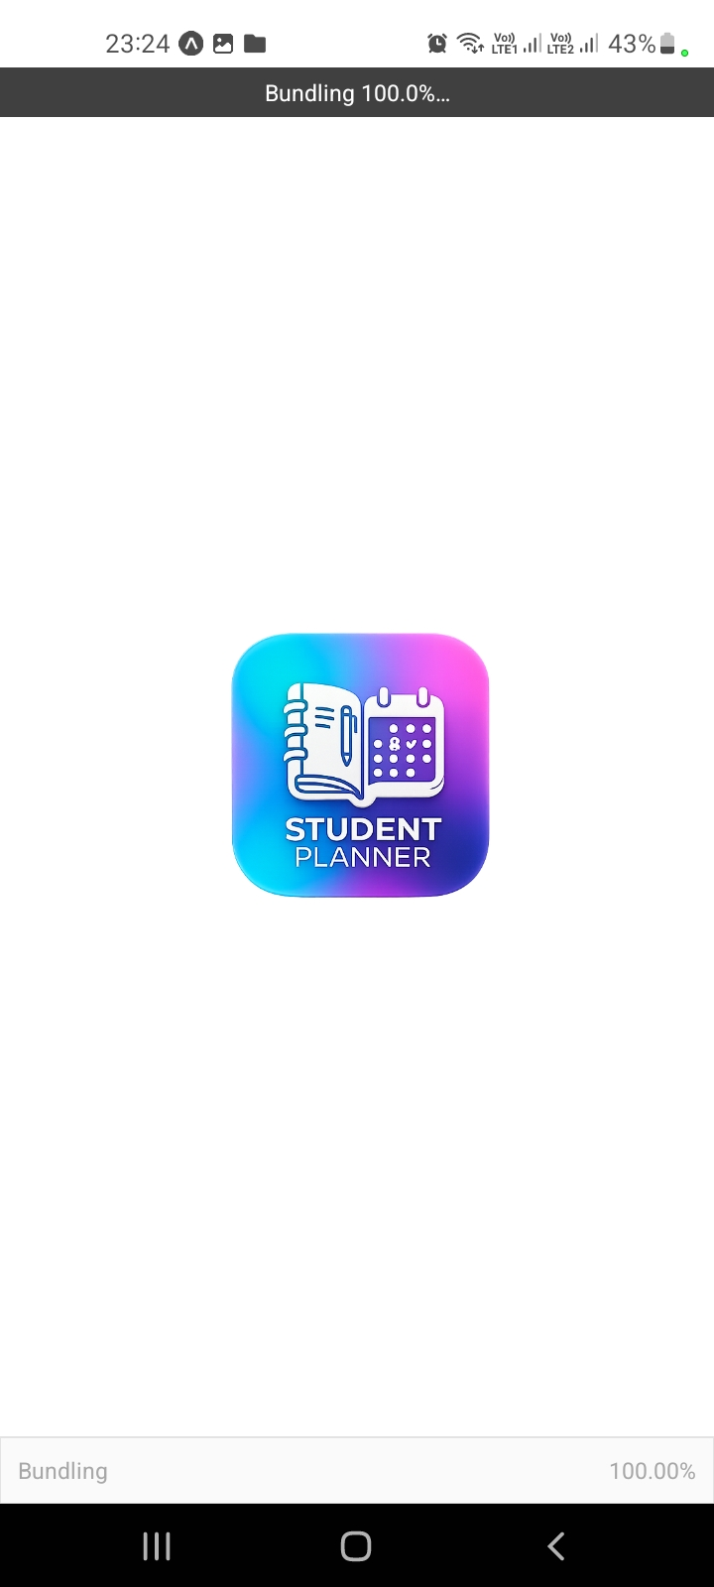
Figure: Expo initial launch loader screen.
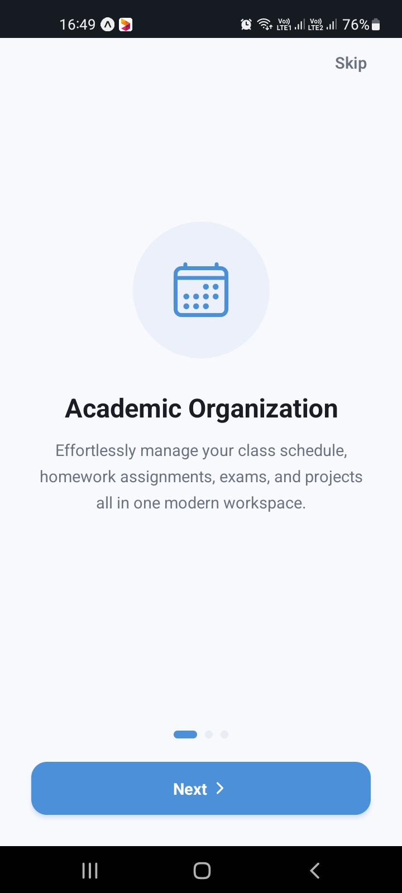
Figure: Onboarding Step 1: Academic organization display.
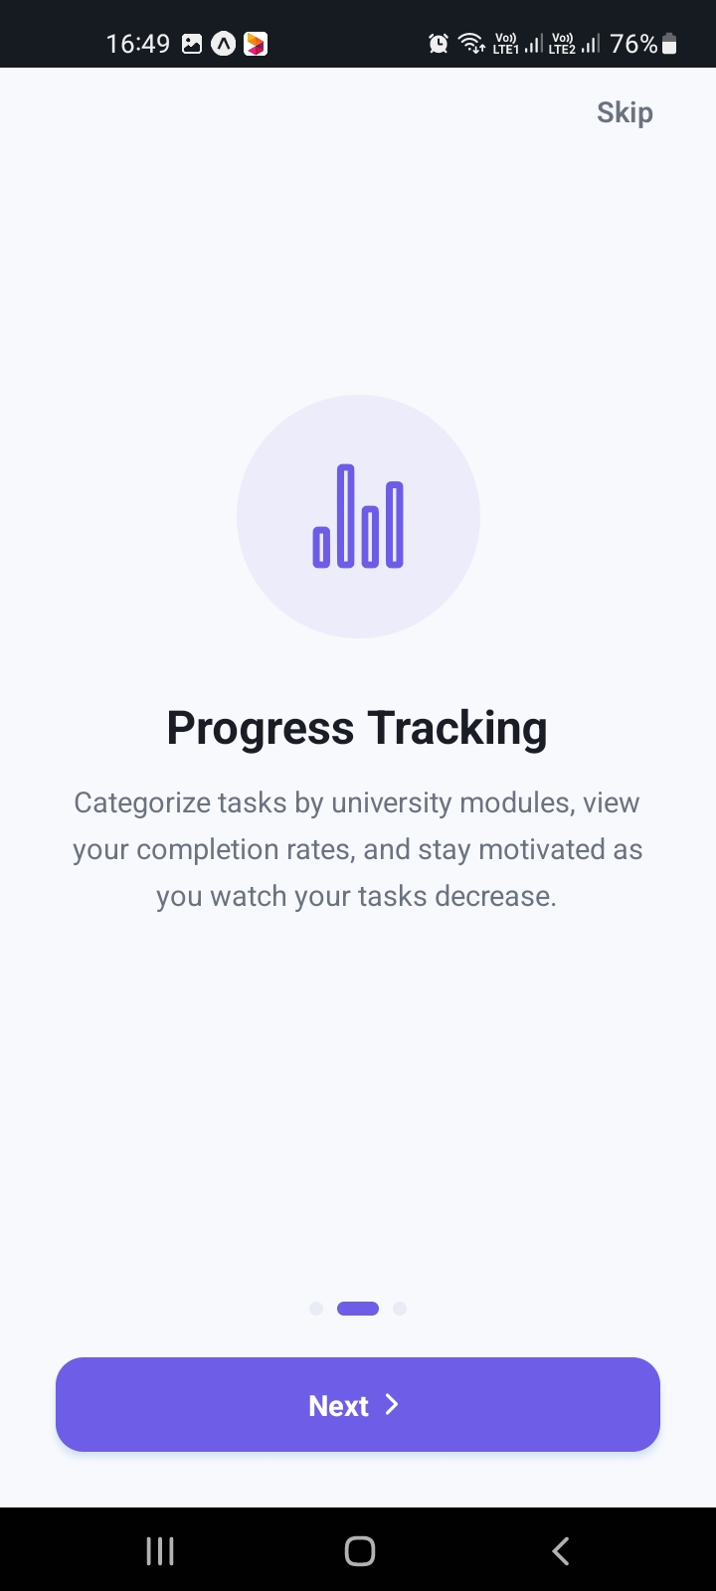
Figure: Onboarding Step 2: Progress tracking display.
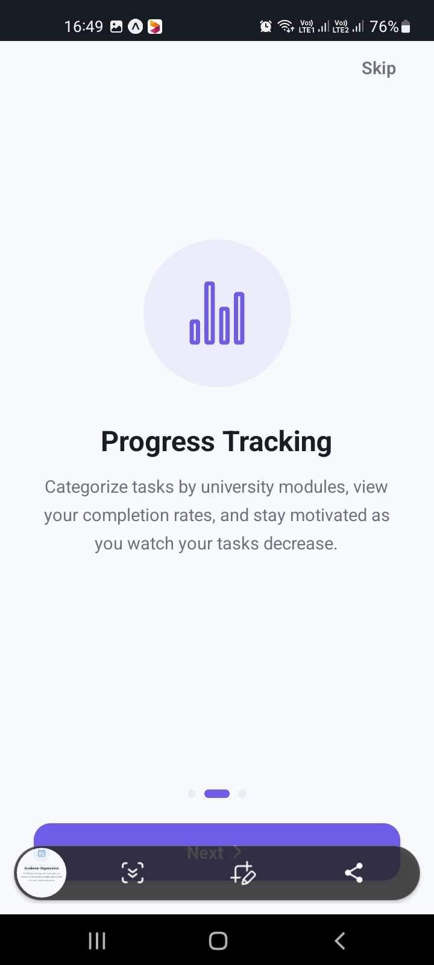
Figure: Onboarding Step 2: Android navigation HUD representation.
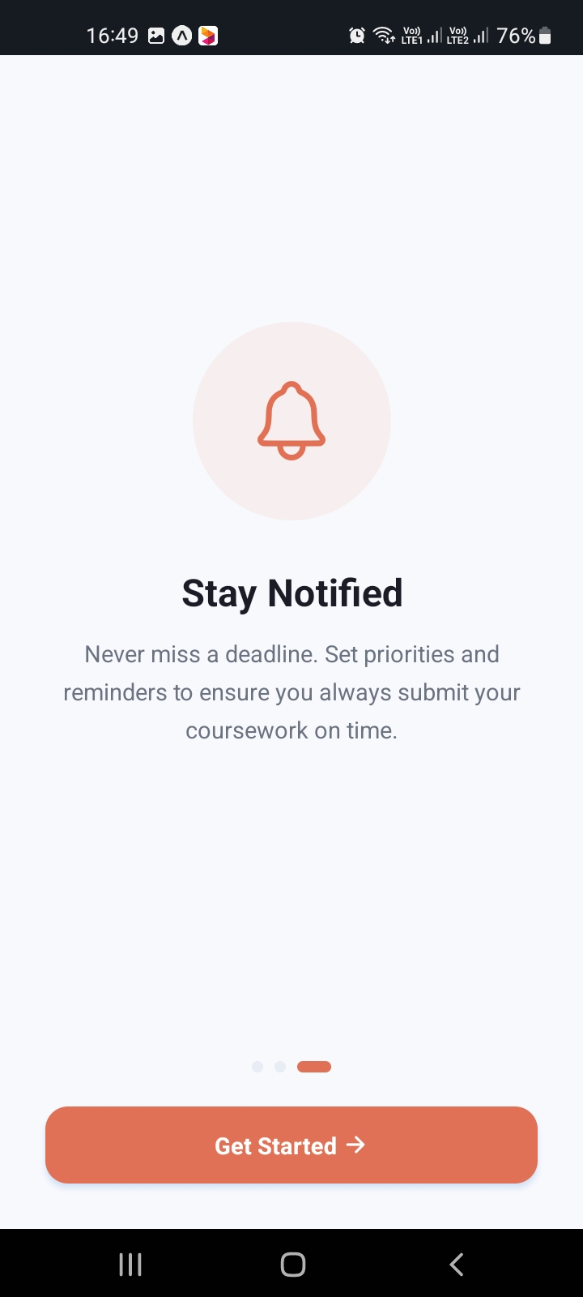
Figure: Onboarding Step 3: Notifications settings introduction.
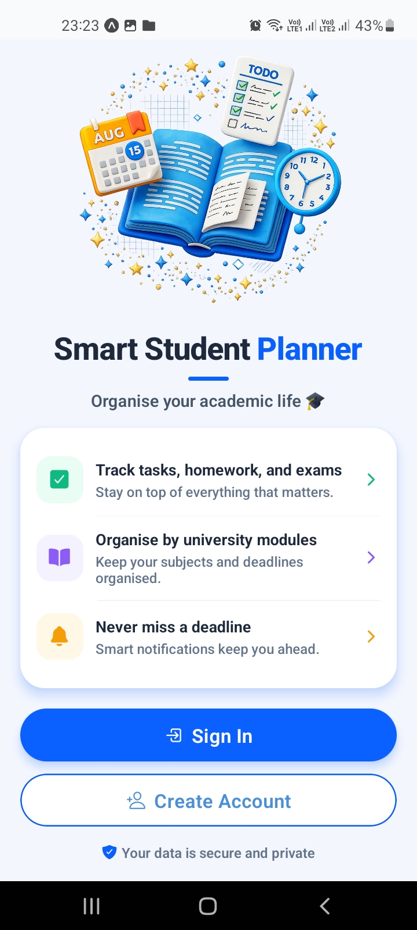
Figure: Welcome / Landing Screen: Login or Register redirection.

4.2 Authentication Flow
To protect student data, a secure Firebase-backed authentication system is deployed. Users can either sign in with an existing account or register a new profile. Form inputs are validated in real-time.
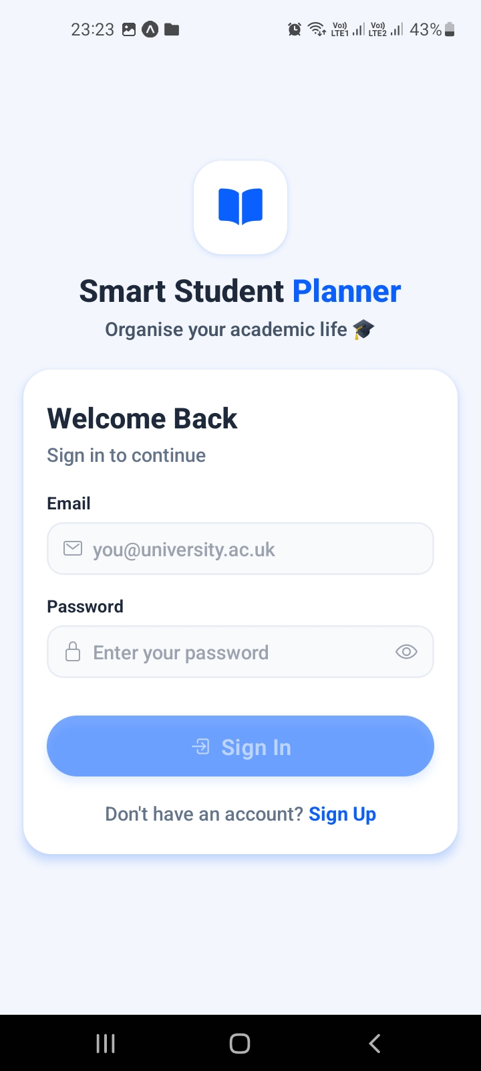
Figure: Login Screen with email validation and show/hide password toggle.
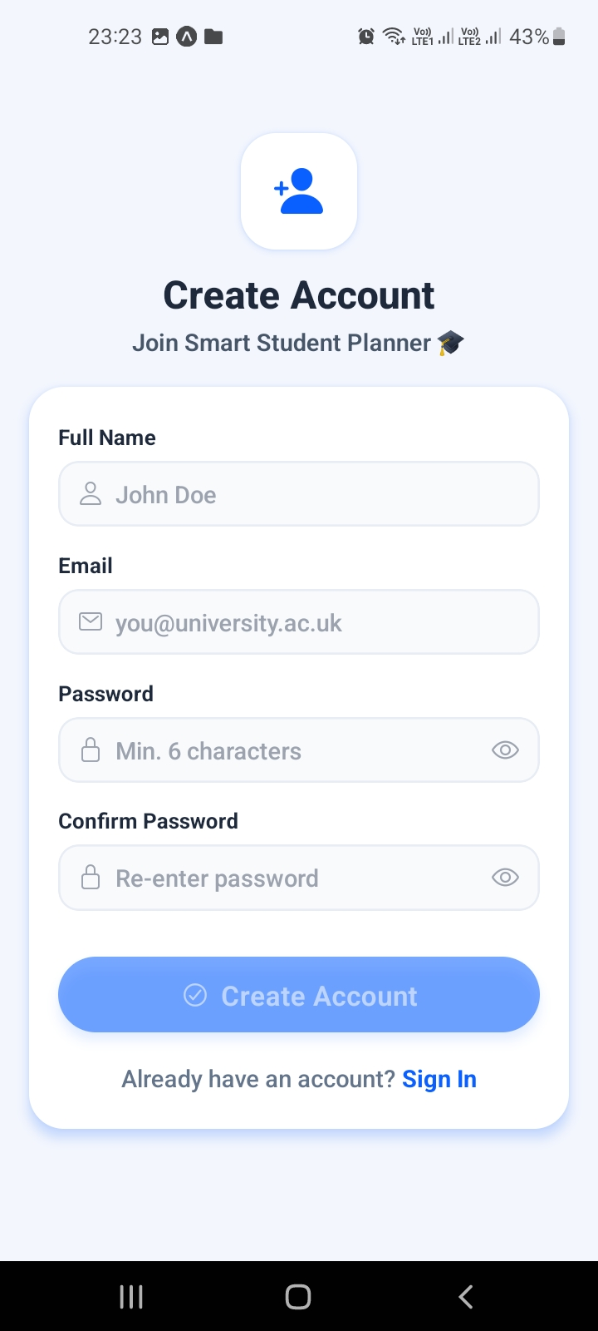
Figure: Register Screen: Account registration with password matching validator.

4.3 Core Dashboard & Filters
The Dashboard serves as the command center, displaying academic statistics, active task counts, completion progress metrics, and upcoming deadlines. The bottom sheet modal provides advanced filters.
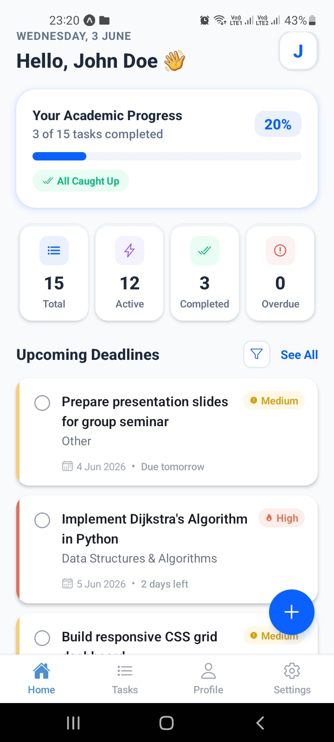
Figure: Home / Dashboard Screen: Summary stats and progress metrics.
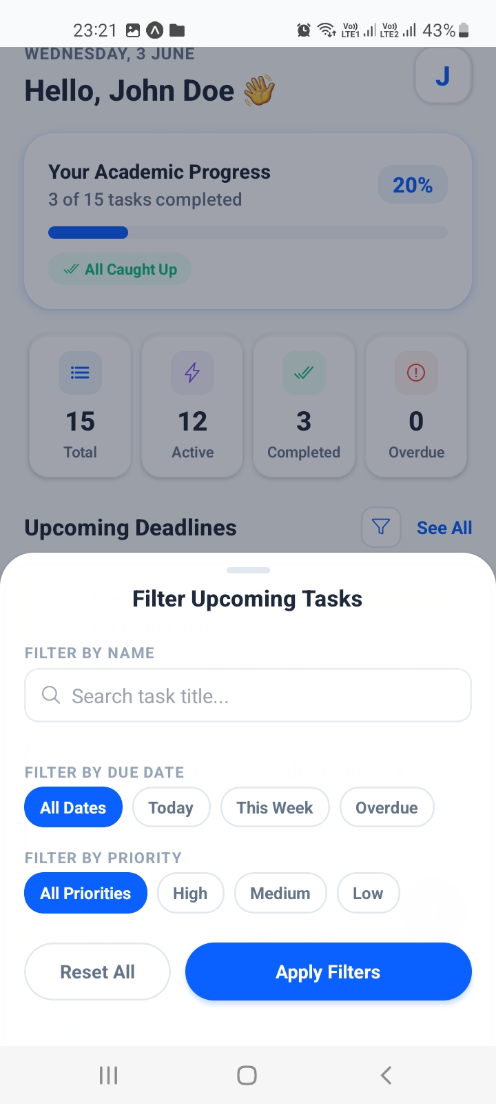
Figure: Filter Modal: Slide-up sheet allowing search, due-date filters, and priority filtering.

4.4 Task Creation Form
The Task Creation form prompts the student for a title, academic module, due date, priority, and notes. The form is governed by strict validations (mandatory fields, character limits).
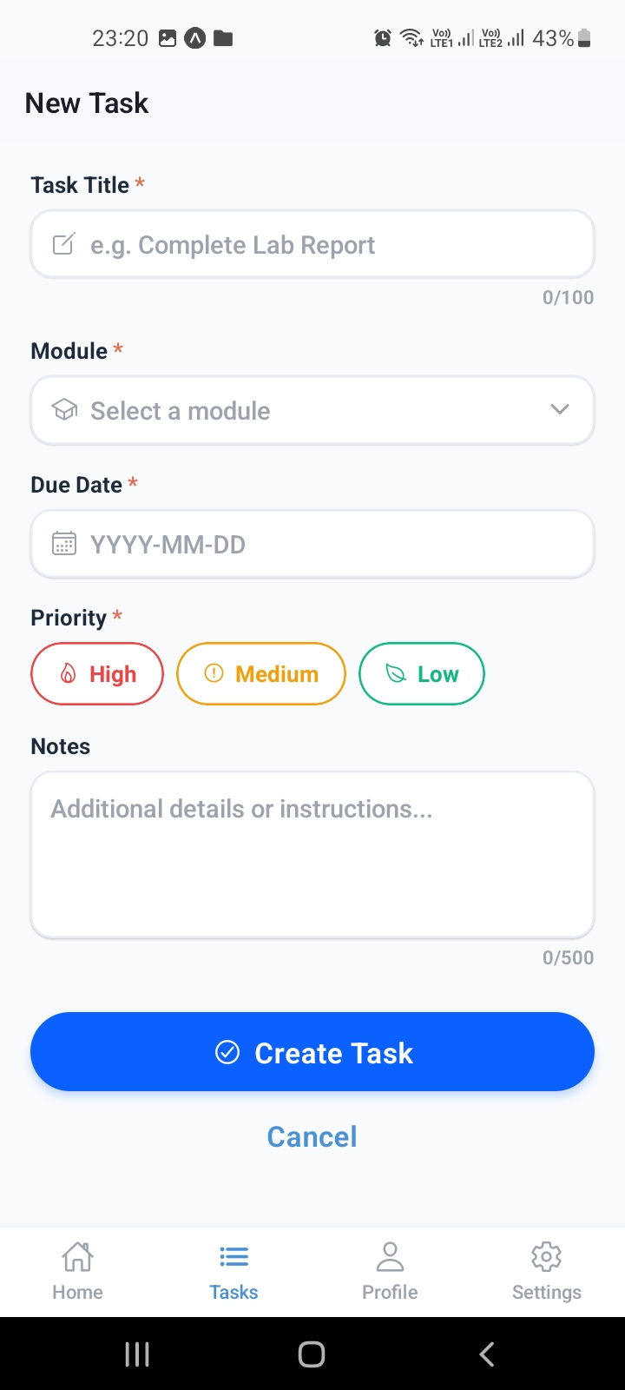
Figure: Add Task Screen: Standard task creator interface.

4.5 Task Detail and Task Priority States
Once a task is selected, the Task Details screen displays module affiliations, exact formatting of due dates, and remaining hours/days. High-priority and medium-priority tasks render distinctive UI badges.
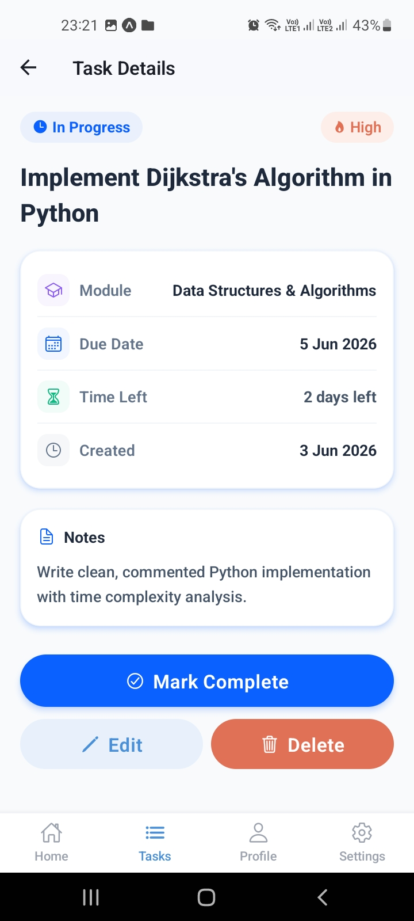
Figure: Task Details Screen: High Priority (Red Badge) view.
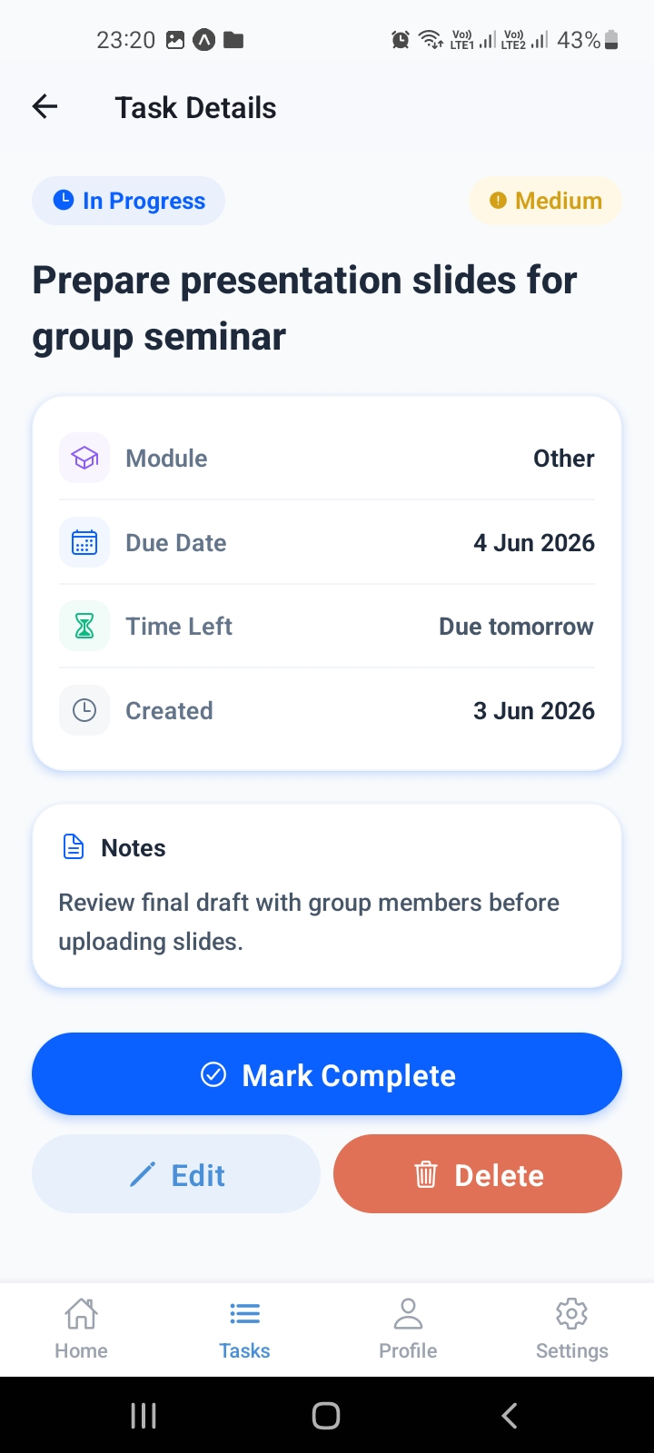
Figure: Task Details Screen: Medium Priority (Yellow Badge) view.

5. Generative AI Sub-Task Breakdown Integration (PLO 6.5)
To fulfill requirement PLO 6.5, the application features an AI-driven task decomposition module. The goal of this module is to mitigate academic procrastination by automatically breaking down large, complex coursework deliverables into smaller, actionable checkpoints.

5.1 Model Configuration and Prompt Directives
The system utilizes the Gemini 2.5 Flash model, which has been configured inside AIService.js. The prompt enforces a strict JSON-only format to prevent text formatting issues:
"Decompose this main task into exactly 4 to 5 smaller, chronological, highly actionable sub-tasks. Each sub-task must be brief, clear, and include a realistic estimated duration. You must return ONLY a raw JSON array of strings containing the sub-task items."

5.2 Integration Steps and Error Handling
When the 'Break Down with AI' button is pressed, the client requests task details. If the API key is missing or connection fails, a warning dialog pops up. Upon success, the raw JSON array is parsed and mapped into Firestore as: { text, completed: false }.
[Screenshot 16_task_detail_ai_prompt.jpeg not found at D:\Shaakir bro\REACT-NATIVE MOBILE APP\SmartStudentPlanner\docs\Screenshots\16_task_detail_ai_prompt.jpeg]
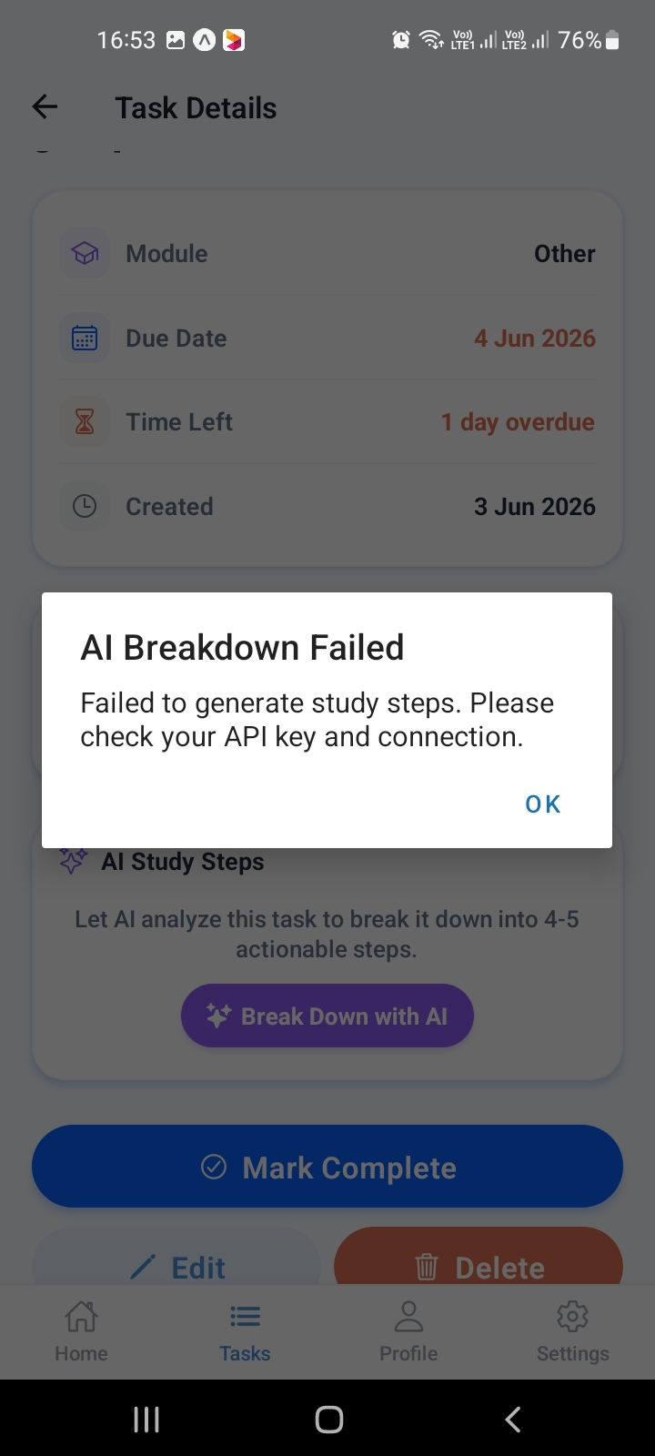
Figure: AI Breakdown: Error handling display.
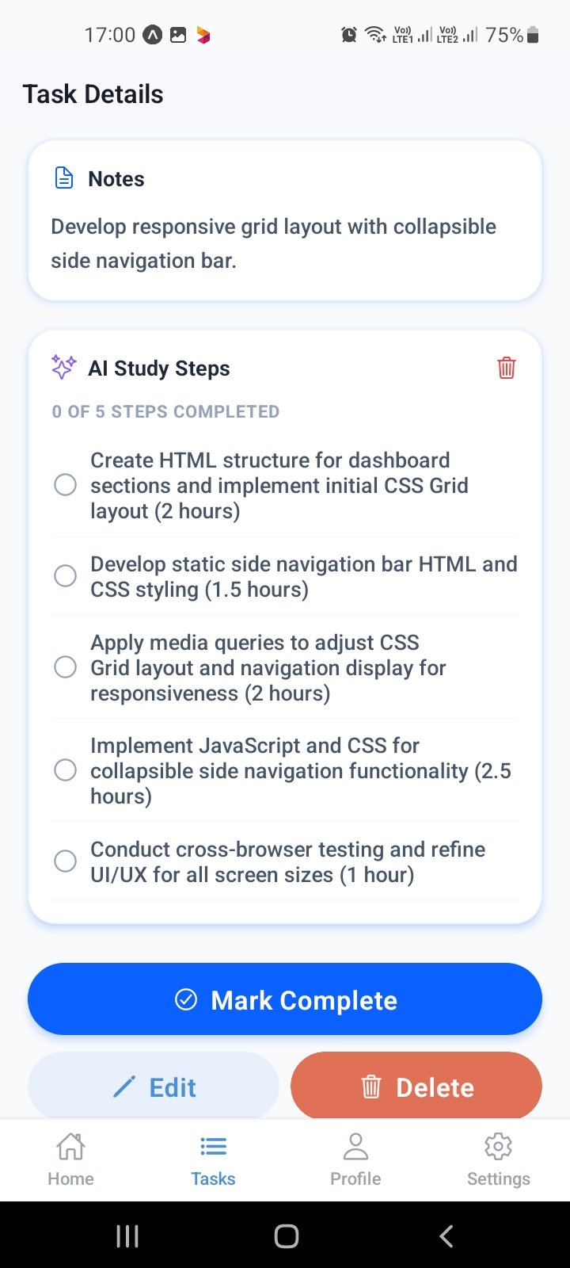
Figure: Task Details: AI checklist rendering with progress indicator.

6. Profile Management and System Settings
The Profile screen monitors academic performance. The Settings panel provides switches for user preferences, sort orders, and triggers a custom module builder modal to manage course categories.
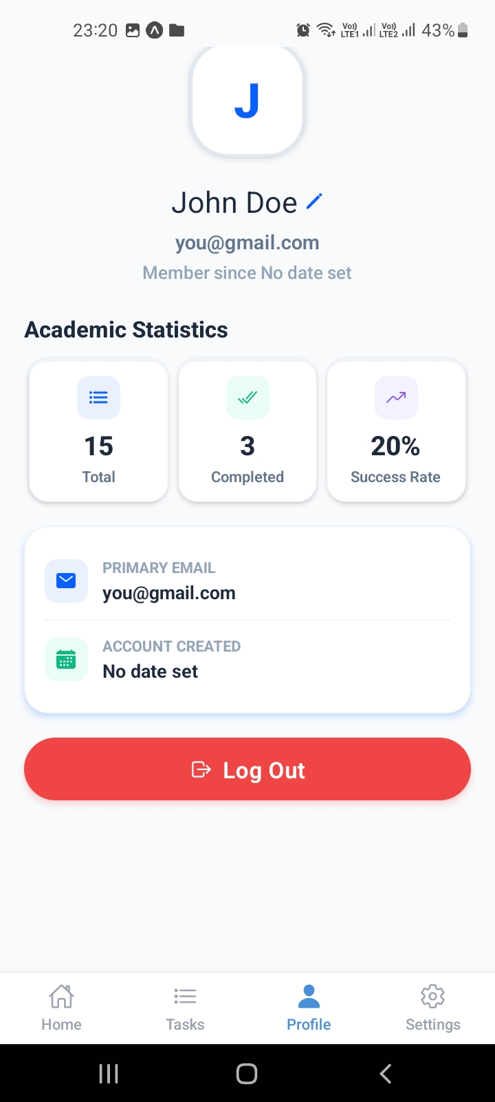
Figure: Profile Screen: Academic statistics tracker.
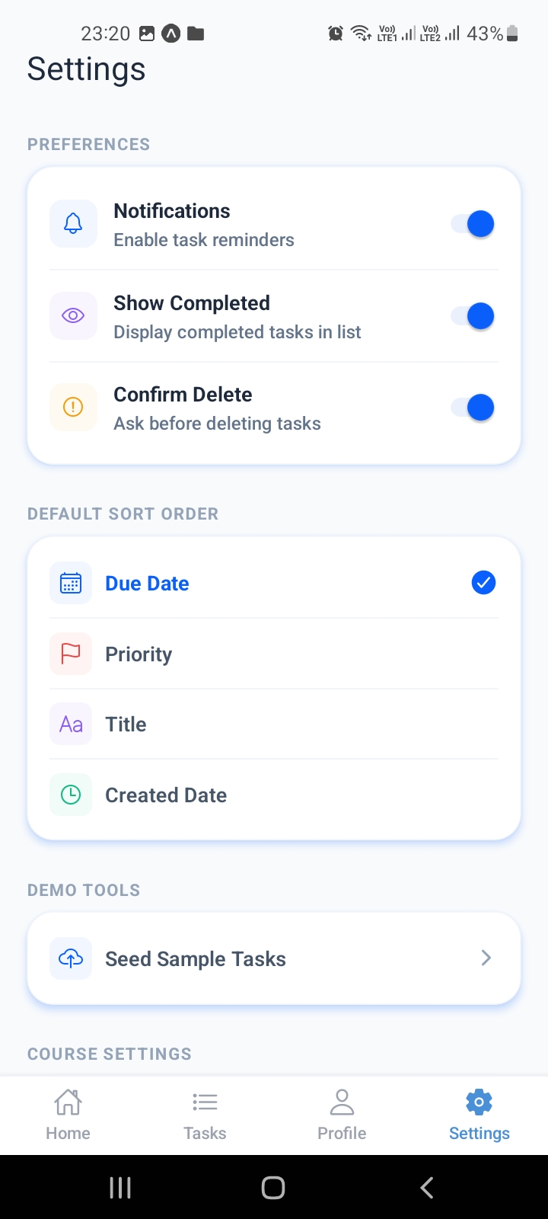
Figure: Settings Screen: Toggles and default sort order configurations.
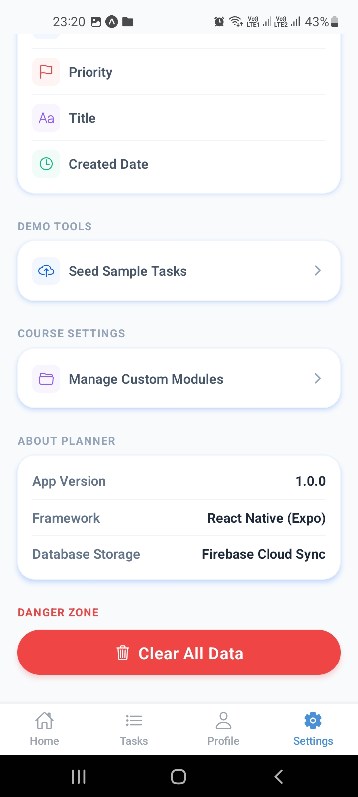
Figure: Settings Screen: Details on database storage and framework, with data reset options.
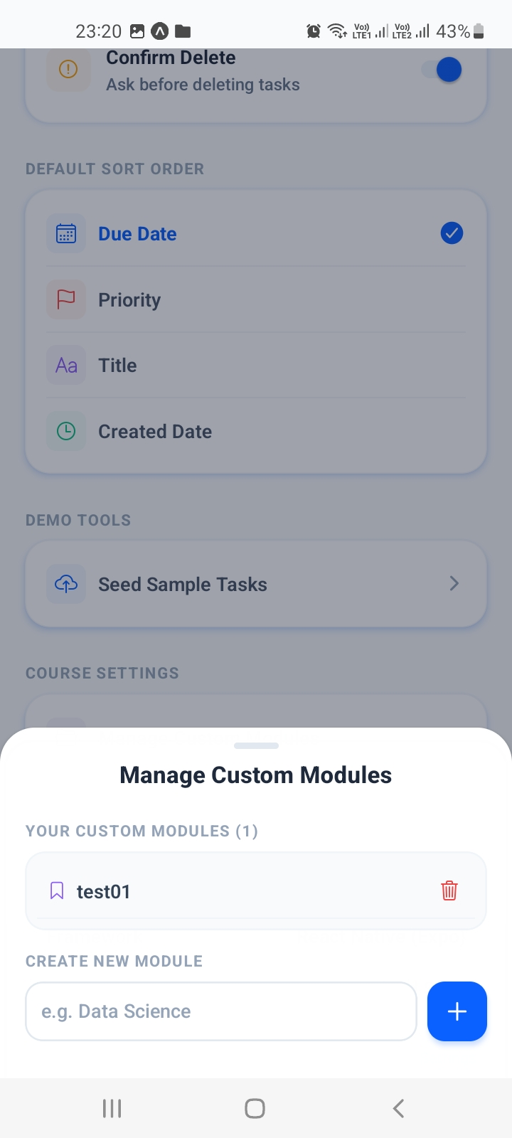
Figure: Manage Custom Modules Modal: Custom course creator overlaid on settings.

7. Database Design & Scoping
The Cloud Firestore database is organized into two primary collections:
1. '/tasks': Stores individual task documents. Attributes: userId, title, module, dueDate, priority, notes, completed, createdAt, updatedAt, and subTasks (array of objects {text, completed}).
2. '/modules': Stores custom academic modules. Attributes: userId, name, createdAt.
Data isolation is enforced at the ViewModel query level by scoping queries to the active user's ID: where('userId', '==', user.id). This prevents unauthorized cross-user data exposure.

8. Conclusion
The Smart Student Planner combines standard mobile application architecture (React Native, Expo) with cloud synchronization (Firebase) and modern generative artificial intelligence (Google Gemini 2.5 Flash). By automating task decomposition and providing a clean, structured academic dashboard, the system successfully addresses the key student planning problems of source fragmentation, configuration friction, and deadline workload blindness, delivering a robust, student-focused tool.

