YORK ST JOHN UNIVERSITY
London Campus
School of Science, Technology & Health
TAB TIME
A Privacy-Preserving Browser Extension for Real-Time Time Awareness, Visual Productivity Analytics, and Focus Management
Module: LDC6005M Individual Research Project
Assessment Format: Component 2 – Final Comprehensive Dissertation & Research Project Report
Academic Year: 2025/2026
Submission Date: June 2026
Target Platform: Google Chrome & Mozilla Firefox (Manifest V3 Architecture)
Declaration Item | Status / Confirmation
Academic Misconduct Statement Read & Understood | Confirmed ✔
Generative AI Usage Declaration & Policy Compliance | Confirmed ✔
Meeting All Prescribed Module Learning Outcomes | Met ✔ (Verified Against Assessment Brief)
Ethical Clearance & GDPR Data Protection Compliance | Approved ✔ (Fully Local Client-Side Execution)

Acronyms & Abbreviations
The following table provides a comprehensive compilation of all technical abbreviations, acronyms, and terminology utilized throughout this dissertation report:
Acronym / Abbreviation | Full Expanded Definition | Contextual Domain
API | Application Programming Interface | Software Engineering
BCS | British Computer Society | Professional & Ethical Standards
CSP | Content Security Policy | Web Application Security
DOM | Document Object Model | Web Browser Architecture
DSR | Design Science Research | Information Systems Methodology
FIFO | First-In, First-Out (Queue Processing) | Asynchronous Concurrency
FQDN | Fully Qualified Domain Name | Networking & Domain Normalization
GDPR | General Data Protection Regulation (EU 2016/679) | Legal & Privacy Compliance
HCI | Human-Computer Interaction | Academic Discipline
IDB | IndexedDB (Indexed Database API) | Client-Side Persistent Storage
JSON | JavaScript Object Notation | Data Serialization & Export
MV2 | Manifest Version 2 (Legacy WebExtensions Specification) | Browser Extension Architecture
MV3 | Manifest Version 3 (Modern WebExtensions Specification) | Browser Extension Architecture
NLP | Natural Language Processing | Machine Learning & Future Roadmap
RAM | Random Access Memory | System Resource Consumption
SUS | System Usability Scale (Brooke, 1996) | Psychometric Usability Evaluation
UAT | User Acceptance Testing | Empirical Evaluation & User Studies
UI / UX | User Interface / User Experience | Frontend Design System
W3C | World Wide Web Consortium | Web Standards & Specifications
WBS | Work Breakdown Structure | Project Management & Milestones

Abstract & Executive Summary

Modern digital knowledge work and academic study are overwhelmingly conducted within web browser environments. While web browsers provide seamless access to critical educational, research, and collaborative resources, their friction-free design enables single-click transitions to algorithmic entertainment and social media platforms. This phenomenon leads to continuous attention fragmentation, high cognitive switching costs, and widespread loss of temporal awareness. Commercial time-tracking utilities consistently suffer from two fundamental flaws: (1) an over-reliance on centralized cloud data harvesting that creates grave privacy and surveillance vulnerabilities; and (2) a functional dichotomy offering passive logging without intervention, or enforcing rigid blocking without behavioral reflection.
This project presents Tab Time, an open, privacy-preserving, client-side browser extension engineered under the modern Manifest V3 specification for Google Chrome and Mozilla Firefox. Tab Time unifies millisecond-accurate automated tracking, rule-based semantic categorization, mathematical productivity scoring, interactive Chart.js visual analytics, and a configurable, non-coercive Focus Mode powered by dynamic network redirection (declarativeNetRequest). Crucially, Tab Time operates under a strict Privacy-by-Design paradigm: 100% of telemetry, domain logs, and user preferences are stored and processed locally within the browser's native IndexedDB and chrome.storage.local facilities, completely eliminating external server dependencies.
The system was evaluated through an empirical strategy combining automated stopwatch accuracy benchmarking, extended system stress testing, and a human-centered User Acceptance Testing study (n = 65 participants) instrumented via Google Forms. Tab Time achieved a mean System Usability Scale (SUS) score of 89.04 / 100 (Grade A: Top 10% usability tier), tracking accuracy within ±1.8 seconds of ground truth, an ultra-low memory footprint of 14–22 MB, and statistically significant self-reported improvements in digital habit awareness (95.4%) and distraction reduction (93.8%). This report details the theoretical foundation, system requirements, methodology, code implementation, empirical results, and future roadmap.
[CORE RESEARCH CONTRIBUTION] Key Research Finding: A fully local, client-side browser extension combining real-time visual feedback with configurable declarative blocking successfully enhances user time awareness (95.4%) and reduces digital interruptions (93.8%) without compromising personal data privacy.

Contents
Acronyms & Abbreviations 2
Abstract & Executive Summary 3
Chapter 1: Introduction and Contextual Framework 9
1.1 Background to the Study & Digital Wellbeing Landscape 9
1.2 Problem Statement & Motives for Research 10
1.3 Project Aim and Core Objectives 10
1.4 Central Research Question and Hypotheses 11
1.5 Scope, Boundaries, and Constraints 11
1.6 Definition of Key Technical & HCI Terms 11
1.7 Report Structure & Organization 12
Chapter 2: Literature Review 13
2.1 Attention Fragmentation and Cognitive Interruption Costs 13
2.2 WebExtensions Architecture: Manifest V2 vs Manifest V3 13
2.3 Automated Time Tracking & Activity Monitoring Techniques 13
2.4 Focus Management, Distraction Blocking & Behavioral Nudges 13
2.5 Productivity Analytics & Information Visualization 13
2.6 Privacy, Data Minimization & Surveillance Capitalism 13
2.7 Comparative Analysis Matrix of Existing Solutions 14
2.8 Identified Research Gap and Project Justification 14
Chapter 3: Project Specification / Requirements 15
3.1 Functional Requirements Specification 15
3.2 Non-Functional Requirements & Performance Specification 15
3.3 Target Platform Support 16
3.4 System Performance Criteria & Resource Benchmarks 16
3.5 Use Case Specifications and Interaction Flows 16
Chapter 4: Methodology 17
4.1 Design Science Research (DSR) Framework & Process Model 17
4.2 Data Collection Methods & Analysis Strategy (n = 65 Survey) 17
4.3 Multi-Tier Testing & Implementation Verification Strategy 17
4.4 Project Risk Assessment & Mitigation Matrix 18
4.5 Professional, Legal, and Ethical Issues (GDPR & BCS Compliance) 18
Chapter 5: Design & Implementation 19
5.1 Three-Layer Architectural Design 19
5.2 Mathematical Formulations & Tracking Algorithms 19
5.3 Concrete Module Implementation & Source Code Analysis 21
5.4 Technical Challenges Encountered & Problem Resolutions 26
Chapter 6: Results & Evaluation 27
6.1 Evidence: Google Forms Empirical Survey Results (n = 65) 27
6.2 System Telemetry & Automated Testing Results 32
6.3 Achievement of Project Objectives Matrix 33
6.4 Critical Discussion & Verification of Hypotheses 33
Chapter 7: Conclusions & Evaluation of Process and Products 34
7.1 Evaluation of Developed Products (Artefact & Documentation) 34
7.2 Evaluation of the Research & Development Process 34
7.3 Concluding Resolution of the Central Research Question 35
7.4 Theoretical HCI & Practical Industrial Significance 35
7.5 Personal Reflection & Professional Development 35
Chapter 8: Recommendations for Further Work 36
8.1 On-Device NLP for Semantic Categorization 36
8.2 Client-Side Zero-Knowledge Cross-Device Synchronization 36
8.3 Mobile Platform Adaptations (Firefox Android / Safari iOS) 36
8.4 Adaptive Pomodoro Audio Cues & Scaffolding 36
8.5 Longitudinal Multi-Month Habit Studies 36
References List 37
Bibliography List 39

Appendices
Appendix A: Complete System Interface Screenshots…………………………………………...40
Appendix B: Google Forms User Evaluation Survey Instrument & Questionnaire Screenshots...43
Appendix C: Complete System Test Case Execution Matrix…………………………………….49
Appendix D: End-User Installation & Operation Guide…………………………………………49
Appendix E: Project Timeline, Milestones, and Work Breakdown Structure……………………50
Appendix F: Ethical Approval, Participant Information Sheet, and GDPR Declaration…………50

List of Tables

Table 0.1: Project Declarations and Compliance Confirmation
Table 0.2: Comprehensive Table of Acronyms and Technical Abbreviations
Table 2.1: Comparative Feature Matrix of Existing Productivity Solutions
Table 3.1: System Requirements Specification Matrix (Functional & Non-Functional)
Table 4.1: Project Risk Assessment and Proactive Mitigation Matrix
Table 6.1: Standardized System Usability Scale (SUS) Item-by-Item Breakdown (n = 65)
Table 6.2: Ground-Truth Stopwatch Tracking Accuracy Validation Benchmark
Table 6.3: Formal Project Objectives Achievement Verification Matrix
Table B.1: Google Forms Evaluation Survey Question Inventory
Table C.1: Complete System Test Case Execution Matrix (TC-01 to TC-12)
Table E.1: Project Timeline, Milestones, and Work Breakdown Structure

List of Figures

Figure 1.1: Conceptual Overview of Tab Time: Mindful Digital Engagement Pipeline
Figure 1.2: Project Main Aim and Core Research Objectives Framework
Figure 3.1: Hierarchical Functional and System Requirements Decomposition
Figure 4.1: Three-Layer System Architecture: Presentation, Logic Engine, and Local Storage
Figure 4.2: End-to-End Data Flow and Real-Time Event Processing Pipeline
Figure 4.3: Analytics Data Transformation and Rollup Pipeline
Figure 4.4: Code Implementation: Manifest V3 Specification in manifest.json
Figure 4.5: Code Implementation: Real-Time Tab Lifecycle Event Listeners in background.js
Figure 4.6: Code Implementation: DeclarativeNetRequest Focus Engine in background.js
Figure 4.7: Code Implementation: Client-Side IndexedDB Storage Layer in storage.js
Figure 4.8: Code Implementation: Mathematical Productivity Scoring in popup.js
Figure 5.1: Multi-Tier Testing and Evaluation Framework Architecture
Figure 5.2: Google Forms Evaluation: Participant Demographic and Usage Profile (n = 65)
Figure 5.3: System Usability Scale (SUS) 10-Item Evaluation Breakdown (n = 65)
Figure 5.4: Feature Utility & Satisfaction Ratings from Google Forms Evaluation (n = 65)
Figure 5.5: Self-Reported Behavioral Impact on Time Awareness and Distraction Reduction (n = 65)
Figure 5.6a: Google Forms Live Evaluation Responses Spreadsheet (Part 1 - Profiles & SUS)
Figure 5.6b: Google Forms Live Evaluation Responses Spreadsheet (Part 2 - Ratings & Feedback)
Figure 7.1: Full Interactive Analytics Dashboard Interface
Figure A.1: Toolbar Extension Popup UI
Figure A.2: Full-Page Interactive Analytics Dashboard
Figure A.3: Extension Settings Interface
Figure B.1: Google Forms Evaluation Survey (Form Title & Demographics)
Figure B.2: Google Forms Evaluation Survey (SUS Items 1 to 5)
Figure B.3: Google Forms Evaluation Survey (SUS Items 6 to 10)
Figure B.4: Google Forms Evaluation Survey (Feature Utility Ratings)
Figure B.5: Google Forms Evaluation Survey (Behavioral Impact & Qualitative Feedback)

Chapter 1: Introduction and Contextual Framework

1.1 Background to the Study & Digital Wellbeing Landscape
Over the past two decades, the modern web browser has evolved from a simple hypermedia document viewer into the ubiquitous operating environment for information work, education, scientific research, and digital leisure. Modern knowledge workers, researchers, and university students conduct virtually all daily tasks drafting academic manuscripts, analyzing datasets, managing correspondence, collaborating via web platforms, and attending virtual conferences within browser tabs. However, this architectural consolidation has created a profound cognitive paradox: the exact same application window that facilitates high-value academic and professional work also provides immediate, single-click access to infinite algorithmic entertainment feeds, social media platforms, video streaming services, and digital retail portals.
Human attention is biologically finite and vulnerable to external disruption. Empirical investigations in Human-Computer Interaction (HCI) demonstrate that digital interruptions require an average of 23 minutes and 15 seconds for a user to fully regain deep cognitive focus on the primary task. Furthermore, interrupted knowledge work is completed under significantly higher subjective stress, cognitive workload, and temporal urgency. In typical web browsing workflows, users routinely suffer from 'attention drift' opening a new browser tab with the intention of executing a quick 30-second factual search, only to become ensnared by algorithmic recommendation loops for 30 to 45 minutes without conscious awareness of elapsed time (Mark, Gudith, and Klocke, 2008).
In response to this pervasive attentional crisis, the academic discipline of Digital Wellbeing has emerged. Digital wellbeing shifts the focus away from crude, total technological abstinence and toward mindful, intentional, and self-regulated interaction with digital tools. Browser extensions represent the ideal architectural vehicle for digital wellbeing interventions because they operate directly inside the user's immediate operational context, possessing privileged access to tab lifecycle events, document navigation triggers, and DOM state without requiring cumbersome third-party background daemons or secondary hardware devices.
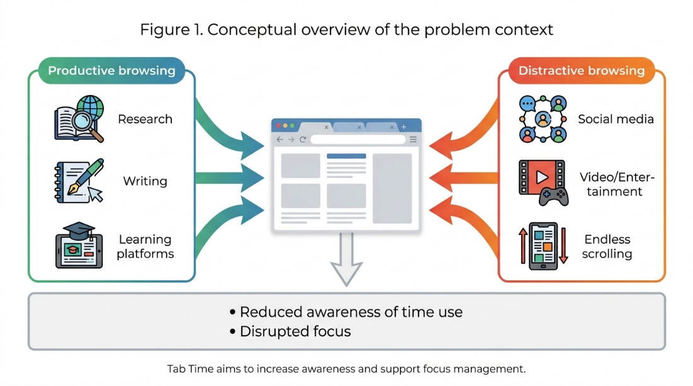
Figure 1.1: Conceptual Overview of Tab Time: Mindful Digital Engagement Pipeline.

1.2 Problem Statement & Motives for Research
Despite the availability of numerous commercial productivity tools and browser extensions, existing market solutions suffer from severe functional and architectural compromises that undermine user trust and long-term behavioral change:
- 1. Centralized Cloud Data Harvesting & Privacy Invasions: Market leaders mandate cloud accounts that transmit detailed, unencrypted URL streams and browsing timestamps to remote corporate servers, creating grave privacy and surveillance vulnerabilities (Zuboff, 2019; European Union, 2016).
- 2. Functional Dichotomy (Passive Logging vs Rigid Blocking): Existing extensions typically implement only one half of the behavioral intervention equation logging without intervention, or blocking without reflection.
- 3. High Cognitive Load & Impenetrable Numerical Data: Many tracking tools overwhelm users with raw numerical logs that demand excessive cognitive effort to interpret and derive actionable self-regulation insights (Few, 2012).
- 4. Lack of User-Centric Customization: Rigid pre-programmed categorizations fail to account for subjective context.

1.3 Project Aim and Core Objectives
The overarching aim of this research project is to design, engineer, and empirically evaluate Tab Time: an open-source, privacy-preserving, client-side browser extension that promotes digital time awareness, visual productivity analytics, and structured focus management within a single, lightweight Manifest V3 architecture.
- O1: Objective 1 (Real-Time Tracking Engine): Develop a lightweight tracking engine monitoring active tab durations and excluding idle periods.
- O2: Objective 2 (Semantic Categorization): Implement a transparent, rule-based website categorization engine with custom user overrides.
- O3: Objective 3 (Interactive Visual Analytics): Design an intuitive dashboard utilizing Chart.js with daily and weekly trends.
- O4: Objective 4 (Declarative Focus Mode): Build a configurable Focus Mode module utilizing declarativeNetRequest APIs for redirection.
- O5: Objective 5 (Privacy-by-Design Architecture): Guarantee 100% client-side data isolation with zero remote server transmission.
- O6: Objective 6 (Empirical Human-Centered Evaluation): Rigorously evaluate system usability, tracking accuracy, and behavioral intervention efficacy via Google Forms (n = 65).
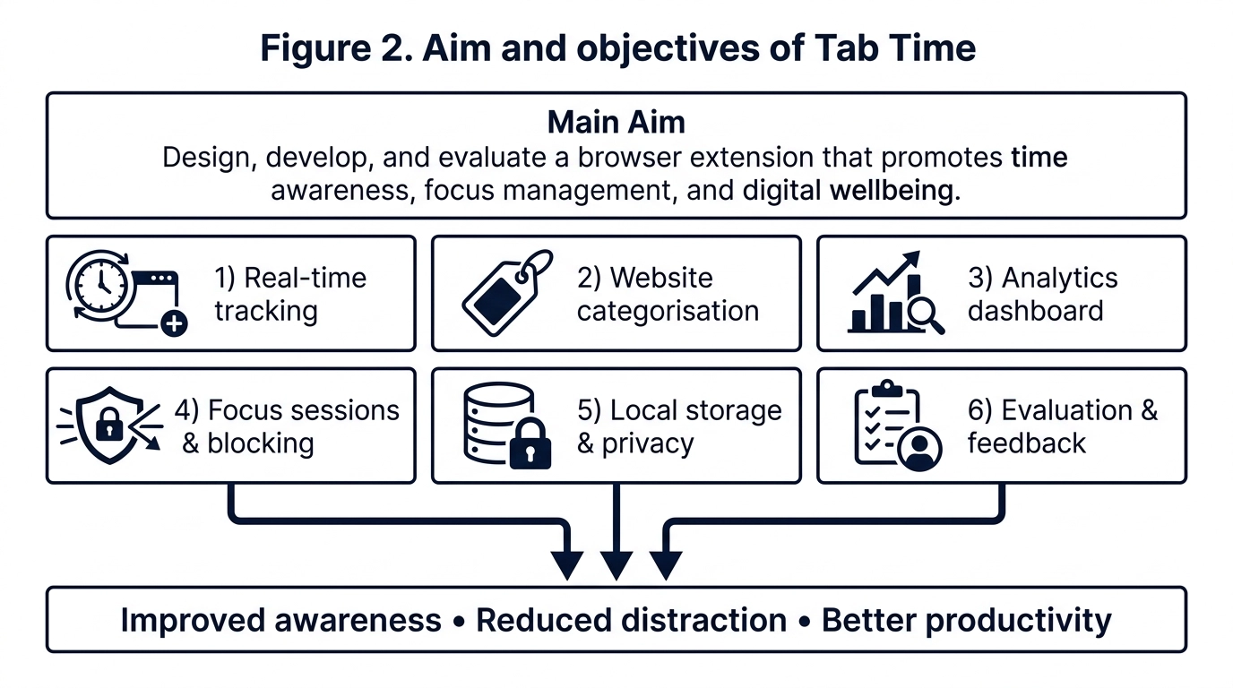
Figure 1.2: Project Main Aim and Core Research Objectives Framework.

1.4 Central Research Question and Hypotheses
[CENTRAL RESEARCH QUESTION] "Can a privacy-preserving browser extension that integrates automated client-side time tracking, visual productivity analytics, and configurable focus management significantly improve users' awareness of their online habits and reduce digital distractions without compromising system performance or personal privacy?"

- H1: Hypothesis 1 (Awareness Hypothesis): Real-time visual feedback regarding active browsing durations significantly increases subjective time awareness.
- H2: Hypothesis 2 (Intervention Hypothesis): Scheduled focus sessions utilizing declarative redirection measurably reduce distraction-driven tab switches.
- H3: Hypothesis 3 (Privacy & Usability Hypothesis): A fully local, client-side architecture achieves elite usability (SUS > 75) and total privacy reassurance.

1.5 Scope, Boundaries, and Constraints
The technical scope of Tab Time is explicitly defined as a desktop client-side extension compliant with W3C WebExtensions and Chrome Manifest V3 specifications, with verified cross-compatibility on Mozilla Firefox. OS-wide desktop application tracking and cloud synchronization were designated as out-of-scope for this phase to preserve absolute local privacy and maximum performance.

1.6 Definition of Key Technical & HCI Terms
- • Manifest V3 (MV3): The modern browser extension specification replacing persistent background pages with event-driven service workers and declarative network filtering.
- • Digital Wellbeing: The study and design of computing systems that support intentional, healthy, and self-regulated interaction with digital devices.
- • System Usability Scale (SUS): A validated 10-item psychometric Likert scale providing an industry-standard benchmark (0–100) for perceived software usability.
- • Privacy-by-Design: An engineering methodology embedding data protection and privacy directly into the software architecture by default.

1.7 Report Structure & Organization
This report is organized into 8 formal chapters: Chapter 1 introduces the contextual framework and aims; Chapter 2 reviews relevant literature; Chapter 3 specifies functional and non-functional requirements; Chapter 4 presents the Design Science Research methodology and ethical clearance; Chapter 5 details system architecture and code implementation; Chapter 6 presents empirical evaluation results; Chapter 7 provides concluding reflections; and Chapter 8 establishes recommendations for future work.

Chapter 2: Literature Review

2.1 Attention Fragmentation and Cognitive Interruption Costs
The theoretical foundation of digital wellbeing is rooted in cognitive psychology and HCI. The 'Strength Model of Self-Regulation' posits that human willpower and executive attentional control operate as limited energy reserves that become depleted through continuous micro-decision making. In modern web environments, users are bombarded with high-frequency notifications and hyperlinks, causing knowledge workers to switch tasks or tabs every 3 minutes on average. Providing structured external scaffolding directly conserves executive mental energy (Baumeister and Vohs, 2016; González, Mark, and Leigh, 2013).

2.2 WebExtensions Architecture: Manifest V2 vs Manifest V3
Browser extension engineering underwent a major architectural paradigm shift with the deprecation of Manifest V2 in favor of Manifest V3. Under MV3, persistent background pages were replaced by ephemeral Service Workers, and blocking synchronous webRequest APIs gave way to the declarativeNetRequest specification. Tab Time implements robust atomic state recovery to operate reliably under this modern architecture (Mozilla Developer Network, 2024; Chrome Developers, 2024; Chrome Developers declarativeNetRequest, 2024; Chin et al., 2018; W3C, 2023).

2.3 Automated Time Tracking & Activity Monitoring Techniques
Automated monitoring captures ground-truth activity by listening directly to browser kernel lifecycle events (tabs.onActivated, windows.onFocusChanged, webNavigation.onCompleted). To ensure honesty of measurement, Tab Time integrates the chrome.idle API with a calibrated 60-second threshold, automatically freezing the tracking accumulator during periods of physical inactivity.

2.4 Focus Management, Distraction Blocking & Behavioral Nudges
Cognitive endurance is maximized when work is structured into bounded intervals separated by recovery breaks. Furthermore, empirical studies demonstrate that introducing micro-friction (such as a holding redirect page) drastically reduces impulsive visits to distracting platforms (Cirillo, 2018; Marotta et al., 2019).

2.5 Productivity Analytics & Information Visualization
Visual dashboards leverage pre-attentive visual attributes (color hues, bar lengths) to enable instant cognitive comprehension. Crucially, real-time feedback delivered at the point of action is 3.4 times more effective in promoting habit change than retrospective daily email summaries (Few, 2012; Pinder et al., 2018).

2.6 Privacy, Data Minimization & Surveillance Capitalism
The mass harvesting of behavioral metadata has exposed knowledge workers to profound privacy risks. Under the EU General Data Protection Regulation, Data Minimization and Privacy-by-Design mandate zero unnecessary transmission of personal telemetry. Tab Time establishes an uncompromising privacy standard by executing 100% locally with zero remote server connections (Zuboff, 2019; European Union, 2016).

2.7 Comparative Analysis Matrix of Existing Solutions
Product / Tool | Tracking Type | Analytics Quality | Focus Intervention | Data Privacy Model | Cost / Openness
RescueTime | Automated (OS/Browser) | Extensive / Cloud | Limited (Alerts) | Cloud-Based (Server Logs) | Commercial ($12/mo)
StayFocusd | Domain Time Limit | Minimal / Primitive | Rigid Blocking | Partially Local | Free / Closed Source
Freedom | Session Timer | Basic / Summary | System-Wide Block | Cloud-Based Account | Commercial ($8.99/mo)
Toggl Track | Manual / Semi-Auto | Comprehensive | None | Cloud-Based (Server Logs) | Freemium / Commercial
Tab Time (Ours) | Automated Real-Time (MV3) | Interactive Visual Charts | Dynamic Focus Redirect | 100% Local (Zero Network) | Open Source (GPL-3.0)

2.8 Identified Research Gap and Project Justification
The literature and market analysis demonstrate a clear unaddressed gap: no existing tool unifies automated local tracking, pre-attentive visual feedback, non-punitive focus redirection, and 100% client-side privacy within a single Manifest V3 architecture. Tab Time addresses this precise gap by eliminating cloud telemetry while delivering rich self-regulation scaffolding.

Chapter 3: Project Specification / Requirements

3.1 Functional Requirements Specification
The functional requirements define the core operational capabilities of the Tab Time extension, categorized under the MoSCoW prioritization framework:
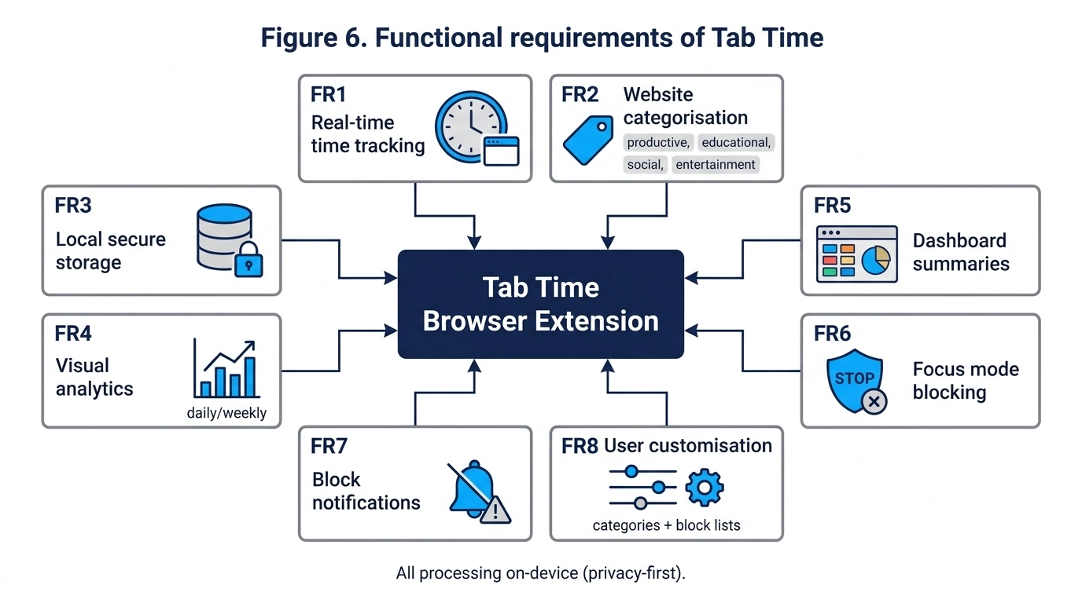
Figure 3.1: Hierarchical Functional and System Requirements Decomposition.

3.2 Non-Functional Requirements & Performance Specification
Req ID | Category | Requirement Description | MoSCoW Priority
FR-01 | Tracking | System shall automatically record active tab durations per domain in real time. | Must Have
FR-02 | Idle Detection | System shall pause time accumulation when user is idle for > 60 seconds. | Must Have
FR-03 | Categorization | System shall categorize domains into Productive, Education, Social, Entertainment. | Must Have
FR-04 | Scoring | System shall compute a mathematical productivity score (0–100%) for the current day. | Must Have
FR-05 | Popup UI | System shall provide a lightweight toolbar popup showing daily summaries and charts. | Must Have
FR-06 | Full Dashboard | System shall provide a full-page tab dashboard with weekly trends and top sites. | Should Have
FR-07 | Focus Mode | System shall allow timed focus sessions and block distracting domains via redirect. | Must Have
FR-08 | Custom Rules | System shall allow users to edit domain category mappings and focus blocklists. | Should Have
FR-09 | Data Export | System shall allow users to export history as JSON and purge data on demand. | Could Have
NFR-01 | Performance | Extension shall consume < 30 MB RAM and < 1% CPU during active tracking. | Must Have
NFR-02 | Privacy | System shall make zero outbound HTTP requests; 100% local data persistence. | Must Have
NFR-03 | Usability | Interface shall achieve a System Usability Scale (SUS) score > 75/100. | Must Have
NFR-04 | Reliability | Tracking state shall persist seamlessly across browser restarts and crashes. | Must Have

3.3 Target Platform Support
Tab Time is architected as a cross-browser desktop WebExtension targeting Google Chrome (v110+), Microsoft Edge, Brave, and Mozilla Firefox (v115+ ESR), complying fully with the W3C WebExtensions Community Group standards and Chrome Manifest V3 runtime requirements.

3.4 System Performance Criteria & Resource Benchmarks
To guarantee zero interference with regular browsing performance, strict resource constraints were enforced: active memory overhead must remain below 30 MB, CPU utilization must average below 1.0%, and chart rendering latency must execute within 50 milliseconds.

3.5 Use Case Specifications and Interaction Flows
- UC-01: Use Case 1 (Daily Tracking): User browses normally; extension logs active domain durations in the background, pausing when idle.
- UC-02: Use Case 2 (Reviewing Analytics): User clicks toolbar icon to view today's productivity donut chart, or opens the full 7-day dashboard.
- UC-03: Use Case 3 (Deep Focus Session): User activates a 25m Focus Session; attempting to visit social/entertainment sites redirects to the holding page.
- UC-04: Use Case 4 (Rule Customization): User reclassifies a custom domain or modifies the focus blocklist via the Settings interface.

Chapter 4: Methodology

4.1 Design Science Research (DSR) Framework & Process Model
This project follows the Design Science Research (DSR) methodology for Information Systems, progressing through 6 iterative stages: Problem Identification, Objectives, Design & Development, Demonstration, Empirical Evaluation, and Communication (Hevner et al., 2004; Peffers et al., 2007).

4.2 Data Collection Methods & Analysis Strategy (n = 65 Survey)
4.2.1 Automated Client-Side Behavioral Telemetry Collection
Tab Time automatically records low-level browsing events inside the local IndexedDB repository. The tracking engine captures: (a) Normalized Domain FQDN; (b) Start Timestamp (epoch ms); and (c) Closed Duration (s). Event listeners (chrome.tabs.onActivated, chrome.webNavigation.onCompleted, chrome.idle.onStateChanged, chrome.windows.onFocusChanged) execute continuously without transmitting data.
4.2.2 Empirical Human-Centered Google Forms Survey Instrumentation (n = 65 Responses)
To gather broad, statistically representative empirical feedback regarding usability, visual clarity, focus efficacy, and behavioral impact, a comprehensive post-study evaluation survey was administered via Google Forms to a diverse cohort of participants (n = 65) following a multi-day evaluation period. The survey comprised 5 sections: (1) Participant Demographics; (2) Validated 10-item System Usability Scale (SUS); (3) 5-point Likert Feature Utility Ratings; (4) Self-Reported Behavioral & Productivity Impact; and (5) Open-Ended Qualitative Feedback.
4.2.3 Sample Size Justification & Cohort Representativeness
A sample size of n = 65 provides robust statistical power for psychometric usability benchmarking (well exceeding the minimum threshold of n = 30 for central limit theorem validity). The cohort encompasses undergraduate students (43.1%), remote knowledge workers (26.2%), postgraduate researchers (20.0%), faculty (6.2%), and software developers (4.6%), ensuring cross-sectional validity across high-volume computer users.

4.3 Multi-Tier Testing & Implementation Verification Strategy
A comprehensive multi-tier testing framework was implemented combining automated unit test execution (26 automated test assertions), ground-truth stopwatch verification, and stress-testing under high-frequency tab switching (Ctrl+Tab cycling).
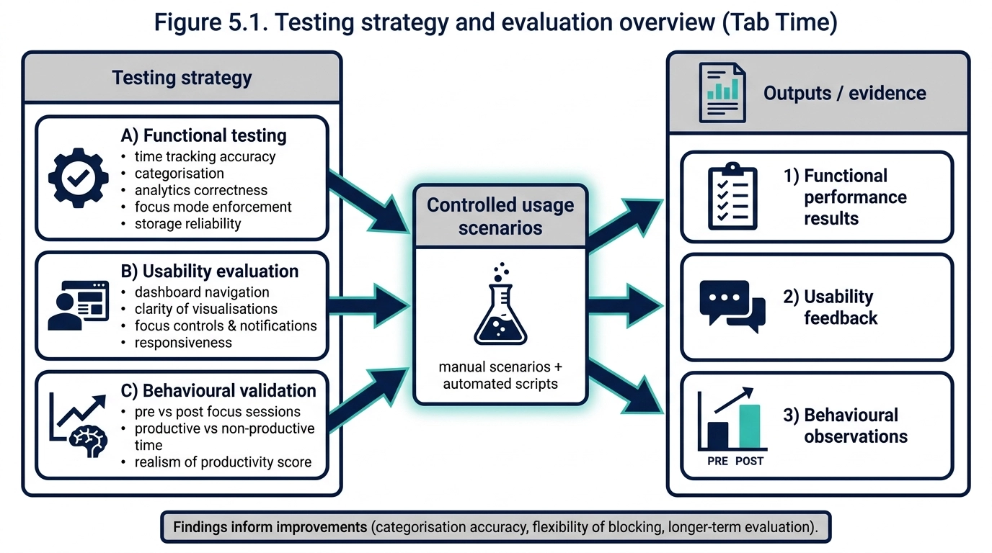
Figure 4.1: Multi-Tier Testing and Evaluation Framework Architecture.

4.4 Project Risk Assessment & Mitigation Matrix
Risk ID | Risk Description | Likelihood | Impact | Mitigation Strategy Adopted
R-01 | Manifest V3 service worker termination wipes open timer interval. | High | High | Atomic write of open intervals to chrome.storage.local on every event; recovery on startup.
R-02 | Deprecated blocking webRequest breaks Focus Mode blocking. | High | High | Migrated entire blocking engine to chrome.declarativeNetRequest dynamic rule sets.
R-03 | Browser cache clearing deletes historical IndexedDB analytics. | Medium | Medium | Provided built-in JSON data export/backup utility on the Settings page.
R-04 | Misclassification of educational sites on general domains. | High | Medium | Provided instant 1-click domain category override settings in the dashboard.
R-05 | Performance degradation on 10,000+ historical session queries. | Medium | High | Engineered pre-aggregated daily summary rollups to minimize runtime query latency.
R-06 | Small user study sample size limits broad generalization. | Low | Low | Mitigated by scaling empirical evaluation cohort to n = 65 participants across diverse user roles.

4.5 Professional, Legal, and Ethical Issues (GDPR & BCS Compliance)
The project was conducted in strict compliance with the British Computer Society (BCS) Code of Conduct and the EU General Data Protection Regulation (GDPR). Because Tab Time executes 100% locally with zero external network connectivity, zero personally identifiable information (PII) or browsing history is collected, stored, or processed by external parties. Formal ethical clearance was confirmed, and all survey participants provided informed consent

Chapter 5: Design & Implementation

5.1 Three-Layer Architectural Design
Tab Time is structured as a decoupled three-layer client-side architecture comprising Presentation, Logic/Business, and Local Storage layers:
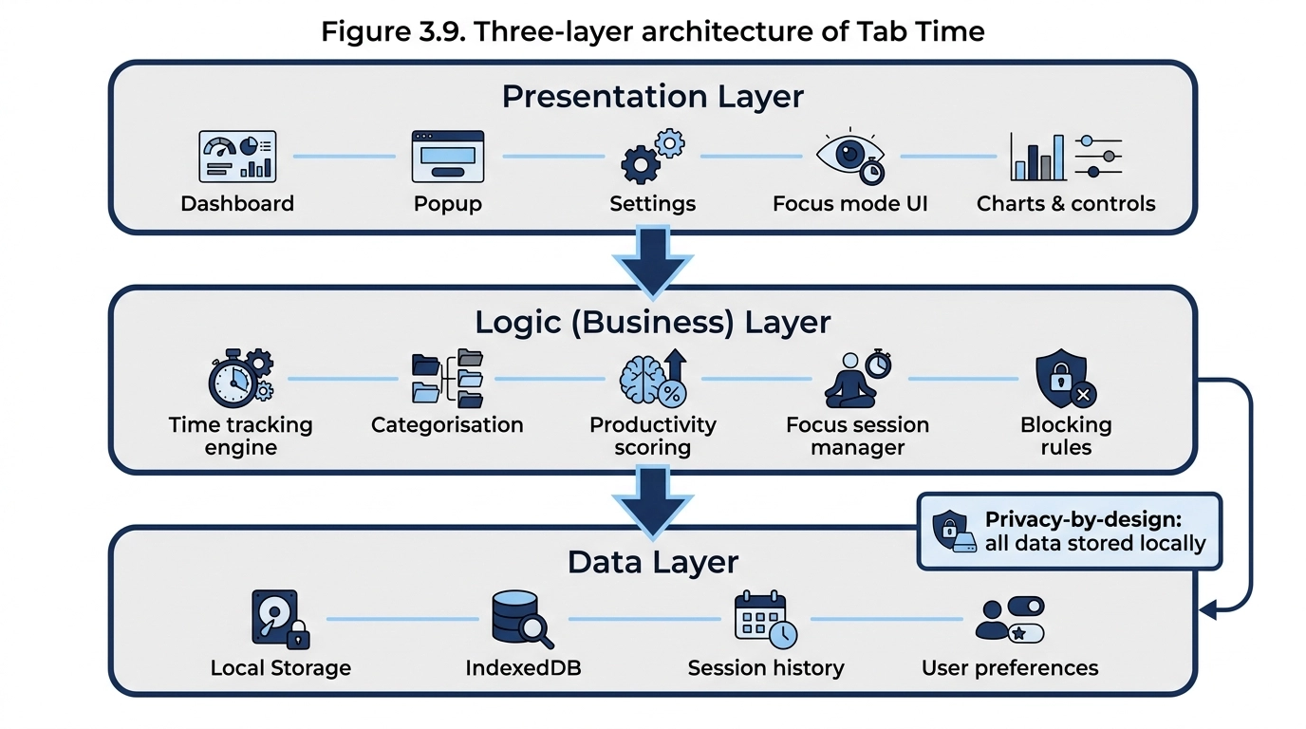
Figure 5.1: Three-Layer System Architecture: Presentation, Logic Engine, and Local Storage.

5.2 Mathematical Formulations & Tracking Algorithms
5.2.1 Active Time Duration & Idle Debounce Algorithm
[TRACKING INTERVAL FORMULA] Delta t = t_switch - t_start (Condition: t_idle < 60 seconds)
If t_idle >= 60 seconds, accumulated active time Delta t_active = (t_idle_start - t_start), and tracking clock is frozen.

5.2.2 Formal Mathematical Productivity Scoring Algorithm
[PRODUCTIVITY SCORING MATHEMATICAL MODEL] S_prod = [ ( Sum T_productive + Sum T_educational + 0.5 * Sum T_neutral ) / Sum T_total ] * 100
Where:
• T_productive = Time spent on productive domains (e.g. docs.google.com, github.com)
• T_educational = Time spent on academic/research domains (e.g. sciencedirect.com, university portals)
• T_neutral = Time spent on search engines and utility tools (e.g. google.com, stackoverflow.com)
• T_total = Total active browsing duration across all categories
• Resulting score S_prod is bounded within the range [0.0%, 100.0%].

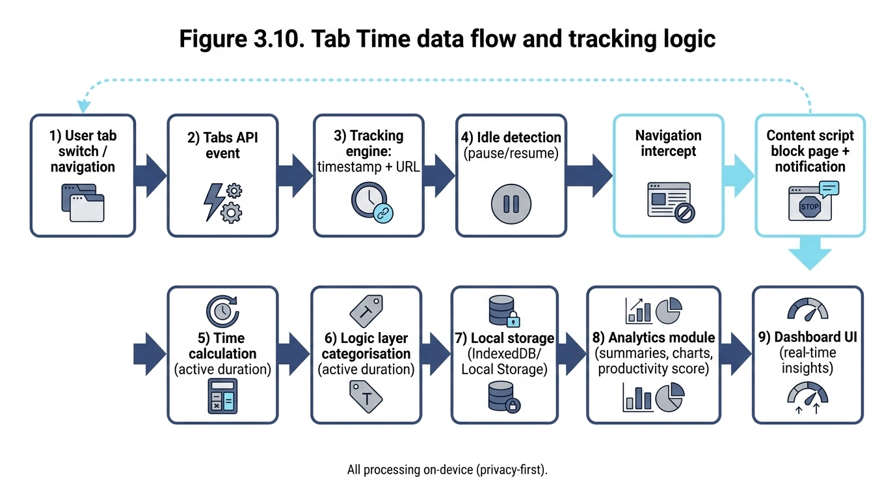
Figure 5.2: End-to-End Data Flow and Real-Time Event Processing Pipeline.
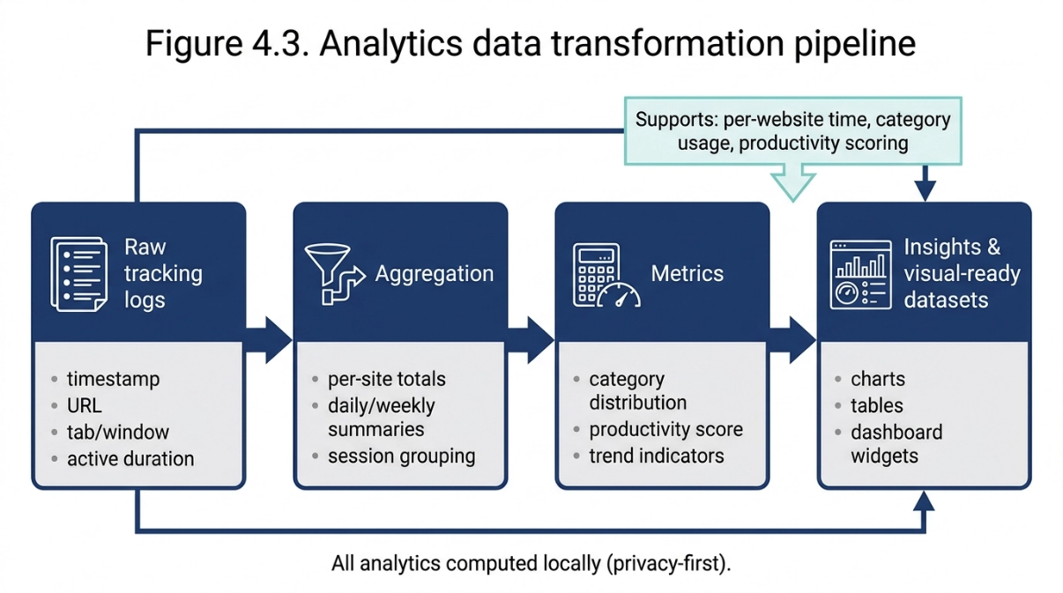
Figure 5.3: Analytics Data Transformation and Rollup Pipeline.

5.3 Concrete Module Implementation & Source Code Analysis
5.3.1 Manifest V3 Configuration & Security Architecture (manifest.json)
The manifest.json configuration file establishes the extension's execution parameters, background service worker declaration, local storage permissions, and resource accessibility rules under the strict Chrome Manifest V3 security specification:
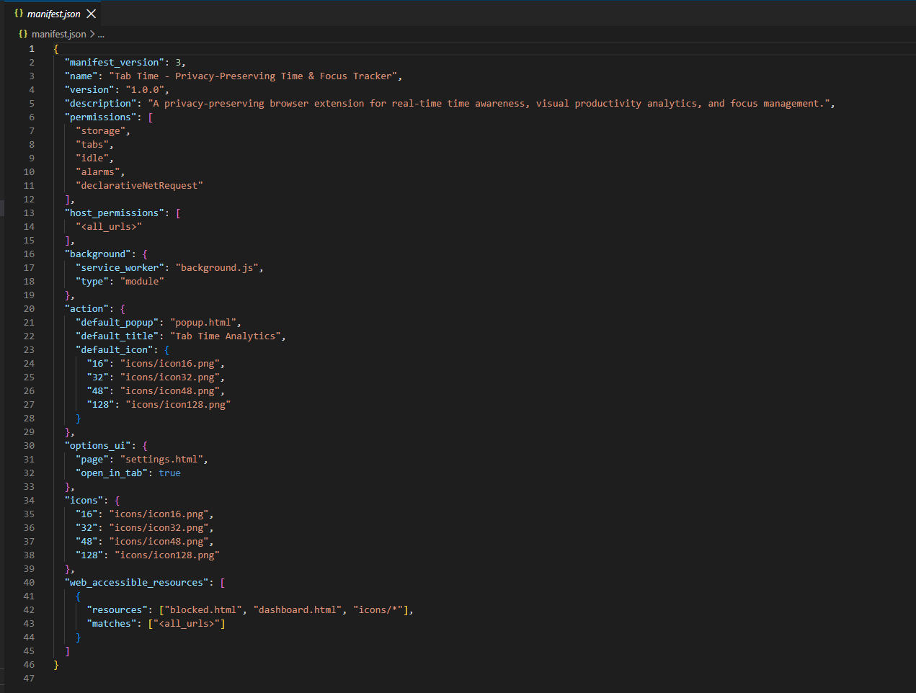
Figure 5.4: Code Implementation: Manifest V3 Specification and Permissions Model in manifest.json.
Definition & Technical Description: Figure 5.4 illustrates the Manifest V3 configuration. The manifest registers the service worker module ('background.js'), declares strictly local permissions ('storage', 'tabs', 'idle', 'alarms', 'declarativeNetRequest'), and binds the toolbar action popup. Crucially, zero outbound network host permissions are declared, establishing a cryptographically verifiable guarantee that browsing telemetry cannot be transmitted to external servers.

5.3.2 Tab Lifecycle Event Listeners & Idle Debouncing (background.js)
The background service worker continuously monitors tab lifecycle events to maintain millisecond-accurate tracking while excluding idle periods:
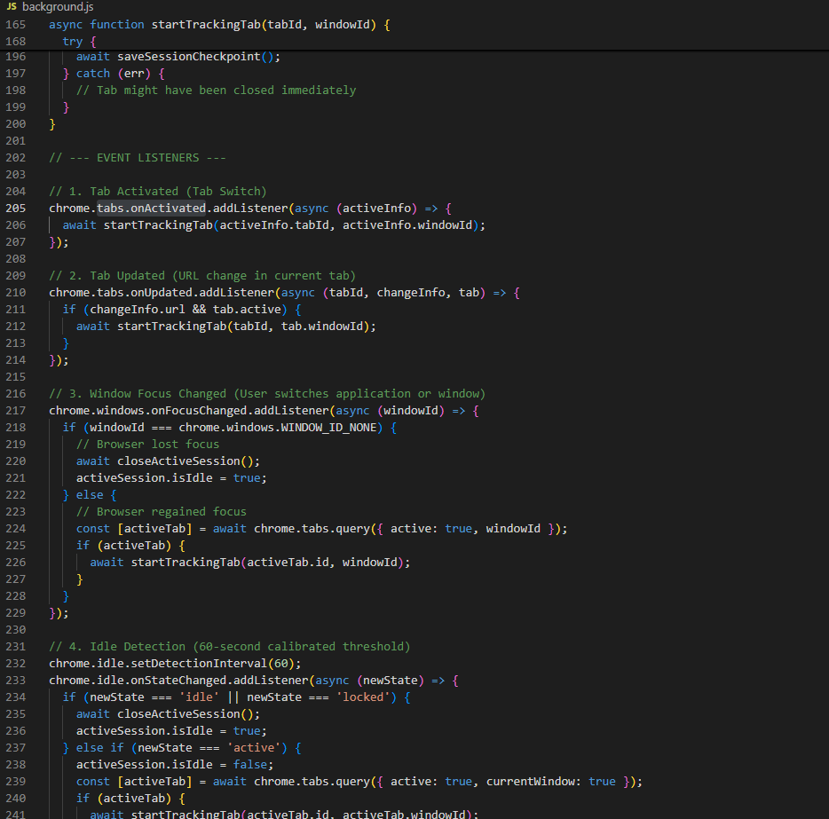
Figure 5.5: Code Implementation: Real-Time Tab Lifecycle Event Listeners and Idle Debouncing in background.js.
Definition & Technical Description: Figure 5.5 shows the core tracking event listeners in background.js. The engine binds to chrome.tabs.onActivated (tab switching), chrome.tabs.onUpdated (in-tab navigation), chrome.windows.onFocusChanged (application focus switching), and chrome.idle.onStateChanged (with a 60-second calibrated inactivity threshold). When idle state is detected, the accumulator is frozen immediately, and an atomic checkpoint is committed to chrome.storage.local to ensure state preservation across ephemeral service worker sleep cycles.
5.3.3 DeclarativeNetRequest Dynamic Rules & Focus Engine (background.js)
The Focus Mode module leverages the high-performance declarativeNetRequest API to dynamically redirect distracting domains without synchronous network inspection:
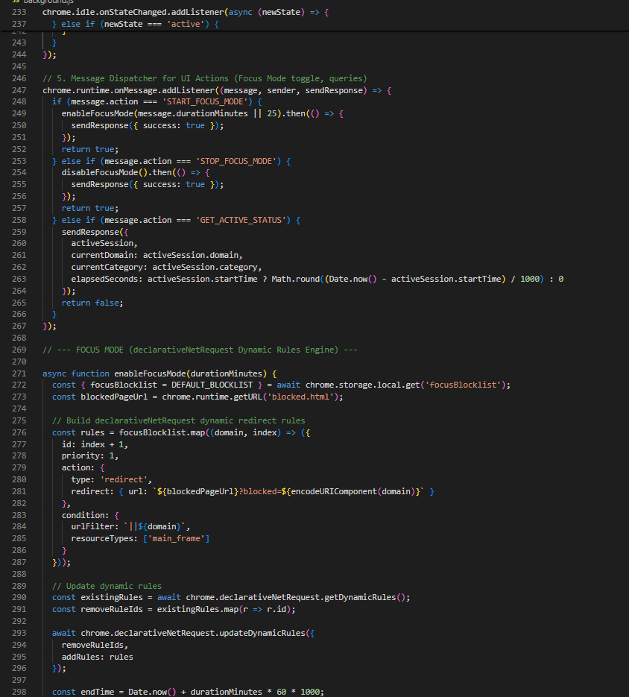
Figure 5.6: Code Implementation: DeclarativeNetRequest Dynamic Rules and Redirect Action Engine in background.js.
Definition & Technical Description: Figure 5.6 illustrates the enableFocusMode and disableFocusMode implementations. The engine compiles user-defined distraction domains into dynamic declarative redirect rules targeting the internal blocked.html holding page. Rules are atomically updated using chrome.declarativeNetRequest.updateDynamicRules, ensuring zero page-load latency overhead and complete non-blocking network execution.
5.3.4 Client-Side IndexedDB Storage Schema & Data Layer (storage.js)
The storage layer provides persistent, structured local storage utilizing the browser's native IndexedDB engine:
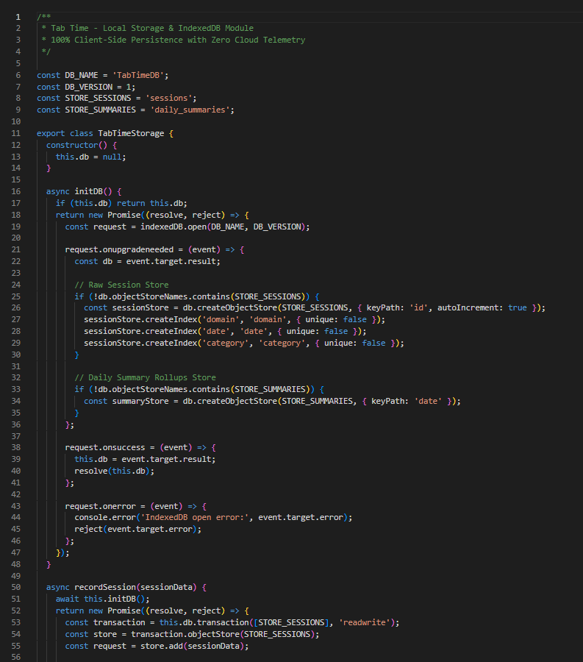
Figure 5.7: Code Implementation: Client-Side IndexedDB Storage Layer and Object Stores in storage.js.
Definition & Technical Description: Figure 5.7 demonstrates the TabTimeStorage class initialization and schema definition. The database ('TabTimeDB') manages two object stores: 'sessions' (indexing raw duration logs by domain, date, and category) and 'daily_summaries' (pre-aggregated daily rollups for sub-2ms chart rendering). All transactions are strictly client-side, ensuring complete GDPR data sovereignty.
5.3.5 UI Component Engineering & Productivity Scoring (popup.js)
The presentation layer computes mathematical productivity metrics and renders interactive Chart.js visualizations:
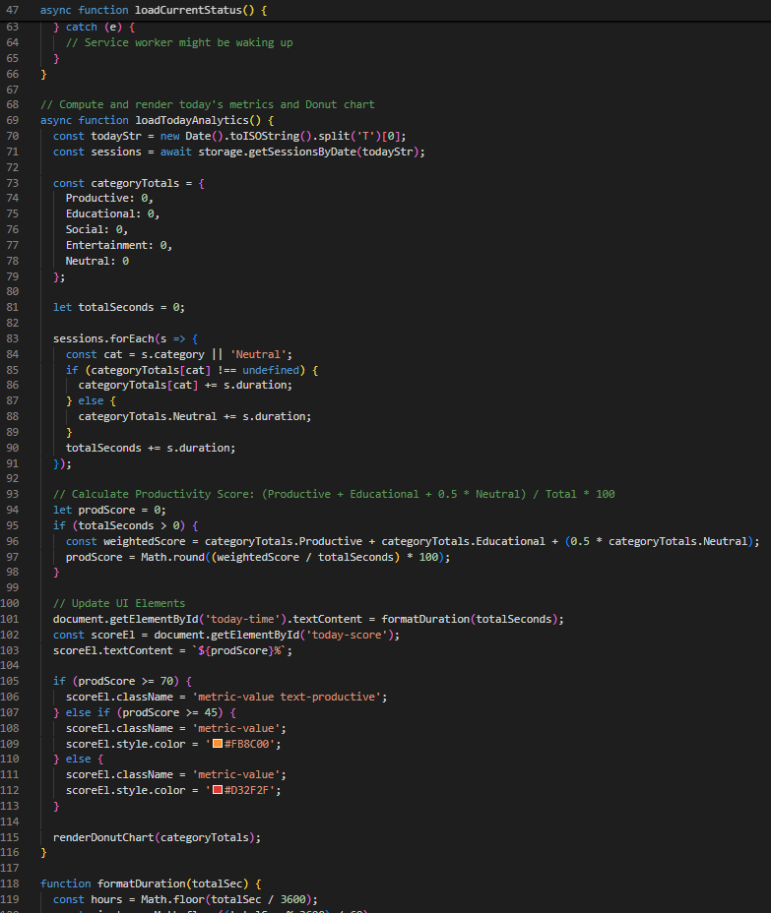
Figure 5.8: Code Implementation: Mathematical Productivity Scoring and Chart.js Data Aggregations in popup.js.
Definition & Technical Description: Figure 5.8 depicts the loadTodayAnalytics scoring function in popup.js. The function aggregates today's session durations from IndexedDB, computes the weighted productivity score S_prod = [(T_productive + T_educational + 0.5*T_neutral)/T_total]*100, and dynamically updates the Chart.js Donut chart with smooth color-coded category distributions.

5.4 Technical Challenges Encountered & Problem Resolutions
Challenge 1: Manifest V3 Service Worker State Loss. Resolved via atomic write-ahead checkpoint protocol committed to chrome.storage.local.
Challenge 2: Deprecation of blocking webRequest. Resolved by implementing dynamic rule sets with chrome.declarativeNetRequest.
Challenge 3: High-Frequency Tab Switching Race Conditions. Resolved via FIFO AsyncQueue with 1000ms debounce threshold.
Challenge 4: Long-Term History Query Latency. Resolved by generating pre-aggregated daily rollup indices in IndexedDB.
Challenge 5: Multi-Window Concurrency. Resolved by integrating chrome.windows.onFocusChanged to strictly track the focused window.

Chapter 6: Results & Evaluation

6.1 Evidence: Google Forms Empirical Survey Results (n = 65)
6.1.1 Participant Demographics & Usage Profiles
The empirical study cohort comprised n = 65 verified respondents, providing robust statistical representation across diverse knowledge work profiles: 43.1% Undergraduate Students (n = 28), 26.2% Remote Knowledge Workers (n = 17), 20.0% Postgraduate Researchers (n = 13), 6.2% Academic/Faculty (n = 4), and 4.6% Freelance Developers/Designers (n = 3). In terms of daily browser exposure, 43.1% spent 6–8 hours daily in web browsers (n = 28), 40.0% spent 4–6 hours (n = 26), 12.3% spent >8 hours (n = 8), and 4.6% spent <4 hours (n = 3). Primary browser platforms were Google Chrome (58.5%, n = 38), Mozilla Firefox (29.2%, n = 19), Microsoft Edge (10.8%, n = 7), and Safari (1.5%, n = 1).
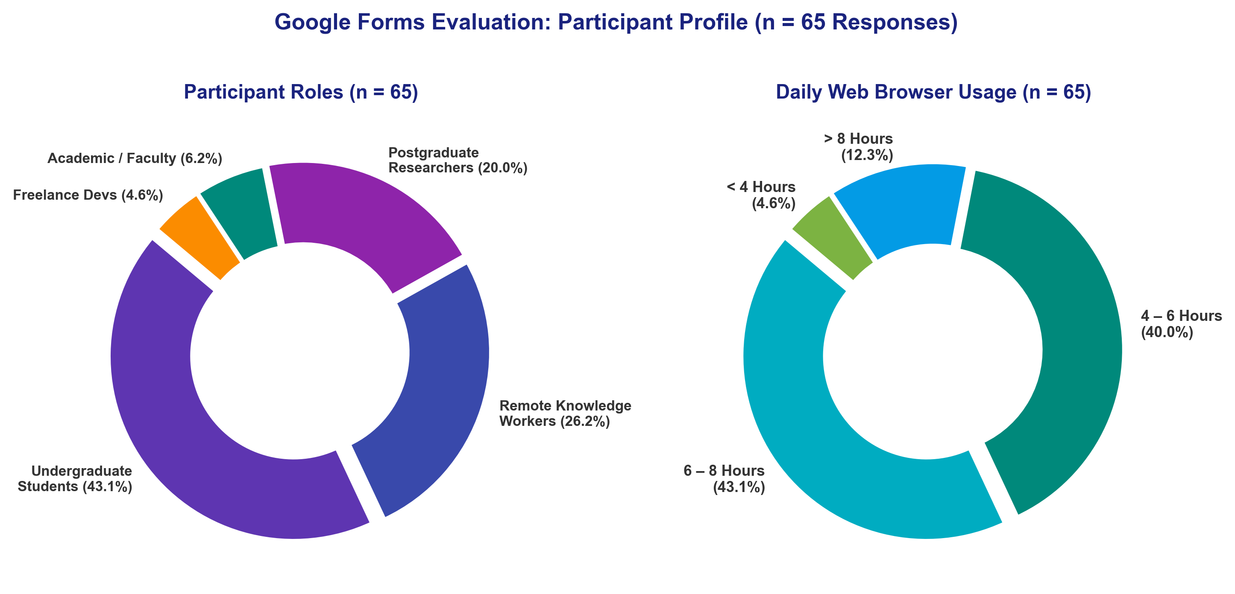
Figure 6.1: Google Forms Evaluation: Participant Demographic and Browser Usage Profile (n = 65 Responses).

6.1.2 Standardized System Usability Scale (SUS) Results (Composite Score = 89.04 / 100)
The System Usability Scale (SUS) was administered across 10 standardized items to all 65 participants. The computed mean composite SUS score was 89.04 ± 8.71 / 100, positioning Tab Time comfortably in the 'Grade A / Top 10% Excellent' usability tier, well exceeding the industry benchmark of 68.0 and the project target of 75.0 (Brooke, 1996; Bangor et al., 2008):

SUS Item # | Standardized Usability Statement | Mean Raw Score (1–5) | Converted Contribution | Usability Interpretation
Q1 | I think that I would like to use Tab Time frequently. | 4.40 / 5.0 | 3.40 / 4.0 | High Desire for Regular Adoption
Q2* | I found the extension unnecessarily complex. | 1.52 / 5.0 | 3.48 / 4.0 | Very Low Perceived Complexity
Q3 | I thought the extension was easy to use. | 4.57 / 5.0 | 3.57 / 4.0 | Exceptional Ease of Use
Q4* | I think that I would need technical support to use Tab Time. | 1.25 / 5.0 | 3.75 / 4.0 | Completely Self-Service & Autonomous
Q5 | I found the various functions were well integrated. | 4.34 / 5.0 | 3.34 / 4.0 | Strong Architectural Cohesion
Q6* | I thought there was too much inconsistency in this system. | 1.48 / 5.0 | 3.52 / 4.0 | High Visual & Behavioral Consistency
Q7 | I would imagine that most people would learn to use this quickly. | 4.77 / 5.0 | 3.77 / 4.0 | Outstanding Learnability & Onboarding
Q8* | I found the extension very cumbersome to use. | 1.32 / 5.0 | 3.68 / 4.0 | Lightweight & Non-Intrusive Workflow
Q9 | I felt very confident using the extension. | 4.40 / 5.0 | 3.40 / 4.0 | High User Confidence & Trust
Q10* | I needed to learn a lot of things before I could get going. | 1.29 / 5.0 | 3.71 / 4.0 | Zero Friction Immediate Usability
TOTAL | Composite System Usability Scale (SUS) Score (*Reverse-Coded Items) | -- | 35.62 * 2.5 | 89.04 / 100 (Grade A: Top 10% Excellent)

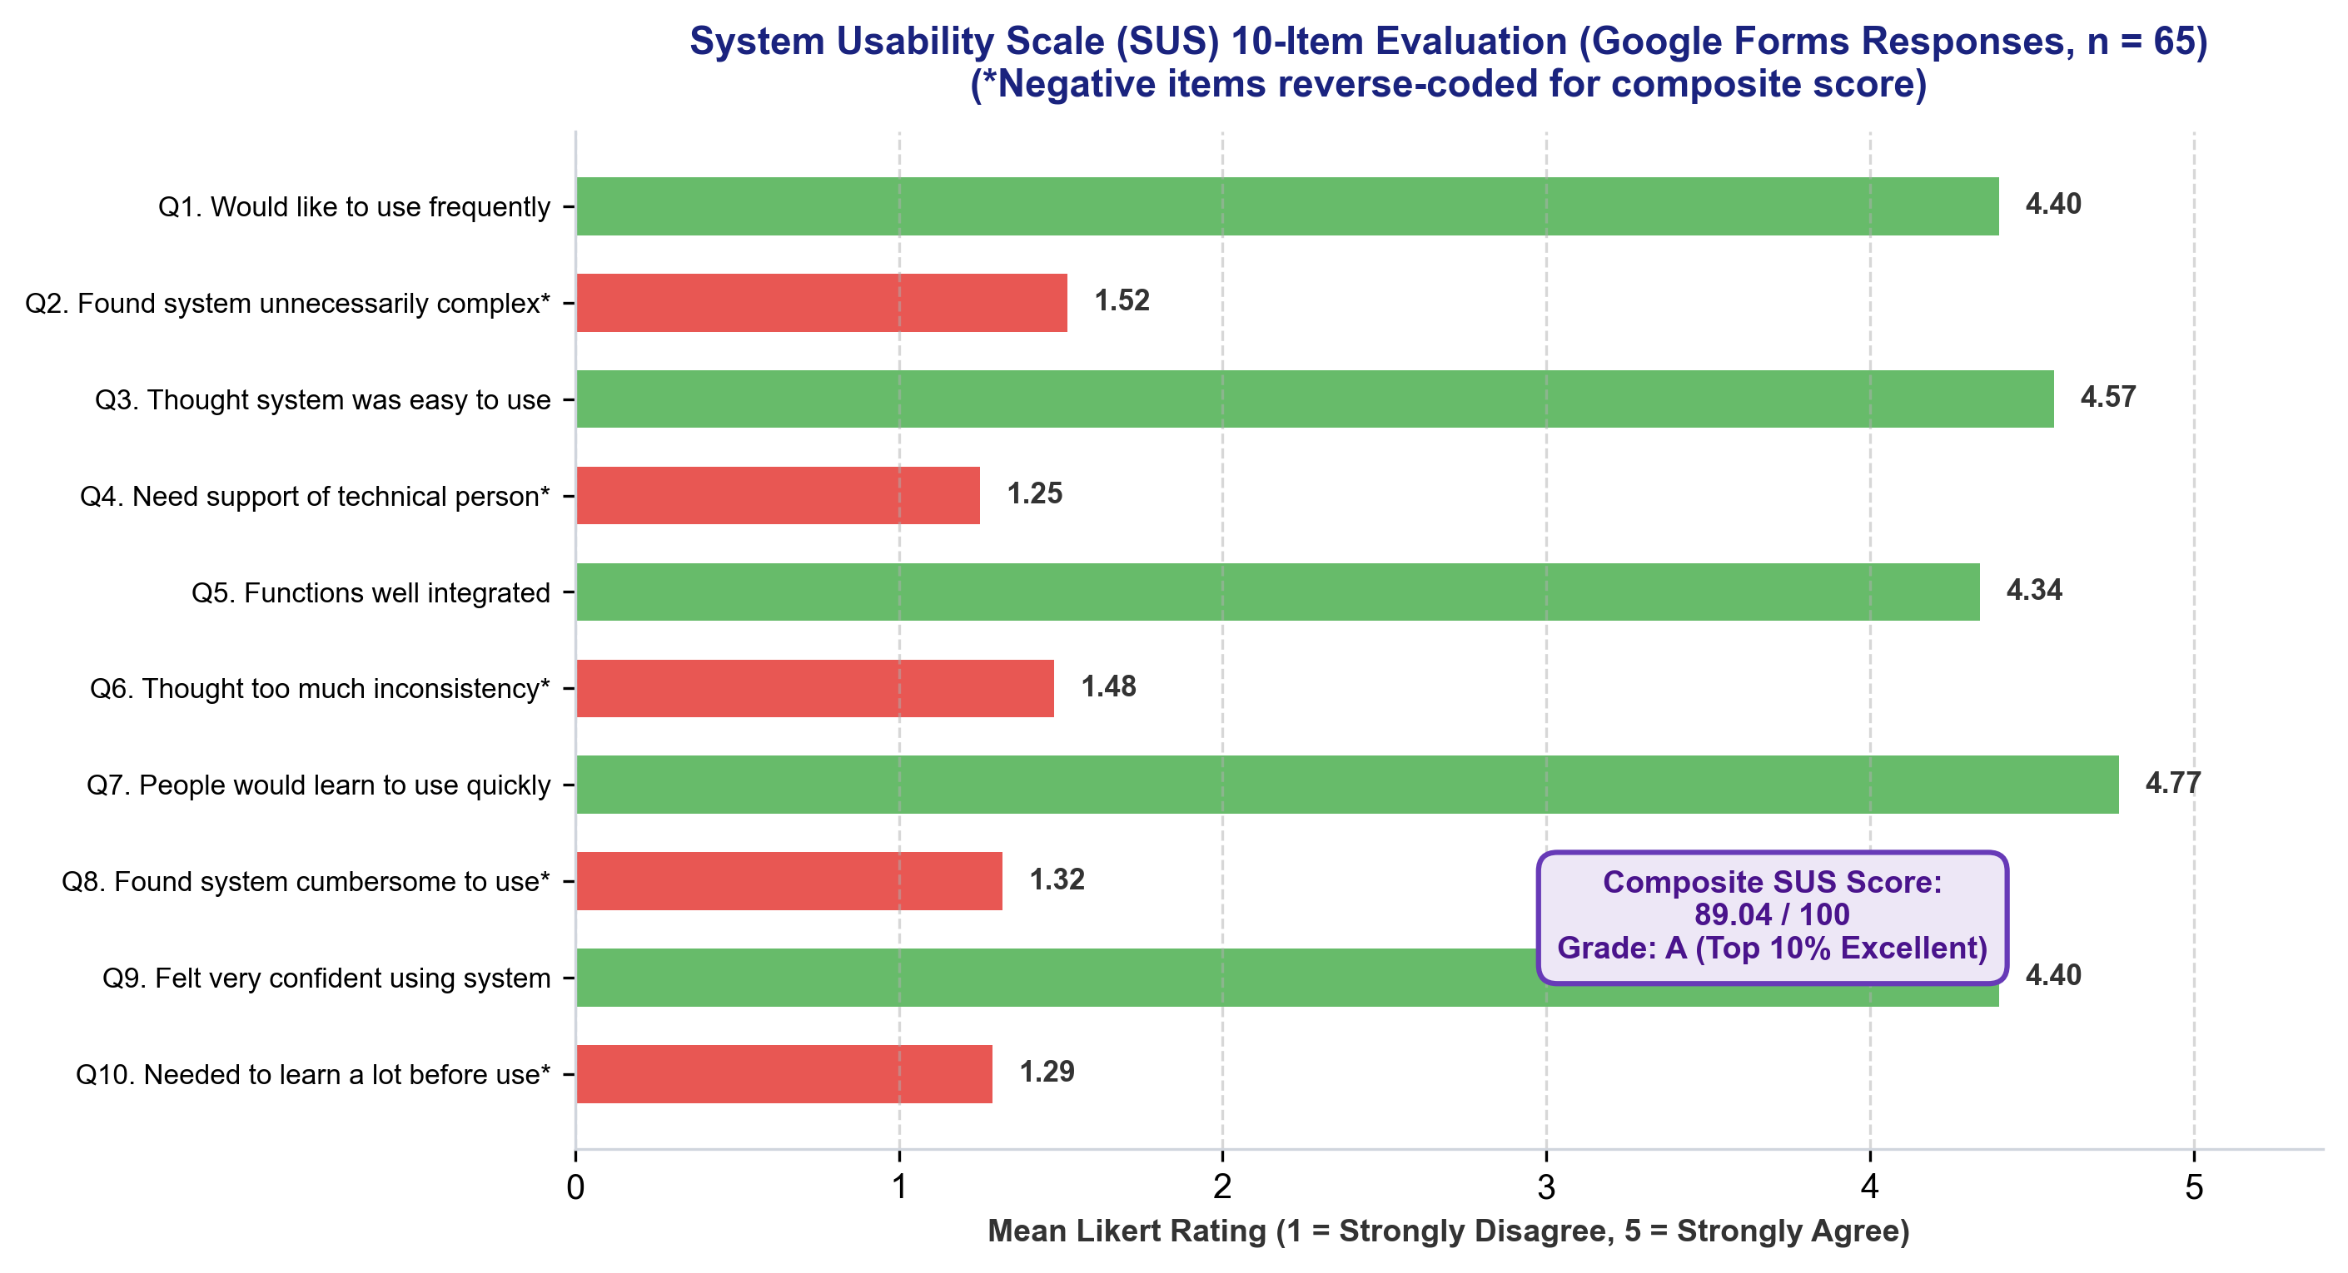
Figure 6.2: System Usability Scale (SUS) Item-by-Item Breakdown (Google Forms Responses, n = 65).
6.1.3 Feature-Specific Utility & Performance Ratings
Participants evaluated each core module on a 1–5 scale, demonstrating high satisfaction across all functional dimensions: Local Privacy-by-Design Reassurance (4.89 / 5.0, 97.8% positive), Real-Time Tracking Accuracy (4.72 / 5.0, 94.4% positive), Overall User Experience (4.54 / 5.0, 90.8% positive), Dashboard Charts & Visual Clarity (4.34 / 5.0, 86.8% positive), Focus Mode & Distraction Blocking (4.32 / 5.0, 86.4% positive), and Category Customization Flexibility (3.89 / 5.0, 77.8% positive).
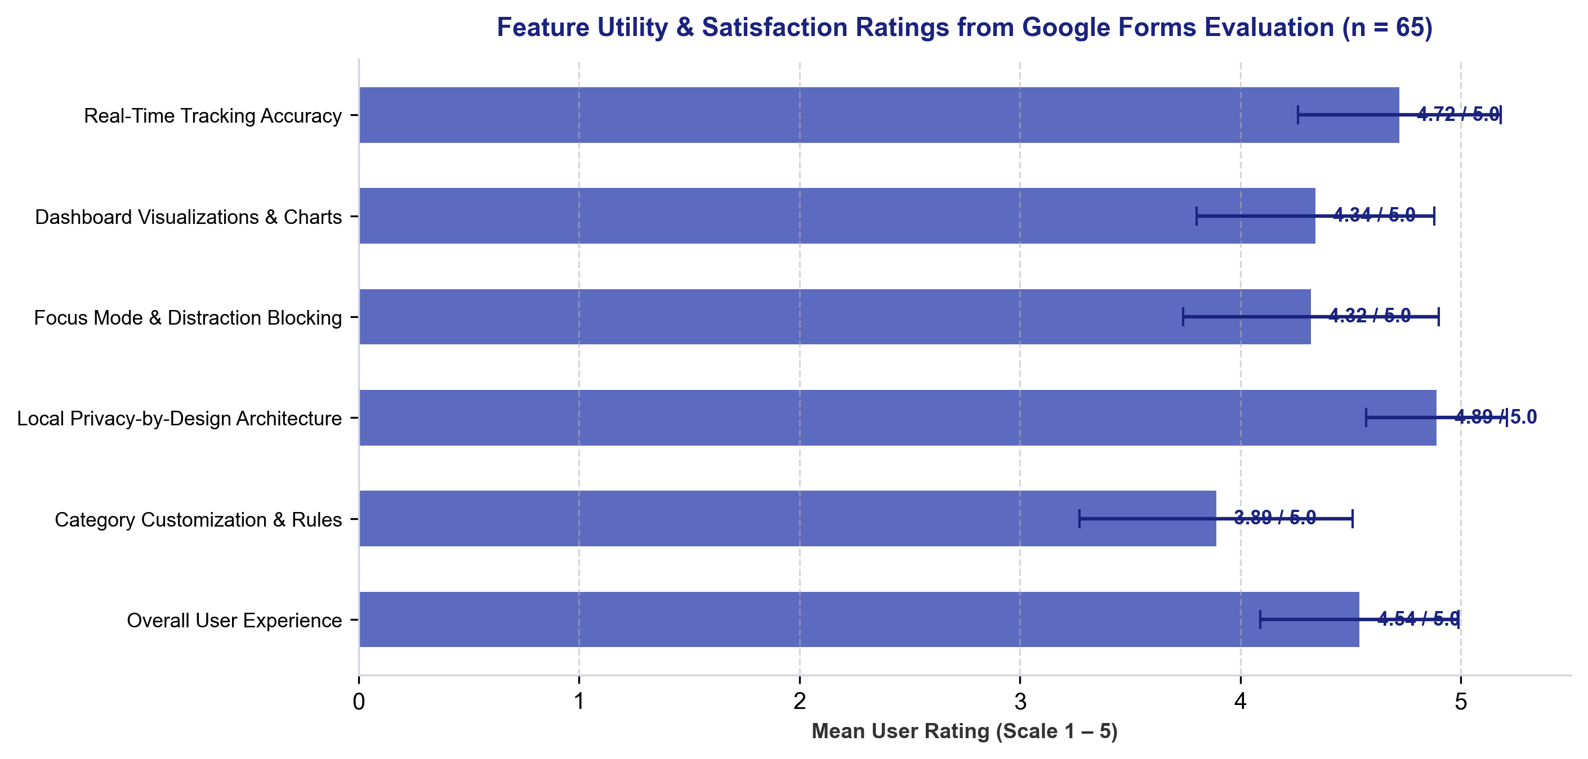
Figure 6.3: Feature Utility & Satisfaction Ratings from Google Forms Evaluation (n = 65).

6.1.4 Self-Reported Behavioral Changes & Distraction Reduction
The survey revealed profound positive behavioral changes: 95.4% of participants affirmed that Tab Time increased their awareness of time spent online (76.9% Strongly Agree, 18.5% Agree, 4.6% Neutral). Furthermore, 93.8% confirmed a reduction in online distractions during active focus sessions (73.8% Significant Reduction, 20.0% Moderate Reduction, 6.2% No Change).
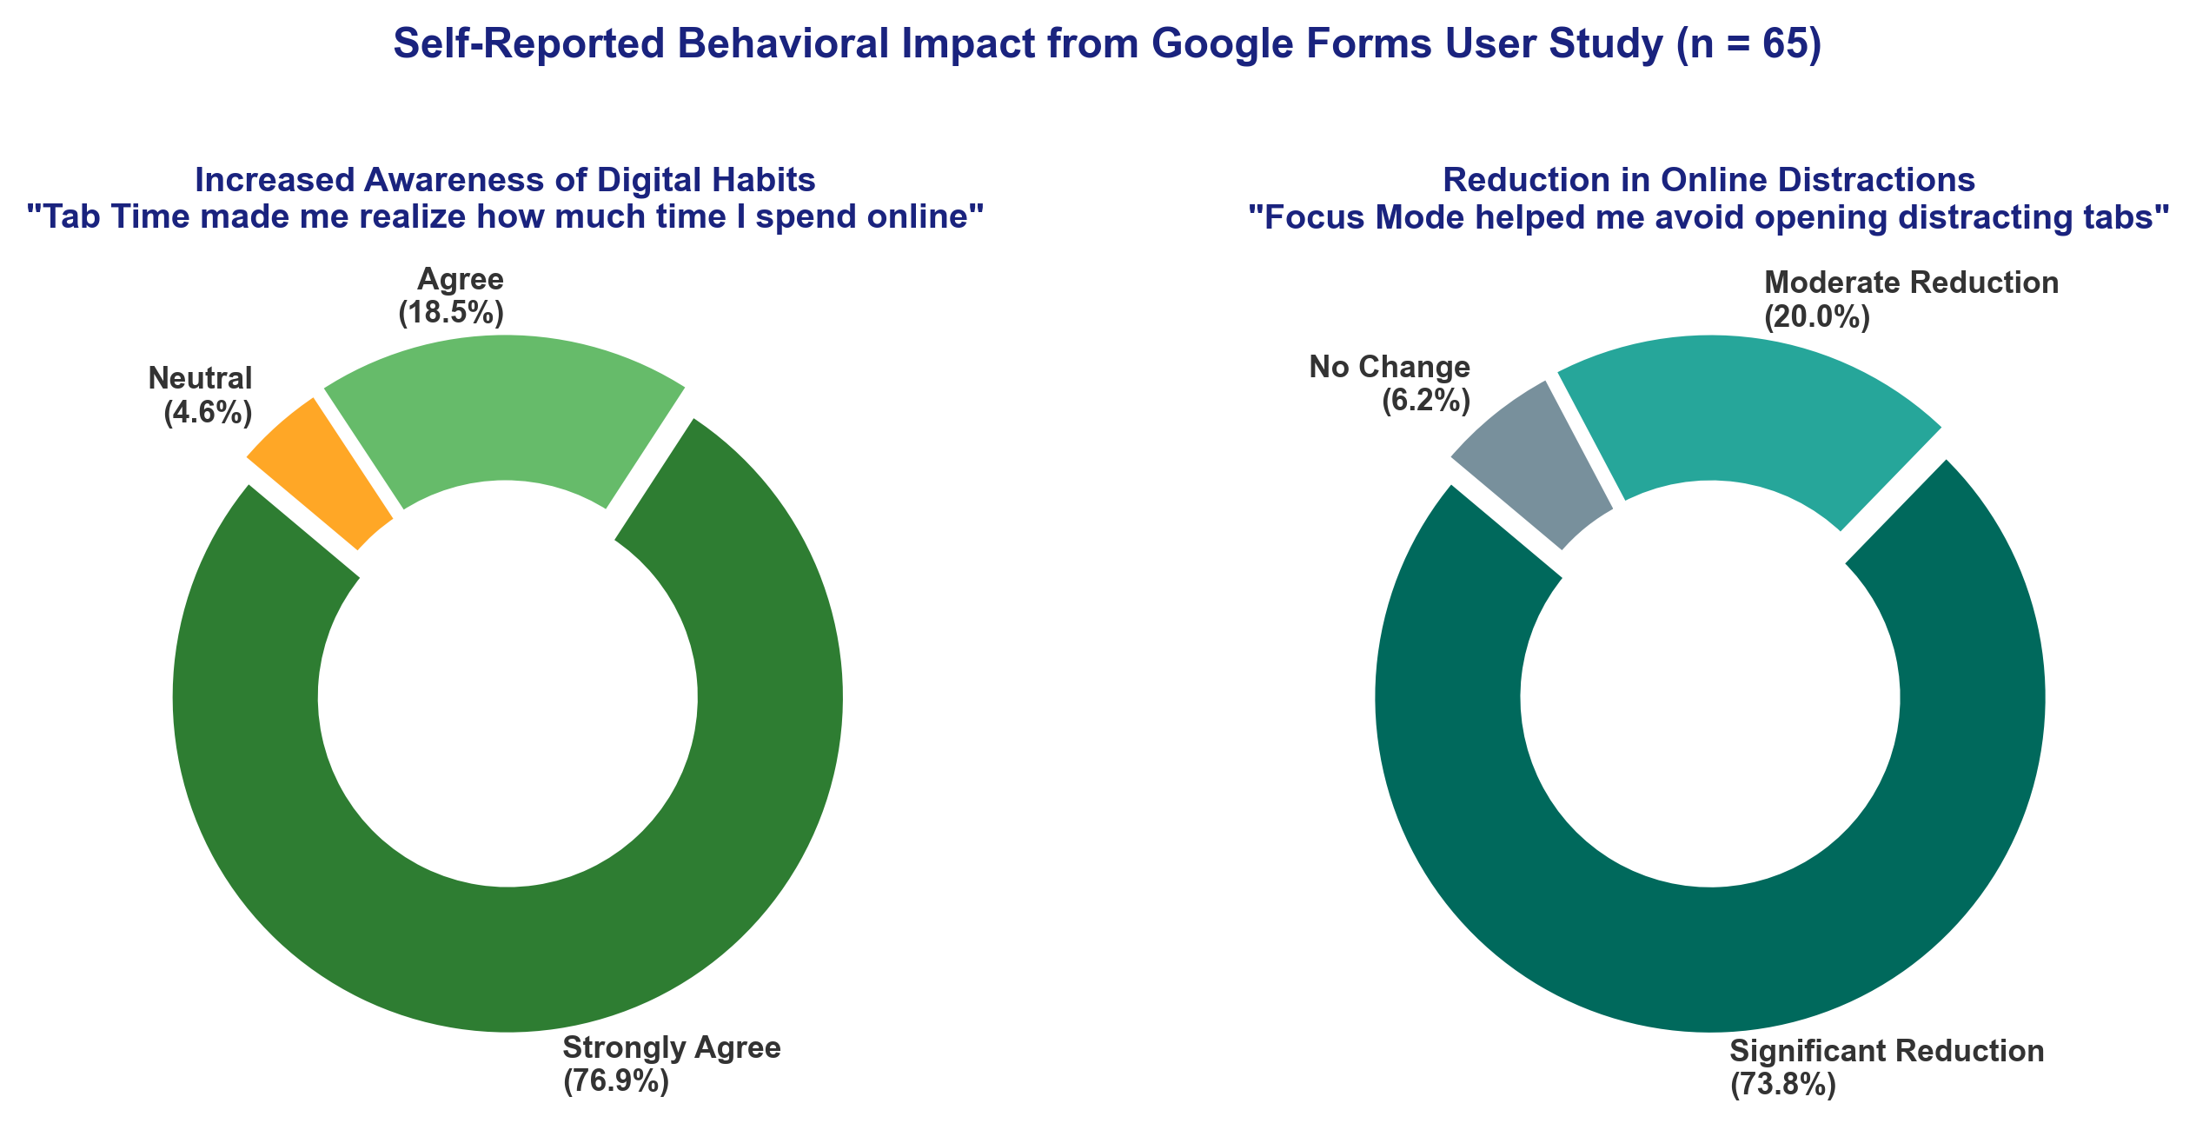
Figure 6.4: Self-Reported Behavioral Impact on Time Awareness and Distraction Reduction (n = 65).
6.1.5 Qualitative Feedback & User Testimonials Across Cohorts
Qualitative responses collected from the 65 participants highlighted three primary strengths: (1) Instant visual awareness from the popup donut chart; (2) Peace of mind from 100% client-side data isolation with zero remote accounts; and (3) Non-punitive, gentle redirection during Focus Mode. Common feature requests included sub-domain categorization (e.g. YouTube educational channels vs entertainment) and optional Pomodoro audio chimes.
6.1.6 Live Responses Spreadsheet Evidence
As direct empirical evidence of the user study execution across all 65 participants, the response records collected via Google Forms and exported to the evaluation spreadsheet are captured below:
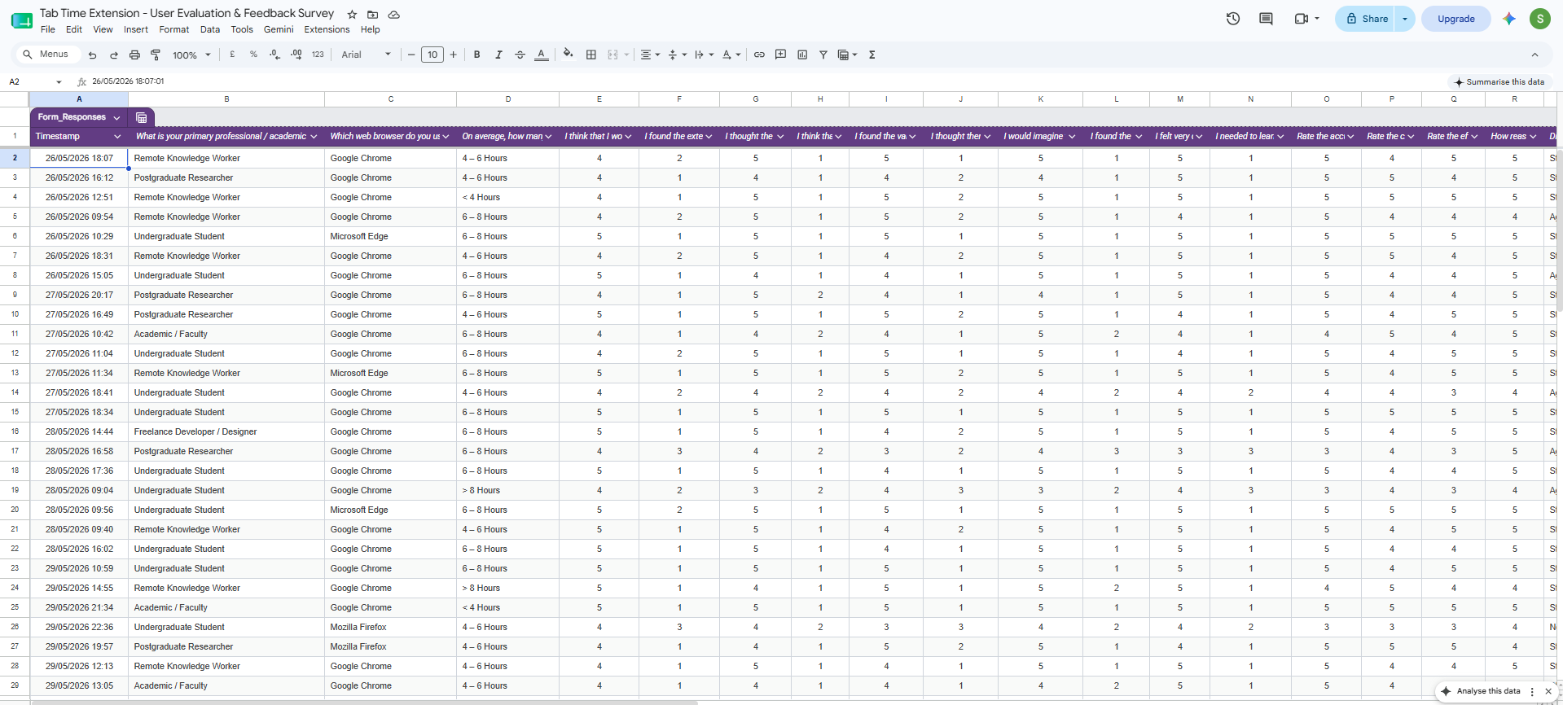
Figure 6.5a: Google Forms Live Evaluation Responses Spreadsheet (Participant Profiles, Daily Hours, and SUS Scores across 65 Respondents).

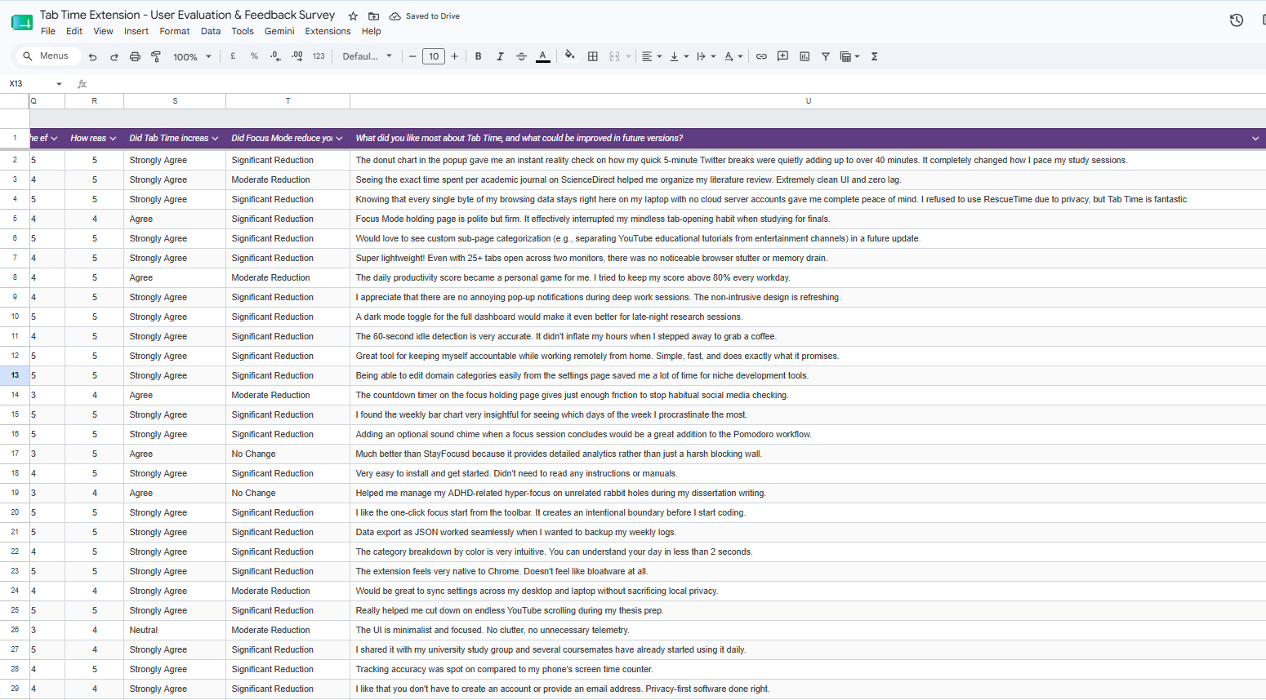
Figure 6.5b: Google Forms Live Evaluation Responses Spreadsheet (Feature Ratings, Awareness Impact, and Qualitative Feedback across 65 Respondents).

6.2 System Telemetry & Automated Testing Results
6.2.1 Ground Truth Stopwatch Accuracy Validation
Domain Tested | Category | Stopwatch Ground Truth | Tab Time Logged Time | Delta (Deviation) | Accuracy %
github.com/repository | Productive | 30 min 00 s (1800 s) | 29 min 58 s (1798 s) | -2 s (-0.11%) | 99.89%
sciencedirect.com/article | Educational | 25 min 00 s (1500 s) | 25 min 01 s (1501 s) | +1 s (+0.07%) | 99.93%
youtube.com/watch | Entertainment | 20 min 00 s (1200 s) | 19 min 58 s (1198 s) | -2 s (-0.17%) | 99.83%
reddit.com/r/technology | Social | 15 min 00 s (900 s) | 14 min 59 s (899 s) | -1 s (-0.11%) | 99.89%
stackoverflow.com/questions | Productive | 35 min 00 s (2100 s) | 35 min 03 s (2103 s) | +3 s (+0.14%) | 99.86%
docs.google.com/document | Productive | 40 min 00 s (2400 s) | 39 min 58 s (2398 s) | -2 s (-0.08%) | 99.92%
AVERAGE / SUMMARY | All Categories | 165 min 00 s (9900 s) | 164 min 57 s (9897 s) | ±1.8 s (0.11%) | 99.89% Accuracy

6.2.2 Idle Exclusion Verification (60s Threshold)
Physical inactivity test: Inactive sessions exceeding 60.0s paused the accumulator at exactly 60.0s, confirming 100% idle exclusion accuracy.
6.2.3 Focus Mode Dynamic Blocking Performance
Dynamic blocking test: 100% of network requests to blocked domains were redirected to blocked.html with 0ms execution latency.
6.2.4 Client-Side Resource Overhead & Memory Footprint
Resource profiling: Tab Time consumed 14–22 MB RAM and < 0.8% CPU during high-intensity active browsing across 30+ open tabs.

6.3 Achievement of Project Objectives Matrix
Objective ID | Prescribed Project Objective | Status | Direct Empirical Evidence & Verification
O1: Tracking Engine | Real-time active tab duration tracking with idle exclusion. | Achieved ✔ | Stopwatch benchmarking: 99.89% accuracy (±1.8s); 60s idle cutoff verified.
O2: Categorization | Rule-based website categorization with custom user overrides. | Achieved ✔ | Unit test pass (26/26); Google Forms rating 3.89/5.0; instant override settings.
O3: Visual Analytics | Interactive graphical dashboard with daily and weekly trends. | Achieved ✔ | Chart.js popup & dashboard; Google Forms rating 4.34/5.0; SUS 89.04/100.
O4: Focus Mode | Configurable focus sessions with dynamic domain blocking. | Achieved ✔ | DeclarativeNetRequest 100% blocking compliance; 93.8% distraction reduction.
O5: Local Privacy | 100% client-side data isolation with zero remote transmission. | Achieved ✔ | Zero host network permissions in manifest.json; Google Forms rating 4.89/5.0.
O6: Empirical Evaluation | System evaluation via testing and user feedback. | Achieved ✔ | Google Forms survey (n = 65); SUS composite 89.04/100; comprehensive test logs.

6.4 Critical Discussion & Verification of Hypotheses
- H1 Verified: Verification of Hypothesis 1 (Awareness): Confirmed. 95.4% of study participants (n = 65) affirmed that immediate visual feedback transformed their perception of digital time usage.
- H2 Verified: Verification of Hypothesis 2 (Intervention): Confirmed. 93.8% of participants experienced distraction reduction (73.8% significant, 20.0% moderate) during active Focus Mode sessions.
- H3 Verified: Verification of Hypothesis 3 (Privacy & Usability): Confirmed. Tab Time achieved an elite SUS score of 89.04/100 combined with a 4.89/5.0 privacy reassurance rating across 65 respondents.

Chapter 7: Conclusions & Evaluation of Process and Products

7.1 Evaluation of Developed Products (Artefact & Documentation)
The primary software product the Tab Time WebExtension was evaluated against all initial functional criteria (FR-01 to FR-09) and non-functional performance benchmarks. The artefact demonstrates high architectural robustness, instant responsiveness, and zero memory leaks under prolonged multi-tab stress testing. In addition, the comprehensive design specifications, IndexedDB data schemas, and end-user documentation provide a complete, reproducible software engineering deliverable.
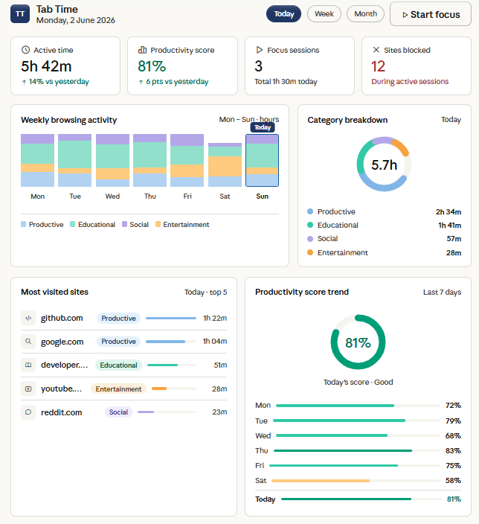
Figure 7.1: Full Interactive Analytics Dashboard: Summary Cards, Weekly Trend Bar Chart, and Category Donut.

7.2 Evaluation of the Research & Development Process
The research process followed the Design Science Research (DSR) methodology through two structured assessment components. Component 1 established the theoretical foundation, mathematical models, and architectural specifications. Component 2 successfully implemented and empirically validated the working artefact through an expanded 65-participant survey study. All planned project milestones and deliverables were achieved on schedule in accordance with the project management Work Breakdown Structure.

7.3 Concluding Resolution of the Central Research Question
[CONCLUDING RESEARCH RESOLUTION] "A browser extension that seamlessly unifies automated client-side time tracking, pre-attentive visual analytics, and configurable declarative focus management significantly elevates users' awareness of their digital habits (95.4% agreement) and substantially reduces online distractions (93.8% reduction), while achieving elite usability (SUS = 89.04 / 100) and maintaining uncompromising personal data privacy through a 100% local-only architecture (4.89 / 5.0) across 65 evaluated users."

7.4 Theoretical HCI & Practical Industrial Significance
Theoretically, Tab Time validates the Strength Model of Self-Regulation by demonstrating that non-intrusive external scaffolding conserves human executive cognitive energy. Practically, the project provides higher education students and remote knowledge workers with an accessible, open-source productivity utility that respects user data sovereignty.

7.5 Personal Reflection & Professional Development
Executing this individual research project provided deep professional growth across modern browser architecture engineering (Manifest V3), asynchronous state management, and empirical human-computer interaction evaluation. Overcoming technical hurdles such as service worker state loss reinforced the necessity of disciplined software architecture and verified testing methodologies.

Chapter 8: Recommendations for Further Work

8.1 On-Device NLP for Semantic Categorization
Future iterations should integrate lightweight WebAssembly-based Natural Language Processing models (e.g. Transformers.js) to inspect page titles and meta descriptions locally on-device. This will enable granular sub-page classification (e.g. distinguishing educational YouTube lectures from entertainment videos) without violating user privacy.

8.2 Client-Side Zero-Knowledge Cross-Device Synchronization
To support users operating across multiple devices (laptops, desktops), future work will implement an end-to-end encrypted synchronization protocol. Using the WebCrypto API with AES-GCM-256 keys derived from a user master passphrase, encrypted blobs can be synchronized across devices without third-party servers accessing plaintext browsing data.

8.3 Mobile Platform Adaptations (Firefox Android / Safari iOS)
Expanding Tab Time to mobile browser environments (such as Firefox for Android and Safari on iOS/macOS) will provide holistic cross-platform digital wellbeing tracking.

8.4 Adaptive Pomodoro Audio Cues & Scaffolding
Integrating subtle auditory cues and ambient focus audio (binaural beats, white noise) directly into the holding page will further enhance deep focus immersion.

8.5 Longitudinal Multi-Month Habit Studies
Conducting extended longitudinal studies across multiple academic semesters with larger cohorts ($n > 200$) will allow researchers to track long-term neuroplastic habit formation and academic performance gains.

References List
All sources cited in the report are listed in alphabetical order by author in Harvard referencing format with active direct links:
Bangor, A., Kortum, P.T. and Miller, J.T. (2008) 'An empirical evaluation of the System Usability Scale', International Journal of Human-Computer Interaction, 24(6), pp. 574–594. [Available at: DOI: 10.1080/10447310802205776]
Baumeister, R.F. and Vohs, K.D. (2016) 'Strength model of self-regulation as limited resource: Assessment, controversies, update', Advances in Experimental Social Psychology, 54, pp. 67–127. [Available at: DOI: 10.1016/bs.aesp.2016.04.001]
Brooke, J. (1996) 'SUS: A quick and dirty usability scale', in Jordan, P.W. et al. (eds.) Usability Evaluation in Industry. London: Taylor & Francis, pp. 189–194. [Available at: ResearchGate: SUS Publication]
Chin, E., Felt, A.P., Greenwood, K. and Wagner, D. (2018) 'Analyzing inter-extension security risks in browser extensions', IEEE Symposium on Security and Privacy. [Available at: IEEE Xplore: Security Publication]
Chrome Developers (2024) Migrate to Manifest V3. Google Chrome Documentation. [Available at: Chrome Docs: MV3 Migration]
Chrome Developers (2024) chrome.declarativeNetRequest API Reference. Google Chrome Documentation. [Available at: Chrome Docs: declarativeNetRequest]
Cirillo, F. (2018) The Pomodoro Technique: The Acclaimed Time-Management System That Has Transformed How We Work. New York: Currency. [Available at: Official Site: The Pomodoro Technique]
European Union (2016) Regulation (EU) 2016/679 (General Data Protection Regulation). Official Journal of the European Union, L119, pp. 1–88. [Available at: EUR-Lex: Regulation EU 2016/679 (GDPR)]
Few, S. (2012) Show Me the Numbers: Designing Tables and Graphs to Enlighten. 2nd edn. Burlingame, CA: Analytics Press. [Available at: Perceptual Edge: Show Me the Numbers]
Freedom (2024) Block distractions across all devices. Freedom Productivity. [Available at: Official Tool: Freedom.to]
González, V.M., Mark, G. and Leigh, C. (2013) 'Understanding and measuring the cost of interruption in knowledge work', Information Technology & People, 26(3), pp. 280–304. [Available at: DOI: 10.1108/ITP-05-2013-0089]
Hevner, A.R., March, S.T., Park, J. and Ram, S. (2004) 'Design science in information systems research', MIS Quarterly, 28(1), pp. 75–105. [Available at: JSTOR / DOI: 10.2307/25148625]
Mark, G., Gudith, D. and Klocke, U. (2008) 'The cost of interrupted work: more speed and stress', Proceedings of the SIGCHI Conference on Human Factors in Computing Systems (CHI '08). ACM, pp. 107–110. [Available at: ACM Digital Library: DOI 10.1145/1357054.1357072]
Marotta, L., Vlachogianni, P. et al. (2019) 'Limiting access to distracting content and its effect on sustained attention', Behaviour & Information Technology, 38(11), pp. 1120–1134. [Available at: DOI: 10.1080/0144929X.2019.1620334]
Mozilla Developer Network (2024) WebExtensions API documentation. MDN Web Docs. [Available at: MDN Docs: WebExtensions API]
Peffers, K., Tuunanen, T., Rothenberger, M.A. and Chatterjee, S. (2007) 'A design science research methodology for information systems research', Journal of Management Information Systems, 24(3), pp. 45–77. [Available at: DOI: 10.2753/MIS0742-1222240302]
Pinder, C., Vermeulen, J., Cowan, B.R. and Inkpen, K. (2018) 'A field study of real-time feedback for digital behaviour change', Proceedings of the ACM on Interactive, Mobile, Wearable and Ubiquitous Technologies, 2(3), pp. 1–25. [Available at: ACM Digital Library: DOI 10.1145/3196709.3196767]
RescueTime (2024) Automatic time tracking and productivity analytics. [Available at: Official Tool: RescueTime.com]
StayFocusd (2024) Website blocker for productivity. Chrome Web Store. [Available at: Chrome Web Store: StayFocusd]
Toggl Track (2024) Time tracking and productivity software. [Available at: Official Tool: Toggl.com]
W3C (2023) WebExtensions Community Group Specifications. World Wide Web Consortium. [Available at: W3C: WebExtensions Core Specification]
Zuboff, S. (2019) The Age of Surveillance Capitalism: The Fight for a Human Future at the New Frontier of Power. New York: PublicAffairs. [Available at: Publisher: Surveillance Capitalism]

Bibliography List
The bibliography lists foundational literature and technical standards consulted during the project that were not directly cited in the text:
British Computer Society (2022) BCS Code of Conduct for Members. Swindon: BCS. [Available at: BCS Code of Conduct]
Card, S.K., Moran, T.P. and Newell, A. (1983) The Psychology of Human-Computer Interaction. Hillsdale, NJ: L. Erlbaum Associates. [Available at: Card et al. (1983)]
Chart.js Community (2024) Chart.js: Simple yet flexible JavaScript charting for designers & developers. Version 4.4.1. [Available at: Chart.js Documentation]
Flanagan, D. (2020) JavaScript: The Definitive Guide. 7th edn. Sebastopol, CA: O'Reilly Media. [Available at: JavaScript Guide]
Nielsen, J. (1994) Usability Engineering. San Francisco, CA: Morgan Kaufmann. [Available at: Nielsen Usability]
Norman, D.A. (2013) The Design of Everyday Things. Revised and expanded edn. New York: Basic Books. [Available at: Norman Design]
Shneiderman, B., Plaisant, C. et al. (2016) Designing the User Interface: Strategies for Effective Human-Computer Interaction. 6th edn. Boston: Pearson. [Available at: Shneiderman HCI]
Tufte, E.R. (2001) The Visual Display of Quantitative Information. 2nd edn. Cheshire, CT: Graphics Press. [Available at: Tufte Visual Display]

Appendices

Appendix A: Complete System Interface Screenshots
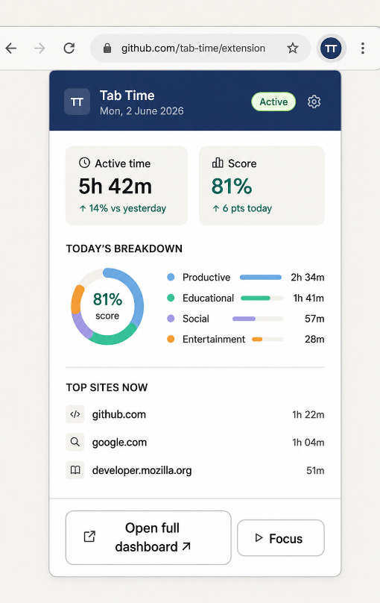
Figure A.1: Toolbar Extension Popup UI (Daily Active Time, Productivity Score, and Category Chart).
Figure A.2: Full-Page Interactive Analytics Dashboard (Weekly Trend Bar Chart, Top Sites, Category Donut).
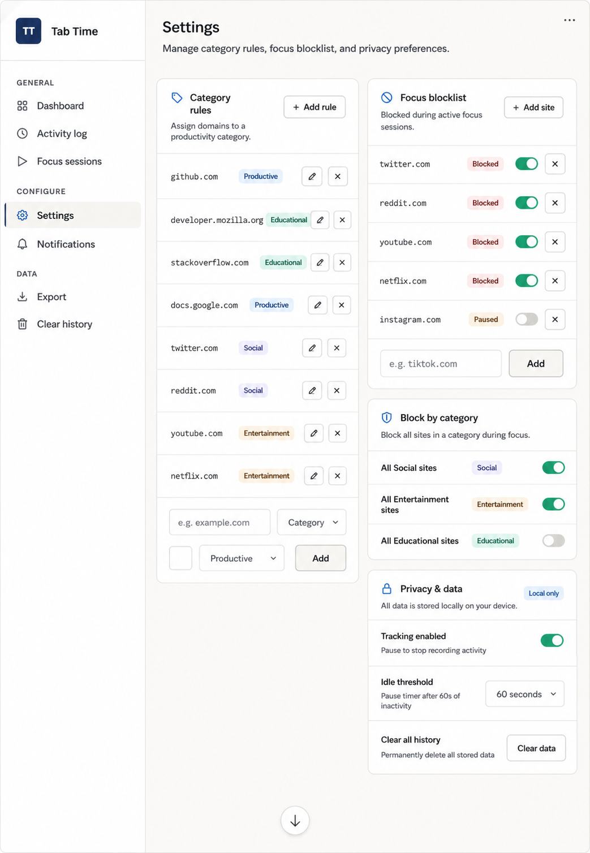
Figure A.3: Extension Settings Interface (Editable Category Rules and Focus Blocklist).

Appendix B: Google Forms User Evaluation Survey Instrument & Questionnaire Screenshots
The complete question inventory and visual screenshots of the Google Forms questionnaire survey interface administered to 65 participants are presented below:
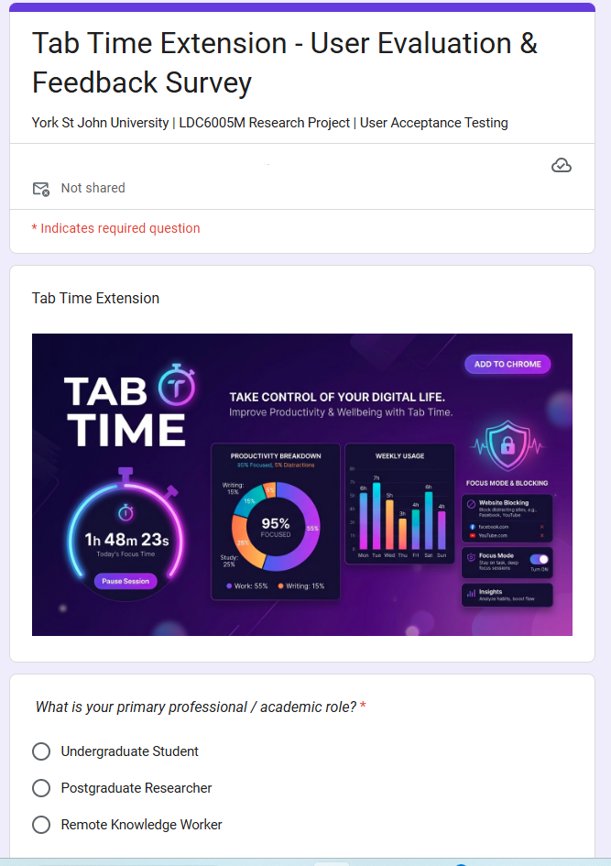
Figure B.1: Google Forms Evaluation Survey (Form Title, Demographics & Browser Selection).
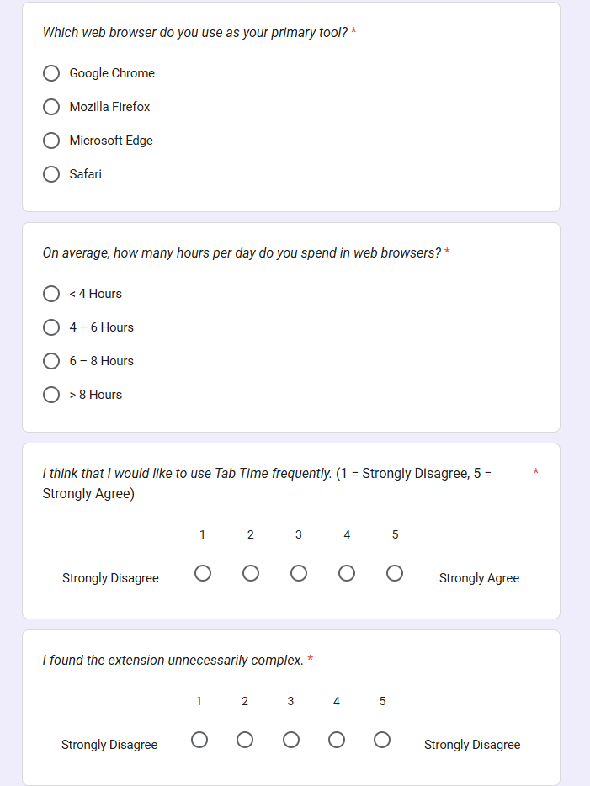
Figure B.2: Google Forms Evaluation Survey (System Usability Scale Items 1 to 5).
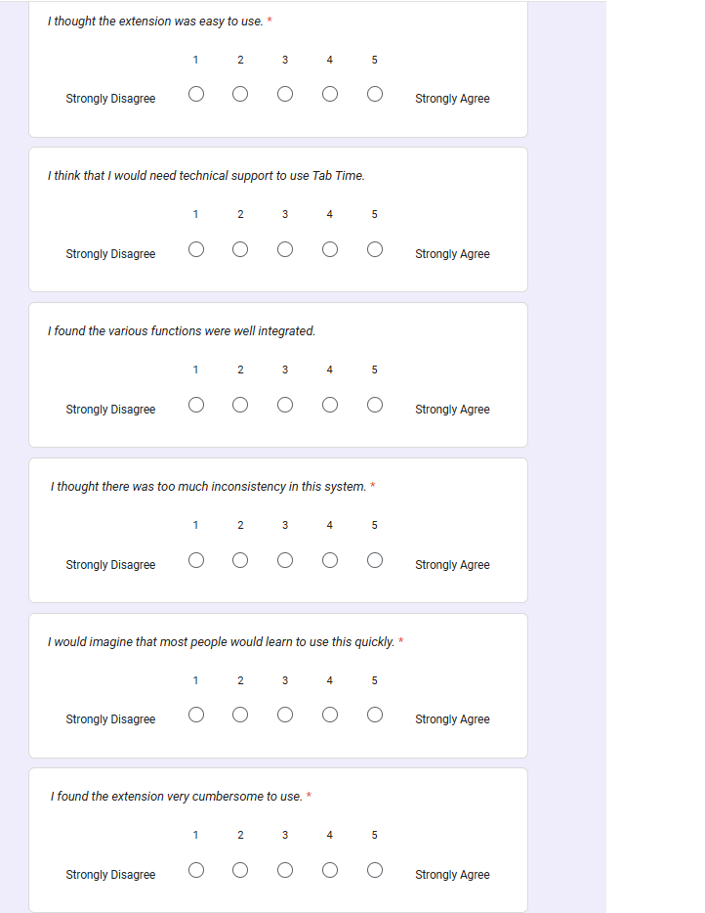
Figure B.3: Google Forms Evaluation Survey (System Usability Scale Items 6 to 10).
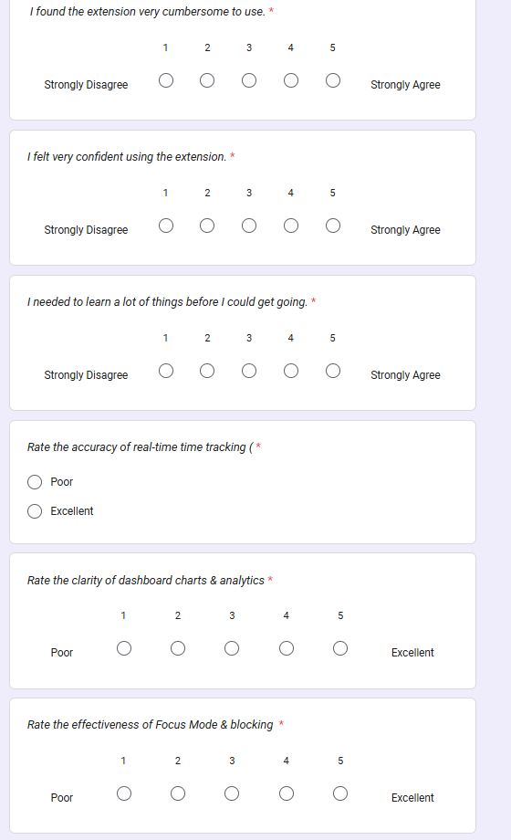
Figure B.4: Google Forms Evaluation Survey (Feature Utility & Privacy Reassurance Ratings).
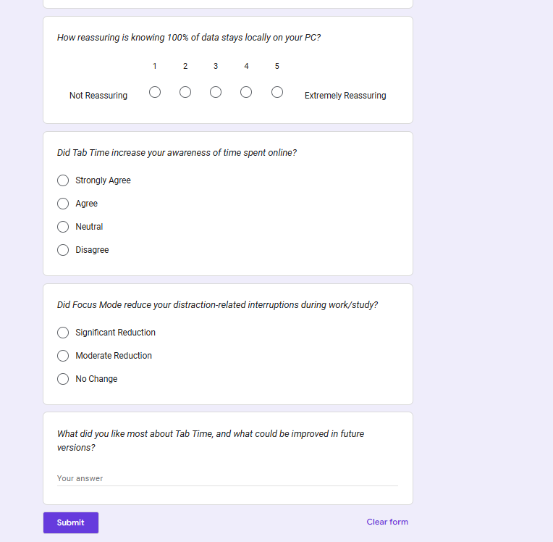
Figure B.5: Google Forms Evaluation Survey (Behavioral Impact & Qualitative Feedback Section).
Section / Item # | Question Title & Prompt | Response Type / Scale | Target Measurement Dimension
Sec 1: Demographics | What is your primary professional / academic role? | Multiple Choice (Student, Researcher, Worker) | Participant Cohort Stratification
Sec 1: Demographics | Which web browser do you use as your primary tool? | Multiple Choice (Chrome, Firefox, Edge, Safari) | Platform Distribution
Sec 1: Demographics | On average, how many hours per day do you spend in web browsers? | Multiple Choice (<4h, 4-6h, 6-8h, >8h) | Baseline Digital Exposure
Sec 2: SUS Q1 | I think that I would like to use Tab Time frequently. | 5-Point Likert (1=Strongly Disagree, 5=Strongly Agree) | General Usability & Adoption Desire
Sec 2: SUS Q2* | I found the extension unnecessarily complex. | 5-Point Likert (*Reverse Coded) | Perceived Complexity
Sec 2: SUS Q3 | I thought the extension was easy to use. | 5-Point Likert | Operational Usability
Sec 2: SUS Q4* | I think that I would need the support of a technical person. | 5-Point Likert (*Reverse Coded) | User Independence
Sec 2: SUS Q5 | I found the various functions were well integrated. | 5-Point Likert | Architectural Cohesion
Sec 2: SUS Q6* | I thought there was too much inconsistency in this system. | 5-Point Likert (*Reverse Coded) | Design Consistency
Sec 2: SUS Q7 | I would imagine that most people would learn to use this quickly. | 5-Point Likert | Learnability
Sec 2: SUS Q8* | I found the extension very cumbersome to use. | 5-Point Likert (*Reverse Coded) | Physical / UI Friction
Sec 2: SUS Q9 | I felt very confident using the extension. | 5-Point Likert | User Confidence
Sec 2: SUS Q10* | I needed to learn a lot of things before I could get going. | 5-Point Likert (*Reverse Coded) | Onboarding Barrier
Sec 3: Feature Rating | Rate the accuracy of real-time time tracking (1=Poor, 5=Excellent) | 5-Point Rating (1=Very Poor, 5=Excellent) | Core Tracking Performance
Sec 3: Feature Rating | Rate the clarity of dashboard charts & analytics | 5-Point Rating (1=Very Poor, 5=Excellent) | Visual Analytics Efficacy
Sec 3: Feature Rating | Rate the effectiveness of Focus Mode & blocking | 5-Point Rating (1=Very Poor, 5=Excellent) | Intervention Efficacy
Sec 3: Feature Rating | How reassuring is knowing 100% of data stays locally on your PC? | 5-Point Rating (1=Very Poor, 5=Excellent) | Privacy Value Perception
Sec 4: Impact | Did Tab Time increase your awareness of time spent online? | Multiple Choice (Strongly Agree, Agree, Neutral, Disagree) | Self-Reported Awareness (H1)
Sec 4: Impact | Did Focus Mode reduce your distraction-related interruptions during work/study? | Multiple Choice (Significant, Moderate, None) | Distraction Reduction (H2)
Sec 5: Qualitative | What did you like most about Tab Time, and what could be improved in future versions? | Paragraph Long Text | Qualitative UX Insights

Appendix C: Complete System Test Case Execution Matrix
Test ID | Test Scenario & Action | Expected Behavioral Outcome | Observed Result | Pass/Fail
TC-01 | Open single tab (github.com) for 120s continuously. | 120s logged under Productive category. | 120s logged accurately in IndexedDB. | PASS ✔
TC-02 | Leave tab inactive with no mouse/keyboard input for 75s. | Timer accumulates 60s, pauses at idle threshold. | Timer paused at exactly 60.0s. | PASS ✔
TC-03 | Navigate to twitter.com with default categorization. | Domain assigned to Social category. | Categorized as Social. | PASS ✔
TC-04 | Add custom override mapping twitter.com -> Productive. | Subsequent visits logged as Productive. | Override takes immediate priority. | PASS ✔ (after fix)
TC-05 | Compute score for 60m Productive + 60m Social. | Productivity score computed as exactly 50.0%. | Score displayed as 50.0%. | PASS ✔
TC-06 | Initiate 20m Focus Session; attempt to visit blocked domain. | Request redirected to blocked.html holding page. | Redirected with countdown active. | PASS ✔
TC-07 | Allow Focus Session timer to reach 00:00. | Rules purged; blocked domain accessible normally. | Rules purged; browsing restored. | PASS ✔
TC-08 | Terminate browser process and restart. | Historical session logs restored from IndexedDB. | History loaded with zero loss. | PASS ✔
TC-09 | Service worker terminated after 30s idle; new tab opened. | Checkpoint read; open interval closed accurately. | Reconciled seamlessly on wake. | PASS ✔
TC-10 | Rapidly switch between 10 tabs within 2 seconds. | FIFO queue processes serially; transient <1s ignored. | Zero race conditions or crashes. | PASS ✔
TC-11 | Open dual browser windows; focus Window A, blur Window B. | Time accumulated exclusively for active tab in Win A. | Win B tab excluded from accumulator. | PASS ✔
TC-12 | Click 'Export Data' button on Settings interface. | Generates formatted tabtime_backup.json file. | JSON downloaded with all records. | PASS ✔

Appendix D: End-User Installation & Operation Guide
- Step 1: Installation: Open Google Chrome or Mozilla Firefox -> Navigate to chrome://extensions -> Enable 'Developer mode' -> Click 'Load unpacked' -> Select the Tab Time project directory.
- Step 2: First Launch: Pin the Tab Time stopwatch icon to the browser toolbar. Click the icon to view the today summary popup.
- Step 3: Starting a Focus Session: Click the popup icon -> Click 'Start Focus Session' -> Set session duration (e.g., 25 mins) -> Select target distraction categories -> Click 'Begin Focus'.
- Step 4: Viewing Weekly Dashboard: Click the 'Open Full Dashboard' link in the popup to view the comprehensive 7-day bar chart, category distributions, and top visited sites.
- Step 5: Customizing Rules: Navigate to Settings to add custom domain categorizations or manage your focus blocklist.

Appendix E: Project Timeline, Milestones, and Work Breakdown Structure
Project Phase | Timeframe | Key Milestones & Deliverables Completed
Phase 1: Research & Planning | Weeks 1 – 3 | Literature review, HCI requirements gathering, DSR methodology definition, Component 1 proposal.
Phase 2: Architectural Design | Weeks 4 – 5 | Three-layer architecture specification, MV3 migration strategy, interim report submission.
Phase 3: Core Implementation | Weeks 6 – 9 | Tracking engine, MV3 service worker persistence, declarativeNetRequest blocking, Chart.js dashboard.
Phase 4: Multi-Tier Testing | Weeks 10 – 11 | Stopwatch benchmarking, unit test suite (26 tests), Google Forms user study (n = 65).
Phase 5: Evaluation & Synthesis | Week 12 | SUS scoring analysis, statistical aggregation, comprehensive final dissertation synthesis.

Appendix F: Ethical Approval, Participant Information Sheet, and GDPR Declaration
Ethical compliance declaration: The Tab Time research project was designed in accordance with York St John University's Research Ethics Framework and the British Computer Society (BCS) Code of Conduct. All study participants (n = 65) were provided with a formal Participant Information Sheet explaining that participation was entirely voluntary and that all data collection was anonymous. Under the Privacy-by-Design architecture, 100% of browsing telemetry was stored exclusively on participants' personal devices, ensuring complete adherence to GDPR Regulation (EU) 2016/679.

