TECHNICAL & STRATEGIC PROJECT PROPOSAL
Next-Generation King Coconut Export & B2B Web Platform
Engineered with Modern MERN Stack (MongoDB, Express.js, React.js, Node.js)

Prepared For: | Executive Stakeholders & Commercial Export Team
Project Scope: | King Coconut Product Detail Showcase, B2B RFQ Portal & Custom MERN Web Application
Technology Stack: | MERN Architecture (React, Node.js, Express, MongoDB Atlas, Tailwind CSS, Redis, Cloudinary)
Document Status & Date: | Official Client Proposal | Version 1.0 (Commercial in Confidence)

1. Executive Summary & Strategic Vision
Sri Lankan King Coconut (Cocos nucifera var. aurantiaca), known locally as 'Thembili', is celebrated worldwide as nature's purest isotonic beverage and a premium natural superfood. With skyrocketing global demand across Europe, the Middle East, North America, and East Asia for organic, nutrient-dense, and unadulterated hydration beverages, there is an unprecedented commercial opportunity to establish a market-leading digital export gateway.
This proposal defines the complete architectural, design, and functional blueprint for developing a high-performance, custom web application built entirely on the modern MERN Stack (MongoDB, Express.js, React.js, and Node.js). While taking functional inspiration from leading Sri Lankan agricultural export websites such as impexlanka.lk, our proposed solution delivers an entirely bespoke, luxury tropical aesthetic, fast single-page application (SPA) responsiveness, an interactive B2B Request for Quote (RFQ) engine, interactive product specification tools, farm-to-shipment traceability, and a centralized enterprise back-office management dashboard.
Strategic Project Mission
Key Objective: To build a digital flagship platform that elevates King Coconut from a generic commodity to a luxury, certified, health-forward Sri Lankan export powerhouse—capturing high-value B2B buyer inquiries, establishing institutional credibility, and automating international sales lead pipelines.

2. Reference Platform Audit (Other Websites) vs. Proposed MERN Solution
A rigorous functional and structural audit of the benchmark reference website (impexlanka.lk) was conducted to map all core functions and identify critical opportunities for technical, aesthetic, and functional superiority.
2.1 Reference Website Functional Breakdown
- Navigation & Layout: Standard WordPress multi-page layout with basic top navbar, mobile off-canvas drawer, search modal, and footer widget grid.
- Content Structure: Home, Who We Are, Products (King Coconut, Fresh Fruits, Fresh Vegetables, Organic Desiccated Coconut), Blog, and Contact.
- King Coconut Details: Static text explaining hydration benefits, natural electrolyte content, vitamin C, potassium, and origin in Sri Lanka.
- Inquiry & Lead Capture: Generic WordPress contact form (WPForms) collecting Name, Email, Phone, Product dropdown, and Message.
- Certifications & Trust: Static display of accreditation logos (CDA, EDB, Organic, ISO) with limited interactive depth.
- Visual Aesthetics: Generic dark-themed template built on Elementor/Blocksy with stock imagery and standard typography.
2.2 Strategic Value Comparison: Reference vs. Custom MERN Stack
Platform Feature | Reference Site (impexlanka.lk) | Proposed Custom MERN Solution
Architecture & Tech | Monolithic WordPress PHP, heavy plugin overhead, slow page loads | Decoupled MERN Stack (React SPA frontend + Node.js/Express API + MongoDB Atlas)
Design & Branding | Generic dark template, standard Elementor styling, basic layout | Bespoke 'Tropical Ceylon Luxury' design system, smooth micro-interactions & modern UI
Product Showcase | Static image & descriptive text paragraphs with basic bullets | Eye catching nut view, live Brix sweetness index, electrolyte radar chart & spec sheets
B2B RFQ & Inquiries | Simple contact form with text fields and email forwarding | Multi-step B2B RFQ builder with pallet/container calculator, Incoterms & automated PDF quote
Traceability & Trust | Static certification logo grid without verifiable data | Interactive harvest-to-export cold-chain journey timeline and compliance verification drawer
Admin Control & CRM | Standard WordPress WP-Admin with cluttered plugin menus | Dedicated, secure, role-based MERN Admin Portal for managing leads, products, content & analytics

3. Brand Identity & UI/UX Design Strategy
To decisively stand out from existing exporters, the new web platform will embody a distinct 'Tropical Ceylon Luxury & Pure Organic Heritage' design philosophy. This aesthetic blends Sri Lanka’s lush natural agricultural terroir with minimalist, modern international corporate design.
3.1 Color Palette & Visual Architecture
- Primary Brand Emerald (#064E3B): Evoking the pristine organic coconut plantations and fertile agricultural valleys of Sri Lanka.
- Sunlit Amber Gold (#D97706 / #F59E0B): Reflecting the distinctive golden orange hue of premium Ceylon Thembili husks and rich tropical sunshine.
- Deep Slate Navy (#0F172A): Providing crisp contrast, executive authority, and sleek modern typography readability.
- Warm Alabaster (#F8FAFC / #FFFFFF): Ultra-clean background surfaces that allow high-resolution product photography and data cards to shine.
3.2 Typography & Interactive Feel
- Headings & Editorial Hierarchy: Playfair Display / Plus Jakarta Sans for refined, editorial authority.
- Body & Technical Data: Inter / Segoe UI for crisp readability, tabular alignment of export logistics data, and nutrient metrics.
- Micro-Interactions: Smooth parallax scroll animations, tactile button hover states, interactive tabbed specs, and mobile-optimized swipe galleries powered by Framer Motion.
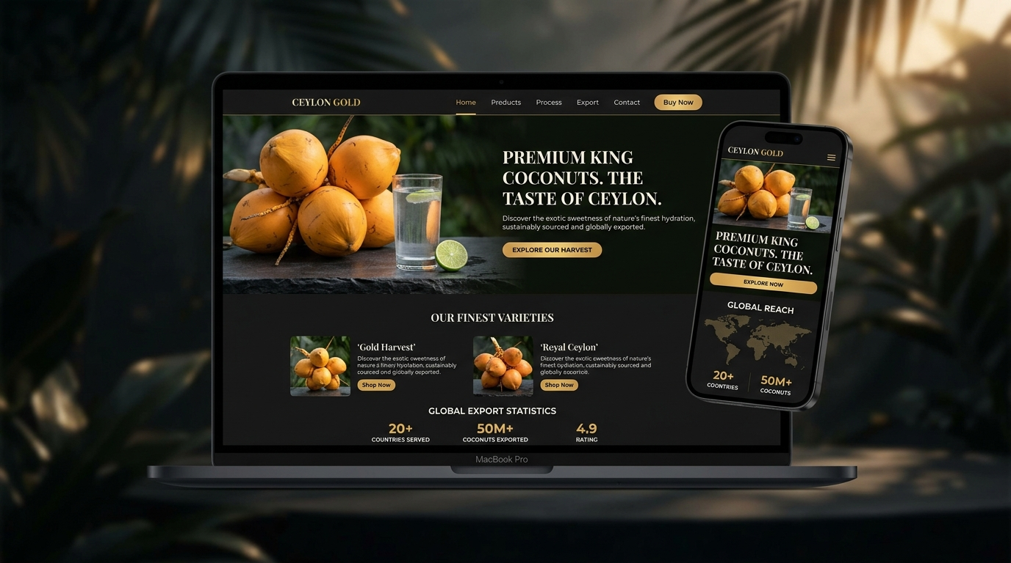
Figure: Concept UI/UX Mockup for the King Coconut Export Web Platform (Responsive Desktop & Mobile Views)
4. Comprehensive Functional Specification & Feature Modules
The proposed platform is engineered into dedicated, highly optimized modules designed to guide B2B buyers from initial discovery to submitted purchase inquiries and long-term commercial partnership.
Module 1: Public Web Portal & Brand Storytelling
- Dynamic Hero Section: Full-width immersive visual banner featuring high-resolution King Coconut photography, live export counter (countries served, nuts exported), and prominent 'Explore Harvest' & 'Request Quote' CTAs.
- The Living Pharmacy Heritage: Interactive educational section highlighting why Ceylon King Coconut is unique to Sri Lanka (endemic cultivar, natural sucrose-free sweetness, rich mineral profile).
- Interactive Origin Map: Visual map of Sri Lanka highlighting harvest regions (Kurunegala, Gampaha, Puttalam Coconut Triangle) and direct shipping connectivity to Colombo Port.
- Global Presence Counter: Real-time interactive statistics showing annual container shipments, international quality accreditations, and buyer satisfaction index.
Module 2: King Coconut Interactive Product Spec Center
- Comprehensive Product Matrix: Dedicated detail pages for: (1) Fresh Whole King Coconut, (2) Semi-Husked / Diamond Cut King Coconut, (3) Bottled 100% Pure King Coconut Water, (4) Organic Coconut Flower Sugar, and (5) Desiccated Coconut.
- Interactive Specification Viewer: Tabbed interface displaying precise parameters: Net Weight (1.2kg - 1.8kg), Water Volume (350ml - 450ml), Brix Sweetness Index (5.5° - 6.5°), and pH balance.
- Electrolyte & Nutritional Radar Chart: Visual comparison illustrating Potassium (290mg/100ml), Sodium, Magnesium, and Vitamin C concentrations vs. standard green coconuts and synthetic sports beverages.
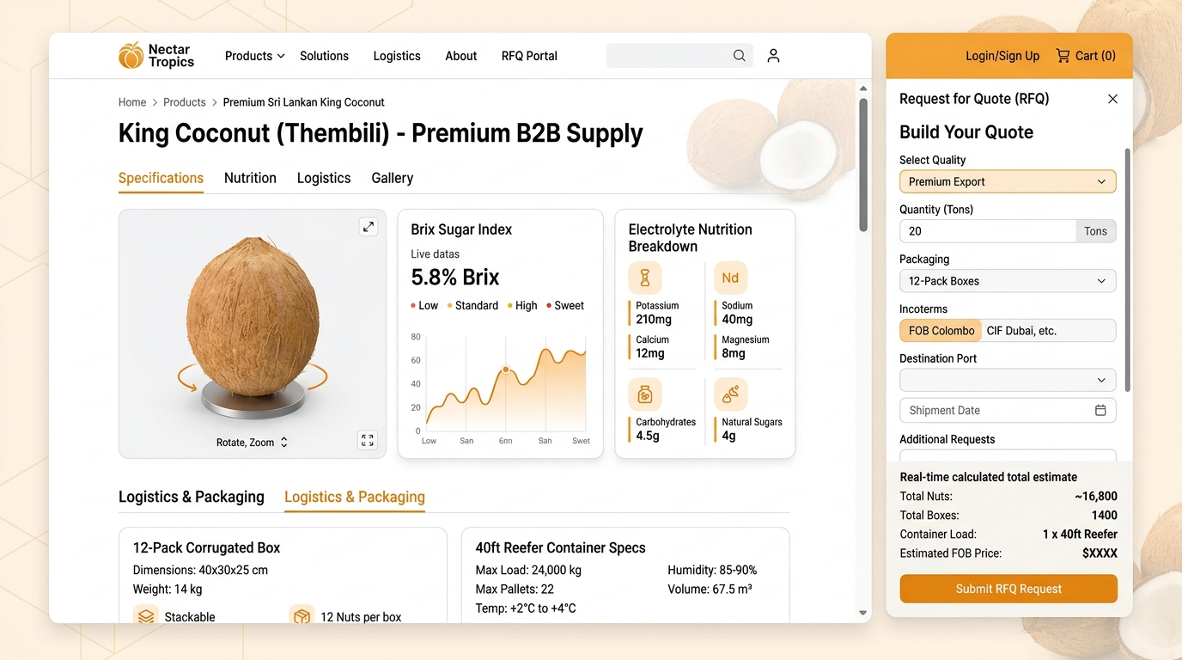
Figure: Interactive King Coconut Product Detail Page & B2B Request for Quote (RFQ) Calculator Modal
Module 3: B2B Request for Quote (RFQ) Engine & Inquiry Hub
- Multi-Step Quote Builder: Allows institutional buyers to configure inquiries by: Selecting product line -> Specifying volume (Cartons / Metric Tons / Containers) -> Selecting packaging finish -> Choosing Incoterms (FOB Colombo, CIF Destination Port, CFR, EXW) -> Designating Target Delivery Date.
- Smart Contact & Direct WhatsApp Bridge: Direct WhatsApp floating widget for rapid buyer communication, alongside an enterprise contact form with Google Maps Colombo Head Office integration.
Module 4: Farm-to-Port Cold-Chain Traceability
- Stage 1 - Ethical Plantation Harvest: Selected hand-picked harvesting of 7-8 month mature golden nuts from certified sustainable groves.
- Stage 2 - Processing & Diamond Cutting: Precise hygienic trimming, outer husk de-fibering, and uniform diamond shaping for international retail presentation.
- Stage 3 - Sterilization & Packaging: Ozone water wash, food-grade biodegradable cling wrapping, stem treatment to prevent mold, and packing in ventilated export cartons.
- Stage 4 - Controlled Atmosphere Reefer Logistics: Pre-cooling to 12°C - 14°C with 85%-90% relative humidity control for 28+ days of guaranteed fresh shelf life during maritime transit.
Module 5: Global Certifications & Compliance Center
- Interactive Accreditation Showcase: High-resolution verifiable credentials for Coconut Development Authority (CDA) Sri Lanka, Export Development Board (EDB), ISO 22000, HACCP, USDA Organic, and EU Organic standards.
- Downloadable Spec Sheets & Lab Reports: One-click access for international procurement officers to download Certificate of Analysis (COA), Phytosanitary certificates, and export compliance datasheets.
Module 6: Knowledge Hub / Insights Blog (SEO Engine)
- Editorial Content Engine: Articles covering King Coconut wellness science, storage & handling guides for importers, global ready-to-drink beverage trends, and Sri Lankan agricultural heritage.
- Search, Filter & Social Sharing: Instant search by keyword, category tagging (Health, Export Logistics, Culinary, Sustainability), estimated reading time, and direct LinkedIn/Twitter sharing.
Module 7: Centralized MERN Back-Office Admin CMS
- Executive KPI Dashboard: Real-time visibility into total inquiries, pending RFQs, most viewed products, visitor geographic distribution, and conversion rates.
- Product Catalog Manager: Full CRUD (Create, Read, Update, Delete) capability for products, variations, nutritional values, packaging specs, and high-res media gallery.
- Lead & RFQ Management CRM: Interactive pipeline to track inquiries by status (New, In Review, Quoted, Dispatched, Closed) with one-click export to Excel/CSV for sales teams.
- Dynamic Blog & SEO Manager: Rich-text WYSIWYG article editor with automatic OpenGraph tag generation, meta descriptions, and image alt optimization.
- Role-Based Access Control (RBAC): Multi-user authentication (Super Admin, Sales Manager, Content Editor) with granular permission management.
5. Technical Architecture & MERN Stack Ecosystem
The application is engineered using a robust, decoupled, and micro-service ready MERN Stack (MongoDB, Express.js, React.js, Node.js) architecture, ensuring maximum speed, infinite scalability, rock-solid security, and effortless maintainability.
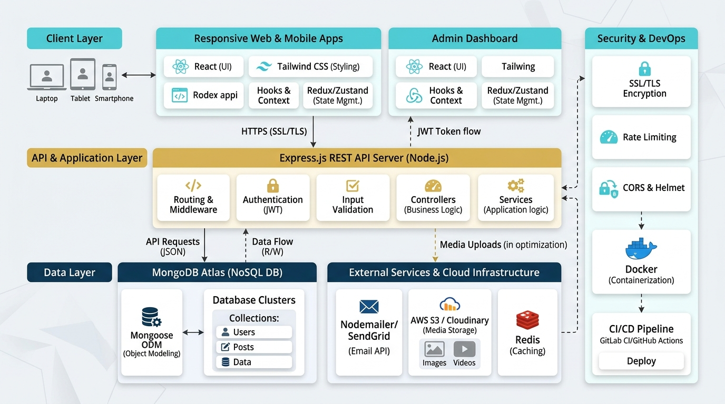
Figure: Comprehensive MERN Stack Technical Architecture & Cloud Infrastructure Blueprint
5.1 Complete Technology Stack Specifications
Layer / Component | Technology / Framework | Strategic Purpose & Benefits
Frontend Client | React.js (v18+) / Next.js, Tailwind CSS, Lucide Icons | Lightning-fast SPA rendering, component modularity, fluid mobile responsiveness, and zero bloated CSS.
Animations & UI | Framer Motion, Canvas 3D / Three.js lightweight | Silky smooth 60fps micro-animations, 3D interactive nut previews, and interactive data visualization.
Backend API Server | Node.js (v20+ LTS) & Express.js RESTful API | High-concurrency non-blocking I/O, REST endpoints, JSON payload handling, and middleware security pipeline.
Database Layer | MongoDB Atlas (NoSQL Cloud Cluster) & Mongoose ODM | Highly flexible schema design for complex agricultural product specs, RFQ documents, and leads with geo-redundancy.
State & Forms | Zustand / Redux Toolkit, React Hook Form, Zod | Predictable global state management, client-side schema validation, and instantaneous form error feedback.
Media & CDN | Cloudinary SDK / AWS S3 + Global CDN | Automated image compression, responsive WebP/AVIF delivery, and ultra-fast media streaming for global buyers.

5.2 Backend Services & Security Architecture
- Authentication & Authorization: JSON Web Tokens (JWT) stored in secure HttpOnly SameSite cookies with bcrypt password hashing for admin portal users.
- API Security Suite: Helmet.js for secure HTTP headers, CORS whitelisting, Express-Rate-Limit against brute-force DDoS attacks, and mongo-sanitize for NoSQL injection prevention.
- Transactional Email System: Nodemailer integrated with SendGrid / Amazon SES for automated RFQ delivery receipts, admin instant alerts, and newsletter onboarding.
- In-Memory Caching: Redis caching for high-traffic product catalog queries, reducing database load and delivering sub-50ms API response times.
6. Non-Functional Requirements & Performance Standards
International B2B procurement professionals demand speed, security, and effortless navigation. The proposed system adheres to the highest modern enterprise standards:
- Core Web Vitals & Speed: Targeting 95+ Google PageSpeed score across Mobile and Desktop. Largest Contentful Paint (LCP) < 1.2s, Cumulative Layout Shift (CLS) < 0.05, and First Input Delay (FID) < 50ms.
- Enterprise Security & Compliance: OWASP Top 10 compliance, HTTPS/TLS 1.3 encryption across all endpoints, strict GDPR/CCPA cookie consent mechanisms, and automated daily MongoDB cloud backups.
- Cross-Browser & Device Responsiveness: Pixel-perfect visual fidelity across all major browsers (Google Chrome, Apple Safari, Mozilla Firefox, Microsoft Edge) and viewports (Smartphones, Tablets, Laptops, 4K Displays).
7. Project Implementation Roadmap & Milestones
The project is structured into seven distinct, agile development phases spanning an estimated 8 to 10 weeks from project kickoff to production deployment.
Phase & Stage | Duration | Key Activities & Concrete Deliverables
Phase 1: Discovery & Architecture | Week 1 | Detailed requirement freezing, King Coconut product taxonomy mapping, API architecture specification, and UX wireframes.
Phase 2: UI/UX Design System | Week 1 | High-fidelity Figma prototypes for desktop and mobile, custom brand asset creation, interactive prototype client review and sign-off.
Phase 3: Backend API & Database | Week 2 | Node.js/Express server setup, MongoDB Atlas cluster provisioning, Mongoose schema modeling, JWT auth, and RFQ calculation endpoints.
Phase 4: Frontend & RFQ Development | Week 3 | React.js frontend build, Tailwind UI styling, interactive product spec viewer, 3D viewer integration, and multi-step RFQ calculator modal.
Phase 5: Admin CMS & Analytics | Week 3 | Admin portal build (Product CRUD, Lead CRM pipeline, Blog WYSIWYG editor, Analytics dashboards), and automated email webhook triggers.
Phase 6: QA, Security Audit | Week 4 | Cross-browser testing, mobile UX stress testing, security vulnerability scanning, Core Web Vitals optimization.
Phase 7: Deployment & Handover | Week 5 | Production cloud deployment (Vercel/Render/AWS), SSL binding, DNS routing, client training, administrative documentation, and official go-live.

8. Scope of Deliverables, Quality Assurance & Warranty
8.1 Formal Deliverables Package
- Production Source Code: Complete, well-commented, production-ready Git repository containing both Frontend React and Backend Node/Express microservices.
- Fully Deployed Live Web Platform: Production deployment configured on secure high-availability cloud infrastructure with custom domain and SSL/TLS certificate.
- Custom Admin CMS & Lead CRM: Fully configured back-office administrative portal with multi-role access control for managing products, leads, and blog content.
- Technical & User Documentation: Comprehensive User Manual for administrative staff and Swagger/Postman API documentation for backend services.
- High-Resolution Asset Pack: Curated graphics library including optimized product renders, certification badges, and custom iconography.
8.2 Quality Assurance & 30-Day care Warranty
- Rigorous Multi-Tier Testing: Unit testing (Jest), API integration testing (Supertest), and End-to-End user flow validation (Cypress/Playwright).
- 30-Day Post-Launch Hypercare: Dedicated 30-day technical support period following go-live for bug fixes, performance tuning, and operational assistance at no additional cost.
- Admin Staff Training Session: Comprehensive live virtual training session for the client's commercial and sales teams on managing inquiries, generating quotes, and publishing content.
9. Project Kickoff & Next Steps
To initiate the project and commence Phase 1 Discovery and Design, the following immediate steps are recommended:
- 1. Proposal Approval & Scope Confirmation: Formal client acceptance of the functional specifications, technical architecture, and implementation timeline.
- 2. Stakeholder Discovery Workshop: A focused alignment session to gather product catalog assets, target export markets, preferred incoterms, and brand guidelines.
- 3. Environment Provisioning & Sprint 1 Launch: Setting up the Git repository, cloud sandbox environments, and commencing UI/UX wireframing.
Commitment to Engineering Excellence
We are excited about the opportunity to partner with your enterprise to engineer a truly world-class digital gateway for Sri Lankan King Coconut exports positioning your brand at the absolute forefront of the global agricultural trade industry.

