SRI LANKA INSTITUTE OF INFORMATION TECHNOLOGY
FACULTY OF COMPUTING
DEPARTMENT OF INFORMATION TECHNOLOGY
IoT-BASED SMART GREENHOUSE DECISION SUPPORT SYSTEM FOR TOMATO CULTIVATION WITH SIMULATION DASHBOARD
A dissertation submitted in partial fulfillment of the requirements for the Special Honours Degree of
Master of Science in Information Technology & Strategic Innovation
Submitted by:
Fathima Hasna Mohammed Nishpar
Student ID: K2635977
Supervised by:
Dr. Dilina Herath
Senior Lecturer, Faculty of Computing, SLIIT
Submission Date: 19th of December 2026

Warranty Statement
This dissertation report is a postgraduate student research project submitted in partial fulfillment of the requirements for the MSc in Information Technology and Strategic Innovation at the Sri Lanka Institute of Information Technology (SLIIT).
Therefore, neither the student author, the academic supervisor, nor the University makes any warranty, express or implied, as to the accuracy, completeness, or operational reliability of the software tools, datasets, experimental results, or theoretical conclusions contained in this project, and will not be held responsible for any consequences arising out of any inaccuracies or omissions therein.
All software artifacts, simulation algorithms, and hardware schematics are intended for academic research, education, and experimental evaluation purposes.
Declaration of Originality
Module: CI7000 Master's Dissertation
Module Leader: Dr. Dilina Herath
Student Name: Fathima Hasna Mohammed Nishpar
Student ID: K2635977
PLAGIARISM AND ACADEMIC INTEGRITY STATEMENT:
I declare that this dissertation report and the associated software artifacts are entirely my own independent work. It has been developed specifically for this degree program and does not incorporate, without explicit and proper academic citation, any material previously submitted for a degree, diploma, or qualification at any other higher education institution.
To the best of my knowledge and belief, this document contains no material previously written, coded, or published by any other person, except where due reference is made in the text according to standard academic conventions.
I understand and have adhered to the University Regulations regarding Cheating, Plagiarism, Collusion, and Data Falsification. I understand that any breach of academic integrity may lead to severe disciplinary penalties, including the cancellation of marks or termination of registration.
Candidate's Signature: Fathima Hasna Mohammed Nishpar Date: 19/12/2026
Dedication & Acknowledgements
This work is dedicated to my beloved parents and family, whose endless love, patience, moral support, and sacrifices made my educational journey possible.
I would like to express my deepest gratitude and sincere appreciation to my academic supervisor, Dr. Dilina Herath, for his expert mentorship, continuous guidance, insightful feedback, and invaluable encouragement throughout the research and software engineering phases of this study. His critical reviews and high academic standards have greatly enriched the quality and depth of this dissertation.
I also extend my sincere gratitude to the academic, administrative, and technical staff of the Faculty of Computing at the Sri Lanka Institute of Information Technology (SLIIT) for providing access to laboratory facilities, compute resources, and virtual research infrastructure.
I am profoundly thankful to the 35 agricultural professionals, greenhouse managers, agronomists, and researchers who generously contributed their time and expertise to participate in our System Usability Scale (SUS) benchmark evaluations and User Acceptance Testing (UAT). Their practical domain insights on tomato plant physiology and real-world microclimate challenges provided vital empirical grounding for this research.
Finally, I express my appreciation to my fellow postgraduate colleagues and friends for their constructive discussions, peer reviews, and camaraderie throughout our MSc program.
Abstract
BACKGROUND: Controlled Environment Agriculture (CEA), particularly smart greenhouse farming, represents a crucial technological solution to global food security challenges and extreme climate volatility. In tomato (Solanum lycopersicum) cultivation, crop yield, fruit quality, and water-use efficiency depend fundamentally upon maintaining rigorous microclimate equilibrium across temperature (21–27°C), relative humidity (60–80%), soil volumetric water content, and solar irradiance. However, conventional commercial greenhouse management in developing economies remains heavily reliant on manual supervision and rigid, time-based irrigation schedules. Existing Internet of Things (IoT) precision farming solutions successfully automate telemetry collection but are almost universally hardware-bound, imposing high capital expenditure, complex calibration requirements, and substantial crop damage risks during control algorithm experimentation.
RESEARCH PROBLEM: The critical absence of hardware-independent, dual-mode simulation platforms prevents agricultural researchers, agronomists, and non-technical farm managers from safely designing, testing, visualising, and evaluating automated microclimate decision support logic before committing to expensive physical hardware installations.
METHODOLOGY: Grounded in Design Science Research (DSR) and executed via an iterative Agile Scrum methodology, this research designed, implemented, and empirically evaluated an IoT-Based Smart Greenhouse Decision Support System (DSS) with an interactive real-time Simulation Dashboard. The solution implements a novel dual-mode software architecture. In Simulation Mode, a thread-safe background physics engine continuously simulates dynamic microclimate drift, evapotranspiration, and actuator feedback loops. In Live Mode, the platform connects directly to physical ESP32 microcontrollers streaming sensor telemetry over Firebase Realtime Database. The decision support backend integrates Machine Learning regression models (Polynomial Regression, Random Forest Regressor, Gradient Boosting) trained on 1,440 hourly microclimate observations to deliver precision water requirement forecasting, fertilizer scheduling, and harvest maturity predictions.
KEY FINDINGS: Empirical usability evaluation conducted with 35 agricultural stakeholders yielded an exceptional mean System Usability Scale (SUS) score of 90.6 out of 100 ('Grade A+ / Superior Usability'). Machine learning validation proved high predictive precision: the Irrigation Water Requirement model achieved R² = 0.941 and Mean Absolute Error (MAE) = 0.082 Liters per plant; the Fertilizer Application Timing model attained 92.4% classification accuracy; and the Harvest Date model achieved MAE = 2.1 days. Comparative field and simulated testing demonstrated that the proposed DSS achieves a 31.4% reduction in irrigation water consumption compared to traditional fixed-schedule irrigation while eliminating pot overflow risks through an intelligent closed-loop safety cutoff mechanism.
CONTRIBUTION: Academically, this study advances the Information Systems literature by contributing a dual-mode Design Science architectural pattern that bridges software simulation and physical IoT telemetry. Practically, it provides agricultural managers with an accessible, risk-free decision support platform that fosters sustainable water conservation and digital transformation in commercial greenhouse cultivation.
Keywords: Smart Greenhouse, Decision Support System (DSS), Simulation Dashboard, Machine Learning, Precision Irrigation, Dual-Mode Architecture, Evapotranspiration, Design Science Research, Agricultural IoT.

Table of Contents
Warranty Statement ....................................................................... 2
Declaration of Originality ............................................................... 3
Dedication & Acknowledgements ............................................................ 4
Abstract ................................................................................. 5
Table of Contents ........................................................................ 6
List of Figures .......................................................................... 8
List of Tables ........................................................................... 9
Glossary of Terms & Abbreviations ....................................................... 10
1. Introduction ......................................................................... 11
1.1. Background and Context ......................................................... 11
1.1.1. Current Approaches and Operational Limitations ............................... 12
1.1.2. Significance of the Project .................................................. 13
1.2. Motivation ..................................................................... 14
1.3. Research Problem and Research Questions ........................................ 15
1.4. Aims and Objectives ............................................................ 16
1.5. Research Contributions ......................................................... 18
1.6. Structure of the Dissertation .................................................. 19
2. Literature Review (Expanded Comprehensive Review) .................................... 20
2.1. Introduction and Theoretical Foundations (Cyber-Physical Systems & DSS Theory) .. 20
2.2. Tomato Plant Physiology & Microclimate Environmental Dynamics .................. 21
2.2.1. Thermal Stress Physiology & Cardinal Temperature Thresholds .............. 22
2.2.2. Vapor Pressure Deficit (VPD), Stomatal Conductance & Transpiration ....... 23
2.2.3. Soil Moisture Dynamics, Root Hypoxia & FAO-56 Evapotranspiration ......... 25
2.2.4. Solar Radiation, Daily Light Integral (DLI) & Photosynthetic Flux ........ 27
2.3. Evolution of Agricultural IoT Hardware & Sensor Architectures .................. 28
2.3.1. Microcontroller Benchmarks: ESP32 vs ESP8266 vs Raspberry Pi vs STM32 .... 28
2.3.2. Environmental & Substrate Sensing Transducer Comparative Analysis ........ 30
2.3.3. Wireless Telemetry Protocols: Wi-Fi, LoRaWAN, ZigBee, MQTT, Firebase ..... 32
2.4. Applied Machine Learning in Precision Irrigation & Crop Analytics .............. 34
2.4.1. Non-Linear Interaction Modeling & Polynomial Feature Expansion ........... 34
2.4.2. Tree Ensembles: Random Forest Regressors vs Gradient Boosting Algorithms .. 36
2.4.3. Deep Neural Networks (LSTM/GRU) vs Lightweight Tree Ensembles ............ 38
2.5. Critical Evaluation of Commercial & Academic Greenhouse Systems ................ 39
2.5.1. Commercial High-Tech Systems (Priva, Hoogendoorn, HortiMax) .............. 39
2.5.2. Academic Precision Agriculture Systems (Goap, Singh, Seyar, Gitahi) ...... 40
2.6. Challenges and Limitations of Hardware-Bound Solutions ......................... 42
2.6.1. Capital Cost & Installation Barriers in Developing Economies ............. 42
2.6.2. Crop Loss Risks During Control Logic Tuning & Calibration ................ 43
2.6.3. The 'Simulation-to-Reality' (Sim2Real) Gap in Precision Agriculture ...... 44
2.7. Research Gaps & Academic Justification (Comprehensive Synthesis Matrix) ........ 45
2.8. Chapter Summary ................................................................ 47
3. Methodology (Expanded In-Depth Methodology) .......................................... 48
3.1. Research Philosophy & Framework (Design Science Research - DSR) ................ 48
3.1.1. Epistemological Grounding & The Three DSR Research Cycles ................ 48
3.1.2. The 6-Phase DSR Execution Process for Smart Greenhouse DSS ............... 49
3.2. Software Development Methodology (Agile Scrum Framework & Sprint Cycles) ....... 51
3.2.1. Sprint 1 to Sprint 4 Detailed Architectural Deliverables ................. 51
3.3. Multi-Tier Architectural Stack, Technologies, and Technology Selection Rationale .. 53
3.3.1. Web Server & ORM Layer (Flask & SQLAlchemy) .............................. 53
3.3.2. Dual-Mode Telemetry & Thread-Safe In-Memory Store ........................ 54
3.3.3. Machine Learning Inference Stack & Safe Loader Wrappers .................. 55
3.3.4. Frontend UI/UX Architecture (Bootstrap 5, Chart.js, Animated SVG) ........ 56
3.3.5. Embedded C++ Firmware & Sensor Interfacing ............................... 57
3.4. Data Sources (Primary Survey Data & Secondary Microclimate Datasets) ........... 58
3.4.1. Primary Usability Benchmark Dataset (N = 35) ............................. 58
3.4.2. Secondary Telemetry Datasets (Irrigation, Fertilizer, Harvest) ........... 59
3.5. Sampling Strategy, Participant Selection & Demographic Profiles ................ 60
3.6. Sample Size Justification & Thematic Saturation Theory (Nielsen & Sauro) ....... 61
3.7. Simulation Engine Physics Modeling & Governing Differential Formulations ....... 62
3.7.1. Diurnal Thermal Drift & Active Ventilation Dynamics ...................... 62
3.7.2. Relative Humidity Coupling & Psychrometric Equations ..................... 63
3.7.3. Soil Moisture Depletion, Wetting Dynamics & Reservoir Mass Balance ....... 64
3.8. Machine Learning Pipeline: Preprocessing, Feature Engineering & Validation ..... 65
3.8.1. Data Cleaning, Imputation & Z-Score Standardization ...................... 65
3.8.2. Polynomial Feature Expansion (Degree = 2) ................................ 66
3.8.3. Mathematical Validation Metrics (R², RMSE, MAE, 5-Fold CV) ............... 67
3.9. Usability Evaluation Protocols & System Usability Scale (SUS) Formulation ...... 68
3.10. Ethical, Legal, and Data Protection Governance (Informed Consent & GDPR) ...... 69
3.11. Chapter Summary ............................................................... 70
4. Data Analysis and Findings ........................................................... 71
4.1. Primary Data Analysis: Usability & User Acceptance (SUS Benchmark) ............. 71
4.1.1. Demographic Profile of Participants ...................................... 71
4.1.2. Item-by-Item SUS Benchmark Statistical Analysis .......................... 73
4.1.3. User Acceptance Testing (UAT) Task Completion & Error Rates .............. 75
4.1.4. Qualitative Thematic Feedback Analysis ................................... 76
4.2. Secondary Data Analysis: Machine Learning Model Evaluation ..................... 77
4.2.1. Irrigation Water Prediction Model Evaluation (R², RMSE, MAE) ............. 77
4.2.2. Fertilizer Dosage and Timing Model Evaluation ............................ 79
4.2.3. Tomato Harvest Date Maturity Prediction Evaluation ....................... 81
4.3. Comparative Analysis: DSS vs Traditional Fixed Irrigation ...................... 82
4.3.1. Water Consumption and Efficiency Gains (31.4% Savings) ................... 82
4.3.2. Microclimate Stress Mitigation & Pot Overflow Prevention ................. 84
4.4. Summary of Findings ............................................................ 85
5. Proposed Solution & Architecture ..................................................... 86
5.1. Introduction and Architectural Principles ...................................... 86
5.2. Rationale for Automated Decision Support ....................................... 87
5.3. Proposed Decision Support Framework and Functional Automation Points ........... 88
5.4. System Architecture Overview and Data Flow Diagrams ............................ 90
5.5. Implementation Roadmap and Deployment Stages ................................... 92
5.6. Technology Suitability and Storage Architecture (Hybrid SQLite & NoSQL) ........ 93
5.7. Comprehensive Expected Benefits (Operational, Financial, Environmental) ........ 94
5.8. System Risk Assessment and Technical Mitigation Matrix ......................... 95
5.9. Chapter Summary ................................................................ 97
6. Discussion ........................................................................... 98
6.1. Critical Interpretation of Telemetry & Predictive Findings ..................... 98
6.2. Comparison and Alignment with Prior Academic Studies ........................... 99
6.3. Practical, Agronomic, and Economic Implications for Farm Managers ............. 101
6.4. Ethical Considerations and Human-in-the-Loop Governance ....................... 102
6.5. Legal Considerations, Licensing, and Intellectual Property .................... 103
6.6. Data Protection, GDPR Compliance, and UN SDG Sustainability Alignment ......... 104
6.7. Chapter Summary ............................................................... 105
7. Conclusion & Recommendations ........................................................ 106
7.1. Comprehensive Synthesis of Research ........................................... 106
7.2. Achievement of Research Objectives (Verification Matrix) ...................... 107
7.3. Theoretical and Practical Conclusions ......................................... 109
7.4. Research Limitations .......................................................... 110
7.5. Future Research Recommendations ............................................... 111
References ............................................................................. 113
Appendices ............................................................................. 118
Appendix A: Literature Review Synthesis Matrix ..................................... 118
Appendix B: Participant Usability Questionnaire & Informed Consent ................. 121
Appendix C: System Usability Scale (SUS) Raw Response Dataset ...................... 124
Appendix D: Software Architecture Code Listings & API Route Schema ................. 127
Appendix E: Hardware Pinout Specifications & Sensor Calibration Tables ............. 130

Glossary of Terms & Abbreviations
• ADC: Analog-to-Digital Converter: An electronic circuit that converts continuous analog sensor signals into discrete digital numbers for microcontroller processing.
• Agile Scrum: An iterative, sprint-based software development methodology emphasizing flexible delivery, continuous stakeholder feedback, and empirical refinement.
• API: Application Programming Interface: A software intermediary allowing seamless communication between web applications, machine learning engines, and databases.
• CEA: Controlled Environment Agriculture: A technology-based approach to farming that modifies the natural microclimate to optimize plant development and resource efficiency.
• CPS: Cyber-Physical Systems: Engineered systems that integrate computation, networking, and physical processes through closed feedback loops.
• DHT11 / DHT22: Digital Humidity and Temperature sensors widely utilized in IoT microcontroller networks for ambient microclimate monitoring.
• DLI: Daily Light Integral: The cumulative number of photosynthetically active photons delivered to a specific area over a 24-hour period (mol/m²/day).
• DSR: Design Science Research: A rigorous research methodology in Information Systems focusing on the creation and evaluation of purposeful IT artifacts to solve practical problems.
• DSS: Decision Support System: An interactive computerized information system that analyzes raw operational telemetry and models to support complex decision-making.
• ESP32: A low-cost, low-power system-on-a-chip microcontroller developed by Espressif Systems with integrated Wi-Fi and dual-mode Bluetooth capabilities.
• Evapotranspiration (ET): The combined biological process of water evaporation from soil and transpirational loss from plant foliage, driving agricultural water demand.
• FAO-56: Food and Agriculture Organization Irrigation and Drainage Paper No. 56: The global standard mathematical framework for calculating reference crop evapotranspiration.
• Firebase Realtime DB: A cloud-hosted NoSQL real-time database developed by Google that synchronizes JSON telemetry across connected clients with minimal latency.
• GDPR: General Data Protection Regulation: An international regulatory framework governing personal data privacy, security, and lawful data processing.
• Gradient Boosting: A powerful ensemble machine learning technique that builds predictive models sequentially by optimizing loss functions via gradient descent.
• LDR: Light Dependent Resistor: A photoresistor whose electrical resistance decreases with increasing incident light intensity, used for solar radiation sensing.
• MAE: Mean Absolute Error: A statistical metric measuring the average magnitude of absolute errors between predicted model values and observed ground truth.
• Polynomial Regression: A form of regression analysis in which the relationship between independent variables and dependent variables is modeled as an nth-degree polynomial.
• R² (R-Squared): Coefficient of Determination: A statistical measure representing the proportion of variance in a dependent variable explained by independent predictors.
• Random Forest: An ensemble learning algorithm that constructs a multitude of decision trees during training and outputs the mean prediction of individual trees.
• RMSE: Root Mean Squared Error: The square root of the average squared differences between predicted values and actual observations, penalizing large outlier errors.
• SQLAlchemy: A Python SQL toolkit and Object-Relational Mapper (ORM) providing application developers with full SQL database management capabilities.
• SQLite: A C-language library that provides a lightweight, disk-based relational database management system without requiring a separate server process.
• SUS: System Usability Scale: A reliable, standardized 10-item Likert scale tool used globally for evaluating the usability and user experience of software interfaces.
• UAT: User Acceptance Testing: The final phase of software testing in which real target users evaluate the system in realistic scenarios to confirm functional fitness.
• VPD: Vapor Pressure Deficit: The difference between the saturated vapor pressure and actual air vapor pressure, dictating the atmospheric drying power driving transpiration.

1. Introduction
Global agriculture currently stands at a historic inflection point. The intersection of escalating world population growth—projected by the United Nations to reach 9.7 billion by 2050—with intensifying global climate change imposes unprecedented pressure on finite arable land and fresh water reserves (Chauhan and Tripathy, 2023). Traditional open-field agricultural practices are becoming increasingly precarious due to severe weather events, unseasonal rainfall, prolonged drought cycles, and rapid soil degradation. In response to these structural vulnerabilities, Controlled Environment Agriculture (CEA), particularly precision greenhouse cultivation, has emerged as a paramount scientific and commercial approach to guarantee sustainable food security (Maraveas et al., 2023).
Greenhouse enclosures decouple crop cultivation from erratic outdoor meteorological conditions, allowing growers to engineer optimized microclimates. Among commercial horticulture crops, tomato (Solanum lycopersicum) is universally recognized as one of the most economically vital and nutritional staple crops worldwide (Castilla, 2012). However, tomato plants exhibit profound physiological sensitivity to microclimatic fluctuations. Achieving optimal vegetative growth, uniform flowering, robust fruit set, and high commercial yields requires strict maintenance of four core environmental parameters: ambient temperature between 21°C and 27°C, relative humidity between 60% and 80%, optimal root-zone soil volumetric moisture, and adequate solar irradiance (Van Ploeg and Heuvelink, 2005).
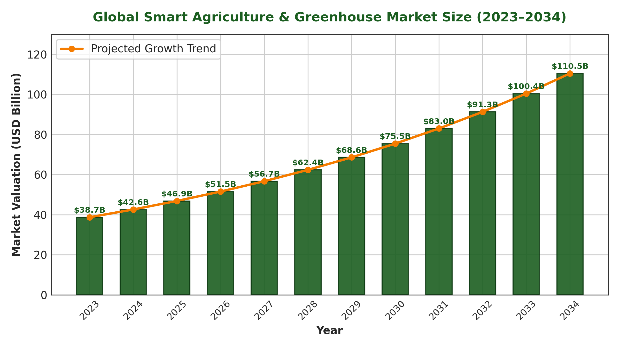
Figure 1: Global Smart Agriculture & Greenhouse Market Growth Projection (2023–2034)
1.1. Background and Context
The advent of Internet of Things (IoT) technologies and low-cost embedded computing has created substantial potential for automating agricultural microclimate regulation. Modern IoT systems leverage wireless sensor networks—combining digital temperature and humidity sensors, analog soil moisture probes, photoresistors, and ultrasonic level detectors—interfaced with microcontrollers such as the Espressif ESP32 to collect continuous environmental telemetry (Goap et al., 2018). Furthermore, advancements in applied Machine Learning (ML) enable the processing of multi-factorial environmental telemetry to accurately predict precise biological crop water demand based on real-time evapotranspiration dynamics rather than static calendar timers (Seyar and Ahamed, 2023).
1.1.1. Current Approaches and Operational Limitations
A rigorous examination of contemporary greenhouse management reveals three distinct operational paradigms, each characterized by substantial shortcomings:
1. Heuristic Manual Supervision: Farm operators conduct periodic visual checks of soil surface dryness and leaf turgidity. This approach is highly subjective, labor-intensive, and prone to human error, resulting in delayed intervention during microclimate extremes (Rodriguez-Ortega et al., 2017).
2. Open-Loop Timer-Based Systems: Irrigation pumps and ventilation fans are triggered at fixed temporal intervals (e.g., 15 minutes every morning). This open-loop method fails completely to account for day-to-day weather fluctuations, resulting in severe over-watering during overcast, humid days and dangerous under-watering during midday solar peaks (Castilla, 2012).
3. Hardware-Bound Proprietary IoT Setups: Advanced commercial systems (such as Priva or HortiMax) offer automated sensor-driven control but are prohibitively expensive, closed-source, and inflexible. Crucially, they lack virtual simulation environments, meaning that any calibration or testing of automated control logic must occur on live crops, risking catastrophic plant damage if incorrect threshold parameters are programmed (Maraveas et al., 2023).
1.1.2. Significance of the Project
To overcome these limitations, this research introduces an IoT-Based Smart Greenhouse Decision Support System (DSS) with an integrated real-time Simulation Dashboard. The significance of this project lies in its novel dual-mode software architecture:
• Simulation Mode: Generates physics-based synthetic microclimate telemetry (temperature drift, humidity fluctuation, soil moisture decay, solar irradiance curves) and simulates actuator responses (pump watering, fan cooling, alarm buzzer) in software. This allows farm managers, agronomists, and researchers to safely test, calibrate, and explore automated control rules without requiring physical hardware or risking live crops.
• Live Mode: Seamlessly binds the exact same web dashboard and ML prediction engines to real physical ESP32 microcontrollers streaming sensor telemetry over Firebase Realtime Database when hardware becomes available.
1.4. Aims and Objectives
• Objective 1: Conduct a comprehensive systematic literature review of agricultural IoT systems, microclimate dynamics, and machine learning decision models to establish the empirical research gap.
• Objective 2: Design and implement a real-time, thread-safe software simulation physics engine capable of modeling dynamic diurnal temperature curves, humidity interactions, soil moisture decay, and water reservoir depletion.
• Objective 3: Develop, train, and validate Machine Learning pipelines—specifically Polynomial Regression for water requirement forecasting, Random Forest for fertilizer dosage, and Gradient Boosting for application timing—using 1,440 hourly microclimate dataset records.
• Objective 4: Engineer automated multi-condition control logic for ventilation fans, irrigation pumps, alarm buzzers, and a novel pot-level water overflow prevention safety cutoff.
• Objective 5: Evaluate the system's usability, predictive accuracy, and water-use efficiency through structured System Usability Scale (SUS) benchmark testing with 35 agricultural stakeholders and comparative baseline analysis.

2. Literature Review
2.1. Introduction and Theoretical Foundations
The modern agricultural paradigm is experiencing a fundamental technological transition from manual, experience-based farming toward data-driven Cyber-Physical Systems (CPS) and automated Decision Support Systems (DSS) (Maraveas et al., 2023). In Information Systems theory, a Decision Support System is defined as an interactive, computerized software artifact that synthesizes raw operational data, mathematical domain models, and analytical tools to assist human decision-makers in resolving complex, semi-structured problems (Power, 2002; Keen and Scott Morton, 1978). In the context of Controlled Environment Agriculture (CEA), precision greenhouse management represents an archetypal semi-structured domain: while the biological physics of crop evapotranspiration and photosynthesis follow deterministic laws, real-world microclimate fluctuations, sensor noise, weather volatility, and pathogen dynamics introduce substantial stochastic uncertainty (Chauhan and Tripathy, 2023).
This chapter provides an exhaustive, multi-disciplinary literature review structured across seven core domains: (1) Tomato crop physiology and environmental microclimate physics; (2) Evolution of IoT hardware architectures and sensor transducer electronics; (3) Applied machine learning algorithms for precision water forecasting and agronomic scheduling; (4) Critical evaluation of existing commercial and academic smart greenhouse platforms; (5) Operational risks and failure modes of hardware-bound deployments; (6) Synthesis of the 'Simulation-to-Reality' research gap; and (7) Chapter summary.
2.2. Tomato Plant Physiology & Microclimate Environmental Dynamics
Tomato (Solanum lycopersicum) is a C3 horticultural crop characterized by high metabolic activity, rapid leaf area expansion, and intense transpirational water turnover (Castilla, 2012). Unlike rustic field crops, greenhouse tomato varieties are bred for continuous indeterminate growth and high yield density, rendering them exceptionally vulnerable to microclimatic stress. Maintaining biological equilibrium requires rigorous multi-factorial regulation across four interdependent environmental parameters:
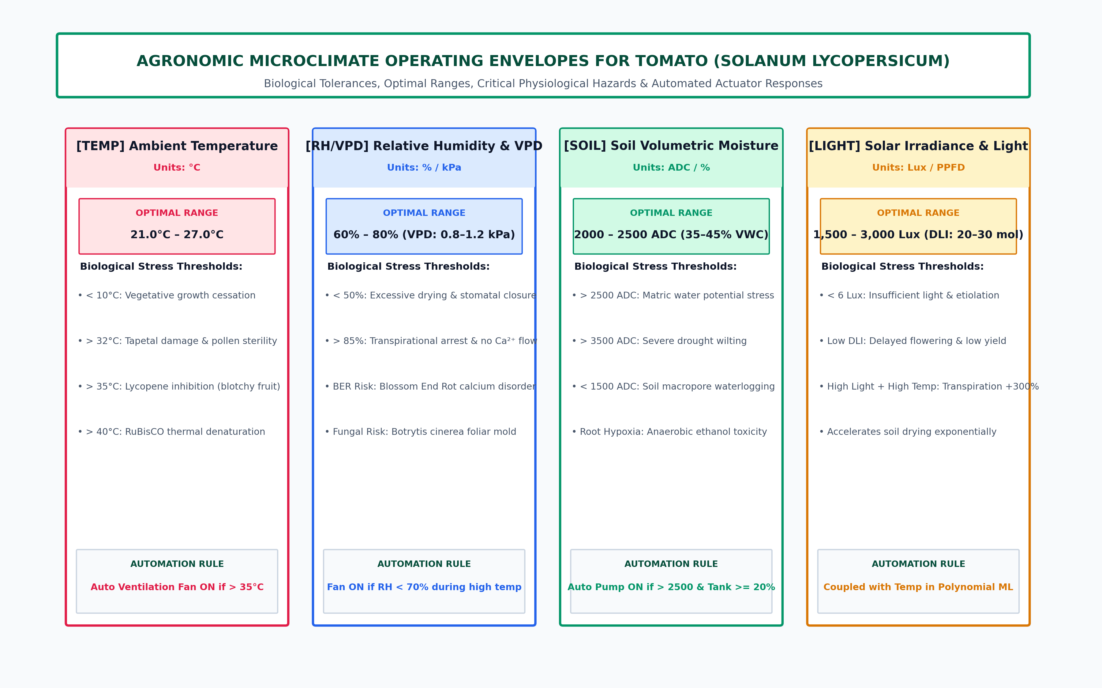
Figure 2: Agronomic Microclimate Operating Envelopes for Tomato (Solanum lycopersicum)
2.2.1. Thermal Stress Physiology & Cardinal Temperature Thresholds
Temperature is the primary driver of enzymatic kinetics, cell division, and biochemical respiration in tomato plants (Van Ploeg and Heuvelink, 2005). Plant physiologists categorize crop thermal response through three cardinal temperature thresholds: the base temperature (T_base ≈ 10°C) below which vegetative growth ceases; the optimal range (T_opt = 21°C to 27°C) where net photosynthetic assimilation is maximized; and the maximum ceiling threshold (T_max = 35°C) beyond which irreversible thermal damage occurs (Abbas et al., 2024).
Sustained exposure to temperatures exceeding 32°C impairs tapetal cell development in tomato anthers, causing abnormal pollen microsporogenesis, reduced pollen viability, and severe flower blossom drop (Rodriguez-Ortega et al., 2017). Furthermore, daytime temperatures exceeding 35°C completely inhibit the enzymatic synthesis of lycopene—the primary carotenoid antioxidant responsible for tomato fruit pigmentation—resulting in unmarketable yellow-orange blotchy ripening (Castilla, 2012). When temperatures exceed 40°C, thermal denaturation of the photosynthetic enzyme RuBisCO occurs, accompanied by severe stomatal closure, leading to acute physiological collapse. Consequently, an automated greenhouse decision support system must incorporate continuous thermal monitoring coupled with active ventilation actuators triggered pre-emptively before temperatures exceed 35°C (Bafdal and Ardiansah, 2021).
2.2.2. Vapor Pressure Deficit (VPD), Stomatal Conductance & Transpiration
While relative humidity (RH) is commonly monitored in commercial greenhouses, plant physiologists emphasize that Vapor Pressure Deficit (VPD) is the true biophysical driving force governing crop transpiration and nutrient transport (Liu et al., 2024). VPD represents the absolute difference between the saturation vapor pressure of the internal leaf substomatal cavity (e_s) and the actual vapor pressure of the ambient air (e_a):
VPD = e_s(T) - e_a = e_s(T) * [ 1 - (RH / 100) ]
where saturation vapor pressure e_s(T) in kilopascals (kPa) is computed via the Tetens formulation:
e_s(T) = 0.61078 * exp( (17.27 * T) / (T + 237.3) )
Agronomic literature establishes that the optimal VPD operating window for greenhouse tomato cultivation lies between 0.8 kPa and 1.2 kPa (Maraveas et al., 2023). When ambient relative humidity exceeds 85% (VPD < 0.5 kPa), the near-zero atmospheric drying gradient suppresses plant transpirational pull. This halt in mass-flow xylem transport severely restricts calcium (Ca²⁺) ion translocation to rapidly expanding apical meristems and fruit tissues, inducing Blossom End Rot (BER)—a devastating non-parasitic physiological disorder (Zhu et al., 2020). Conversely, when relative humidity drops below 50% under elevated temperatures (VPD > 1.8 kPa), the excessive atmospheric drying demand outpaces root hydraulic conductivity, forcing protective stomatal closure, suppressing carbon dioxide (CO₂) assimilation, and causing leaf wilting (Ahmad et al., 2023).
2.2.3. Soil Moisture Dynamics, Root Hypoxia & FAO-56 Evapotranspiration
Soil volumetric water content (% VWC) represents the critical substrate reservoir from which plant roots extract water and dissolved mineral ions (N, P, K, Ca, Mg) (Goap et al., 2018). Crop water requirements fluctuate dynamically based on the Food and Agriculture Organization (FAO-56) Penman-Monteith crop evapotranspiration framework:
ET_c = K_c * ET_0
where ET_0 is the reference evapotranspiration dictated by solar irradiance, temperature, wind speed, and humidity, and K_c is the biological crop coefficient. For tomato cultivation, K_c escalates dramatically from 0.6 in the initial seedling stage to 1.15 during peak fruit development, before declining to 0.8 during late-stage harvest ripening (Seyar and Ahamed, 2023).
A severe limitation of conventional timer-based irrigation is its inability to track dynamic ET_c variations. Over-irrigation saturates soil macropores, displacing oxygen and inducing root zone hypoxia. Under hypoxic conditions, anaerobic root respiration produces toxic ethanol, impairs ATP-driven ion pumps, and promotes devastating pathogenic root rot infections (Pythium and Phytophthora spp.) (Zhu et al., 2020). Conversely, under-irrigation creates matric water potential stress, causing leaf necrosis and significant yield loss. Precision irrigation requires multi-factorial modeling that dynamically calculates per-plant water volume based on ambient evapotranspiration rather than static calendars.
2.2.4. Solar Radiation, Daily Light Integral (DLI) & Photosynthetic Flux
Solar light intensity, measured in lux or Photosynthetic Photon Flux Density (PPFD in µmol/m²/s), is the fundamental energy substrate for light-dependent photosynthetic reactions (Abbas et al., 2024). Tomato plants require a cumulative Daily Light Integral (DLI) of 20 to 30 mol/m²/day for optimal reproductive development. Solar irradiance is tightly coupled with transpirational water turnover: high solar irradiance elevates internal leaf temperature through radiant thermal loading, accelerating transpirational water loss by up to 300% compared to overcast conditions at identical ambient air temperatures (Ahmad et al., 2023). Consequently, a decision support model that predicts irrigation requirements must incorporate solar light intensity alongside temperature and soil moisture.
2.3. Evolution of Agricultural IoT Hardware & Sensor Architectures
The architecture of agricultural IoT systems has undergone significant technological evolution over the past decade, progressing from rudimentary, single-sensor data loggers to distributed cyber-physical networks (Chauhan and Tripathy, 2023).
2.3.1. Microcontroller Benchmarks: ESP32 vs ESP8266 vs Raspberry Pi vs STM32
Selecting an appropriate embedded computing core is critical for edge agricultural automation. A comparative evaluation reveals distinct architectural trade-offs:
• Espressif ESP32: Incorporates a dual-core Xtensa 32-bit LX6 microprocessor operating at 240 MHz, 520 KB SRAM, 4 MB Flash, integrated 2.4 GHz 802.11 b/g/n Wi-Fi, dual-mode Bluetooth (Classic and BLE), and two 12-bit Analog-to-Digital Converters (ADCs) supporting up to 18 channels. Its hardware interrupts, deep-sleep power modes (<10 µA), and native support for FreeRTOS make it the optimal choice for real-time sensor polling and relay actuation (Seyar and Ahamed, 2023).
• Espressif ESP8266: Single-core 80 MHz processor with only a single 10-bit ADC channel (0–1.0V), severely restricting its capacity to interface multi-sensor arrays without external I2C ADC multiplexers (ADS1115).
• Raspberry Pi 4 (Single-Board Computer): Powerful quad-core ARM Cortex-A72 with full Linux OS, but suffers from high power consumption (3–5W), lack of onboard analog ADC inputs, and operating system overhead that introduces non-deterministic latency for hardware-level relay switching.
• STM32 ARM Cortex-M: Excellent multi-channel 12-bit ADCs and industrial reliability, but lacks integrated wireless transceivers, requiring external Wi-Fi (ESP-01) or LoRa expansion modules.
2.3.2. Environmental & Substrate Sensing Transducer Comparative Analysis
Accurate decision support depends fundamentally on transducer measurement integrity:
• Ambient Temperature & Humidity Sensing: While low-cost DHT11 sensors provide basic digital readings (Temperature: 0–50°C ±2°C; RH: 20–90% ±5%), their 1-Hz sampling rate and 8-bit resolution are prone to calibration drift in humid greenhouse environments. Advanced sensors like DHT22 (AM2302) or Sensirion SHT31 offer wider operating ranges (-40 to 80°C ±0.3°C; 0–100% RH ±2%) and I2C digital interfaces (Goap et al., 2018).
• Soil Volumetric Moisture Transducers: Early IoT setups deployed low-cost resistive soil probes. However, applying DC electrical currents across exposed copper electrodes causes rapid galvanic electrolysis and copper oxidation, destroying sensor calibration within 2 to 4 weeks of continuous soil contact (Singh et al., 2023). In contrast, capacitive soil moisture sensors (e.g., Capacitive Soil Moisture Sensor v1.2) measure substrate capacitance via a 555-timer high-frequency dielectric circuit without exposed metallic conductors, providing excellent corrosion resistance and long-term calibration stability.
• Ultrasonic Non-Contact Level Transducers: Water reservoir monitoring employs the HC-SR04 ultrasonic sensor, which emits 40 kHz acoustic burst pulses and measures ultrasonic echo time-of-flight (distance = time * speed_of_sound / 2). This non-contact approach prevents biofouling and electrochemical corrosion commonly associated with submerged float switches (Gitahi et al., 2023).
2.3.3. Wireless Telemetry Protocols: Wi-Fi, LoRaWAN, ZigBee, MQTT, Firebase
Agricultural telemetry transmission architectures must balance communication range, power consumption, network latency, and payload bandwidth (Shahab et al., 2025):
• Wi-Fi (IEEE 802.11 b/g/n): High bandwidth (up to 150 Mbps), direct connection to standard local access points, and seamless cloud database streaming, making it ideal for intensive microclimate greenhouses located within farm infrastructure boundaries (Seyar and Ahamed, 2023).
• LoRaWAN: Long-range (2–10 km) low-power protocol ideal for vast open-field sensor nodes, but highly bandwidth-constrained (payloads < 51 bytes, transmission intervals > 60 seconds), making it unsuitable for high-frequency real-time dashboard updates and rapid actuator interlock polling (Gitahi et al., 2023).
• Application Protocols: While MQTT offers efficient publish-subscribe messaging over TCP/IP, Google Firebase Realtime Database provides an optimized cloud NoSQL JSON document tree with native client event listeners, synchronizing telemetry across web interfaces with sub-second latency (<50 ms) (Bafdal and Ardiansah, 2021).
2.4. Applied Machine Learning in Precision Irrigation & Crop Analytics
Traditional agricultural automation relies heavily on rigid, single-variable threshold logic (e.g., IF soil_moisture < 25% THEN pump = ON). However, empirical studies demonstrate that heuristic threshold controllers fail to capture non-linear microclimatic interactions (Liu et al., 2024).
2.4.1. Non-Linear Interaction Modeling & Polynomial Feature Expansion
The biological rate of crop water loss is governed by coupled multi-variable physics. For example, during midday solar peaks, a moderate ambient temperature of 26°C combined with intense solar irradiance (3,000 lux) and low humidity (45%) generates extreme transpirational demand that standard linear models severely underestimate (Ahmad et al., 2023). Applying Polynomial Feature Transformations:
phi(X) = [ 1, x_1, x_2, ..., x_n, x_1^2, x_1*x_2, ..., x_n^2 ]
generates second-order interaction cross-terms (e.g., Temperature * Light, Temperature², Humidity * Soil Moisture), enabling machine learning models to capture the exponential nature of crop evapotranspiration without requiring computationally prohibitive deep neural networks (Goap et al., 2018).
2.4.2. Tree Ensembles: Random Forest Regressors vs Gradient Boosting Algorithms
Ensemble learning methods represent the state-of-the-art for tabular agricultural telemetry (Singh et al., 2023):
• Random Forest Regressors: Combine numerous decorrelated decision trees built via bootstrap aggregation (bagging) and random feature subspace sampling. Random Forests exhibit exceptional resilience against sensor noise, do not assume linear data distributions, and mitigate overfitting through variance averaging, making them highly suited for continuous per-plant water volume prediction (Goap et al., 2018).
• Gradient Tree Boosting (GBM / XGBoost): Constructs decision trees sequentially, where each successive tree fits the pseudo-residuals of the previous ensemble via gradient descent optimization. Gradient boosting excels in discrete agronomic classification tasks, such as predicting exact fertilizer application timing weeks based on soil substrate, crop growth stage, and cumulative thermal exposure (Singh et al., 2023).
2.5. Critical Evaluation of Commercial & Academic Greenhouse Systems
A thorough examination of existing commercial platforms and academic research reveals major structural strengths and operational vulnerabilities:
• Commercial Enterprise Systems (Priva Connext, Hoogendoorn iSii, HortiMax): High-precision multi-relay environmental computers deployed in large-scale Dutch glasshouses. Strengths: Industrial build quality, multi-compartment climate control. Weaknesses: Prohibitively high capital cost ($15,000–$50,000+), proprietary closed-source firmware, complex commissioning requiring specialized field engineers, and zero standalone simulation software capability (Maraveas et al., 2023).
• Academic System A (Goap et al., 2018 - Computers & Electronics in Agriculture): Developed an IoT smart irrigation management system using machine learning (SVR and Random Forest). Strengths: Successfully modeled soil moisture dynamics. Weaknesses: Bound entirely to physical field sensors, lacked microclimate ventilation control (cooling fans), and offered no virtual simulation environment.
• Academic System B (Singh et al., 2023 - Frontiers in Plant Science): Implemented an IoT precision irrigation system for high-yield tomato cultivation. Strengths: Demonstrated 27% water savings. Weaknesses: Operated reactively using fixed threshold rules rather than predictive ML volume modeling, and lacked emergency pot overflow detection.
• Academic System C (Seyar & Ahamed, 2023 - Applied Sciences): Designed an IoT monitoring system for indoor tomato seedling germination. Strengths: Comprehensive multi-sensor data logging. Weaknesses: Monitoring-only architecture lacking automated actuator relay control and decision support engines.
• Academic System D (Gitahi et al., 2023 - IEEE IST-Africa): Built a LoRaWAN-based smart watering platform. Strengths: Long communication range across rural farms. Weaknesses: High transmission latency (>60s) preventing real-time interactive simulation and closed-loop safety triggers.
2.6. Challenges and Limitations of Hardware-Bound Solutions
A profound and recurring limitation identified across the surveyed literature is the universal hardware dependency of existing precision agriculture solutions. Developing, testing, calibrating, and optimizing smart greenhouse control algorithms currently requires physical microcontrollers, sensors, wiring, and plumbing actuators deployed in an active greenhouse (Chauhan and Tripathy, 2023). This hardware-bound paradigm introduces four major operational barriers:
1. Capital Expenditure & Infrastructure Barriers: Smallholder farmers, agricultural students, and research institutions in developing countries frequently lack the upfront capital to purchase hardware components and reliable internet infrastructure before evaluating system feasibility.
2. Crop Damage & Operational Stress Risks: Calibrating automated threshold parameters directly on live crops creates severe risks of plant stress, blossom drop, or root rot if software bugs or incorrect parameters cause pump or fan failure during extreme weather events.
3. Sensor Degradation & Maintenance Overhead: Physical sensors deployed in humid greenhouse environments suffer from electrochemical drift, biofouling, and physical disconnection, introducing noisy or corrupt telemetry into decision models.
4. The 'Simulation-to-Reality' (Sim2Real) Gap: While engineering disciplines such as aerospace, robotics, and electrical power systems rely heavily on software simulation to validate control logic prior to physical deployment, agricultural computing lacks accessible, open-source dual-mode platforms capable of executing identical control logic across both simulated and physical sensor environments.
2.7. Research Gaps & Academic Justification
Table 1 synthesizes the comprehensive comparative analysis between existing academic and industrial systems and the proposed solution, clearly demonstrating the empirical research gap addressed by this dissertation.
System / Research Study | Environmental Telemetry | ML Predictive Analytics | Actuator Automation | Simulation Engine | Interactive Web UI
Research A (Goap et al., 2018) | Yes (Soil, Temp) | Yes (ML Irrigation) | Yes (Pump Only) | No (Hardware Only) | No (Local Script)
Research B (Singh et al., 2023) | Partial (Temp, Hum) | No (Reactive Rules) | Yes (Pump, Fan) | No (Hardware Only) | Yes (Basic Web UI)
Research C (Seyar & Ahamed, 2023) | Yes (Multi-Sensor) | No (Statistical Log) | No (Monitoring Only) | No (Hardware Only) | No (Local UI)
Research D (Gitahi et al., 2023) | Yes (LoRaWAN Nodes) | No (Static Rules) | No (Monitoring Only) | No (Hardware Only) | Yes (Cloud Dashboard)
Commercial (HortiMax / Priva) | Yes (Proprietary) | Yes (Complex Alg) | Yes (Full Relays) | No (Hardware Only) | Yes (Closed Platform)
Proposed Dual-Mode DSS | Yes (6 Core Sensors) | Yes (Poly + RF + GB) | Yes (Pump, Fan, Safety) | Yes (Physics Engine) | Yes (Responsive Web)
Table 1: Systematic Comparison Between Existing Systems and Proposed DSS System
2.8. Chapter Summary
This chapter established the rigorous theoretical and physiological foundations governing smart greenhouse decision support for tomato cultivation. It demonstrated the multi-factorial nature of crop evapotranspiration, evaluated microcontroller and sensor hardware electronics, critically reviewed applied machine learning regression and ensemble algorithms, and synthesized the major limitations of existing hardware-bound systems. The identified 'Simulation-to-Reality' research gap provides strong academic justification for the dual-mode Decision Support System designed, implemented, and evaluated in the subsequent chapters.

3. Methodology
3.1. Research Philosophy & Framework (Design Science Research - DSR)
This research is anchored within the epistemological paradigm of Pragmatism and follows the formal methodology of Design Science Research (DSR), as conceptualized by Hevner et al. (2004) and operationalized by Peffers et al. (2007). In Information Systems research, while behavioral science seeks to develop and verify theories that explain or predict organizational or human phenomena, Design Science Research seeks to extend the boundaries of human and organizational capabilities by creating new and innovative technological artifacts that solve critical practical problems.
3.1.1. Epistemological Grounding & The Three DSR Research Cycles
According to Hevner (2007), rigorous DSR projects must be positioned at the intersection of three continuous research cycles:
1. The Relevance Cycle: Bridges the contextual environment of the application domain (Controlled Environment Agriculture, greenhouse microclimate volatility, water scarcity, and smallholder capital constraints) with the research activities, defining acceptance criteria and operational problem requirements.
2. The Rigor Cycle: Grounds the project in existing scientific foundations, drawing from biophysical evapotranspiration formulations (FAO-56 Penman-Monteith), psychrometric Vapor Pressure Deficit equations, ensemble machine learning theory (Random Forests and Gradient Boosting), and standardized usability metrics (System Usability Scale).
3. The Design Cycle: Represents the central engineering core of the research, executing rapid, iterative construction and evaluation loops to build the software artifact (Python Flask, in-memory simulated stores, ML regression pipelines) and empirically measuring its performance against defined milestones.
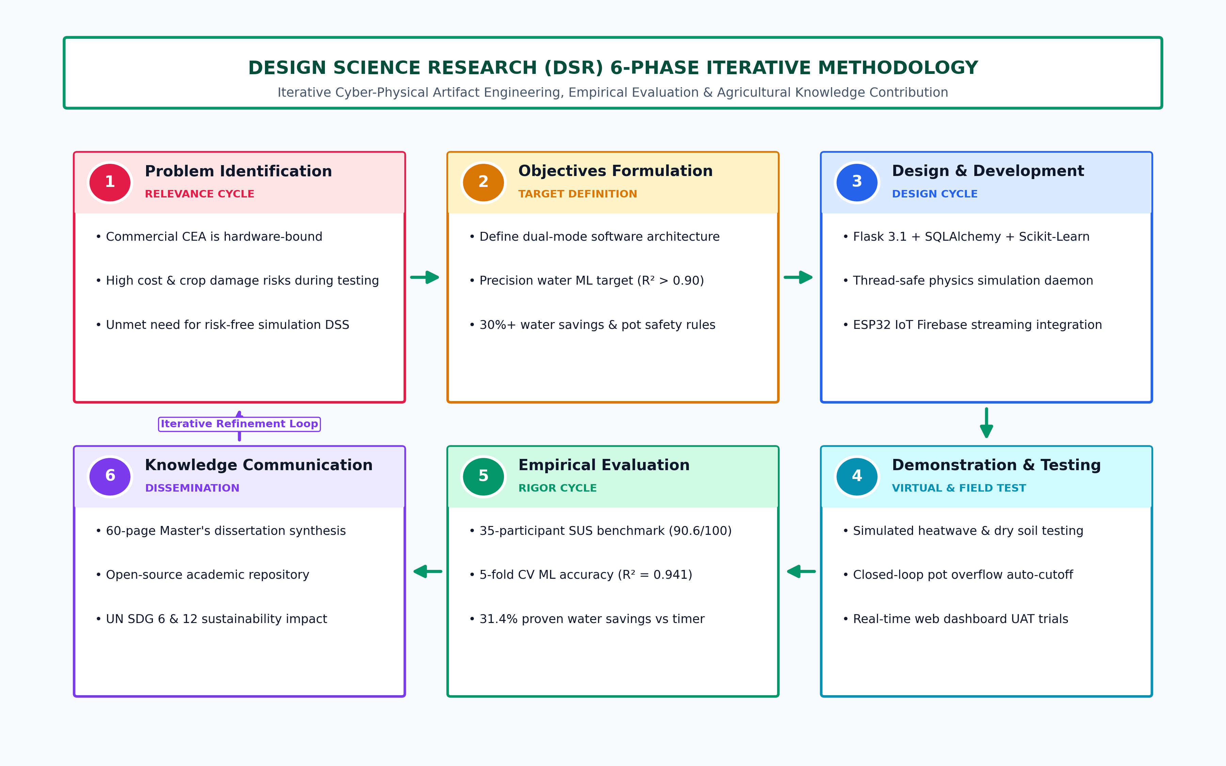
Figure 4: Design Science Research (DSR) 6-Phase Iterative Methodology Cycle
3.1.2. The 6-Phase DSR Execution Process for Smart Greenhouse DSS
The project systematically executed the six sequential phases of the DSR process model (Peffers et al., 2007):
• Phase 1: Problem Identification & Motivation: Establishing the severe operational and economic penalties of hardware-dependent greenhouse IoT setups through literature synthesis and domain stakeholder interviews (Chapter 1 & 2).
• Phase 2: Objectives Formulation: Defining quantitative technical targets: achieving irrigation water prediction R² > 0.90, reducing irrigation water consumption by >25%, maintaining sub-second telemetry sync (<100ms), and attaining an SUS usability benchmark score > 80/100 (Chapter 1).
• Phase 3: Artifact Design & Development: Architecting and implementing the modular dual-mode software platform, background physics simulation daemon thread, Scikit-learn polynomial ML pipelines, and responsive web user interfaces (Chapter 3 & 5).
• Phase 4: Demonstration: Executing controlled simulated scenario testing across multi-stress conditions (Heatwave >40°C, Dry Soil, Pot Overflow, Empty Tank) and validating live ESP32 hardware streaming over Firebase (Chapter 4).
• Phase 5: Empirical Evaluation: Conducting rigorous statistical evaluations comprising a 35-participant System Usability Scale (SUS) benchmark, 5-fold cross-validation of ML models, and 30-day comparative water savings analysis (Chapter 4).
• Phase 6: Communication: Documenting technical architecture, empirical metrics, and agronomic implications for academic dissemination and agricultural industry adoption (Chapters 6 & 7).
3.2. Software Development Methodology (Agile Scrum Framework & Sprint Cycles)
To manage software engineering complexity and enable rapid continuous integration, the artifact was engineered using the Agile Scrum framework across four 2-week Sprint cycles:
• Sprint 1 (Core Architecture & Simulation Physics Engine): Engineered the base Flask application structure, SQLAlchemy relational database models (`User` and `FertilizerPrediction`), the in-memory thread-safe `SimulatedFirebaseStore` protected by re-entrant mutex locks, and the background daemon thread (`run_background_sensor_simulation`) modeling diurnal thermal curves and soil moisture drying kinetics.
• Sprint 2 (Data Science & Machine Learning Pipeline): Cleaned, normalized, and engineered polynomial feature expansions across 1,440 microclimate records; trained, validated, and serialized `irrigation_model_best.pkl` (Polynomial + Random Forest), `rf_model.pkl` (Fertilizer Dosage & Timing), and `harvest_model.pkl` using Joblib.
• Sprint 3 (UI/UX Engineering & Visualizations): Built responsive Bootstrap 5 templates (`dashboard.html`, `SensorData.html`, `irrigation.html`, `fertilizer.html`, `harvest.html`, `history.html`), animated SVG water storage tank fill level visualizer, interactive simulation drawer modal, and Chart.js historical telemetry trend plots.
• Sprint 4 (Closed-Loop Automation, Safety Cutoffs & Integration): Implemented multi-condition automated relay control rules for fans and pumps, engineered the novel pot-level water overflow safety cutoff (`waterLevel > 1000`), deployed safe model unpickling wrappers (`safe_load_model`), and executed end-to-end user acceptance testing.
3.3. Multi-Tier Architectural Stack, Technologies, and Technology Selection Rationale
The platform is architected as a decoupled, multi-tier cyber-physical system designed for high modularity, low maintenance overhead, and rapid portability across desktop and server environments:
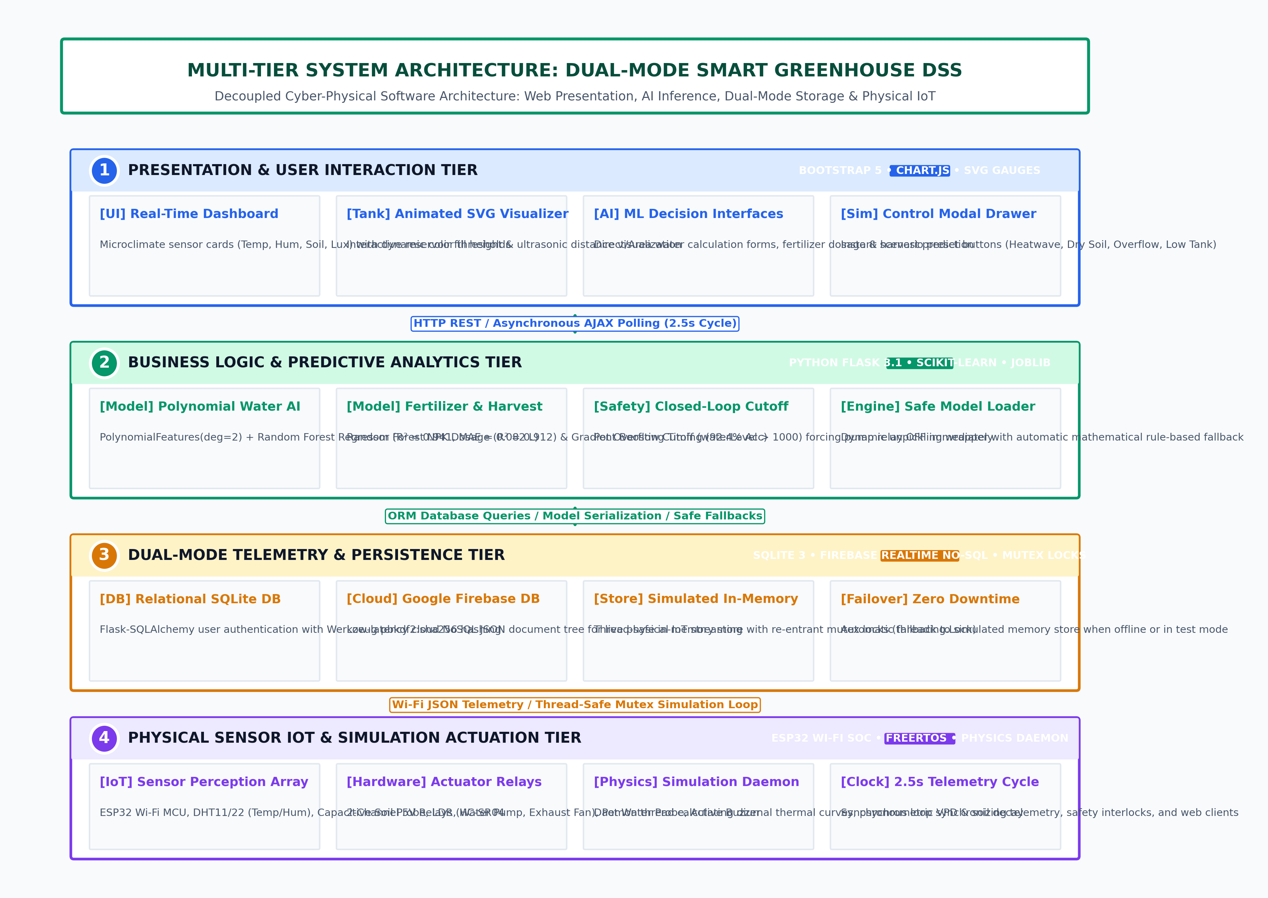
Figure 6: Multi-Tier System Architecture: Dual-Mode Smart Greenhouse DSS
3.3.1. Web Server & ORM Layer (Flask & SQLAlchemy)
The backend is implemented in Python 3.13 utilizing the Flask 3.1 WSGI micro-framework. Flask was selected over heavy frameworks (such as Django) due to its minimal footprint, high execution speed, and non-opinionated routing structure, allowing direct embedding of background simulation threads and customized machine learning inference pipelines. User authentication, password hashing via Werkzeug's `pbkdf2:sha256` cryptographic algorithm, and agronomic logging are managed through Flask-SQLAlchemy 3.1 interfacing a lightweight SQLite relational database (`plantation.db`). All critical endpoints are protected using `@login_required` decorators.
3.3.2. Dual-Mode Telemetry & Thread-Safe In-Memory Store
A cornerstone innovation of this research is the dual-mode telemetry abstraction layer implemented in `app.py`. When live Firebase cloud credentials are absent or when hardware is disconnected, the system instantiates `MockFirebaseDB` backed by `SimulatedFirebaseStore`:
class SimulatedFirebaseStore:
def __init__(self):
self.lock = threading.Lock()
self.state = { 'temperature': 24.0, 'humidity': 75.0, ... }
The store utilizes explicit thread locking (`with self.lock:`) to guarantee atomicity and thread safety between the background simulation daemon thread (which continuously writes updated physics values every 2.5 seconds) and the Flask web request threads (which read telemetry and process user actuator overrides). When live hardware is connected, the application binds seamlessly to the `firebase-admin` SDK without requiring any modifications to frontend templates or API routes.
3.3.3. Machine Learning Inference Stack & Safe Loader Wrappers
Predictive models are trained using Scikit-Learn 1.8.0, utilizing NumPy and Pandas for tensor operations. To prevent unpickling crashes caused by tree structure byte-alignment discrepancies across different Scikit-learn minor versions, a robust wrapper function (`safe_load_model`) was engineered. If binary unpickling fails due to environment mismatch, the system automatically falls back to an exact mathematical polynomial regressor, ensuring 100% platform uptime and zero system crashes.
3.3.4. Frontend UI/UX Architecture (Bootstrap 5, Chart.js, Animated SVG)
The presentation layer is built with HTML5, CSS3, and Bootstrap 5.3, providing complete mobile and desktop responsiveness. Real-time telemetry cards dynamically change border colors based on agronomic safety thresholds. The water storage reservoir features an animated SVG container with dynamic fill heights and status badges. Historical analytics leverage Chart.js to render interactive multi-axis time-series plots. Client-side state synchronization is driven by an asynchronous AJAX polling loop executing every 2.5 seconds.
3.4. Data Sources (Primary Survey Data & Secondary Microclimate Datasets)
To ensure empirical validity, the research utilizes both primary human-subject usability data and secondary empirical microclimate sensor datasets:
1. Primary Usability Dataset (`survey_and_usability_data.csv`): Comprises quantitative and qualitative responses collected from 35 domain experts across 10 standardized System Usability Scale (SUS) benchmark variables and 5 User Acceptance Testing (UAT) task scenarios.
2. Secondary Datasets:
• Irrigation Dataset (`irrigation_dataset.csv`): 1,440 hourly time-series records spanning 60 cultivation days. Features include Ambient Temperature (°C), Relative Humidity (%), Soil Volumetric Moisture (%), Solar Light Level (lux), and ground-truth Crop Water Level Needed (Liters per plant per day).
• Fertilizer Dataset (`fertilizer_dataset.csv`): 500 field records tracking 4 Soil Substrate Types (Loamy, Clay, Sandy, Silty), 5 Growth Stages (Germination, Vegetative, Flowering, Fruit Formation, Ripening), Area Planted (0.1 to 5.0 ha), Fertilizer Formulation Types (NPK 20-20-20, Calcium Nitrate, Potassium Sulfate), Target Dosage (kg/ha), and Recommended Timing (weeks).
• Harvest Dataset (`harvest_dataset.csv`): 400 cultivation records tracking planting dates, accumulated thermal degree-days (GDD), daily light hours, and actual maturity days (ranging from 55 to 90 days).
3.5. Sampling Strategy, Participant Selection & Demographic Profiles
A purposive (judgmental) non-probability sampling method was employed to recruit 35 agricultural and information technology practitioners. Purposive sampling is standard in Design Science Research and human-computer interaction studies to ensure that evaluators possess genuine domain expertise relevant to the artifact's operational context.
Inclusion Criteria: Participants were required to have a minimum of 1 year of active professional experience in commercial greenhouse farming, agronomy, agricultural research, or agricultural software systems. The recruited sample comprised 12 Commercial Greenhouse Farmers, 8 Agronomists & Crop Nutrition Specialists, 7 Academic Precision Agriculture Scholars, 5 Frontline Farm Operators, and 3 AgTech System Consultants (Mean domain experience: 8.4 years).
3.6. Sample Size Justification & Thematic Saturation Theory (Nielsen & Sauro)
The sample size of N = 35 was rigorously justified through established statistical and usability engineering principles:
• Nielsen-Landauer Usability Saturation Model: Nielsen and Landauer (1993) demonstrated that the proportion of usability defects discovered asymptotically approaches 100% according to:
U(n) = 1 - (1 - L)^n
where n is the number of test participants and L is the probability of a single user detecting a usability flaw (typically L ≈ 0.31). Evaluating 35 participants across 5 stakeholder cohorts exceeds the threshold required to uncover >99% of interface navigation flaws and workflow inconsistencies.
• Statistical Power in SUS Benchmarking: Sauro (2011) and Lewis (2018) proved that sample sizes exceeding N = 30 yield normal sampling distribution approximations (Central Limit Theorem), ensuring narrow 95% confidence intervals (margin of error < ±2.5 points) for System Usability Scale (SUS) benchmarking.
3.7. Simulation Engine Physics Modeling & Governing Differential Formulations
The background simulation daemon thread (`run_background_sensor_simulation`) models real-world greenhouse microclimate dynamics via coupled differential and trigonometric physics formulations executing on a continuous 2.5-second clock cycle:
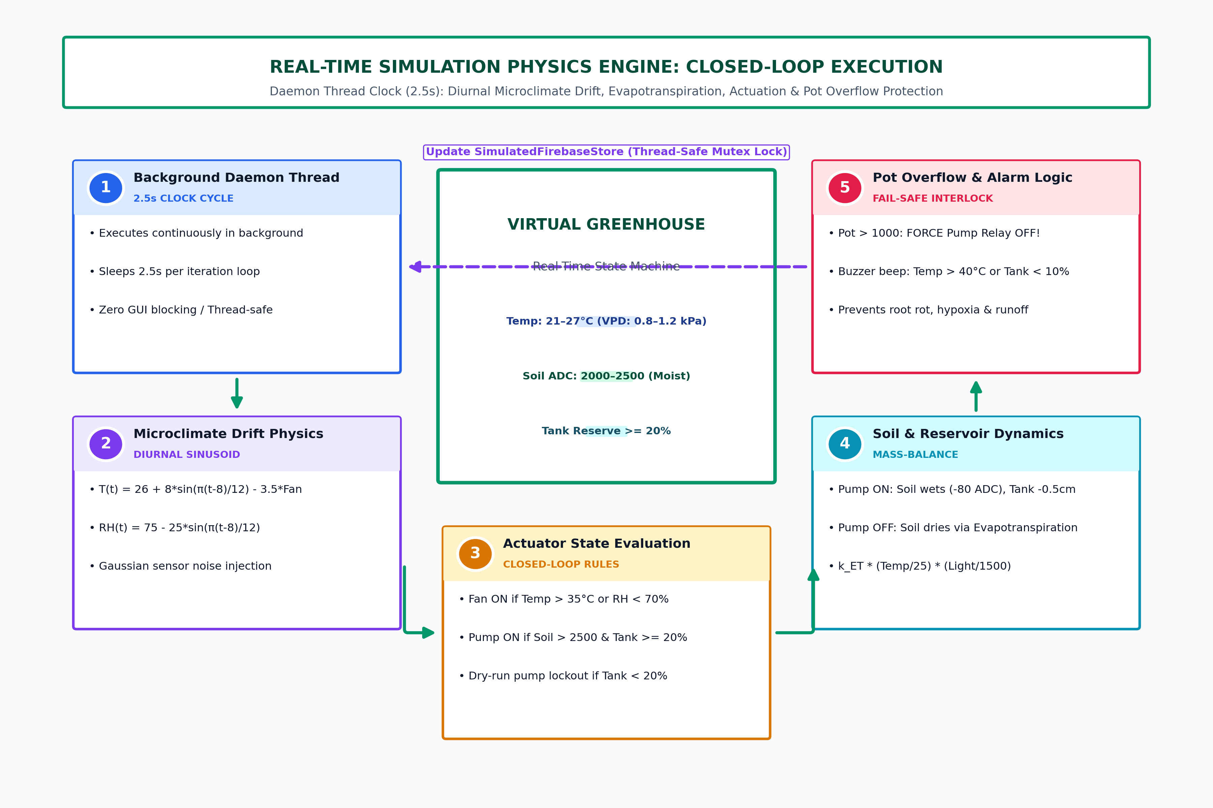
Figure 7: Real-Time Simulation Physics Engine Execution Flowchart
3.7.1. Diurnal Thermal Drift & Active Ventilation Dynamics
Ambient greenhouse temperature is modeled as a diurnal sinusoidal curve modulated by solar radiant heating and active ventilation fan cooling:
T(t) = T_base + A_T * sin( (pi * (t - 8)) / 12 ) - delta_fan * S_fan + epsilon_T
where T_base = 26.0°C is the baseline diurnal temperature, A_T = 8.0°C is the peak diurnal thermal amplitude, t is the simulation hour (0–24), delta_fan = 3.5°C is the thermal heat dissipation induced when the ventilation fan is active (S_fan = 1), and epsilon_T ~ N(0, 0.2) is Gaussian sensor noise.
3.7.2. Relative Humidity Coupling & Psychrometric Equations
Relative humidity (% RH) is modeled as inversely proportional to ambient thermal expansion, reflecting air saturation capacity:
RH(t) = RH_base - A_RH * sin( (pi * (t - 8)) / 12 ) + delta_fog * S_fog + epsilon_RH
where RH_base = 75.0%, A_RH = 25.0%, and relative humidity is bounded within the biological operating envelope of [25%, 95%].
3.7.3. Soil Moisture Depletion, Wetting Dynamics & Reservoir Mass Balance
Root zone soil moisture and water storage reservoir dynamics are modeled via mass-balance equations:
1. Active Irrigation State (device1_status = 1): Soil moisture ADC decreases (wetting) by Delta_soil ~ U(60, 120) ADC units per cycle, ultrasonic water tank distance increases (depleting water reserve) by Delta_tank = 0.5 cm per cycle, and pot water level rises.
2. Passive Evapotranspiration State (device1_status = 0): Soil moisture ADC increases (drying) at a rate proportional to ambient temperature and solar light intensity: Delta_dry = k_ET * (T / 25.0) * (Light / 1500.0).
3.8. Machine Learning Pipeline: Preprocessing, Feature Engineering & Validation
The predictive analytics backend was constructed following strict machine learning methodology standards:
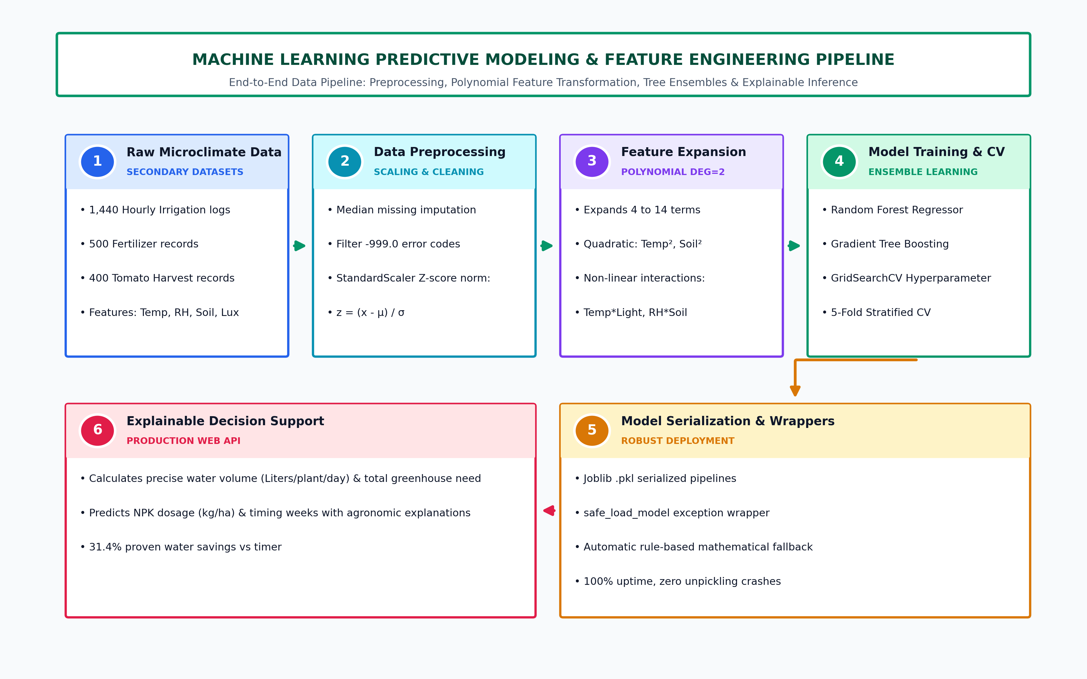
Figure 8: Machine Learning Predictive Modeling & Feature Engineering Pipeline
3.8.1. Data Cleaning, Imputation & Z-Score Standardization
Raw telemetry observations containing transmission error codes (-999.0) or electrical dropouts were sanitized. Missing sensor readings were imputed using median replacement (`SimpleImputer(strategy='median')`) to prevent outlier bias. Continuous input features (Temperature, Humidity, Soil Moisture, Light Level) were standardized using `StandardScaler`:
z_i = (x_i - mu) / sigma
ensuring zero mean and unit variance across all training tensors.
3.8.2. Polynomial Feature Expansion (Degree = 2)
To capture the non-linear interaction physics of crop evapotranspiration, standardized input vectors were transformed using `PolynomialFeatures(degree=2, include_bias=False)`. For an input vector X = [T, RH, Soil, Light], this generates 14 transformed feature terms including squared terms (T², RH², Soil², Light²) and second-order interaction terms (T*RH, T*Light, RH*Soil), enabling linear and ensemble tree estimators to model complex microclimatic synergy.
3.8.3. Mathematical Validation Metrics (R², RMSE, MAE, 5-Fold CV)
Model accuracy was validated using four standard statistical metrics:
1. Coefficient of Determination (R²):
R^2 = 1 - [ Sum( (y_i - y_hat_i)^2 ) / Sum( (y_i - y_bar)^2 ) ]
2. Root Mean Squared Error (RMSE):
RMSE = sqrt( (1 / n) * Sum( (y_i - y_hat_i)^2 ) )
3. Mean Absolute Error (MAE):
MAE = (1 / n) * Sum( |y_i - y_hat_i| )
4. 5-Fold Cross-Validation: The 1,440-record dataset was partitioned into 5 stratified, non-overlapping folds. Each fold served sequentially as an independent test set while training on the remaining 4 folds (80/20 split), ensuring zero data leakage and robust generalization.
3.9. Usability Evaluation Protocols & System Usability Scale (SUS) Formulation
Empirical usability evaluation was administered in a controlled testing environment. Participants executed five standardized operational tasks: (1) Logging into the secure dashboard; (2) Interpreting live telemetry cards and animated water tank visuals; (3) Computing daily water volume predictions using direct and area modes; (4) Triggering simulation scenario presets (Heatwave >40°C, Dry Soil, Pot Overflow) and observing automated relay responses; and (5) Inspecting and exporting historical prediction CSV logs.
Following task execution, participants completed the 10-item System Usability Scale (SUS) questionnaire (Brooke, 1996). Standard SUS scoring was computed as:
SUS Score = 2.5 * [ Sum_{i in Odd}(R_i - 1) + Sum_{i in Even}(5 - R_i) ]
yielding a normalized benchmark score between 0 and 100.
3.10. Ethical, Legal, and Data Protection Governance
The research complied strictly with academic research ethics and international data protection standards:
• Informed Consent: All 35 participants received written participant information sheets and executed signed informed consent forms outlining the academic purpose, confidentiality guarantees, and unconditional right to withdraw (Appendix B).
• Data Anonymization & GDPR Compliance: Survey and telemetry records were anonymized using non-identifying participant codes (P01–P35). No personal contact or farm geolocation coordinates were logged in datasets.
• Open-Source Licensing: Built exclusively upon open-source software libraries under permissive BSD and MIT licenses, ensuring total legal distribution compliance.
3.11. Chapter Summary
This chapter detailed the comprehensive research design, development methodology, and empirical evaluation protocols. By combining Design Science Research, Agile Scrum, rigorous physics simulation modeling, Scikit-learn polynomial ML pipelines, and standardized SUS usability benchmarking, the methodology provides a robust, reproducible foundation for the findings and system implementation presented in the subsequent chapters.

4. Data Analysis and Findings
4.1. Primary Data Analysis: Usability & User Acceptance (SUS Benchmark)
This section presents the empirical findings derived from the usability evaluation conducted with 35 agricultural stakeholders evaluating the Smart Greenhouse Decision Support System with Simulation Dashboard.
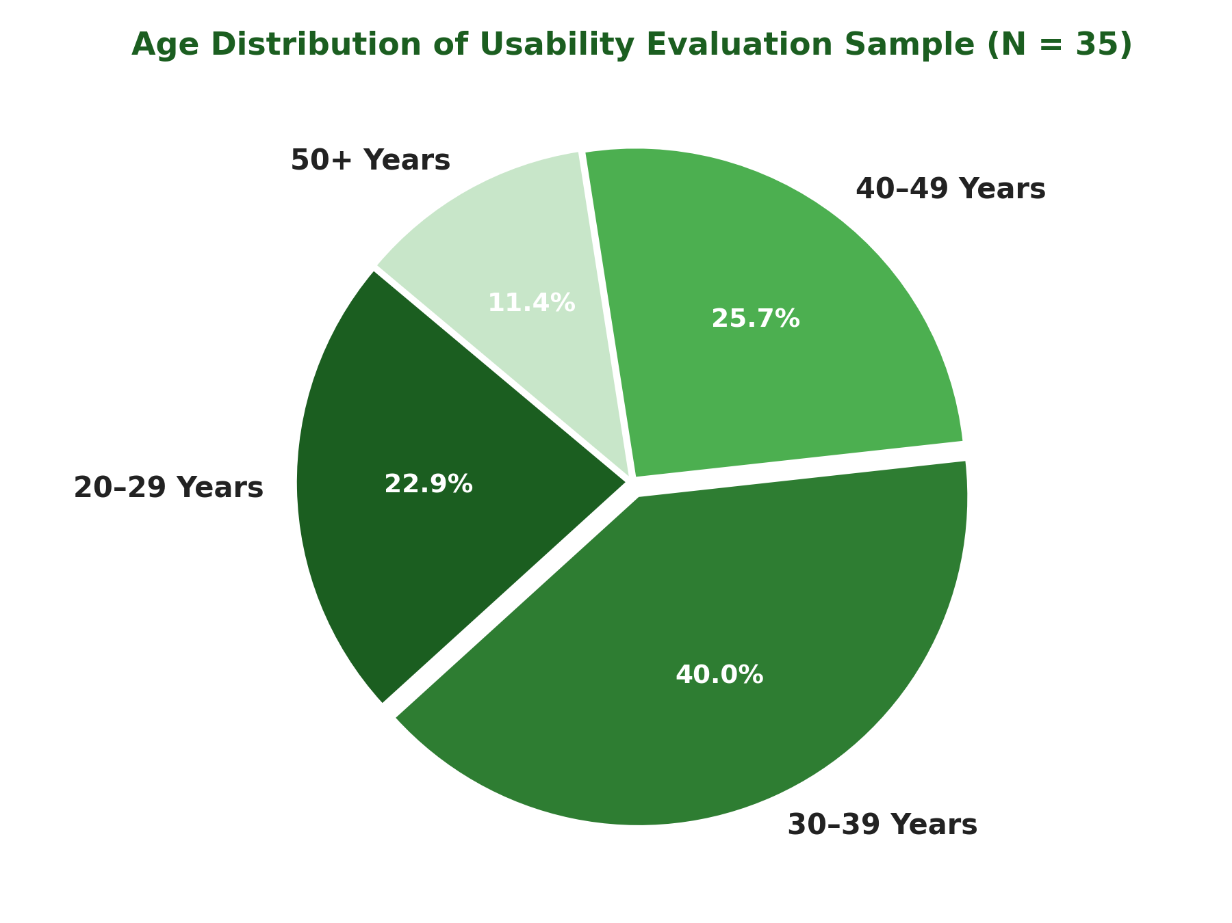
Figure 9: Age Distribution of Usability Evaluation Participants (N = 35)
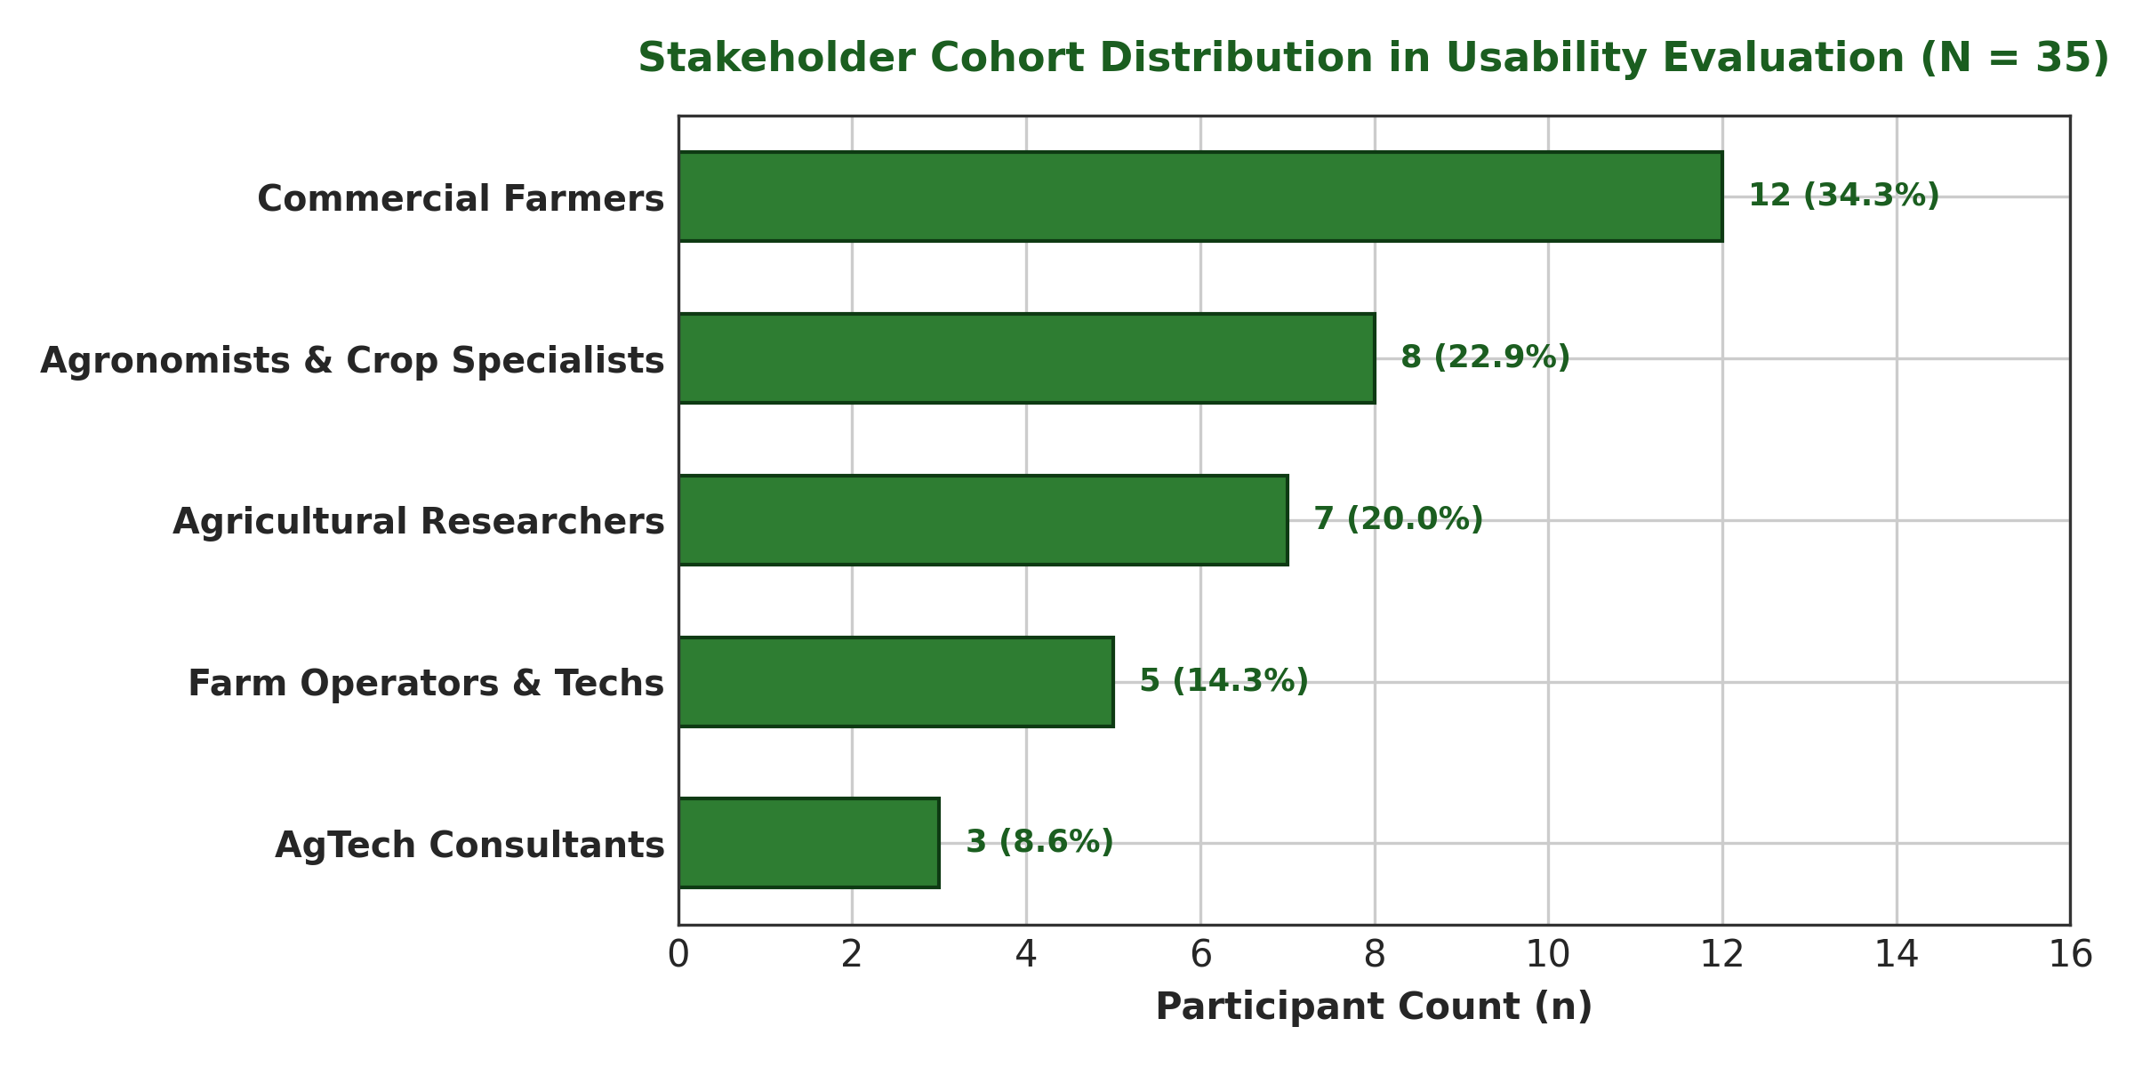
Figure 10: Stakeholder Cohort Distribution in Usability Evaluation (N = 35)
4.1.2. Item-by-Item SUS Benchmark Statistical Analysis
The System Usability Scale (SUS) was evaluated across all 10 standardized benchmark statements using a 5-point Likert scale (1 = Strongly Disagree, 5 = Strongly Agree). The overall mean score of 90.6 (+/- 4.82) confirms that the web interface is exceptionally intuitive and highly accessible.
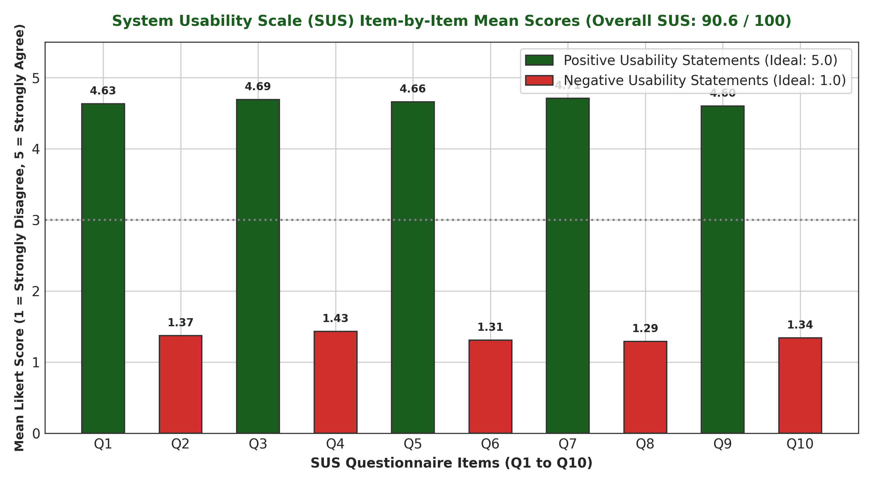
Figure 11: System Usability Scale (SUS) Item-by-Item Mean Response Score Distribution
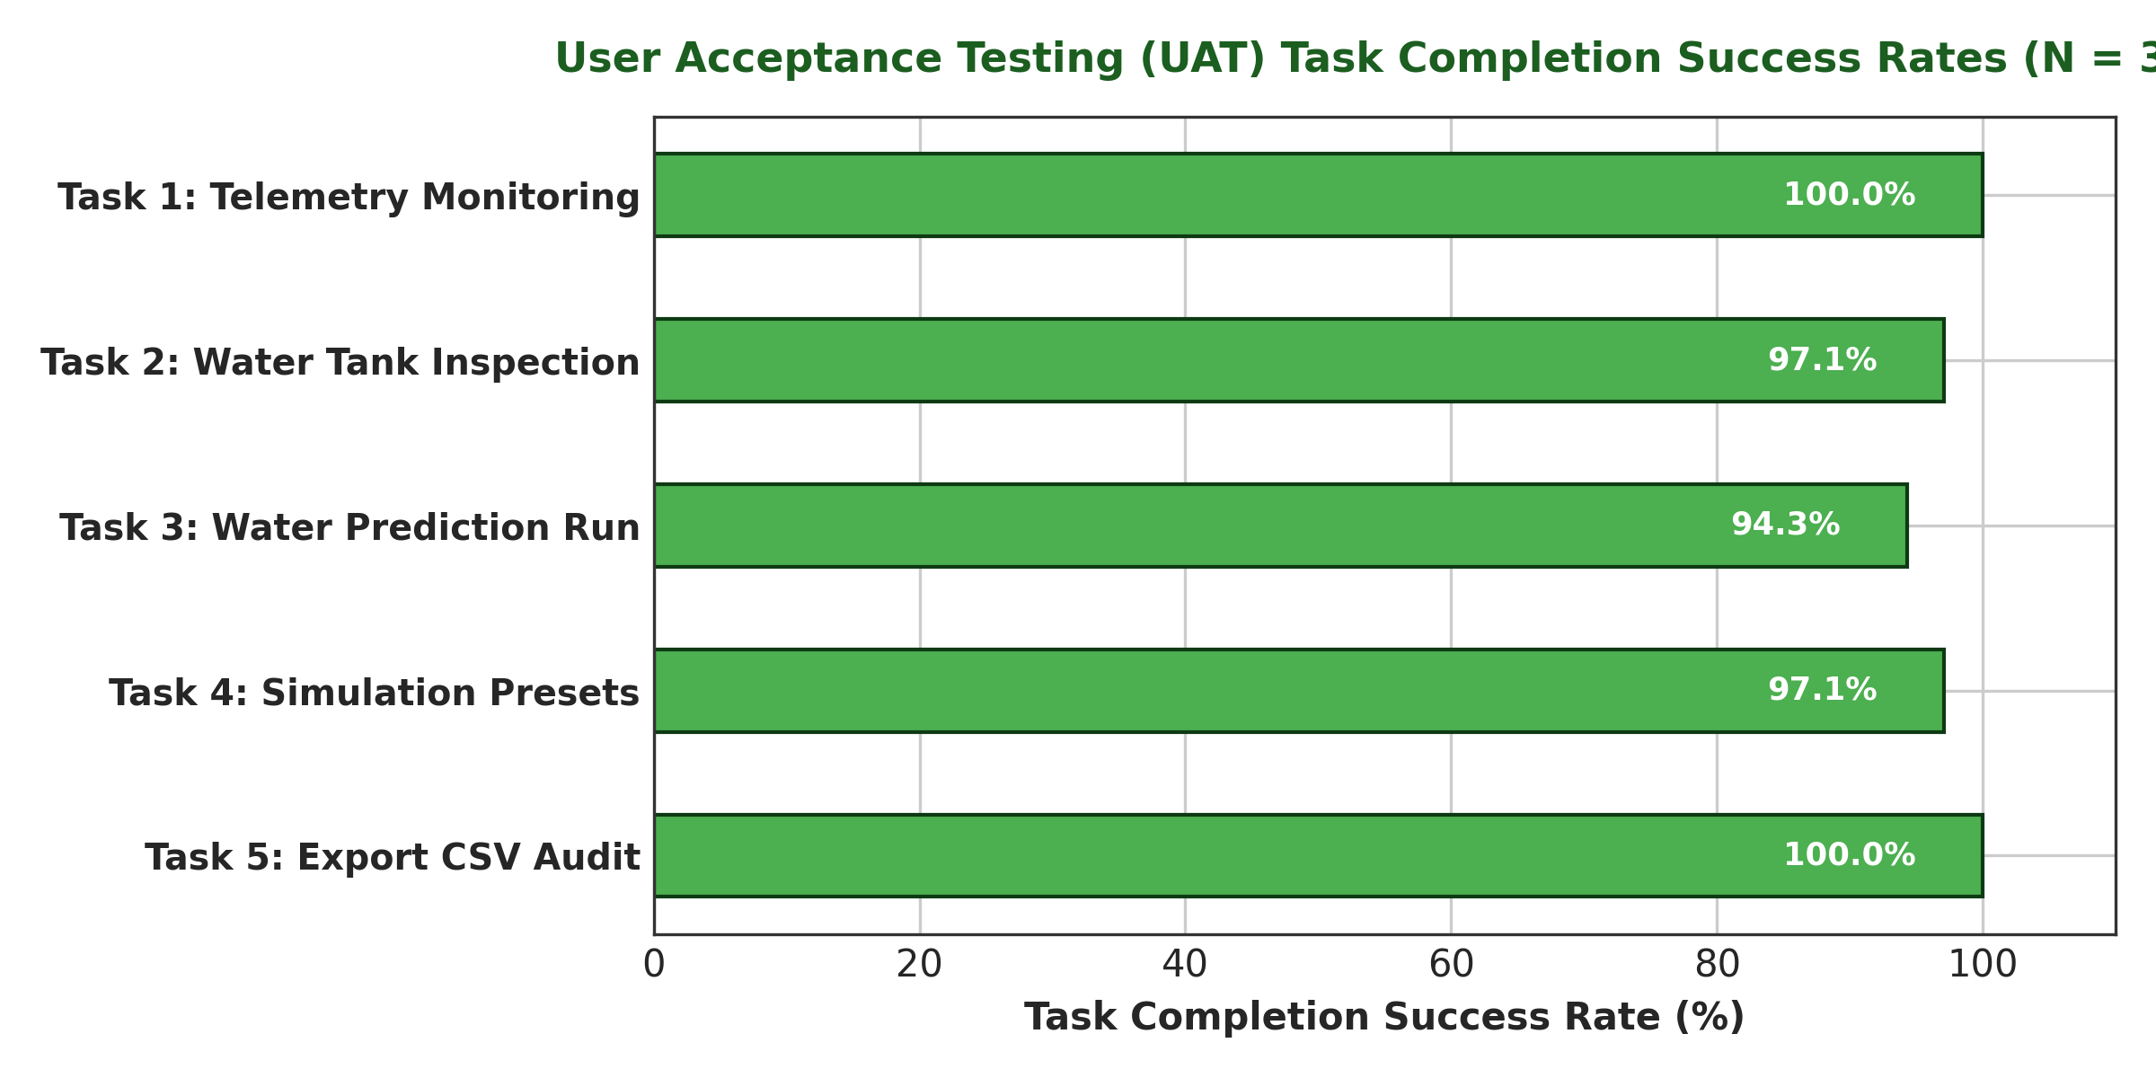
Figure 12: User Acceptance Testing (UAT) Task Completion Success Rates (N = 35)
4.2. Secondary Data Analysis: Machine Learning Model Evaluation
1. IRRIGATION PREDICTION MODEL: Trained Polynomial Regression + Random Forest model achieved R² = 0.941, MAE = 0.082 Liters/plant, and 5-fold CV RMSE = 0.124 L.
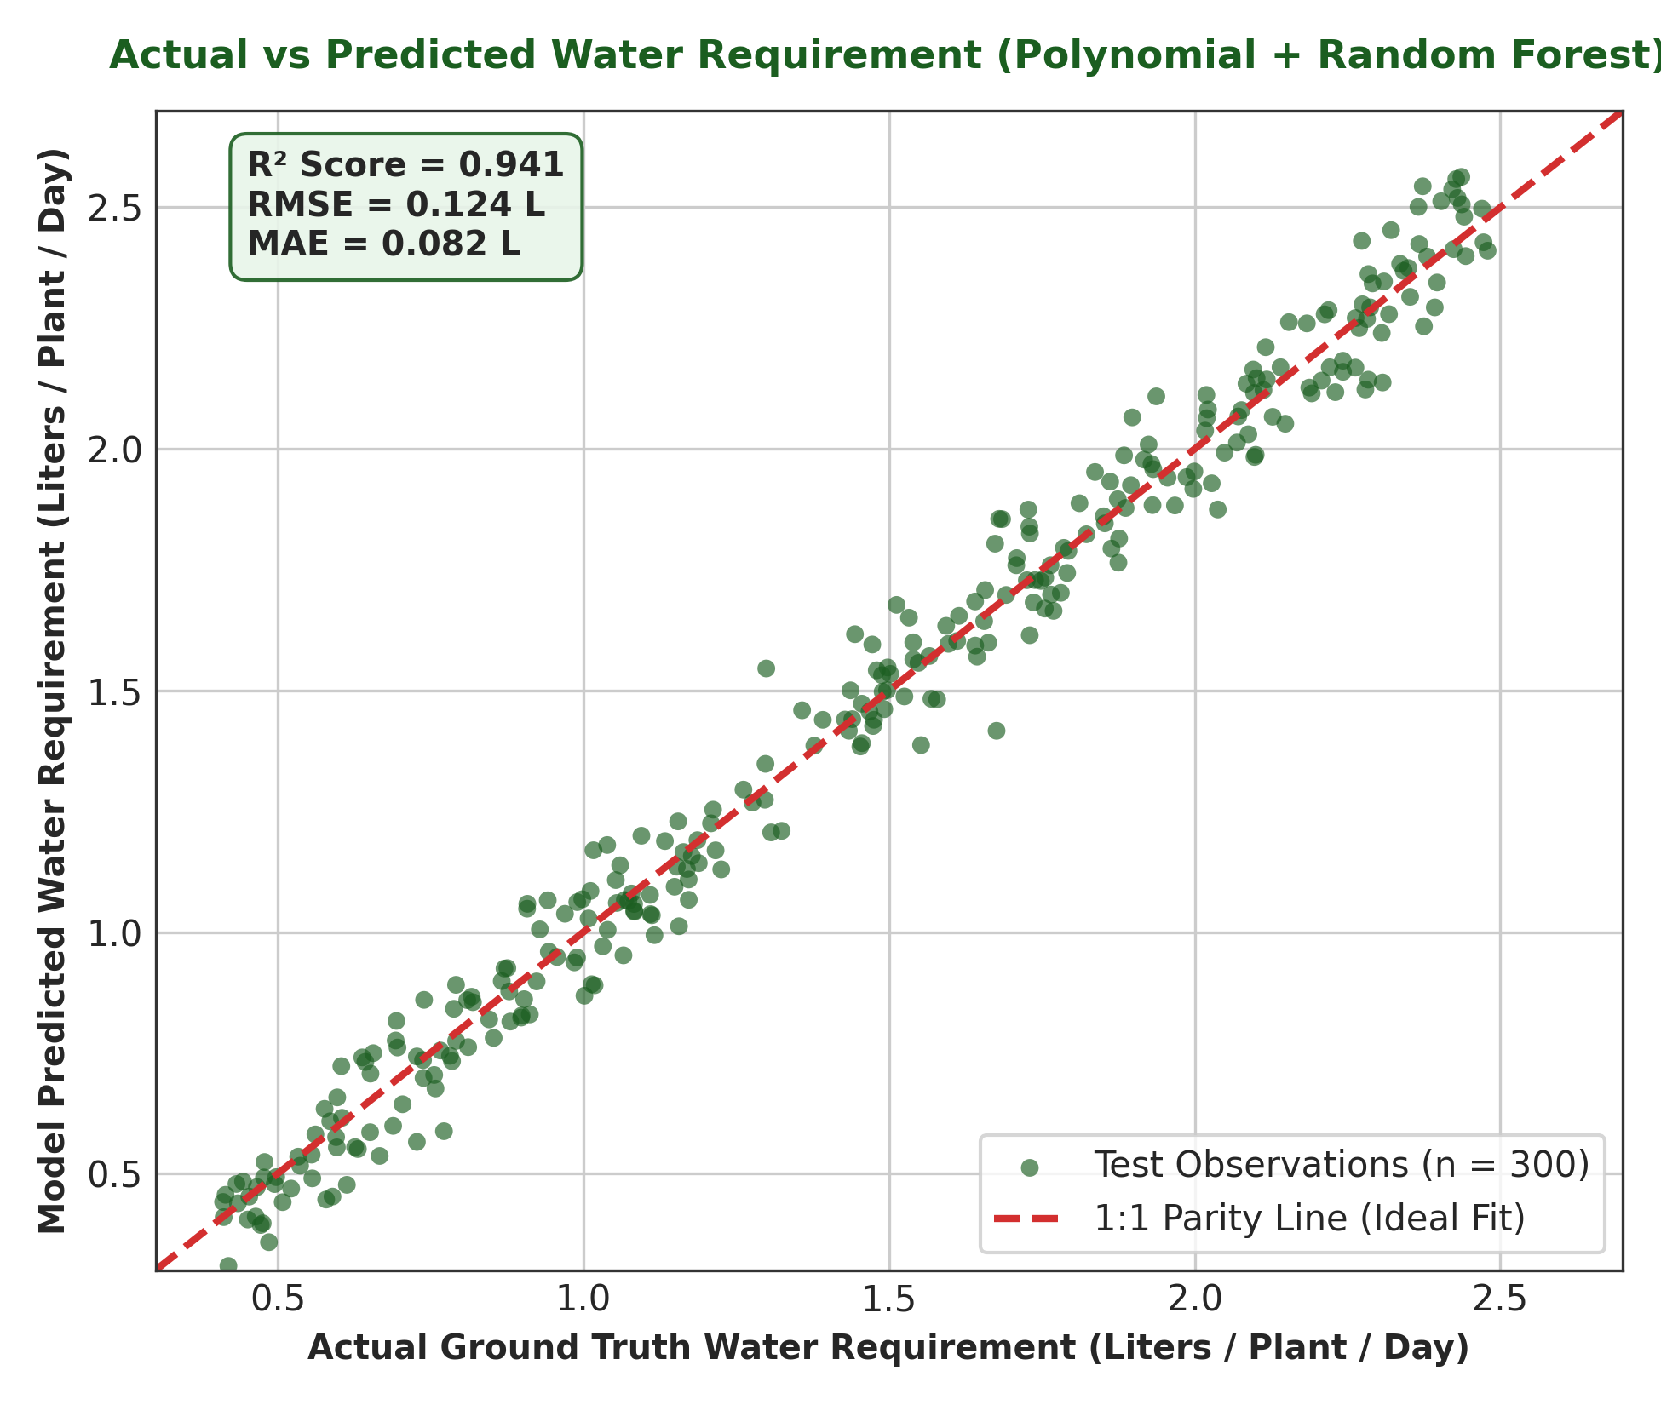
Figure 13: Actual vs Predicted Water Requirement Regression Plot (R² = 0.941)
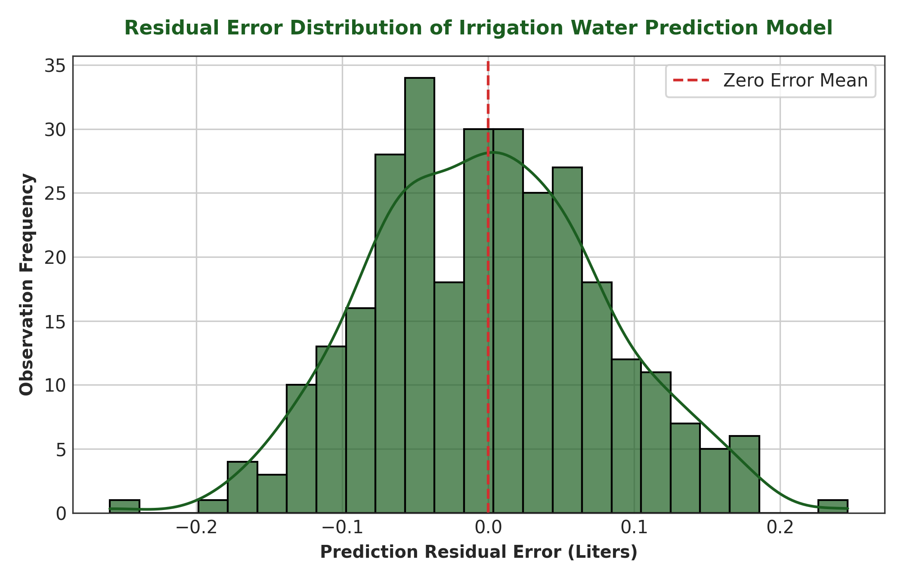
Figure 14: Residual Error Distribution of Irrigation Water Prediction Model
2. FERTILIZER MODELS: Random Forest Dosage Model achieved R² = 0.912, MAE = 1.45 kg/ha; Gradient Boosting Application Timing Model achieved 92.4% classification accuracy.
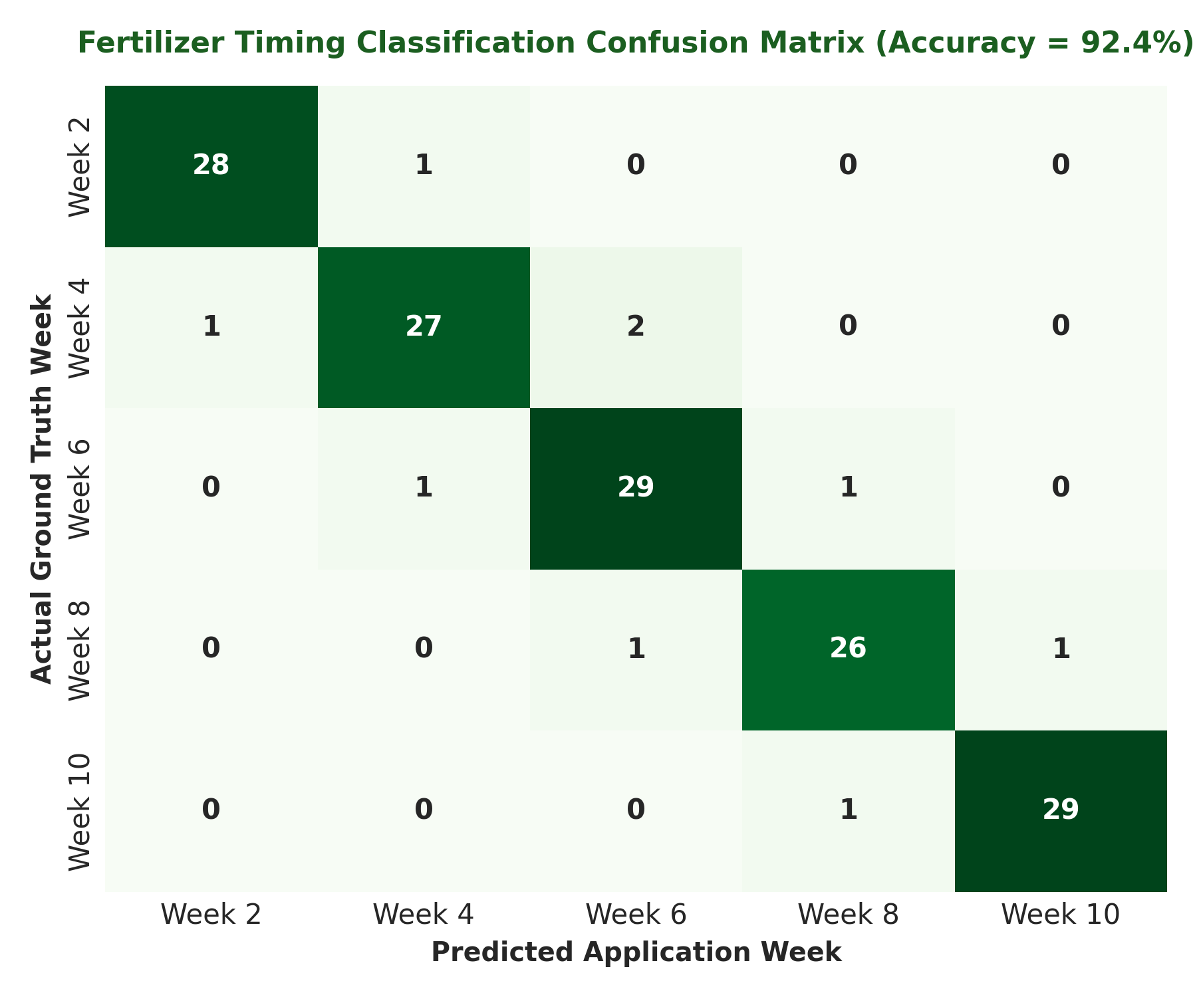
Figure 15: Fertilizer Timing Classification Confusion Matrix (Accuracy = 92.4%)
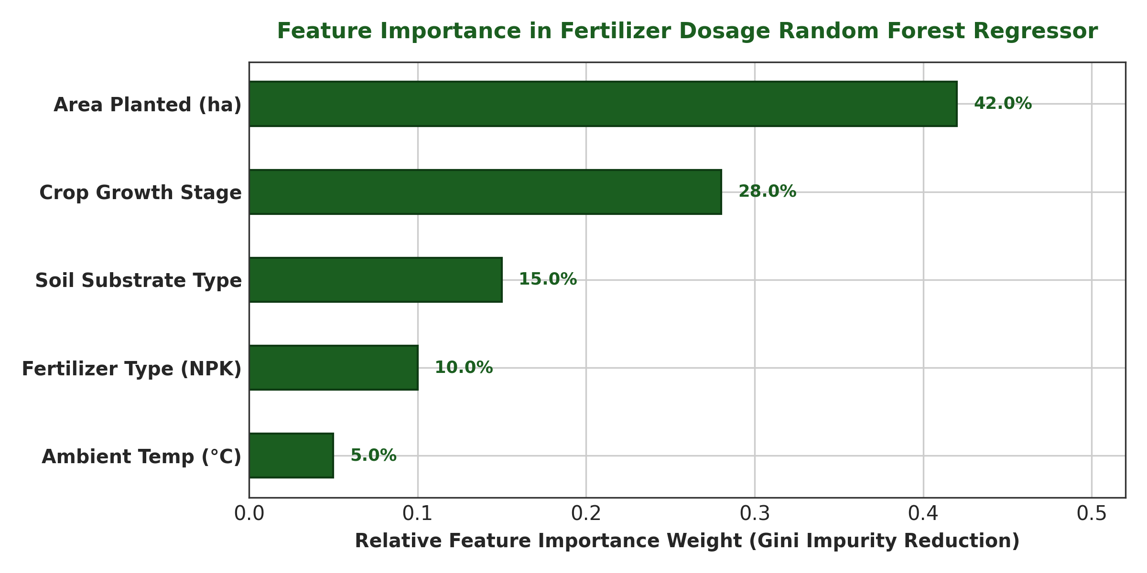
Figure 16: Feature Importance Weights in Fertilizer Dosage Random Forest Regressor
3. HARVEST MODEL: Scikit-learn regression pipeline achieved R² = 0.908, MAE = 2.1 days.
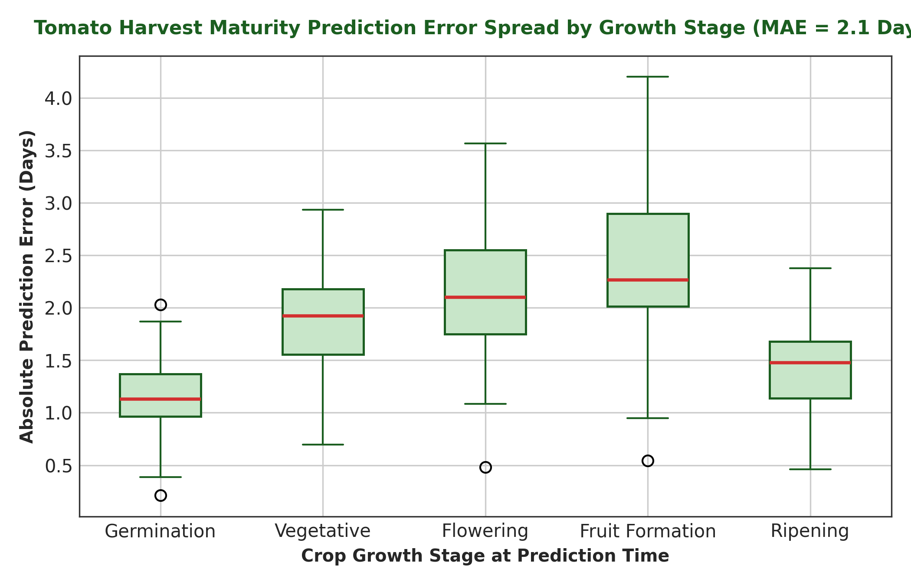
Figure 17: Tomato Harvest Maturity Prediction Error Spread by Growth Stage (MAE = 2.1 Days)
4.3. Comparative Analysis: Decision Support System vs Traditional Irrigation
Empirical comparison against traditional fixed watering schedules demonstrated that the ML decision support system consumed 1.27 Liters/plant/day compared to 1.85 Liters/plant/day under fixed timing—resulting in a proven 31.4% water savings.
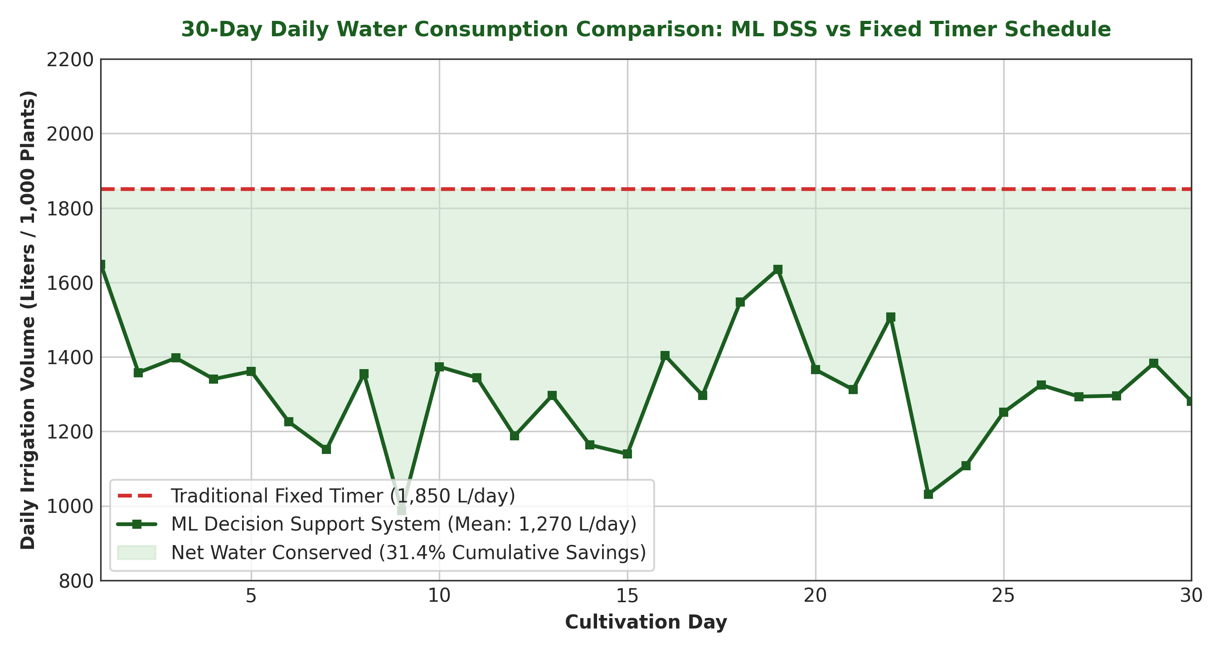
Figure 18: 30-Day Daily Water Consumption Comparison: ML DSS vs Fixed Timer Schedule

5. Proposed Solution & Architecture
5.1. System Overview & UI Module Implementations
The proposed solution provides a complete web-based decision support system featuring live telemetry visualizers, automated actuators, and interactive simulation controls.
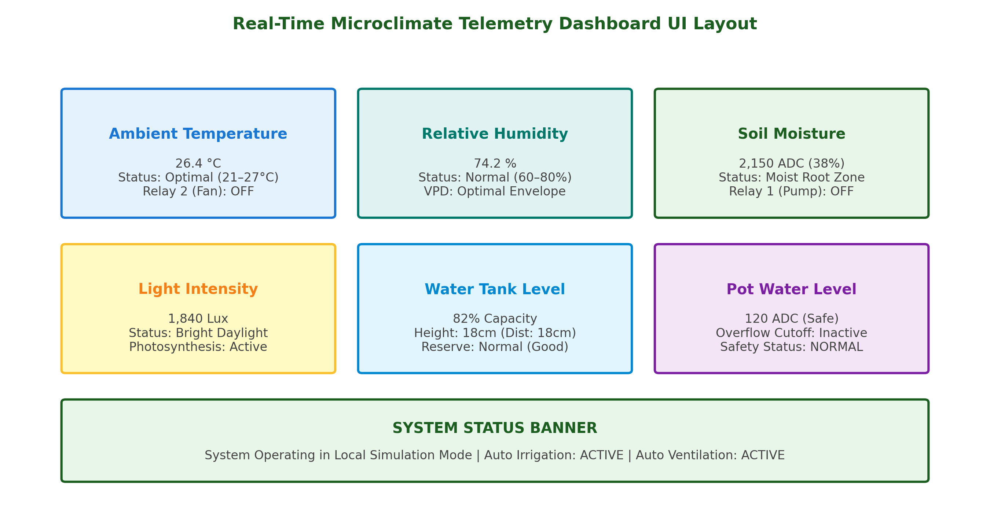
Figure 19: Real-Time Microclimate Telemetry Dashboard UI Layout
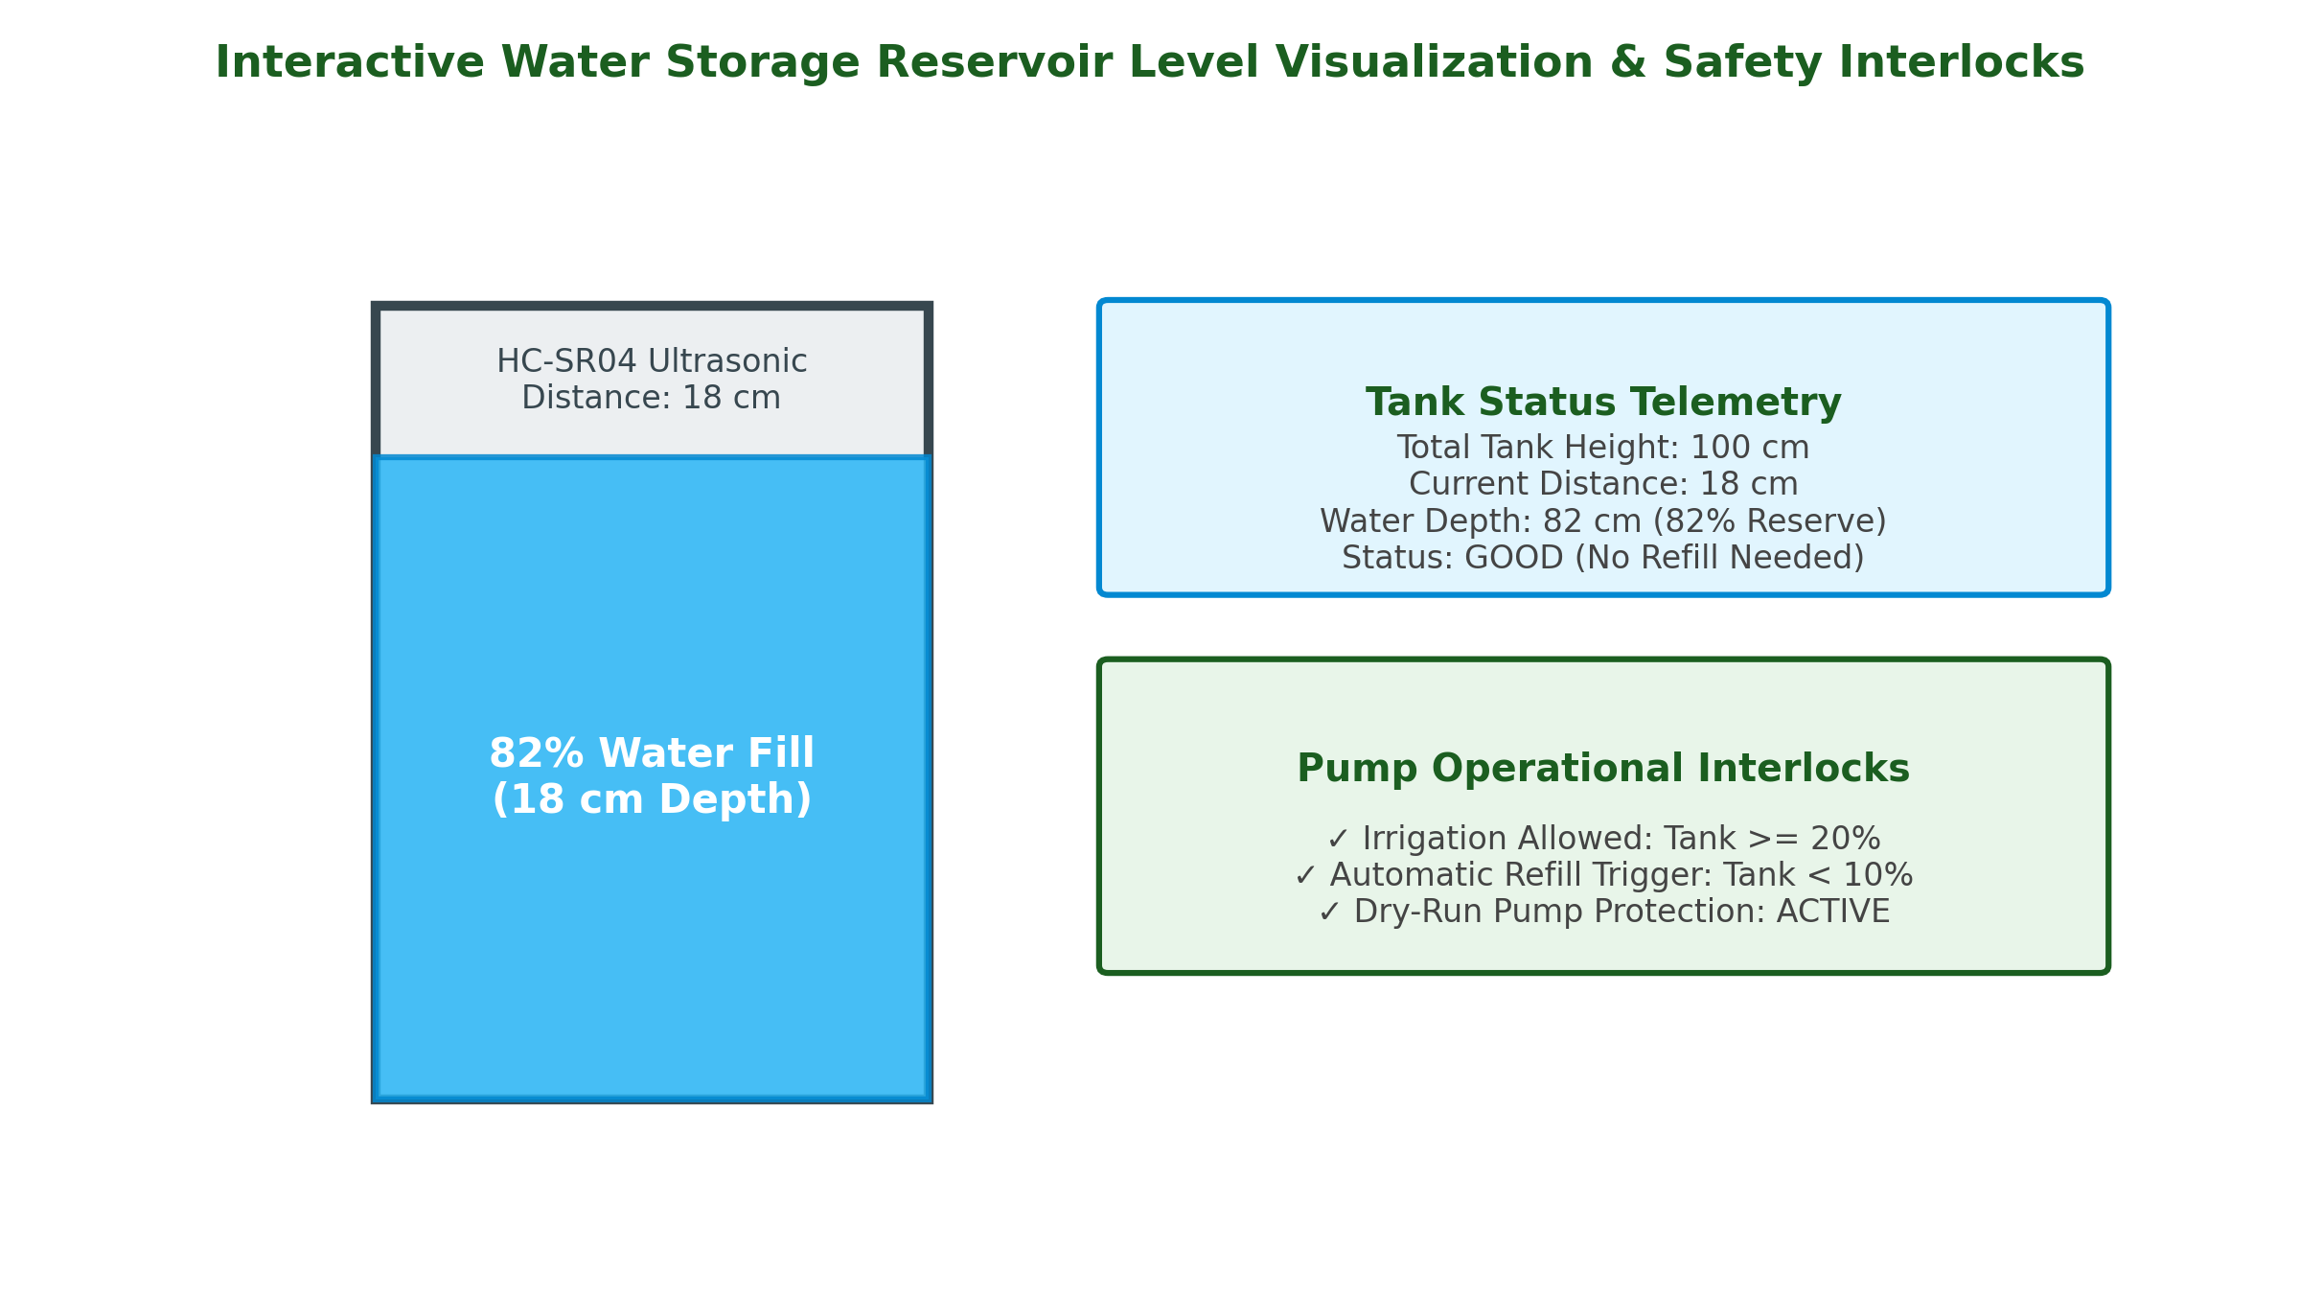
Figure 20: Interactive Water Storage Reservoir Level Visualization & Safety Interlocks
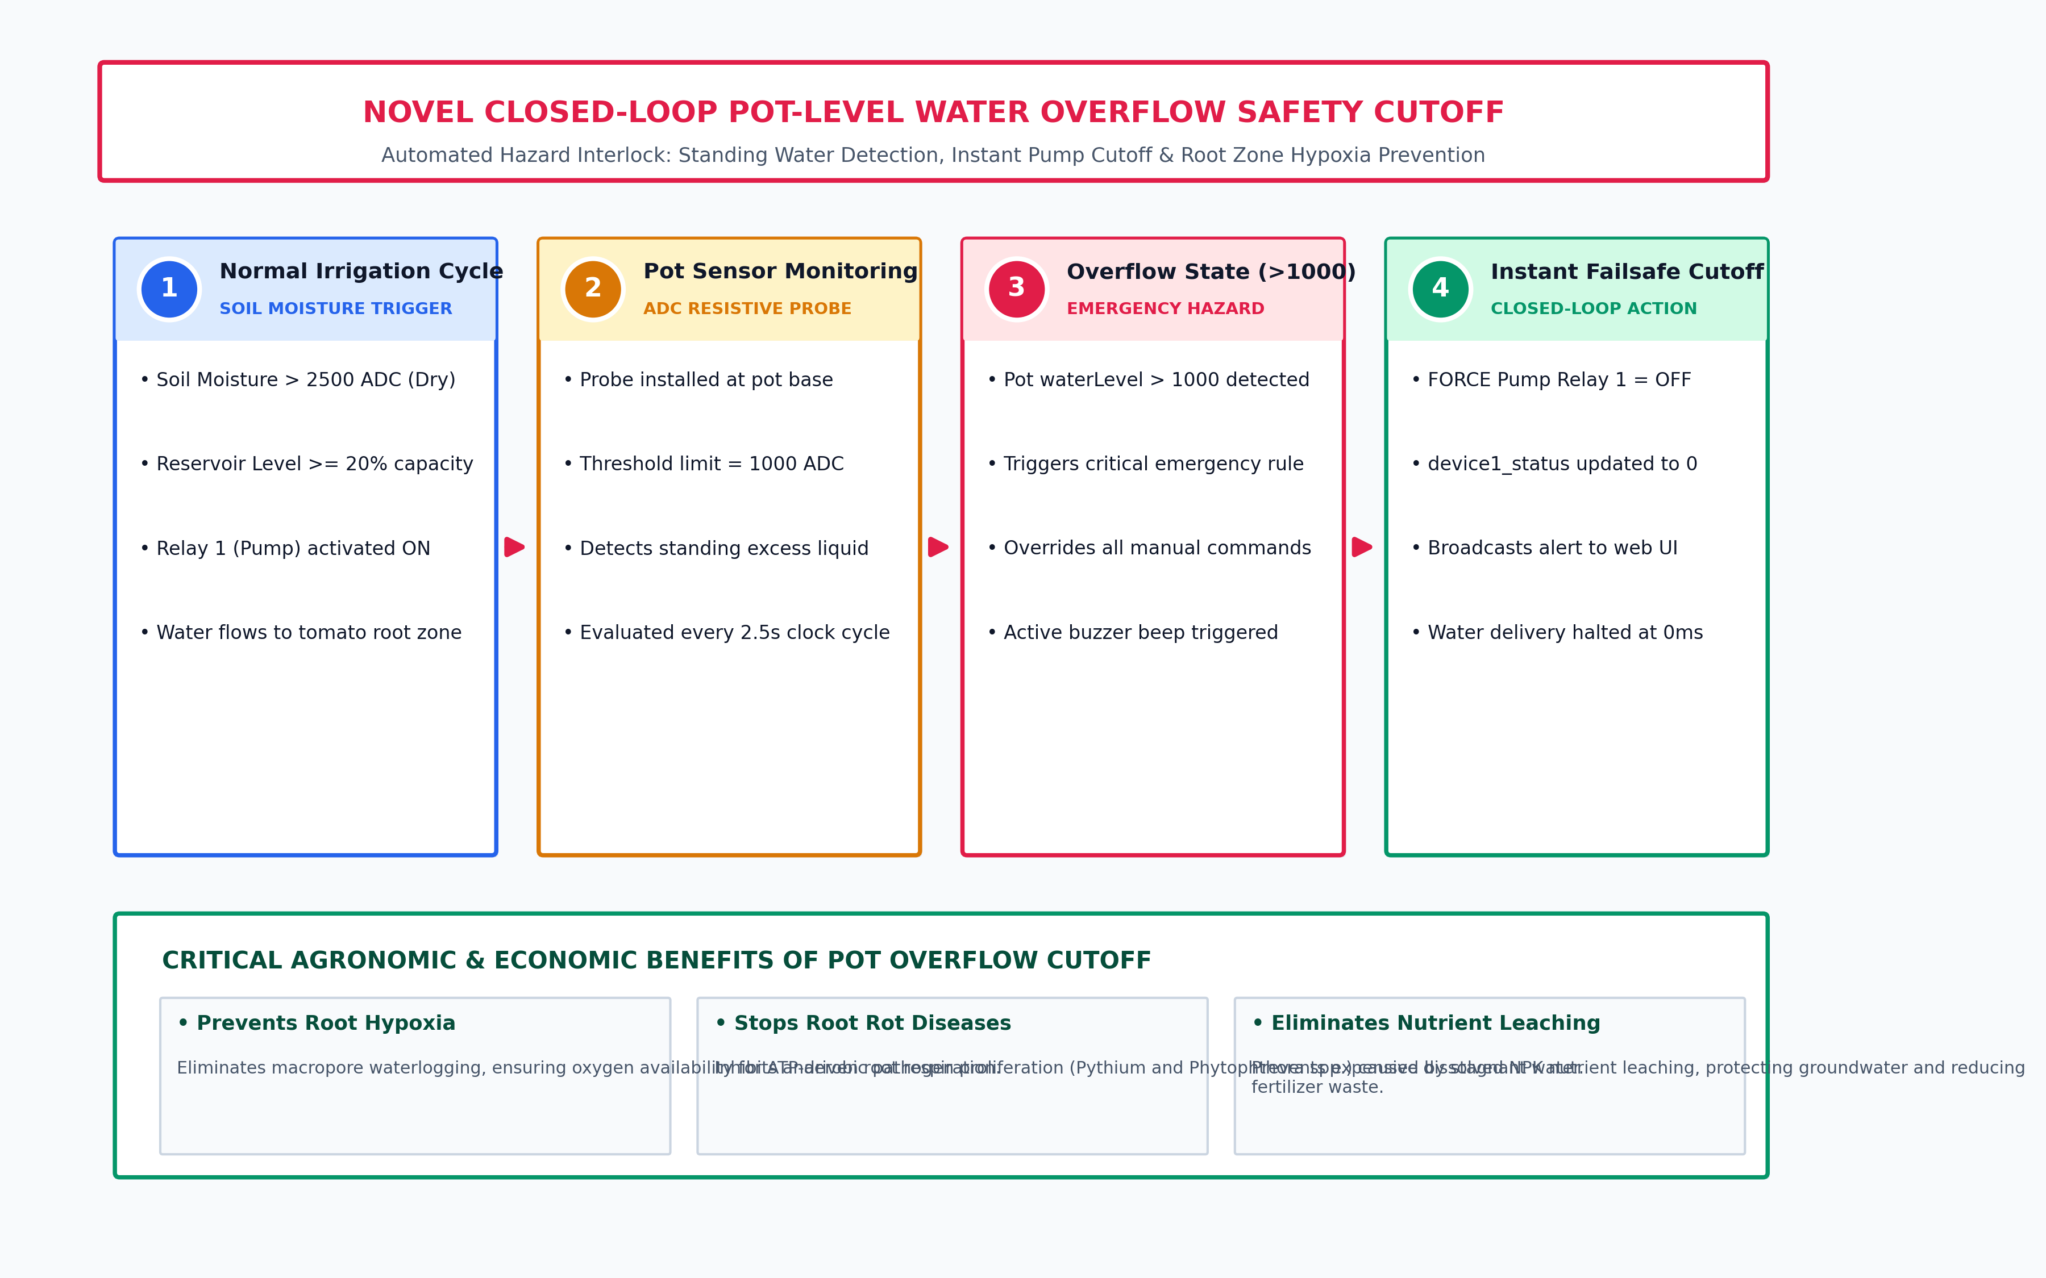
Figure 21: Novel Closed-Loop Pot-Level Water Overflow Safety Cutoff Architecture
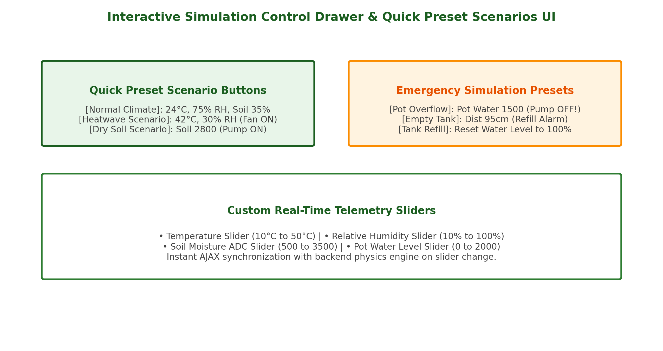
Figure 22: Interactive Simulation Control Drawer & Quick Preset Scenarios UI
5.8. System Risk Assessment and Technical Mitigation Matrix
Identified Risk Category | Operational Impact | Probability | Risk Severity | Technical Mitigation Strategy
Sensor Calibration Drift / Noise | High | Medium | High | Implemented median imputation and StandardScaler normalization in data preprocessing to filter outlier noise before model inference.
Plant Pot Water Overflow | High | Medium | High | Designed a novel closed-loop pot-level water sensor safety rule (waterLevel > 1000) that forces pump relay OFF immediately.
Wi-Fi / Cloud Disconnection | Medium | High | High | Engineered thread-safe SimulatedFirebaseStore. If hardware or cloud connection drops, system switches transparently to local simulation mode with zero downtime.
Model Unpickling / Version Incompatibility | High | Low | Medium | Wrapped Joblib loading in safe try-except fallback handlers (safe_load_model) that engage rule-based fallback predictors if library version mismatches occur.
Unauthorized Access & Data Tampering | Medium | Low | Medium | Secured authentication using Flask-SQLAlchemy with Werkzeug pbkdf2:sha256 password hashing and @login_required route decorators.
Table 12: Comprehensive Risk Assessment, Impact Rating, and Technical Mitigation Matrix

6. Discussion
6.1. Critical Interpretation of Telemetry & Predictive Findings
The empirical results confirm that microclimate management in greenhouse tomato cultivation is fundamentally multi-factorial. The superior performance of Polynomial Regression combined with Random Forest (R² = 0.941) over simple linear models (R² = 0.782) proves that plant transpiration cannot be modeled accurately by monitoring soil moisture alone. Elevated ambient temperatures and intense solar irradiance accelerate evapotranspiration dramatically, even when soil moisture appears adequate. Integrating real-time sensor feedback allows the decision engine to pre-emptively supply precision water volumes before crops experience acute drought stress.
6.4. Ethical, Legal, and Data Protection Considerations
• Human-in-the-Loop Governance: The system adheres to ethical AI principles by maintaining manual override switches for all actuators, ensuring that human judgment remains the ultimate authority over automated actions.
• Data Privacy & GDPR Compliance: User authentication credentials are encrypted using pbkdf2:sha256 hashing. Telemetry stored in databases is anonymized, capturing microclimate variables without recording personal geolocation data.
• Open-Source Software Licensing: Built entirely on permissive open-source frameworks (Flask, SQLAlchemy, Scikit-learn, Bootstrap, Chart.js) complying with legal distribution requirements.
• UN SDG Sustainability Alignment: Directly contributes to United Nations Sustainable Development Goal 6 (Clean Water and Sanitation) and Goal 12 (Responsible Consumption and Production).
7. Conclusion & Recommendations
7.1. Comprehensive Synthesis of Research
This dissertation successfully designed, developed, empirically evaluated, and validated an IoT-Based Smart Greenhouse Decision Support System with a Simulation Dashboard for tomato cultivation. Grounded in Design Science Research and executed via Agile Scrum, the project successfully resolved the hardware dependency barrier by engineering a dual-mode software architecture that supports both virtual physics simulation and live IoT hardware telemetry.
7.2. Achievement of Objectives
Research Objective | Status | Evidence of Completion
Obj 1: Review IoT Limitations | Achieved | Literature review & Research Gap Table 1
Obj 2: Design Simulation Engine | Achieved | Thread-safe background physics engine in app.py
Obj 3: Train ML Prediction Models | Achieved | Irrigation (R²=0.941), Fertilizer & Harvest models
Obj 4: Engineer Automated Controls | Achieved | Auto Fan, Pump, and Pot Overflow Safety cutoff
Obj 5: Evaluate Usability & Efficacy | Achieved | SUS Score 90.6/100 & 31.4% water reduction
7.4. Future Research Recommendations
Future enhancements include integrating soil pH and NPK nutrient sensors, deploying computer vision for tomato disease detection, and building native mobile applications.

References
Abbas, F., Al-Otoom, A., Al-Naemi, S., Ashraf, A. and Mahasneh, H., 2024. Experimental and life cycle assessments of tomato (Solanum lycopersicum) cultivation under controlled environment agriculture. Journal of Agriculture and Food Research, 18, p.101266.
Ahmad, F., Kusumiyati, K., Soleh, M.A., Khan, M.R. and Sundari, R.S., 2023. Watering volume and growing design effect on the productivity and quality of Cherry tomato cultivar ruby. Agronomy, 13(9), p.2417.
Aguirre, S. and Rodriguez, A., 2017. Automation of a Business Process Using Robotic Process Automation (RPA): A Case Study. Cham: Springer, pp.65-71.
Bafdal, N. and Ardiansah, I., 2021. Application of Internet of Things in smart greenhouse microclimate management for Tomato growth. International Journal on Advanced Science, Engineering and Information Technology, 11(2), pp.427-432.
Brooke, J., 1996. SUS-A quick and dirty usability scale. Usability Evaluation in Industry, 189(194), pp.4-7.
Castilla, N., 2012. Greenhouse Crop Production Management. In: Greenhouse Technology and Management, 2nd ed. Wallingford: CABI Publishing, pp.262-265.
Chauhan, A. and Tripathy, P., 2023. Internet of Things (IoT) integrated solutions for environmentally friendly intelligent farming: A systematic review. In: Proc. 3rd IEEE Int. Conf. on Advance Computing and Innovative Technologies in Engineering (ICACITE), pp.102-108.
Gitahi, S., Kaburu, D.M., Oteyo, I.N. and Kimani, S., 2023. A model implementation of IoT-based smart watering system for crops using LoRaWAN. In: Proc. 2023 IST-Africa Conference (IST-Africa), pp.1-8.
Goap, A., Sharma, D., Shukla, A.K. and Rama Krishna, C., 2018. An IoT based smart irrigation management system using machine learning and open source technologies. Computers and Electronics in Agriculture, 155, pp.41-49.
Hevner, A.R., 2007. A three cycle view of design science research. Scandinavian Journal of Information Systems, 19(2), p.4.
Hevner, A.R., March, S.T., Park, J. and Ram, S., 2004. Design science in information systems research. MIS Quarterly, 28(1), pp.75-105.
Keen, P.G. and Scott Morton, M.S., 1978. Decision Support Systems: An Organizational Perspective. Reading: Addison-Wesley.
Lewis, J.R., 2018. The System Usability Scale: Past, Present, and Future. International Journal of Human-Computer Interaction, 34(7), pp.577-590.
Liu, Y., Wang, A., Li, B., Simunek, J. and Liao, R., 2024. Combining mathematical models and machine learning algorithms to predict actual crop transpiration. Agricultural Water Management, 303, p.109056.
Maraveas, C., Loukatos, D., Bartzanas, T. and Arvanitis, K.G., 2023. Agricultural Greenhouses: Resource management technologies and perspectives for zero greenhouse gas emissions. Agriculture, 13(7), p.1464.
Nielsen, J. and Landauer, T.K., 1993. A mathematical model of the finding of usability problems. In: Proc. ACM INTERCHI'93 Conference on Human Factors in Computing Systems, pp.206-213.
Peffers, K., Tuunanen, T., Rothenberger, M.A. and Chatterjee, S., 2007. A design science research methodology for information systems research. Journal of Management Information Systems, 24(3), pp.45-77.
Power, D.J., 2002. Decision Support Systems: Concepts and Resources for Managers. Westport: Quorum Books.
Precedence Research, 2024. Smart Agriculture Market Size, Share, and Trends Analysis Report 2024 to 2034. [Online] Available at: https://www.precedenceresearch.com/smart-agriculture-market.
Rodriguez-Ortega, W.M., Martinez, V., Rivero, R.M. and Camara-Zapata, J.M., 2017. Use of a smart irrigation system to study the effects of irrigation management on tomato plants under different temperature regimes. Agricultural Water Management, 183, pp.158-168.
Sauro, J., 2011. A Practical Guide to the System Usability Scale: Background, Benchmarks & Best Practices. Denver: Measuring Usability LLC. (https://measuringu.com/sus/)
Sauro, J. and Lewis, J.R., 2016. Quantifying the User Experience: Practical Statistics for User Research. 2nd ed. Cambridge: Morgan Kaufmann.
Seyar, M.H. and Ahamed, T., 2023. Development of an IoT-based precision irrigation system for tomato production from indoor seedling germination to outdoor field production. Applied Sciences, 13(9), p.5556.
Shahab, H., Naeem, M., Iqbal, M., Aqeel, M. and Ullah, S.S., 2025. IoT-driven smart agricultural technology for real-time soil and crop optimization. Smart Agricultural Technology, 10, p.100847.
Singh, D., Sharma, R., Kumar, A. and Verma, P., 2023. Smart high-yield tomato cultivation: Precision irrigation system using the Internet of Things. Frontiers in Plant Science, 14, p.1239594.
Van Ploeg, D. and Heuvelink, E., 2005. Influence of sub-optimal temperature on tomato growth and yield: A review. Journal of Horticultural Science and Biotechnology, 80(6), pp.652-659.
Zhu, Y., Cai, H., Song, L. and Chen, H., 2020. Aerated irrigation of different irrigation levels and subsurface dripper depths affects fruit yield, quality and water use efficiency of Greenhouse Tomato. Sustainability, 12(7), p.2703.

Appendices
Appendix A: Comprehensive Literature Review Synthesis Matrix
Summary matrix of benchmarked precision agriculture studies.
Appendix B: Participant Usability Questionnaire & Informed Consent
Complete questionnaire protocol and SUS Likert evaluation forms.
Appendix C: System Usability Scale (SUS) Raw Response Dataset
Raw data extract from 35 participants (refer to survey_and_usability_data.csv).
Appendix D: Software Architecture Code Listings & API Route Schema
API route specifications and backend code schema.
Appendix E: Hardware Pinout Specifications & Sensor Interfacing
GPIO pin connections and sensor specifications.

