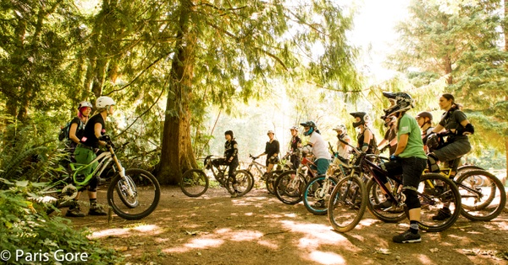

Sweetlines Shred Session-Alsea Falls

Take your mountain slaying skills to the next level! This class is perfect for new and experienced mountain bikers interested in building confidence by turning fear into fun on the trail!

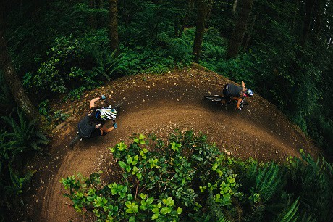

Date: October 4th & 5th

Saturday – co-ed

Sunday – ladies only

# Location: Fall Creek Access Rd, Alsea, OR 97324 Fhttps://www.google.com/maps/place/Fall+Creek+Access+Rd/@44.3184694,-123.5073526,17z/data=!3m1!4b1!4m2!3m1!1s0x54c1adbeb0106e79:0xac994beecd34e144

Time: 10am-4pm

Cost: $115

Max: 12 students (1:6 ratio of coaches to students); 2 coaches each day

Ages: 16 and older

Levels: intermediate to advanced (must have a minimum of one year of riding experience)

Skills: body position, flowy berms, jumps, drops, line selection, and on-trail tech training

Prerequisite: must have a year of mountain bike experience and be ready to catch some air!

Registration Link: <https://www.bikereg.com/sweetlines-shred-session-alsea-falls>

Kat Sweet is a ICP Level 3 Coach from IMBA with 10 years of teaching experience.

A portion of proceeds are benefitting BLM trail system budget and Team Dirt chapter efforts on the trail.

Contact:

Kat Sweet

kat@sweetlines.com

206-427-3090

“Ride Like You Can”

(photos by Paris Gore)