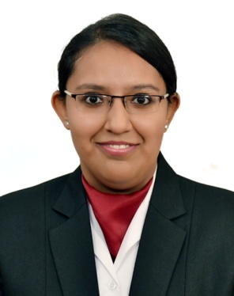**POOJA ASHWIN TRIVEDI**

Mobile : (+91)9833106492, (+91)9130230642

Email: [141519pooja@gmail.com](mailto:141519pooja@gmail.com)

**OBJECTIVES**

Looking forward for an opportunity where I will implement my ideas and contribute towards growth of the organisation.

**STRENGTHS**

Talking, leadership quality, co-operating ability and punctual.

**EDUCATIONAL QUALIFICATION**

* At present pursuing a course in Hotel Management (3rd year) from institute of Hotel Management, Goa.
* Obtained 81.3% in 12th grade from KES shroff college Mumbai.
* Passed 10th with distinction by ICSE board from SNK Rajkot in 2012.

**PERSONAL INFORMATION**

**NAME :** Pooja Ashwin Trivedi.

**ADDRESS :** 502,SaiPrakash, Plot No.108, Charkop sector-02,

Kandivali West- 460007.

**GENDER :**Female.

**DATE OF BIRTH :**8th June 1995.

**NATIONALITY :**Indian.

**PASSPORT NO :**(on request)

**LANGUAGES KNOWN :**English, Hindi and Gujarati.

**WORK EXPOSURE :**Successfully completed IRT Training at Westine

Undergoes outdoor Catering from college.

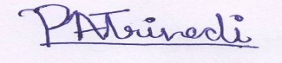**HOBBIES :**Reading, Dancing, Martial arts and Interactin

**__________________**

**( PoojaTrivedi )**