# **Introduction**

## **Overview**

In lieu of completing an Internship for this work placement module, I completed a project instead. This project was to develop a timetable web application that could be used by module coordinators and lectures and students of the UCD Computer Science Undergraduate degree. The project was to be completed over a similar timeframe as an Internship, however the project had to be completed independently.

## **Goals**

My goals for creating this project was to timetable web application that would read in data from a CSV file and populate a database. Then, based on this data, I would write code to show the student timetable (i.e. the Semester 1 and 2 timetables seen on SISWeb for UCD Students) for a specified stage, semester and academic year, in order to make it easier for lectures and module coordinators to view/edit their timetables and for students to view their timetable. This code would also allow for privileged users (i.e. lecturers/module coordinators) to make changes to the timetable.

Moreover, my main goal was to challenge myself. Before completing this project, I had completed similar projects, one of which I completed (as part of a team) using flask, python, MySQL, json, JavaScript, google analytics and html, etc. for web application that displayed how many Dublin bikes were free at various stations around Dublin. The other similar project I completed (independently) used php, MySQL, JavaScript, html5 and css3 to display product information on a website (which I created). So, instead of returning to these languages and technologies that I was familiar with, I chose to expand my knowledge of Java, to learn and implement the Tomcat (server) (after researching different servers commonly used for Java web-based applications and which one would be best for my project), learn about Servlets and JSPs and then decide which of these would be appropriate for my project (ultimately, I chose to implement both of them), learn how to use JDBC to connect to a database and then expand my knowledge of mysql and how it interacts with a Java web-based application, and then learn how to implement them (which also involved thinking about my schema and how many tables I would need). I also had to research about the Model-View-Controller architecture and use it to build the architecture of my project. Lastly, I wanted to learn to work effectively on such an immense undertaking as an independent person and not as part of a team. This was a major goal for me, as I would have to work on the frontend, backend, report and presentation by myself, even though each of these tasks are a skill (and a full-time job) in and of themselves.

## **Contributions**

My contribution was to produce a working timetable application.

# **Work Performed**

## **A Typical Day**

As this project was to be undertaken solely by me and completed over the course of approximately 3 and a half months, my days were long and varied. However, I met with my supervisor (Dr. Michael O'Mahony) every week (on a Wednesday/Thursday usually) in order to discuss my agenda for that week, which usually entailed a description/demonstration of what portion of the project I had completed over the previous week, a run-down of the issues I had encountered and the methods that I had used to solve the various issues I had come across, Dr. O’Mahony would then layout the next steps I had to take in order to complete the next section of the project and I would be free to ask questions or make comments in order to show my understanding of this next section of work. Due this being a solo project, I tried to be as disciplined as possible, this meant that on a given day, I would consult my notebook (which contained all my detailed notes, my rough work of problem solving, algorithms, diagrams, scheduling and musing related to this project). I would do some research on the problem, write code for the backend/frontend of my project, debug the project and then researched solutions for problems and usually debugged my project again in order to see that everything was working properly. I would then catalogue my day in my notebook and constructed a plan of action for the next day.

## **The Work**

As mentioned previously, I developed and finished a project instead of attaining a work placement opportunity for my work placement module. The specification of this project was to create a timetable web-based application that would be utilized by administrators (with elevated access) and students of the UCD Computer Science Undergraduate program. My other specifications for creating this project were to complete a timetable web-based application that could take data from a CSV file and populate a database. Then, I would compose code to display the student course timetable (which are the Semester 1 & 2 schedules that can be viewed on the SISWeb for students of UCD) for a previously stated stage, semester and scholastic year, which would to allow lectures and module coordinators to change or see their timetables and for students to see their timetable with ease and peace of mind. This code would also allow for privileged users (who had been granted elevated access- a lecturer or a module coordinator most likely) to make changes to their timetable.

Moreover, the following is text of my specification for the database, views and input file:

**Database tables:**

**Module:**

* id
* code
* name
* link to MD
* undergraduate (Boolean T/F)
* year (or stage) in which it runs
* semester in which it runs
* active/inactive (Boolean T/F)
* module coordinator (i.e. lecturer)

**Lecturer:**

* id
* name
* office location

**Room:**

* id
* name
* capacity

**Views:**

* Student timetable for a specified stage, semester and academic year (default current?)
* Room timetable for a specified semester and academic year (default current?)
* Lecturer timetable for a specified semester and academic year (default current?)
* Should be able to view each of the above by academic year - e.g. display the Stage 1 Semester 1 student timetable for e.g. academic year 2015/16 or for the current academic year (2018/19)

**Admin Page:**

* allow admin to add a show/add new/delete/update Module/Lecturer/Room
* update the e.g. room assigned to a module at a particular time/day

**Input data:**

* **“Input CSV File.xlsx”:**
  + missing year (stage) modules are run
  + missing module coordinator
  + not all modules in file are undergraduate modules (can ignore modules not part of undergraduate programme)

These specifications and goals were achieved by employing a Model-View-Controller (MVC) architecture.

MVC architecture in a web-based application is used to separate business logic from user interfaces and allows you to make changes to either piece of the architecture without affecting all of them. It achieves this by separating the Model, View and Controller into 3 divided yet connected components MVC transformed the way in which internal representations of information, (Codeacademy, 2019). According to Ongraph (2016), It changed the way in which information is shown to or approved from the user. The three parts of MVC are:

**The Controller** – The Controller is the mastermind and hub of the application. The Controller receives incoming HTTP requests and decides what to do with them and binds the model and view together (Codeacademy, 2019).

**The View** – The View is the part of your application that interprets what the user perceives and interacts with on the application (Codeacademy, 2019, Ongraph, 2016).

**The Model** – the Model is the part of the application that defines the entities you are interested in working with in the application (Ongraph, 2016).

**The following is a diagram of the Model-View-Controller architecture and how it interacts with the user.**

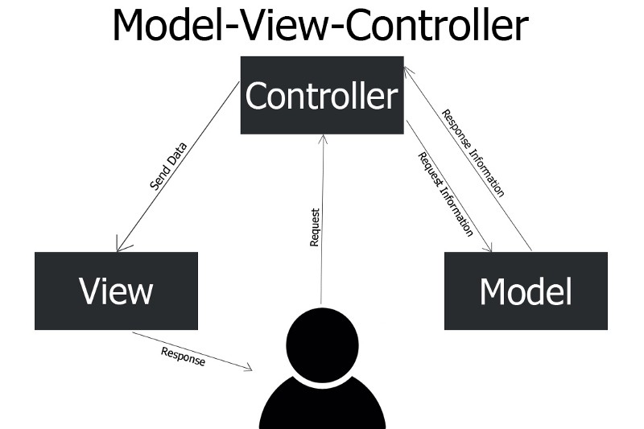

In terms of my web application, my Controller was a single Servlet, my View was the various views I employed to display different pages (which were JSP’s) and my Model were two classes (called Module and TimeTable) with additional helper classes. I used Java, MySQL and HTML to write my code. I then referred extensively to the oracle website, that provided a multitude of tutorials on Servlets, JSPs, JDBC (for the connection to the database), etc. I also referred to various MYSQL online documentation and my Java programming textbook (used in my Programming II module in Semester 2) in order to achieve my previously stated goals.

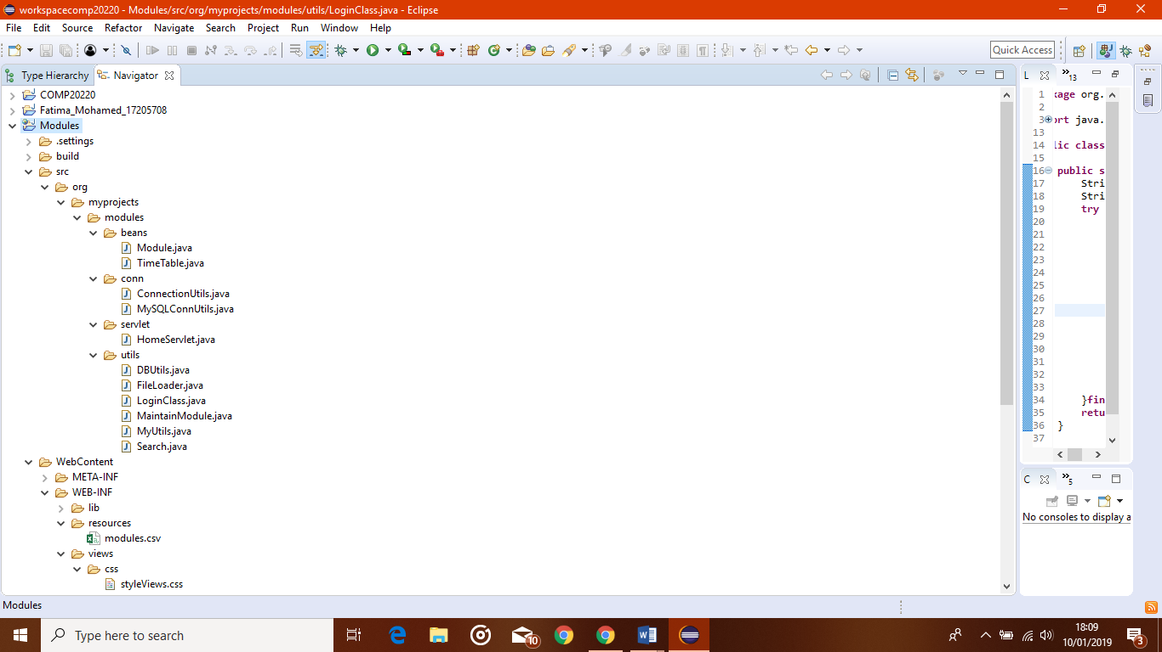**The following are two screenshots of the file structure of I used for my project:**

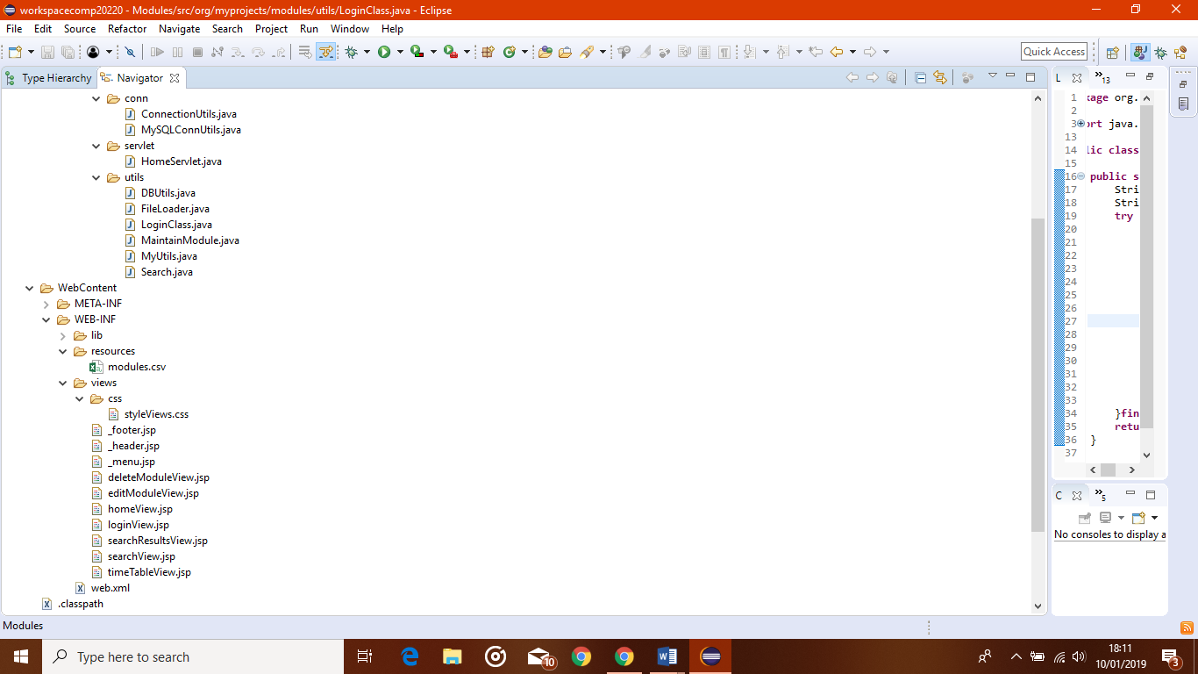

As one can see from viewing the above structure, I had a csv file called ‘modules’ in a folder labelled ‘resources’. This csv file is my input file consisting of raw data (including code, name, classification, start & end times, etc. for the undergraduate Computer Science degree schedule) to this data, I added fields for undergraduate (Boolean true/false), active_inactive (Boolean true/false), year and module_coordinator (following the instructions shown in the specification shown previously).

In the implementation of this web application, there were many issues that I encountered. The first of these issues was that I encountered IT issues which took time away from my deadline. The issue was that I had erroneously removed the administrative privileges from my laptop which meant that, among many things, that I could not download any of the tools/software that I would need for this project (such as Tomcat). I ended up having to resolve this issue myself by borrowing another laptop, downloading the software to fix it, which then restored my admin privileges. Another issue was that I wrongly started with the wrong file structure and put files in the wrong place along with my input .csv file which meant that I could not read form my CSV file and populate my database and that, essentially, my application would not work properly. This meant that I had to start over by referring to online Oracle tutorials for java web-based web applications (including Servlet and JSP tutorials) which led me to implement a clean/ordered structure that I have now, using one Servlet (where previously I had multiple Servlets) and various other helper classes. These tutorials also helped me order my JSP pages for my views) which solved that issue. I also had miscellaneous issues that involved syntax and semantic errors that were solved through debugging and research.

Furthermore, my main issue was that I was working independently and not as part of a team which, initially, wasn’t a cause for concern. However, as I worked on my project I discovered that working on the backend, the frontend, doing so much research/debugging, as well as keeping detailed notes for my report and the eventually presenting this project were all individual careers in and of themselves and that for one person it was a lot of work, and led to many issues, the most glaring one being an issue of time, in that I simply did not have time to complete each task to the level that I would have liked. I solved this problem by consolidating the most important aspects of this project and concentrating on the backend of my project, which that led to issues with CSS and displaying my Admin timetable like the Student timetable, however my Supervisor was aware of these issues and helped me with my planning and refocusing (specification-wise) me.

To that end, the Java programming (for learning Java), Data Structures & Algorithms (for algorithmic problem-solving and learning Object-Oriented Programming), Relational Databases and Information Systems (for learning about databases and MySQL and how to use Workbench), Software Engineering (for writing specifications, building web-applications, learning Agile and for doing a project similar to this one but with flask, as mentioned previously), Networks and Internet Systems (for learning about HTTP request-response methods) and Web Development (how to construct and build web pages using html, CSS, JavaScript , JSON and for doing a project using PHP, as mentioned previously) modules I undertook in my HDip programme were greatly beneficial over the course of this project.

## **Technology**

The technologies I used for this project were: Apache Tomcat (server, version 9), Eclipse Java Oxygen (IDE), and MYSQL Workbench (database).



The Apache Tomcat software was the server I used which is open-source and allowed for the use of Java Servlets and JavaServer Pages (JSPs). Java Servlets are classes that run in a java server and act as a controller in a web-based application. JavaServer Pages (JSPs) allow for the combinative linking of html and java that allow faster, more dynamic way of displaying content for the user and the use of Servlets with JSPs leads to a better experience for the user (The Apache Software Foundation, 1999-2019).



Eclipse Java Oxygen is an integrated development environment that provides the facilities to structure, organise and build a project from beginning to end. It also provides the appropriate tools in order to debug a project (i.e. to step into a project in order to detect/solve errors in a program) (Study.com, 2003-2019).

MySQL Workbench is the graphical user-interface (GUI) that is used to build databases schemas (it also allows you to construct/test SQL queries which is very important when trying to construct complicated/difficult SQL queries) (Oracle Corporation, 2019).

I had previously used Eclipse and Workbench for my studies and learned how to use Tomcat for this project. Glassfish, JBoss, or Wildfly servers could have been used instead of Tomcat and NetBeans or IntelliJ are examples of other IDEs that could have been used. PostgreSQL and SQLite could have been used instead of WorkBench.

# **Critical Analysis**

## **Work Placement Reflections**

As I have stated previously, I completed this project in lieu of gaining an internship. The reason for this was that I was unable to find an internship within the required timeframe and as such I resorted to plan B with my supervisor (which I was aware of from workshops held during my Work Placement module). This plan B was that a student would complete an independent project during an 8-week timeframe, which was what I did.

However, because I undertook this project, I feel that my research skills, discipline, patience, and coding skills greatly improved over the duration of this project. Furthermore, my Java, MySQL, and html language skills greatly improved, along with my knowledge of algorithmic problem-solving and debugging skills. My planning and scheduling skills also greatly improved over this time.

This experience of building my own web application in Java & MySQL has shown me that a career in full stack development would be very exciting and that this project is a perfect demonstration of my skills to potential employers. As such, this experience has made me more ambitious career-wise as completing this project was a great boost of confidence and affirmed my skills as I was able to deliver a much-needed web application to my supervisor that could be used by UCD in the future.

Due to the fact that I completed this project independently, I feel that I will need to work on my teamwork and interpersonal skills in order to become a desirable potential employee.

I feel that I could have added more to the design of my web app and extended my project to cover a room/lecturer timetable which would have contributed more to my project.

Moreover, what surprised me the most about my project was that in the end this project constituted a full-time job. However, with the help of my supervisor I was able to plan this project effectively, to break this project down to smaller, more manageable problems which I was able to solve. I also was able to manage my time and plan out this project and use my research and problem skills in order to complete this project.

Next time, I would extend my project to cover room, lecturers and module coordinators’ timetables. I would also prefer to work as part of a team in order to avail of that collegial support which would lead to fewer mistakes and bug hold ups, shared best practices and make it harder to procrastinate, all of which are inherent things that encompass working as part of a team.

# **Self-Assessment**

**1. Quality –** The extent to which your work was completed thoroughly and correctly following established process & procedures.

☐Outstanding ☑ Good ☐ Fair ☐ Poor ☐ N/A

**2. Productivity / Independence / Reliability -** The extent to which you produced a significant volume of work efficiently in a specified period of time. Ability to work independently with little or no direction/ follow-up to complete tasks / job assignment.

☐Outstanding ☑ Good ☐ Fair ☐ Poor ☐ N/A

**3. Job Knowledge -** The extent to which you possessed and demonstrated an understanding of the work instructions, processes, equipment and materials required to perform the job. Intern possesses the practical and technical knowledge required of the job.

☐Outstanding ☑ Good ☐ Fair ☐ Poor ☐ N/A

**4. Interpersonal Relationships / Cooperation / Commitment –** The extent to which you demonstrated the ability to cooperate, work and communicate with coworkers, supervisors, subordinates and/or outside contacts. The extent to which you accepted job assignments and additional duties willingly, took responsibility for your own performance and job assignments.

☑Outstanding ☐ Good ☐ Fair ☐ Poor ☐ N/A

**5. Attendance –** The extent to which you were is punctual, observed prescribed work break/meal periods and had an acceptable overall attendance record.

☑Outstanding ☐ Good ☐ Fair ☐ Poor ☐ N/A

**6. Initiative/ Creativity –** The extent to which you sought out new assignments, proposed improved work methods, suggested ideas to eliminate waste, found new and better ways of doing things.

☐Outstanding ☑ Good ☐ Fair ☐ Poor ☐ N/A

## **Process Improvements**

My supervisor was so kind and patient with me and explained everything so well that I don’t feel that I have improvements to suggest, other that I would have liked a desk to work at on-campus, however I understand that space was an issue and It was kind of the school to allow me to pursue this plan B option of a project.

# **Conclusion**

Overall, my experience of completing this project was a positive one. I felt supported at every turn by my supervisor and learned such a breadth of new skills and my knowledge of the programming languages and technologies I utilized in this project improved greatly. I also felt that over time my work ethic grew as did my confidence as I completed the majority of the Back End of this project. I feel that I achieved so much and gained so much knowledge that my future career prospects have improved even more. I also greatly appreciated being able to implement what I had learned over the course of my HDIP in this project, which adds to my skillset.

# **Appendices**

Codeacademy. (2019). MVC: Model, View, Controller: App organization explained. Retrieved 10th January 2019 from: <https://www.codecademy.com/articles/mvc>

Ongraph. (2016). What is MVC Architecture in a Web Based Application? Retrieved 7th January 2019 from: <https://www.ongraph.com/what-is-mvc-architecture-in-a-web-based-application/>

Oracle Corporation. (2019). MySQL Workbench. Retrieved 10th January 2019 from: <https://www.mysql.com/products/workbench/>

Study.com. (2003-2019). IDE in Software: Definition & Examples. Retrieved 10th January 2019 from: <https://study.com/academy/lesson/ide-in-software-definition-examples.html>

The Apache Software Foundation. (1999-2019). Apache Tomcat. Retrieved 10th January 2019 from: <http://tomcat.apache.org/>