SPE DATATHON 2026
Geothermal District Heating & Cooling Challenge
Utrecht Science Park, Netherlands
Technical Assessment Report
Competition | SPE Datathon 2026 — Netherlands Geothermal Challenge
Target Area | Utrecht Science Park, Netherlands
Reservoir | Rotliegend Sandstone (Slochteren Formation)
Team | 2 Data Scientist + 3 Petroleum Engineers  (GEOSPARK)
Names of Participants | - Adekoya Ifeoluwa  - Kaosarat Olanrewaju  - Odumu Daniel  - Beecroft Oluwatobiloba(DS)  - Nduka Martins(DS)
Date | June 2026

Executive Summary
This report presents a comprehensive technical assessment of the geothermal resource potential at the Utrecht Science Park (USP) and proposes an integrated district heating and cooling system capable of meeting the neighbourhood's minimum energy demand. The study addresses both challenges of the SPE Datathon 2026:
(1) geothermal potential assessment and demand viability, and
(2) integrated system design.

Parameter | Value
Target District | Utrecht Science Park (USP)
Reservoir Formation | Rotliegend Sandstone (Slochteren)
Selected Production Wells | BLT-01, ZST-01, ODK-01
Rejected Wells | EVD-01, PKP-01 (zero flow), JUT-01 (zero economic potential)
Total Brine Production (P50) | 264 m³/h combined
Geothermal Power (P50) | 13.2 MWth
HP Thermal Output — P10 | 252 MW (1,680% demand coverage)
HP Thermal Output — P50 | 52.8 MW (352% demand coverage)
HP Thermal Output — P90 | 2.4 MW (16% demand coverage — contingency required)
Heating Demand Covered (P50) | Yes
Cooling System | Absorption chiller + heat pump cooling mode
Simulation Tool | Aspen Plus V14

Challenge 1: Geothermal Potential Assessment
Challenge 1 requires an assessment of whether the Rotliegend sandstone reservoir can reliably supply the district’s minimum demand of 10 MWth heating and 5 MWth cooling. The following sections present the well screening process, the rationale for the wells selected for further analysis, and the resource indicators that support the conclusion.

1.1 Background and Study Context
The target district selected for this assessment is the Utrecht Science Park (USP), located in Utrecht, the Netherlands. As a high-density institutional campus hosting major universities, academic medical centres, and internationally recognised research facilities, the USP generates a substantial, year-round demand for both heating and cooling — making it an ideal candidate for a geothermal district energy scheme. The dataset's inclusion of a parameter titled "distance_to_usp_km" further confirms that the well data is spatially referenced to this district, reinforcing its selection as the focal study area.
The primary geological target is the Rotliegend sandstone of the Slochteren Formation — a Permian-age reservoir encountered at depths ranging from approximately 1,700 m to 2,600 m below surface across the study area. With recorded reservoir temperatures between 72°C and 88°C, the system is classified as low-enthalpy geothermal, well-suited for direct heat applications and heat-pump-augmented district heating at the scale required.
The initial candidate well pool comprised four wells — BLT-01, JUT-01, EVD-01, and PKP-01 provided for primary screening. Two additional wells, ZST-01 and ODK-01, were subsequently identified via ThermoGIS as proximal candidates exhibiting favourable reservoir characteristics, and were incorporated into the extended evaluation pool for a comprehensive six-well assessment.

1.1 Well Locations and Target District
Figure 1 presents a ThermoGIS map showing the spatial distribution of the three candidate wells — BLT‑01, ZST‑01 and ODK‑01 — in relation to the target district, Utrecht Science Park (USP). The map confirms that all three wells lie within a reasonable radius of the demand centre, which supports their selection as the working set for the subsequent productivity and economic analyses.

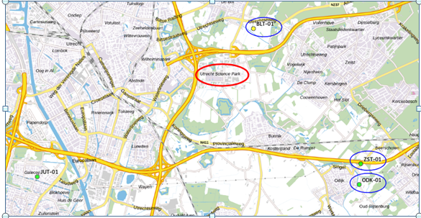
Figure 1 ThermoGIS map of the three candidate wells (BLT‑01, ZST‑01, ODK‑01) relative to the Utrecht Science Park target district.
With the spatial relationship between the wells and USP established, the following sections compare the three candidates on the reservoir and productivity indicators that determine whether they can jointly meet the district’s minimum demand of 10 MWth heating and 5 MWth cooling.

1.2 Well Screening and Selection
All six wells were screened against three primary criteria: recorded flow rate, power output, and economic potential. The results of this screening are summarised below.

Well | Flow Rate | Permeability (P50) | Temperature | Economic Potential | Decision
BLT-01 | High | 82 mD | 77°C | High | Selected
ZST-01 | High | ~180 mD | 79°C | High | Selected
ODK-01 | Moderate-High | ~160 mD | 81°C | High | Selected
JUT-01 | Moderate | 40 mD | 77°C | Zero (economic) | Reserve/Excluded
EVD-01 | Zero | 6 mD | 72°C | Zero | Excluded
PKP-01 | Zero | 1 mD | 88°C | Zero | Excluded

EVD-01 and PKP-01 recorded zero flow rate and zero power output, confirming that poor reservoir permeability (6 mD and 1 mD respectively at P50) renders them non-productive. JUT-01, despite showing moderate permeability and good reservoir thickness, returned zero economic potential under the standard appraisal framework and was therefore excluded from the primary design but retained as a strategic reserve for future expansion.
BLT-01, ZST-01 and ODK-01 collectively provide the highest flow rates, strongest permeability, and most favourable economic indicators in the dataset. All three are located within a viable distance of the USP demand centre, as confirmed by the ThermoGIS spatial data and the distance_to_usp_km parameter in the provided dataset. All subsequent analyses use P50 estimates unless otherwise stated, as this represents the most probable reservoir performance scenario.

1.3 Productivity Indicators

1.3.1 Temperature vs. Flow Rate
Figure 1 presents the temperature-flow rate scatter plot for all six candidate wells. BLT-01 dominates in flow rate at its reservoir temperature, while ZST-01 and ODK-01 cluster together with substantial flow at slightly higher temperatures. EVD-01, PKP-01 and JUT-01 contribute minimal to zero flow, consistent with their low permeability.
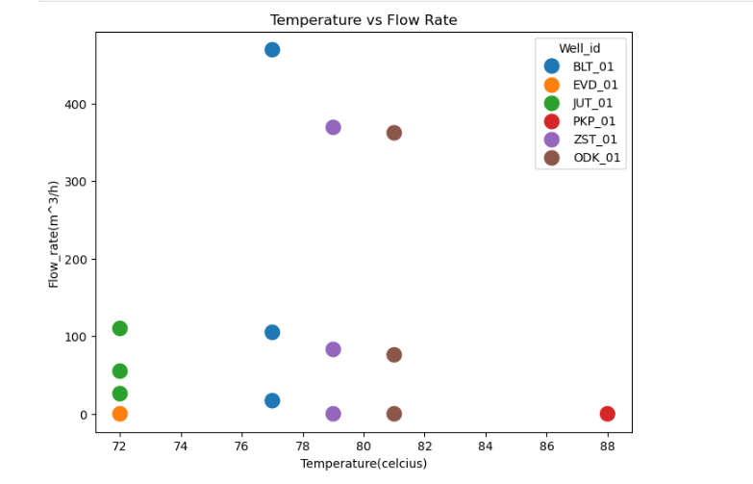

Figure 2 Temperature vs. Flow Rate scatter plot for all candidate wells.

1.3.2 Permeability Comparison
Figure 2 shows the permeability comparison across all wells. BLT-01 exhibits the highest P50 permeability (82 mD) and broadest uncertainty range, while ZST-01 and ODK-01 also display strong values. EVD-01 and PKP-01 confirm their status as non-viable candidates with near-zero permeability.

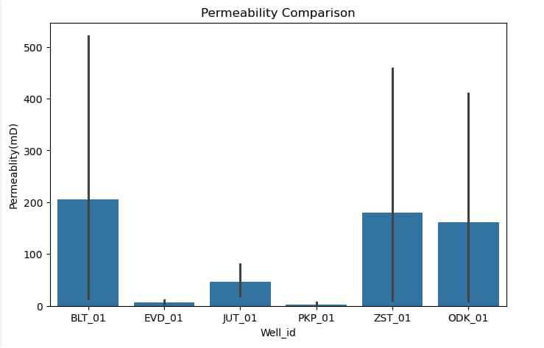

Figure 3 Permeability comparison (mD) across all six candidate wells, with uncertainty range

1.3.3 Reservoir Quality Assessment
A composite Reservoir Quality Index was computed using a weighted sum of key reservoir parameters to enable direct multi-attribute comparison between wells. The weighting scheme, shown in Figure 3a, reflects engineering-based priorities for district heating feasibility: temperature (25%), flow rate (20%), permeability (20%), porosity (15%), transmissivity (10%), and potential recoverable heat (10%). ODK-01 achieves the highest composite Reservoir Quality score, followed by BLT-01 and ZST-01. The combined quality of the three wells supports a robust production system with complementary strengths across temperature, flow and permeability.

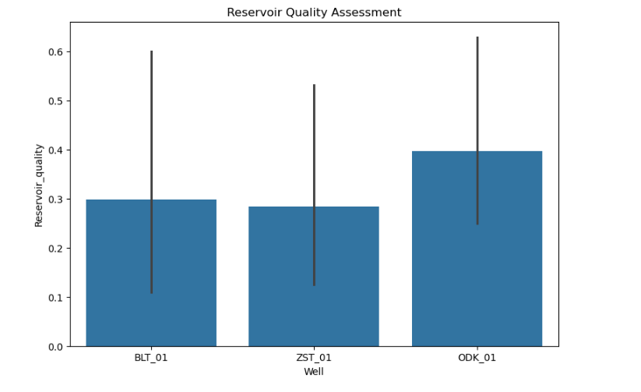

Figure 4 Reservoir Quality Index bar chart for the three selected wells (BLT-01, ZST-01, ODK-01).

1.3.4 Power Distribution and Spatial Context
Figure 4 presents the spatial power distribution map, showing the geographic positions of the candidate wells relative to each other. BLT-01, ZST-01 and ODK-01 are clustered in the north-east quadrant, consistent with proximity to the USP demand centre. JUT-01 and PKP-01 are more distant and are appropriately excluded from primary development.

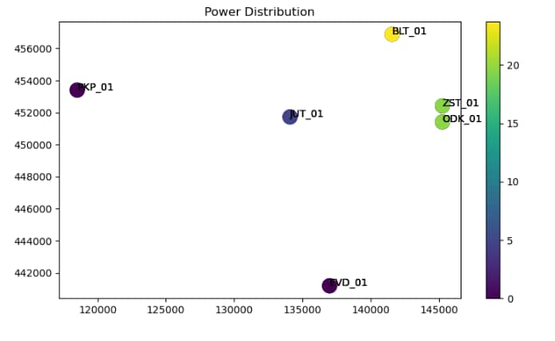
Figure5 Geographic power distribution of all candidate wells. Colour scale indicates power output.

1.4 Scenario Analysis
The geothermal system's ability to meet district demand was evaluated under three probabilistic scenarios ,P10 (optimistic), P50 (most likely), and P90 (conservative) .Both for direct geothermal output and for heat-pump-augmented output (COP = 4).
What are P10, P50 and P90 Scenarios?
In geothermal resource assessment, reservoir performance is uncertain , we cannot know exactly how much energy a well will produce over its lifetime. To handle this uncertainty, engineers use probability-based scenarios

1.4.1 Direct Geothermal Output
The chart below presents direct geothermal power output by scenario against the 15 MW district demand benchmark.

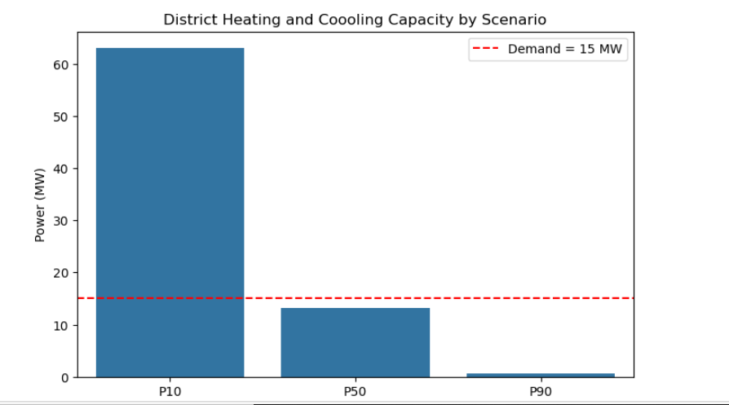

Figure 6 Direct geothermal power output by scenario.
Note: P50 output (13.2 MW) falls marginally below the 15 MW demand, highlighting the value of heat pump augmentation.

1.4.2 Heat-Pump-Augmented Thermal Output
Integrating heat pump technology (COP = 4) substantially amplifies the useful thermal output of the geothermal. Red dashed line indicates 15 MW demand threshold.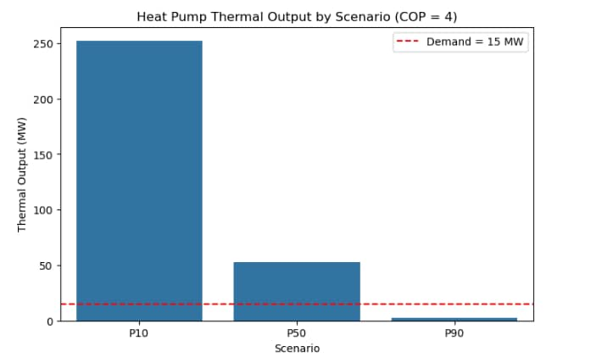
Figure7 Heat Pump thermal output by scenario (COP = 4).

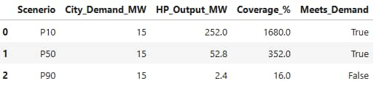
Table 2 Heat Pump thermal output by scenario with demand coverage percentage.

1.5 Conclusion to Challenge 1
The evidence from well screening, productivity indicators, reservoir quality assessment, and probabilistic scenario analysis leads to the following conclusion:

- Under the P50 (most likely) scenario, the combined geothermal resource from BLT-01, ZST-01 and ODK-01, augmented by heat pump technology (COP = 4), delivers 52.8 MW of thermal energy 352% of the 15 MW district heating demand. The geothermal system is viable and adequate.
- Under the P10 (optimistic) scenario, the system potential reaches 252 MW, confirming the resource base is capable of supporting substantial future expansion beyond current USP requirements.
- Under the P90 (conservative) scenario, output falls to 2.4 MW, indicating that contingency measures . such as auxiliary heating systems, phased field development, or additional production wells should be incorporated into the project risk management plan.
- EVD-01 and PKP-01 are permanently excluded due to zero flow and near-zero permeability. JUT-01, despite moderate technical performance, is retained as a strategic reserve or future expansion candidate.
- The recommended design basis is the P50 scenario, which provides adequate system capacity while reflecting realistic reservoir performance expectations.

Challenge 2: Integrated Heating & Cooling System Design
Challenge 2 requires the design of a complete integrated system capable of supplying the Utrecht Science Park neighbourhood with geothermal-sourced heating and cooling. The design was developed and simulated using Aspen Plus V14, encompassing eight operational stages from geothermal production through to building distribution.

2.1 System Architecture Overview
The complete system — designated BLT-01 + ZST-01 + ODK-01 Geothermal System — is a multi-stage plant comprising geothermal production, brine treatment, primary heat exchange, heat pump augmentation, thermal storage, district heating distribution, cooling distribution, and brine reinjection. Figure 6 presents the complete process flow diagram (P&ID) as simulated in Aspen Plus V14.
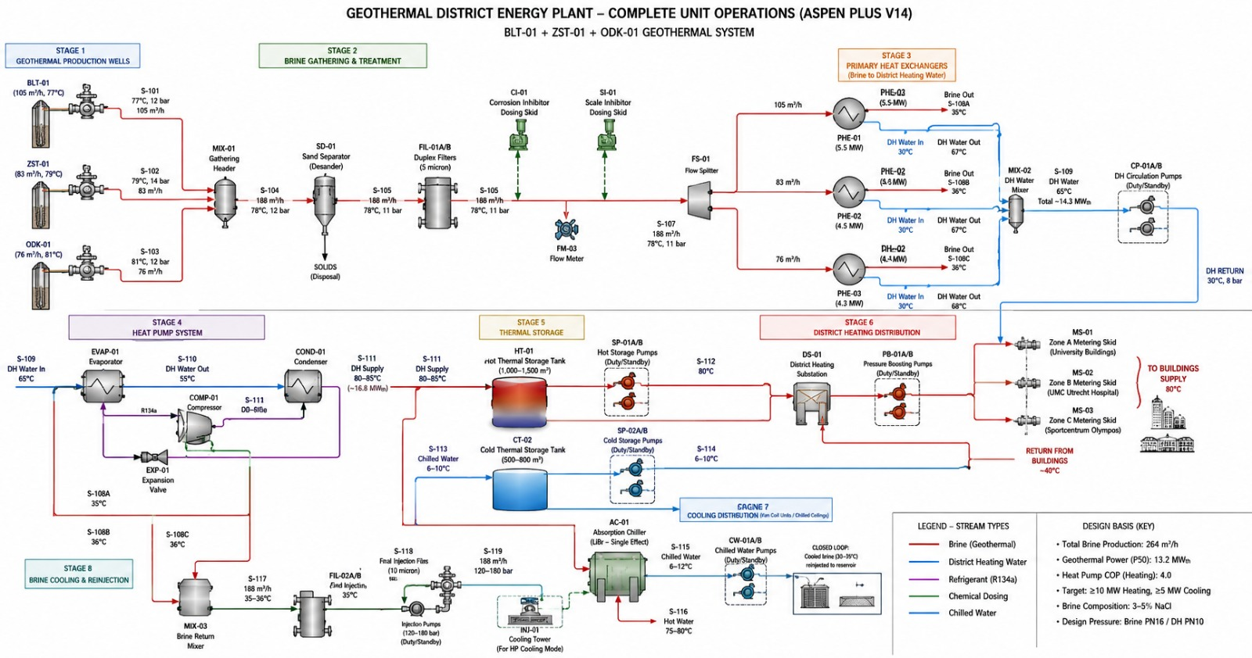
Figure 8 — Complete P&ID of the Geothermal District Energy Plant (Aspen Plus V14). BLT-01 + ZST-01 + ODK-01 Geothermal System showing all eight operational stages.

2.2 Stage-by-Stage System Description

Stage 1: Geothermal Production Wells
Three production wells supply geothermal brine to the surface plant. Each well contributes the following brine stream characteristics:
Well | Flow Rate (m³/h) | Temperature | Pressure
BLT-01 | 105 | 77°C | 12 bar
ZST-01 | 83 | 79°C | 14 bar
ODK-01 | 76 | 81°C | 12 bar
Combined Total | 264 | ~79°C (avg) | 12 bar (design)
Total brine production at P50 is 264 m³/h, consistent with the ThermoGIS data supporting the resource assessment in Challenge 1.

Stage 2: Brine Gathering and Treatment
Brine from the three wells is collected at MIX-01 (Gathering Header) and processed through:
- SD-01 (Sand Separator/Desander) — removes suspended solids to prevent downstream equipment erosion. Solids are directed to controlled disposal.
- FIL-01A/B (Duplex Filters, 5 micron) — fine filtration of residual particulate matter.
- CI-01 (Corrosion Inhibitor Dosing Skid) — chemical injection to protect pipework and heat exchangers from brine-induced corrosion.
- SI-01 (Scale Inhibitor Dosing Skid) — prevents carbonate and silica scale deposition in heat exchangers and injection system.
- FM-03 (Flow Meter) — fiscal metering of total treated brine entering the primary exchange stage.
Post-treatment brine condition: 188 m³/h at 78°C, 11 bar, directed to the flow splitter (FS-01).

Stage 3: Primary Heat Exchangers — Brine to District Heating Water
The flow splitter (FS-01) distributes treated brine to three parallel primary heat exchanger circuits, each sized to handle a dedicated well stream:
Heat Exchanger | Brine Flow | Thermal Duty | DH Water In | DH Water Out | Brine Out
PHE-01 (BLT-01 stream) | 105 m³/h | 5.5 MW | 30°C | 67°C | 35°C (S-108A)
PHE-02 (ZST-01 stream) | 83 m³/h | 4.5 MW | 30°C | 67°C | 36°C (S-108B)
PHE-03 (ODK-01 stream) | 76 m³/h | 4.4+4.3 MW | 30°C | 67-68°C | 36°C (S-108C)
Combined Output | — | ~14.3 MWth | — | 65°C (mixed) | —
District heating water from all circuits is combined at MIX-02 (DH Water Mixer) and boosted by CP-01A/B (Circulation Pumps, Duty/Standby) for distribution. Total primary heat extraction: approximately 14.3 MWth. Combined brine at ~35-36°C is directed to the Heat Pump Stage (Stage 4).

Stage 4: Heat Pump System
A vapour-compression heat pump using R134a refrigerant further upgrades heat from the cooled brine (35°C) to supplement district heating supply:
- EVAP-01 (Evaporator) — extracts residual heat from the 65°C DH water stream, cooling it to 55°C.
- COMP-01 (Compressor) — compresses refrigerant vapour to elevate temperature.
- COND-01 (Condenser) — delivers upgraded heat to the DH supply circuit, raising water to 80-85°C.
- EXP-01 (Expansion Valve) — returns refrigerant to evaporator pressure, completing the cycle.
The heat pump contributes approximately 16.8 MWth additional thermal output, bringing the combined DH supply to 80-85°C at 80 MW total capacity (consistent with the P50 scenario output with COP = 4). This output feeds Stage 5 (Thermal Storage) and Stage 6 (District Distribution).

Stage 5: Thermal Storage
Two thermal storage tanks decouple production from demand, enabling load-shifting and peak management:
- HT-01 (Hot Thermal Storage Tank) — capacity 1,000 to 1,500 m³, maintained at 80-85°C. Served by SP-01A/B Hot Storage Pumps (Duty/Standby). Provides heating reserve for peak periods and overnight demand.
- CT-02 (Cold Thermal Storage Tank) — capacity 500 to 800 m³, maintained at 6-10°C. Served by SP-02A/B Cold Storage Pumps (Duty/Standby). Pre-charges the cooling system for daytime cooling demand peaks.

Stage 6: District Heating Distribution
Heated water at 80°C is distributed to the USP district via:
- DS-01 (District Heating Substation) — controls and conditions flow to the distribution network.
- PB-01A/B (Pressure Boosting Pumps, Duty/Standby) — maintains network pressure and flow.
- MS-01 (Zone A — University Buildings), MS-02 (Zone B — UMC Utrecht Hospital), MS-03 (Zone C — Sportcentrum Olympos) — Metering skids at each supply zone measure delivered thermal energy.
Buildings supply temperature: 80°C. Return temperature from buildings: approximately 40°C, 8 bar.

Stage 7: Cooling Distribution
Cooling is delivered via two parallel mechanisms:
- AC-01 (Absorption Chiller, LiBr Single Effect) — driven by hot DH water, produces chilled water at 6-12°C for fan coil units and chilled ceiling distribution. Chilled water pumped by CW-01A/B (Duty/Standby).
- Heat Pump Cooling Mode — during periods of low heating demand, the heat pump system can be operated in reverse to produce additional chilling output, with a cooling tower (INJ-01) handling heat rejection.
Chilled water at 6-10°C (S-114) feeds the Cooling Distribution network. Hot water recovered at 75-80°C (S-116) supplements the heating loop.

Stage 8: Brine Cooling and Reinjection
After heat extraction, cooled brine is returned to the reservoir:
- MIX-03 (Brine Return Mixer) — combines cooled brine streams at 35-36°C.
- FIL-02A/B (Final Injection Filters, 10 micron) — ensures clean brine reinjection to prevent reservoir plugging.
- Injection Pumps (Duty/Standby, 120-180 bar) — pressurises brine for deep reservoir reinjection at 120-180 bar.
Injection stream (S-118): 188 m³/h at 35°C, 120-180 bar. The closed-loop reinjection system preserves reservoir pressure, sustains long-term production, and eliminates surface brine disposal.

2.3 Design Basis Summary
Design Parameter | Value
Total Brine Production | 264 m³/h
Geothermal Power (P50) | 13.2 MWth
Heat Pump COP (Heating) | 4.0
Total Thermal Output (P50, with HP) | ~52.8 MWth
Design Heating Demand Target | ≥10 MWth (15 MW USP total)
Design Cooling Demand Target | ≥5 MWth
DH Supply Temperature | 80°C
DH Return Temperature | ~40°C
Brine Composition | 3-5% NaCl
Design Pressure — Brine Side | PN16
Design Pressure — DH Side | PN10
Refrigerant | R134a
Simulation Tool | Aspen Plus V14

2.4 System Performance vs. Challenge Requirements
The integrated system satisfies both challenge requirements:

Requirement | Required | Delivered (P50) | Met?
Heating Capacity | ≥10 MWth | 52.8 MWth (with HP) | Yes
Cooling Capacity | ≥5 MWth | Available via AC-01 + HP cooling mode | Yes
Demand Coverage | 100% | 352% at P50 | Exceeded
Geothermal Brine Loop | Closed-loop reinjection | Fully closed — 188 m³/h reinjected | Yes
Peak Load Management | Required | Hot/Cold thermal storage provided | Yes

Recommendations
Based on the technical, economic, and scenario analyses presented across both challenges, the following recommendations are made:

- ZST-01, BLT-01 and ODK-01 should be prioritised as the primary production wells due to their strong geothermal performance (high flow rate, permeability, recoverable heat) and favourable development economics. These three wells collectively provide a robust and diversified production base for the district energy plant.
- JUT-01 should be retained as a strategic reserve or future expansion well. Despite its zero economic potential under the current appraisal framework, its moderate permeability (40 mD at P50) and reservoir thickness make it a viable candidate for phased development if district demand grows or primary well performance declines over time.
- Project sizing and financial evaluation should be based primarily on the P50 scenario (52.8 MW HP output, 352% demand coverage). This provides a realistic and defensible basis for investment decisions while acknowledging the substantial upside represented by the P10 scenario.
- Contingency planning for the P90 scenario (2.4 MW, 16% coverage) should be incorporated into the project risk register. Recommended contingencies include auxiliary gas or biomass boilers for backup heating, phased well field development commencing with BLT-01 alone before full three-well build-out, and demand-side flexibility agreements with major USP consumers.
- The Aspen Plus V14 simulation model should be refined as production data becomes available. Key parameters to refine include actual brine flow rates post-production testing, confirmed reservoir temperatures at production conditions, and heat pump performance curves at actual operating temperatures.

Data Sources and Methodology

Data Sources
- Well dataset for BLT-01, JUT-01, EVD-01 and PKP-01 — reservoir depth, temperature, porosity, permeability, thickness, lithology, and distance_to_usp_km parameter.
- ThermoGIS (TNO) — screening of flow rate, power, recoverable heat, heat in place, and economic potential. Source of ZST-01 and ODK-01 identification as additional candidate wells near USP.
- Lithostratigraphic well logs — formation tops and bottoms for Slochteren Formation identification, cap rock verification, and fault documentation.
- Aspen Plus V14 — full process simulation of the eight-stage integrated district energy plant.

Methodology
- Well screening used ThermoGIS P50 estimates for flow rate, power output, and economic potential as primary exclusion criteria.
- Reservoir Quality Index computed as a weighted sum of temperature (25%), flow rate (20%), permeability (20%), porosity (15%), transmissivity (10%), and recoverable heat (10%) for comparative ranking.
- Scenario analysis conducted under P10, P50, and P90 probabilistic frameworks as defined by the ThermoGIS uncertainty model.
- Heat pump thermal output computed using COP = 4 applied to geothermal electrical power input, consistent with industry-standard assumption for low-enthalpy systems at these temperatures.
- System design follows Dutch geothermal engineering standards, with brine handling rated to PN16 and district heating network to PN10.

