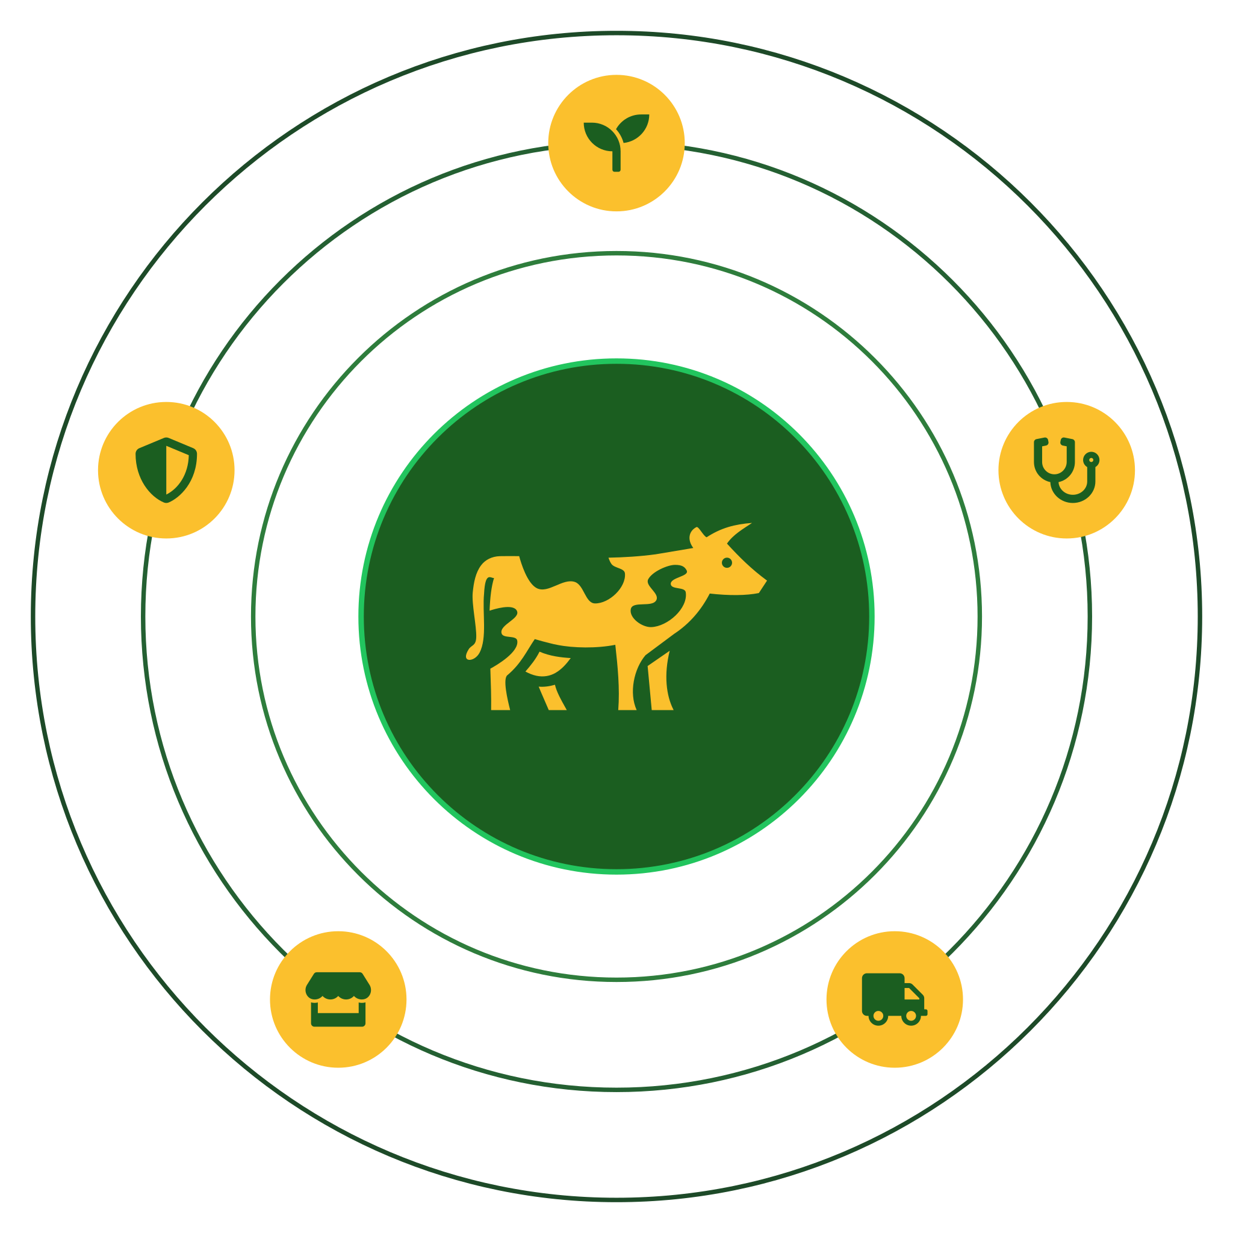
PFUMA
Technical & National Impact Dossier
An Enterprise Agri-Health Intelligence Platform for Zimbabwean Livestock

Prepared for: Zimbabwe Agricultural Show 2026 — National Innovation Competition Judging Panel
Prepared by: Team GRIWD — Arnold T. Mapindu & Adrianny Jaliele
Contact: teamgriwd@gmail.com
Live platform: https://38-247-146-172.sslip.io:8443 (production deployment, not a mock-up)
Date: 27 August 2026

Structured against the Competition's four judging criteria:
Measurable Impact & ROI • Scalability & Accessibility • Technical Innovation & Data Utilization • Sustainability & Socio-Economic Ethics

Executive Summary
PFUMA (Shona: “wealth”) is a production livestock-management and traceability platform that digitizes the exact process Zimbabwean law already requires before livestock changes hands — ownership proof, veterinary inspection, and police clearance — and pairs it with a solar-powered IoT collar system for real-time animal health and location monitoring. It is not a prototype: PFUMA is live in production today as a web PWA, an Android application, and a working ESP32/LoRa hardware collar and base-station pair, backed by an audited Flask/MySQL backend.
This dossier responds directly to feedback gathered on the Show floor from Ministers, a company CEO, the Permanent Secretary, and delegates from the Office of the President — six specific, high-value suggestions that are addressed individually in Section 5 and folded into the roadmap throughout. The document is organised around the four criteria the judging panel evaluates: measurable impact and return on investment; scalability and accessibility; technical innovation and data utilization; and sustainability with socio-economic ethics.
THE PROBLEM, AT NATIONAL SCALE
500,000+ cattle lost to January Disease (Theileriosis) in Zimbabwe since 2016 — most of it preventable with early detection.

THE PROBLEM, IN LAW ENFORCEMENT
A single ZRP anti-stock-theft crackdown produced over 3,400 arrests — livestock crime in Zimbabwe is a documented, active problem, not a hypothetical one.

PFUMA answers both problems with one shared record across five account types — Farmer, Veterinarian, Supplier, Retailer, and Police — so that a sale cannot legally complete, a disease case cannot go unlogged, and an animal's ownership cannot be disputed from memory.
1. Measurable Impact and Return on Investment
1.1 The cost of doing nothing
Disease and theft are not abstract risks in the Zimbabwean livestock sector — they are the two largest destroyers of rural household wealth, and both are addressed structurally by PFUMA rather than left to a farmer's memory or an informal phone call:
- Disease: 500,000+ cattle deaths nationally since 2016 from January Disease alone, most of it preventable with early detection — a gap PFUMA's Jinda AI assistant and Diagnostics engine target directly.
- Theft: 3,400+ arrests in a single ZRP anti-stock-theft operation — evidence of an active, organised national problem that a paper-based clearance process cannot keep pace with.
1.2 Unit economics of the hardware layer
Every cost below is a real, itemised bill of materials — not a rough guess — drawn from the project's own component-level sourcing research across AliExpress, LCSC, and local Harare suppliers (full breakdown: BUDGET_PROPOSAL.md).
Hardware Unit | Role | Online-sourced cost | Local (Zimbabwe) est.
CN-01 Collar Node | Worn on animal — GPS, LoRa, IMU, heart-rate, temperature, solar+LiPo | $39.80 | $67.90
BS-01 Base Station | Fixed at farm — receives collar data, relays to cloud | $24.80 | $42.60
System set (1 collar + 1 base station) | Minimum viable field unit | $64.60 | $110.50

1.3 Costed deployment path, not a wish list
The budget model already scales through three concrete phases, each fully costed including a 10% contingency and a modelled 12% bulk-order discount at 50 units:
Deployment Phase | Scope | Total (online sourcing) | Total (local sourcing)
A — Show demo | 2 collars + 1 base station + dev tools + 1yr infra | $216.40 | $290.40
B — Pilot farm | 10 animals, 1 farm, 2 base stations (redundant) | $615.56 | $963.82
C — Commercial rollout | 50 animals, 3 farms, 6 base stations | $2,312.20 | $3,761.34

1.4 Indicative return on investment
A commercial-weight beef animal in Zimbabwe typically trades in the range of $300–500 (this figure should be validated against current DVS/livestock-market data before external citation, and the team commits to publishing a confirmed figure prior to formal submission). Against that range, the $64.60–110.50 system-set cost means a single collar-and-base-station unit pays for itself by preventing a fraction of one animal's loss — disease death, theft, or an unresolved ownership dispute — with every subsequent prevented loss across the unit's multi-year working life pure return. On the software side, the police-clearance gate and vet-certification record remove the cost of resolving ownership disputes and fraudulent sales after the fact, and district-tagged veterinary case data cuts the cost of a vet's wasted physical trips to livestock that could have been triaged remotely.
1.5 This is a live platform, not a demo built for one day
PFUMA is deployed in production on dedicated infrastructure — a real HTTPS web app installable as a PWA on any smartphone (including iPhone, which matters given how iPhone-heavy Show attendance skews), a permanently-hosted Android APK, and a working hardware collar and base station validated in Proteus simulation before physical assembly. Field engagement with real partner farmers ahead of the Show is documented in the project's own records. This is the difference between a UI mock-up and a system a judge can actually log into today.
2. Scalability and Accessibility
2.1 Network capacity is a calculated number, not a marketing claim
A common weak point in agri-IoT pitches is an invented “range” or “capacity” figure. PFUMA's is computed from the actual firmware using the standard Semtech LoRa airtime formula (AN1200.13). The first firmware revision used SF9 with a verbose JSON payload, which the team's own capacity analysis caught as a bottleneck — airtime per packet was too high to support more than a handful of collars reporting concurrently. The fix, now shipped in both `collar_node.ino` and `base_station.ino`, is SF7 with a compact 28-byte binary packet:
Metric | Original design (SF9 + JSON) | Current design (SF7 + binary)
Airtime per packet | ~1.15 seconds | ~72 milliseconds
Practical collars per base station | Far below the array size the code assumed | 40 (MAX_COLLARS, field-verified against the airtime budget)
Typical farm-terrain range | ~5 km link-budget maximum (open field, not typical) | ~1–2 km typical — traded down deliberately for capacity

This is disclosed as an honest engineering trade-off in the project's own hardware documentation, not smoothed over: larger or hilly grazing areas are handled by deploying a second base station rather than overclaiming range from a single unit.
2.2 Scaling the network: multiple base stations, unlimited farms
Because each base station independently forwards to the cloud API over Wi-Fi/LTE, scaling PFUMA beyond one farm is horizontal, not architectural rework: additional base stations extend coverage across paddocks, and additional farms simply register additional base stations against the same backend. Scenario C in Section 1.3 already models this at 3 farms / 6 base stations / 50 animals with a commercial per-unit discount.
2.3 Software accessibility: built for the phone people actually have
- Web: A PWA that installs like a native app from the browser — no app-store approval delay, no storage-hungry install, works identically on Android and iPhone.
- Mobile: A native Android APK re-hosted permanently on PFUMA's own infrastructure specifically so the Show's QR code never expires — Expo's own build links die after 14 days, which would have gone dead before the Show itself.
- Inclusion: Every legitimate Zimbabwean land-tenure document is accepted at signup — title deed, 99-year lease, offer letter, A1/A2 resettlement permit, or communal land allocation letter — so communal farmers are not locked out by a system that only recognises formal title.
2.4 Roadmap: connectivity for the base station in the field (Show feedback)
Raised directly at the stand: base stations deployed far from town need more than a standard internet uplink. The roadmap response is a WAN module option on BS-01 — LTE SIM (cellular modem) as the primary rural option, with Starlink or VSAT available for genuinely remote sites — so connectivity is chosen per-site rather than assumed.
2.5 Roadmap: RFID-tag herd mapping (Show feedback) — the biggest scale lever available
The single highest-impact suggestion received at the stand: instead of one full smart collar per animal, equip one animal per herd (e.g. the herd's Brahman or other high-value lead animal) with the full CN-01 collar, and tag every other animal with a low-cost passive or active RFID ear tag that the lead collar reads locally and relays to the base station as one batched report. This mirrors ISO 11784/11785 livestock-ID standards already used internationally. Because RFID ear tags cost roughly $1–3 versus $39.80–67.90 for a full collar, this is the single change that would let PFUMA scale to full commercial herds — hundreds of animals — at close to a tenth of current per-animal hardware cost. The real engineering constraint to design around: passive tag read range is short (typically under a metre for LF/HF tags, several metres for UHF), so the lead collar needs a UHF reader stage, not the LF/HF tags used in some low-cost livestock systems. This is scoped as a BOM and firmware revision to CN-01, not a rebuild of the platform.
3. Technical Innovation and Data Utilization
3.1 Software regulation modelled as system state, not a form
PFUMA's core innovation is structural, not cosmetic: the Stock Theft Prevention Act's real-world ownership → veterinary inspection → police clearance sequence is enforced as software state. Every livestock listing is created `pending_clearance` and is invisible to buyers until an officer verifies ownership/brand papers and issues a movement-permit reference — it is impossible to list an animal for sale and skip the legal gate, because the gate is the database, not a checklist a seller can ignore.
3.2 Jinda: a role-aware AI assistant grounded in cited law, not guesswork
- Natural-language queries answered from a condensed version of the project's own researched compliance knowledge base — e.g. “what do I legally need before I can sell this animal?” draws on cited Zimbabwean statute, not a generic LLM guess.
- Role-aware by design: the assistant will not discuss another user's data, and its answers change based on whether the caller is a Farmer, Vet, Supplier, Retailer, or Police account.
- A weighted diagnostic engine differentiates primary from secondary symptoms rather than doing flat keyword matching — a deliberate algorithmic choice, trained specifically on regional Zimbabwean threats (January Disease, Anthrax, FMD, Lumpy Skin Disease, African Swine Fever, Peste des Petits Ruminants) across cattle, pigs, sheep, and goats.
3.3 Real embedded-systems engineering, verified before physical build
- Custom two-layer PCBs for both CN-01 and BS-01, designed in KiCad with full schematic and netlist documentation — not a breadboard glued into an enclosure.
- Every board was simulated in Proteus 8 before physical assembly, catching real issues (a component -overlap and a colour-rendering defect on the hardware concept visualisation were both found and fixed via automated headless-browser screenshot verification, not “trust the code by eye”).
- The LoRa capacity fix described in Section 2.1 is the clearest evidence of real systems engineering in this project: the team identified their own firmware's capacity ceiling using the Semtech airtime formula, rather than shipping an untested `collars[8]` array size as a claimed spec.
3.4 Data utilization: the surveillance dataset already being collected
Every veterinary case in PFUMA is tagged by province and district at the point of entry. This is not a cosmetic filter — it is the exact structure the Department of Veterinary Services needs for contact tracing during an outbreak, and it already exists in the schema today. This directly enables the highest-value suggestion raised at the stand:
Roadmap: geo-fenced disease outbreak broadcast (Show feedback)
A vet-submitted, district/province-tagged outbreak report, pushed as a real-time broadcast alert to every farmer registered in the affected area — e.g. a January Disease outbreak logged in Kadoma immediately notifying Mashonaland West farmers on the platform. Because the geo-tagging already exists on every vet case, this is a new alert-broadcast layer on existing data, not a new data-collection effort — the fastest of the six Show suggestions to ship, and arguably the single highest national-impact feature on the entire roadmap.
3.5 Security as engineering, not an afterthought
- Fail-closed secret-key handling — the backend refuses to start in production without one, closing a real forgeable-session vulnerability found and fixed in this project's own audit.
- bcrypt password hashing, JWT-authenticated sessions, per-owner data scoping (a Farmer only ever sees their own animals/records; Vets and Police get oversight visibility, never blanket access).
- Rate limiting on login, registration, and IoT telemetry-ingest endpoints; CORS allow-listing; uploaded documents stored outside the web root and served only to their owner or an authorized reviewer.
- A real bypass was found and closed in this project's own audit: livestock listings only required police clearance when an `animal_id` was attached, but attaching one was optional — meaning a verified user could originally list livestock with no linked animal record and skip clearance entirely. Both the backend and the web/mobile listing UI were corrected to close this.
4. Sustainability and Socio-Economic Ethics
4.1 Power sustainability at the hardware layer
CN-01 is solar-charged (40×70mm panel feeding a protected LiPo cell via a TP4056 charge controller), reducing dependence on disposable batteries in a rural deployment context where battery replacement logistics are themselves a real cost and waste stream.
4.2 Economic inclusion by design, not as an afterthought
Livestock is frequently a rural family's single largest store of wealth. PFUMA's signup flow deliberately accepts the full range of legitimate Zimbabwean land-tenure documentation — title deed, 99-year lease, offer letter, A1/A2 resettlement permit, or communal land allocation letter — specifically so that formalising livestock ownership through a verified profile, brand/tag record, and clean sale history is available to communal farmers, not only to holders of formal title. A verified, documented ownership history is also the kind of record that makes it easier to access credit against livestock as an asset — a meaningful, if indirect, financial-inclusion effect.
4.3 Built on real law, and honest about the limits of that research
Every major PFUMA feature is mapped to a specific, cited Zimbabwean statute: the Stock Theft Prevention Act [Chapter 9:18], the Animal Health Act [Chapter 19:01], the Veterinary Surgeons Act [Chapter 27:15], the Livestock Identification framework (Brands Act and related regulations), and the Consumer Protection Act [Chapter 14:44]. This research is compiled from primary and secondary Zimbabwean legal sources (ZimLII, law.co.zw, FAOLEX, CVSZ, Veritas Zimbabwe, the Consumer Council of Zimbabwe) and international veterinary references (WOAH, FAO). Where a specific detail could not be independently confirmed — for example, current fine levels under the Standard Scale of Fines Act, or whether nationwide RFID cattle tagging is a hard mandate everywhere versus a phased rollout — the project's own compliance documentation says so explicitly, rather than presenting an unverified claim as settled fact. The team's position is that this research is citable and built with the real legal framework in mind from day one, while stopping short of calling it a lawyer-certified compliance audit — and recommends exactly that review (by a Zimbabwean lawyer or the relevant regulator) before any formal compliance claim is made to a partner or regulator.
4.4 Protecting the institutions PFUMA depends on, not just its users
- Police accounts are never self-service — an existing verified officer must create and vouch for the next one, mirroring real ZRP onboarding, so no one can register as a police officer off the street and approve fraudulent clearances.
- Veterinarian applicants require a CVSZ registration/licence number and are peer-reviewed by an existing verified vet before activation — the platform cannot be used to impersonate a credentialed professional.
- This is a deliberate ethical stance: PFUMA is designed to strengthen trust in DVS and ZRP as institutions by digitizing their existing role, not to route around them.
4.5 A monetization model that keeps the vulnerable side free
Sustainability has to survive contact with a real budget, not just a mission statement. The go-to-market and monetization suggestions raised by the CEO at the stand map cleanly onto PFUMA's existing five-role structure:
- Sponsored listings: Suppliers and retailers can pay to feature or advertise a listing — a natural extension of the existing Marketplace, monetizing the commercial side of the platform.
- Premium tiers: Premium feature tiers with volume-based discounts as the user base grows, again targeted at the commercial roles rather than at Farmers.
- DVS-first distribution: The Department of Veterinary Services is the primary go-to-market channel — DVS already has farmer trust and physical reach that a WhatsApp group cannot replicate, making DVS a distribution partner rather than a customer PFUMA has to persuade cold.
Deliberately, none of this touches the Farmer's core feature set: registration, health records, the AI assistant, and marketplace listing stay free for the Farmer, because Farmers are the platform's primary intended beneficiaries, not its primary revenue source. Monetization sits on the commercial roles (Supplier, Retailer) that are already paying customers of the farmers they serve.
4.6 Data protection as a built commitment, not a promise for later
A full privacy policy and internal data-protection standard already exist (`docs/PRIVACY_POLICY.md`, `docs/DATA_PROTECTION_INTERNAL.md`), alongside the per-owner data scoping and outside-web-root document storage described in Section 3.5. As PFUMA scales commercially, this dossier also responds to the administrative-access and data-residency question raised at the stand: at national scale, PFUMA's roadmap includes evaluating in-country data centre and TelOne hosting options specifically to keep Zimbabwean livestock and citizen data on Zimbabwean infrastructure, rather than defaulting indefinitely to the team's own external VPS used at pilot stage.
5. Stakeholder Feedback From the Show, Mapped to the Roadmap
The suggestions below were raised in person at the PFUMA stand by Ministers, a company CEO, the Permanent Secretary, and delegates from the Office of the President. Each is addressed on its merits elsewhere in this dossier; this table is a single point of reference tying each suggestion to where it lives in the document and its practical scope.
# | Suggestion raised at the stand | Where addressed | Scope
1 | RFID ear tags per animal, relayed through one lead collar per herd, rather than a full collar per animal. | §2.5 | Hardware BOM + firmware revision to CN-01
2 | Real-time disease-outbreak alerts broadcast to farmers by geographic area (e.g. a Kadoma outbreak notifying the affected district/province). | §3.4 | New alert layer on data already collected
3 | Administrative access, data storage, and data-centre strategy (incl. TelOne) at commercial scale. | §4.6 | Infrastructure / data-residency roadmap
4 | Base-station connectivity options for the field — Starlink, LTE SIM, VSAT. | §2.4 | BS-01 hardware revision (WAN module)
5 | Searchable vet/police directory by province/district, linked to DVS records. | §2.3 / §4.4 | Directory feature + government data-sharing partnership
6 | Go-to-market via DVS as primary channel; monetize via sponsored listings and premium tiers with volume discounts. | §4.5 | Business model / commercial roadmap

Two honest distinctions worth stating plainly to the panel: items 1, 2, and 4 are engineering scope the team can execute unilaterally on the existing codebase and hardware design. Items 3, 5, and part of 6 involve a government or institutional partnership (DVS data-sharing, TelOne infrastructure) that PFUMA cannot build alone — and the team is explicit about that dependency rather than presenting it as already solved.

PFUMA — Team GRIWD | Arnold T. Mapindu & Adrianny Jaliele | teamgriwd@gmail.com

