

# 

COMPLAINT :

DATE:

The Manager,

«BRANCH_ADDRESS»

Subject: Quotation of Repair and Maintenance. FOR APPROVAL

Number of AC: 1

|  |  |  |  |  |
| --- | --- | --- | --- | --- |
| Sr. | Job Description | Qty | Rate | Amount |
|  |  |  |  |  |
|  | Total |  |  |  |
|  | Tax 16% |  |  | «tax» |
|  | «Type» | «chargesqty» | «chargesrate» |  |
|  | Total |  |  | «totalamount» |

**Yours truly,**

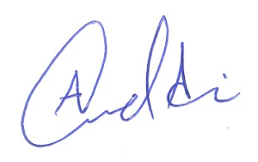 **ECO ENTERPRISES**