

# 

COMPLAINT : LB001-01-2021

DATE: 01-01-2021

The Manager,

Bank Al Habib Ltd,

address

Subject: Quotation of subject_line.

Number of AC: 1

|  |  |  |  |  |
| --- | --- | --- | --- | --- |
| Sr. | Job Description | Qty | Rate | Amount |
| 1 | a black little boy have ajump on to the road to avoid car. He knows the value of life | 10 | 200 | 1000 |
| 1 | a black little boy have ajump on to the road to avoid car. He knows the value of life | 10 | 200 | 1000 |
| 1 | a black little boy have ajump on to the road to avoid car. He knows the value of life | 10 | 200 | 1000 |
| 1 | a black little boy have ajump on to the road to avoid car. He knows the value of life | 10 | 200 | 1000 |
| 1 | a black little boy have ajump on to the road to avoid car. He knows the value of life | 10 | 200 | 1000 |
| 1 | a black little boy have ajump on to the road to avoid car. He knows the value of life | 10 | 200 | 1000 |
| 1 | a black little boy have ajump on to the road to avoid car. He knows the value of life | 10 | 200 | 1000 |
| 1 | a black little boy have ajump on to the road to avoid car. He knows the value of life | 10 | 200 | 1000 |
| 1 | a black little boy have ajump on to the road to avoid car. He knows the value of life | 10 | 200 | 1000 |
| 1 | a black little boy have ajump on to the road to avoid car. He knows the value of life | 10 | 200 | 1000 |
|  | Total |  |  |  |
|  | Tax 16% |  |  |  |
|  | Total |  |  |  |

**Yours truly,**

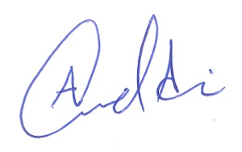 **ECO ENTERPRISES**