Objectively graded retinal disease, self-reported diagnosis, and eye-care utilisation in US adults
Jianhuang Huang¹*, Jing Wang²*
¹ Department of Neurosurgery, Affiliated Hospital of Putian University, Putian, Fujian, China.
² Eye Institute of Shandong First Medical University; Qingdao Eye Hospital of Shandong First Medical University, Qingdao, Shandong, China.
Corresponding authors: Jianhuang Huang (teamhuang@sina.com); Jing Wang (13273530801@163.com)
Keywords: diabetic retinopathy; age-related macular degeneration; diagnosis awareness; health services utilisation; NHANES; NHIS

Abstract
The relationship between objectively graded retinal disease, patient-reported diagnosis and eye-care use remains incompletely characterised across diabetic retinopathy and age-related macular degeneration in nationally representative US data. We combined centrally graded retinal photographs with self-reported diagnoses and eye-examination history from US adults aged ≥40 in NHANES 2005–2008 (n = 6,797), using the 2016 National Health Interview Survey (NHIS) as a contextual benchmark and survey weights with design-based confidence intervals among item responders. Among adults with diabetes and objectively graded retinopathy, 70.2% (63.8–75.9) reported no prior diabetic-eye diagnosis; among those with objectively graded age-related macular degeneration (AMD), 82.2% (77.3–86.2) reported none, including 41.4% (25.3–59.6) with late AMD. Within the diabetic-retinopathy group, 32.4% (25.9–39.7) reported no dilated examination within 12 months. Greater severity was associated with higher reported awareness, and in an exploratory adjusted analysis a recent dilated examination was associated with lower odds of no reported diagnosis (adjusted OR 0.30, 0.10–0.92), although this did not survive multiple-testing correction. Objectively graded AMD prevalence (6.58%) exceeded age-standardised self-report (2.45%); this is a contextual comparison, not a paired one. These findings document substantial discordance between retinal imaging, patient-reported diagnosis and eye-care use in a historical US population and do not alone establish clinical underdiagnosis.

Introduction
Diabetic retinopathy and age-related macular degeneration (AMD) are leading causes of irreversible vision loss and account for a large share of global blindness and moderate-to-severe visual impairment.¹,² Diabetic retinopathy is usually asymptomatic until advanced proliferative diabetic retinopathy or diabetic macular oedema develops, whereas early age-related macular degeneration (AMD) is often subclinical with progression to late AMD causing irreversible central vision loss; both are detectable on retinal examination and treatable in their advanced forms through glycaemic and blood-pressure control, laser photocoagulation, and anti–vascular endothelial growth factor therapy.³⁻⁵ Their public-health impact therefore depends not only on how much disease exists but on how much of it is recognised and brought into care.
National surveys have measured the prevalence of these conditions extensively.⁶⁻⁸ More recently they have also begun to measure awareness and undiagnosed disease: recent work has quantified social determinants of diabetic-retinopathy awareness in NHANES 2005–2008,⁹ and the burden of undiagnosed age-related eye disease among older adults has been described elsewhere.¹⁰,¹¹ A persistent obstacle is that most datasets capture only one side of the ledger. Self-report surveys such as the National Health Interview Survey (NHIS) record who has entered the health system but are blind to disease that was never diagnosed.¹² Imaging cohorts record disease that exists but often lack matched self-report of diagnosis and care.
NHANES 2005–2008 is a rare nationally representative resource that collected centrally graded retinal photographs and self-reported physician-diagnosed eye disease, diabetic eye-examination history, and health-insurance/utilisation information in the same examined adults aged ≥40.¹³ This allows an individual-level measurement of the concordance between three quantities usually studied separately: objectively graded disease, patient-reported diagnosis, and eye-care utilisation.
We therefore aimed to (i) quantify, in US adults ≥40, the proportion of objectively graded retinopathy in diabetes and of AMD that carries no self-reported diagnosis, and the proportion of at-risk people with diabetes not receiving recommended eye care; (ii) describe how this discordance varies with disease severity and across age strata; (iii) examine whether sociodemographic, access, and eye-care-utilisation factors are associated with having no reported diagnosis; and (iv) benchmark the self-reported side against an independent national survey (NHIS 2016) with age-standardisation.

Results

Study flow, denominators, and missingness
Of 6,797 examined adults aged ≥40 with retinal photography, 5,704 had a gradable retinopathy image and 5,604 a gradable AMD image (Supplementary Table S1, Figure S1). Because the diagnosis-discordance outcome requires an answer to the corresponding self-report item, all denominators below are responders. Among adults with diabetes and objectively graded retinopathy (n = 319), 313 answered the diabetic-eye item and formed the DR denominator; six non-responders were excluded. Among adults with objectively graded AMD (n = 441), 436 answered the macular-degeneration item (five excluded). Multivariable models were smaller because education and income were missing, not because of the outcome: of the 313 DR responders, 102 lacked education and 30 lacked income, leaving 187 in the complete-case core model; of the 436 AMD responders, 188 lacked education and 42 lacked income, leaving 226 (Supplementary Table S1). Design degrees of freedom were computed with survey::degf() for each subset (Supplementary Table S2b): the DR and AMD responder sets spanned 31 strata with 59 and 61 PSUs (design df 28 and 30), and the complete-case core models retained df 22 and 29. Regression inference used each model's residual degrees of freedom, degf(design) − model rank + 1 (13 for the eye-care model); Supplementary Table S2c reports the design df, rank, residual df, t-multiplier and every coefficient, standard error, confidence interval, raw P and Holm-adjusted P from the same fitted object, so intervals and P values cannot drift apart.

Prevalence of objectively graded disease
Weighted prevalence among adults ≥40 was 9.75% (95% CI 8.79–10.80) for any objectively graded retinopathy and 1.35% (1.10–1.65) for moderate-or-worse retinopathy. Restricting to adults with diabetes, objectively graded retinopathy was present in 33.0% (29.3–37.0). Any AMD was present in 6.58% (5.65–7.66) and late AMD in 0.80% (0.54–1.18); diagnosed diabetes in 12.05% (10.68–13.56); and any health insurance in 87.4% (85.1–89.4) (Table 1). Because fundus microvascular signs are not specific to diabetes, the whole-population retinopathy figure is reported descriptively and the primary diabetic-retinopathy analyses are confined to adults with diabetes.

Diagnosis discordance (objectively graded disease without a self-reported diagnosis)
Among adults with diabetes who had objectively graded retinopathy and answered the item, 70.2% (63.8–75.9) reported no prior diabetic-eye diagnosis (Table 2, Figure 1). Among adults with objectively graded AMD who answered the item, 82.2% (77.3–86.2) reported no prior macular-degeneration diagnosis, and even among those with late AMD — the stage most likely to be symptomatic — 41.4% (25.3–59.6) reported no diagnosis (n = 55). The outcome is the absence of a recalled, patient-reported diagnosis, not a chart-confirmed absence of diagnosis. We do not estimate a diagnosis gap for people with objectively graded retinopathy who do not report diabetes, because the diabetic-eye item (DIQ080) is asked only of people with diabetes; the appropriate denominator is therefore diabetic respondents (n = 313). Extreme-scenario bounds that assign the six DR and five AMD item non-responders first to "diagnosed" and then to "undiagnosed" move the weighted estimates only marginally (DR 69.2–70.6%, AMD 81.6–82.3%), so the headline gaps are not an artefact of non-response (Supplementary Table S2).

Eye-care discordance
Among adults with diabetes, 35.8% (31.3–40.5) had not had a dilated eye examination within 12 months; restricting to those with objectively graded retinopathy, 32.4% (25.9–39.7) had not (Table 2, Figure 1). Because clinical guidance permits intervals longer than 12 months for some low-risk patients, this measure reflects "not examined within 12 months" rather than "not following an individualised guideline."

Discordance by severity and age
Self-reported diagnosis rose steeply with retinopathy severity among adults with diabetes — from 16.6% with no gradable retinopathy, to 21.9% mild, 35.6% moderate, and 84.3% severe-or-proliferative retinopathy — and the corresponding diagnosis gap fell from 78.1% (71.3–83.7) for mild, to 64.4% (48.3–77.8) moderate, to 15.7% (5.0–39.7) severe-or-proliferative retinopathy (Figure 2, left panel; Supplementary Table S3). AMD discordance was similarly graded: the gap was higher for early AMD — 87.9% (84.4–90.6), n = 381 — than for late AMD (41.4%, 25.3–59.6, n = 55), each computed from its own responder set (Figure 2, right panel). By age stratum, AMD discordance was near-complete at 40–59 years (99.1%, 95.6–99.8), fell to 86.6% (77.8–92.3) at 60–74 and 66.7% (60.1–72.6) at ≥75, whereas the DR gap was flatter (Supplementary Table S3). The severe-DR and late-AMD strata are small and their intervals wide, so the fall in discordance with severity is best read as a graded descriptive pattern rather than a series of individually tested contrasts.

Discordance in advanced retinal disease
Reframing around clinically more advanced disease, the diagnosis gap remained substantial at or above the moderate-non-proliferative threshold: among adults with diabetes and moderate-or-worse retinopathy (n = 116) the pooled gap was 53.4% (38.7–67.5), comprising 64.4% (48.3–77.8) for moderate and 15.7% (5.0–39.7) for severe-or-proliferative retinopathy (Figure 2, left panel). For AMD, 41.4% (25.3–59.6) of objectively graded late AMD carried no reported diagnosis. The "moderate-or-worse" grouping denotes clinically more advanced disease, not a treatable or immediately blinding category — moderate non-proliferative retinopathy is typically monitored rather than treated — and imaging severity is not a treatment indication. Splitting late AMD, geographic atrophy was undiagnosed in 50.3% (26.6–73.9; n = 32) and exudative/neovascular AMD in 27.7% (8.0–62.9; n = 23); both strata are small with widely overlapping intervals, so this difference is not an established group difference. The two phenotypes also differ in therapy and in treatability at the time these data were collected.

Correlates of having no self-reported diagnosis
These covariate analyses are descriptive; they identify factors that co-occur with the patient-reported gap and do not support causal reading. In survey-adjusted complete-case core models (Table 3), older age was the only factor independently associated with lower odds of no self-reported diagnosis for AMD (aOR 0.93 per year, 95% CI 0.89–0.96; Holm-adjusted P = 0.003). For DR, no covariate reached significance after Holm correction. The family-income association was directionally consistent (aOR > 1 in every specification) but its magnitude and precision varied with missing-data handling: complete-case core aOR 1.34 (0.92–1.96, Holm P = 0.59); adding insurance, 1.39 (0.96–2.00, P = 0.077); dropping education, 1.46 (1.08–1.97, P = 0.017, n = 283); and multiple imputation (m = 20, Rubin-pooled) 1.38 (1.02–1.87, P = 0.037, n = 313), with the income aOR above 1 in all 20 imputations (range 1.24–1.49, SD 0.048). Higher income is therefore treated as a tentative correlate with imprecise magnitude, not an established driver. Education and insurance associations were non-significant under every approach (Supplementary Table S4). In the AMD model, insurance was not included because complete separation in the uninsured stratum prevented a stable estimate; the descriptive pattern is reported in Supplementary Table S4 rather than as a fitted term. Across specifications we found no consistent socioeconomic association with diagnosis discordance; limited precision does not rule out differences of clinical size.

Eye-care utilisation and diagnosis awareness
Within the diabetic-retinopathy cohort, recent eye-care contact tracked awareness. Unadjusted, 82.0% (70.1–89.9) of adults not examined within 12 months (n = 106) reported no diabetic-eye diagnosis versus 64.5% (55.9–72.2) of those examined (n = 207). This secondary analysis is exploratory; the adjusted odds ratio with its confidence interval is the primary quantity (full model in Supplementary Table S5). In the fully adjusted model (Table 4, n = 187), a recent dilated examination was associated with lower odds of a self-reported diagnosis being absent (aOR 0.30, 0.10–0.92, P = 0.038), but this did not remain significant after correction across the model's nine terms (Holm-adjusted P = 0.27); model-adjusted predicted risk was 81.8% versus 62.4% (a −19.4-percentage-point descriptive difference; Figure S2). The odds ratio, interval and P value come from a single quasi-binomial Wald t test on the model's residual degrees of freedom (df = 13), so they are internally consistent. The term that survived correction was the severe-or-proliferative retinopathy category (aOR 0.05, 0.01–0.24, Holm-adjusted P = 0.010; relative to mild non-proliferative diabetic retinopathy, the reference because all participants had graded retinopathy). An eye-care × severity interaction tested in the same model gave no evidence of effect modification (aOR 1.61, 0.24–10.79, P = 0.59). A recent dilated examination was thus associated with lower odds of an absent self-reported diagnosis in the adjusted model, though the association did not survive Holm correction; the cross-sectional design cannot separate examination-driven diagnosis from diagnosis-driven examination. The analogous AMD analysis is not feasible: dilated-examination timing (DIQ360) is collected only for people with diabetes, and only 59 of the 436 AMD responders were diabetic.

Grading feasibility and potential selection
Images were ungradable for 1,093 participants, who differed from gradable participants: they were older (mean 64.5 vs 59.6 years), more often diabetic (22.1% vs 15.9%) and more likely to have less than a high-school education (23.2% vs 14.4%) (Supplementary Table S6). To test whether this imbalance biases estimates, we reweighted gradable participants by the inverse probability of a gradable image. A base model (age, sex, race/ethnicity) moved whole-population prevalence only slightly (any retinopathy 9.75% → 9.98%; any AMD 6.58% → 6.87%); an extended model adding diabetes, insurance and education gave 9.75% → 10.13% and 6.58% → 6.77%. The inverse-probability factors were modest (1/P about 1.0–1.8; the smallest predicted gradability probability was 0.57, so the 0.05 floor never bound and no observation was truncated), and the Kish effective sample size of the combined weights (≈3,635–3,656 of 5,704) stayed close to the raw-weight value (≈3,508). This stability check is limited; an unchanged aggregate ESS can still sit alongside a long weight tail and speaks only to observable differences. The diagnosis gaps themselves were essentially unchanged under IPW (DR 70.2% → 70.2%; AMD 82.2% → 82.0%). The descriptive prevalence and primary discordance proportions therefore move little under observable gradable-vs-ungradable reweighting; inverse-probability weighting cannot address unmeasured selection (Supplementary Table S6).

Cross-survey benchmark (NHIS 2016)
In NHIS 2016, weighted self-reported prevalence among adults ≥40 was 2.66% (2.40–2.91) for macular degeneration and 1.27% (1.09–1.46) for diabetic retinopathy; 48.7% (47.7–49.7) had seen an eye doctor and 49.9% (48.9–51.0) had a dilated examination within 12 months (Table 5). Self-reported glaucoma (3.97%) and cataract (21.17%) are reported in Supplementary Table S7c and, being outside the objective-versus-reported comparison, are not carried into the main analysis; the NHIS cataract item ("ever told you had cataract") is also a different construct from the NHANES cataract-surgery history in Table 1, so the two are not compared directly. Directly age-standardising the NHIS macular-degeneration proportion (2.66% crude) to the NHANES 40+ age structure yielded 2.45% (2.22–2.69) using the full design-based covariance of the age-band estimates; age-and-sex standardisation gave 2.46% (2.22–2.70) (Figure 3; Supplementary Table S7, S7b). The difference between objectively graded AMD (6.58%) and age-standardised self-report persisted after standardisation, but it cannot be attributed specifically to diagnostic unawareness because the surveys differ in calendar period, ascertainment and respondents. NHIS is therefore an auxiliary contextual benchmark, not a paired validation of individual diagnosis status.

Discussion
In a nationally representative sample of US adults aged ≥40 examined in 2005–2008, objectively graded retinal abnormalities, patient-reported diagnosis, and eye-care utilisation were substantially discordant. Roughly seven in ten adults with diabetes and graded retinopathy, and more than eight in ten with graded AMD, reported no prior diagnosis; even among those with late AMD, about four in ten reported no diagnosis, and about one third of the highest-risk people with diabetes had not been examined within 12 months. These proportions, the severity gradient and the eye-care association are the study's core contributions.
The observed discordance is not a direct estimate of clinically undiagnosed disease. Imaging identifies retinal abnormalities under a standardised protocol, whereas the questionnaire captures whether participants recall being told they had a corresponding condition; the two differ in diagnostic threshold, terminology and susceptibility to recall error. Retinal microvascular abnormalities in adults with diabetes are also not necessarily attributable to diabetes alone. Even so, discordance persisted in advanced categories — a 15.7% gap in severe-or-proliferative retinopathy and 41.4% in late AMD — so it cannot be explained solely by the inclusion of mild imaging abnormalities. The small numbers with severe retinopathy and late AMD warrant caution in interpreting these severity-specific estimates.
Three findings stand out. First, discordance narrowed but did not close with severity: self-reported diabetic-eye diagnosis rose from about 17% without gradable retinopathy to about 84% in severe-or-proliferative retinopathy, and the AMD gap fell from 87.9% in early to 41.4% in late disease, yet a substantial gap persisted in advanced categories. Second, discordance was broadly distributed across sociodemographic strata: after adjustment we found no consistent association with education, income or insurance; only age was significant for AMD, and the income association varied in precision with missing-data handling. Third, the eye-care–awareness association was secondary: a recent dilated examination was linked to a lower likelihood of reporting no prior diagnosis, but the association did not survive Holm correction, and a cross-sectional design cannot tell whether eye-care contact facilitates recognition, whether a known diagnosis prompts examination, or whether both track severity and access. Examination patterns may shape diagnostic awareness, but these data do not test that pathway; prior diagnosis can itself prompt eye-care visits, so the relationship is bidirectional and requires prospective study.
Our work extends prior NHANES analyses of retinopathy prevalence and awareness.⁶,⁹ Earlier work estimated diabetic-retinopathy prevalence in NHANES 2005–2008⁶ and examined social determinants of DR awareness in the same cycles using NHANES imaging together with the diagnosis questionnaire.⁹ Because that study already paired objective grading with a patient-reported diagnosis in the same respondents, our contribution lies elsewhere: a parallel treatment of DR and AMD with explicit, disease-specific responder denominators; presentation of the patient-reported discordance by clinical severity, including moderate-or-worse retinopathy and late AMD, with confidence intervals; an explicit link between reported diagnosis and recent dilated eye-care use among adults with diabetes, with the reciprocal-direction caveat a cross-section imposes; a systematic set of sensitivity analyses covering survey design, item non-response, covariate missingness and image gradability; and an NHIS comparison used only as auxiliary context. The marked AMD age gradient is not simply a proxy for worse disease in older participants: it persisted after adjustment for AMD stage (0.92 per year) and within a stage-restricted early-AMD sample (Supplementary Table S8), consistent with greater cumulative ophthalmic contact at older ages, not severity alone. Because the abnormalities that matter are frequently silent and discordance is broad, case-finding cannot rely on symptom- or risk-triggered referral alone; the American Academy of Ophthalmology preferred-practice-pattern and NHANES-based evidence support periodic dilated or imaged examination for people with diabetes.⁴,⁵,¹⁴ These findings motivate evaluation of targeted retinal assessment and diagnosis-communication strategies in contemporary populations. This study did not compare screening strategies, diagnostic yield, false-positive rates, referral burden or cost-effectiveness, so nothing here speaks to the effectiveness or cost-effectiveness of broader population screening.
Several limitations define the scope of these findings. NHANES retinal imaging covers only adults ≥40, so estimates do not generalise to younger adults with type 1 diabetes, and the design is cross-sectional: we measure a snapshot of diagnostic awareness and care, not time-to-diagnosis or outcomes. "No self-reported diagnosis" is not identical to "never diagnosed". Respondents may forget or misname a diagnosis, or have it recorded only in an eye-care chart, which would overstate the apparent gap; conversely, a participant may report a diagnosis that was never formally made, which would understate it. Including mild imaging lesions that never reached a threshold a clinician would label as disease would also tend to overstate the apparent diagnosis gap, because such eyes were arguably never candidates for a clinical diagnosis. Missing socioeconomic information substantially reduced the complete-case samples; reduced-covariate, missing-indicator and multiple-imputation models gave income associations in a similar direction, but their precision and significance varied, the imputation did not fully reproduce the complex sampling structure, and neither complete-case analysis nor multiple imputation can exclude bias from unobserved determinants of missingness. We therefore read all socioeconomic associations as exploratory; the direction of the income association is not settled. Participants with ungradable photographs differed in age, diabetes prevalence and education, and inverse-probability weighting for these observed predictors changed prevalence and the diagnosis gaps only modestly; that analysis depends on the gradability-model specification and cannot account for unmeasured factors affecting both image quality and disease status, so it does not eliminate selection bias. Several strata are small (severe DR n = 31; uninsured AMD n = 14; late-AMD subtypes n = 32/23), producing wide intervals and one non-estimable coefficient, and the AMD eye-care analysis is not feasible because examination timing is collected only for people with diabetes. Finally, the retinal imaging data were collected in 2005–2008, before substantial changes in imaging, screening pathways and treatment availability, and the NHIS benchmark is from 2016, so the cross-survey comparison cannot be attributed purely to under-diagnosis. The findings therefore characterise historical patterns rather than current US prevalence, and validation in contemporary populations with linked clinical diagnoses and imaging would strengthen their relevance.

Conclusions
In US adults aged ≥40 examined in 2005–2008, objectively graded retinal abnormalities frequently lacked a corresponding patient-reported diagnosis, and a substantial proportion of adults with diabetes and graded retinopathy reported no recent dilated eye examination. Discordance was less pronounced in more advanced disease but remained evident in late AMD and severe retinopathy. These findings describe historical differences between imaging-based classification, diagnostic awareness and eye-care utilisation; they are not estimates of current clinical underdiagnosis or of present US practice. Studies with contemporary imaging, linked clinical records and longitudinal eye-care data are needed to determine how these discrepancies arise and whether targeted interventions improve outcomes.

Methods

Study design and data sources
This was a cross-sectional analysis of de-identified public-use data and was exempt from further institutional review; NHANES and NHIS protocols were approved by the National Center for Health Statistics (NCHS) Research Ethics Review Board and all participants gave written informed consent.¹³,¹² Reporting follows the STROBE statement for observational studies.¹⁵ No formal sample-size calculation was performed (secondary analysis of existing cohorts).
The main analysis pooled NHANES 2005–2006 and 2007–2008 (n = 6,797 examined adults ≥40 with retinal photography). NHANES uses a stratified, multistage probability design represented by mobile-examination-centre (MEC) weights.¹³,¹⁶ Retinal photography was offered to all examined participants aged ≥40 without contraindication; the retinal dataset equals the examined ≥40 sample rather than a random subsample, so the standard MEC examination weight applies without a separate subsample adjustment (verified: retinal-fundus records match the examined-≥40 counts exactly). Two-year MEC weights (WTMEC2YR) were divided by two when pooling the two cycles, with design identifiers SDMVSTRA (strata) and SDMVPSU (PSU) and design-based (Taylor linearisation) variance estimation, using the survey.lonely.psu = "adjust" option for lone primary sampling units. Health-insurance coverage (HIQ011) and usual source of care (HUQ030) were obtained from the NHANES health-utilisation and insurance questionnaires. The 2016 NHIS Sample Adult file (n = 22,371 adults ≥40) provided a cross-survey benchmark of self-reported disease and eye-care utilisation, with its own design identifiers (VARPSU, VARSTRAT) and annual sample-adult weight (WTSSA);¹² because the two surveys use different frames and non-overlapping respondents, records were not merged at the individual level.

Objective retinal grading
Retinal photographs were graded at a central reading centre following the NHANES digital grading protocol.¹³ Outcomes were analysed at the person level using the worse eye (the OPDU* variables); eye-level measurements are aggregated, not treated as independent samples. Retinopathy was operationalised as any retinopathy on the worse eye (OPDUARMA = 1, "any retinopathy, worse eye"), with a four-level severity grade (OPDURL4: 1 none / 2 mild non-proliferative / 3 moderate non-proliferative / 4 severe-or-proliferative). Because these microvascular signs are not specific to diabetes, this construct is described as retinopathy among adults with diabetes, and whole-population retinopathy prevalence is reported descriptively while the primary analysis is restricted to adults with diabetes. AMD was operationalised as early-or-late age-related maculopathy (OPDUARM ≥ 1, "age-related maculopathy, 3 severity levels, worse eye"), with late AMD defined as OPDUARM = 2 and further split by its worse-eye components, geographic atrophy (OPDUGA = 1) and exudative/neovascular AMD (OPDUEXU = 1). Ungradable images were excluded from the relevant analysis. Every imaging code, its official variable label, valid values and analysis recoding are tabulated in Supplementary Table S9 (variable provenance), which was compiled from the NHANES data files and public documentation.

Self-reported diagnosis, diabetes, eye care and covariates
Self-reported physician diagnosis came from the Vision and Diabetes Questionnaires (full provenance in Supplementary Table S9): ever told diabetes affected the eyes or that the person had retinopathy (DIQ080, asked only of people with diabetes); ever told of macular degeneration (VIQ310), glaucoma (VIQ090); cataract surgery (VIQ071); diagnosed diabetes (DIQ010 = 1); and timing of last dilated examination (DIQ360: <1 month, 1–12 months, 13–24 months, >2 years, never), coded as examined-within-12-months for categories 1–2. DIQ080 and DIQ360 are asked only of people with diabetes, which is why the eye-care-utilisation analysis could be run for the DR cohort but not for AMD. DIQ080 measures whether a participant reports having been told that diabetes affected the eyes, not whether a retinopathy diagnosis exists in a clinical record; the diagnosis-discordance outcome is thus a patient-reported construct. Refused/don't-know/missing responses were treated as missing, so each diagnosis-discordance proportion is computed only among participants who answered the relevant item (responders-only denominators of 313 for DR and 436 for AMD). Covariates were age (top-coded 85), sex, race/ethnicity (non-Hispanic White vs non-White), education (< high school vs high school or more), family poverty-to-income ratio, health-insurance coverage, and usual source of care. Education and race were coarsely recoded to limit sparse-cell instability.

Outcomes and analysis classification
The primary diagnosis-discordance outcome was objectively graded disease with no corresponding self-reported diagnosis among item responders; "diagnosis gap" is an operational label for this patient-reported construct, not a chart-confirmed one. These proportions and their severity strata are the study's primary descriptive analyses, reported as survey-weighted percentages with design-based 95% confidence intervals. The eye-care-discordance outcome was no dilated examination within 12 months among adults with diabetes (overall and restricted to those with objectively graded retinopathy), also descriptive. A secondary association analysis examined the link between recent (within-12-month) dilated examination and having no self-reported diabetic-eye diagnosis, adjusted for demographics, income, insurance and retinopathy severity. No verifiable pre-registration exists for this or any other regression analysis reported here, so all regression results — the covariate models, the eye-care model and the interaction terms — are exploratory: we report effect sizes, confidence intervals and Holm-corrected P values and interpret them without causal intent. We also report weighted prevalence of objectively graded disease, self-reported glaucoma and cataract surgery, insurance coverage, and, from NHIS, self-reported eye disease and 12-month eye-care utilisation.

Statistical analysis
All estimates used the R survey package under the appropriate complex-survey design (pseudo-stratum SDMVSTRA, pseudo-PSU SDMVPSU and pooled MEC weight for NHANES; VARSTRAT, VARPSU and sample-adult weight for NHIS). Proportions and 95% confidence intervals used design-based logit-transformed intervals (svyciprop(method = "logit")), which keep every interval within 0–100% and are used uniformly rather than only near the boundaries; subpopulation estimates were obtained with subset() on the full design so that strata and PSUs (and hence the variance estimate) are preserved rather than by deleting records. Survey-adjusted logistic regression (quasi-binomial) modelled having no self-reported diagnosis as a function of age, sex, education, race/ethnicity and income (the core model); a separate supplementary model added health-insurance coverage where estimable, so the core-model income estimate and the income-adjusted-for-insurance estimate are reported distinctly. Coefficients were exponentiated to adjusted odds ratios. Adjusted-odds-ratio confidence intervals are Wald intervals using the design-based t critical value on each model's residual degrees of freedom (degf(design) minus model rank plus one), so every odds ratio, its interval and its P value come from the same quasi-binomial t test (for the eye-care model, residual df = 13). Where a coefficient was affected by complete separation (the AMD uninsured stratum), it was reported descriptively rather than as an odds ratio. All reported numbers are generated by analysis scripts and consolidated into one machine-readable file (numbers_v7.csv) from which every figure, table and in-text value is drawn; per-model design/residual degrees of freedom, model rank and all coefficient/standard-error/confidence-interval/P/Holm-P values are exported from the same fitted model objects into an audit table (Supplementary Table S2c), and analyses used R 4.3.3 (survey, mice) and Python 3.10 with fixed seeds and single-threaded BLAS.
Missing-data handling. The primary multivariable analysis was complete-case. Because education and income were substantially missing, we added three sensitivity analyses reported together in Supplementary Table S4: (a) a missing-indicator model retaining all responders, in which missing income was median-filled and missing education assigned the high-education placeholder, each with a missingness flag (an auxiliary stability check; it does not show that missingness is ignorable); (b) reduced models dropping the high-missingness covariate(s); and (c) multiple imputation by chained equations (mice, m = 20) over the outcome, demographics, severity, cycle, income and education, followed by Rubin-pooled survey-logistic estimation within each completed dataset's design. The imputation used outcome and covariates as predictors; the survey weights and design were applied at the estimation stage on each imputed set (impute-then-analyse-in-design). As the imputation does not reproduce the finite-population variance of the design, pooled inference is presented as a sensitivity analysis that supports the direction of the income association, not as the primary inferential estimate. We additionally report imputation diagnostics (per-variable missingness among responders — education 32.6%, income 9.6% — and the income aOR across the 20 imputations, which lay above 1 in each, range 1.24–1.49, SD 0.048; these 20 values share the same data and imputation assumptions and are not 20 independent replications, and standard convergence diagnostics such as trace plots and fraction-of-missing-information were not generated for this single-model pooled estimate) and descriptive missingness-mechanism models: education-missingness tracked age and insurance and income-missingness tracked race/ethnicity, but neither missingness indicator was associated with the outcome (both P > 0.7). These tests inform which observed covariates to adjust or impute for; they do not identify the missingness mechanism and do not establish MAR or exclude unobserved bias.
Age standardisation. For the NHIS benchmark, the survey-weighted self-reported macular-degeneration proportion was directly age-standardised to the NHANES 40+ age distribution across five bands (40–49, 50–59, 60–69, 70–79, 80+). Rather than assume independent bands, we obtained the standardised rate and its design-based confidence interval through a reweighting identity — rescaling each NHIS respondent's weight by the ratio of the target (NHANES) band share to the realised weighted respondent total in that band — so that a single design-based mean reproduces Σb wb·rate_b and carries the full covariance between age-band estimates. An analogous ten-cell (age × sex) standardisation used joint NHANES cell weights. Standard-population weights are treated as fixed, so the reported interval is conditional on the chosen NHANES-derived weights (Supplementary Table S7b).
Multiple comparisons and analysis status. Because there is no verifiable pre-registration for this secondary analysis, all regression associations — the covariate models and the eye-care–awareness model alike — are reported as exploratory. Holm adjustment is applied within each model for transparency only (raw and adjusted P values shown together), not as a filter on interpretation. The study's headline conclusions rest on the design-weighted descriptive proportions and the severity gradient, not on whether any single regression coefficient survives correction; the descriptive estimates carry no multiplicity adjustment because each is a pre-specified quantity for its own population. Severity strata are reported primarily as effect sizes with confidence intervals, and the Holm result is used only to flag which term (the severe-or-proliferative retinopathy category) happens to survive within-model correction.
Ethics. Secondary analysis of de-identified public NHANES/NHIS data; exempt. Original surveys approved by the NCHS Research Ethics Review Board with written informed consent.
Code availability. The complete analysis archive — dataset construction (build_dataset_v2.py), survey-weighted models (survey_analysis_v7.R), number consolidation (consolidate_v7.py), Nature-style figure generation (build_figures_v11.py) and end-to-end verification (verify_v7.py) — is deposited, version-tagged, in a public repository at https://github.com/teamhuang/eye3-nhanes-diagnosis-care-gap (release v8.0.0: https://github.com/teamhuang/eye3-nhanes-diagnosis-care-gap/releases/tag/v8.0.0). It redistributes no individual-level data; the public NHANES and NHIS source files must be downloaded separately from NCHS.
The authors used an AI coding assistant (QoderWork) to help write and debug the analysis scripts and to assist in drafting and editing the manuscript. All statistical outputs, numbers, code and prose were independently checked by the authors, who take full responsibility for them and confirmed their accuracy before submission. No AI tool meets the ICMJE authorship criteria and none is listed as an author, consistent with ICMJE and Scientific Reports policy.

Data availability
NHANES 2005–2008 retinal-photography (OPXRET), Vision (VIQ), Diabetes (DIQ), Demographics (DEMO), Health-Utilisation (HUQ) and Health-Insurance (HIQ) files, and the 2016 NHIS Sample Adult file, are publicly available from the National Center for Health Statistics, CDC (https://wwwn.cdc.gov/nchs/nhanes/ and https://ftp.cdc.gov/pub/Health_Statistics/NCHS/Datasets/NHIS/2016/). These are third-party public-use data; no individual-level data are redistributed here. This work is a secondary analysis of previously collected data.

Funding
This research received no specific grant from any funding agency in the public, commercial, or not-for-profit sectors.

Author contributions
Jianhuang Huang: Conceptualization, Methodology, Software, Formal analysis, Data curation, Visualization, Writing – original draft. Jing Wang: Conceptualization, Resources, Supervision, Validation, Project administration, Writing – review & editing. Both authors contributed to the conception and design of the work, interpreted the results, revised the manuscript critically for important intellectual content, approved the final version, and agree to be accountable for all aspects of the work. Correspondence and material requests should be addressed to the corresponding authors.

Competing interests
The authors declare no competing financial or non-financial interests.

Figure legends
Figure 1. Diagnosis and eye-care discordance among US adults aged ≥40 (NHANES 2005–2008), computed among participants who answered the relevant self-report item. Survey-weighted percentages with design-based 95% confidence intervals. Orange = objectively graded disease with no self-reported diagnosis; blue = no dilated examination within 12 months. Denominators are stated in Table 2.
Figure 2. Diagnosis-gap gradient by disease severity among US adults aged ≥40 (NHANES 2005–2008), survey-weighted % with no self-reported diagnosis and design-based 95% CIs (logit) among item responders. Left panel: retinopathy severity in adults with diabetes (mild NPDR n = 197, moderate NPDR n = 85, severe-or-proliferative n = 31, and the combined moderate-or-worse group n = 116). Right panel: AMD stage and late phenotype (early AMD n = 381, late AMD n = 55, geographic atrophy n = 32, neovascular n = 23). Unweighted responder counts are shown below each bar. The two panels are separate diseases on separate severity scales and are not a within-figure causal comparison. Note: the moderate-or-worse bar is a pooled, overlapping category that combines the moderate and severe-or-proliferative strata; it is shown alongside (not in addition to) the individual tiers and does not represent a fourth mutually exclusive group.
Figure 3. Objectively graded versus self-reported AMD among US adults aged ≥40. NHANES retinal-photograph grading (2005–2008, weighted 6.58%) compared with NHIS self-reported diagnosis (2016, survey-weighted crude 2.66% and age-standardised 2.45% to the NHANES 40+ structure); the surveys differ in instrument, year and measurement method and are shown as a contextual comparison. Bars show 95% CIs. The age-standardised 95% CI is estimated conditional on the fixed NHANES-derived standard-population weights; uncertainty in those weights themselves is not propagated.
Figure S1. Study flow of NHANES 2005–2008 examined adults aged ≥40, showing gradability, responders-only primary-analysis denominators, and multivariable-model entry with attrition reasons.
Figure S2. Model-adjusted (g-computation) predicted probability of having no self-reported diabetic-eye diagnosis by recent dilated-examination status, DR cohort; descriptive point estimates.
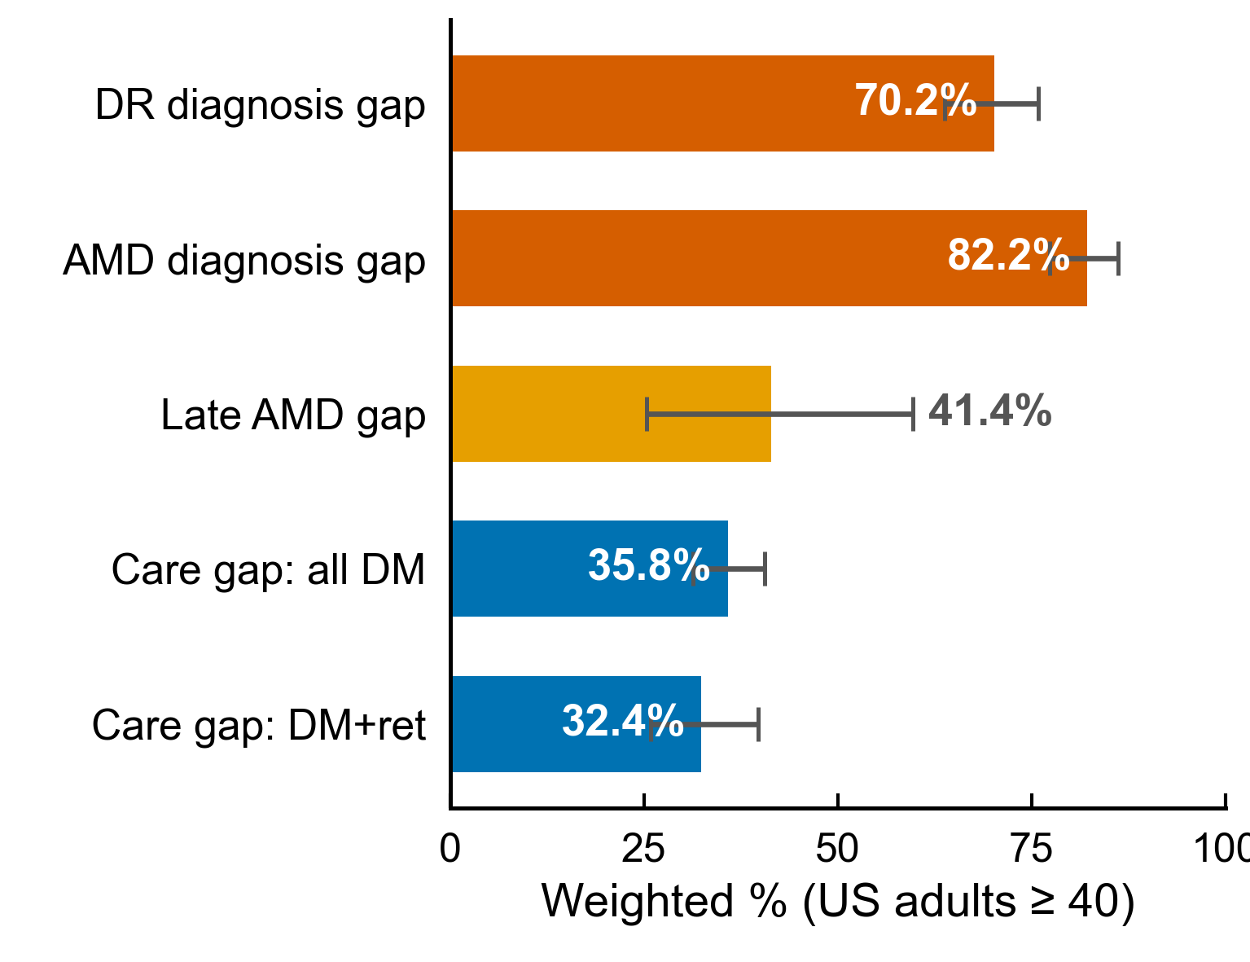
Figure 1
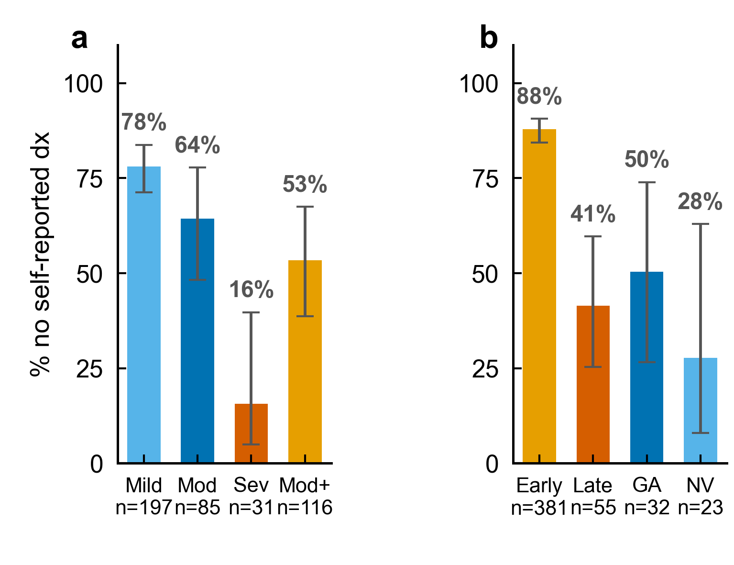
Figure 2
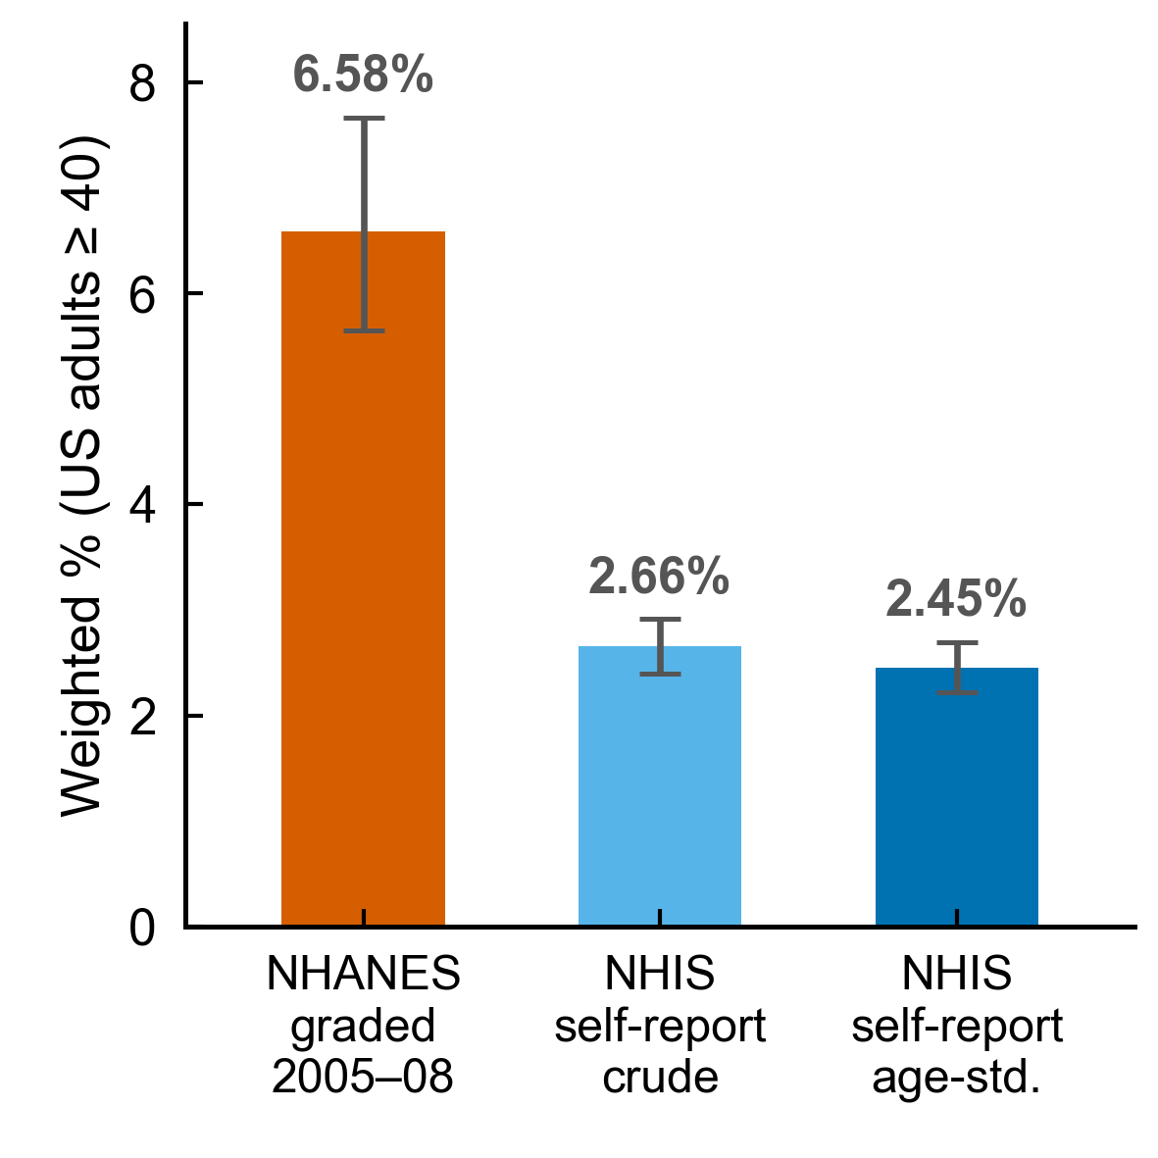
Figure 3

Tables

Table 1. Weighted prevalence, US adults aged ≥40, NHANES 2005–2008 Unweighted n denotes the analytic (gradable-image) denominator for each measure, not the case count. The row "Objectively graded retinopathy among adults with diabetes" uses n = 884 (diabetic, gradable-image subset) and should not be confused with the 319 DR case count reported in Table 2.
Measure | Unweighted n | Weighted % (95% CI)
Any objectively graded retinopathy (all ≥40, descriptive) | 5,704 | 9.75 (8.79–10.80)
Moderate-or-worse retinopathy (all ≥40) | 5,704 | 1.35 (1.10–1.65)
Objectively graded retinopathy among adults with diabetes | 884 | 33.0 (29.3–37.0)
Any AMD (early or late) | 5,604 | 6.58 (5.65–7.66)
Late AMD | 5,604 | 0.80 (0.54–1.18)
Diagnosed diabetes | 6,639 | 12.05 (10.68–13.56)
Any health insurance | 6,788 | 87.4 (85.1–89.4)
Self-reported glaucoma diagnosis | 6,760 | 5.06 (4.41–5.80)
Self-reported cataract surgery | 6,790 | 11.07 (10.03–12.21)

Table 2. Diagnosis and eye-care discordance (item responders), US adults aged ≥40, NHANES 2005–2008
Discordance metric (denominator) | Unweighted n | Weighted % (95% CI)
No self-reported DR diagnosis, diabetes + objective retinopathy | 313 | 70.2 (63.8–75.9)
No self-reported AMD diagnosis, objective AMD | 436 | 82.2 (77.3–86.2)
No self-reported diagnosis, objective early AMD | 381 | 87.9 (84.4–90.6)
No self-reported diagnosis, objective late AMD | 55 | 41.4 (25.3–59.6)
No dilated exam within 12 months, all adults with diabetes | 1,119 | 35.8 (31.3–40.5)
No dilated exam within 12 months, diabetes + objective retinopathy | 313 | 32.4 (25.9–39.7)

The diagnosis gap is the absence of a recalled, patient-reported diagnosis among item responders, not a chart-confirmed absence. Early and late AMD are computed separately from their own responder sets (the total 82.2% is not partitioned by subtraction).

Table 3. Survey-adjusted odds of having no self-reported diagnosis (given objectively graded disease), complete-case core models
Covariate | DR core (n = 187) aOR (95% CI), Holm P | AMD core (n = 226) aOR (95% CI), Holm P
Age (per year) | 0.99 (0.96–1.02), 1.00 | 0.93 (0.89–0.96), 0.003
Male vs female | 1.29 (0.45–3.71), 1.00 | 0.99 (0.32–3.08), 1.00
Education <HS vs ≥HS | 0.67 (0.28–1.61), 1.00 | 0.82 (0.31–2.21), 1.00
Race non-White vs White | 1.57 (0.49–5.07), 1.00 | 1.56 (0.29–8.52), 1.00
Poverty-income ratio (per unit) | 1.34 (0.92–1.96), 0.59 | 0.88 (0.60–1.31), 1.00
Supplementary DR model + insurance (n = 187)
Poverty-income ratio (per unit) | 1.39 (0.96–2.00), P = 0.077 | —
Uninsured vs insured | 1.87 (0.57–6.13), P = 0.28 | not included (complete separation)

Core model excludes insurance. Adjusted-odds-ratio intervals use the design-based t critical value on each model's residual degrees of freedom, matching the Wald P values (per-model design df, rank, residual df, t-multiplier, and all coefficients/SEs/CIs/raw and Holm P are audited in Supplementary Table S2c). Income is reported once in the core model (1.34) and once in the insurance-adjusted model (1.39) and must not be conflated; missing-data sensitivity (missing-indicator, reduced, multiple-imputation) is in Supplementary Table S4. Insurance was not included in the AMD model because complete separation in the uninsured stratum prevented a stable conventional estimate; the raw descriptive counts (177/211 insured, 14/14 uninsured with no reported diagnosis) are reported in Supplementary Table S1, not as a fitted term here.

Table 4. Eye-care utilisation and diagnosis awareness, adults with diabetes + objective retinopathy (item responders)
Measure | Estimate (95% CI)
No self-reported DR diagnosis, NOT examined within 12 months (unadjusted) | 82.0% (70.1–89.9), n = 106
No self-reported DR diagnosis, examined within 12 months (unadjusted) | 64.5% (55.9–72.2), n = 207
Recent dilated examination vs no recent examination: odds of no reported diagnosis (adjusted, n = 187) | aOR 0.30 (0.10–0.92), raw P = 0.038, Holm P = 0.27
Model-adjusted predicted risk, exam vs no exam (g-computation) | 62.4% vs 81.8% (−19.4 points, descriptive)
Poverty-income ratio (adjusted) | aOR 1.49 (1.04–2.15), Holm P = 0.26
Moderate NPDR (adjusted, ref = mild NPDR) | aOR 0.43 (0.15–1.21), Holm P = 0.61
Severe / proliferative (adjusted, ref = mild NPDR) | aOR 0.05 (0.01–0.24), Holm P = 0.010
Eye-care × moderate-or-worse interaction (exploratory) | aOR 1.61 (0.24–10.79), P = 0.59

Adjusted model also included age (1.00), sex (1.09), education (0.90), race/ethnicity (1.90) and insurance (0.72), all non-significant. Mild NPDR is the severity reference because all participants had graded retinopathy. Only the severe-or-proliferative retinopathy category remained statistically significant after within-model Holm adjustment. Cross-sectional; direction of the exam–awareness association is not identifiable. Analogous AMD analysis not feasible (examination timing collected only for people with diabetes). Confidence intervals correspond to the unadjusted Wald test at each model’s residual degrees of freedom; where a 95% CI excludes 1 but the Holm-adjusted P exceeds 0.05, both are reported together for transparency and are not internally inconsistent.

Table 5. Cross-survey benchmark, self-reported eye disease and eye care, US adults ≥40, NHIS 2016
Measure | Unweighted n | Weighted % (95% CI)
Diabetic retinopathy (ever told) | 22,330 | 1.27 (1.09–1.46)
Macular degeneration (ever told) | 22,310 | 2.66 (2.40–2.91)
Saw eye doctor within 12 months | 22,112 | 48.71 (47.69–49.72)
Dilated eye exam within 12 months | 22,142 | 49.93 (48.87–51.00)
Dilated eye exam within 12 months, among adults with diabetes | 3,261 | 67.73 (65.59–69.88)

Table 5 is restricted to the two conditions in the study's core question (self-reported diabetic eye disease and macular degeneration) and the eye-care items directly relevant to them. NHIS self-reported glaucoma and cataract, which are not part of the objective-versus-reported comparison here, are reported for completeness in Supplementary Table S7c. Note that NHANES cataract data are cataract-surgery history (`VIQ071`) whereas NHIS is ever told you had cataract; these are different constructs and are not placed side by side as if comparable. NHIS 2016 asks the "ever told by a doctor that diabetes affected the eyes" item (VIM_DREV) of ALL Sample Adult respondents without a diabetes branch screener, in contrast to NHANES DIQ080, which is asked only of participants who first report diabetes. The 1.27% weighted prevalence in Table 5 is therefore a whole-adult ≥40 self-reported prevalence (unweighted denominator n = 22,330, i.e., NHIS 40+ respondents who gave a substantive answer), not a rate restricted to NHIS diabetics. A diabetes-restricted analogue (weighted 8.18% among NHIS 40+ adults with diagnosed diabetes) is documented in results/sr_nhis_dr_denom_trace_v10.csv and is not interchangeable with the value shown here.
Supplementary Tables S1–S9 and Figures S1–S2 provide detailed cohort reconciliation, severity analyses, model diagnostics, sensitivity analyses, variable provenance and additional results. All supplementary values are generated from ‘numbers_v7.csv’.

References
- Flaxman SR, Bourne RRA, Resnikoff S, Ackerman P, Giannaccare G, Graetz SB, et al. Global causes of blindness and distance vision impairment 1990–2020: a systematic review and meta-analysis. Lancet Glob Health. 2017;5(12):e1221-e1234. PMID:29032195. doi:10.1016/S2214-109X(17)30393-5
- World Health Organization. World report on vision. Geneva: World Health Organization; 2019. ISBN 978-92-4-151657-0.
- Diabetes Control and Complications Trial Research Group (Nathan DM, Genuth S, Cleary PA, et al.). The effect of intensive treatment of diabetes on the development and progression of long-term complications in insulin-dependent diabetes mellitus. N Engl J Med. 1993;329(14):977-986. PMID:8366922. doi:10.1056/NEJM199309303291401
- Rosenfeld PJ, Brown DM, Heier JS, Boyer DS, Kaiser PC, Chung M, et al. (MARINA Study Group). Ranibizumab for neovascular age-related macular degeneration. N Engl J Med. 2006;355(14):1419-1431. PMID:17021318. doi:10.1056/NEJMoa054481
- Lee R, Wong TY, Sabanayagam C. Epidemiology of diabetic retinopathy, diabetic macular edema and related vision loss. Eye Vis (Lond). 2015;2:17. PMID:26605370. doi:10.1186/s40662-015-0026-2
- Zhang X, Saaddine JB, Chou CF, Cotch MF, Cheng YJ, Geiss LS, et al. Prevalence of diabetic retinopathy in the United States, 2005-2008. JAMA. 2010;304(6):649-656. PMID:20699456. doi:10.1001/jama.2010.1111
- Yau JW, Rogers SL, Kawasaki R, Akagi T, et al. Global prevalence and major risk factors of diabetic retinopathy. Diabetes Care. 2012;35(3):556-564. PMID:22301125. doi:10.2337/dc11-1909
- Friedman DS, O'Colmain BJ, Munoz B, Tomany SC, McCarty CA, de Jong PTVM, et al. Prevalence of age-related macular degeneration in the United States. Arch Ophthalmol. 2004;122(4):564-572. PMID:15078675. doi:10.1001/archopht.122.4.564
- Nwanyanwu K, Andoh J, Chen E, Xu Y, Granados A, Deng Y, Desai M, Nunez-Smith M. Social determinants associated with diabetic retinopathy awareness: National Health and Nutrition Examination Survey (2005-2008). Am J Ophthalmol. 2025;278:389-401. PMID:40550446. doi:10.1016/j.ajo.2025.06.028
- Yee H, Wong CMJ, Gupta P, Thakur S, Fenwick E, Lamoureux EL, Man REK. Prevalence, risk determinants, and burden of undiagnosed age-related eye diseases among older Asian adults. JAMA Ophthalmol. 2026;144(1):23-32. PMID:41264299. doi:10.1001/jamaophthalmol.2025.4623
- Rein DB, et al. Prevalence of age-related macular degeneration in the United States in 2019. JAMA Ophthalmol. 2022;140(12):1202-1208. PMID:36326752. doi:10.1001/jamaophthalmol.2022.4401
- National Center for Health Statistics, CDC. 2016 National Health Interview Survey (NHIS), Sample Adult (samadult) file and codebook. https://ftp.cdc.gov/pub/Health_Statistics/NCHS/Datasets/NHIS/2016/
- National Center for Health Statistics, CDC. NHANES 2005–2008 Ophthalmology – Retinal Photographs (OPXRET), Vision (VIQ), Diabetes (DIQ), Health-Utilisation (HUQ) and Health-Insurance (HIQ) questionnaires: data files and documentation. https://wwwn.cdc.gov/nchs/nhanes/continuousnhanes/default.aspx?BeginYear=2005
- Lim JI, Kim SJ, Bailey ST, Kovach JL, Vemulakonda GA, Ying GS, Flaxel CJ; American Academy of Ophthalmology Preferred Practice Pattern Retina/Vitreous Panel. Diabetic Retinopathy Preferred Practice Pattern®. Ophthalmology. 2025;132(4):P75-P162. PMID:39918521. doi:10.1016/j.ophtha.2024.12.020
- von Elm E, Altman DG, Egger M, Pocock SJ, Gøtzsche PC, Vandenbroucke JP; STROBE Initiative. The Strengthening the Reporting of Observational Studies in Epidemiology (STROBE) statement: guidelines for reporting observational studies. Ann Intern Med. 2007;147(8):573-577. PMID:17938396. doi:10.7326/0003-4819-147-8-200710160-00010.
- National Center for Health Statistics, CDC. NHANES Analytic and Reporting Guidelines (sample weights). https://wwwn.cdc.gov/nchs/nhanes/analyticguidelines.aspx

