Supplementary Materials

Objectively graded retinal disease, self-reported diagnosis, and eye-care utilisation in US adults (NHANES 2005–2008)
All supplementary values are generated by `code/survey_analysis_v4.R` (core), `code/survey_analysis_v5.R`, `code/survey_analysis_v6.R` (construct-validity and robustness extensions) and `code/survey_analysis_v7.R` (per-model degrees-of-freedom audit, IPW weight decomposition, severity-adjusted AMD age model and late-AMD phenotype check), consolidated in `results/tables/numbers_v7.csv`, and audited by `code/verify_v7.py`, which enforces the sample-denominator assertions against the raw analytic dataset, verifies the per-model design/residual degrees-of-freedom and CI/P consistency, and re-checks every in-text value. Supplementary figures are produced by `code/build_figures_v13.py`. Every diagnosis-discordance denominator is restricted to participants who answered the relevant self-report item (responders-only). Proportion confidence intervals are design-based logit-transformed (`svyciprop(method="logit")`) and lie within 0–100%; adjusted-odds-ratio intervals use the design-based t critical value on each model's residual degrees of freedom, matching the Wald P values. Supplementary tables and figures are numbered S1–S9 and S1–S2, respectively, by first appearance in the main text; sub-parts are lettered (a)/(b)/(c) within a single table rather than given nested "S2b/S2c"-style numbers.

Supplementary Figure S1. Grading-feasibility sensitivity (naive versus inverse-probability-weighted prevalence)
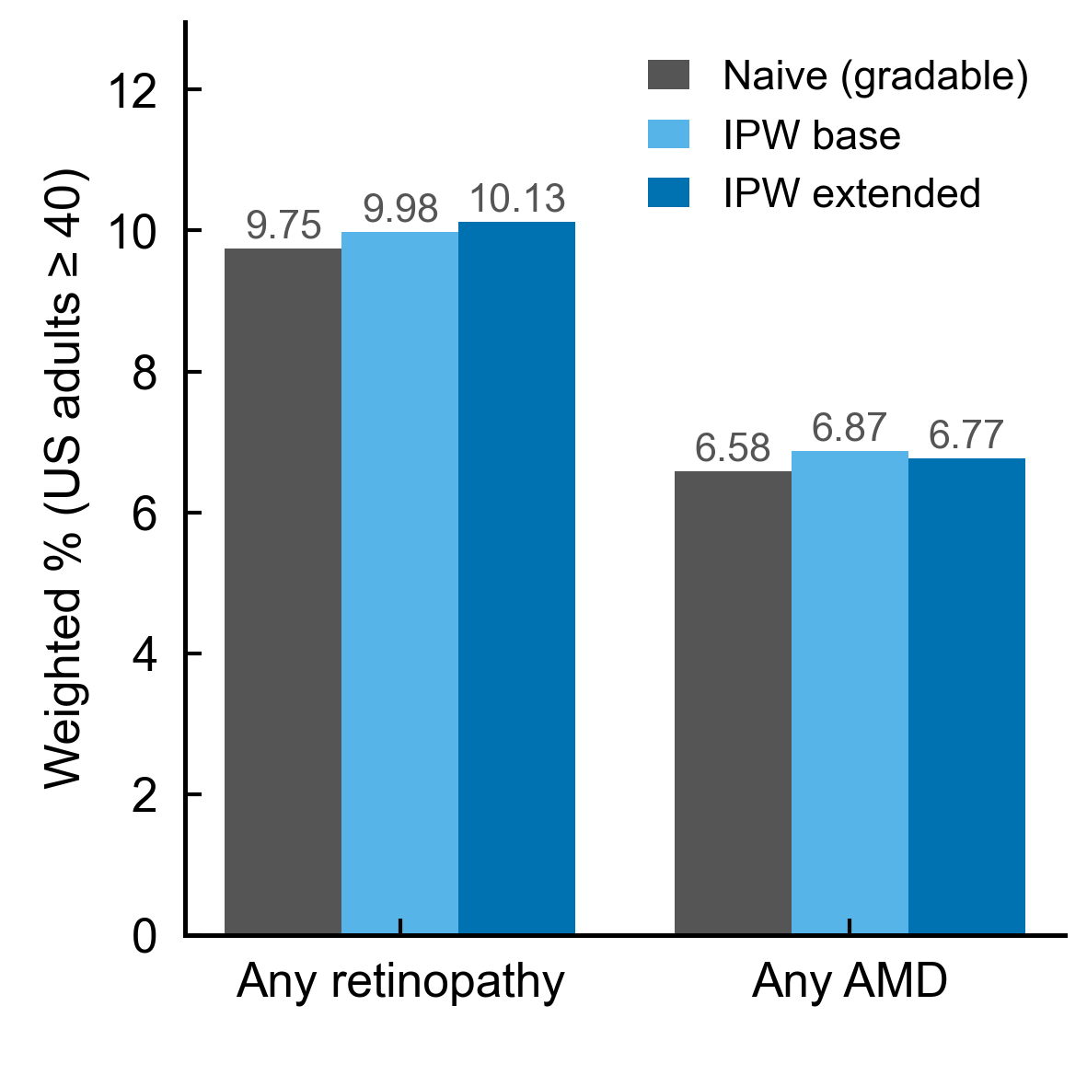
Figure S1
Naive (gradable-only) versus inverse-probability-weighted whole-population prevalence of any retinopathy and any AMD under a base (age, sex, race/ethnicity) and an extended (+ diabetes, insurance, education) gradability model. IPW shifts each estimate by ≤ 0.6 percentage points, indicating that observable gradable-vs-ungradable differences do not materially move the descriptive prevalence. Full weight decomposition in Supplementary Table S8.

Supplementary Figure S2. Objectively graded versus self-reported AMD: NHANES imaging compared with NHIS self-report
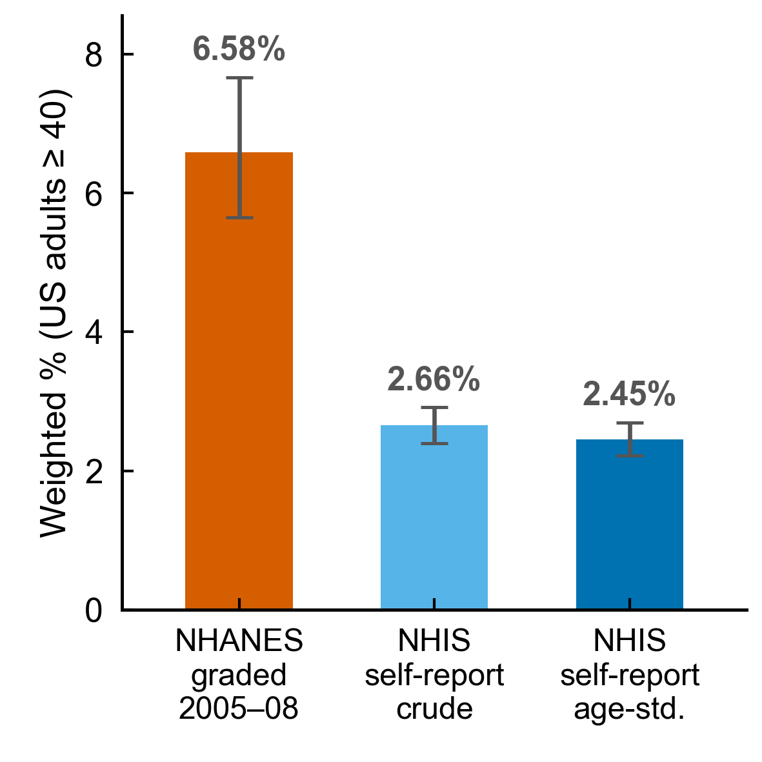
Figure S2
NHANES retinal-photograph grading (2005–2008, weighted 6.58%) compared with NHIS self-reported macular degeneration (2016, survey-weighted crude 2.66% and directly age-standardised 2.45% to the NHANES 40+ structure). The surveys differ in instrument, calendar year and measurement method and are shown only as a contextual comparison; bars show 95% CIs. The age-standardised CI is conditional on the fixed NHANES-derived standard weights. Corresponds to the main-text cross-survey benchmark paragraph; numeric detail in Supplementary Table S4.

Supplementary Table S1. Variable provenance (NHANES codes, official labels, valid values, analysis recoding)
Official variable labels below are taken verbatim from the NHANES public-use data files; valid-value distributions are counts in the examined ≥40 sample. Exact item wording for the self-report questions should be read from the corresponding NHANES questionnaire (Reference 13) — we reproduce the intent as coded in the data, not a paraphrased "verbatim" question, to avoid introducing wording errors.
Variable | Official label (from data file) | Values used | Analysis recoding | Missing handling | Source file
OPDUARMA | Any retinopathy, worse eye | 0 none (4,994) / 1 any (710) / ungradable NA (1,093) | any retinopathy = 1 | ungradable NA excluded | OPH_UE (retinal)
OPDURL4 | 4-level retinopathy severity, worse eye | 1 none (4,994) / 2 mild NPDR (573) / 3 moderate NPDR (106) / 4 severe-or-proliferative (31) / NA ungradable (1,093) | used as ordinal severity factor; mild NPDR is the regression reference within the retinopathy cohort | ungradable NA excluded | OPH_UE (retinal)
OPDUARM | Age-related maculopathy, 3 severity levels, worse eye | 0 none (5,163) / 1 early (386) / 2 late (55) / NA ungradable (1,193) | AMD present = ≥1; late AMD = 2 | ungradable NA excluded | OPH_UE (retinal)
OPDUGA | Geographic atrophy, worse eye | 0 (5,593) / 1 (32) / NA ungradable | late-AMD phenotype | NA excluded | OPH_UE (retinal)
OPDUEXU | Exudative (neovascular) AMD, worse eye | 0 (5,622) / 1 (23) / NA ungradable | late-AMD phenotype (mutually exclusive with GA here) | NA excluded | OPH_UE (retinal)
DIQ010 | Doctor told you have diabetes (diagnosed diabetes) | 1 yes (used to define diabetes) | diabetes = 1 | — | DIQ
DIQ080 | Ever told diabetes affected the eyes / retinopathy (asked only if DIQ010 = 1) | 1 yes / 0 no / refused-DK/missing NA | diagnosis reported = 1; responders-only | NA = non-responder, excluded | DIQ
DIQ360 | Last time pupils dilated for eye exam (asked only if DIQ010 = 1) | <1 mo / 1–12 mo / 13–24 mo / >2 yr / never | examined-within-12-mo = first two categories | NA = non-responder, excluded | DIQ
VIQ310 | Ever told had macular degeneration | 1 yes / 0 no / NA | AMD diagnosis reported = 1; responders-only | NA excluded | VIQ
VIQ090 | Ever told had glaucoma | 1 / 0 / NA | descriptive | NA excluded | VIQ
VIQ071 | Ever had cataract surgery | 1 / 0 / NA | descriptive | NA excluded | VIQ
HIQ011 | Health-care coverage | yes / no | insured vs uninsured | — | HIQ
HUQ030 | Usual source of care | categories | descriptive | — | HUQ
WTMEC2YR | 2-year MEC examination weight | continuous | ÷ 2 when pooling cycles E+F | — | DEMO
SDMVSTRA/SDMVPSU | Masked pseudo-stratum / pseudo-PSU | integers | design identifiers | — | DEMO

All retinal outcomes are person-level worse-eye variables (`OPDU`); eye-level measurements are aggregated, never treated as independent samples. The self-report items are used as patient-reported constructs. Valid-value counts are from the full examined ≥40 sample and thus differ from the disease-restricted analytic denominators in Table S5.*

Supplementary Table S2. Regression coefficients and design-degrees-of-freedom audit (all estimates read from the same fitted model object)
(a) Design degrees of freedom contributing to each analytic subset.
Analytic subset | Unweighted n | Number of strata | Total number of PSUs | Design degrees of freedom (survey::degf)
DR responders (313) | 313 | 31 | 59 | 28
AMD responders (436) | 436 | 31 | 61 | 30
DR core complete-case model (187) | 187 | 30 | 52 | 22
AMD core complete-case model (226) | 226 | 31 | 60 | 29

PSUs are counted as unique stratum×PSU combinations. NHANES samples two PSUs per stratum, so the total PSU count in a subset is roughly twice the number of strata (59–62), not 2; `SDMVPSU` itself only carries the within-stratum labels 1 and 2. Design degrees of freedom equal (total PSUs − strata), and are reduced further where a complete-case subset leaves a stratum with a single contributing PSU. These values were obtained with `survey::degf()` on each subset design. Design df, model residual df and the `summary.svyglm` df are distinct quantities and are not interchangeable: `survey` performs regression inference at the model residual df, which equals `degf(design) − model rank + 1`. Panel (b) exports, for every model reported in this study, the design df, the model rank, the resulting residual df, the exact t-multiplier `qt(0.975, df)`, and the coefficient/SE/aOR/CI/raw-P/Holm-P all read from the same fitted model object, so that confidence intervals and P values cannot drift apart from one another. For the DR eye-care model the residual df is 13 (degf 22 − rank 10 + 1), and this single df reproduces both the reported exam odds ratio 0.30 (0.10–0.92) and P = 0.038.
(b) Per-model degrees-of-freedom and estimate audit.
Model | n | Design df (degf) | Rank | Residual df | CI multiplier t(0.975, df) | Term | aOR (95% CI) | Raw P | Holm P
PRIMARY DR core | 187 | 22 | 6 | 17 | 2.110 | Age (per yr) | 0.99 (0.96–1.02) | 0.65 | 1.00
 |  |  |  |  |  | Male | 1.29 (0.45–3.71) | 0.62 | 1.00
 |  |  |  |  |  | Education <HS | 0.67 (0.28–1.61) | 0.35 | 1.00
 |  |  |  |  |  | Race non-White | 1.57 (0.49–5.07) | 0.43 | 1.00
 |  |  |  |  |  | Poverty-income ratio | 1.34 (0.92–1.96) | 0.119 | 0.594
PRIMARY AMD core | 226 | 29 | 6 | 24 | 2.064 | Age (per yr) | 0.93 (0.89–0.96) | 0.00061 | 0.0031
 |  |  |  |  |  | Male | 0.99 (0.32–3.08) | 0.98 | 1.00
 |  |  |  |  |  | Education <HS | 0.82 (0.31–2.21) | 0.69 | 1.00
 |  |  |  |  |  | Race non-White | 1.56 (0.29–8.52) | 0.59 | 1.00
 |  |  |  |  |  | Poverty-income ratio | 0.88 (0.60–1.31) | 0.52 | 1.00
SUPP DR + insurance | 187 | 22 | 7 | 16 | 2.120 | Poverty-income ratio | 1.39 (0.96–2.00) | 0.077 | 0.463
 |  |  |  |  |  | Uninsured | 1.87 (0.57–6.13) | 0.28 | 1.00
ANALYSIS A (eye-care) | 187 | 22 | 10 | 13 | 2.160 | Poverty-income ratio | 1.49 (1.04–2.15) | 0.033 | 0.261
 |  |  |  |  |  | Uninsured | 0.72 (0.17–2.97) | 0.62 | 1.00
 |  |  |  |  |  | Recent dilated exam | 0.30 (0.10–0.92) | 0.038 | 0.266
 |  |  |  |  |  | Severity grade 3 | 0.43 (0.15–1.21) | 0.102 | 0.614
 |  |  |  |  |  | Severity grade 4 | 0.05 (0.01–0.24) | 0.0011 | 0.0099

The aORs, CIs, SEs, raw P and Holm P in every row were extracted programmatically from the single `svyglm` (quasibinomial) object for that model (see `t_model_audit_v7.csv` / keys `audit| and auditdf|*` in `numbersv7.csv); none were hand-filled or computed from a different df than the P value. The 95% CI uses exp(coef ± t(0.975, dfres)·SE) at the residual df in the same row, and the raw P is the Wald-t P from summary()` at that same df — the two are guaranteed mutually consistent. Holm adjustment is applied within each model's set of tested terms. The two models whose headline figures the reviewer asked us to re-verify are the DR core model (poverty-income 1.34) and the DR eye-care model (recent dilated exam 0.30, 0.10–0.92, P = 0.038, Holm P = 0.266, residual df = 13): both are reproduced here exactly as reported in the main text, from one model object.*
(c) Complete eye-care–awareness model (analysis A), adults with diabetes + objective retinopathy, responders, n = 187. Outcome = no self-reported diabetic-eye diagnosis; all covariates shown. Mild NPDR is the severity reference category because every participant in this cohort had objectively graded retinopathy (OPDURL4 levels present: mild 197, moderate 85, severe 31).
Term | aOR (95% CI) | Raw P | Holm P
Recent dilated exam (within 12 mo) | 0.30 (0.10–0.92) | 0.038 | 0.27
Age (per year) | 1.00 (0.97–1.03) | 0.872 | 1.00
Male vs female | 1.09 (0.35–3.38) | 0.876 | 1.00
Education <HS vs ≥HS | 0.90 (0.26–3.07) | 0.852 | 1.00
Race non-White vs White | 1.90 (0.58–6.23) | 0.262 | 1.00
Poverty-income ratio (per unit) | 1.49 (1.04–2.15) | 0.033 | 0.26
Uninsured vs insured | 0.72 (0.17–2.97) | 0.625 | 1.00
Moderate NPDR (ref = mild NPDR) | 0.43 (0.15–1.21) | 0.102 | 0.61
Severe-or-proliferative retinopathy (ref = mild NPDR) | 0.05 (0.01–0.24) | 0.0011 | 0.010

This model is exploratory; intervals use the design-based t critical value on the model's residual degrees of freedom (df = 13), so each aOR, interval and P come from one quasi-binomial Wald t test. Only the severe-or-proliferative retinopathy category remained statistically significant after within-model Holm correction. Unadjusted, 82.0% (70.1–89.9) of adults not examined within 12 months (n = 106) reported no diabetic-eye diagnosis versus 64.5% (55.9–72.2) of those examined (n = 207). Model-adjusted (g-computation) predicted probability of no reported diagnosis: 81.8% without a recent examination vs 62.4% with one (−19.4 percentage points, descriptive point estimates; a design-based interval was not reliable given the sparse primary-stratum structure and is therefore not reported — see main-text Figure 3). Exploratory eye-care × moderate-or-worse interaction: aOR 1.61 (0.24–10.79), P = 0.59 — no evidence of effect modification.

Supplementary Table S3. Missing-data sensitivity for the DR cohort: complete-case, missing-indicator, reduced models, and multiple imputation
(a) Four handling strategies for the two high-missingness covariates (education, income). The complete-case column is the core model (n = 187, education and income required complete); the missing-indicator column retains all 313 responders by median-filling income (with an income-missingness flag) and assigning missing education the "HS-or-more" placeholder with an education-missingness flag; the reduced column drops education and keeps income (n = 283); the multiple-imputation column uses chained equations (m = 20) over outcome, demographics, severity, cycle, income and education, pooled with Rubin's rules within the survey design (n = 313).
Term | Complete-case (n = 187) aOR (95% CI), Holm P | Missing-indicator (n = 313) aOR (95% CI), P | Reduced — drop education (n = 283) aOR (95% CI), P | Multiple imputation (m = 20, n = 313) aOR (95% CI), P
Age (per year) | 0.99 (0.96–1.02), 1.00 | 1.00 (0.97–1.03), 0.935 | 1.00 (0.97–1.03), 0.842 | 1.00 (0.98–1.03), 0.776
Male vs female | 1.29 (0.45–3.71), 1.00 | 0.93 (0.44–1.96), 0.832 | 0.80 (0.36–1.75), 0.558 | 0.99 (0.49–2.01), 0.987
Education <HS vs ≥HS | 0.67 (0.28–1.61), 1.00 | 0.86 (0.38–1.95), 0.711 | excluded by design | 0.76 (0.33–1.79), 0.527
Race non-White vs White | 1.57 (0.49–5.07), 1.00 | 1.27 (0.72–2.25), 0.397 | 1.18 (0.67–2.06), 0.553 | 1.38 (0.82–2.34), 0.221
Poverty-income ratio | 1.34 (0.92–1.96), 0.59 | 1.48 (1.10–1.99), 0.013 (median-filled) | 1.46 (1.08–1.97), 0.017 | 1.38 (1.02–1.87), 0.037
Income-missing indicator | — | 1.08 (0.33–3.56), 0.894 | — | —
Education-missing indicator | — | 0.70 (0.30–1.60), 0.375 | — | —

The income point estimate is above 1 in every specification (1.34–1.48), so the direction is stable, but its precision depends on missing-data handling: non-significant in the complete-case core model, nominally significant when education is dropped (1.46, P = 0.017), under multiple imputation (1.38, P = 0.037) and in the median-filled missing-indicator model (1.48, P = 0.013). Higher income is therefore treated as a tentative correlate with imprecise magnitude, not an established driver. Neither missingness indicator showed a statistically detectable association with the outcome in this model; however, these results do not establish that the missingness mechanism is ignorable, and multiple imputation does not reproduce the finite-population design variance, so its inference is a sensitivity check. Attrition: model entrants (n = 187) vs excluded (n = 126) were similar on the outcome (66.8% vs 68.3% with no reported diagnosis) and differed mainly in age (mean 65.2 vs 61.6 years).
(b) Imputation diagnostics (DR responders, n = 313). Missingness among responders: education 32.6%, income 9.6%; all other imputation variables (outcome, age, sex, race, insurance, severity, cycle) had 0% missing. The income aOR was above 1 in each of the 20 imputations (pooled 1.388, per-imputation range 1.24–1.49, between-imputation SD 0.048; age 1.00, sex 0.99, education 0.76, race 1.39 pooled; ranges in numbers_v7.csv, keys mimi|*). These 20 values are not 20 independent replications — they share the same observed data and the same imputation model and assumptions, so the tight range reflects within-imputation variability under one set of MAR-style assumptions rather than external confirmation of the income estimate. Conventional convergence diagnostics (trace plots, potential-scale-reduction, fraction-of-missing-information) were not generated for this single-model pooled analysis; the per-imputation spread reported here is therefore a limited stability check only, and the pooled inference remains a sensitivity analysis (multiple imputation does not reproduce the finite-population survey-design variance).
(c) Missingness-mechanism models (descriptive). Logistic models of whether education (resp. income) is missing on age, sex, race, diabetes, insurance, the outcome and cycle. Education-missingness was associated with younger age (OR 0.94/yr, P < 0.001) and insurance status (P < 0.001) but not with the outcome (OR 0.995, P = 0.99). Income-missingness was associated with race/ethnicity (non-White OR 4.11, P = 0.011) but not with the outcome (OR 1.21, P = 0.73). Missingness was thus associated with several observed participant characteristics, supporting their inclusion in the imputation and sensitivity analyses; neither missingness model identified a statistically detectable association with the diagnosis-discordance outcome. However, these findings do not establish a missing-at-random mechanism and cannot exclude bias due to unobserved factors — the absence of a detectable outcome association in models of this size is not evidence that MAR holds. A further reduced model dropping both education and income (retaining all 313 responders) left only age, sex and race, none associated with the outcome (age aOR 0.99, sex 1.11, race 1.05; all P > 0.5). This reduced model was fitted only to describe associations with the remaining demographic covariates in the full responder sample; because it excludes income, it does not test — and is not interpreted as evidence for — the consistency of the income association reported above.

Supplementary Table S4. NHIS 2016 benchmark: self-reported eye disease, eye-care use, direct age-standardisation and denominator trace
(a) NHIS 2016 self-reported eye disease and eye-care utilisation (US adults ≥40). This is the cross-survey benchmark referenced in the main text.
Measure (NHIS 2016, adults ≥40) | Unweighted n | Weighted % (95% CI)
Diabetic retinopathy (ever told) | 22,330 | 1.27 (1.09–1.46)
Macular degeneration (ever told) | 22,310 | 2.66 (2.40–2.91)
Saw eye doctor within 12 months | 22,112 | 48.71 (47.69–49.72)
Dilated eye exam within 12 months | 22,142 | 49.93 (48.87–51.00)
Dilated eye exam within 12 months, among adults with diabetes | 3,261 | 67.73 (65.59–69.88)

Denominator trace for the 1.27% diabetic-eye figure: NHIS 2016 asks the "ever told by a doctor that diabetes affected the eyes" item (VIM_DREV) of ALL Sample Adult respondents without a diabetes branch screener, in contrast to NHANES DIQ080, which is asked only of participants who first report diabetes. The 1.27% weighted prevalence is therefore a whole-adult ≥40 self-reported prevalence (unweighted denominator n = 22,330), not a rate restricted to NHIS diabetics. A diabetes-restricted analogue (weighted 8.18% among NHIS 40+ adults with diagnosed diabetes) is documented in `results/sr_nhis_dr_denom_trace_v10.csv` and is not interchangeable with the value shown here.
(b) Direct age-standardisation of the NHIS self-reported macular-degeneration proportion to the NHANES 40+ structure.
Age band | NHIS weighted rate (%) | Standard-population weight (NHANES)
40–49 | 0.47 | 0.3358
50–59 | 1.05 | 0.2894
60–69 | 2.48 | 0.1832
70–79 | 5.26 | 0.1207
80+ | 12.71 | 0.0709
Crude weighted (≥40) | 2.66 (2.40–2.91) | —
Directly age-standardised (design covariance) | 2.45 (2.22–2.69) | —

Standard weights are the survey-weighted NHANES 2005–2008 distribution of adults ≥40 across the five bands. The 80+ band is age ≥80; because NHANES top-codes age at 85, this band contains ages 80–84 plus the 85+ top-coded group. The standardised estimate is a weighted mean of band-specific rates, Σ(rate_b·w_b)/Σ(w_b). Its confidence interval is obtained from the full design-based covariance between the age-band estimates (panel c) rather than treating bands as independent strata; this widens the interval slightly (from 2.23–2.68 under the independence assumption to 2.22–2.69). The age-standardised NHIS proportion (2.45%) is lower than the crude (2.66%) because the NHANES 40+ population is somewhat younger than NHIS's; the objectively graded AMD prevalence (6.58%) exceeds both.
(c) Standardisation with full design covariance and an age-and-sex variant.
Quantity | Estimate (%) | 95% CI | Method
NHIS crude weighted (≥40) | 2.66 | 2.40–2.91 | design-based mean of self-reported macular degeneration
NHIS age-standardised | 2.45 | 2.22–2.69 | reweighting identity; full design covariance; standard weights fixed
NHIS age-and-sex-standardised | 2.46 | 2.22–2.70 | ten age×sex cells; joint NHANES weights; same method

Direct standardisation was implemented through a reweighting identity: each NHIS respondent's weight was rescaled by the ratio of the target (NHANES) band or cell share to the realised weighted respondent total in that band/cell, so that a single design-based `svymean` reproduces the standardised rate and carries the covariance between domains automatically. The standard-population weights are treated as fixed, so each interval is conditional on the chosen NHANES-derived weights; we did not additionally propagate the sampling uncertainty of the standard weights themselves. The age-and-sex result (2.46%) is essentially identical to age-only (2.45%), so sex composition does not materially affect the benchmark. Because NHANES (2005–2008 imaging) and NHIS (2016 self-report) differ in year and instrument, the gap between 6.58% and ~2.45% cannot be attributed solely to under-diagnosis.
(d) Additional NHIS 2016 self-reported eye disease (outside the objective-versus-reported comparison).
Measure (NHIS 2016, adults ≥40) | Unweighted n | Weighted % (95% CI)
Glaucoma (ever told) | 22,332 | 3.97 (3.66–4.28)
Cataract (ever told you have cataract) | 22,343 | 21.17 (20.37–21.96)

Note on construct mismatch: the NHIS cataract item records whether a person was ever told they had cataract, whereas the NHANES cataract figure (Supplementary Table S5d) is cataract-surgery history (VIQ071). These are different endpoints and are deliberately not placed side by side. No NHANES glaucoma-imaging analogue exists (glaucoma is not graded in the retinal photographs), so NHIS glaucoma is presented here without an objective comparator.

Supplementary Table S5. Screening, per-variable missingness, model-denominator reconciliation, and additional NHANES descriptive context
(a) Cohort build-up (NHANES 2005–2008, examined adults ≥40).
Step | DR cohort | AMD cohort
Examined adults ≥40 with retinal photography | 6,797 | 6,797
Gradable retinal image (worse eye) | 5,704 | 5,604
Objectively graded disease present | 319 (diabetes + retinopathy) | 441 (any AMD)
Answered the self-report diagnosis item → primary gap denominator | 313 | 436
Non-responders excluded | 6 | 5

(b) Per-variable missingness among gap-eligible responders.
Cohort | Eligible (responders) | Missing education | Missing income | Missing insurance | Missing usual source | Missing dilated-exam item
DR | 313 | 102 | 30 | 0 | 0 | 0
AMD | 436 | 188 | 42 | 1 | 0 | 377

The AMD dilated-exam item is missing for 377/436 because `DIQ360` is asked only of people with diabetes; only 59 AMD responders were diabetic, which is why the eye-care–awareness analysis cannot be run for AMD.
(c) Model-denominator reconciliation.
Quantity | DR | AMD
Descriptive diagnosis-gap denominator (responders) | 313 | 436
Core complete-case model (education AND income complete) | 187 | 226
Core + insurance (education, income, insurance complete) | 187 | —
Missing-indicator sensitivity model (retains all responders; income median-filled + income & education missingness flags) | 313 | —
Multiple-imputation model (m = 20, Rubin-pooled; retains all responders) | 313 | —
Reduced model (education dropped, income kept) | 283 | —
Education-complete subset — descriptive count only, not a fitted model | 211 | —
Insurance descriptive (coverage known) | — | 225

The reduction from 313 (436) to the core model 187 (226) is driven by missing education and income. The single fitted missing-indicator model retains all 313 responders by median-filling income and adding missingness indicators for both income and education; it is therefore distinct from the education-complete count of 211, which is reported only to explain attrition and is not itself a model. Because a missing-indicator approach cannot exclude informative (MNAR) missingness, it is used as a stability check, not as evidence that missingness is ignorable. AMD insurance descriptive (moved here from the main-text model table because it is not a fitted term): among the 225 AMD responders with a known coverage status — a subset of the 226 core cases in which insurance was recorded, not all 436 AMD responders — 177 of 211 insured (83.9%) and all 14 of 14 uninsured reported no prior diagnosis. Because the uninsured stratum was perfectly separated from the outcome, an insured-versus-uninsured odds ratio is not estimable in a conventional logistic model for AMD; the AMD model therefore excludes insurance, and this table records the raw descriptive contrast only.
(d) Additional NHANES descriptive measures (moved out of the main prevalence table). These whole-population descriptives are reported for completeness and are not part of the objective-versus-reported comparison; they should not be read alongside the imaging outcomes in main-text Table 1.
Measure (NHANES 2005–2008, examined ≥40) | Unweighted n | Weighted % (95% CI)
Any health insurance | 6,788 | 87.4 (85.1–89.4)
Self-reported glaucoma diagnosis | 6,760 | 5.06 (4.41–5.80)
Self-reported cataract surgery (VIQ071) | 6,790 | 11.07 (10.03–12.21)

Note the construct: NHANES records cataract-surgery history (`VIQ071`), which is different from the NHIS "ever told you had cataract" item reported in Supplementary Table S4(d); the two are deliberately not compared.

Supplementary Table S6. Extreme-scenario non-response bounds (survey-weighted, not simple count arithmetic)
Cohort | Responders-only (primary) | If all non-responders were "diagnosed" | If all non-responders were "undiagnosed"
DR (n = 319 base; 6 non-responders) | 70.2 (63.8–75.9) | 69.2 (62.5–75.2) | 70.6 (64.4–76.1)
AMD (n = 441 base; 5 non-responders) | 82.2 (77.3–86.2) | 81.6 (76.7–85.7) | 82.3 (77.5–86.3)

Bounds were recomputed with the full survey weights (not by adding/subtracting people from a percentage): non-responders were assigned y = 0 (all diagnosed) then y = 1 (all undiagnosed) and the weighted logit proportion re-estimated. The primary responders-only estimate lies within the bounds and the bound width is ~1–1.4 percentage points, so the headline gaps are not driven by the few diagnosis-item non-responders.

Supplementary Table S7. Diagnosis discordance by severity, stage and age (survey-weighted % with no self-reported diagnosis; responders; logit CIs)
(a) DR diagnosis gap by retinopathy severity.
Stratum | Unweighted n | % (95% CI)
Any retinopathy (primary) | 313 | 70.2 (63.8–75.9)
Mild NPDR (OPDURL4 = 2) | 197 | 78.1 (71.3–83.7)
Moderate NPDR (OPDURL4 = 3) | 85 | 64.4 (48.3–77.8)
Severe-or-proliferative (OPDURL4 = 4) | 31 | 15.7 (5.0–39.7)
Moderate-or-worse (pooled, overlapping summary) | 116 | 53.4 (38.7–67.5)

*(b) Self-reported diabetic-eye diagnosis (percent diagnosed) by severity, for contrast.*
Stratum | Unweighted n | % diagnosed
No gradable retinopathy (OPDURL4 = 1) | 560 | 16.6
Mild NPDR | 197 | 21.9
Moderate NPDR | 85 | 35.6
Severe-or-proliferative | 31 | 84.3

(c) AMD diagnosis gap by stage and late phenotype.
Stratum | Unweighted n | % (95% CI)
Any AMD (primary, all stages) | 436 | 82.2 (77.3–86.2)
Early AMD | 381 | 87.9 (84.4–90.6)
Late AMD (clinically relevant) | 55 | 41.4 (25.3–59.6)
Geographic atrophy (high-severity) | 32 | 50.3 (26.6–73.9)
Exudative / neovascular AMD (high-severity) | 23 | 27.7 (8.0–62.9)

(d) Diagnosis gap by age stratum.
Cohort / band | Unweighted n | % (95% CI)
AMD 40–59 | 75 | 99.1 (95.6–99.8)
AMD 60–74 | 165 | 86.6 (77.8–92.3)
AMD ≥75 | 196 | 66.7 (60.1–72.6)
AMD ≥50 | 406 | 79.7 (75.0–83.8)
DR 40–59 | 101 | 73.4 (59.9–83.6)
DR 60–74 | 156 | 66.5 (58.6–73.6)
DR ≥75 | 56 | 71.1 (56.0–82.7)

The severity responder counts (560/197/85/31 = 873) are the diabetes-restricted gradable participants who answered `DIQ080`; the retinopathy subset (197+85+31 = 313) equals the primary DR gap denominator. Severity is a grading category, not a treatment indication. Early and late AMD gaps are computed directly from their own responder sets (381 and 55), not by subtracting one percentage from another. Because the late-AMD and high-severity strata are small, they are reported as design-weighted proportions with confidence intervals, without additional multivariable modelling; the geographic-atrophy vs neovascular difference has wide, overlapping intervals and is not an established group difference. The subtype counts are mutually exclusive rather than double-counted: NHANES records the two late-AMD phenotypes as separate flags (`OPDUGA`, `OPDUEXU`), the worse-eye summary assigns each participant to a single late-AMD category, and no participant was flagged with both phenotypes in the same worse eye (0 of 55), so 32 + 23 = 55 reproduces the late-AMD total exactly. A single worse eye can carry only one graded phenotype, so a bilateral-mixed pattern (geographic atrophy in one eye, neovascular disease in the other) could in principle be undercounted; the counts are best read as an approximately mutually exclusive partition rather than clinically exhaustive phenotyping.

Supplementary Table S8. Grading feasibility: gradable vs ungradable comparison and inverse-probability-weighted prevalence
(a) Observable characteristics of gradable vs ungradable images (person-level, examined ≥40).
Group | n | Mean age | Male % | Diabetes % | Non-White % | Insured % | Education <HS %
Gradable (retinopathy) | 5,704 | 59.6 | 50.1 | 15.9 | 46.4 | 83.7 | 14.4
Ungradable | 1,093 | 64.5 | 47.3 | 22.1 | 55.4 | 86.2 | 23.2

Ungradable-image participants were older, more often diabetic and less often high-school-educated, a plausible signal that images failed more often in higher-risk eyes.
(b) Naive vs inverse-probability-weighted (IPW) whole-population prevalence, and full weight decomposition.
Measure | Naive (gradable-only) % | IPW, base model % | IPW, extended model %
Any retinopathy (all ≥40) | 9.75 | 9.98 | 10.13
Any AMD (all ≥40) | 6.58 | 6.87 | 6.77

The weight diagnostics below separate the three distinct quantities that were previously conflated under a single "Weight" label. The very large values are the combined survey weight (baseline MEC weight × inverse-probability factor), not the inverse-probability factor itself, which is modest.
Quantity (over the 5,704 gradable respondents) | Base model (age, sex, race) | Extended model (+ diabetes, insurance, education)
Gradability probability P (min / median / max) | 0.637 / 0.849 / 0.938 | 0.569 / 0.915 / 1.000
Observations truncated by the 0.05 probability floor | 0 | 0
Inverse-probability factor 1/P (min / median / max) | 1.07 / 1.18 / 1.57 | 1.00 / 1.09 / 1.76
Combined survey weight (median / max) | 16,566 / 110,456 | 15,545 / 115,872
Kish effective sample size of the combined weights | 3,656 | 3,635
Kish effective sample size of the raw (un-IPW'd) weights | 3,508 | 3,508
Complete-case rows used to fit the gradability model | 6,797 | 3,687

Probabilities of a gradable image were modelled with a base specification (age, sex, race/ethnicity) and an extended specification adding diabetes, insurance and education; gradable respondents were reweighted by their inverse predicted probability, with a probability floor of 0.05 to bound extreme weights. Because the smallest predicted gradability probability was 0.637 (base) and 0.569 (extended), the 0.05 floor was never binding — no observation was truncated — so the reported IPW estimates are unaffected by the truncation rule. The extended model, which adds education and insurance, could only be fitted on the 3,687 respondents with complete covariates (vs 6,797 for the base model); gradable respondents with missing extended covariates were assigned P = 1 (no up-weighting), so the extended model reweights a subset and thus targets a slightly different effective population than the base model. The large numbers under "combined survey weight" are the baseline NHANES MEC weight multiplied by the 1/P factor and should not be read as the inverse-probability factor. ESS was computed as the Kish effective sample size, (Σw)²/Σw², over the combined weights of the 5,704 gradable respondents.
Across both specifications IPW prevalence moved from the naive value by ≤0.6 percentage points, indicating that observable gradable-vs-ungradable differences do not materially bias the descriptive prevalence. The combined-weight ESS (≈3,635–3,656) is close to the raw-weight ESS (≈3,508), which suggests the reweighting did not concentrate the sample into a small handful of observations. This closeness is a limited stability check only, not proof of weight stability: a near-unchanged aggregate ESS can coexist with a long weight tail, and it says nothing about selection on unobserved factors. IPW corrects only for observable differences; unobservable sources of grading selection remain possible.
(c) Discordance-specific selection sensitivity (does the gap itself depend on gradability weighting?).
Outcome | Responders, standard weights | IPW for gradability (extended model)
DR diagnosis gap | 70.2 (63.8–75.9) | 70.2 (64.1–75.6)
AMD diagnosis gap | 82.2 (77.3–86.2) | 82.0 (77.1–86.0)

Because prevalence-level IPW does not by itself demonstrate that the discordance proportions are unaffected by grading feasibility, we reweighted the DR and AMD responder sets directly by 1/P(gradable) and re-estimated the diagnosis gap. Both gaps were essentially unchanged (DR 70.2→70.2; AMD 82.2→82.0), indicating the headline discordance estimates move little under observable grading-feasibility reweighting; this still cannot exclude unmeasured selection among people whose images could not be graded.

Supplementary Table S9. Is the AMD age gradient independent of disease severity?
The AMD diagnosis gap falls steeply with age (from ~99% in the youngest band to ~67% in the oldest). Because older participants also carry more late AMD, we tested whether the age gradient is simply a proxy for severity, using two complementary approaches (both at the model residual df from the same fitted objects as Table S2b).
(a) Age adjusted for AMD stage (logistic, no-reported-diagnosis outcome).
Term | aOR (95% CI) | Raw P | Holm P
Age (per year) | 0.92 (0.89–0.95) | 7.9 × 10⁻⁶ | 2.4 × 10⁻⁵
Late vs early stage | 0.18 (0.08–0.37) | 6.1 × 10⁻⁵ | 1.2 × 10⁻⁴
Male | 1.02 (0.52–1.98) | 0.96 | 0.96

n = 436 AMD responders with a gradable stage; design df = 30, model rank = 4, residual df = 27, CI multiplier t(0.975, 27) = 2.052. Both age and stage retain strong, mutually independent effects: adjusting for severity barely changes the age term (0.93/yr unadjusted → 0.92/yr adjusted), and late stage is independently associated with a much lower gap.
(b) Age strata within early AMD only (severity held roughly constant).
Stratum | Unweighted n | Gap % (95% CI)
Early AMD, age 40–59 | 74 | 99.1 (95.6–99.8)
Early AMD, age 60–69 | 86 | 92.4 (80.5–97.3)
Early AMD, age 70+ | 221 | 78.4 (72.9–82.9)

Restricted to participants graded as early AMD, so the severity mix is approximately fixed across the age bands. The gap still falls monotonically with age (99.1% → 92.4% → 78.4%), i.e. even among people with the same (early) disease stage, older participants more often reported a prior diagnosis.
Together these show that the AMD age gradient is not an artefact of older people being more severely affected: it persists after adjusting for stage (a) and within a stage-restricted early-AMD sample (b). This is consistent with greater cumulative ophthalmic contact / diagnosis opportunity with advancing age, but the cross-sectional design cannot establish that ageing itself causes higher awareness.

