A heme-detoxification-failure state links red-cell dysfunction to ferroptotic vulnerability after subarachnoid hemorrhage
Authors: [To be supplied by the corresponding author]
Affiliations: [To be supplied]
Corresponding author: [To be supplied]
Abstract
Aneurysmal subarachnoid hemorrhage (SAH) kills or disables roughly one in three patients, largely through secondary brain injury rather than the initial bleed ¹. In a published MIMIC-IV analysis of 842 patients with non-traumatic SAH, a lower hemoglobin-to-red-cell-distribution-width ratio (HRR = Hb/RDW) was independently associated with in-hospital mortality ^{2,3}. Because HRR combines the oxygen-carrying (Hb) and erythrocyte-turnover (RDW) arms of red-cell biology, we asked what molecular programs connect it to secondary injury. Two same-platform whole-blood transcriptomes (discovery GSE36791, 43 acute SAH vs 18 controls; test GSE73378, remote aSAH) ^{4,5}, signed co-expression networks, and a mouse single-cell SAH brain atlas (GSE311852; 43,241 cells; sham vs 24 h vs 72 h) ⁶ showed that acute SAH blood carries a coordinated heme–iron program (HP, SLC40A1, FTH1, SLC25A37, NFE2) superimposed on the canonical inflammation-plus-immunosuppression response, with enrichment for erythro-myelopoiesis and heme metabolism. This blood signal did not survive adjustment for leukocyte fractions, so the mechanistic analysis was carried at single-cell resolution: heme handling localized to neutrophils and microglia/macrophages, and neurons carried a ferroptosis expression signature (GPX4 down; ACSL4, SLC7A11, PTGS2, HMOX1 up). We formalized the balance as a Heme-Detoxification-Failure Index, HDFI = z(HMOX1) − z(FTH1+FTL1) − z(GPX4). Within neurons HDFI tracked a FerrDb ferroptosis-execution score, although much of that association was shared with the GPX4 term common to both scores and a leakage-free re-test reduced it about five-fold. Mendelian randomization on public summary statistics showed that genetically higher haptoglobin is not associated with SAH risk (inverse-variance-weighted odds ratio 0.98, 95% CI 0.89–1.07; P = 0.63), placing heme scavenging downstream of rupture. The whole-blood heme program is largely composition-driven, the HP–CD163 interaction was not supported in dissociated brain myeloid, and HDFI did not replicate as a bulk-blood biomarker; the falsifiable core is a myeloid-to-neuron heme-detoxification-failure state whose end-organ signature is ferroptosis.
Keywords
subarachnoid hemorrhage; ferroptosis; heme oxygenase-1; haptoglobin; Mendelian randomization; single-cell transcriptomics; red-cell distribution width
1. Introduction
Ruptured aneurysms bleed into the subarachnoid space, and the resulting subarachnoid hemorrhage causes death or long-term disability in a large minority of survivors, most of the harm arising in the days after the bleed through secondary brain injury rather than the hemorrhage itself ¹. Blood that lyses in the subarachnoid and intravascular compartments releases hemoglobin, heme, and free iron, which drive oxidative injury; the peripheral handling of red-cell breakdown products is therefore a plausible contributor to the systemic response, not only a bystander ⁷.
Two ordinary red-cell indices, hemoglobin and the red-cell distribution width (RDW), carry prognostic information after SAH. RDW tracks erythrocyte size heterogeneity and the turnover of the red-cell pool and is repeatedly associated with mortality across critical illness ^{3,8}. In a MIMIC-IV cohort of 842 non-traumatic SAH patients, Liu and Wang reported that a lower admission hemoglobin-to-RDW ratio (HRR = Hb/RDW) is independently associated with higher in-hospital mortality, with a non-linear threshold near HRR 9.5 ^{2,3}. HRR marks a peripheral red-cell phenotype, but its molecular effector has not been identified: the clinical analysis read HRR through oxygen-carrying capacity (Hb) plus an inflammation–nutrition–hematopoiesis axis (RDW) and did not name a pathway.
Here we ask whether the molecular programs from which HRR is built, namely heme, iron, and erythroid handling, are coordinately altered in SAH blood and coupled to inflammation, oxidative stress, and ferroptosis. No public transcriptomic cohort measures HRR alongside these programs, so this analysis characterizes the biology that HRR indexes rather than HRR itself. Two independent whole-blood cohorts and a mouse single-cell SAH brain atlas allow the heme-handling response to be followed from blood to brain and to individual cell types, and a set of orthogonal public datasets (chromatin, protein, and lipid layers) tests where that response holds and where it does not.
We organize the result around a single measurable quantity, the Heme-Detoxification-Failure Index (HDFI = z(HMOX1) − z(ferritin) − z(GPX4)). The premise is that heme oxygenase-1 is antioxidant only while ferritin can sequester the liberated iron and GPX4 can reduce the resulting lipid peroxides; when catabolism outruns those two sinks, the heme-handling program fails. We report where this model is supported, where the signal reflects leukocyte composition, and where public data cannot yet answer the question.
2. Materials and methods
2.1 Cohorts and data sources
Discovery was GSE36791 (acute ruptured aneurysm, human whole blood, 43 SAH vs 18 controls) ⁴; the independent test was GSE73378 (remote/past aneurysmal SAH, 103 vs 107 controls) ⁵, both on Illumina HumanHT-12 V4 (GPL10558), so probe-to-symbol mapping and cross-cohort transfer are identical (Table 1). Single-cell validation used a mouse brain SAH atlas, GSE311852 (sham vs SAH-24 h vs SAH-72 h; 43,241 cells; 10x 3′) ⁶. Orthogonal public resources (macrophage and monocyte chromatin, monocyte surface protein, other intracerebral-hemorrhage blood cohorts, human cerebrospinal-fluid proteome and lipidome, and metabolomics of ferroptotic lipids) are introduced where first used and inventoried in Table S1. Series-matrix (RMA) intensities were used for bulk data; after collapsing probes to symbols and dropping genes with missing values, 20,336 (discovery) and 17,008 (test) genes were testable. All analyses used fixed random seeds (2026).
2.2 Preprocessing and differential expression
Bulk values were log2(intensity + 1) transformed and quantile-normalized within cohort ⁹, then filtered to genes expressed above log2 1 in at least 10% of samples. Differential expression was fitted per gene with a sex-adjusted ordinary least-squares model, expression ~ Sex + Group (SAH vs control), giving log2 fold-change, a moderated-equivalent t statistic, and Benjamini–Hochberg-adjusted P ¹⁰. The model is a limma-equivalent fixed effect without empirical-Bayes variance shrinkage; the called set agreed with limma within two genes (35 vs 37) ¹⁰. Threshold: adjusted P < 0.05 and |log2FC| > 1.
2.3 Red-cell/HRR signature and cross-analysis
An HRR/red-cell-dysfunction signature was defined as the union of HALLMARK_HEME_METABOLISM ¹¹, curated globin, heme-biosynthesis, iron-handling, red-cell-membrane, and erythropoiesis modules, and Gene Ontology terms for erythrocyte differentiation, oxygen transport, and heme metabolism ^{12,13}. Candidates were the intersection of SAH differentially expressed genes (adjusted P < 0.05) with the signature; 151 signature genes were measurable in the discovery universe and the intersection yielded 32 candidates.
2.4 Enrichment
Over-representation analysis of the candidate set used Enrichr against GO-Biological Process, KEGG, Hallmark, and Reactome ^{12,13}. Gene-set enrichment analysis (prerank, weighted, 2,000 permutations) was run on the signed −log10 P ranking against Hallmark, KEGG, and Reactome ^{11,14}.
2.5 Machine learning, network, and scoring models
The feature space was the union of strict differentially expressed genes and candidates (66 genes), z-scored within cohort. Hub genes were those ranked in the top 12 by at least three of four criteria: LASSO logistic regression ¹⁵, random forest (Gini plus permutation importance) ¹⁶, and recursive-feature-elimination support vector machines ¹⁷. A linear predictor from an L1-logistic model gave the molecular score; internal discrimination used repeated stratified five-fold cross-validation (20 repeats, area under the ROC curve), and external performance was assessed by fitting on discovery and transferring to the test cohort after within-cohort gene-wise standardization on shared genes, with a 50-permutation null for significance. Signed weighted gene co-expression network analysis on the discovery cohort used the top 4,000 variable genes, scale-free topology soft-threshold power 12, topological-overlap clustering, module eigengenes, and gene-significance/module-membership correlations ¹⁸. Gradient-boosting (XGBoost, depth 3, 200 trees) compared four feature sets (differentially expressed genes; red-cell candidates; heme–iron panel; single-cell-derived macrophage/heme markers) ¹⁹.
2.6 Single-cell pipeline
Filtered 10x matrices for the five samples (sham; SAH-24 h ×2; SAH-72 h ×2) were loaded in scanpy ²⁰. Quality control retained genes detected in at least 200 cells and cells with 2,500 or more genes and under 20% mitochondrial counts; data were CPM-normalized and log1p-transformed, reduced with 2,500 highly variable genes and principal components (40), clustered by Leiden (resolution 1.0), and embedded by UMAP. Cell types were assigned by z-scored marker-panel scores (microglia/macrophage, neutrophil, T, B, NK, endothelial, astrocyte, oligodendrocyte, OPC, neuron, erythroid, mast). A heme/iron module score (Hp, Hmox1, Fth1, Ftl1, Slc40a1, Slc25a37, Nfe2, Alas1/2, Cd163, Mrc1, Ftmt, Blvrb) was compared SAH versus sham per cell type (Mann–Whitney). Cell-type-specific differential expression used per-type Wilcoxon tests, and a diffusion-pseudotime trajectory was rooted at homeostatic P2ry12-high microglia.
2.7 Ligand–receptor and regulon analyses
Ligand–receptor inference applied the statistical core of CellChat (over-expression filter requiring a gene in more than 10% of sender and receiver cells and mean log-expression above 0.05; law-of-mass-action interaction probability; 1,000-label permutation test) to HP–CD163 and HP–MRC1 against competing DAMP routes (S100A8/9–TLR4, IL1B–IL1R1, TNF–TNFRSF1A/B), per timepoint ²¹. Ligand-to-target prioritisation used a NicheNet-style score (curated 0–3 prior ligand-to-target weights × sender log2FC × empirical ligand-to-target Spearman), an approximation of the NicheNet algorithm rather than the full package ²². Regulon activity was a curated NRF2 (NFE2L2)/BACH1/HMOX1 target-set score (z-scored mean of target expression).
2.8 Ferroptosis and deconvolution scoring
Ferroptosis genes were categorized by FerrDb ^{23,24}: Driver (ACSL4, TFRC, NCOA4, LPCAT3, PTGS2, ALOX15), Suppressor (GPX4, SLC7A11, FSP1/AIFM2, GCH1, DHODH, DHRS3), and Iron-metabolism (FTH1, FTL, HMOX1, SLC40A1, STEAP3, HAMP, ALAS2, BLVRB), each scored as a within-cohort gene-wise z-mean; execution = z(Driver) − z(Suppressor). The Heme-Detoxification-Failure Index was HDFI = z(HMOX1) − z(FTH1 + FTL1) − z(GPX4) ²³. Marker-based immune deconvolution of the discovery cohort used lineage signature scores as reference-free surrogates for neutrophil, monocyte, T, NK, B, and erythroid fractions; composition-adjusted expression was refit as gene ~ SAH + neutrophil + monocyte + T fraction.
2.9 Genetic causal inference and regulatory layers
Two-sample Mendelian randomization (inverse-variance-weighted fixed and random effects, MR-Egger with an intercept pleiotropy test, weighted median, Cochran's Q) used instruments at P < 5×10⁻⁸ with physical-distance clumping and effect-allele harmonisation ^{25,26,27}; the estimator was validated on a labelled synthetic ground-truth set. Colocalisation used coloc.abf with single-causal-variant Wakefield Bayes factors (priors p1 = p2 = 1e-4, p12 = 1e-5) ²⁸, validated on synthetic shared-, distinct-, and null-causal scenarios. Real instruments and outcomes came from the GWAS Catalog ^{29,30,31,32,33,34}. A sequence-level regulatory analysis extracted promoters (transcription-start-site ± 2 kb) and regulatory features through the Ensembl REST API ^{35,36}, scanned them with the JASPAR NFE2L2 matrix (MA0150.3) and the canonical ARE/MARE consensus ^{37,38}, and tallied ENCODE regulatory features ³⁹. NRF2 chromatin occupancy was checked against ENCODE NFE2L2 ChIP-seq peaks ³⁹, and macrophage chromatin state against a public monocyte-derived-macrophage ATAC-seq contrast ⁴⁰.
2.10 Statistical conventions
Analytical units were the sample (bulk), the cell or patient (single-cell and deconvolution), and the genetic instrument (Mendelian randomization). Within-patient and per-replicate quantities were aggregated to the patient or biological-replicate level before testing; single-cell cell-level tests are labelled as pseudo-replicated where the number of independent samples is small. Multiplicity used Benjamini–Hochberg within each analysis block, with raw and adjusted P reported side by side where a specific claim depends on it. Effect sizes carry 95% confidence intervals; correlation coefficients are Spearman unless stated. Associations are described as "associated with"; causal claims are reserved for the Mendelian-randomization section.
3. Results
3.1 Acute SAH blood is an inflammation–oxidative–heme/iron switch that is largely composition-driven (Figure 1, Figure 2)
We first placed the HRR question and the analysis design in context (Figure 1A). Acute SAH blood showed 35 differentially expressed genes (adjusted P < 0.05, |log2FC| > 1; 23 up, 12 down; Figure 2A). Up genes were dominated by neutrophil and acute-phase effectors and by oxidative, hypoxia, and heme–iron programs (HP, S100A12, ANXA3, ARG1, MMP9, MARC1, PFKFB3, SLC40A1, FTH1, SLC25A37, NFE2, GYPB), and down genes were adaptive-lymphocyte programs (IL2RB, CD27, CD6, CCR7, EOMES), the canonical systemic inflammation plus immunodepression phenotype of SAH. Intersecting the differentially expressed genes with the red-cell signature yielded 32 candidates (Figure 2B, Table S2), enriched for erythrocyte differentiation (adjusted P ≈ 5×10⁻²⁶), erythropoietin→STAT5, SCF-KIT and G-CSF signalling, and complement and heme metabolism (Figure 2C). Preranked enrichment confirmed coordinated up-regulation of neutrophil degranulation (normalized enrichment score 2.22), complement and coagulation (2.11), TNF-α/NF-κB (1.92), reactive oxygen species (1.89), heme metabolism (1.89), and, more modestly, hypoxia (1.45) and ferroptosis (1.44) (Figure 2D, Table S3).
This whole-blood picture is largely a shift in which cells are present rather than an intrinsic per-cell induction. Marker-based deconvolution quantified the same systemic move (neutrophil Δ = +0.86, Cohen d = 1.56; T Δ = −1.32, d = −1.92; Figure 2E, F). Refitting each heme gene as expression ~ SAH + neutrophil + monocyte + T fraction removed essentially all of it: HP adjusted P = 0.87 (from 0.001 unadjusted), HMOX1 = 0.41, FTH1 = 0.69, SLC40A1 = 0.86, the heme-module score = 0.17, and HDFI = 0.95, all with q > 0.8 (Figure 2G, H, Table S4). The bulk-blood heme program is therefore treated throughout as a leukocyte-composition readout, and the mechanistic analysis is carried at single-cell resolution.
3.2 Co-expression, hubs, and diagnostic reach (Figure S1–S4)
Signed co-expression placed the heme–iron genes inside a SAH-correlated module (eigengene r = 0.55, P = 3.8×10⁻⁶; MARC1 gene significance 0.61 / module membership 0.73; HP 0.54 / 0.63; SLC40A1 0.44 / 0.73; Figure S1A, B; Table S5). Consensus machine-learning hubs across LASSO, random forest, and recursive-feature elimination were CST7, MARC1, NFE2, and IL2RB (Figure S2A, Table S6). Internally the molecular score discriminated acute SAH (cross-validated AUC 0.84–0.90; Figure S3A–C) and a gradient-boosting comparison found the heme–iron panel generalized best externally (AUC 0.60) while the immune panel overfit (0.52; Figure S4A) ¹⁹. None of the panels reached a transferable external AUC, and the reason is the time window: the test cohort is a remote aSAH series whose own authors reported essentially no blood differentially expressed genes, so an acute transcriptional response is not expected to persist there.
3.3 The single-cell brain atlas localises heme handling to myeloid cells and ferroptotic vulnerability to neurons (Figure 3)
In GSE311852 (43,241 cells; Figure S5A–C) the heme/iron module score was higher in SAH than sham across essentially every cell type (Mann–Whitney P < 0.001 except oligodendrocytes), largest in neutrophils (Δ = 0.35) and present in neurons (Δ = 0.23; Figure 3A), with Hp expressed predominantly in neutrophils (Figure 3B). Per-cell-type differential expression sharpened this into a mechanism (Figure 3C–E, Table S7): neutrophils up-regulated Hp, Hmox1 (log2FC 6.6), Fth1, Lcn2 and Mmp9; microglia/macrophages up-regulated Hmox1 (log2FC 2.4) but not Cd163 (log2FC 0.30, P = 0.83); and neurons carried a textbook ferroptosis signature, Gpx4 down with Acsl4, Slc7a11, Ptgs2 and Hmox1 up. The atlas is time-stamped, and the response is dynamic and myeloid-driven (Figure 3F–H, Figure S6A–C): neutrophils flooded in acutely (0.5% of sham → 38.6% at 24 h → 3.7% at 72 h) while microglia/macrophages expanded steadily (14.8% → 32.3% → 53.3%, all Kruskal–Wallis P < 1e-16), with heme/iron and neuronal-ferroptosis scores tracking the succession. Moving from cell type to cell state (Figure 3I–K), SAH reprogrammed brain macrophages from homeostatic (82% → 53%) toward iron-handling (4% → 23%) and ferroptosis-prone (14% → 24%) states (χ² P = 9×10⁻¹²⁵, KMeans-confirmed) and shifted neutrophils to a heme-stressed state (11% → 50%, P = 2×10⁻²⁶). A microglial diffusion-pseudotime trajectory did not confirm a monotonic homeostatic-to-heme-processing order (Figure S7A–C).
3.4 The HP→CD163 model refines into a broader heme-handling program (Figure 4)
An expression-product estimate of an HP→CD163 edge did not survive rigorous ligand–receptor inference. A CellChat-style test requiring the receptor in more than 10% of receiver cells found Cd163 in only 2.4–5.7% of brain myeloid cells, so HP–CD163 failed the over-expression filter in every condition; the statistically supported neutrophil-to-myeloid routes were instead MRC1 and the DAMP pathways S100A8/9–TLR4 and TNF–TNFRSF1A/B (permutation P < 0.001; Figure 4A–C). NicheNet-style ligand-to-target ranking was consistent, with IL1B, S100A8/9 and TNF at the top and the Hp→Cd163 route ranking eighth (Figure 4D), and nominated MIF(CD74/CXCR4) as a follow-up hypothesis. In dissociated brain myeloid the receptor is transcriptionally rare, a known consequence of enzymatic dissociation and cell state. A monocyte CITE-seq reference quantifies why that limitation matters: CD163 surface protein was detected in 75.1% of cells versus 28.7% for its RNA, and 68.5% of RNA-negative cells were still protein-positive (Figure 4E–H) ⁴¹. The RNA-negative CD163 call therefore reflects under-detection rather than absence; the atlas supports MRC1 and DAMP signalling, and CD163 remains a literature-based hypothesis that intact or spatially preserved human SAH myeloid data would be needed to test.
3.5 HDFI captures a conditional detoxification-failure state, with its dependence disclosed (Figure 5)
Curated-regulon scoring resolves the long-standing "is HMOX1 protective or damaging?" question as conditional (Figure 5A–C, Table S8): in microglia/macrophages NRF2 activity is up, BACH1 functional activity is down (its targets de-repressed even as Bach1 messenger RNA rises, the canonical heme-displacement behaviour), HMOX1 is strongly up (Δ = +1.03, P ≈ 0), and the detoxification-failure index turns positive; in neutrophils NRF2 and HMOX1 rise but iron storage is retained and the index falls. HDFI itself is not different in bulk blood (Δ = +0.18, P = 0.28; Figure 5D), consistent with the composition result above. At single-cell resolution, HDFI correlates with the neuron's own FerrDb ferroptosis-execution score (Spearman ρ = 0.34, P = 9×10⁻⁴⁴, n = 1,604 neurons; Figure 5E–G, Figure S8A–C).
Two caveats define how far that association can be pushed. First, GPX4 appears on both sides of the relationship, in the HDFI predictor and among the execution-score suppressors, so part of ρ = 0.34 is structural overlap. A leakage-free re-test (shared genes removed from both sides) gives ρ ≈ 0.07, and a leave-one-gene-out analysis collapses the association to 0.095 when GPX4 is dropped (Figure 5J–M, Table S9) ²³. Second, a factor-structure audit shows HDFI behaves as a heme–oxidative–ferroptosis axis rather than an inflammation proxy (blood ρ versus inflammation = −0.007, P = 0.96; microglial ρ versus heme = 0.30; Figure 5H, I), but it is not the leading principal component of the heme/iron block, so it is presented as a theory-driven composite rather than a data-derived latent factor (Figure 5I). Across 5,000 random signed weightings of the same genes the canonical index sits at about the 93rd percentile and its sign structure is stable, but it is a principled representative of the correct-direction family, not a proven optimum, and the early-24-hour co-peak is not robust across index variants (Figure 5K, M). HDFI is thus associated with neuronal ferroptosis partly through its GPX4 term, and a GPX4-independent execution readout in the same neurons is the experiment required to confirm it.
3.6 The heme-handling program is under coordinated NRF2/ARE control (Figure 6)
Because HMOX1 activation is central to HDFI, we tested its regulatory substrate. Sequence scanning of promoter and regulatory features found HMOX1 to be the most ARE/NRF2-dense promoter in the module (6 ARE consensus sites on top of one promoter, three enhancers, and a CTCF feature), with GPX4 (7 ARE), SLC40A1 (5), FTH1 (4) and FTL similarly ARE-rich (Figure 6A–C) ^{35,36,37,38}. ENCODE NFE2L2 ChIP-seq confirmed real NRF2 occupancy at the HMOX1 locus in four human cell lines (2.3–5.7-fold enrichment within ±10 kb of the transcription start site; Poisson P < 0.023 in 4/4; Figure 6D, E) ³⁹. In a monocyte-derived-macrophage ATAC-seq contrast the HMOX1 region was constitutively open in resting macrophages and was not opened further by acute stimulation, and the ARE signal was enriched on genuinely accessible peaks (NRF2/ARE consensus hit rate 64.5% versus 36.7%, Fisher P = 0.0076; Figure 6F–I) ⁴⁰. Taken together these layers upgrade NRF2 control of HMOX1 from predicted-by-motif to observed-by-ChIP on open chromatin, and locate regulation on NRF2 activity rather than chromatin gating. They are a cancer-cell-line and macrophage reference, not SAH-specific chromatin, so they establish that the NRF2/BACH1 apparatus at HMOX1 is real, without demonstrating that SAH engages it in a specific cell type.
3.7 The execution lipids are real, but the protein and external-validation layers set limits (Figure 7)
Ferroptosis is executed by lipid peroxidation, so we checked the actual execution species. Across two independent targeted liquid-chromatography–mass-spectrometry ferroptosis models the oxidised arachidonoyl-phosphatidylethanolamine markers rose 17–28-fold, free arachidonate rose 2.4-fold (P = 0.0045), and the corresponding diacyl-PE substrates were consumed (Figure 7A, B, Table S10) ⁴². 4-HNE and MDA were not in these panels and the models are mouse cell culture, not human SAH. In a rat transient-focal-ischemia plasma lipidomics panel, arachidonate and related PUFA species moved in the same direction (Figure S9A) ⁴². At the protein level, the only openly retrievable human SAH cerebrospinal-fluid proteome (label-free, SAH n = 4 vs control n = 4) detected HP (trending up, P = 0.057) and CD163 (lower, not significant) but left HMOX1, GPX4, ACSL4 and SLC40A1 below its depth, so a protein-level HDFI is not computable from public CSF data (Figure 7C–H, Table S11) ⁴³; in a larger independent CSF cohort the two detectable axis proteins moved at the protein level (HP up, P = 0.031; TFRC up, P = 0.001; Figure 7C–H) ⁴⁴. Within the same CSF samples, the iron-storage arm covaried with a neuronal-injury protein score (FTH1 ρ = 0.86, P = 0.007; FTL ρ = 0.76, P = 0.028; leave-one-out robust) while haptoglobin did not (ρ = 0.02; Figure 7I–K, Table S12), an eight-point hypothesis-generating association rather than a mediation test. HDFI did not replicate as a case-versus-control bulk-blood biomarker in independent intracerebral-hemorrhage cohorts (GSE163256 P = 0.75; Figure 7L–O) ^{45,46}, mirroring the blood-composition null and indicating that the mechanism, if real, is a single-cell neuron phenomenon rather than a blood test. The human SAH cerebrospinal-fluid lipidome corroborates the PUFA/ether-PE substrate direction (Figure S10A) but deposits code rather than per-sample matrices, so the quantitative execution anchor remains the mouse ox-PE data above ⁴⁷.
3.8 Genetic support locates heme-scavenging downstream of rupture (Figure S11–S13; Figure 8)
We executed real two-sample Mendelian randomization on downloadable summary statistics, pairing a European haptoglobin plasma-protein quantitative-trait-locus study ³⁰ with a European SAH genome-wide association study ²⁹. Nine retained instruments (mean F = 335) gave an inverse-variance-weighted β = −0.023, standard error 0.046, P = 0.625, odds ratio 0.978 (95% CI 0.893–1.071) per standard-deviation-higher genetic HP, with no heterogeneity (Q P = 0.77) and no directional pleiotropy (MR-Egger intercept P = 0.94; Figure S11A, Table S13) ^{25,26,27}. An expanded panel across HP, ferritin, HMOX1, TFRC and hepcidin against SAH and intracerebral hemorrhage was uniformly null on incidence (Figure S12A, Table S14) ^{30,31,32,33}. Genetically higher circulating haptoglobin is not associated with the risk of SAH occurring, the expected result if HP acts after rupture, clearing released hemoglobin during secondary injury, rather than preventing the aneurysm. Colocalisation and transcriptome-wide association remain validated engines awaiting accessible summary statistics, and the spatial co-localisation test on an independent brain-injury Visium cohort was null (Figure S13A–C). The integrated model is summarised in Figure 8A.
4. Discussion
This analysis contributes a single, measurable, and falsifiable quantity, HDFI, and a specific claim attached to it: after subarachnoid hemorrhage, lysis of red cells releases hemoglobin, a myeloid heme-handling program under NRF2-activated and BACH1-de-repressed control catabolises heme, and when HMOX1-driven iron liberation outruns ferritin storage and GPX4 repair, the program fails into a state associated with neuronal ferroptotic vulnerability. Read this way, HRR is a peripheral index of the oxygen-carrying and red-cell-turnover arms of that failure, consistent with its reported association with mortality ^{2,3}. The mechanism is not claimed to be established here, only localised, contextualised, and bounded.
Three results refine the clinical observation. First, the acute-blood heme and inflammation signal is largely a leukocyte-composition confound: once estimated neutrophil, monocyte, and T fractions are adjusted for, the heme genes lose significance (HP P = 0.87), so generic systemic inflammation behaves as the confounder, not the effector. Second, the candidate effector that can actually be localised is central-nervous-system: heme handling in myeloid cells and ferroptotic vulnerability in neurons, visible only at single-cell resolution and not in blood. Third, the receptor-level detail matters: the HP→CD163 hand-off that the hypothesis assumed is not inferable in dissociated brain myeloid, where MRC1 and DAMP routes are the ones the data support, and CD163 RNA dropout reflects a detection limitation confirmed by CITE-seq rather than absence ^{21,41}.
The evidence for the HDFI–ferroptosis link is two-sided. Its GPX4 dependence, the failure of HDFI to replicate as a bulk-blood biomarker ^{45,46}, and the cell-context-dependent coupling of HDFI to ferroptosis across blood and monocyte datasets all constrain how strongly it can be stated. Framing HDFI as a hypothesis-focusing composite is the point: it names one quantity a wet-lab experiment can refute, and it says what would refute it, namely a GPX4-independent lipid-peroxide measurement (4-HNE or oxidised-PE imaging) in the same neurons. On the causal side, Mendelian randomization adds a negative that relocates HP to a downstream, prognostic role rather than a susceptibility role ^{29,30}, the distinction the clinical analysis left open ². Translational follow-up is tractable: the axis proteins are pharmacologically accessible, with target-availability and LINCS L1000 signature-reversal screens nominating candidate modulators (Figure S14A; Figure S15A, B) that remain untested in any hemorrhage model.
Limitations
No public SAH transcriptome measures HRR, so the HRR→HDFI→injury link is a hypothesis, not a tested relation; the mechanistic core is a mouse atlas, with human evidence limited to composition-confounded blood and detection-limited cerebrospinal fluid, so species and context transfer are assumed; the discovery cohort is small and the only acute human blood SAH series available, and the test cohort is the wrong time window, so external transportability is not expected; cell-type and cell-state assignments use marker-score heuristics; the ligand–receptor and regulon layers are statistical reimplementations (CellChat-style, NicheNet-style, curated targets) rather than the native packages; and colocalisation, transcriptome-wide association, and the clinical-mediation bridge await a matched human cohort that pairs admission Hb/RDW with plasma heme mediators, iron and lipid-peroxide products, imaging severity, and outcome.
5. Conclusions
Integrative analysis of bulk blood, co-expression networks, and a single-cell brain atlas supports a testable heme-detoxification-failure hypothesis after subarachnoid hemorrhage. The whole-blood heme program is largely composition-driven, the HP→CD163 interaction is not supported in dissociated myeloid, and genetically higher haptoglobin is not associated with SAH risk; the falsifiable core is a myeloid-to-neuron HDFI state whose end-organ signature is ferroptosis. The confirmatory work is now defined and wet-lab: a GPX4-independent neuronal lipid-peroxide readout, intact or spatially preserved human SAH myeloid to settle CD163 engagement, and a matched acute cohort measuring HRR, plasma heme mediators, and outcome.
Declarations
Author contributions
[CRediT statement to be completed by the authors: conceptualisation, methodology, software, formal analysis, data curation, writing – original draft, writing – review and editing, supervision.]
Competing interests
The authors declare no competing interests. [Confirm.]
Funding
[Grant identifiers to be supplied; if no external funding was received, state "This research did not receive any specific grant from funding agencies in the public, commercial, or not-for-profit sectors."]
Ethical approval
The analyses use only previously published, de-identified public datasets and summary statistics; no new human-subject data were generated. Use of the human cohorts and summary statistics is covered by the approvals of the original studies; the mouse single-cell atlas was generated under its original institutional protocol.
Acknowledgements
[To be supplied.]
Data availability
All data analysed in this study are from public resources: GEO GSE36791, GSE73378, GSE311852, GSE163256, GSE296792, GSE269478, GSE172116, GSE254161; PRIDE PXD030593; GWAS Catalog accessions in Table S1 and Table S13; ENCODE NFE2L2 ChIP-seq (ENCSR584GHV, ENCSR707IUN, ENCSR488EES, ENCSR197WGI); JASPAR MA0150.3; Metabolomics Workbench ST002968, ST003337, ST004928. Derived result tables are provided in the repository and as Supplementary Tables.
Code availability
Reproduction code for all analyses and figures is available at https://github.com/teamhuang/sah-hdfi-axis.
Generative-AI use statement
[Confirm target-journal policy. Standard wording if required: "An AI assistant was used for code drafting and language editing; all scientific content was reviewed and verified by the authors."]
References
1. van Gijn J, Kerr RS, Rinkel GJ. Subarachnoid haemorrhage. Lancet. 2007;369(9558):306–318. doi:10.1016/S0140-6736(07)60153-6.
2. Liu J, Wang J. Association between hemoglobin-to-red blood cell distribution width ratio and hospital mortality in patients with non-traumatic subarachnoid hemorrhage. Front Neurol. 2023;14:1180912. doi:10.3389/fneur.2023.1180912.
3. Min J, Zhao Y, Wang X, Zhao J. Associations of neutrophil-to-lymphocyte ratio and red cell distribution width on different days with the prognosis of aneurysmal subarachnoid hemorrhage patients. Medicine (Baltimore). 2023;102(47):e36021. doi:10.1097/MD.0000000000036021.
4. Pera J, Korostynski M, Golda S, et al. Gene expression profiling of blood in ruptured intracranial aneurysms: in search of biomarkers. J Cereb Blood Flow Metab. 2013;33(7):1025–1031. doi:10.1038/jcbfm.2013.37. (GEO GSE36791)
5. van 't Hof FNG, Ruigrok YM, Medic J, et al. Whole blood gene expression profiles of patients with a past aneurysmal subarachnoid hemorrhage. PLoS One. 2015;10(10):e0139352. doi:10.1371/journal.pone.0139352. (GEO GSE73378)
6. Wang K, Liu C, Chu H, Huang Y, Qiu G, Liu Y. A NET-competent neutrophil subpopulation drives early brain injury after subarachnoid hemorrhage. Front Neurosci. 2026;20:1923057. doi:10.3389/fnins.2026.1923057. (GEO GSE311852, mouse brain atlas)
7. Stalder AT, Buzzi RM, Vallelian F, Schaer DJ. Haptoglobin and hemopexin redirect heme-driven oxidative stress and neurotoxicity in organotypic brain slices. ACS Chem Neurosci. 2026;17(1):77–89. doi:10.1021/acschemneuro.5c00511.
8. Luo R, Hu J, Jiang L, Zhang M. Prognostic value of red blood cell distribution width in non-cardiovascular critically or acutely patients: a systematic review. PLoS One. 2016;11(12):e0167000. doi:10.1371/journal.pone.0167000.
9. Bolstad BM, Irizarry RA, Åstrand M, Speed TP. A comparison of normalization methods for high density oligonucleotide array data based on variance and bias. Bioinformatics. 2003;19(2):185–193. doi:10.1093/bioinformatics/19.2.185.
10. Ritchie ME, Phipson B, Wu D, et al. limma powers differential expression analyses for RNA-sequencing and microarray studies. Nucleic Acids Res. 2015;43(7):e47. doi:10.1093/nar/gkv007.
11. Liberzon A, Birger C, Thorvaldsdóttir H, et al. The Molecular Signatures Database (MSigDB) hallmark gene set collection. Cell Syst. 2015;1(6):417–425. doi:10.1016/j.cels.2015.12.004.
12. Chen EY, Tan CM, Kou Y, et al. Enrichr: interactive and collaborative HTML5 gene list enrichment analysis tool. BMC Bioinformatics. 2013;14:128. doi:10.1186/1471-2105-14-128.
13. Kuleshov MV, Jones MR, Rouillard AD, et al. Enrichr: a comprehensive gene set enrichment analysis web server 2016 update. Nucleic Acids Res. 2016;44(W1):W90–W97. doi:10.1093/nar/gkw377.
14. Subramanian A, Tamayo P, Mootha VK, et al. Gene set enrichment analysis: a knowledge-based approach for interpreting genome-wide expression profiles. Proc Natl Acad Sci U S A. 2005;102(43):15545–15550. doi:10.1073/pnas.0506580102.
15. Friedman J, Hastie T, Tibshirani R. Regularization paths for generalized linear models via coordinate descent. J Stat Softw. 2010;33(1):1–22. doi:10.18637/jss.v033.i01.
16. Breiman L. Random forests. Machine Learning. 2001;45(1):5–32. doi:10.1023/A:1010933404324.
17. Guyon I, Weston J, Barnhill S, Vapnik V. Gene selection for cancer classification using support vector machines. Machine Learning. 2002;46(1–3):389–422. doi:10.1023/A:1012487302797.
18. Langfelder P, Horvath S. WGCNA: an R package for weighted correlation network analysis. BMC Bioinformatics. 2008;9:559. doi:10.1186/1471-2105-9-559.
19. Chen T, Guestrin C. XGBoost: a scalable tree boosting system. Proc 22nd ACM SIGKDD Int Conf Knowledge Discovery and Data Mining. 2016:785–794. doi:10.1145/2939672.2939785.
20. Wolf FA, Angerer P, Theis FJ. SCANPY: large-scale single-cell gene expression data analysis. Genome Biol. 2018;19(1):15. doi:10.1186/s13059-017-1382-0.
21. Jin S, Guerrero-Juarez CF, Zhang L, et al. Inference and analysis of cell–cell communication using CellChat. Nat Commun. 2021;12(1):1088. doi:10.1038/s41467-021-21246-9.
22. Browaeys R, Saelens W, Saeys Y. NicheNet: modeling intercellular communication by linking ligands to target genes. Nat Methods. 2020;17(2):159–162. doi:10.1038/s41592-019-0667-5.
23. Zhou N, Bao J. FerrDb: a manually curated resource for regulators and markers of ferroptosis and ferroptosis-disease associations. Database (Oxford). 2020;2020:baaa021. doi:10.1093/database/baaa021.
24. Zhou N, Yuan X, Du Q, et al. FerrDb V2: update of the manually curated database of ferroptosis regulators and ferroptosis-disease associations. Nucleic Acids Res. 2023;51(D1):D571–D582. doi:10.1093/nar/gkac935.
25. Sanderson E, Glymour MM, Holmes MV, et al. Mendelian randomization. Nat Rev Methods Primers. 2022;2:6. doi:10.1038/s43586-021-00092-5.
26. Burgess S, Thompson SG. Interpreting findings from Mendelian randomization using the MR-Egger method. Eur J Epidemiol. 2017;32(5):377–389. doi:10.1007/s10654-017-0255-x.
27. Bowden J, Davey Smith G, Burgess S. Mendelian randomization with invalid instruments: effect estimation and bias detection through Egger regression. Int J Epidemiol. 2015;44(2):512–525. doi:10.1093/ije/dyv080.
28. Giambartolomei C, Vukcevic D, Schadt EE, et al. Bayesian test for colocalisation between pairs of genetic association studies using summary statistics. PLoS Genet. 2014;10(5):e1004383. doi:10.1371/journal.pgen.1004383.
29. UK Biobank Whole-Genome Sequencing Consortium. Whole-genome sequencing of 490,640 UK Biobank participants. Nature. 2025;645(8081):692–701. doi:10.1038/s41586-025-09272-9. (GWAS GCST90473583 SAH; GCST90473584 ICH.)
30. Pietzner M, Wheeler E, Carrasco-Zanini J, et al. Genetic architecture of host proteins involved in SARS-CoV-2 infection. Nat Commun. 2020;11(1):6397. doi:10.1038/s41467-020-19996-z. (GCST90019428 haptoglobin.)
31. Butler-Laporte G, Farjoun Y, Chen Y, et al. Increasing serum iron levels and their role in the risk of infectious diseases: a Mendelian randomization approach. Int J Epidemiol. 2023;52(4):1163–1174. doi:10.1093/ije/dyad010. (GCST90270865 ferritin.)
32. Allara E, Bell S, Smith R, et al. Novel loci and biomedical consequences of iron homoeostasis variation. Commun Biol. 2024;7(1):1631. doi:10.1038/s42003-024-07115-3. (GCST90451683 hepcidin.)
33. Loya H, Kalantzis G, Cooper F, Palamara PF. A scalable variational inference approach for increased mixed-model association power. Nat Genet. 2025;57(2):461–468. doi:10.1038/s41588-024-02044-7. (GCST90469465 HMOX1; GCST90470840 TFRC.)
34. Buniello A, MacArthur JAL, Cerezo M, et al. The NHGRI-EBI GWAS Catalog of published genome-wide association studies, targeted arrays and summary statistics 2019. Nucleic Acids Res. 2019;47(D1):D1005–D1012. doi:10.1093/nar/gky1120.
35. Yates A, Beal K, Keenan S, et al. The Ensembl REST API: Ensembl data for any language. Bioinformatics. 2015;31(1):143–145. doi:10.1093/bioinformatics/btu613.
36. Martin FJ, Amode MR, Aneja A, et al. Ensembl 2023. Nucleic Acids Res. 2023;51(D1):D933–D941. doi:10.1093/nar/gkac958.
37. Khan A, Fornes O, Stigliani A, et al. JASPAR 2018: update of the open-access database of transcription factor binding profiles and its web framework. Nucleic Acids Res. 2018;46(D1):D260–D266. doi:10.1093/nar/gkx1126. (matrix MA0150.3, NFE2L2.)
38. Otsuki A, Yamamoto M. Cis-element architecture of Nrf2-sMaf heterodimer binding sites and its relation to diseases. Arch Pharm Res. 2020;43(3):275–285. doi:10.1007/s12272-019-01193-2.
39. ENCODE Project Consortium. An integrated encyclopedia of DNA elements in the human genome. Nature. 2012;489(7414):57–74. doi:10.1038/nature11247. (NFE2L2 ChIP-seq portal experiments.)
40. Zhang P, Amarasinghe HE, Whalley JP, et al. Epigenomic analysis reveals a dynamic and context-specific macrophage enhancer landscape associated with innate immune activation and tolerance. Genome Biol. 2022;23(1):136. doi:10.1186/s13059-022-02702-1. (GEO GSE172116.)
41. Bashore AC, Xue C, Kim E, et al. Monocyte single-cell multimodal profiling in cardiovascular disease risk states. Circ Res. 2024;135(6):685–700. doi:10.1161/CIRCRESAHA.124.324457. (GEO GSE269478.)
42. Sud M, Fahy E, Cotter D, et al. Metabolomics Workbench: an international repository for metabolomics data and metadata, metabolite standards, protocols, tutorials and training, and analysis tools. Nucleic Acids Res. 2016;44(D1):D463–D470. doi:10.1093/nar/gkv1042. (ST003337, ST004928.)
43. Fang Y, Wang X, Lu J, et al. Inhibition of caspase-1-mediated inflammasome activation reduced blood coagulation in cerebrospinal fluid after subarachnoid haemorrhage. EBioMedicine. 2022;76:103843. doi:10.1016/j.ebiom.2022.103843. (PRIDE PXD030593.)
44. Lolansen SD, Rostgaard N, Olsen MH, et al. Proteomic profile and predictive markers of outcome in patients with subarachnoid hemorrhage. Clin Proteomics. 2024;21(1):51. doi:10.1186/s12014-024-09493-6.
45. Goods BA, Askenase MH, Markarian E, et al. Leukocyte dynamics after intracerebral hemorrhage in a living patient reveal rapid adaptations to tissue milieu. JCI Insight. 2021;6(6):e145857. doi:10.1172/jci.insight.145857. (GEO GSE163256.)
46. Walsh KB, Marion MC, Li D, et al. Neutrophil degranulation is increased at seven days after human intracerebral hemorrhage, but not at 72 h, and correlates with decreased miR-3613 and miR-3690. BMC Neurol. 2025;25(1):388. doi:10.1186/s12883-025-04408-w. (GEO GSE296792.)
47. Toft-Bertelsen TL, Andreassen SN, Rostgaard N, et al. Distinct cerebrospinal fluid lipid signature in patients with subarachnoid hemorrhage-induced hydrocephalus. Biomedicines. 2023;11(9):2360. doi:10.3390/biomedicines11092360.
Tables
Table 1.Data and design of the primary cohorts.
Cohort | Accession | Tissue | Biology | SAH / control | Platform
Discovery | GSE36791 | human whole blood | acute ruptured aneurysm | 43 / 18 | GPL10558 (HumanHT-12 V4)
Independent test | GSE73378 | human whole blood | remote/past aSAH | 103 / 107 | GPL10558 (HumanHT-12 V4)
Single-cell | GSE311852 | mouse brain | sham vs SAH 24 h vs 72 h | 4 SAH / 1 sham (43,241 cells) | 10x 3′

Figure legends
Figure 1. Overview and study design.(A) schematic of the HRR→heme-detoxification→ferroptosis axis: red-cell lysis releases hemoglobin; haptoglobin (HP) and myeloid receptors clear it; HMOX1 catabolises heme to labile iron and ROS, buffered by ferritin and GPX4; when buffering fails, the HDFI state, neuronal ferroptosis, and secondary injury follow.
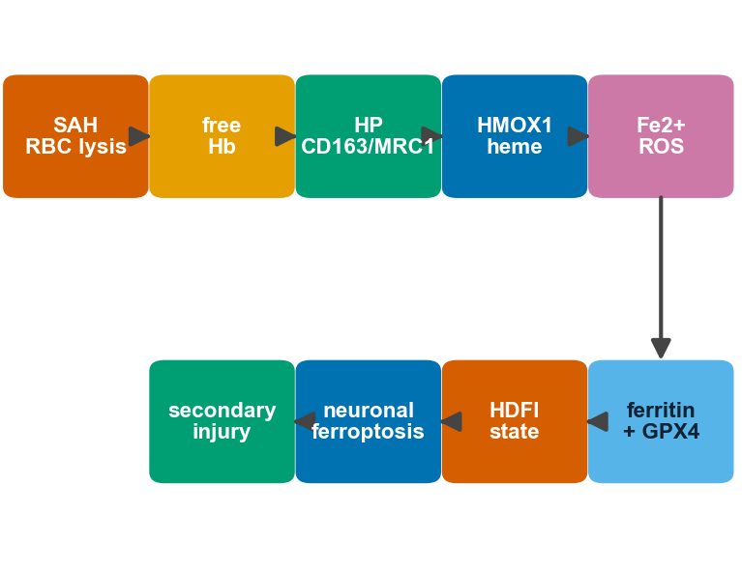
Figure 2. The acute whole-blood heme–immune program is largely composition-driven.(A) volcano plot of differentially expressed genes in acute SAH blood (GSE36791); (B) heatmap of the 32 candidate genes at the intersection of SAH differentially expressed genes and the red-cell signature; (C) over-representation enrichment of the candidate set; (D) Hallmark/Reactome gene-set enrichment scores; (E, F) marker-based immune deconvolution of the neutrophilia/monocytosis/lymphopenia shift and the heme/iron program; (G, H) composition-adjusted differential expression showing heme genes lose significance after leukocyte-fraction adjustment.
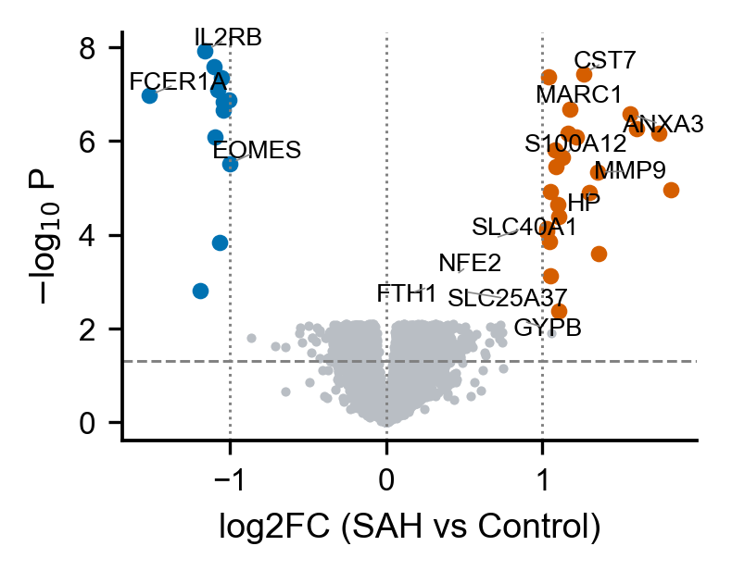
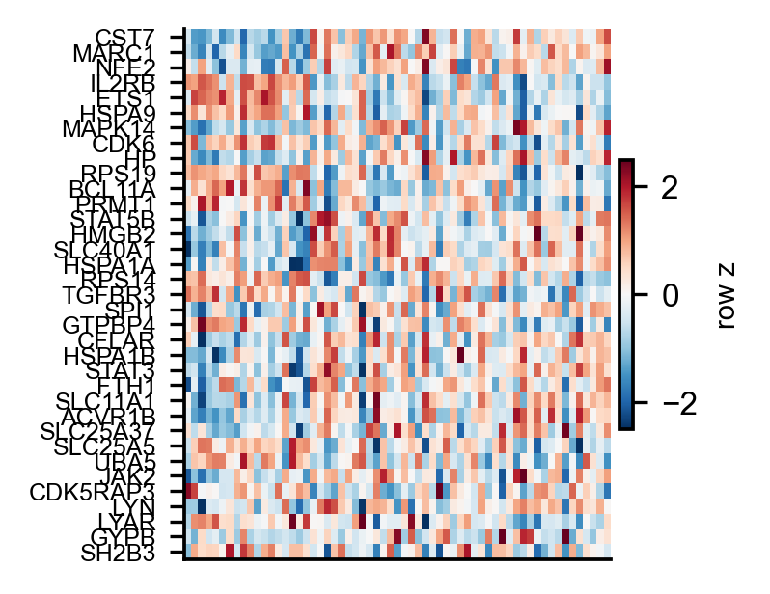
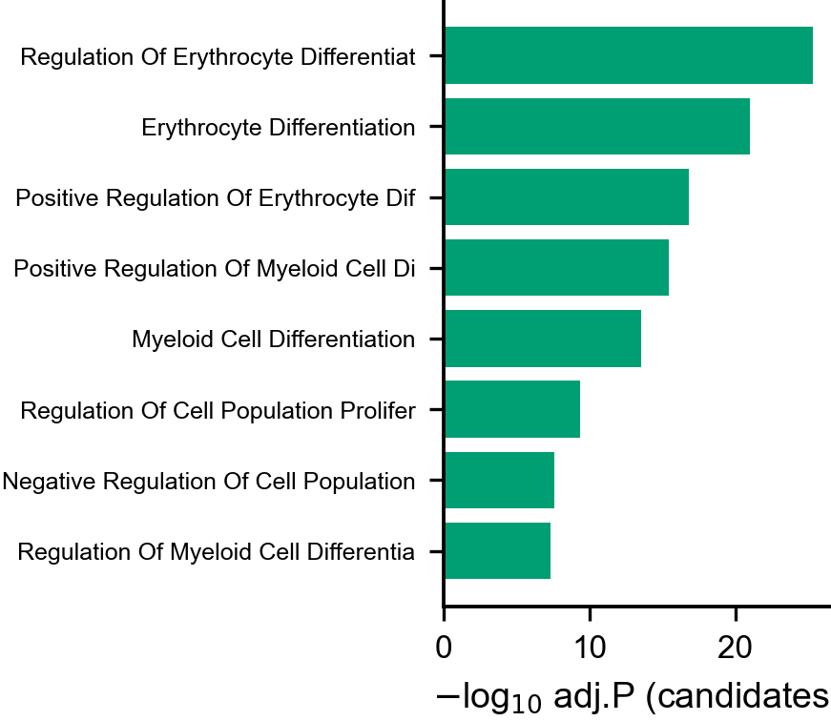
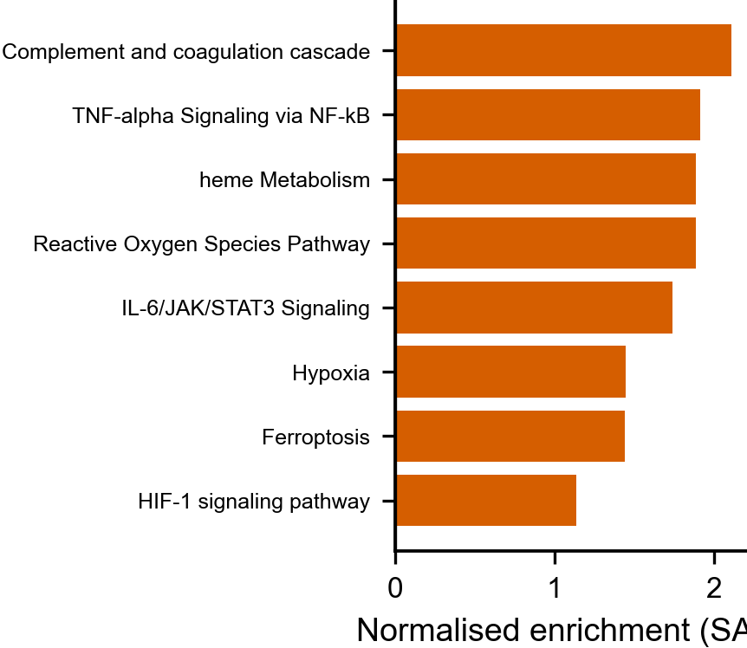
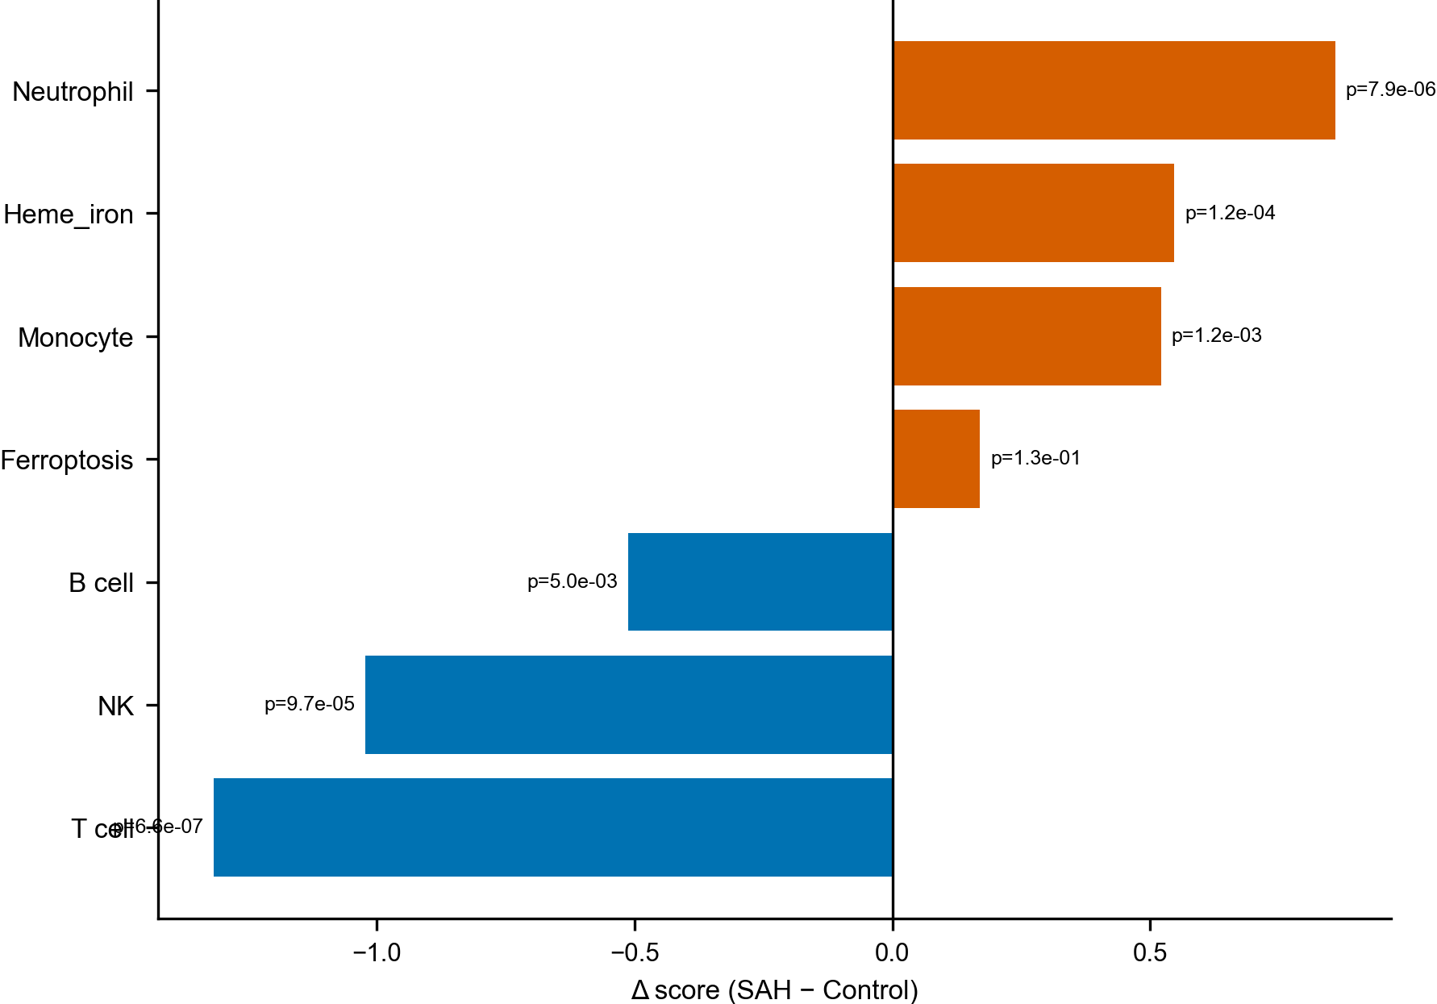
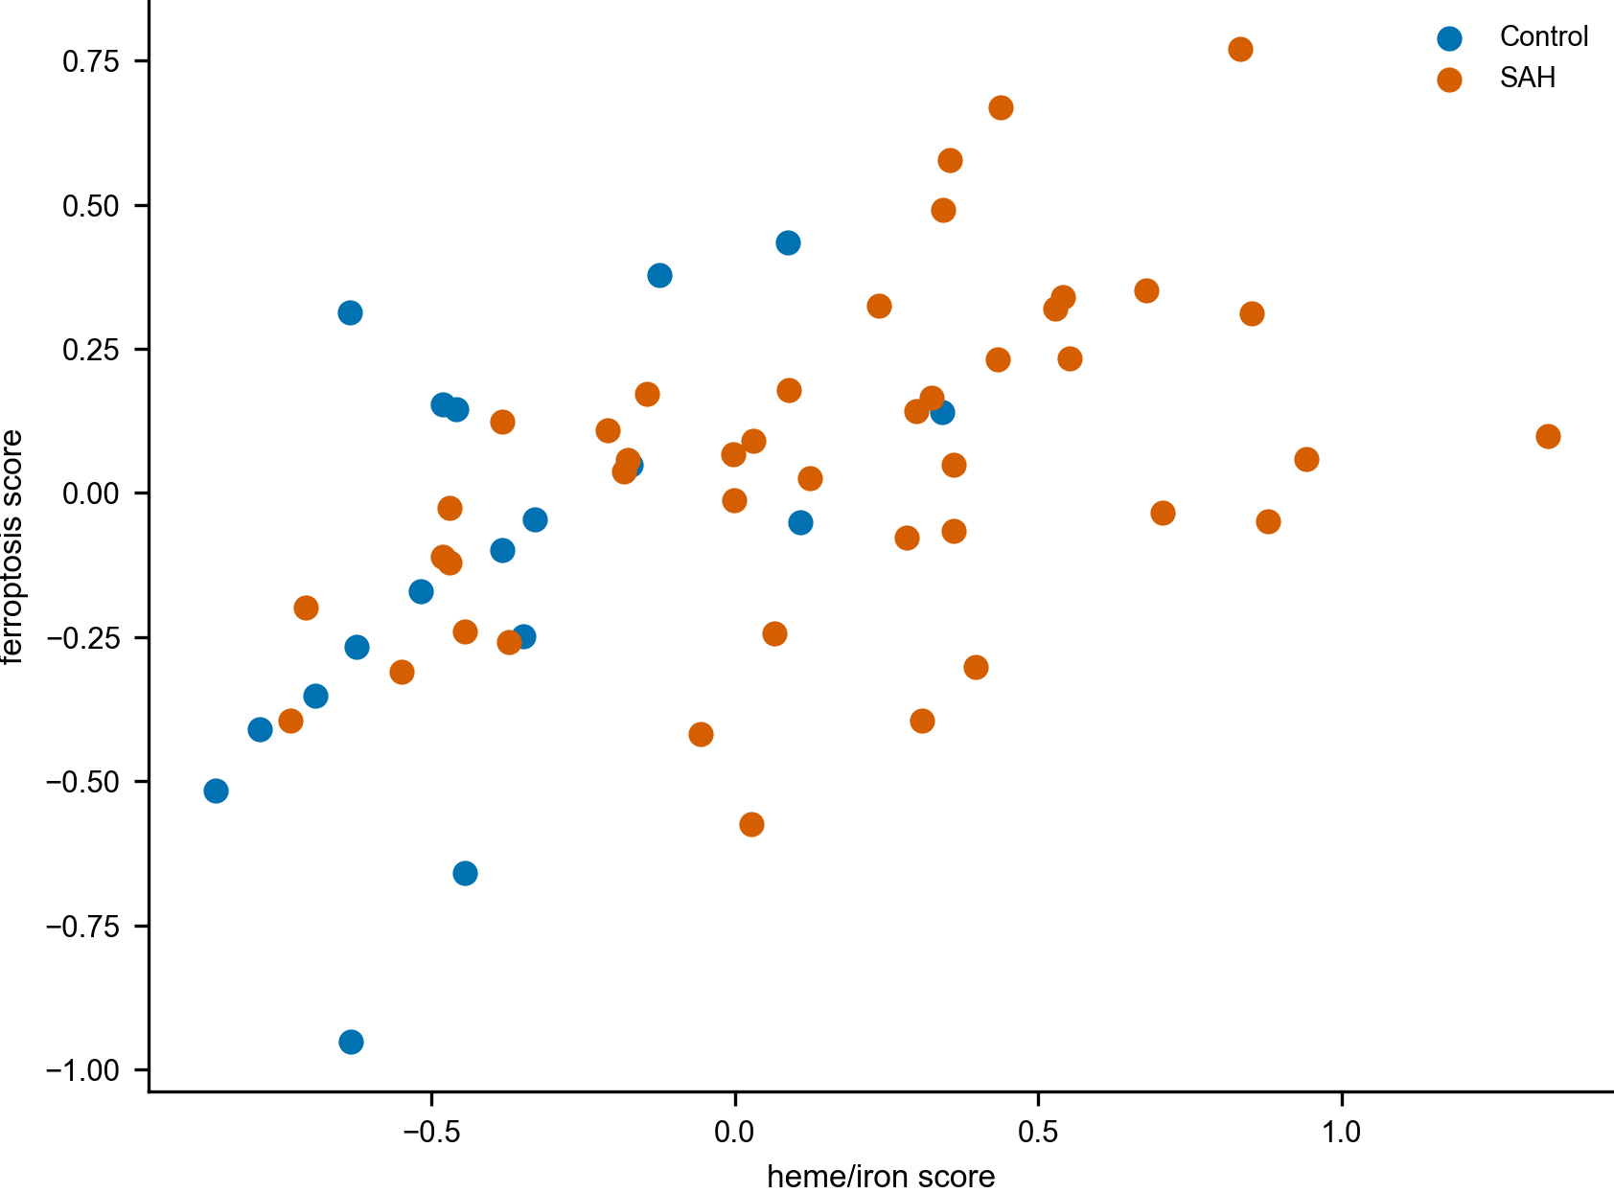
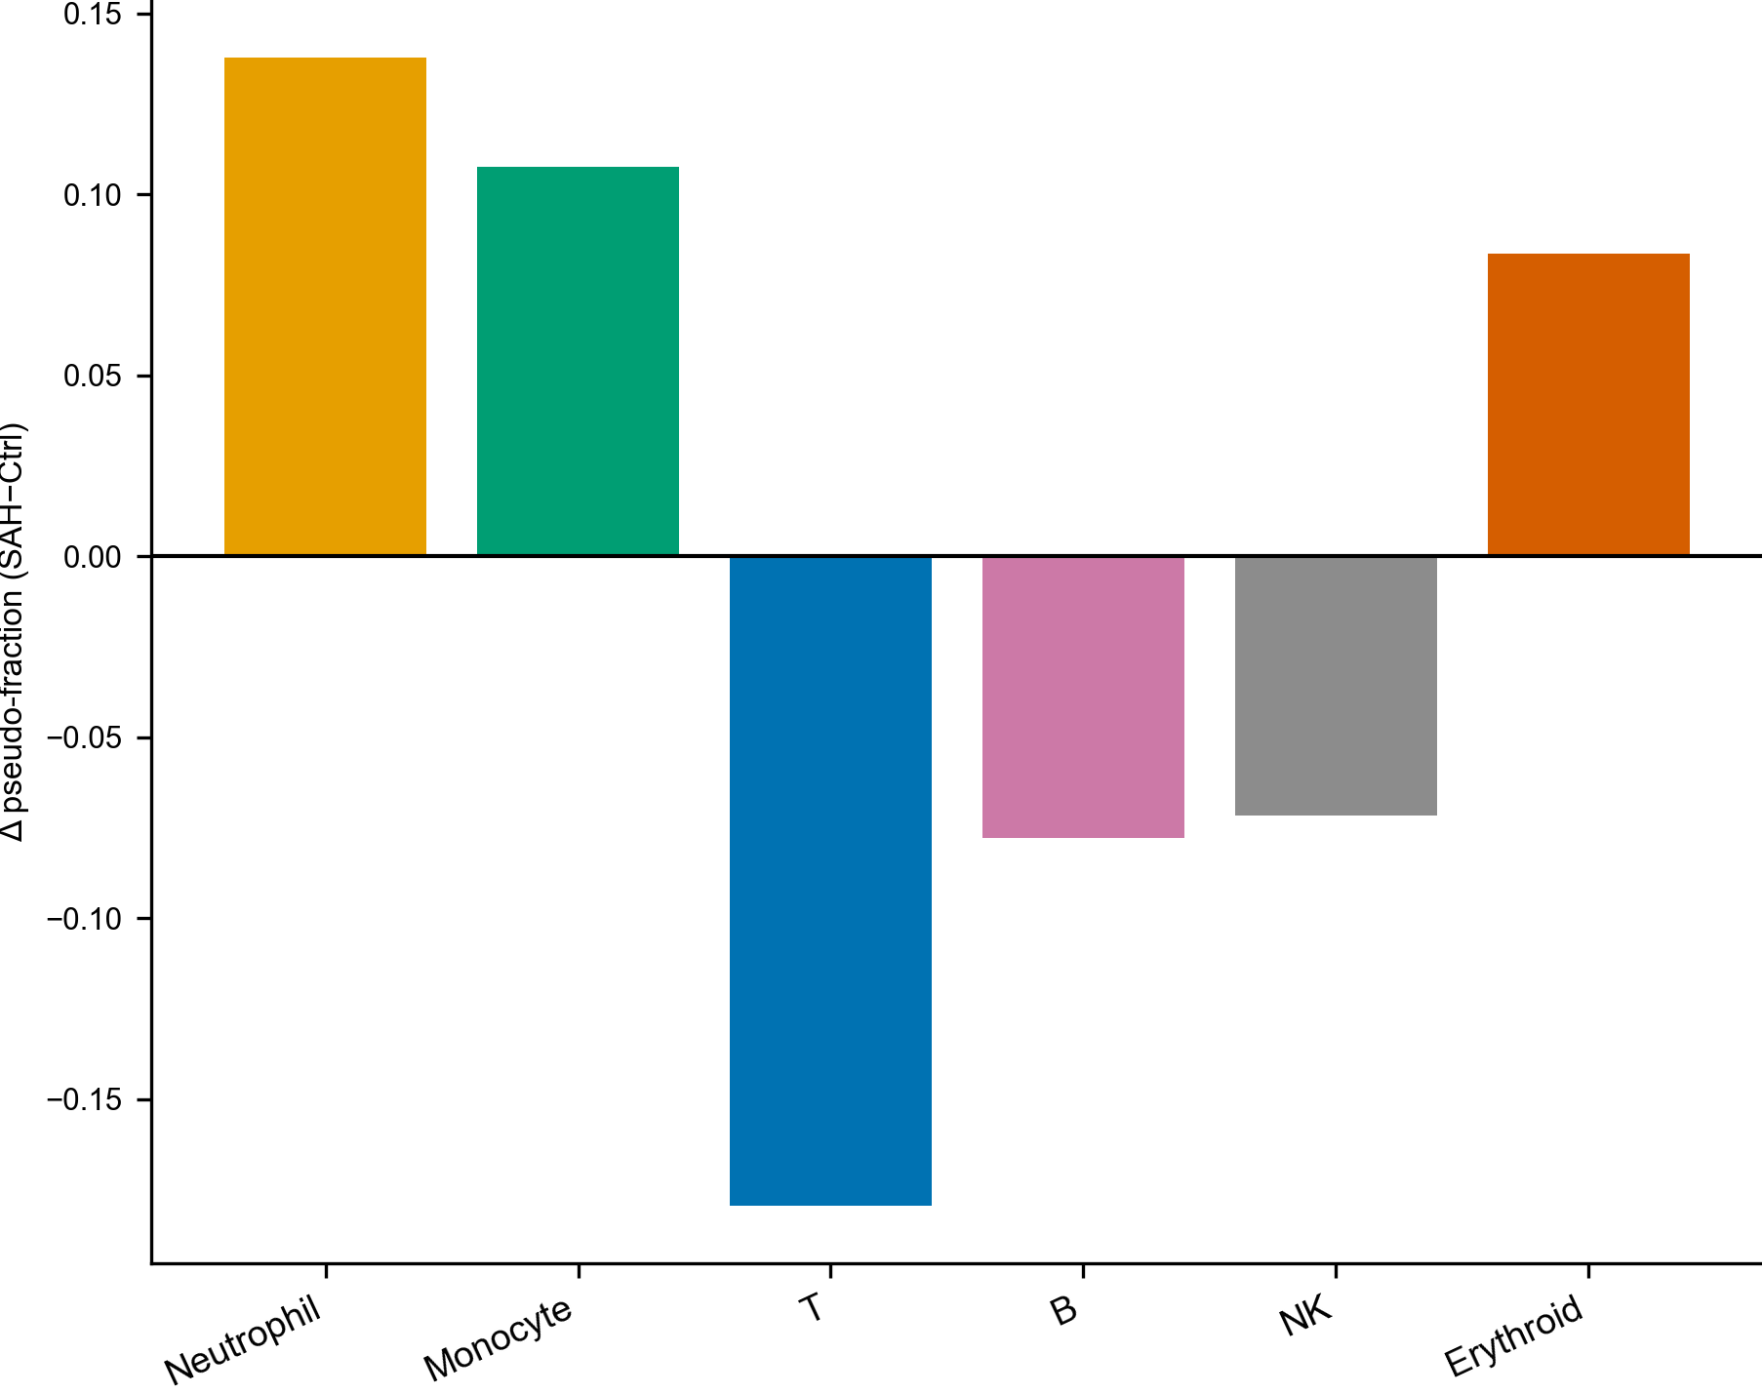
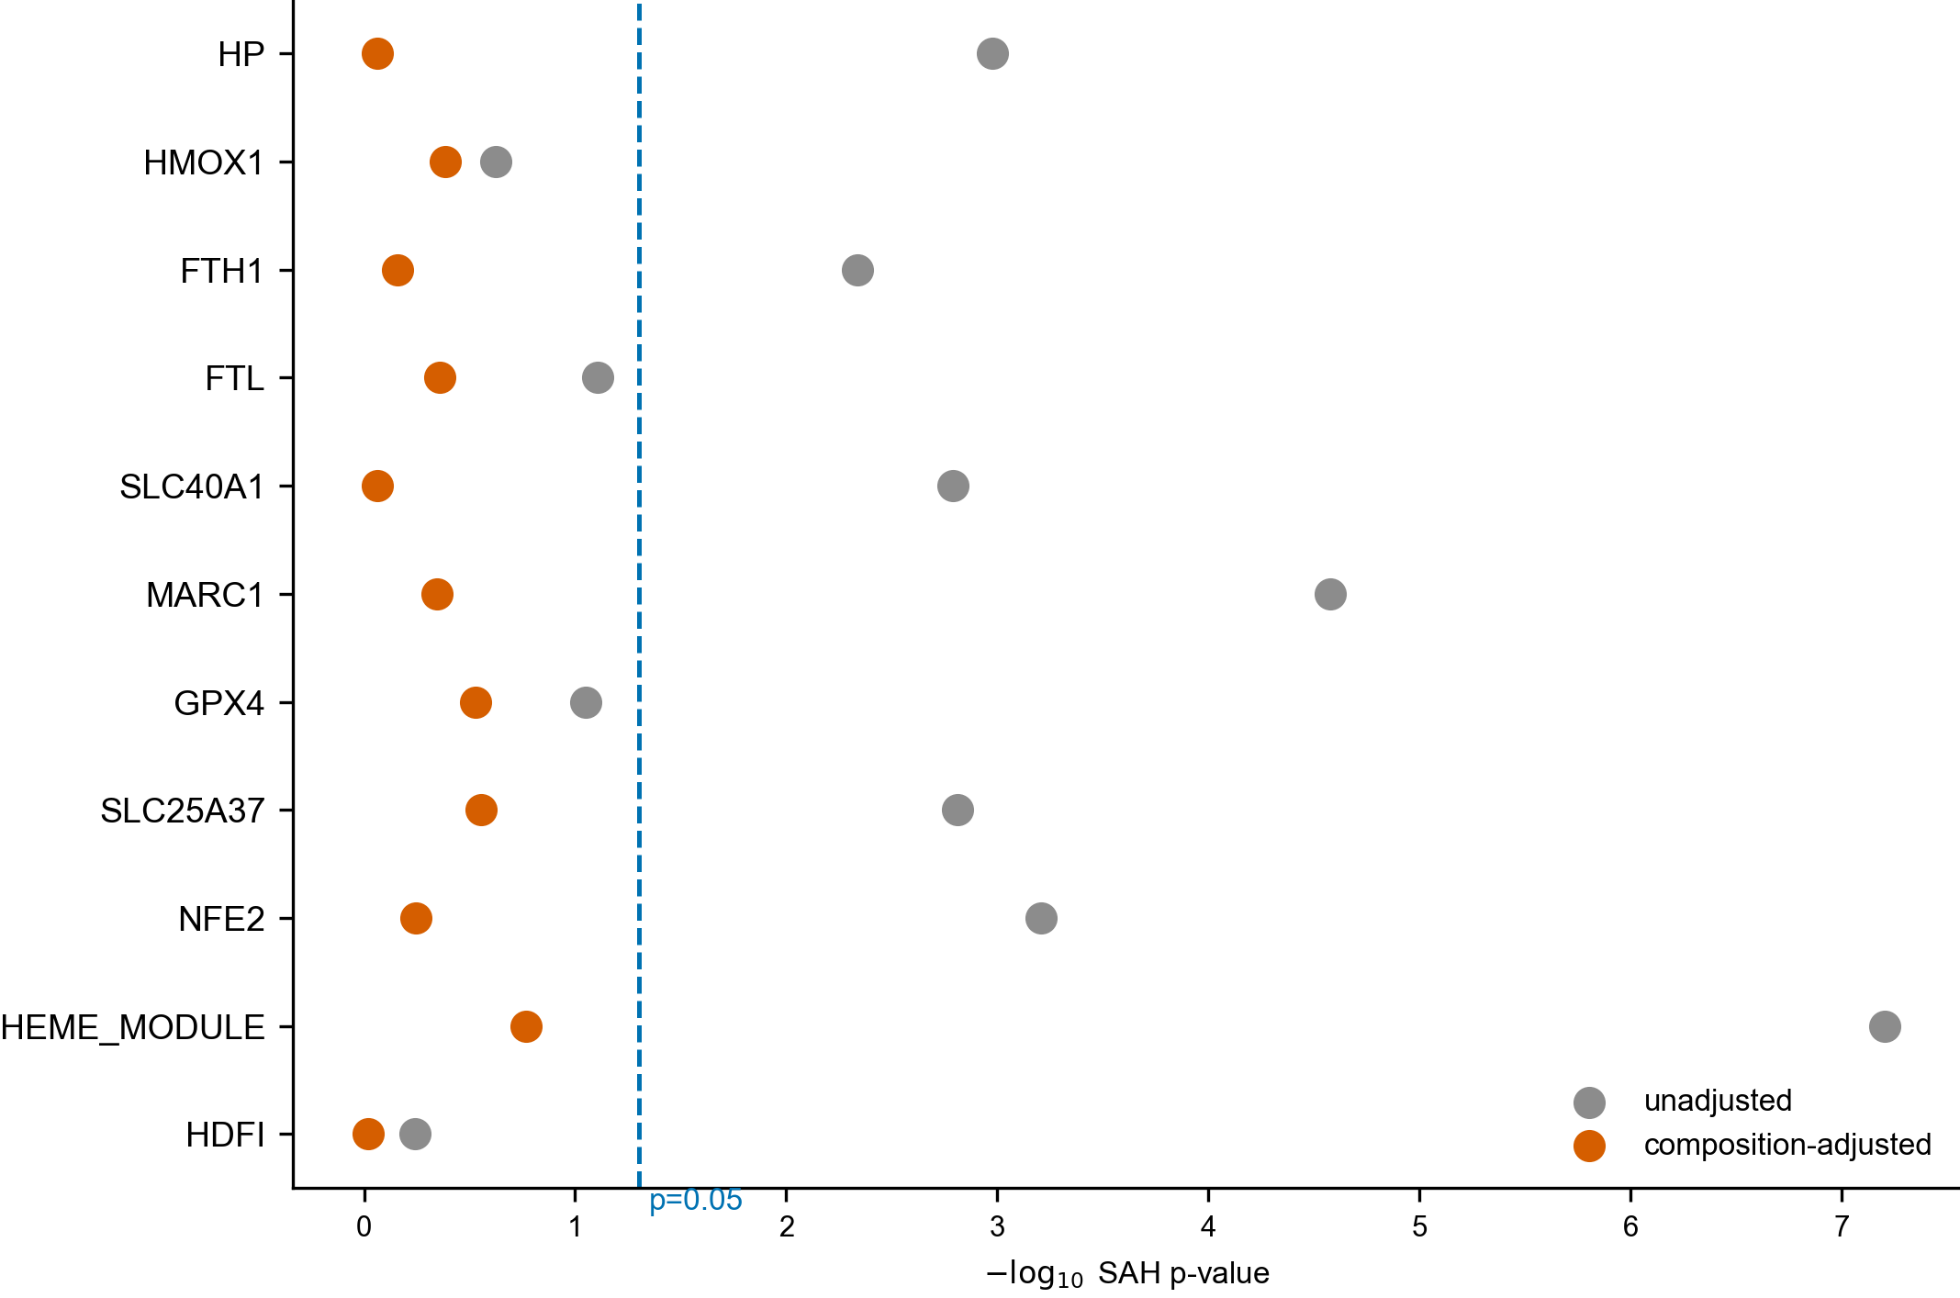
Figure 3. Single-cell brain atlas localises heme handling to myeloid cells and ferroptotic vulnerability to neurons.(A) heme/iron module score by cell type (SAH versus sham); (B) marker localisation heatmap in the mouse SAH atlas; (C–E) cell-type-specific differential expression, the neuronal ferroptosis program, and curated regulon activity; (F–H) temporal composition and heme/iron and ferroptosis scores across sham, 24 h and 72 h; (I–K) macrophage and neutrophil cell-state transitions between homeostatic, iron-handling and ferroptosis-prone states.
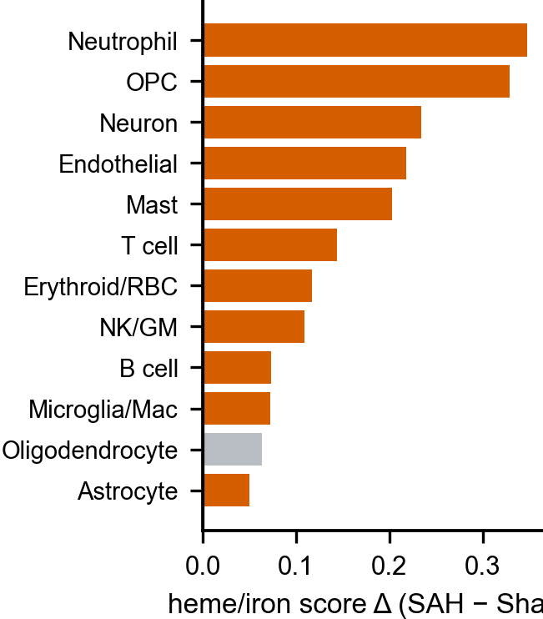
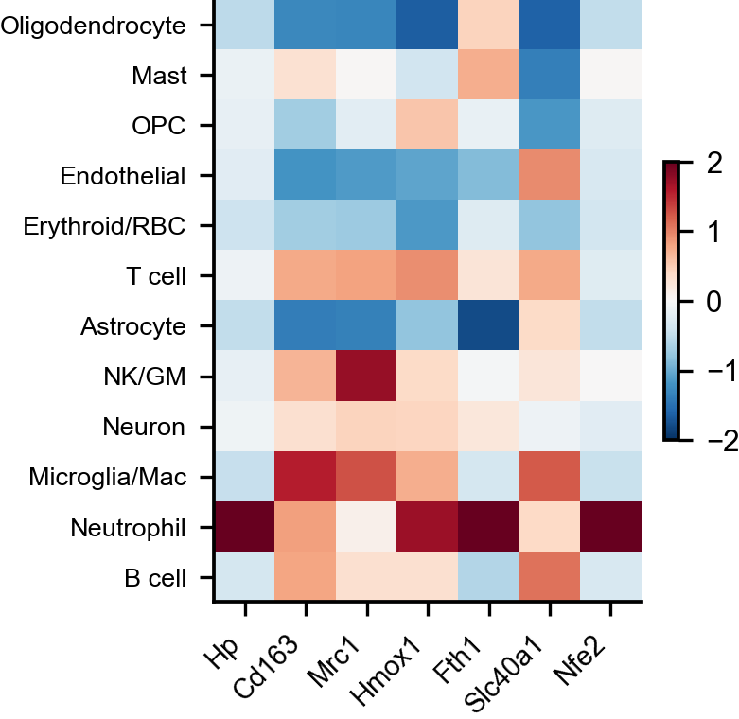
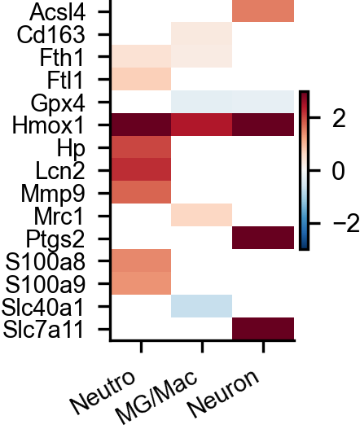
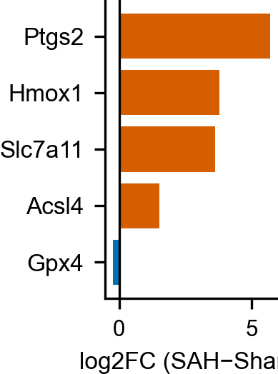
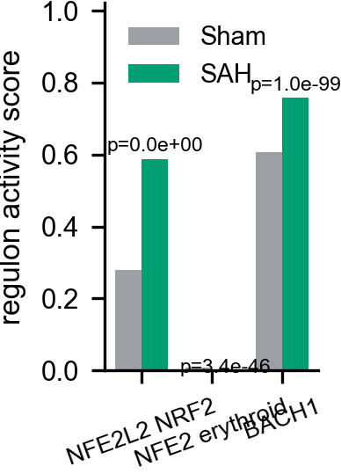
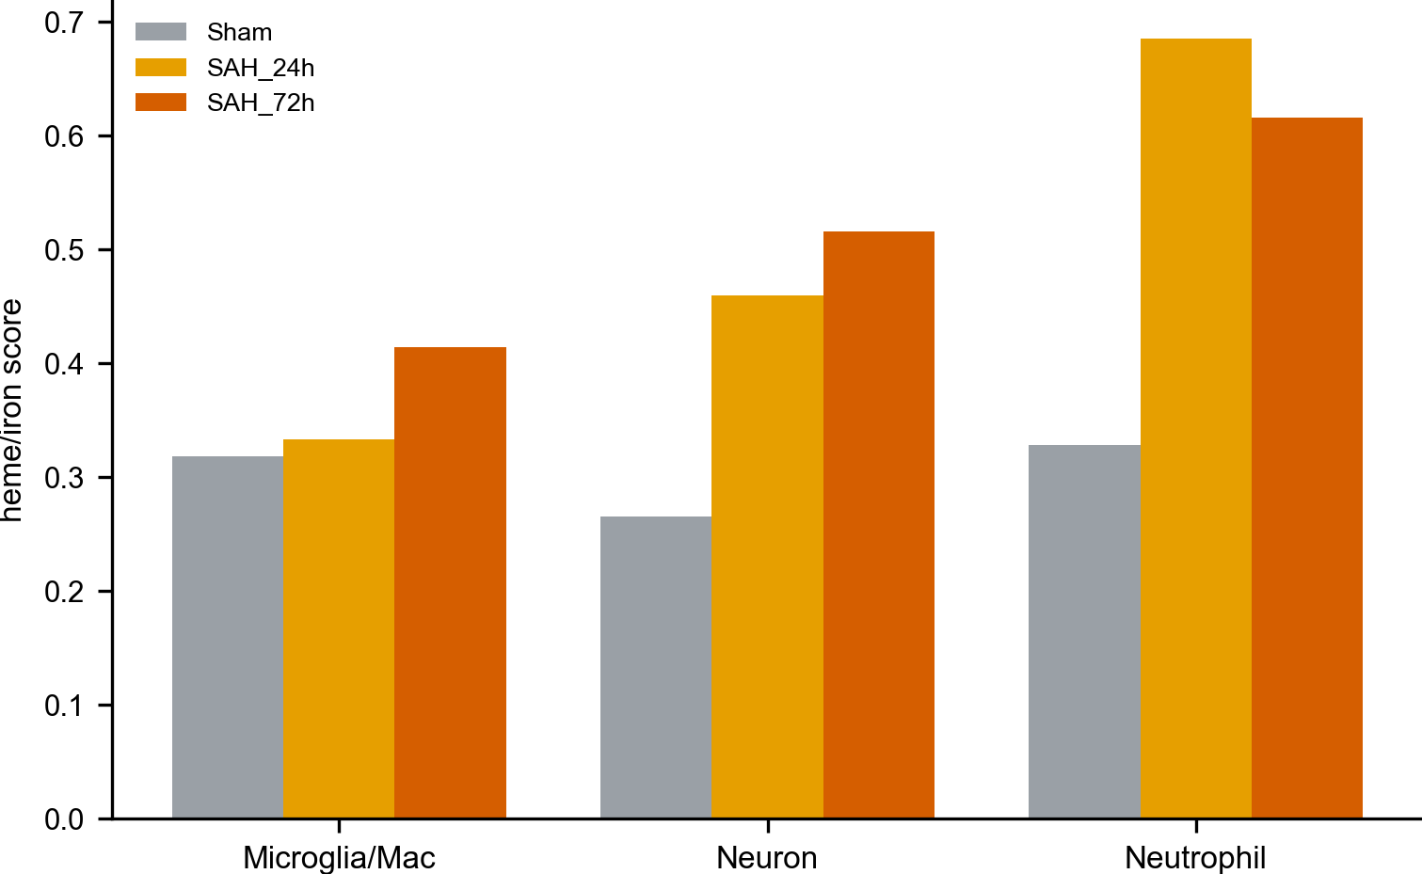
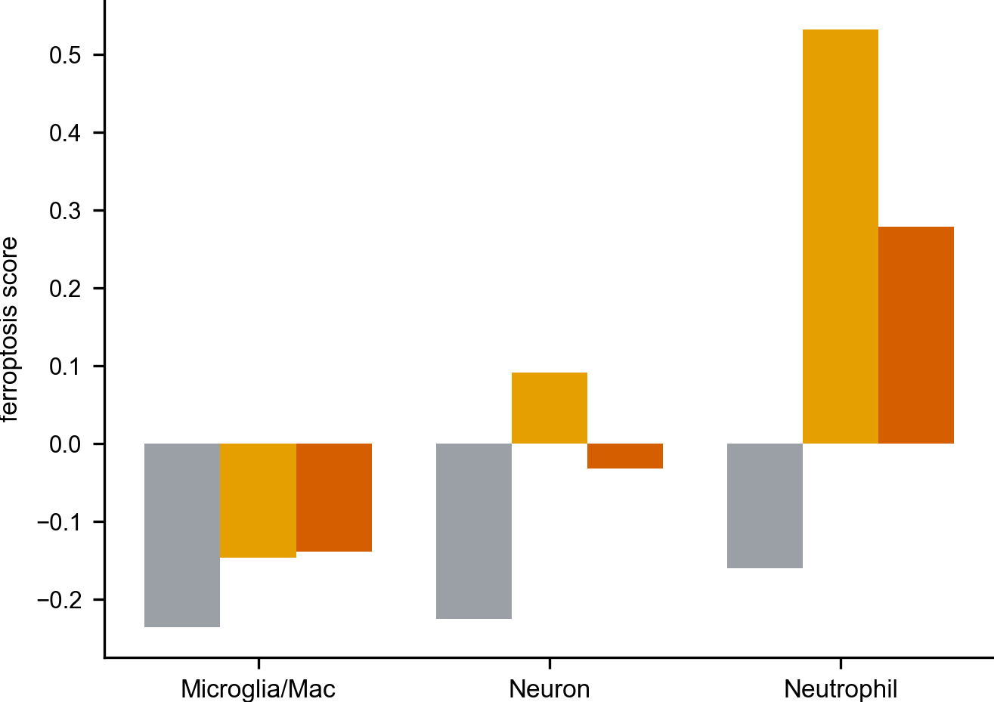
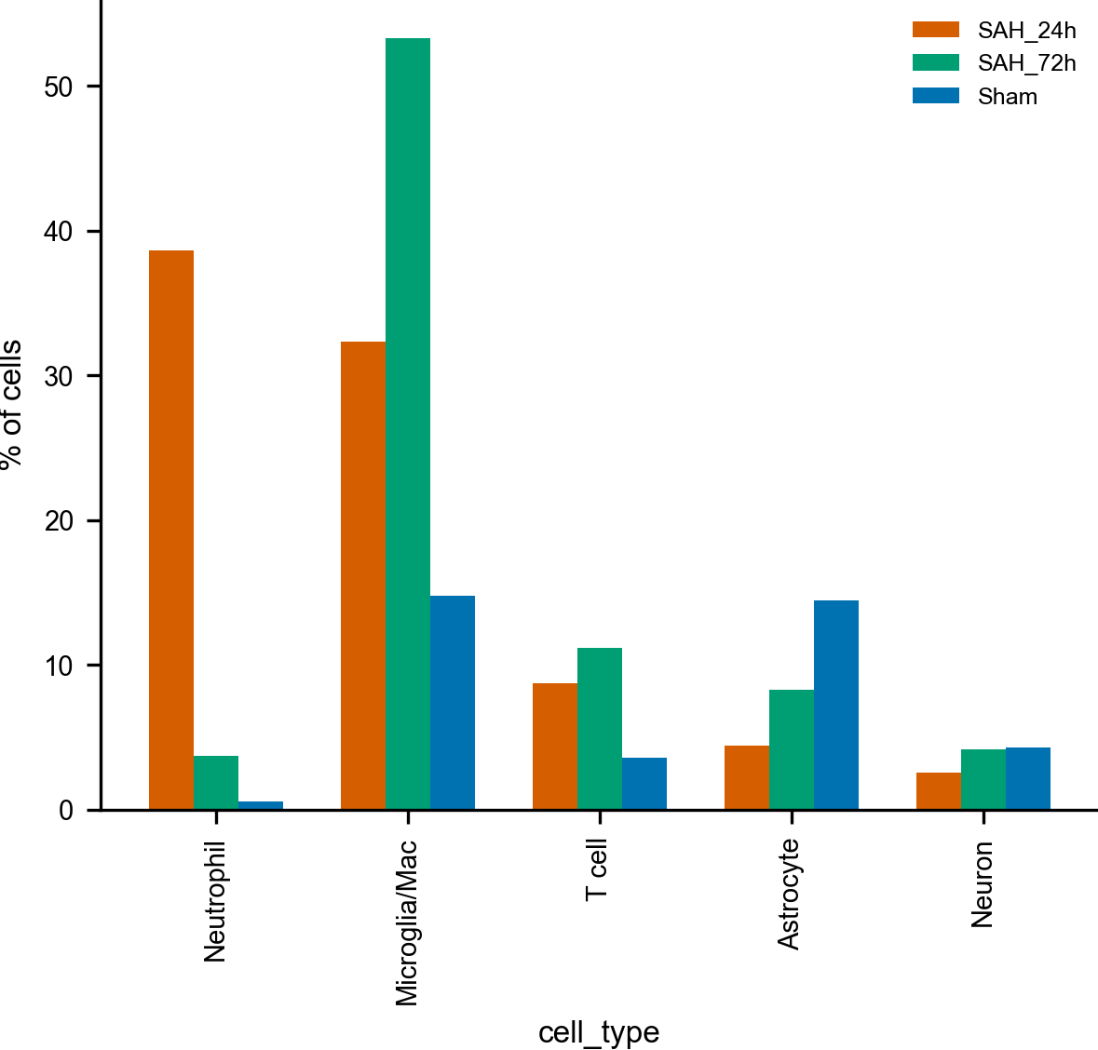
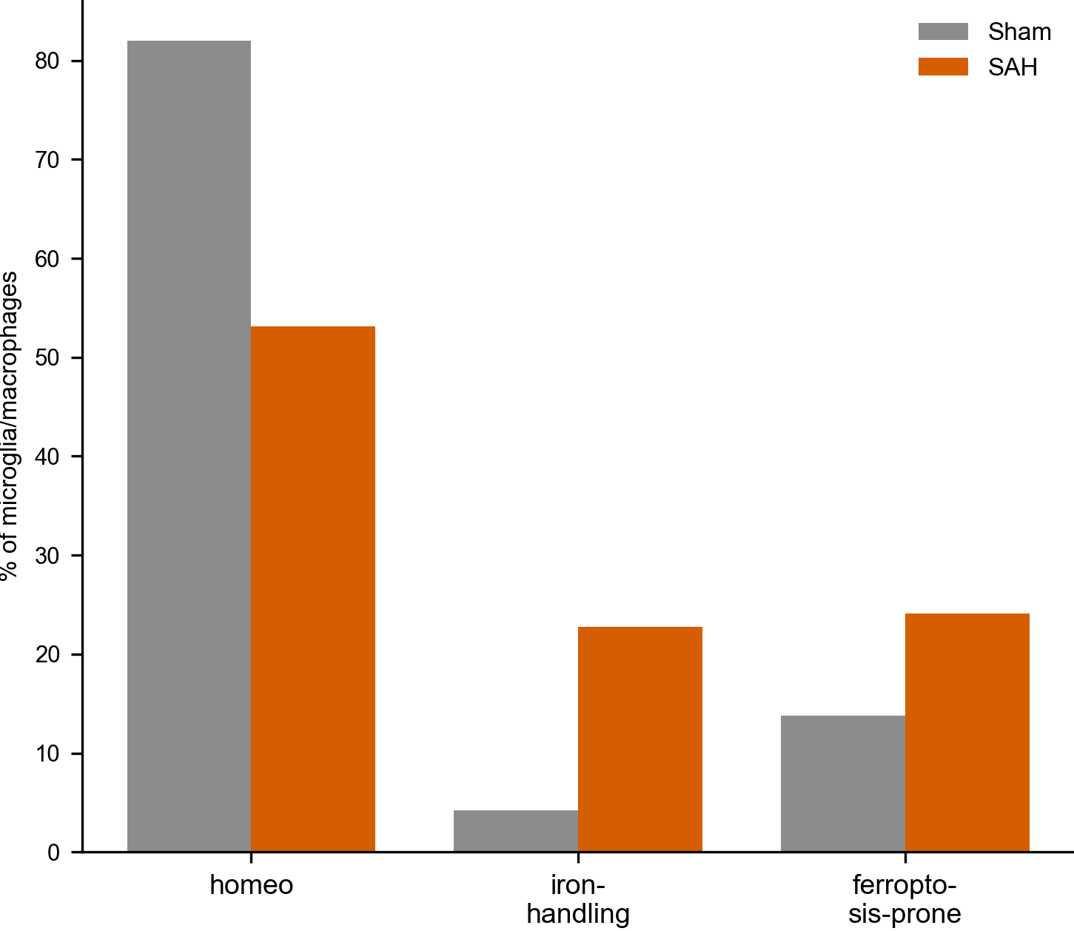
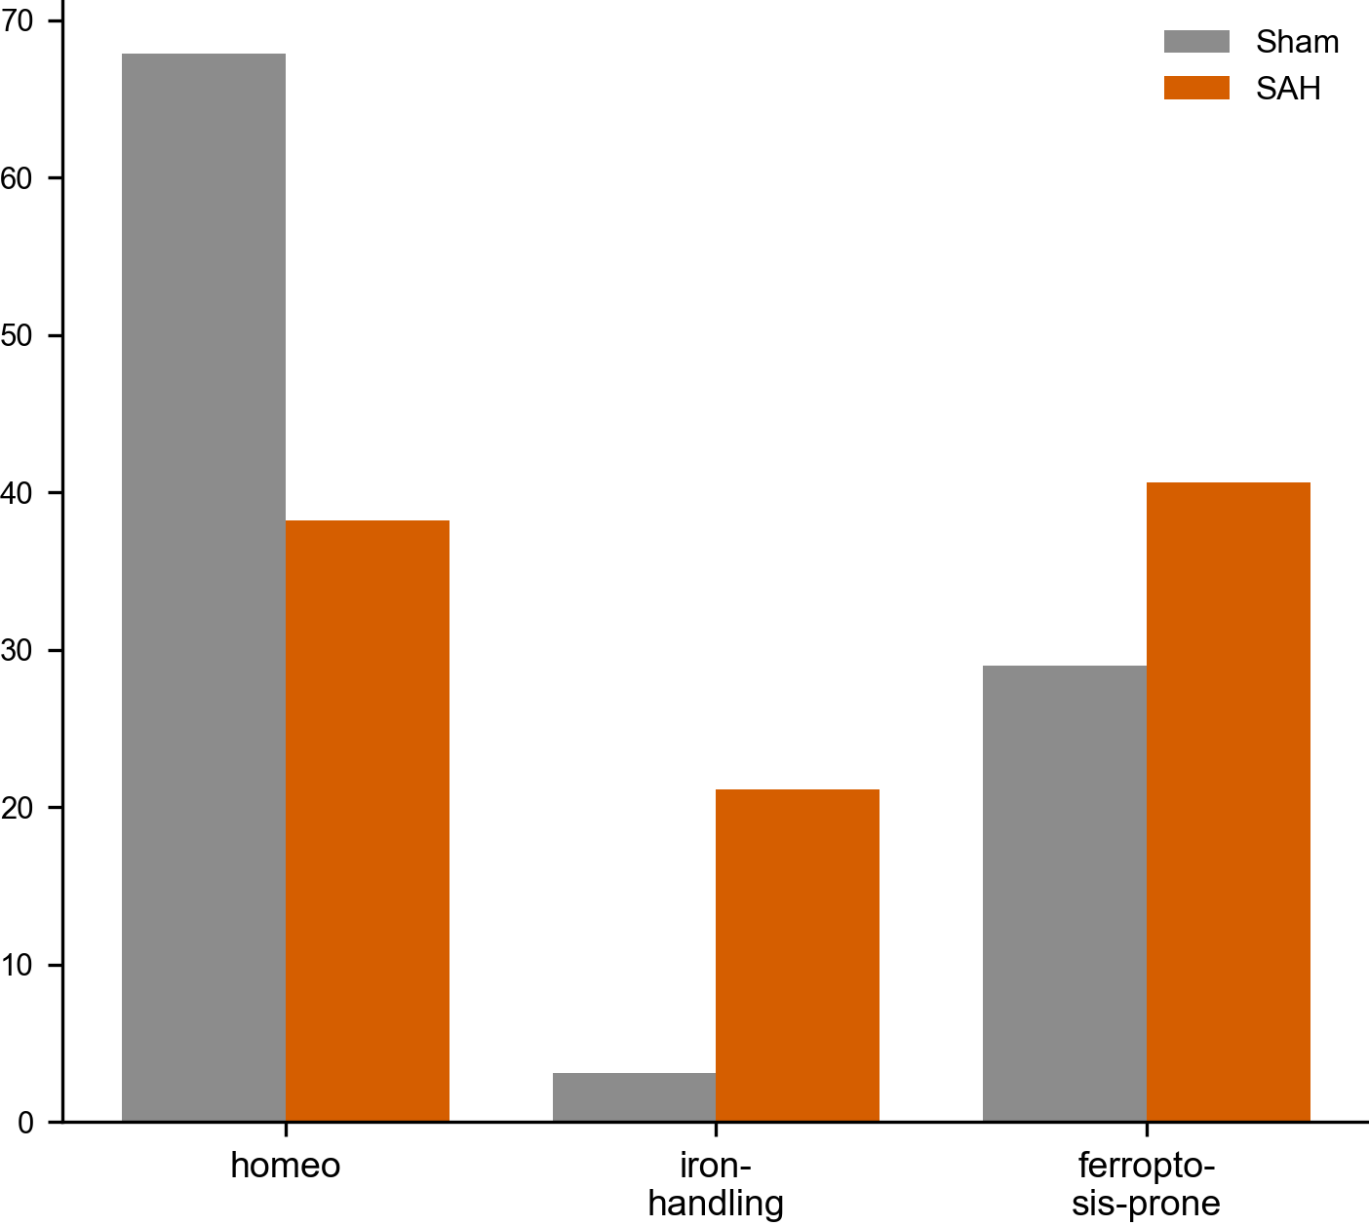
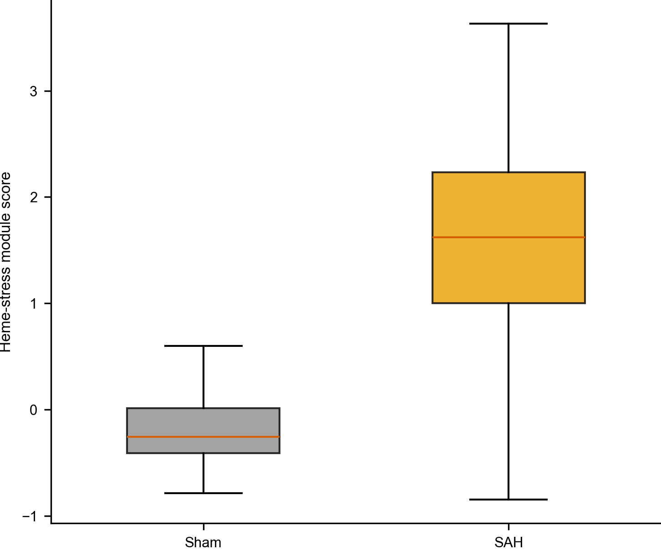
Figure 4. The HP→CD163 model refines into a broader heme-handling program.(A–C) CellChat-style ligand–receptor test (HP–CD163, HP–MRC1, DAMP routes) per timepoint; (D) NicheNet-style ligand-to-target prioritisation of the microglial heme-handling program; (E–H) monocyte CITE-seq showing CD163 surface protein where its RNA dropped out, and MRC1 levels.
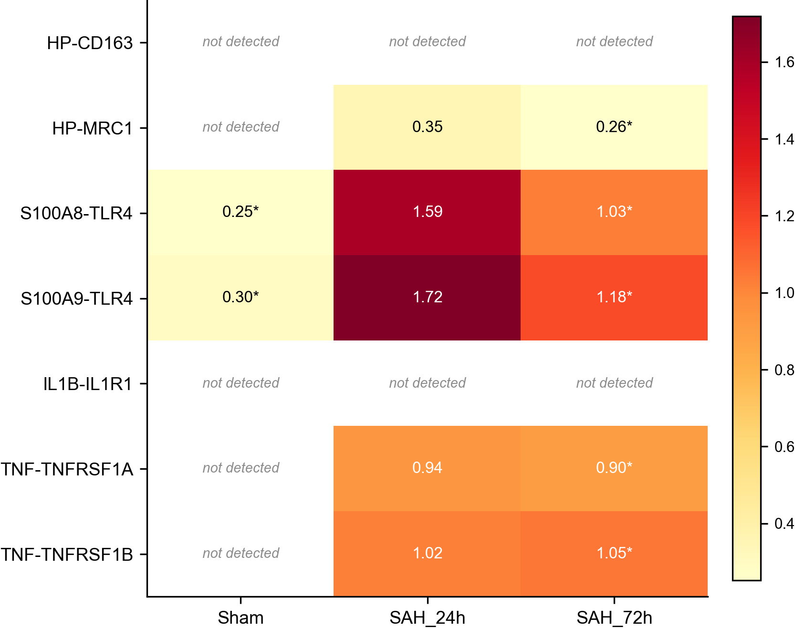
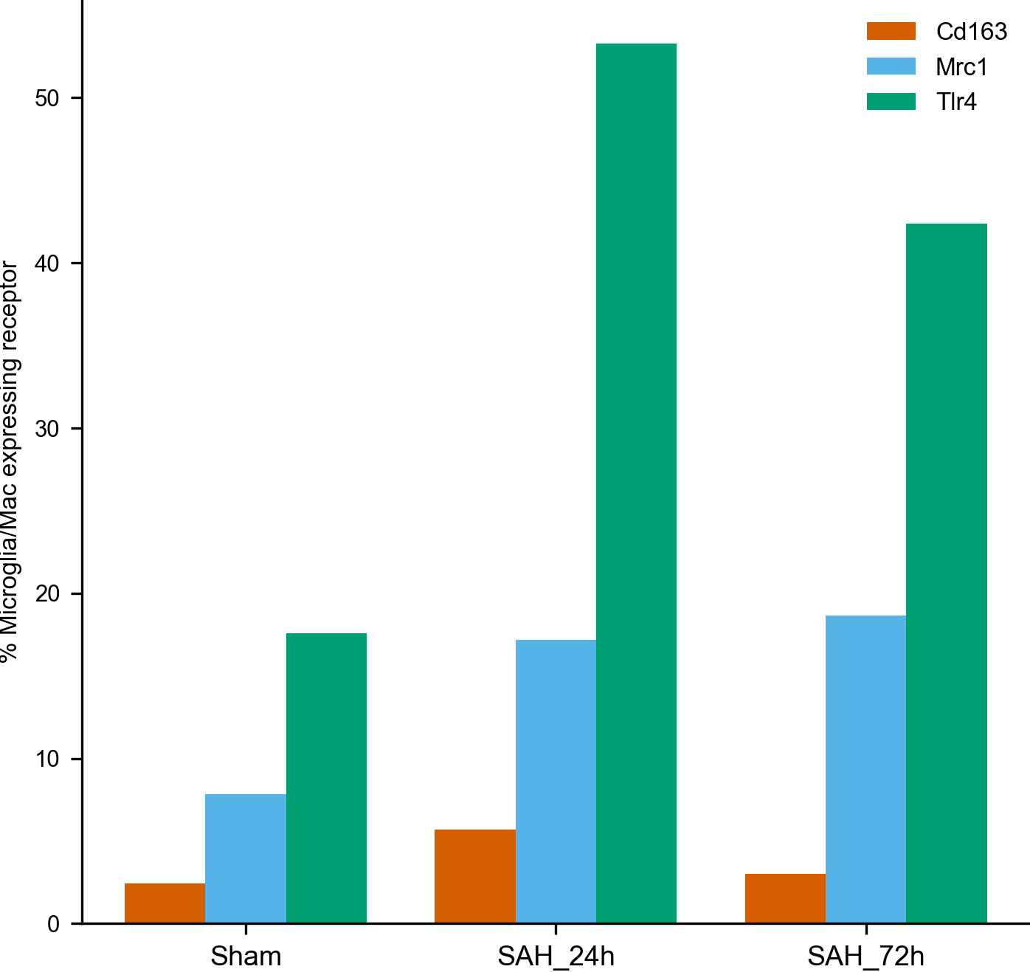
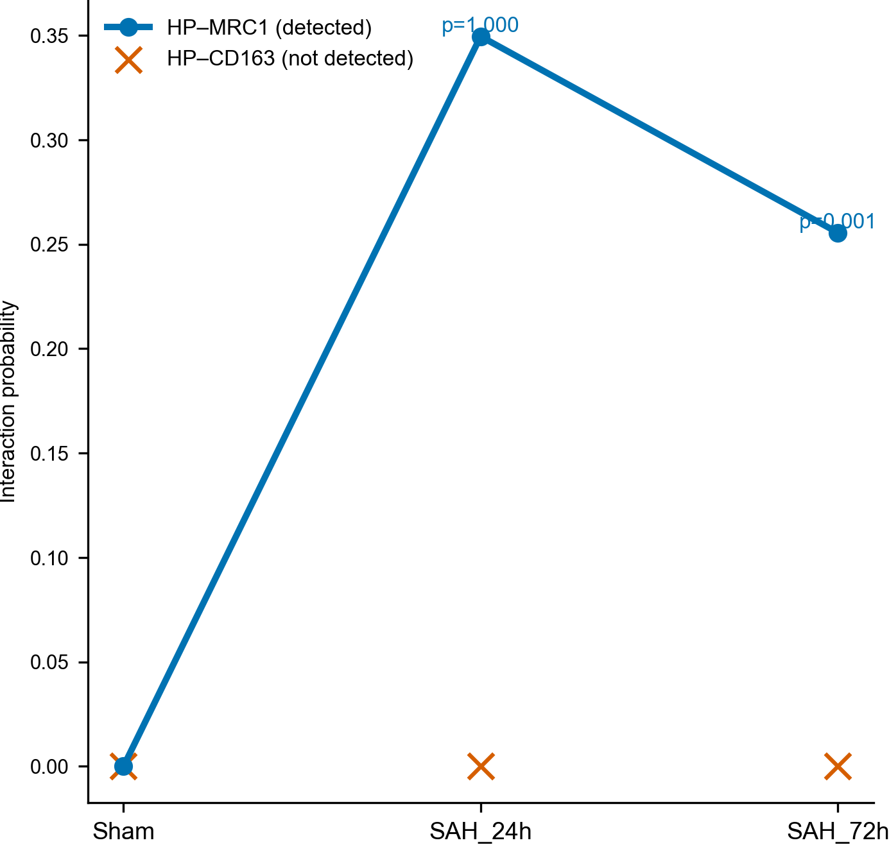
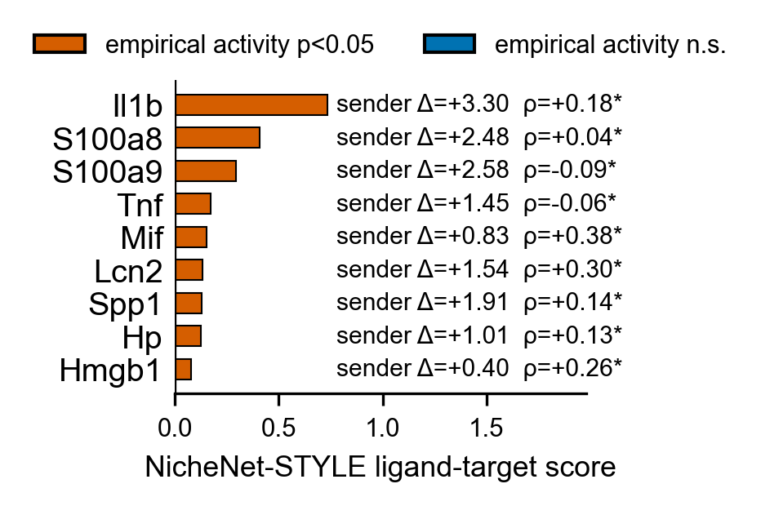
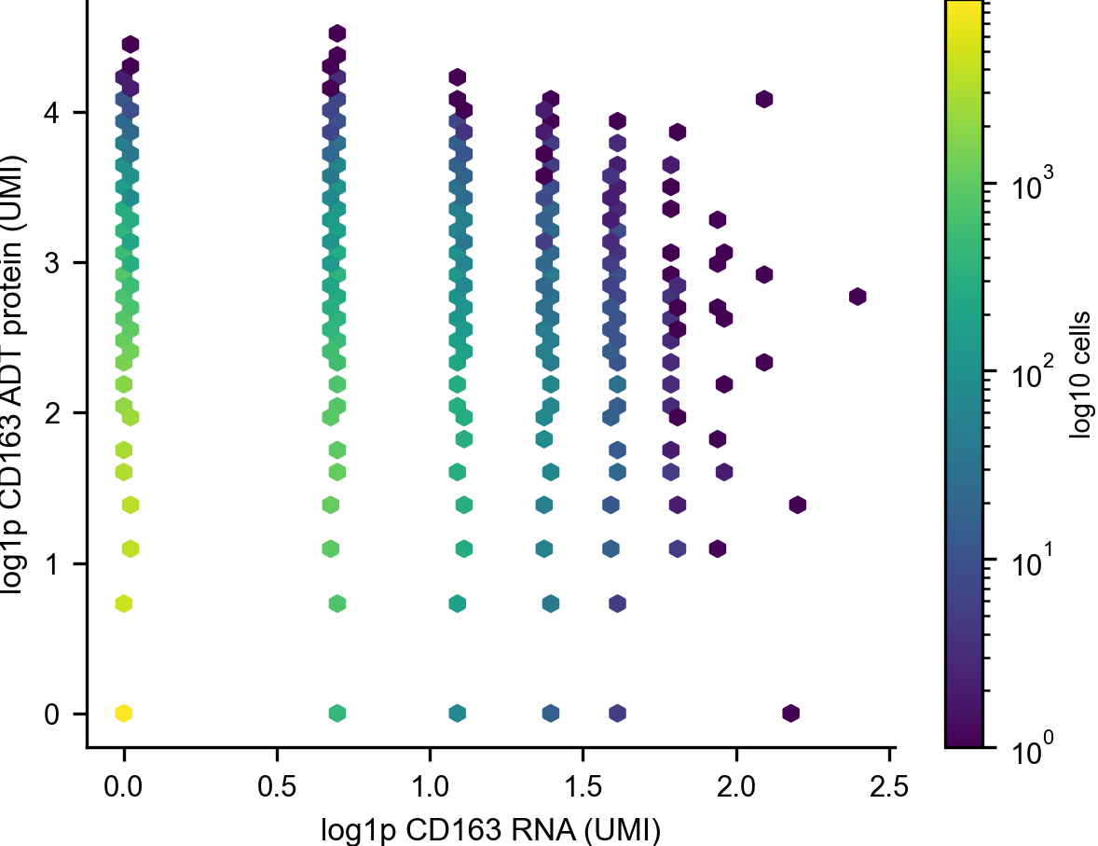
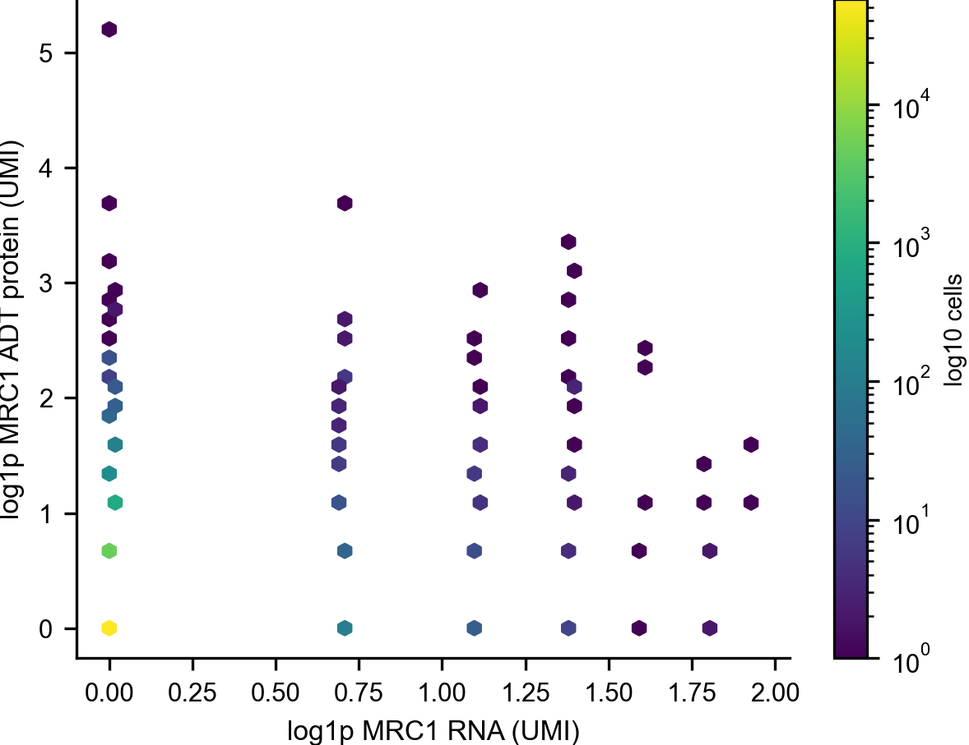
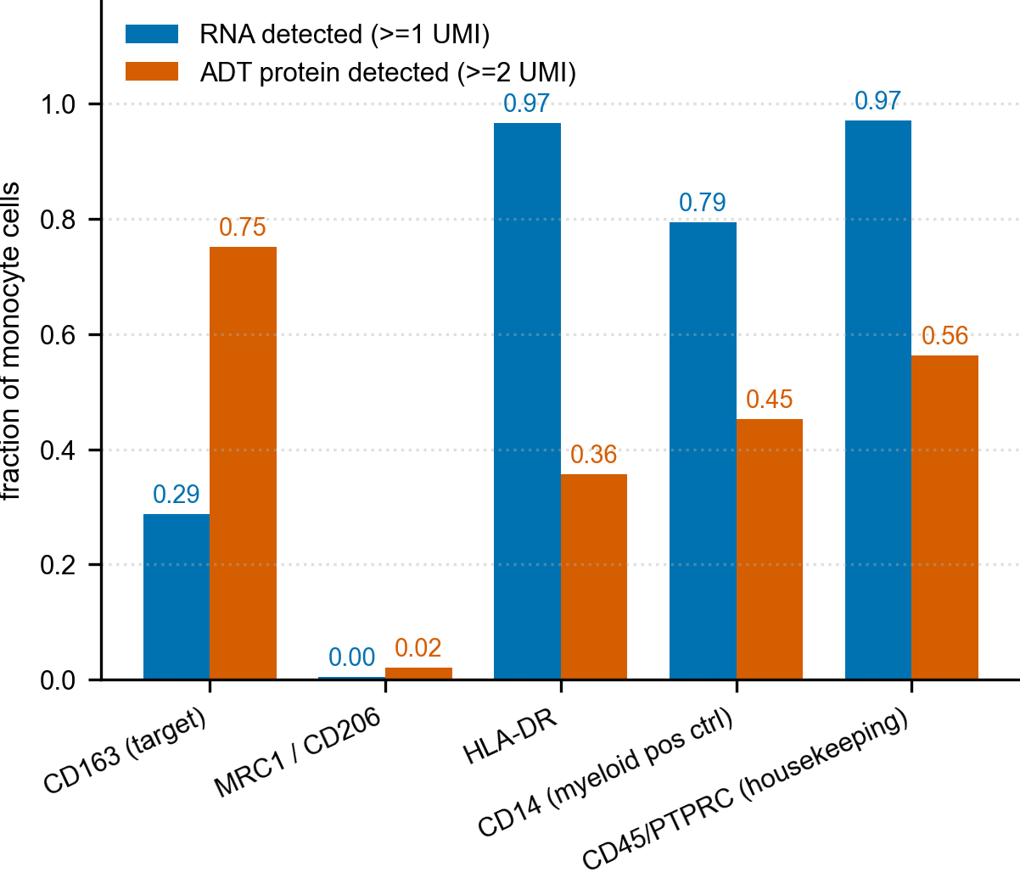
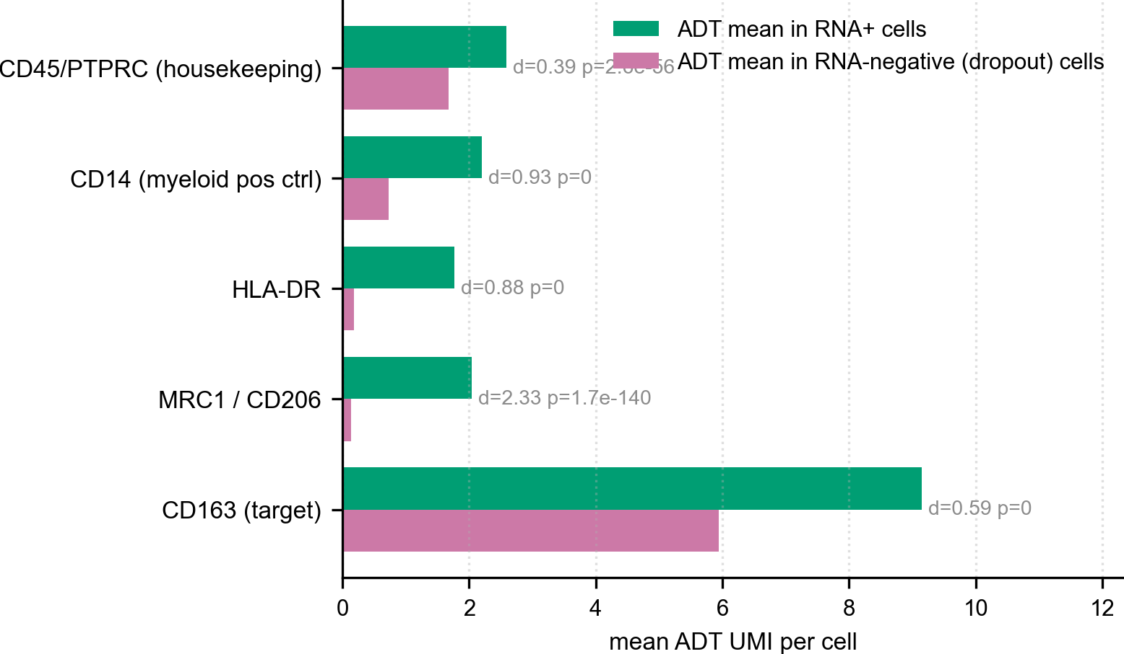
Figure 5. HDFI as a conditional detoxification-failure state, with its dependence disclosed.(A–C) NRF2/BACH1/HMOX1 regulon activity and the heme-detoxification-failure index by cell type; (D–G) HDFI in bulk blood, by cell type, versus neuronal ferroptosis-execution within neurons, and its temporal behaviour; (H, I) pathway-specificity and PCA factor-structure audit of HDFI; (J–M) HDFI structural-variant, leave-one-gene-out, GPX4-leakage, random-weighting and PCA-independence robustness tests.
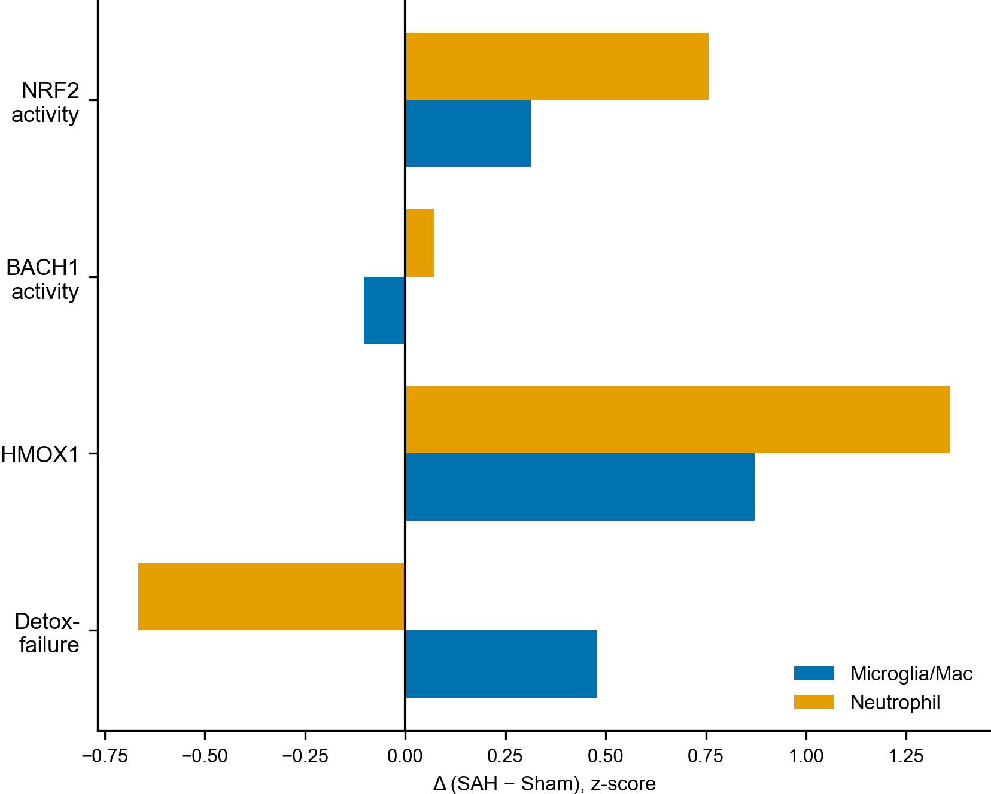
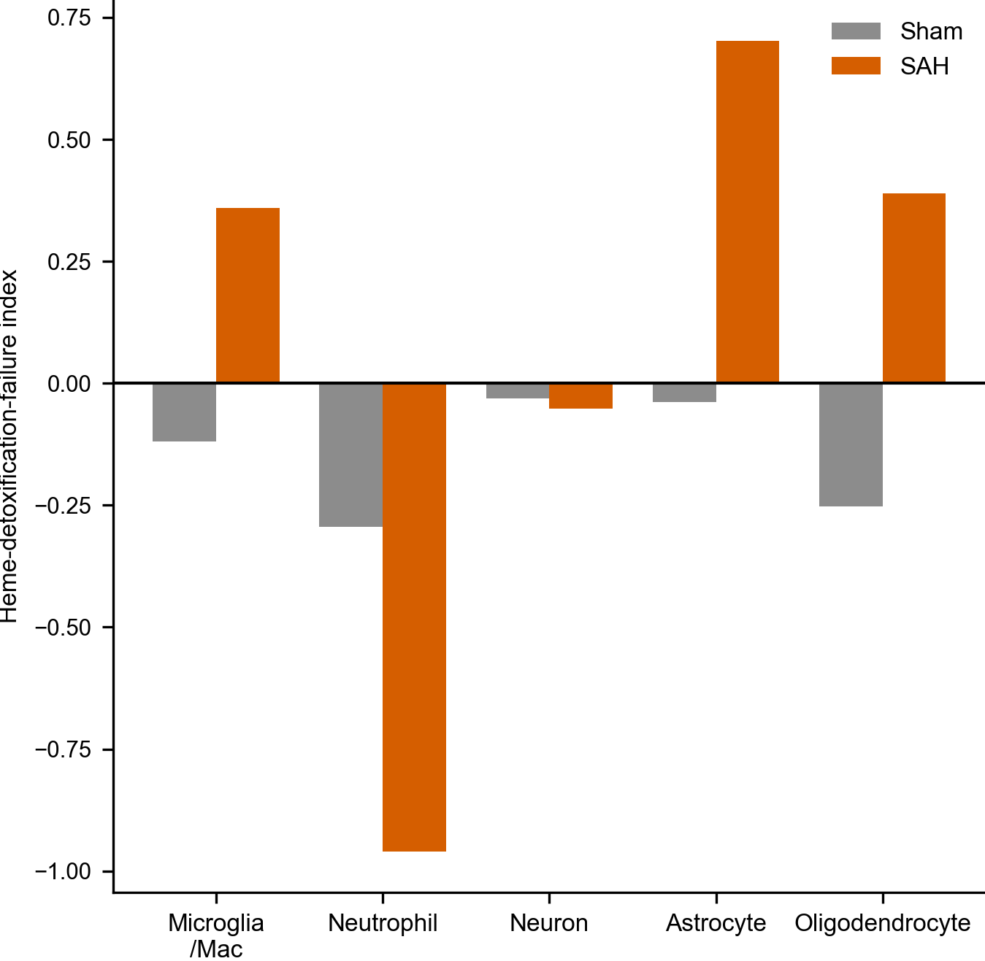
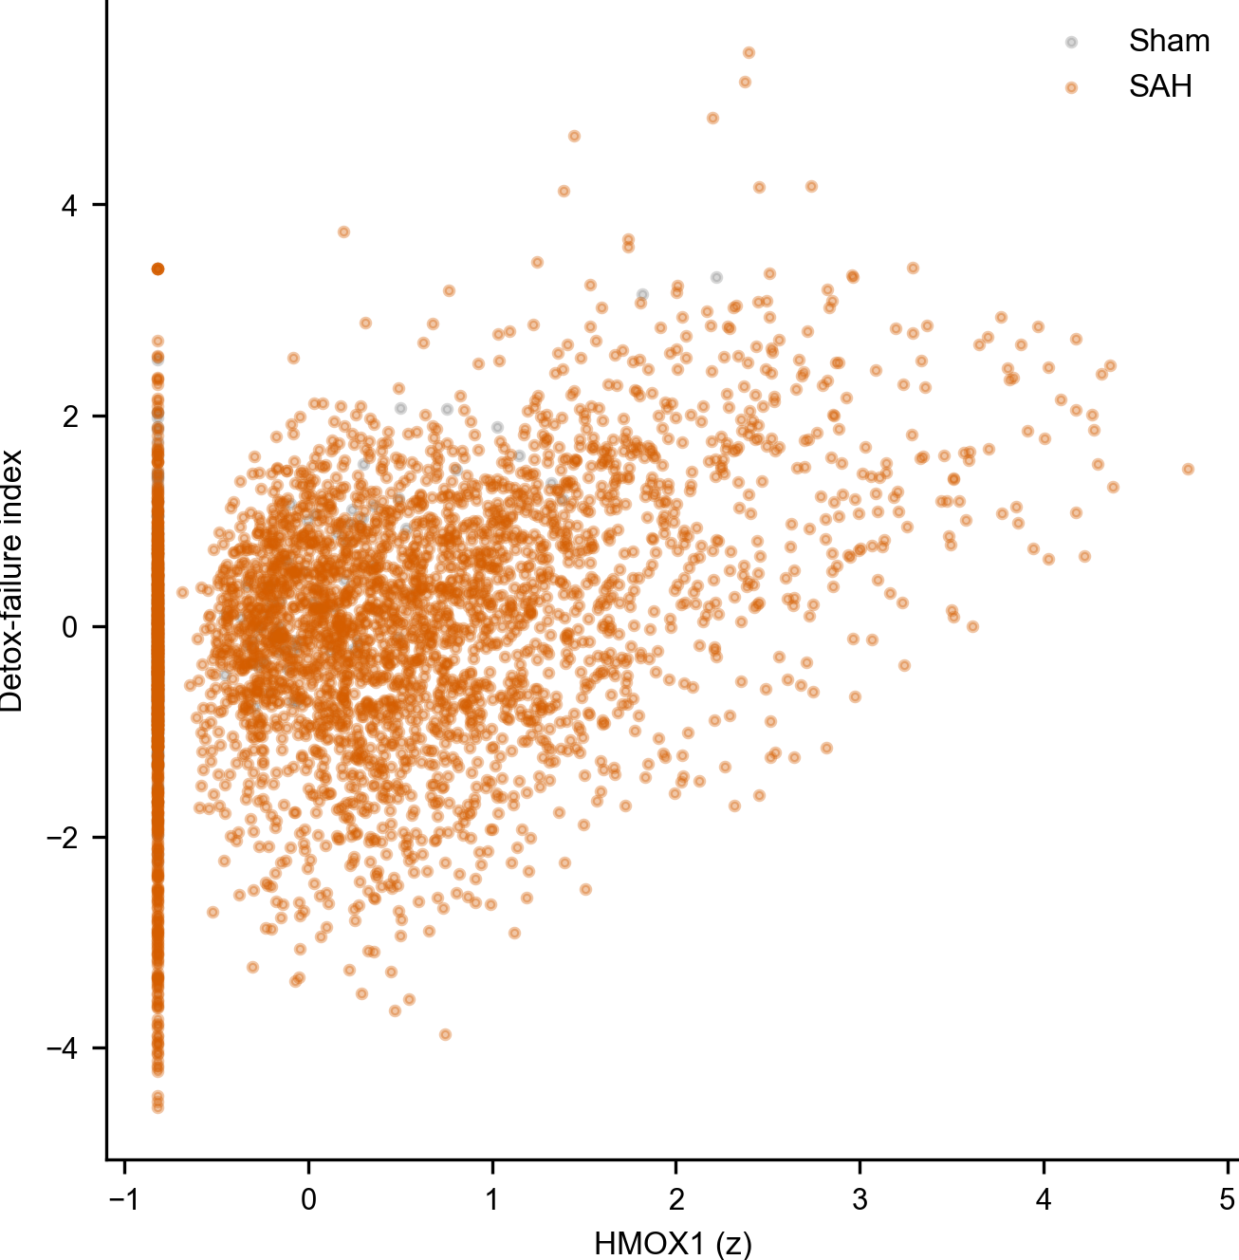
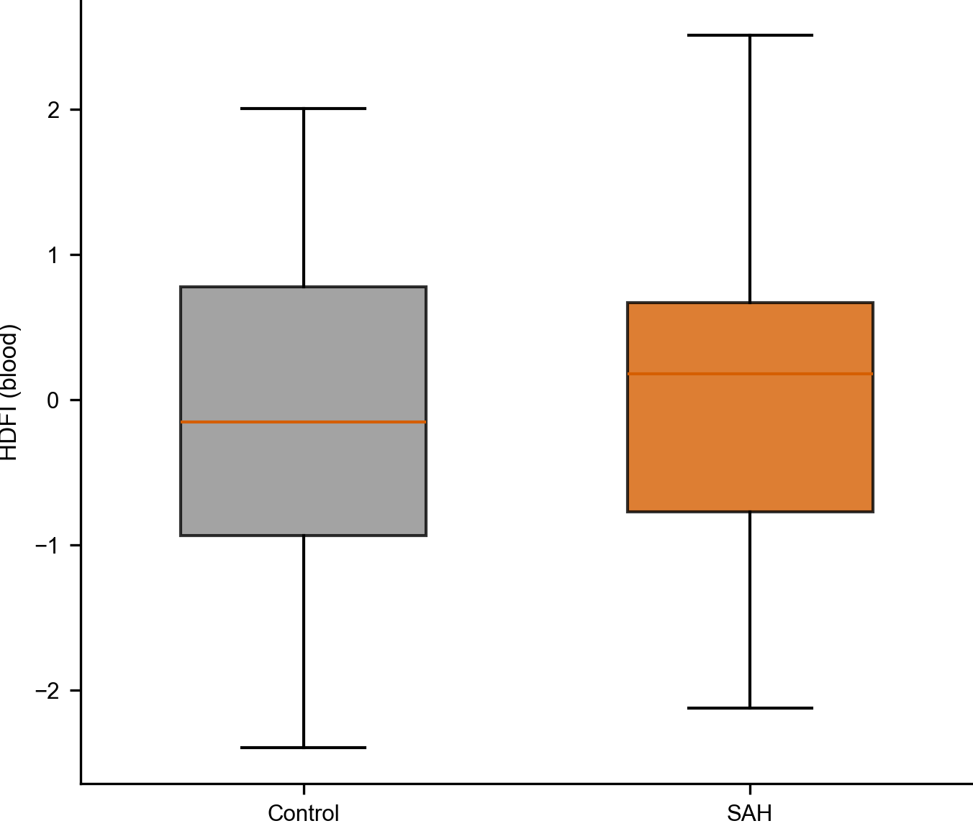
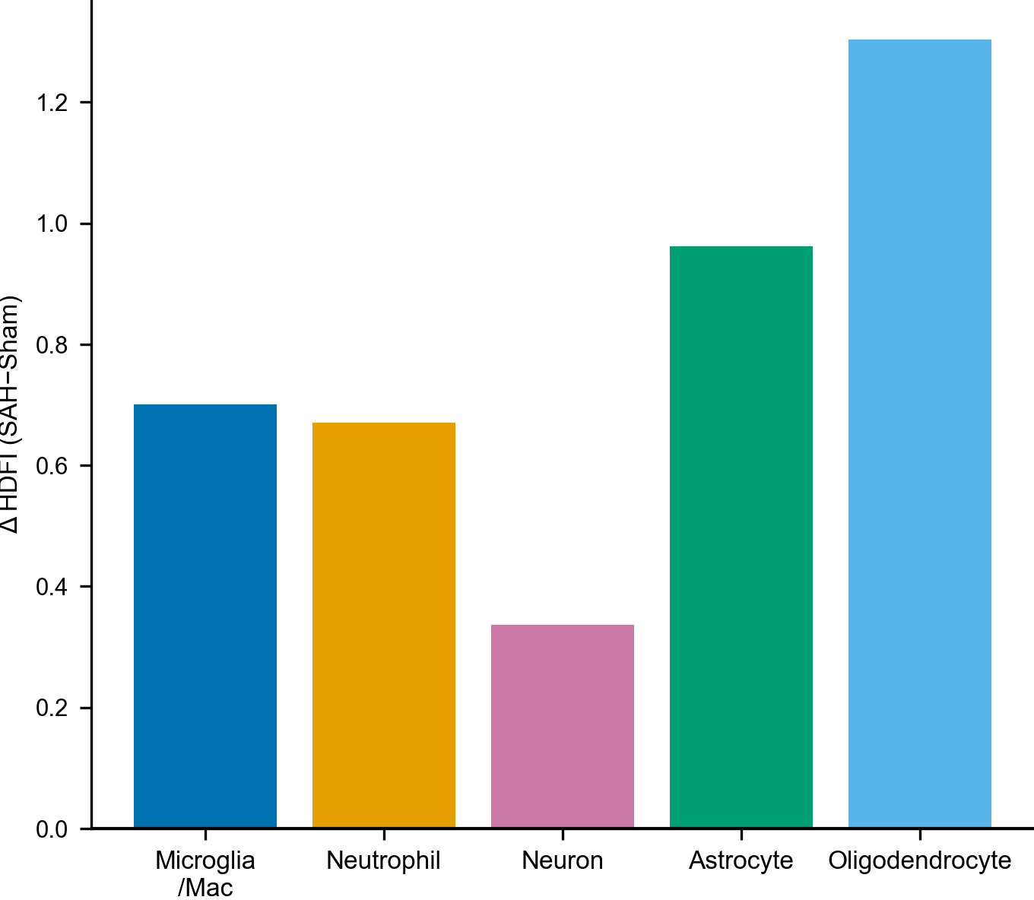
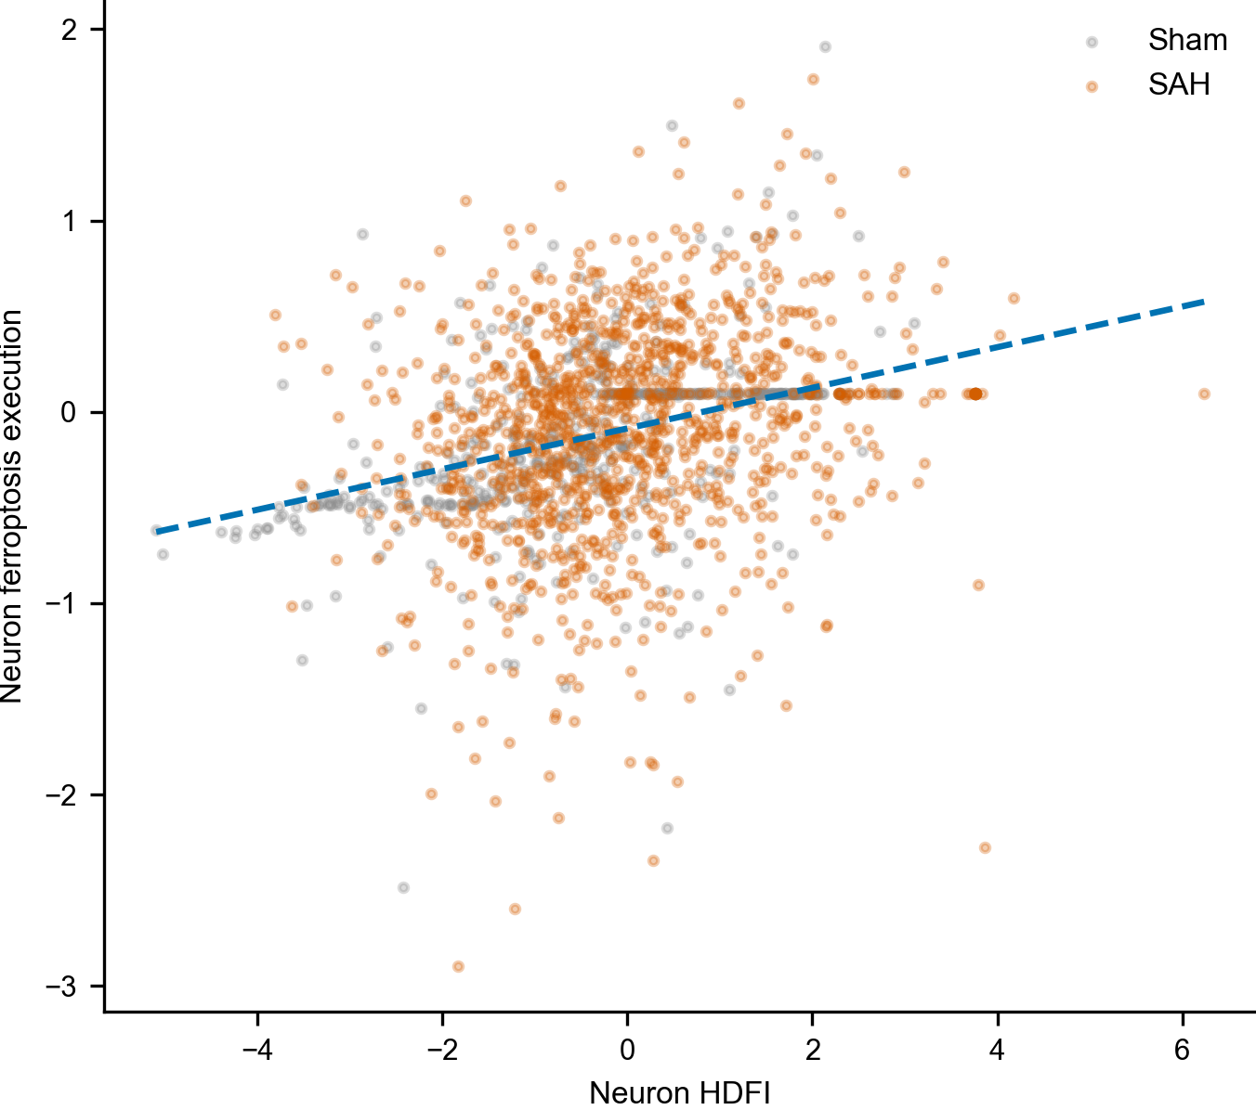
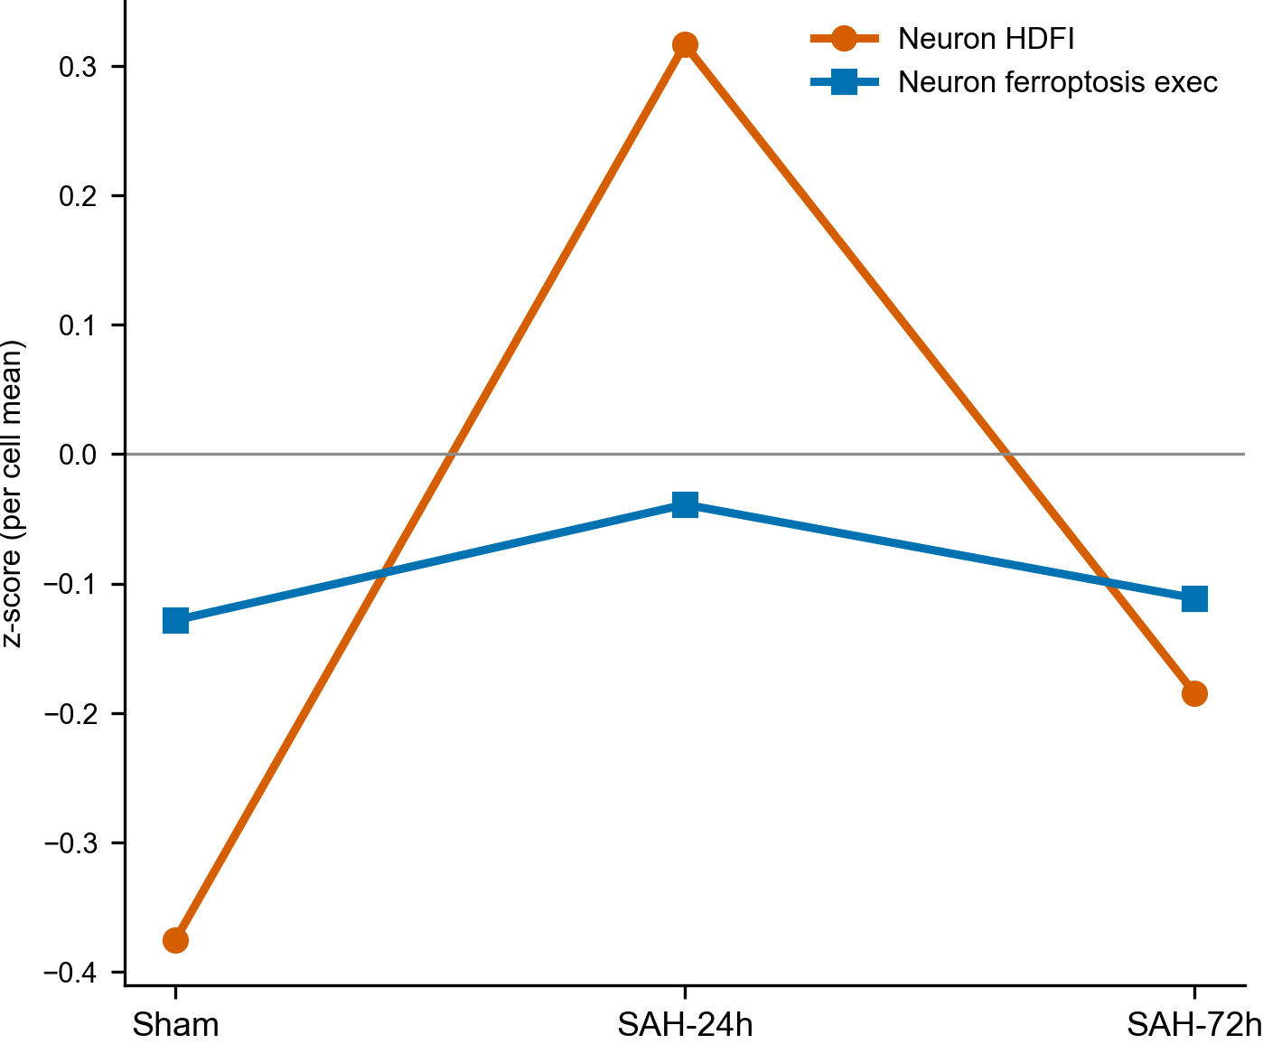
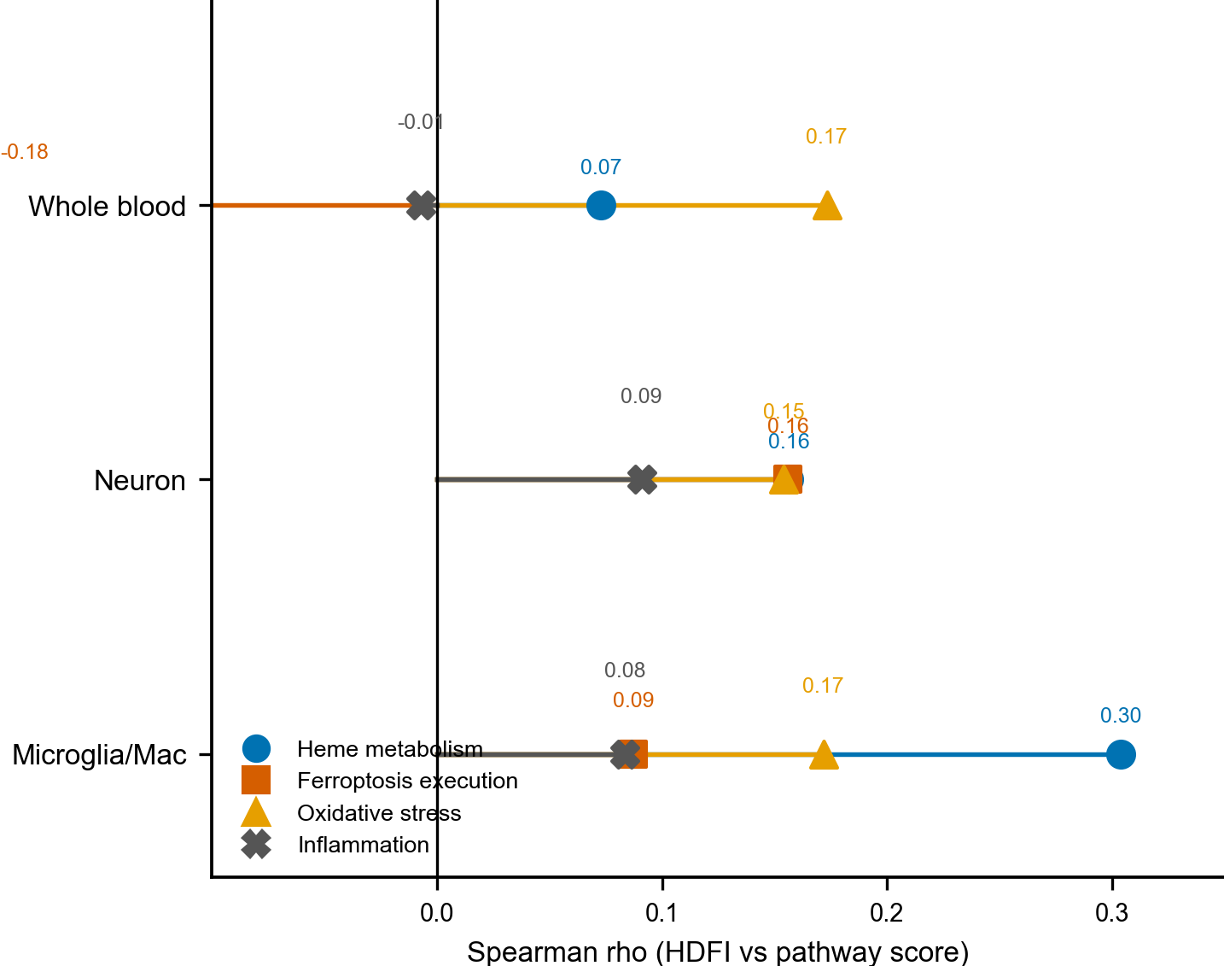
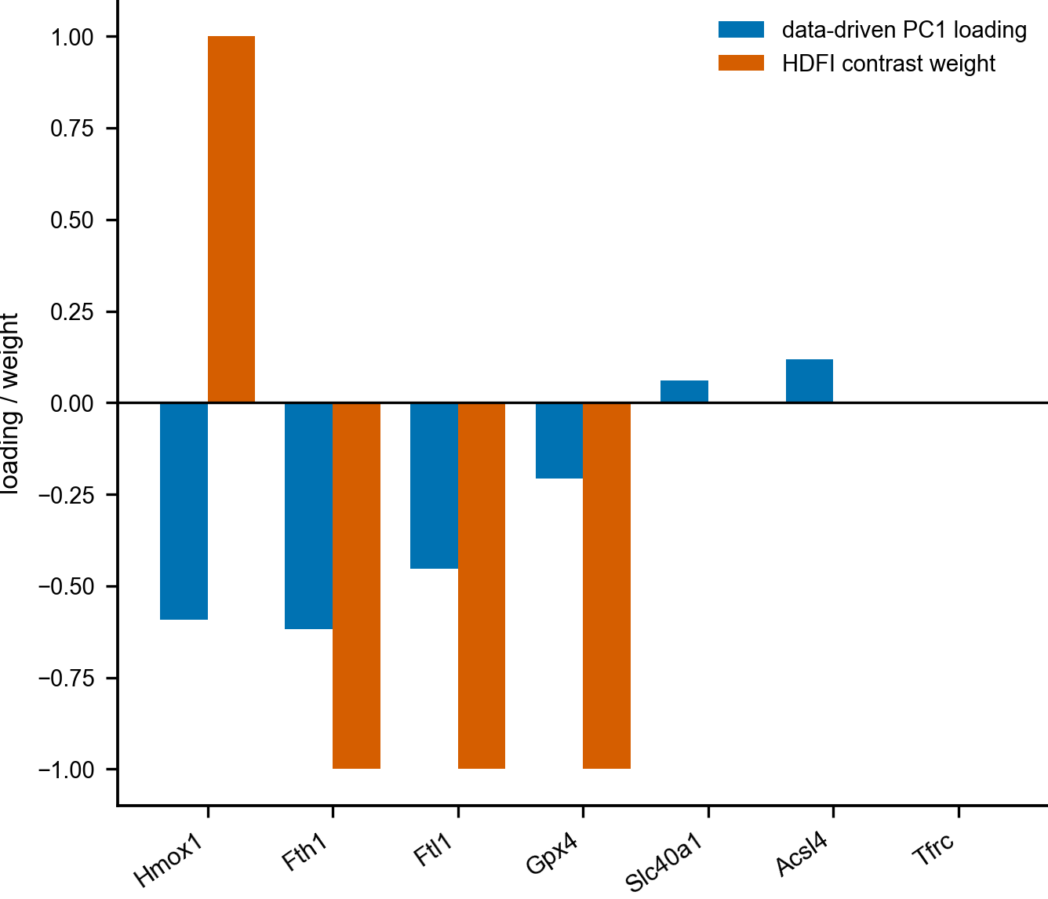
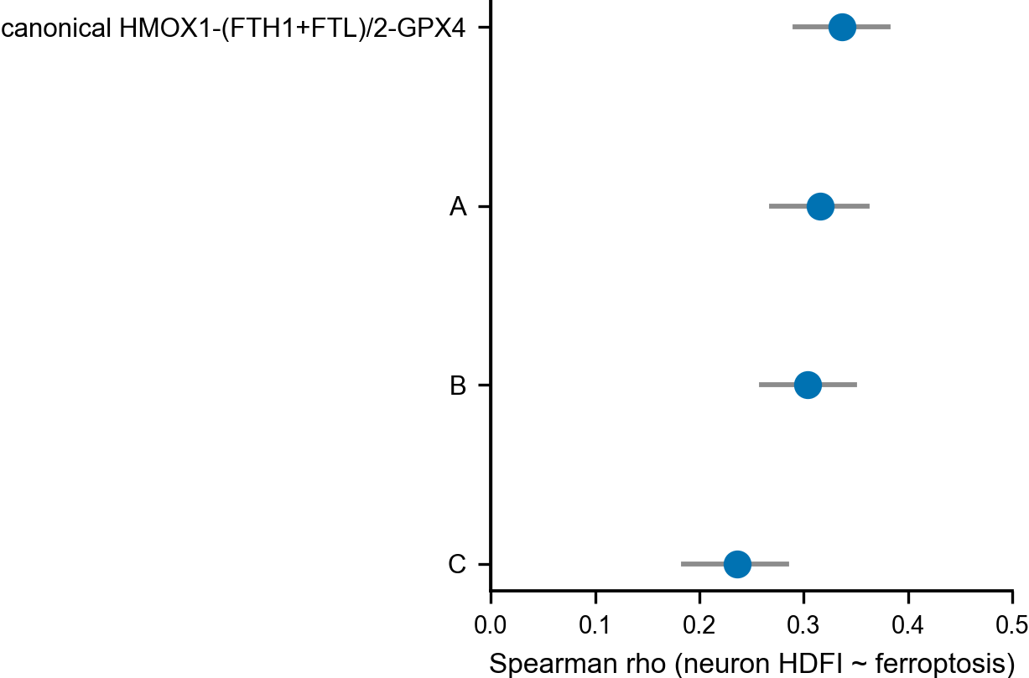
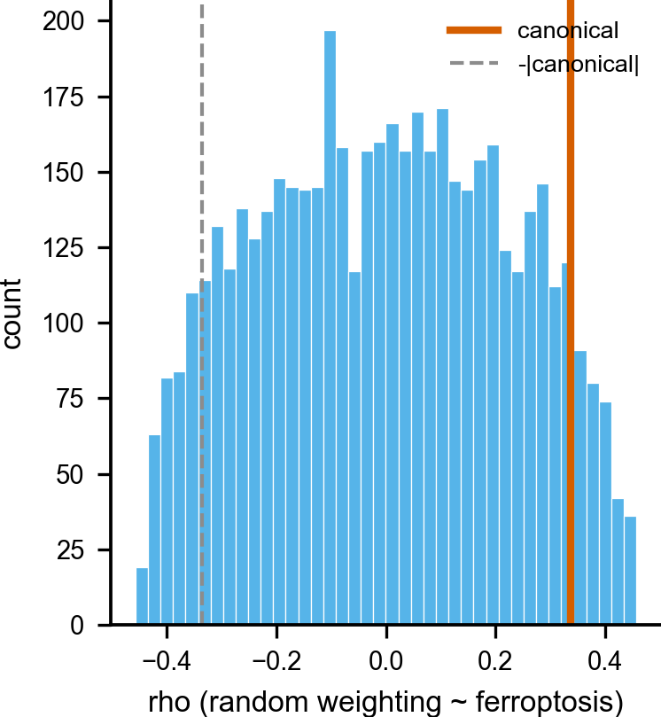
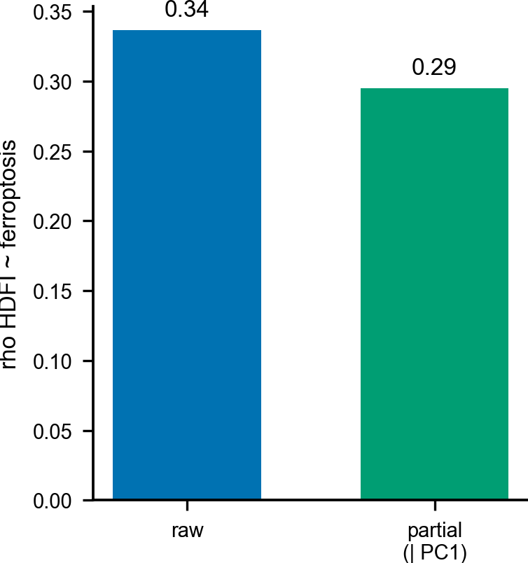
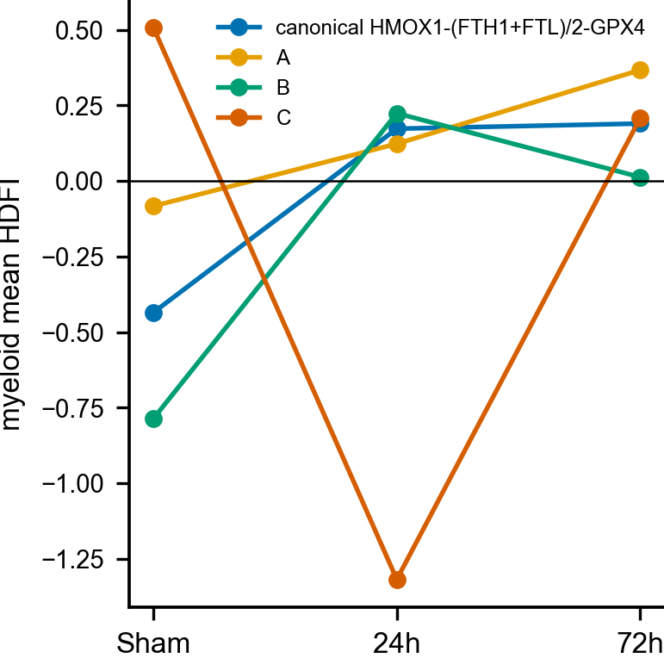
Figure 6. Coordinated NRF2/ARE control of the heme-handling program.(A–C) ARE/NFE2L2 promoter motif density and ENCODE regulatory-feature counts across the heme-handling genes; (D, E) ENCODE NFE2L2 ChIP-seq enrichment at the HMOX1 locus across four cell lines; (F–I) macrophage ATAC-seq showing constitutive HMOX1 openness and NRF2/ARE enrichment on accessible peaks.
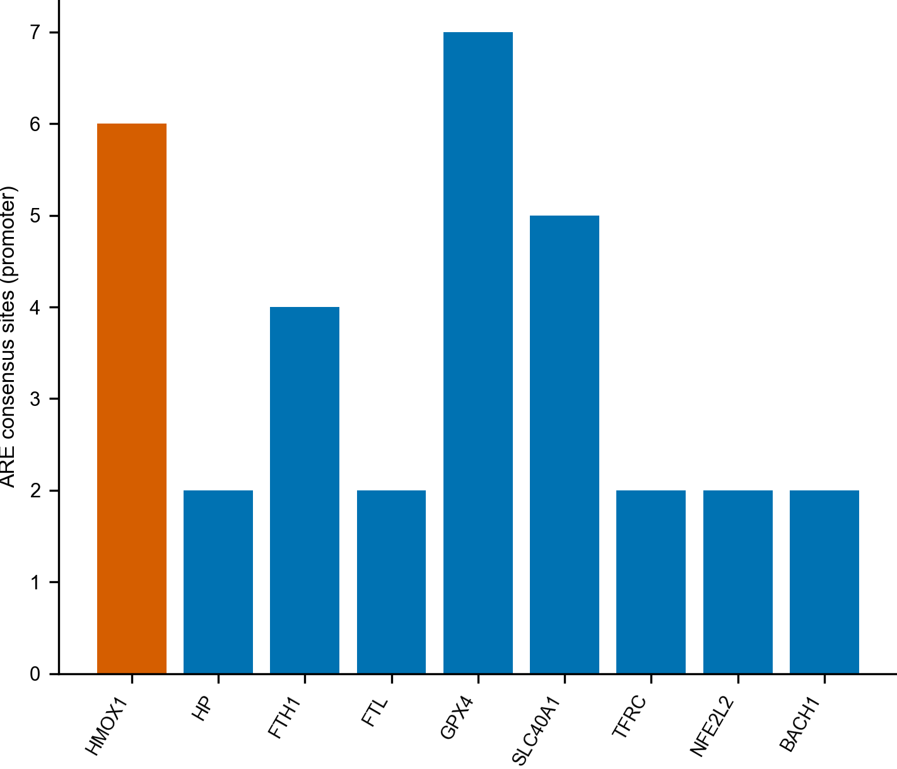
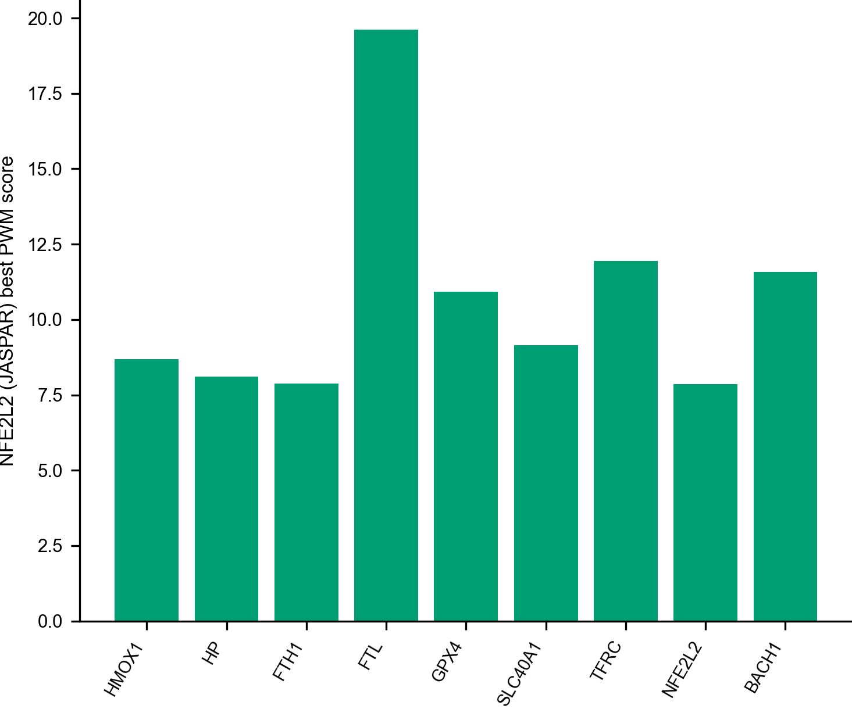
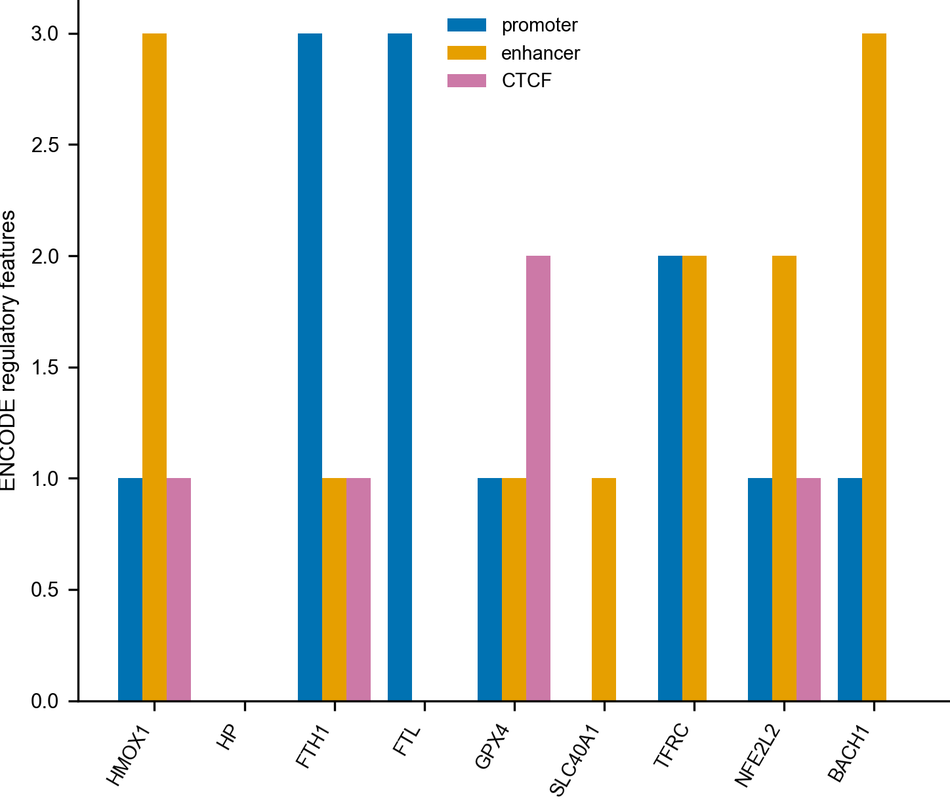
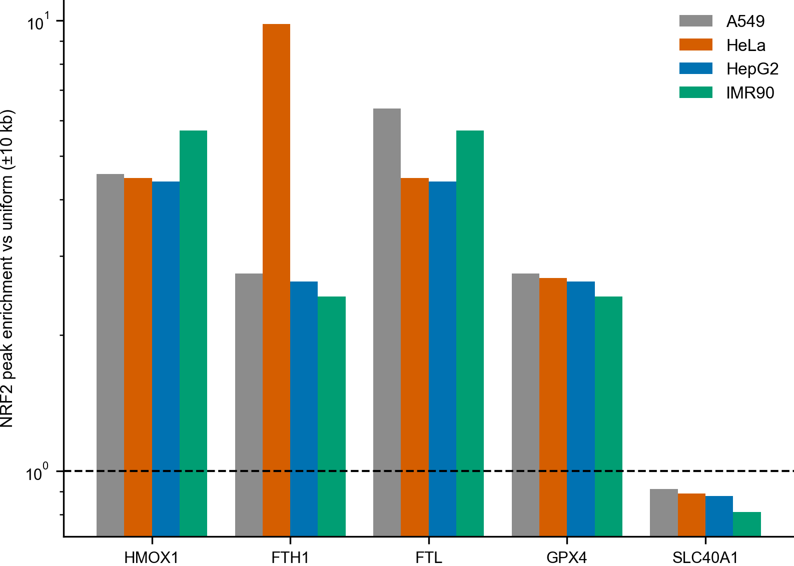
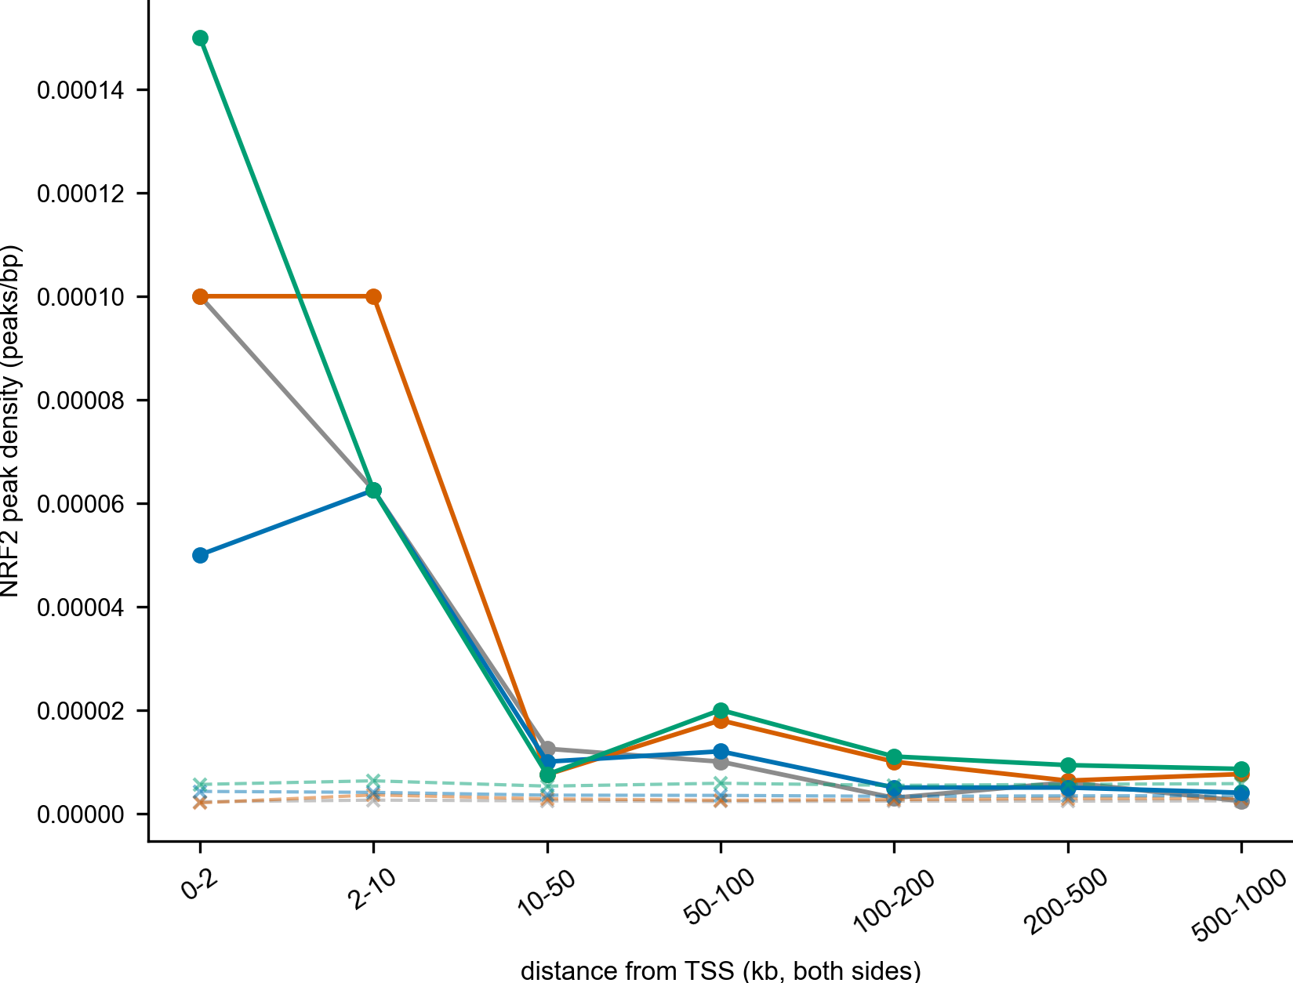
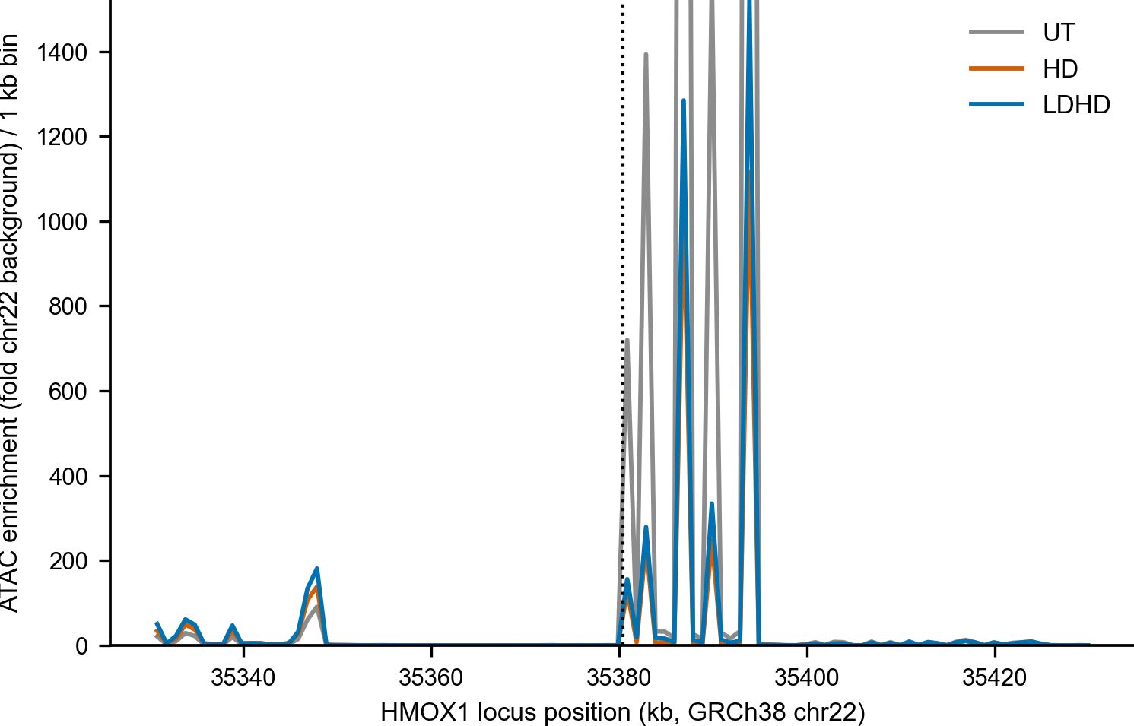
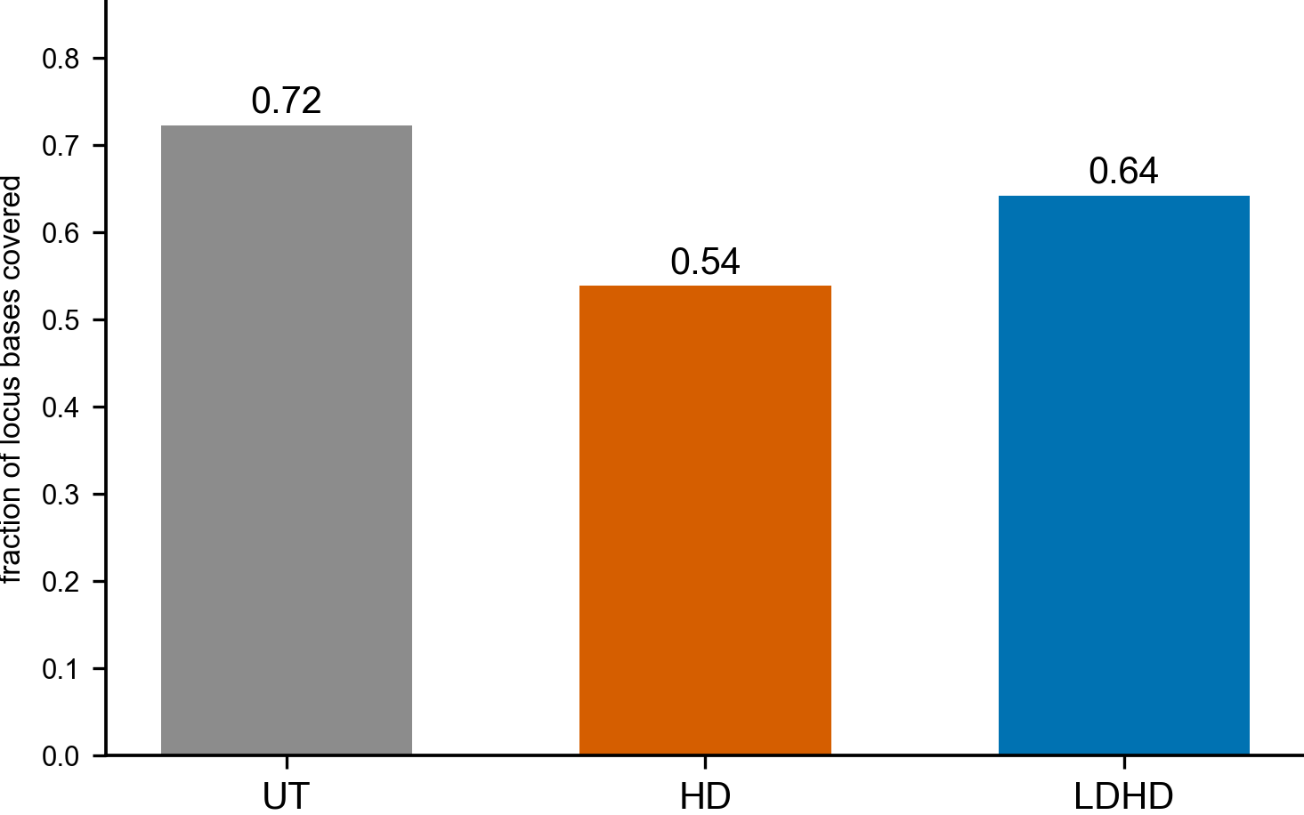
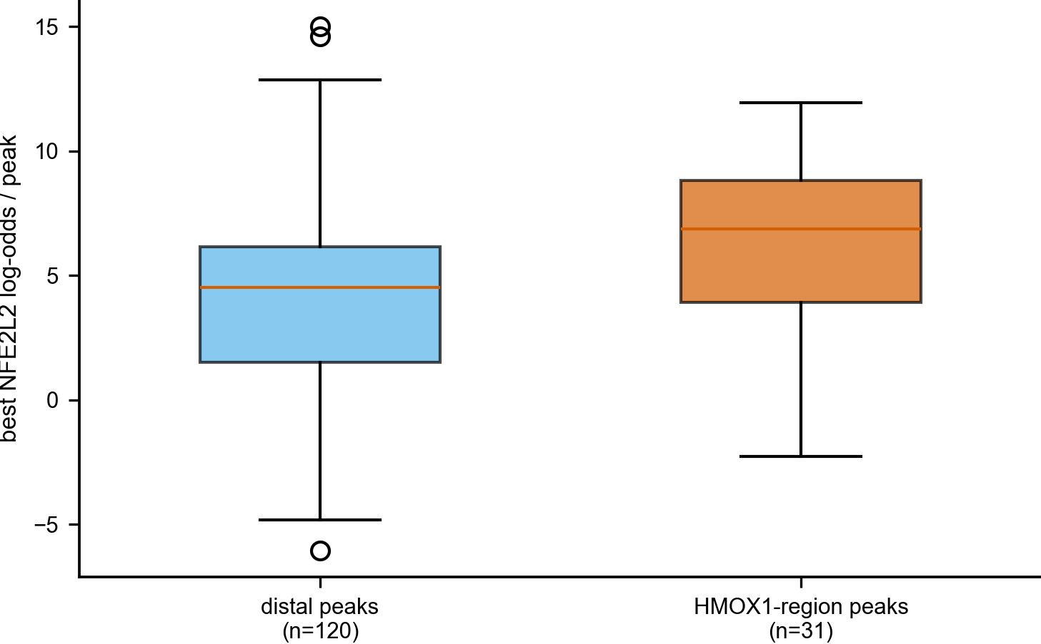
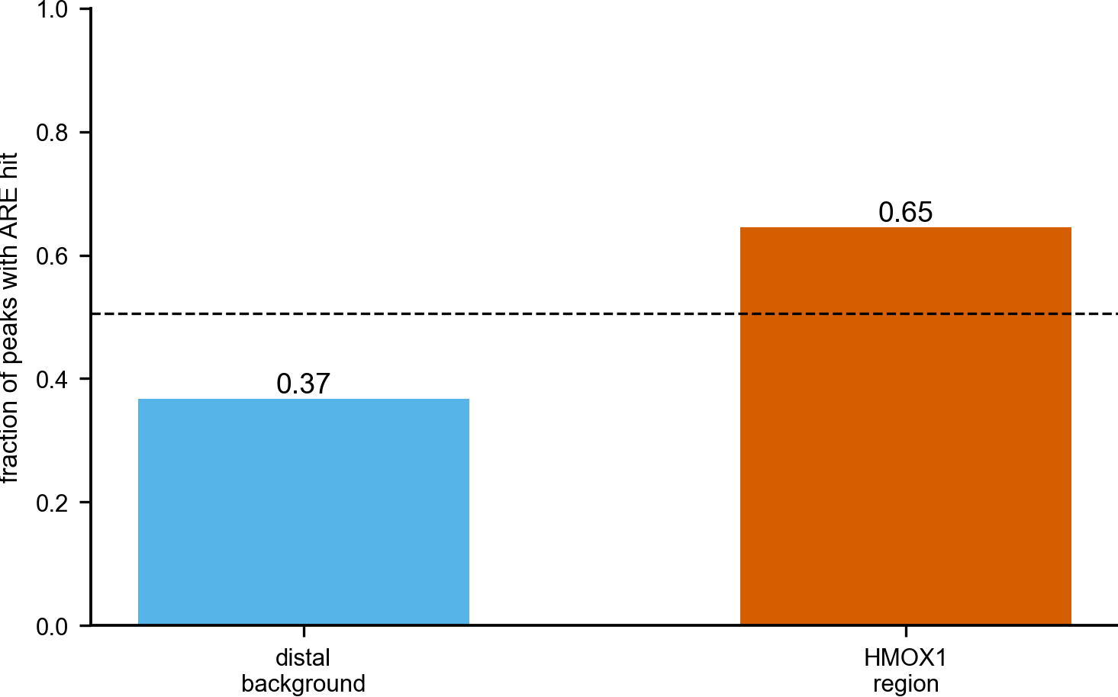
Figure 7. Real execution lipids; protein and external-validation limits.(A, B) oxidised arachidonoyl-PE ferroptosis execution markers across two targeted metabolomics models; (C–H) human SAH-CSF proteome axis-protein detection and the independent-cohort cross-check; (I–K) within-CSF association of the iron-storage arm with a neuronal-injury protein score, with leave-one-out and blood-contamination controls; (L–O) HDFI external validation in independent intracerebral-hemorrhage blood cohorts (null).
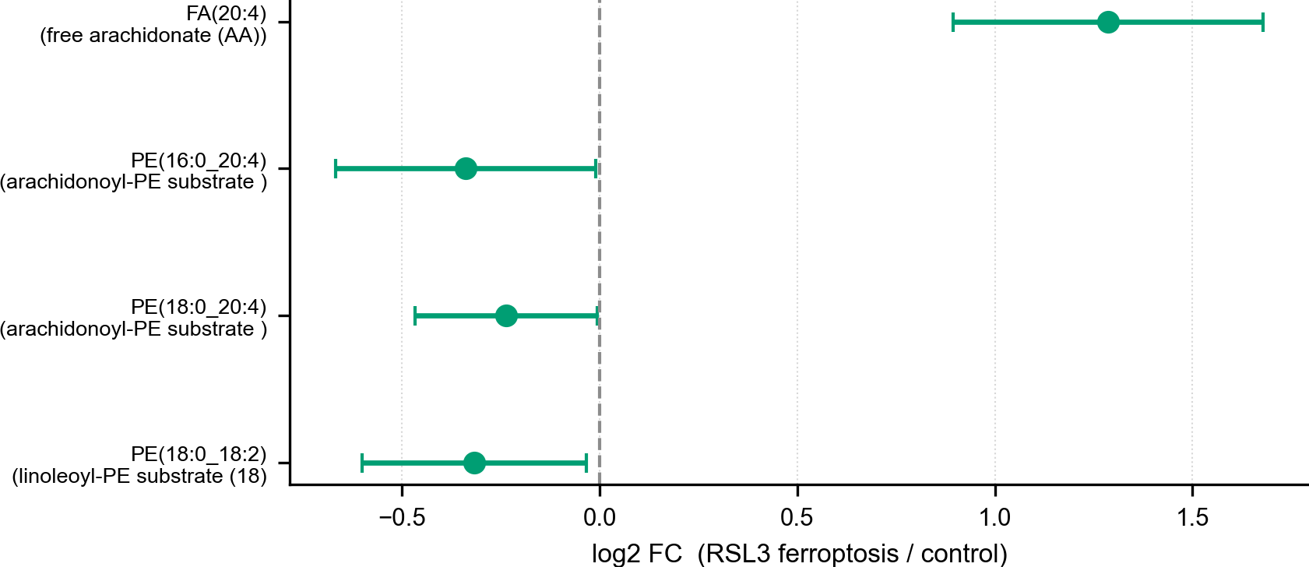
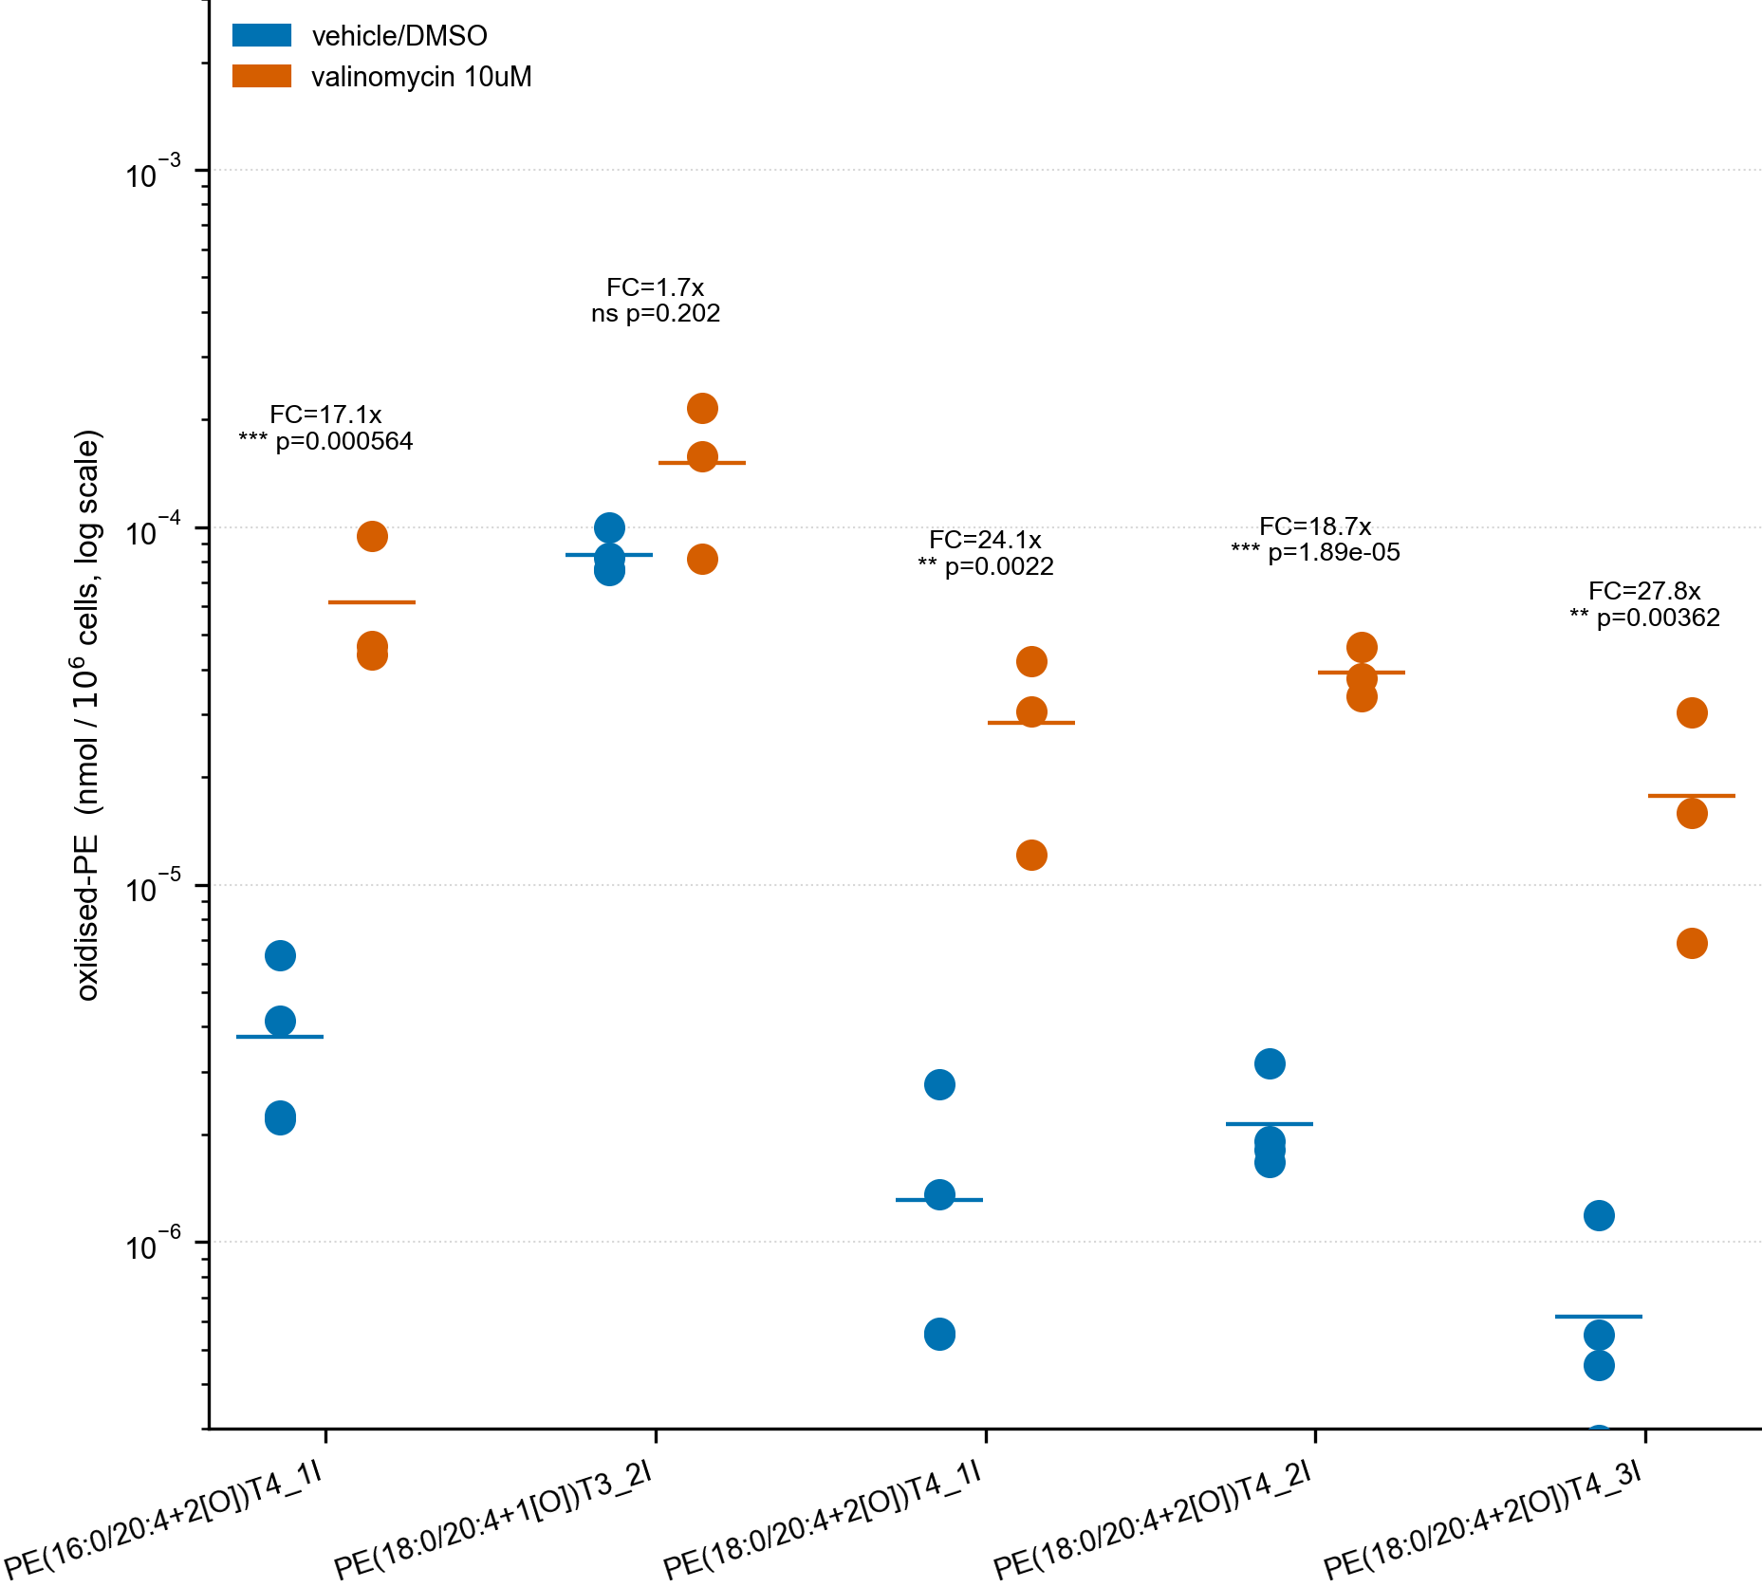
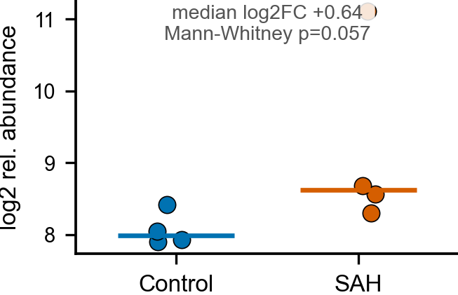
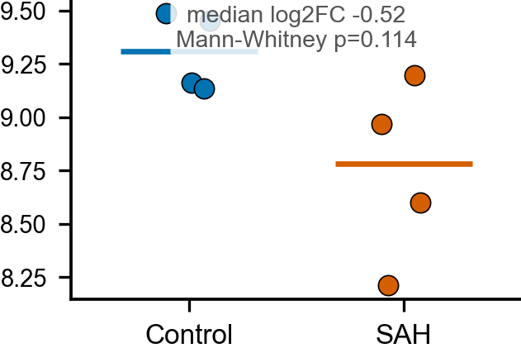
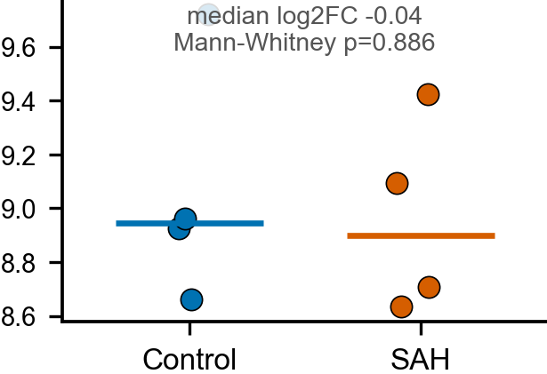
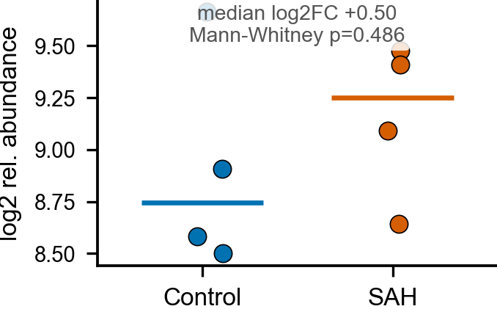
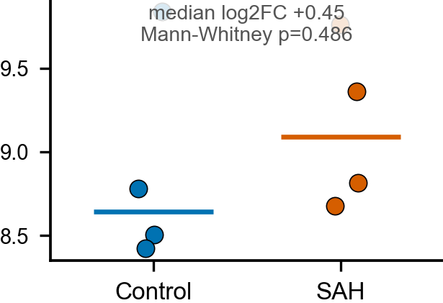

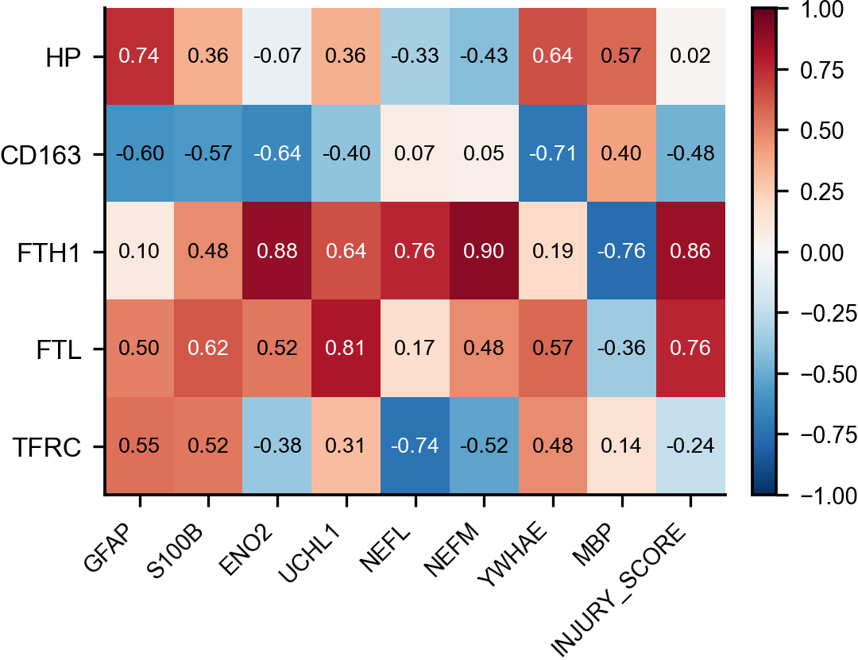
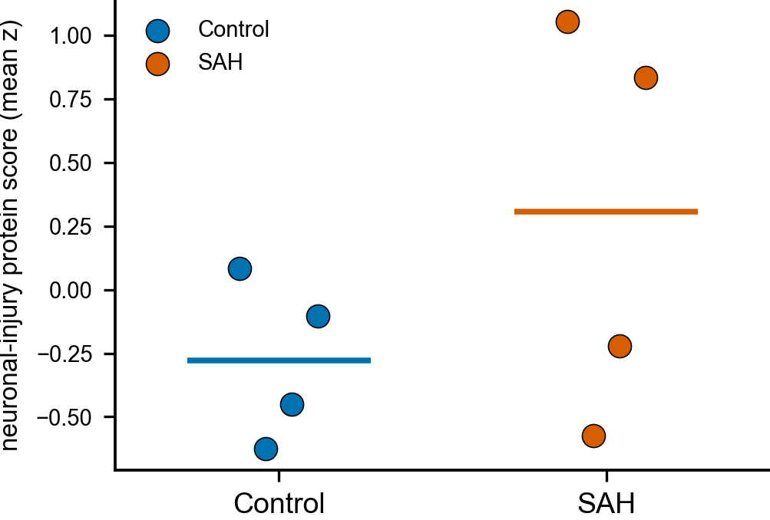
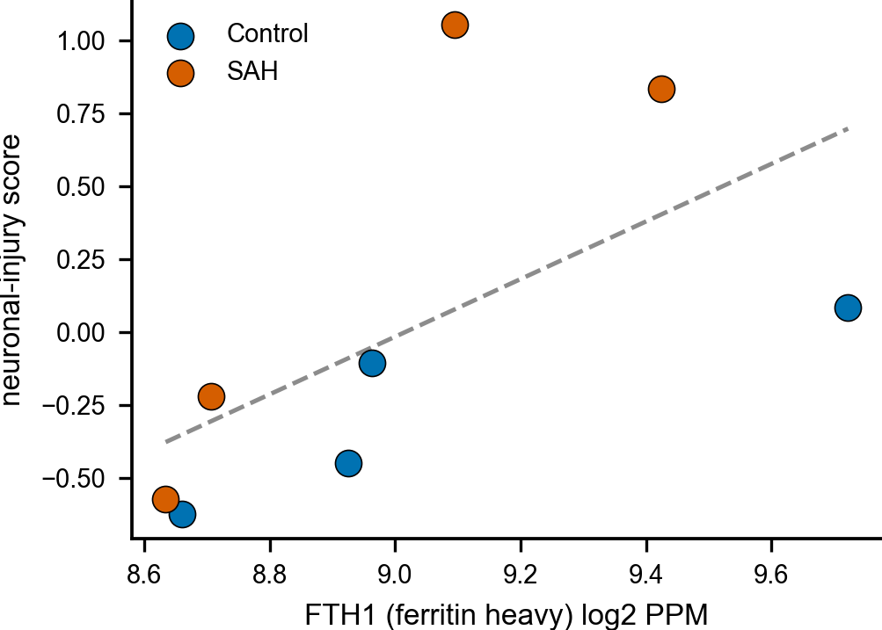
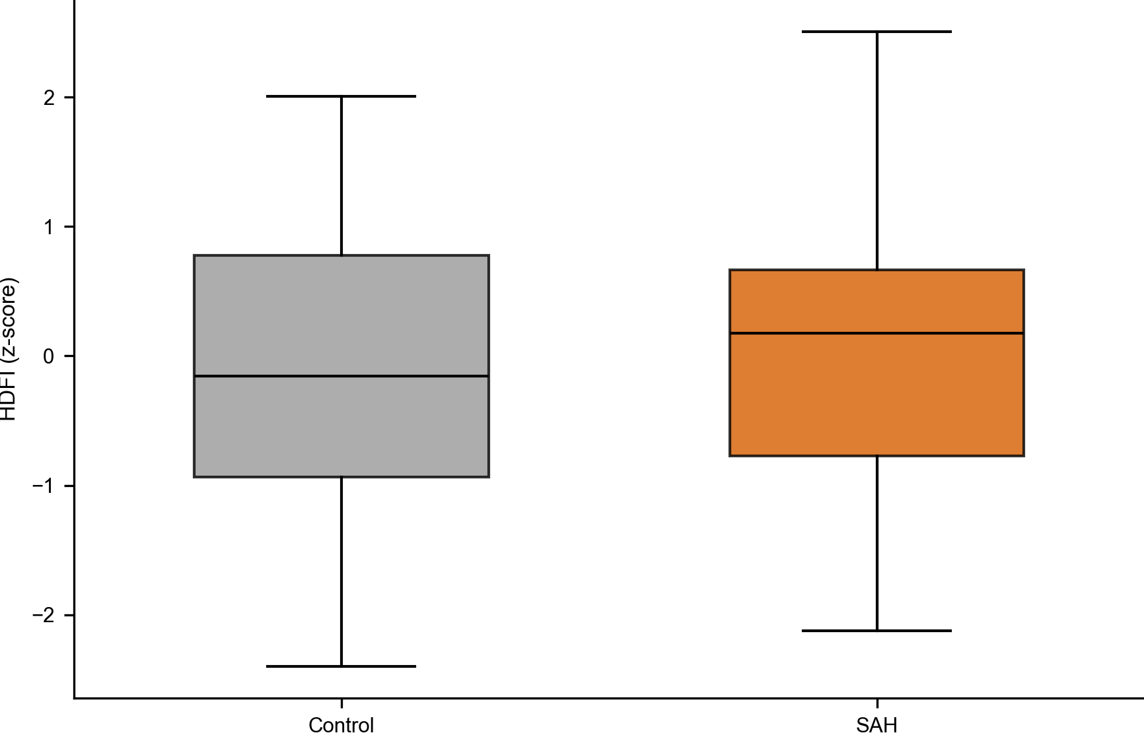
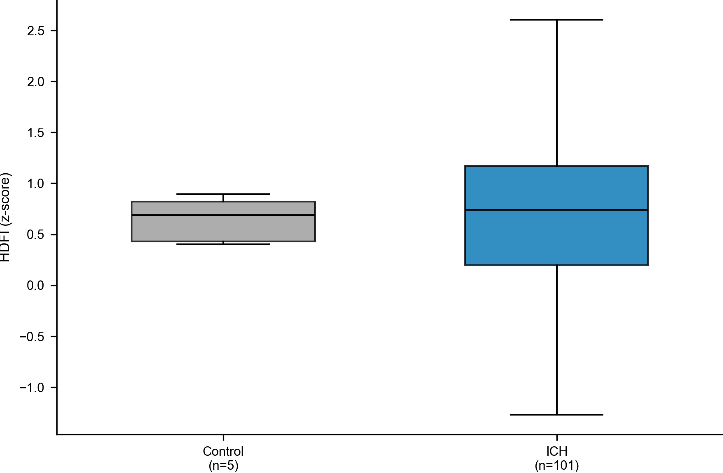
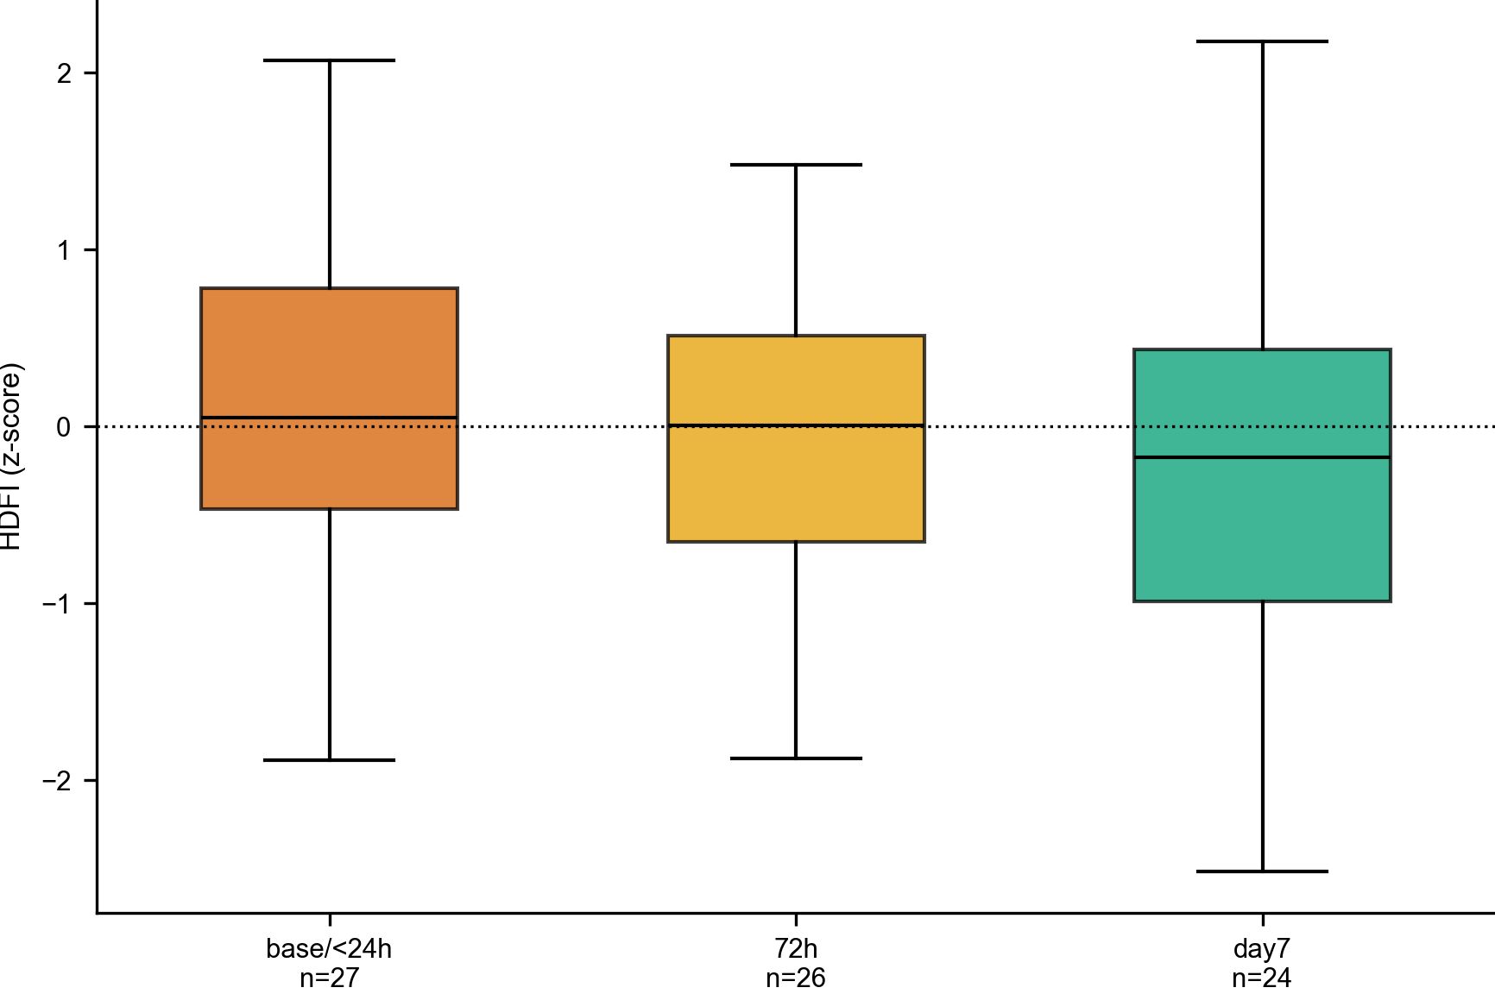
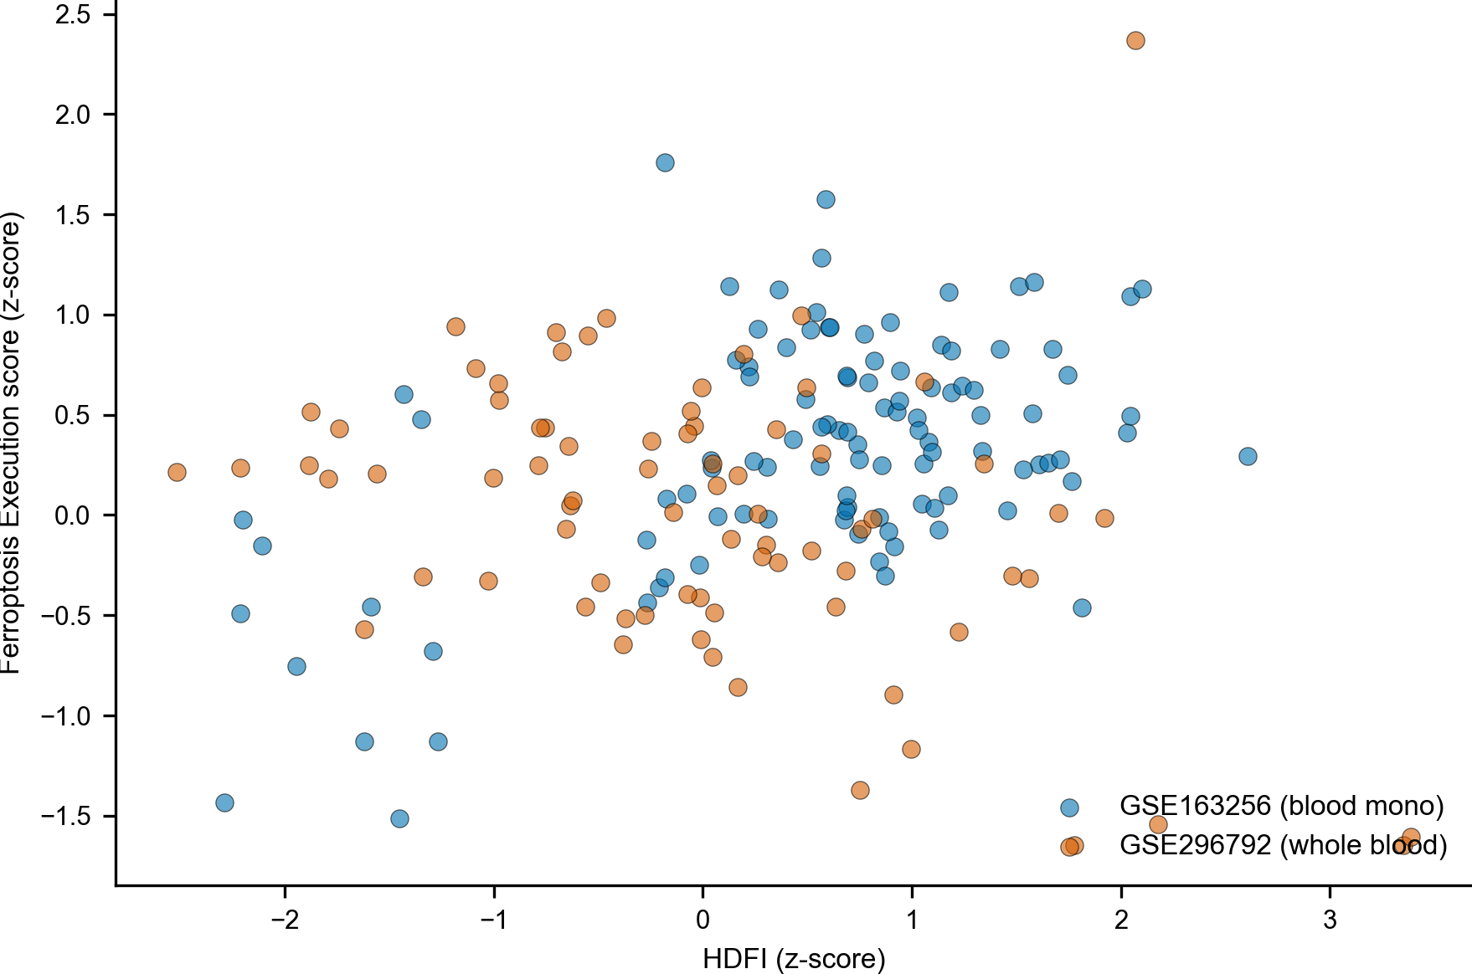
Figure 8. Integrated model.(A) integrated model of the heme-detoxification-failure state; every arrow denotes association, not causation.


