Website Review: May 2026
- About Us: See below my comments:
- Our Team:
- Advisory Council:
- John Paul Lederach: Ok
- Malick Niang: Business Development & Catalytic Investments
- Elizabeth Jorden: Ok
- Stephanie Russell (Remove Lederach): Nonprofit Management, Arts & Culture
- Leymah R. Gbowee: Ok
- Abibatu K. Turay: Ok
- Cerue Konah Garlo: Delete
- Juliet Were: Ok
- Barbara Bratton: Delete
- Atty. Samuel Koffi Woods, II: Ok
- Roseline Toweh: Delete
- Paul Takow: Ok
- Emmanuel Wettee: Ok
- Sidi M. Diawara: Ok
- The Board:
- David Kudel: Ok
- Cecelia T.M. Danuweli
- Sophie Blame: Remove (Past member)
- Allen Lincoln: Remove (Past member)
- Alexander Jeffy Remove (Past Remove)
- Jeffrey Myers: Remove (Deceased member)
- Grace Yeanneh: Remove (Past member)
- Sam Gotomo: Remove (Past member)
- Patrick Flomo: Financial Secretary- Add
- Dr. Ahjah Marie Johnson (Member)- Add
- Deddeh Kwekwe (member)- Add
- Lindora Kolu Howard-Diawara
- Joyce Myers: Member

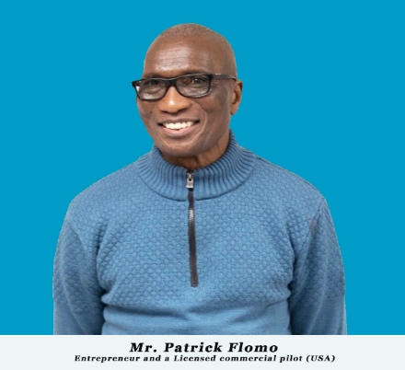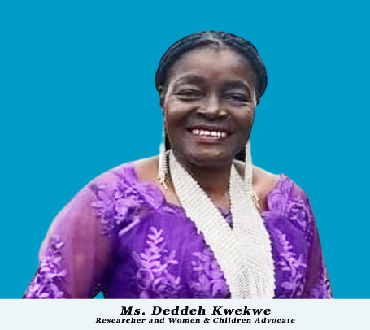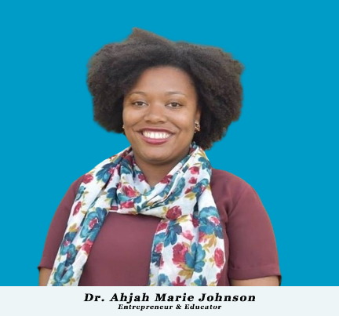
- The Management:
- Lindora Kolu Howard-Diawara: Ok
- Jenean Smith Hughes: Move to Advisory Council
- Awanah F. Shatamon: Ok
- Darlington Vanghen: Ok
- Thomas Mulbah: Ok
- Love Dlehbolo: Remove
- Wilmot Kerkula: Add
- Fatumata: Ok
- Cerue: Remove

- The Director’s Corner: Ok but please make sure the font size is same as on other pages
- Who We Are:
- The Page should also reflect who we are and not say About Us. Please also center the main information and move it from the right.
- Please remove the entire section on What we do and everything else that comes after as it’s misplaced.
- Our Impact: This should again reflect the Numbers but tell the stories behind the number (Let’s discuss.

