AK UNIVERSE
Website update
Developer handoff — approved mockups and implementation notes
Scope | Homepage, Contact, Agents IA (navigation, catalog, profiles), Marketing, Digital (websites pricing, mobile app page)
Language | Instructions in English. All customer-facing labels and copy stay in French, exactly as written in bold.
Reference | Each section ends with the approved mockup. When text and mockup differ, the written instruction wins.
Date | 4 November 2026

Summary of changes
Quick checklist of every change requested in this document. Tick each line once it is live.
# | Page / area | Change | Type
1 | Homepage | New hero + three equal service blocks (Agents IA, Marketing, Digital) | Update
2 | Contact | Standalone Contact page with two-column form | New page
3 | Agents IA — secondary menu | Remove “Nos agents IA”, keep “Tous les agents” | Fix
4 | Agents IA — catalog | “Rencontrez votre équipe IA”: named agents with portrait, role, example | Update
5 | Agents IA — profiles | One dedicated profile page per agent | New pages
6 | Marketing | Reuse Agents IA layout, header highlight, full service grid | Update
7 | Digital — Sites internet & e-commerce | Pricing cards cleanup (buttons, prices, running costs) | Fix
8 | Digital — Application mobile | New “Application mobile sur mesure” page | New page

1. Homepage
Page | Home (Accueil)
Goal | The first screen gives equal space to the three main service categories: Agents IA, Marketing, Digital.

Hero
- Heading: “Agents IA, Marketing et Digital”
- Subtitle: “Automatisez vos échanges, faites connaître votre activité et créez les outils dont votre entreprise a besoin.”
- Main button “Parlons de votre projet” → links directly to the Contact form.

Service blocks
Block | Image | Description | Button → link
01 Agents IA | Supplied portrait of the character with glasses | Automated calls, WhatsApp messages, routine customer inquiries | “Découvrir les agents IA” → Agents IA page
02 Marketing | Supplied filming scene, camera in the foreground | Video production, social media content, advertising campaigns | “Découvrir le marketing” → Marketing page
03 Digital | Supplied purple website / app / SaaS illustration | Business websites, online stores, custom mobile apps | “Découvrir le digital” → Digital page
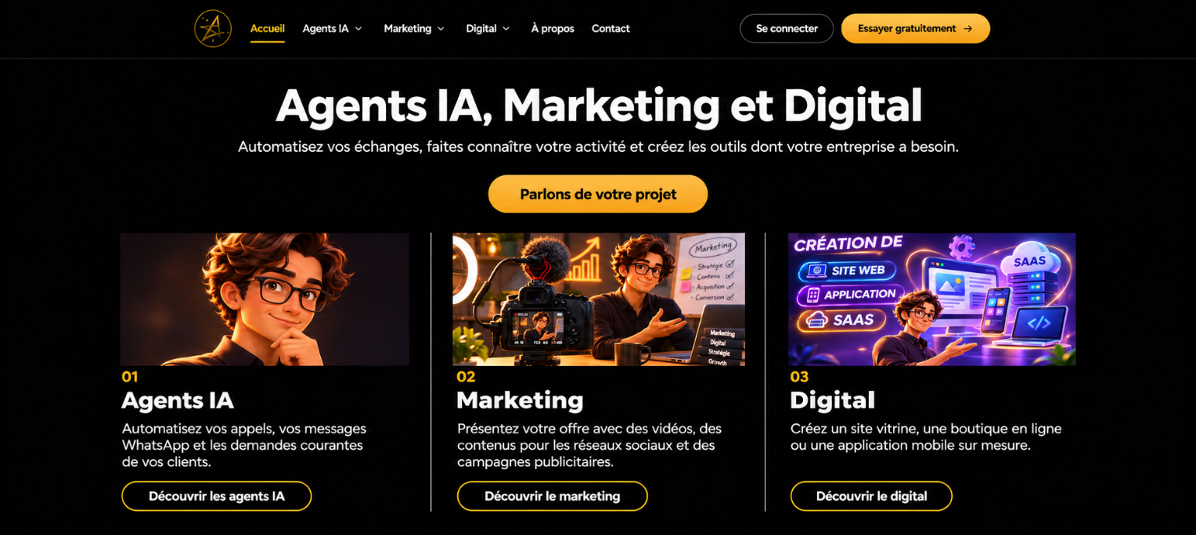
Figure 1 — Approved homepage mockup

2. Contact page
Page | Contact (new standalone page)
Header | Keep Mon projet and Devis gratuit as separate header actions.

- Make Contact a standalone page. Visitors can send a message without selecting a service or creating a project.
- Desktop: two-column layout (introduction left, form right). Mobile: stack the introduction above the form.
- Connect the email button to the official contact address and the privacy link to the existing policy.
- Validate the required fields and show a clear confirmation after successful submission.
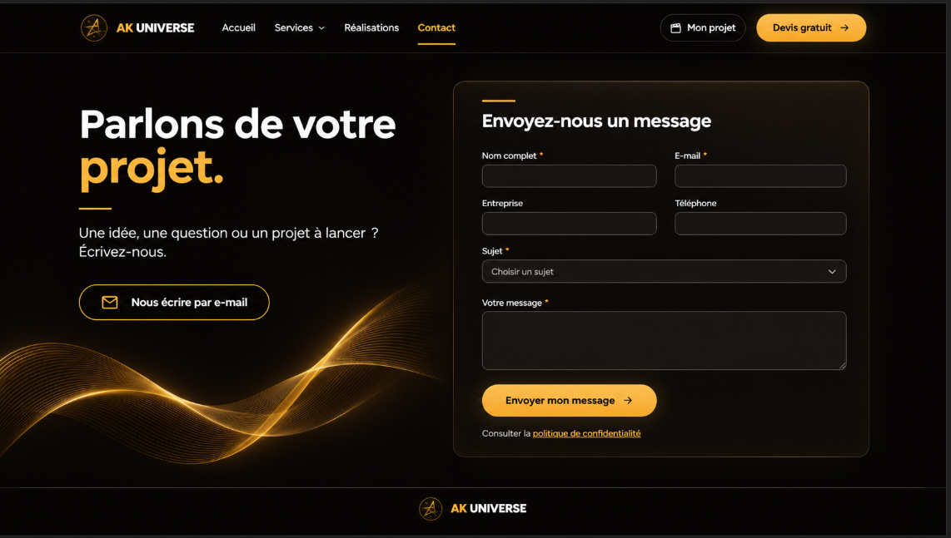
Figure 2 — Approved Contact page mockup

3. Agents IA — secondary navigation
Page | Agents IA (secondary menu)
Problem | “Nos agents IA” and “Tous les agents” both open the same “Choisissez votre agent” catalog.

 | Description
Before | “Nos agents IA” and “Tous les agents” both open the same agent catalog.
After | Remove “Nos agents IA” from the secondary navigation. Keep “Tous les agents” as the first item, link it to the existing catalog, and use the gold active state when the catalog is open.

Final menu order
Tous les agents · Catégories · Démos · Tarifs · FAQ
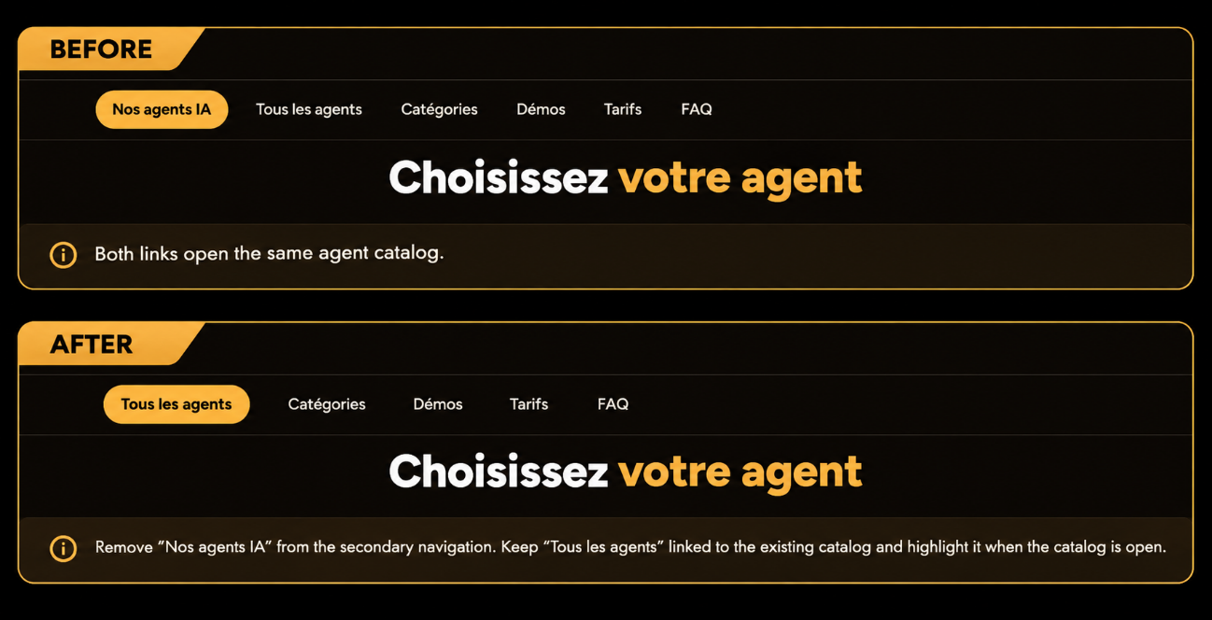
Figure 3 — Secondary navigation, before / after

4. Agents IA — catalog
Page | Agents IA → Tous les agents
Heading | “Rencontrez votre équipe IA”

Present each agent as a named specialist with a portrait, a role, and a realistic example of a task the customer can delegate. Keep all customer-facing text in French — the English descriptions below are for implementation only.
Agent | Role | Example customer request
Milo | Phone reception | “Answer my calls while I’m in a meeting and send me a summary.”
Nora | Customer support | “Answer questions about orders, deliveries, and returns. Pass sensitive requests to me.”
Léa | Executive assistant | “Summarize my important emails, draft replies, and organize my calendar.”
Adam | Sales prospecting | “Find companies that match my target audience and draft a personalized first message for each one.”
Hugo | Sales follow-up | “Find quotes that haven’t received a reply, draft follow-up messages, and update my CRM.”
Jade | Marketing and social media | “Prepare this month’s content calendar and send me the posts for approval.”
Sacha | SEO and web content | “Find the questions my customers search for and suggest pages or articles that answer them.”
Inès | Recruitment | “Answer questions about the role, collect applications, and schedule interviews.”
Noé | Invoicing and administrative follow-up | “Prepare invoices for approval and flag overdue payments.”
Éva | Internal knowledge assistant | “Find the expense reimbursement policy and give me the link to the correct form.”

Rules for the catalog copy
- Treat WhatsApp as a communication channel, not an agent. Example: customers reach Nora through WhatsApp; a business owner uses it to talk to Léa.
- Keep the roles distinct: Adam finds new prospects, Hugo follows up on existing sales opportunities, Jade prepares social media content, Sacha improves the website’s visibility in search results.
- The names and missions above are proposed catalog content.

To confirm
The approved catalog mockup also shows an 11th agent, Clara — Assistante juridique, who is not in the table above. Confirm whether Clara should go live.
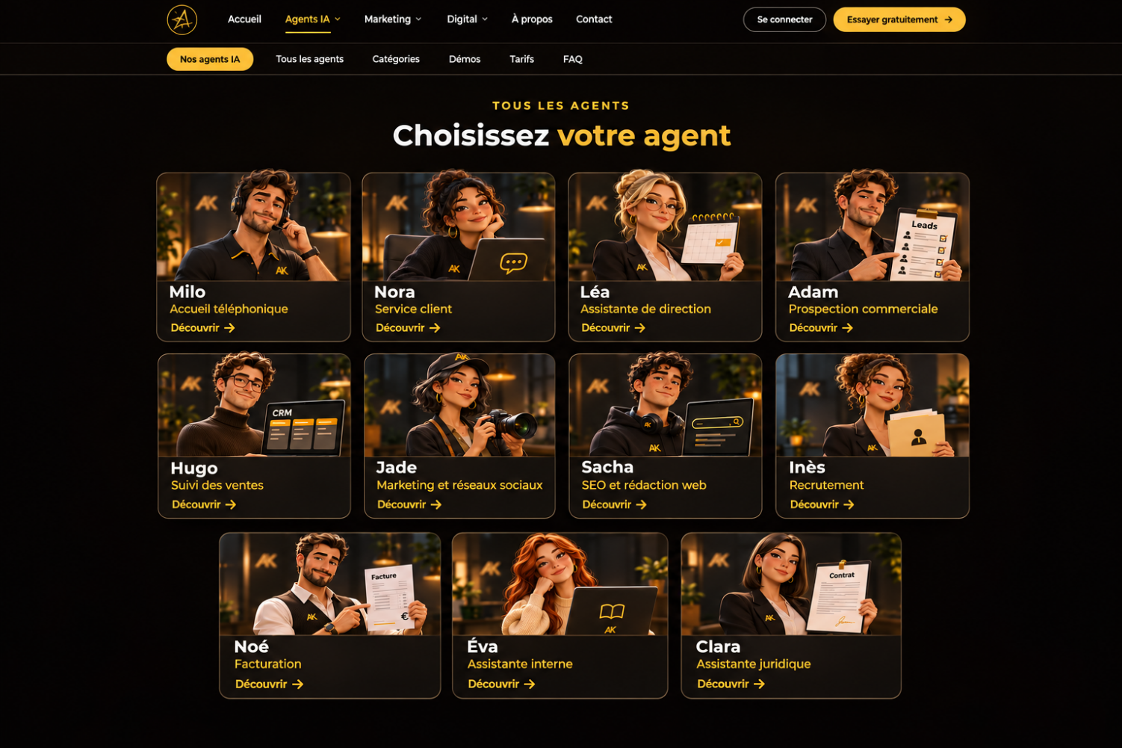
Figure 4 — Approved agent catalog mockup

5. Agents IA — profile pages
Page | One dedicated profile per agent
Entry point | Each catalog card (“Découvrir”) links to its agent’s profile.

Each profile page contains:
- The agent’s portrait
- Three main tasks (“Ce que [agent] peut faire”)
- A practical example (“[Agent] en action”)
- Confirmed tool integrations
- A “Voir l’agent en action” button
Approved profile mockups:
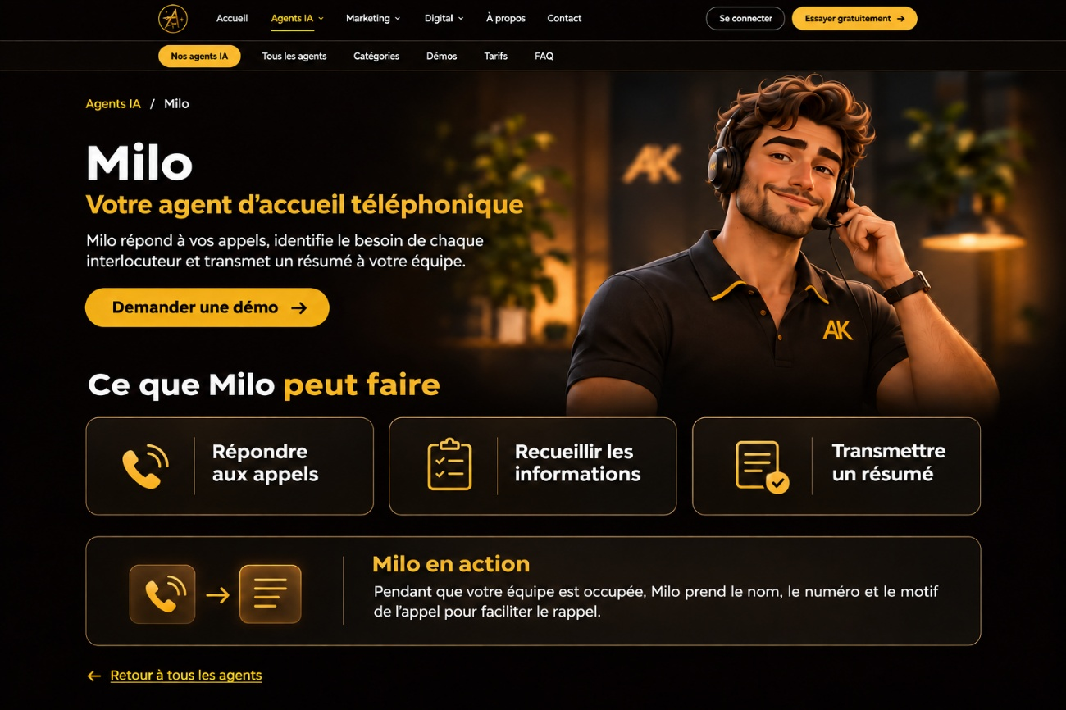  Milo · Phone reception | 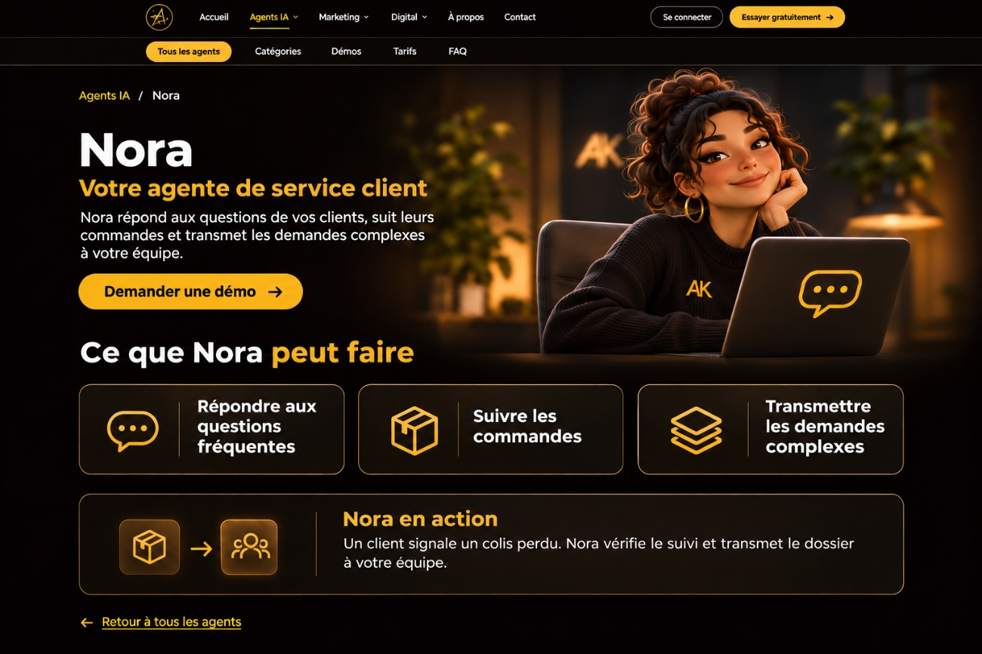  Nora · Customer support
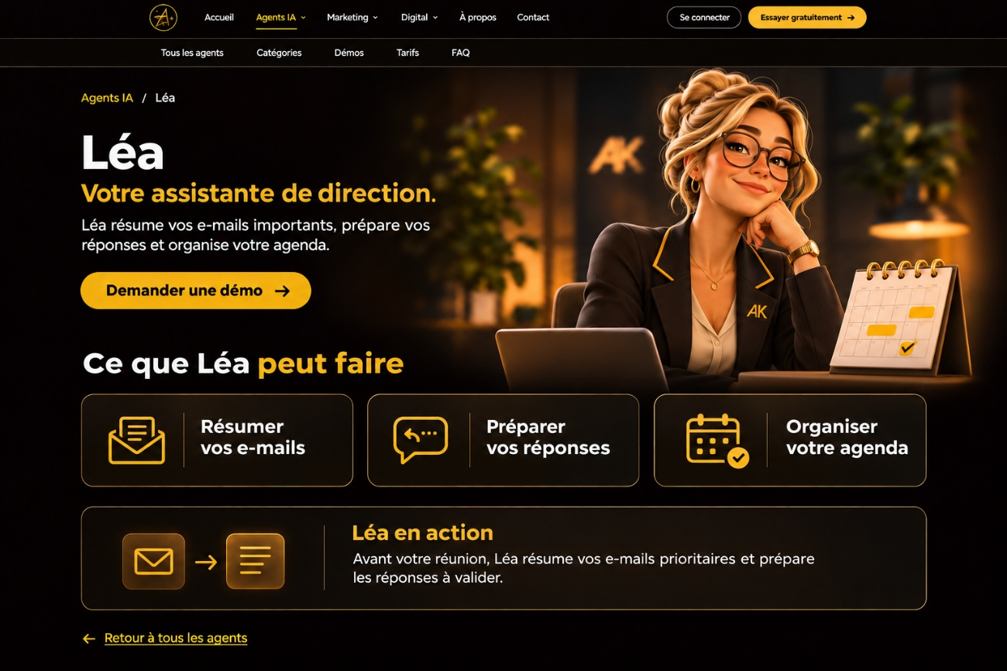  Léa · Executive assistant | 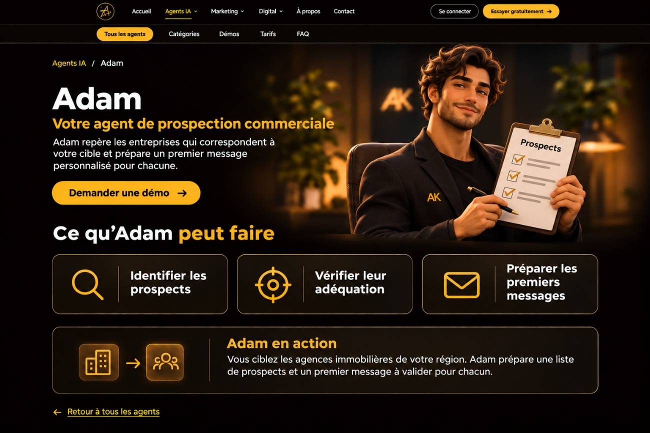  Adam · Sales prospecting
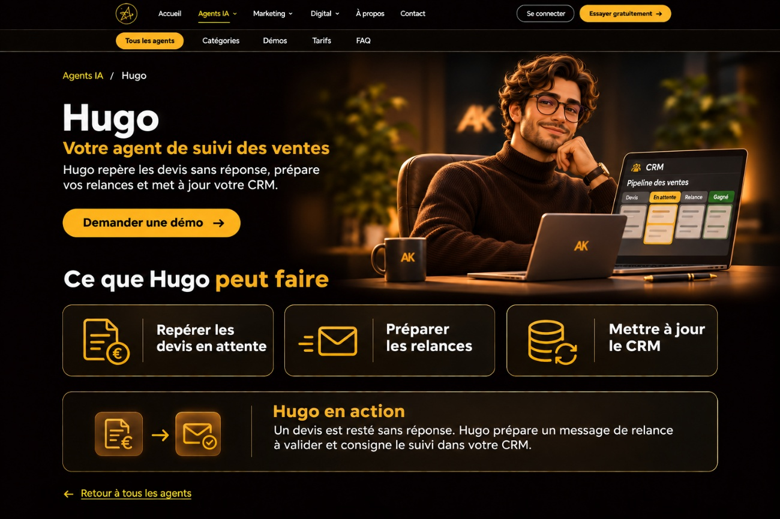  Hugo · Sales follow-up | 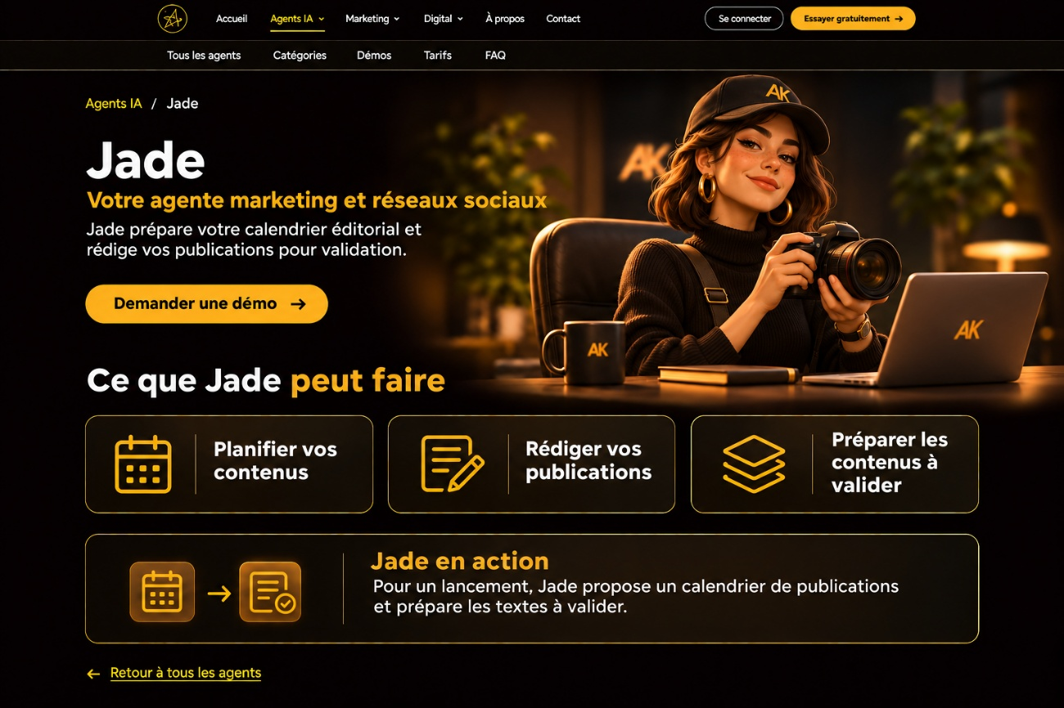  Jade · Marketing and social media
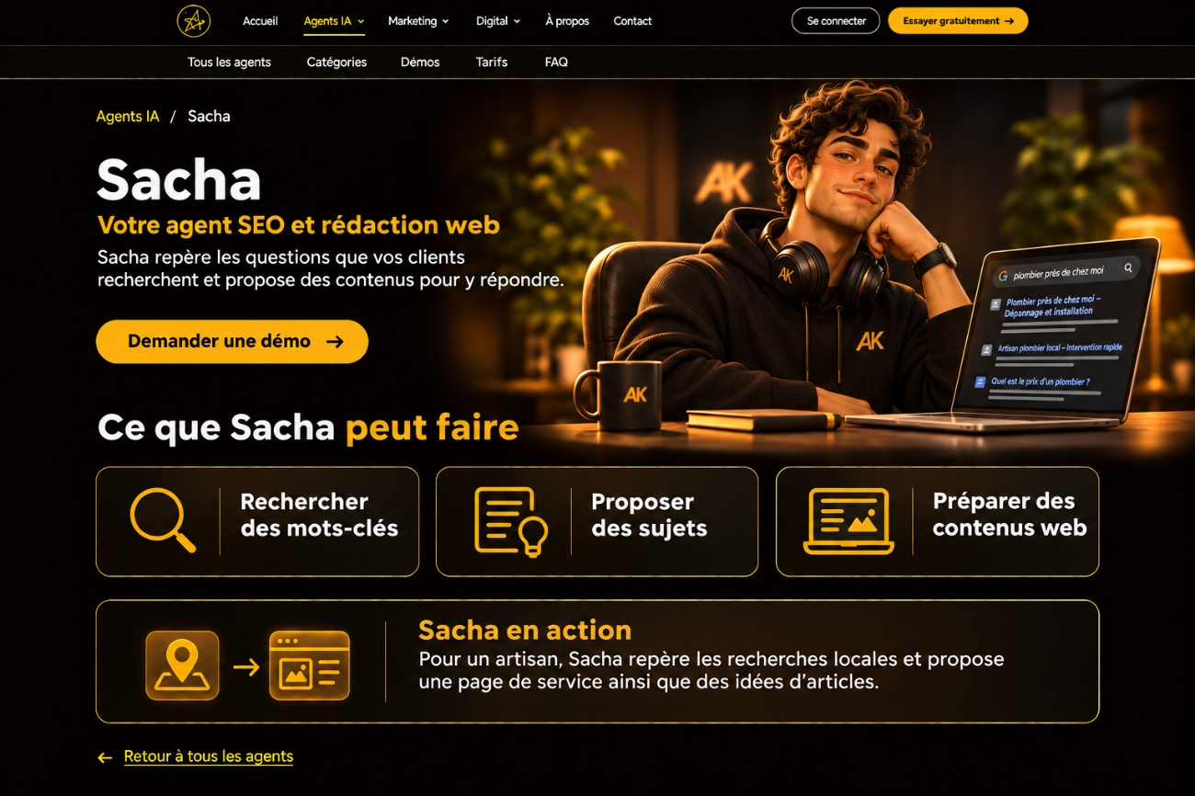  Sacha · SEO and web content | 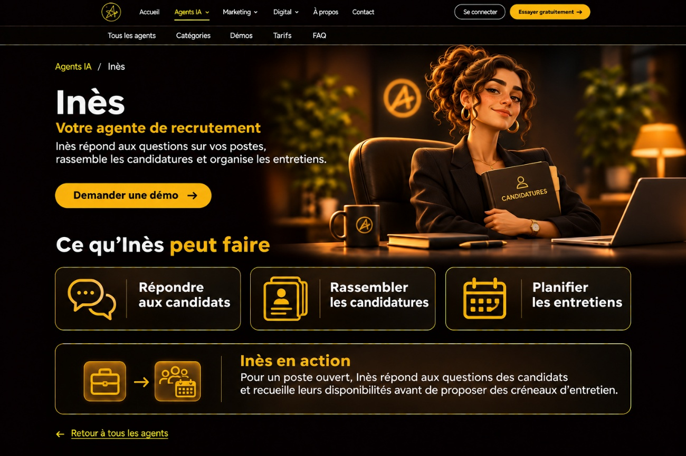  Inès · Recruitment
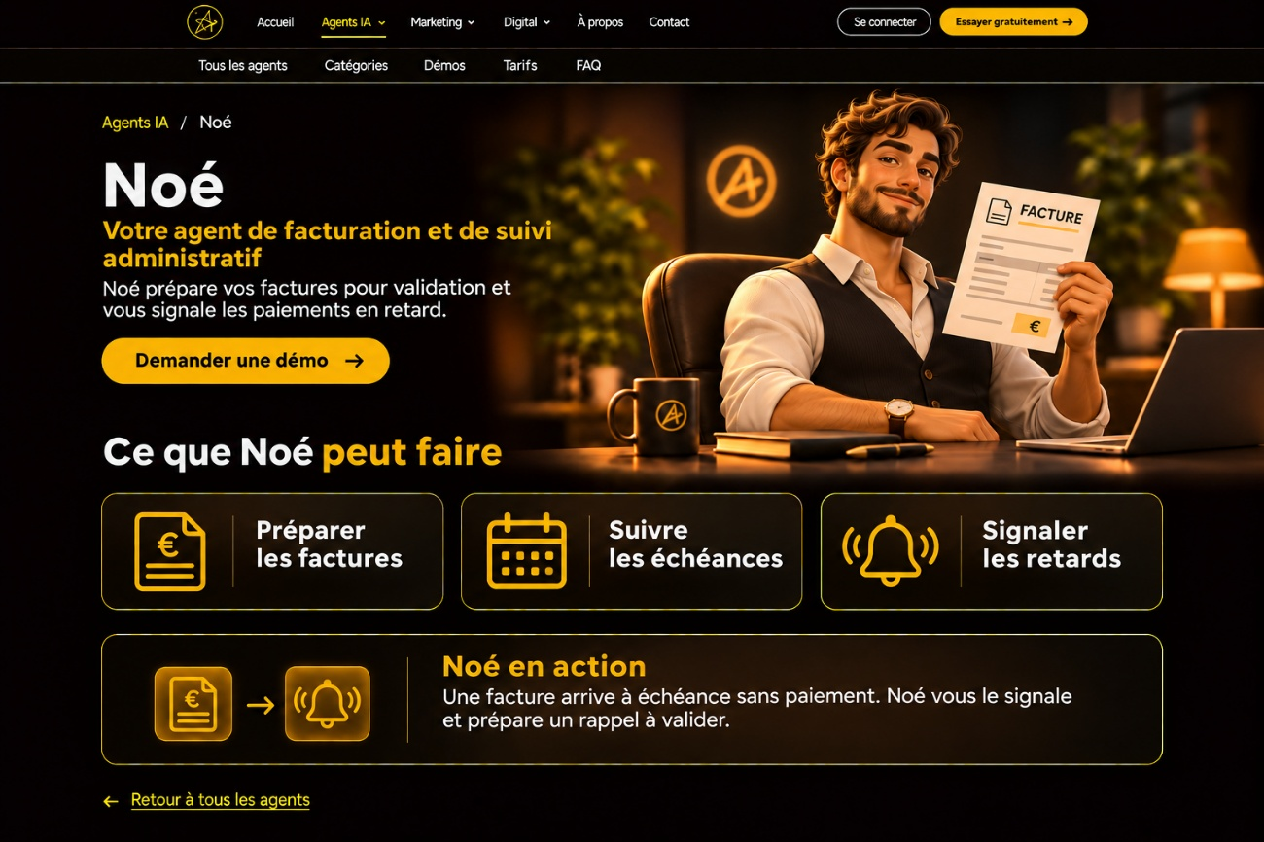  Noé · Invoicing and administrative follow-up | 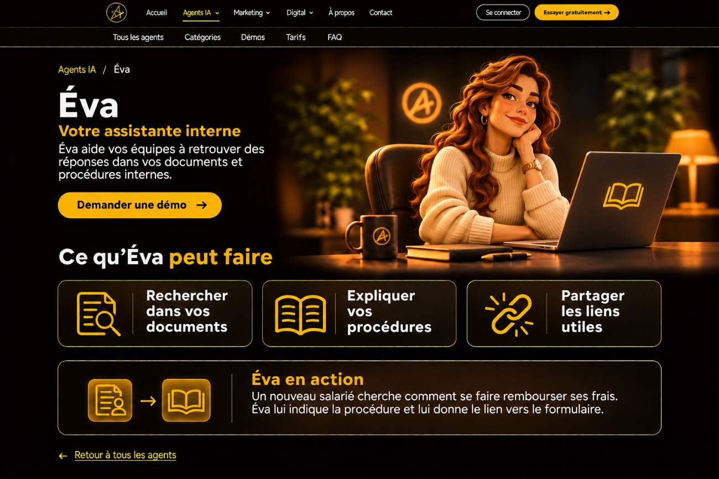  Éva · Internal knowledge assistant
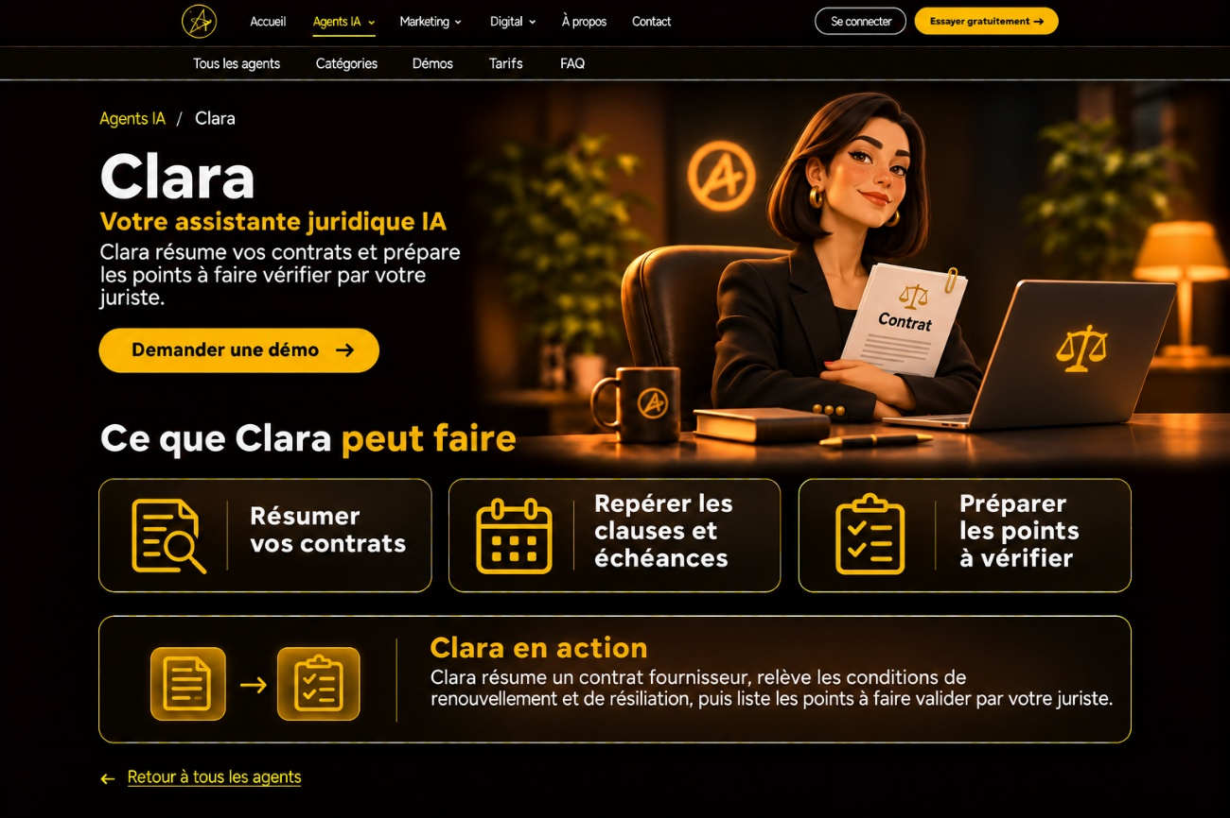
Clara · Legal assistant (not in the table above — to confirm)

6. Marketing page
Page | Marketing
Template | Same layout and components as the Agents IA page.

- Reuse the Agents IA page layout and components for Marketing.
- Highlight Marketing in the shared header.
- Link the secondary navigation to the corresponding Marketing sections.
- Use the same responsive card grid as Agents IA for the full Marketing service catalog.
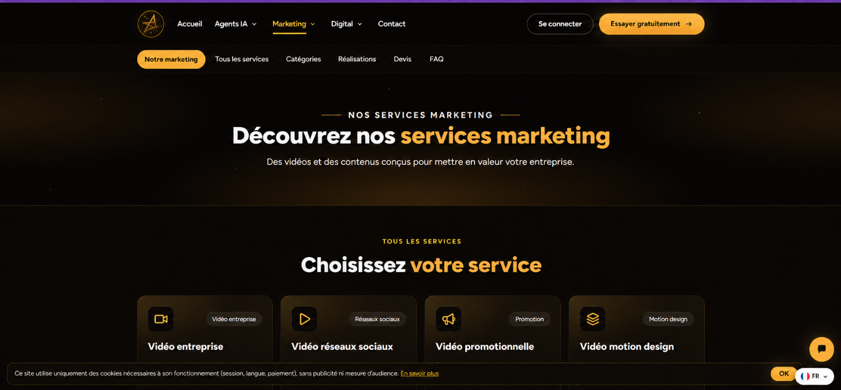
Figure 5 — Approved Marketing page mockup

7. Digital — Sites internet & e-commerce
Page | Digital → “Sites internet & e-commerce” pricing cards

- Remove the “Demander un devis” button from all four cards.
- Remove “Mise en place dès” and display the prices on their own.
- Keep “Frais de fonctionnement” and the current monthly starting prices on the first three cards.
- On the Landing page card, remove “Sur devis” and hide the “Frais de fonctionnement” label too (no amount to display).

Card | Price | Frais de fonctionnement
Site vitrine | 2 900 € | À partir de 150 € / mois
Site restaurant + commande | 3 900 € | À partir de 190 € / mois
Site e-commerce | 6 900 € | À partir de 290 € / mois
Landing page | 990 € | — hidden (label removed)
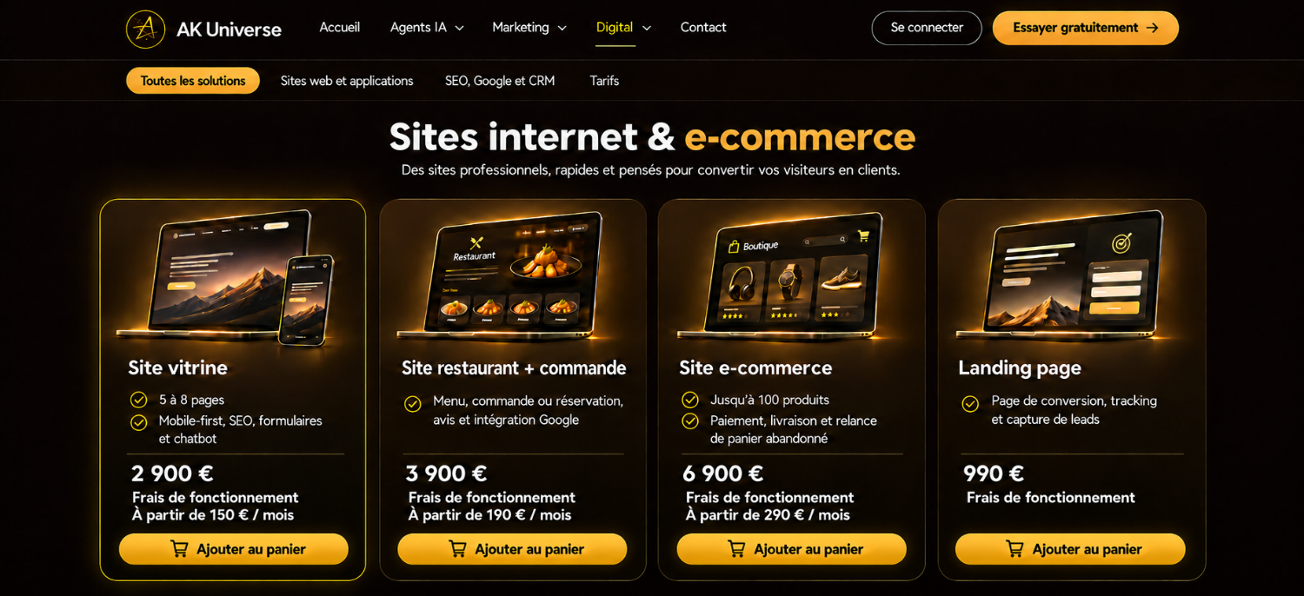
Figure 6 — Approved pricing cards mockup

8. Digital — Application mobile sur mesure
Page | New page “Application mobile sur mesure”
Location | Digital → Sites web et applications
Header | Keep the existing site header and Digital navigation.
Entry point | The “Application mobile” card on the overview page links to this new page.

Breadcrumb
The small line above the main title is a breadcrumb: Sites web et applications → Application mobile. The first label links back to the overview page; Application mobile identifies the current page.

Page sections
Section | Content
Hero | Introduce custom iOS and Android app development for customers or internal teams. Two phone mockups: a booking app and a customer portal. Main button: “Parler de mon projet”.
What we can build | “Réservation et commande” — appointments, orders, online payments. “Espace client” — order tracking, documents, notifications. “Application métier” — internal workflows such as field service and activity tracking.
How we build it | 1. Cadrage — define requirements and scope. 2. Design et prototype — validate the user experience. 3. Développement et intégrations API — build the app, connect tools (CRM, payment services). 4. Tests et publication — test and publish on the App Store and Google Play.
Pricing | End with “Mise en place et frais de fonctionnement sur devis.” Both initial development and ongoing operating costs are quoted per project.

Reminder
Keep the page labels and customer-facing copy in French.
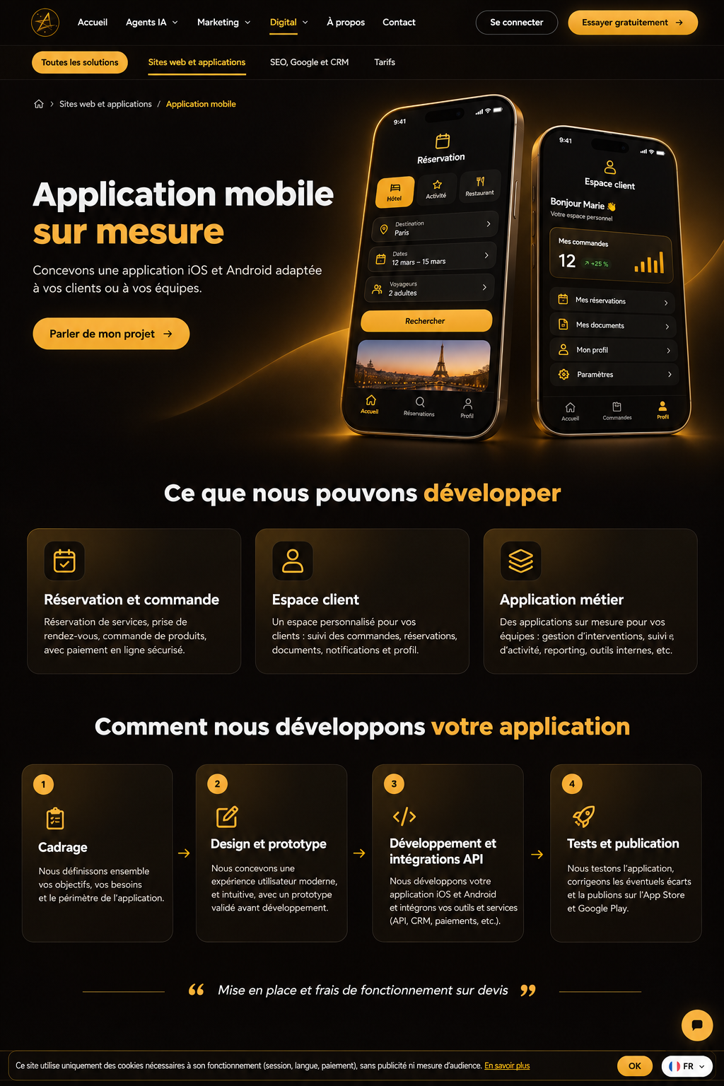
Figure 7 — Approved mobile app page mockup

