Figure S1
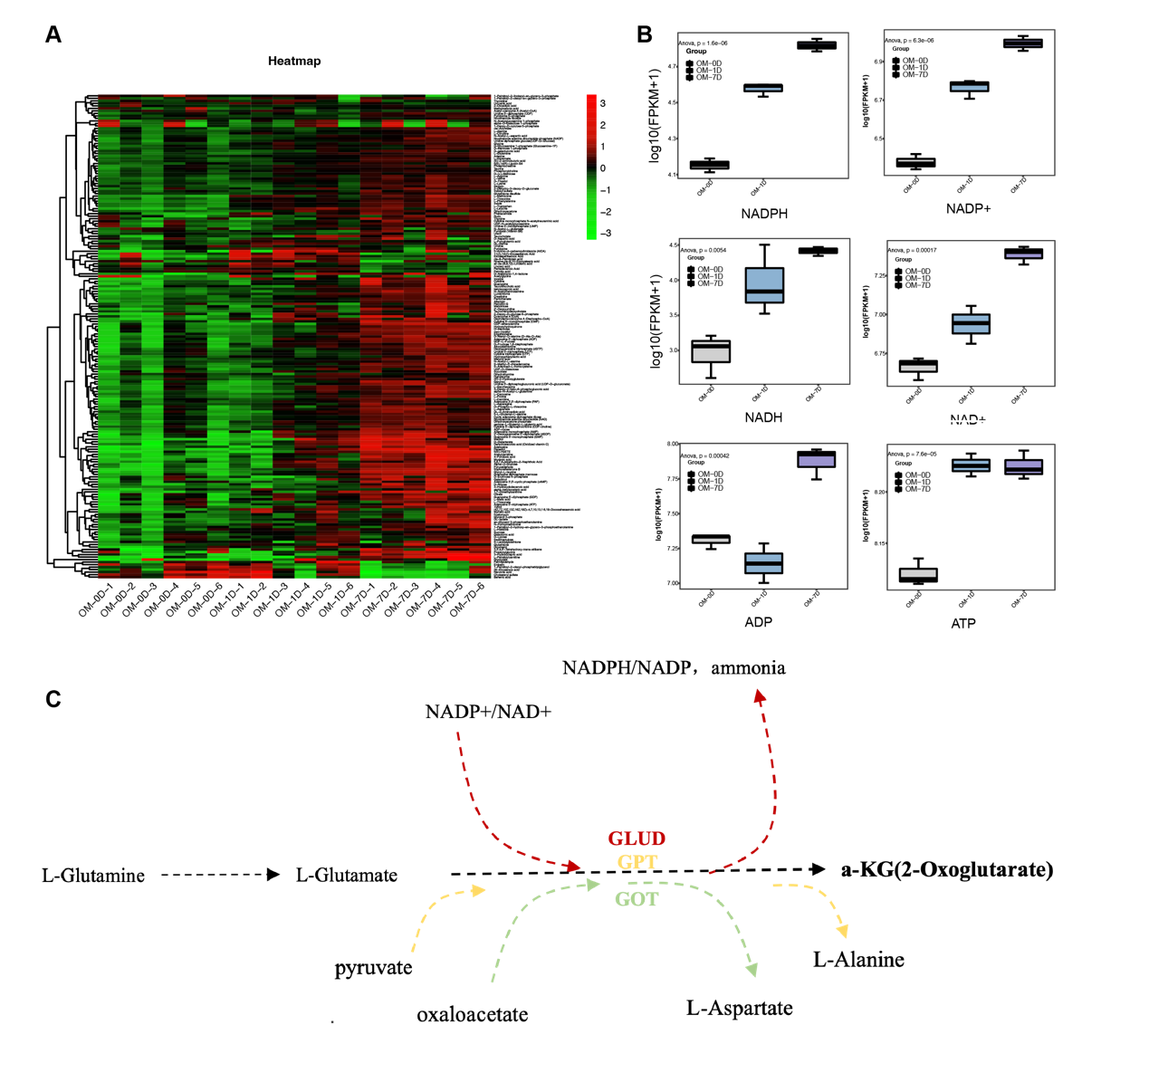 Figure S1. Metabolomic analysis. (A) Heatmap of all differential metabolites during odontogenic differentiation of hDPSCs. (B) Boxplot of energy supply related metabolites including NADPH, ADP, NADP+, NADH, NAD+ and ATP. (C) Sketch map of glutamine-αKG axis, in which three enzymes that could catalyze glutamate into αKG were involved.

Figure S2
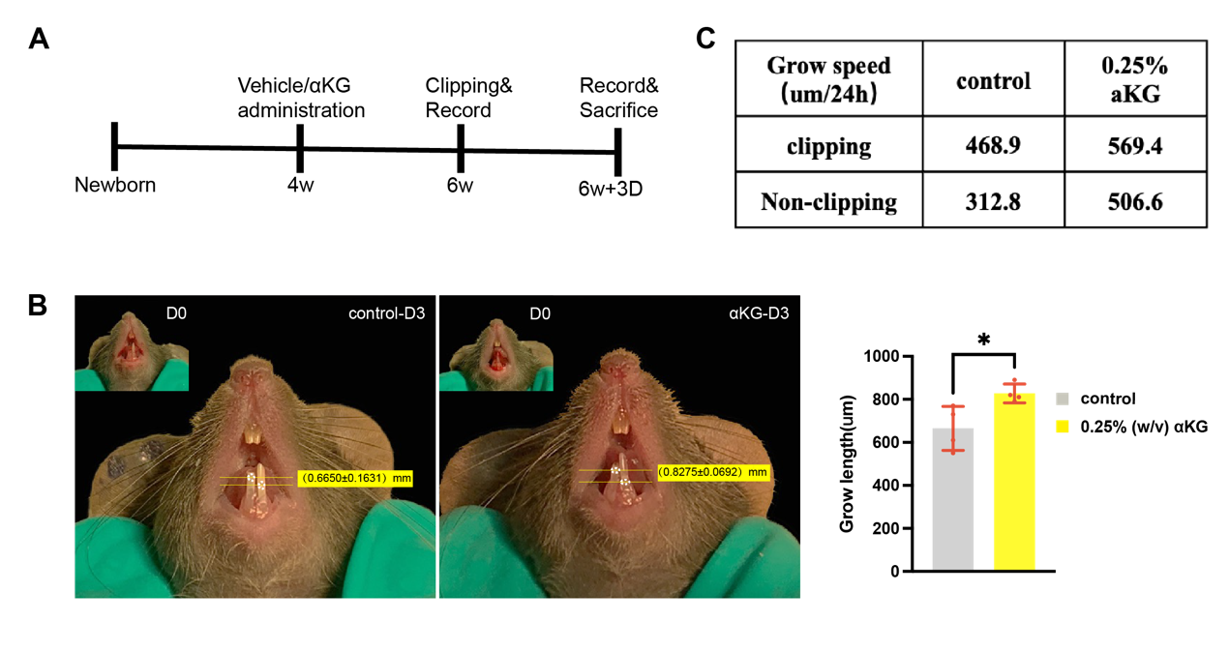
Figure S2. Clipping Model. (A) Sketch map of the establishment procedure of mice clipping model and drug administration design. (B) αKG promotes the growing speed of mice clipped incisor (t-test was performed) (n=4 mice per group). (C) Grow speed (μm/24h) of clipping side incisors in each group.

Figure S3
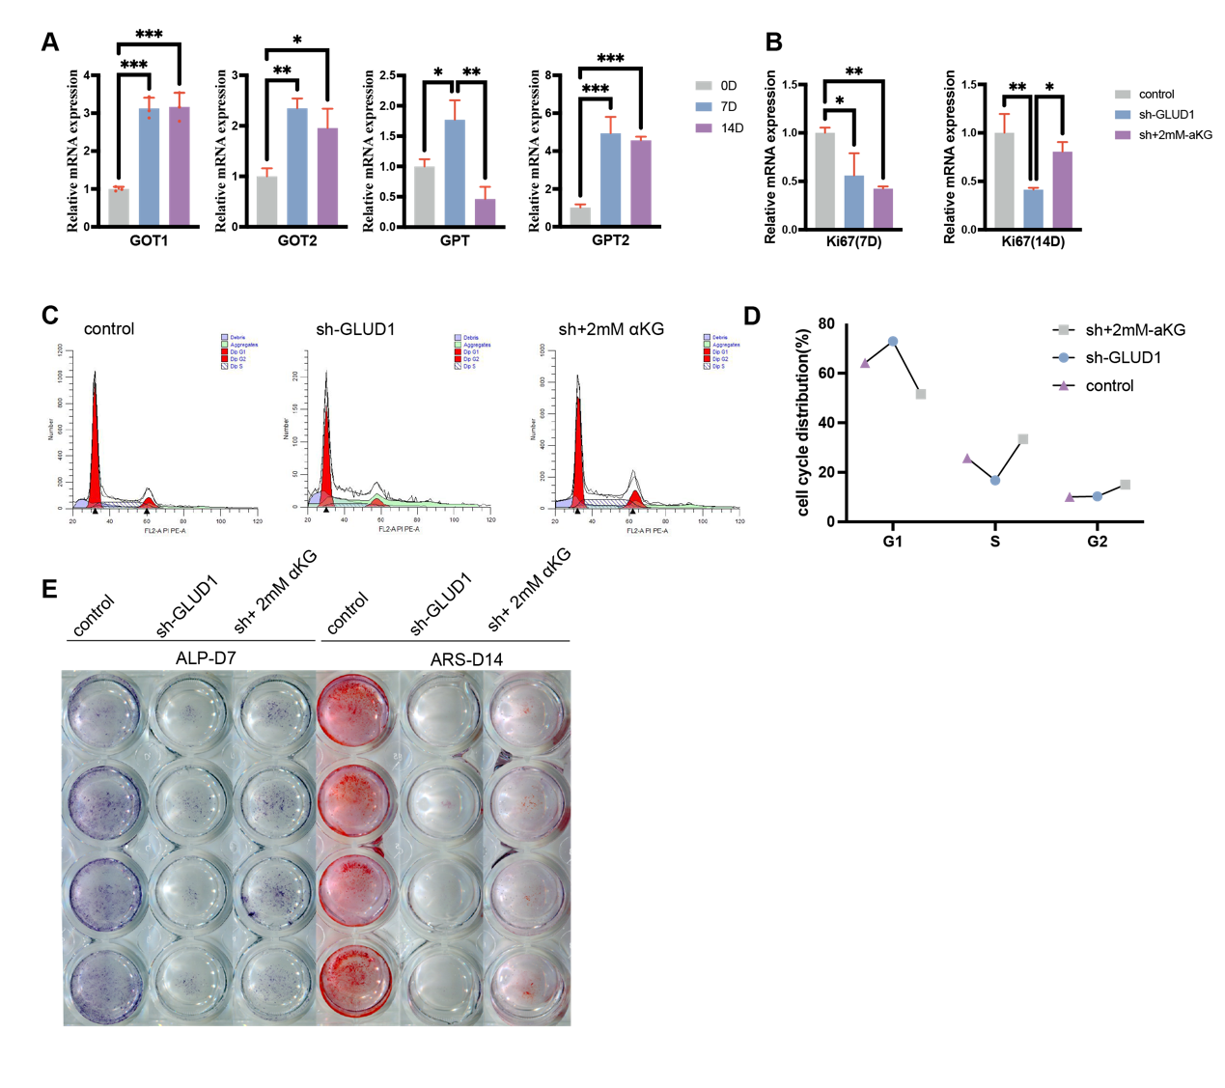
Figure S3. Intervention of αKG level via GLUD1 knockdown. (A) The mRNA expression tendency of GOT1, GOT2, GPT and GPT2 during odontogenic differentiation. (B) The mRNA expression tendency of Ki67 after GLUD1 knockdown and 2mM-αKG supplementation. (C) Histogram of cell cycle experiment (flow cytometry assay) result of control, sh-GLUD1, and sh+2mM αKG group. (D) Line chart of cell cycle experiment. (E) The original scanning image of ALP and ARS staining after GLUD1 knockdown and DM-αKG supplementation.

Figure S4-Original Western Blots
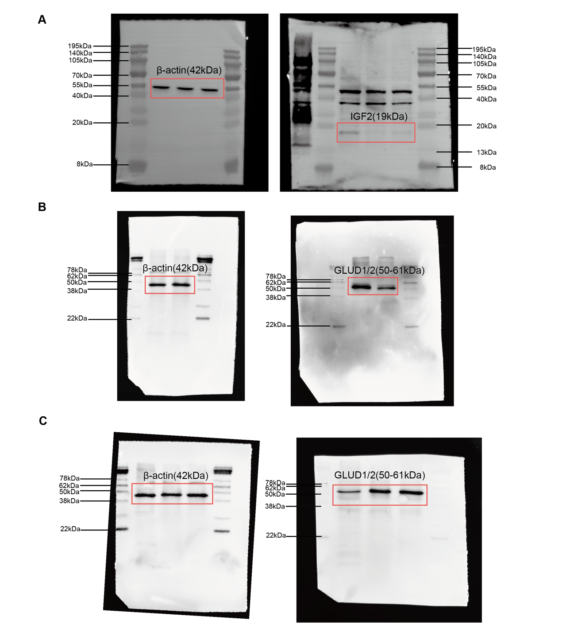
Figure S4. Original Western Blots. (A) Original Western Blots of Figure 6F. (B) Original Western Blots of Figure 4E. (C) Original Western Blots of Figure 4B.

Figure S5- Molecular Docking Model of IGF2 and IGFBP5

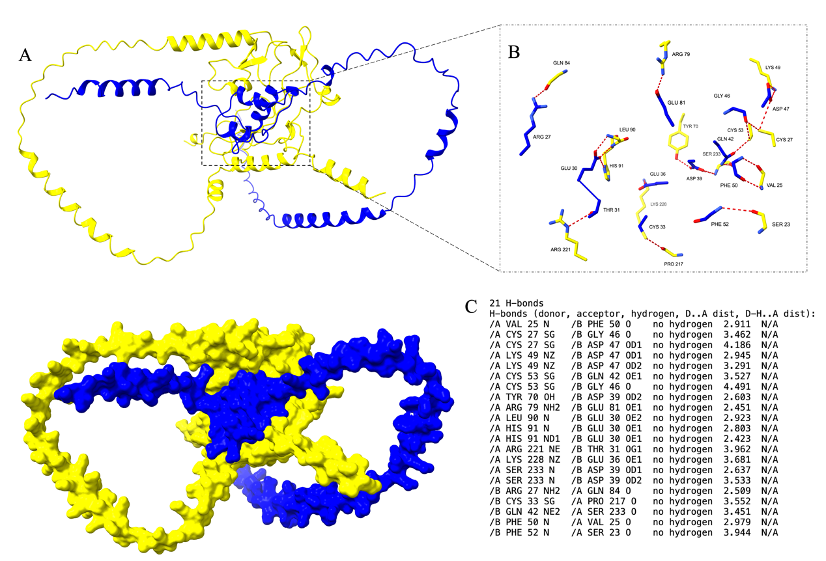
Figure S5. Molecular Docking Model of IGF2 and IGFBP5. (A-B) Molecular Docking Model of IGF2 and IGFBP5. (C) H-bonds details of IGF2 and IGFBP5 binding.

