**Figure S1**

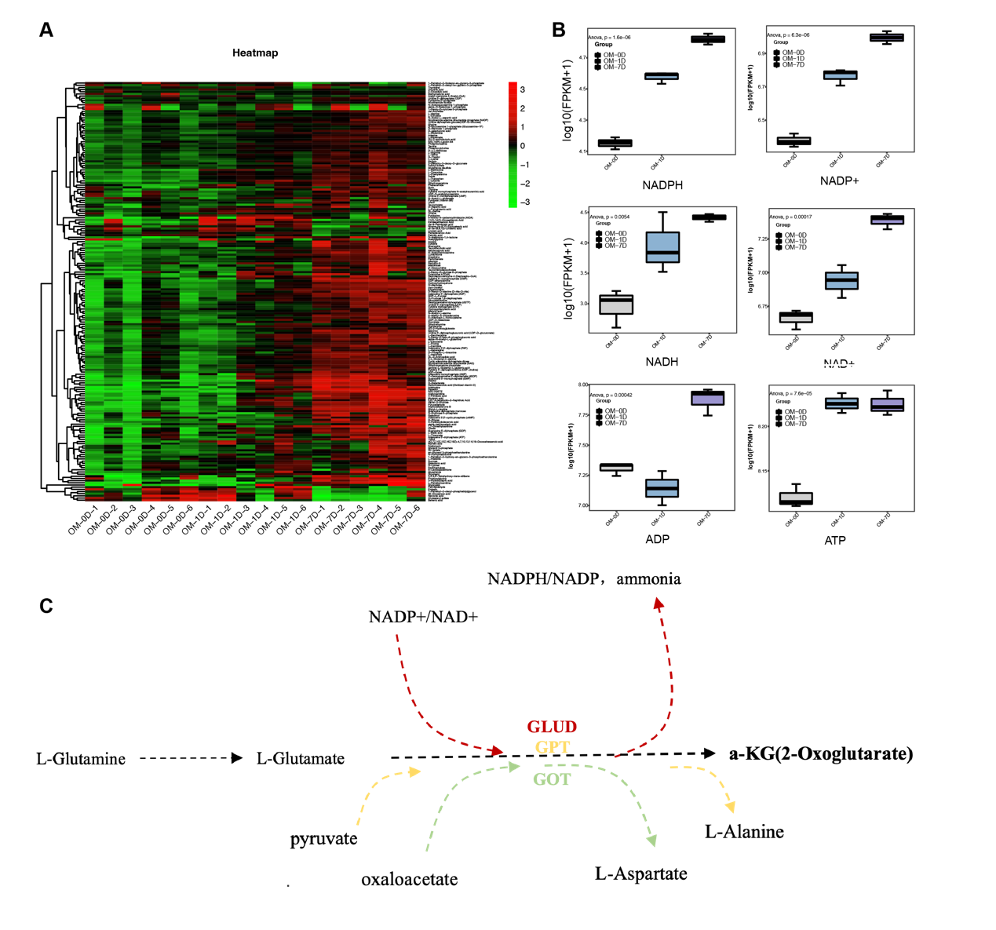 **Figure S1**. **Metabolomic analysis**. **(A)** Heatmap of all differential metabolites during odontogenic differentiation of hDPSCs. **(B)** Boxplot of energy supply related metabolites including NADPH, ADP, NADP+, NADH, NAD+ and ATP. **(C)** Sketch map of glutamine-αKG axis, in which three enzymes that could catalyze glutamate into αKG were involved.

**Figure S2**

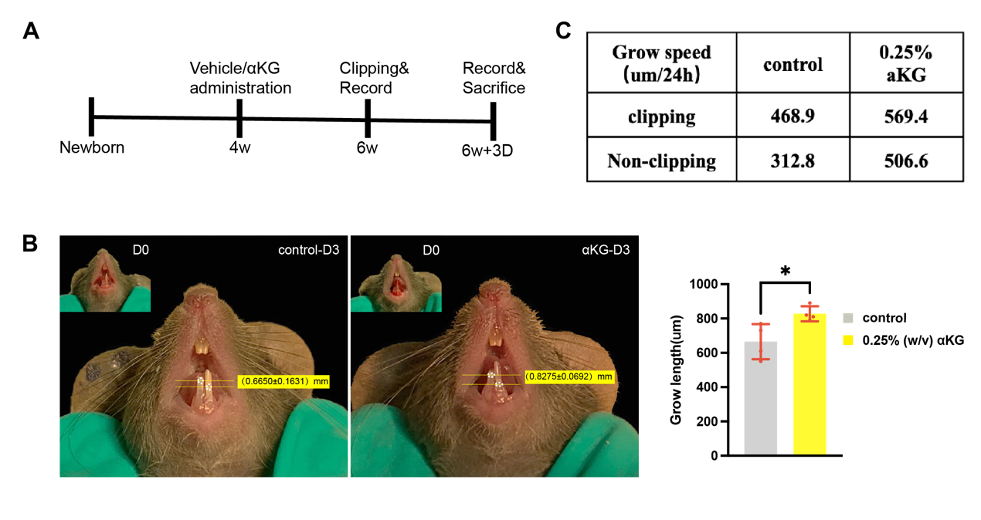

**Figure S2**. **Clipping Model**. **(A)** Sketch map of the establishment procedure of mice clipping model and drug administration design. **(B)** αKG promotes the growing speed of mice clipped incisor (t-test was performed) (*n*=4 mice per group). **(C)** Grow speed (μm/24h) of clipping side incisors in each group.

**Figure S3**

**Figure S3**. **Intervention of αKG level via GLUD1 knockdown**. **(A)** The mRNA expression tendency of GOT1, GOT2, GPT and GPT2 during odontogenic differentiation. **(B)** The mRNA expression tendency of Ki67 after GLUD1 knockdown and 2mM-αKG supplementation. **(C)** Histogramofcell cycle experiment (flow cytometry assay) result of control, sh-GLUD1, and sh+2mM αKG group. **(D)** Line chart ofcell cycle experiment. **(E)** The original scanning image of ALP and ARS staining after GLUD1 knockdown and DM-αKG supplementation.

**Figure S4-Original Western Blots**

**Figure S4**. **Original Western Blots**. **(A)** Original Western Blots of Figure 6F. **(B)** Original Western Blots of Figure 4E. **(C)** Original Western Blots of Figure 4B.

**Figure S5- Molecular Docking Model of IGF2 and IGFBP5**

地图

**Figure S5.** **Molecular Docking Model of IGF2 and IGFBP5**. **(A-B)** Molecular Docking Model of IGF2 and IGFBP5. **(C)** H-bonds details of IGF2 and IGFBP5 binding.