Report Title
An intro paragraph with italic, struck words, inline code and a link.

Section One
A short paragraph in the first section.
- First bullet
- Second bullet
  - Nested bullet
- Third bullet

Numbered Steps
- Step one
- Step two
- Step three
- Open task
- Done task

Data Table
City | Code
Berlin | BER
Nairobi | NBO
A quoted line with bold words.

Maths
Inline maths 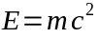 appears here.
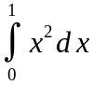

Code
print("hello")
A sentence with a footnote.

Closing paragraph.

The footnote text.

