SINGLE TAP
Drawer Module
Complete Screen Documentation
Module | App Drawer + Profile Menu Screens
Total Screens | 13 (1 drawer widget + 8 destination screens + 4 inline/sub-screens)
Stack | Flutter, Firebase, Firestore, SharedPreferences
Last Updated | 17 Mar 2026

Table of Contents
# | Section
1 | App Drawer (Sidebar Menu)
2 | Downloads Screen
3 | Notifications Screen
4 | Library Screen
5 | Profile Screen
6 | Upgrade Plan Screen
7 | Personalization Screen
8 | Settings Screen
9 | Help Center Screen
10 | New Chat (Drawer Feature)
11 | My Posts Screen
12 | Chat History (Inline Feature)
13 | Edit Profile Screen

SCREEN 1

App Drawer (Sidebar Menu)
File: lib/widgets/common widgets/app_drawer.dart
Purpose: Right-side end-drawer providing access to all app features. Contains feature cards (main menu), expandable chat history, and a bottom profile bar with a popup menu for profile/settings/help/logout.
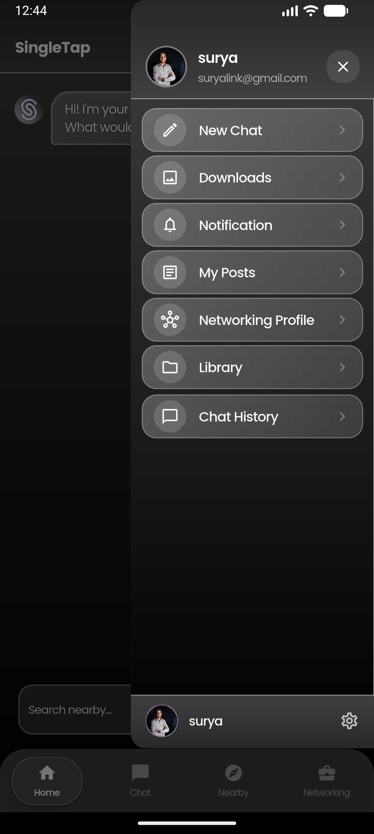📱
[ App Drawer (Sidebar Menu) ]
Paste screenshot here

Constructor Parameters
Parameter | Type | Required | Default | Description
onNewChat | Future<void> Function()? | No | null | Callback to save current conversation and start new chat
onNavigate | Function(int)? | No | null | Callback to navigate bottom tabs
onLoadChat | Function(String chatId)? | No | null | Callback to load a specific chat by ID
onNewChatInProject | Function(String projectId)? | No | null | Callback to create new chat within a project

Static Key
static final GlobalKey<AppDrawerState> globalKey = GlobalKey<AppDrawerState>();

How It Opens
Opened as an endDrawer (right-side) via:
MainNavigationScreen.scaffoldKey.currentState?.openEndDrawer();

Drawer Container
Property | Value
Width | 65% of scre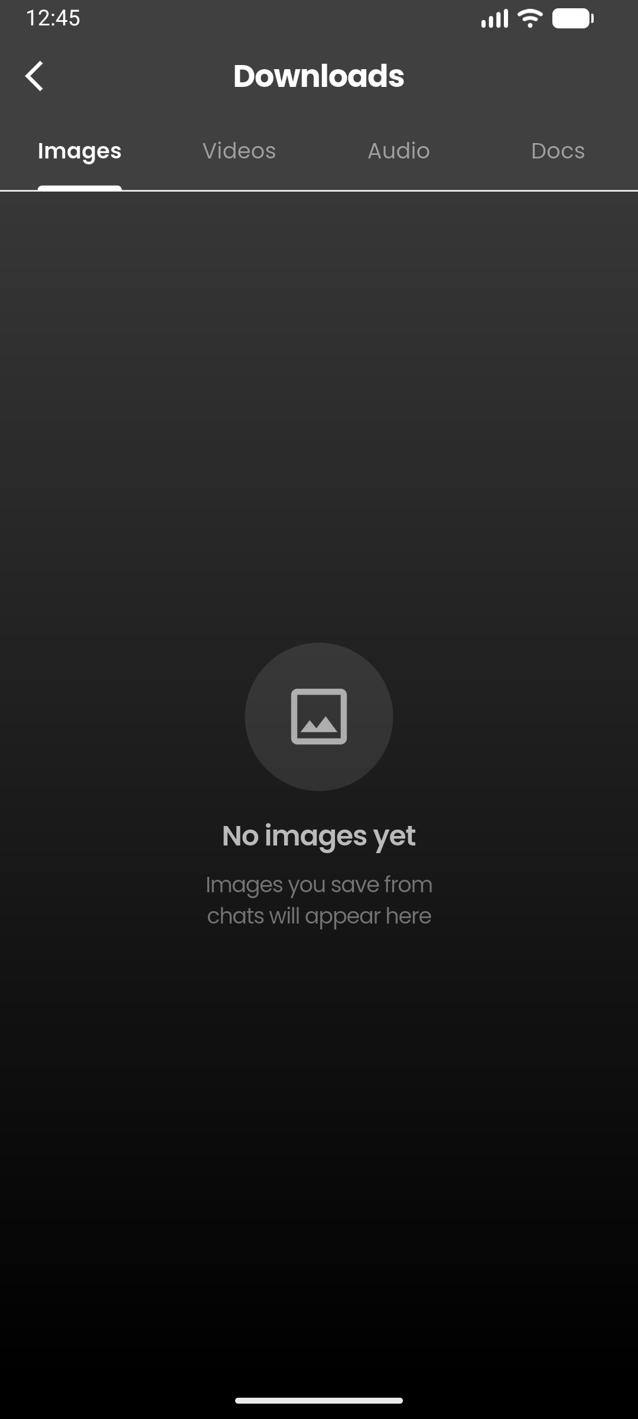en width (size.width * 0.65)
Background | Transparent (gradient applied internally)
Position | Right-side (endDrawer), above bottom nav bar
Bottom margin | MediaQuery.of(context).padding.bottom + 70

Overall Layout
┌──────────────────────────┐
│ [Avatar] Name [X] │ ← Header
│ email@mail.com │
├──────────────────────────┤ ← White 0.5px border
│ ✏️ New Chat > │
│ 🖼 Downloads > │
│ 🔔 Notification 3 > │ ← Unread badge (StreamBuilder)
│ 📄 My Posts > │
│ 🔗 Networking Prof. > │
│ 📁 Library > │
│ 💬 Chat History ⌄ │ ← Expandable
│ ┌────────────────┐ │
│ │ 📌 Chat 1 ··· │ │ ← Pinned chats first
│ │ Chat 2 ··· │ │
│ │ Chat 3 ··· │ │
│ │ Show more │ │ ← If >10 chats
│ └────────────────┘ │
├──────────────────────────┤ ← White 0.5px border
│ [Avatar] Name ⚙️ │ ← Bottom profile button
└──────────────────────────┘
When ⚙️ tapped:
┌──────────────────────────┐
│ 👤 Profile > │
│ 👑 Upgrade Plan > │
│ 🎛 Personalization > │
│ ⚙ Settings > │
│ ❓ Help > │
│ 🚪 Log out │ ← Red text
└──────────────────────────┘

Background Gradient
Gradient: RGBA(64, 64, 64, 1) (top) → RGBA(0, 0, 0, 1) (bottom)

Right Border
Property | Value
Color | White
Width | 0.5px
Side | Right only

Header (_buildHeader)
Property | Value
Padding | fromLTRB(16, 50, 16, 12)
Background gradient | #282828 (top) → #404040 (bottom)
Bottom border | White, 0.5px

Header — Avatar
Property | Value
Size | 46 × 46
Shape | Circle
Border | Colors.white38, width 2
Image | CachedNetworkImage from photoUrl
Fallback | Purple circle (alpha 0.5) with white initial letter, Poppins 16px bold

Header — User Info
Element | Style
Name | Poppins, 16px, w600, white, maxLines: 1, ellipsis
Email | Poppins, 12px, normal, white 60% opacity, maxLines: 1, ellipsis
Gap (name → email) | 2

Header — Close Button
Property | Value
Icon | close_rounded, size 20, white
Container bg | Colors.white alpha 0.1
Border radius | 16
Padding | 8
Haptic | lightImpact

Feature Card (_buildFeatureCard)
Property | Value
Margin | horizontal: 12, vertical: 2
Padding | vertical: 5, horizontal: 12
Background gradient | Colors.white alpha 0.25 (topLeft) → alpha 0.15 (bottomRight)
Border | Colors.white alpha 0.3, width 1
Border radius | 16

Feature Card — Icon Container
Property | Value
Padding | 8
Background | Colors.white alpha 0.15
Shape | Circle
Icon size | 20, color: white

Feature Card — Label
Property | Value
Font | Poppins, 15px, w500, white
Gap (icon → label) | 14 (SizedBox)

Feature Card — Chevron
Property | Value
Icon | chevron_right, size 20
Color | Colors.white alpha 0.3
Position | Right (Spacer before)

Feature Card — Notification Badge
Property | Value
Background | Colors.red
Border radius | 10
Padding | horizontal: 7, vertical: 2
Text | Poppins, 11px, w600, white
Max display | 99+
Data source | StreamBuilder on notifications where read == false

Menu Items (Feature Cards)
# | Label | Icon | Color | Target Screen
1 | New Chat | edit_outlined | Blue | Callback (onNewChat)
2 | Downloads | image_outlined | Purple | DownloadsScreen
3 | Notification | notifications_outlined | Amber | NotificationsScreen
4 | My Posts | article_outlined | TealAccent | ApiMyPostsScreen
5 | Networking Profile | hub_outlined | #016CFF | NetworkingProfilesPageScreen
6 | Library | folder_outlined | Orange | LibraryScreen
7 | Chat History | chat_bubble_outline | Green | Expandable (inline)

Expandable Feature Card (_buildExpandableFeatureCard)
Property | Value
Margin | horizontal: 12, vertical: 4
Border (expanded) | Color with alpha 0.5
Border (collapsed) | Colors.white alpha 0.3
Chevron rotation | AnimatedRotation, 0.25 turns when expanded, 200ms duration

Chat History (Expanded Content)
Property | Value
Container margin | left: 12, right: 12, top: 2, bottom: 4
Background gradient | Colors.white alpha 0.25 → 0.15
Border | Colors.white alpha 0.3, width 1
Border radius | 16
Max items (collapsed) | 10 (+ "Show more" button)
Max items (total) | 20
Data source | chat_history collection, filtered by userId, limit 50
Sort | Pinned first, then by createdAt desc
Excludes | Archived chats, project chats

Chat Item (_buildChatItem)
Property | Value
Margin | horizontal: 4
Padding | left: 12, top: 4, bottom: 4, right: 2
Unread bg | Colors.white alpha 0.05
Border radius | 6
Divider below | White alpha 0.12, height 0.5, horizontal margin 12

Chat Item — Text
Element | Style
Name (normal) | Poppins, 14px, normal, white 85% opacity
Name (unread) | Poppins, 14px, w600, white 85% opacity
Pin icon | push_pin, size 12, white 40% opacity
Unread dot | 6×6, blue circle, right margin 4

Chat Item — 3-Dot Menu
Property | Value
Icon | more_horiz, size 16, white 50% opacity
Button size | 28×28
Menu bg | #2D2D2D
Menu border radius | 12
Actions | Share, Pin/Unpin, Delete

Show More Button
Property | Value
Icon | expand_more_rounded, size 18, white 50% opacity
Text | Poppins 12px, white 50% opacity
Margin | horizontal: 12, vertical: 4
Padding | vertical: 10

Bottom Profile Button (_buildProfileButton)
Property | Value
Padding | fromLTRB(16, 10, 16, 12)
Background gradient | #282828 (bottom) → #404040 (top)
Top border | White, 0.5px

Bottom Profile Button — Avatar
Property | Value
Size | 36 × 36
Shape | Circle
Background | Purple alpha 0.3
Border | Colors.white38, width 1
Tap action | Opens ProfileWithHistoryScreen

Bottom Profile Button — Name
Property | Value
Font | Poppins, 14px, w500, white
Max lines | 1, ellipsis

Bottom Profile Button — Settings Icon
Property | Value
Icon | settings_outlined, size 22, white70
Tap action | Toggles profile menu popup

Profile Menu Popup (_buildProfileMenuCard)
Property | Value
Position | left: 12, right: 12, bottom: 80
Background gradient | RGBA(50,50,50,1) (top) → RGBA(25,25,25,1) (bottom)
Border | Colors.white alpha 0.3, width 1
Border radius | 16
Shadow | Colors.black alpha 0.5, blur 20, offset (0, -5)
Overlay | Transparent full-screen GestureDetector to dismiss

Profile Menu Items
# | Label | Icon | Destructive | Target
1 | Profile | person_outline_rounded | No | ProfileWithHistoryScreen
2 | Upgrade Plan | workspace_premium_outlined | No | UpgradePlanScreen
3 | Personalization | tune_rounded | No | PersonalizationScreen
4 | Settings | settings_outlined | No | SettingsScreen
5 | Help | help_outline_rounded | No | HelpCenterScreen
6 | Log out | logout_rounded | Yes | FirebaseAuth.signOut() → OnboardingScreen

Profile Menu Item (_buildProfileMenuItem)
Property | Value
Padding | horizontal: 16, vertical: 14
Icon size | 22
Icon color (normal) | White
Icon color (destructive) | Red alpha 0.9
Label font | Poppins, 15px, w500
Label color (normal) | White
Label color (destructive) | Red alpha 0.9
Arrow icon | chevron_right, size 18, white alpha 0.3
Divider | White alpha 0.08, height 0.5, margin horizontal 16

Navigation Pattern
All drawer menu items follow the same flow:
- Close drawer (Navigator.pop(context))
- Push target screen (Navigator.push(...))
- On return, re-open drawer: .then((_) { MainNavigationScreen.scaffoldKey.currentState?.openEndDrawer(); })

SCREEN 2

Downloads Screen
File: lib/screens/profile/downloads_screen.dart
Purpose: Displays files downloaded from chat conversations (filtered by `plink_` prefix), organized into 4 tabs. Supports multi-select with long-press for bulk deletion.
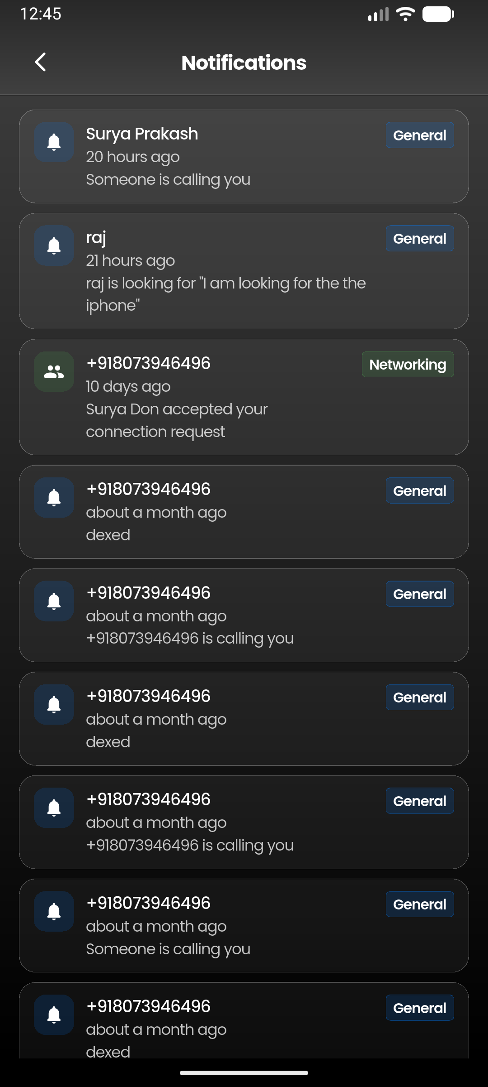
[ Downloads Screen ]
Paste screenshot here

Constructor Parameters
None.

AppBar Layout
┌────────────────────────────────────────────────────┐
│ [←] Downloads [Select All] │ ← Select All only in select mode
├────────────────────────────────────────────────────┤
│ Images │ Videos │ Audio │ Docs │
└────────────────────────────────────────────────────┘

AppBar Styling
Element | Style
Background | RGBA(64, 64, 64, 1) solid
Bottom border | White, 1px
Blur | BackdropFilter sigmaX: 15, sigmaY: 15
Preferred height | kToolbarHeight + 52
Title (normal) | "Downloads", Poppins 20px bold white, centered
Title (select mode) | "{N} selected", Poppins 18px w600 white
Leading (normal) | arrow_back_ios, white
Leading (select mode) | close, white
Toolbar height | kToolbarHeight - 6

Tab Bar Styling
Property | Value
Indicator color | White
Indicator weight | 2.5
Indicator size | TabBarIndicatorSize.label
Label color (selected) | White
Label style (selected) | Poppins, 14px, w600
Label color (unselected) | White 50% opacity
Label style (unselected) | Poppins, 14px, normal
Divider color | Transparent

Tabs
Tab | Description
Images | .jpg, .jpeg, .png, .webp, .gif, .heic, .heif
Videos | .mp4, .mov, .avi, .mkv
Audio | .m4a, .aac, .mp3, .wav, .ogg, .wma, .flac
Docs | .pdf, .doc, .docx, .xls, .xlsx, .ppt, .pptx, .txt, .csv

Body Background
Gradient: RGBA(64, 64, 64, 1) (top) → RGBA(0, 0, 0, 1) (bottom)

Data Source
Local device filesystem scan:
- Android: `/storage/emulated/0/Pictures/Plink/`
- iOS: App documents directory
- Filter: Only files with plink_ prefix
- Sort: By modification date (newest first)

Grid Layout
Property | Value
Images/Videos columns | 3
Audio/Docs columns | 2
Cross axis spacing | 6
Main axis spacing | 6
Aspect ratio (images/videos) | 1.0 (square)
Aspect ratio (audio/docs) | 2.2 (wide)
Padding | 12 all sides
Physics | BouncingScrollPhysics with AlwaysScrollableScrollPhysics

Grid Item Styling
Property | Value
Border radius | 10 (normal), 8 (selected)
Border (normal) | Colors.white alpha 0.1, width 0.5
Border (selected) | Blue, width 2

Selection Overlay
Property | Value
Position | top: 4, right: 4
Size | 24 × 24
Shape | Circle
Background (selected) | Blue
Background (unselected) | Black alpha 0.4
Border | White alpha 0.6, width 1.5
Check icon | check, size 16, white

Image Tile
Property | Value
Fit | BoxFit.cover
Cache width | 300
Error widget | broken_image_outlined, size 28, white54, bg white alpha 0.05

Video Tile
Property | Value
Background | White alpha 0.05
Camera icon | videocam_rounded, size 32, white54
Play button | Circle, black alpha 0.5, play_arrow_rounded size 24 white

Audio Tile
Property | Value
Background | White alpha 0.05
Padding | horizontal: 12, vertical: 8
Icon container | Circle, white alpha 0.1, audiotrack_rounded size 20 white70
Filename | Poppins 12px w500 white70, maxLines 1 ellipsis
Date | Poppins 12px white60
Play icon | play_circle_filled_rounded, size 28, white alpha 0.4

Doc Tile
Property | Value
Background | White alpha 0.05
Padding | horizontal: 12, vertical: 8
PDF icon | picture_as_pdf_rounded, redAccent, bg redAccent alpha 0.15
Other icon | description_rounded, blueAccent, bg blueAccent alpha 0.15
Filename | Poppins 12px w500 white70, maxLines 1 ellipsis
Info line | "EXT • dd/mm/yyyy", Poppins 12px white60

Multi-Select Bottom Bar
Property | Value
Background | #1a1a2e alpha 0.95
Top border | White alpha 0.1
Padding | horizontal: 16, vertical: 12
Count text | Poppins 14px white70
Delete button bg | Red alpha 0.8
Delete button radius | 10

Delete Confirmation Dialog
Property | Value
Background | #1a1a2e
Border radius | 16
Title font | Poppins, white
Cancel color | White
Delete color | Red

Full Screen Image Viewer
Property | Value
Background | Black
AppBar | Transparent, elevation 0
Close icon | close, white
Title | Filename, Poppins 14px white, ellipsis
Viewer | InteractiveViewer, minScale 0.5, maxScale 4.0

Empty States
Tab | Icon | Title | Subtitle
Images | image_outlined | "No images yet" | "Images you save from\nchats will appear here"
Videos | videocam_outlined | "No videos yet" | "Videos you save from\nchats will appear here"
Audio | audiotrack_outlined | "No audio yet" | "Audio you save from\nchats will appear here"
Docs | description_outlined | "No documents yet" | "Documents & PDFs you save\nfrom chats will appear here"
Empty state styling:
- Circle bg: Colors.white alpha 0.1
- Icon: size 48, white alpha 0.6
- Title: Poppins 18px w600 white70
- Subtitle: Poppins 14px white40, textAlign center

SCREEN 3

Notifications Screen
File: lib/screens/home/notifications_screen.dart
Purpose: Displays real-time notifications from Firestore `notifications` collection, filtered by current user. Shows sender name (cached), time ago, body text, and screen label badges.

[ Notifications Screen 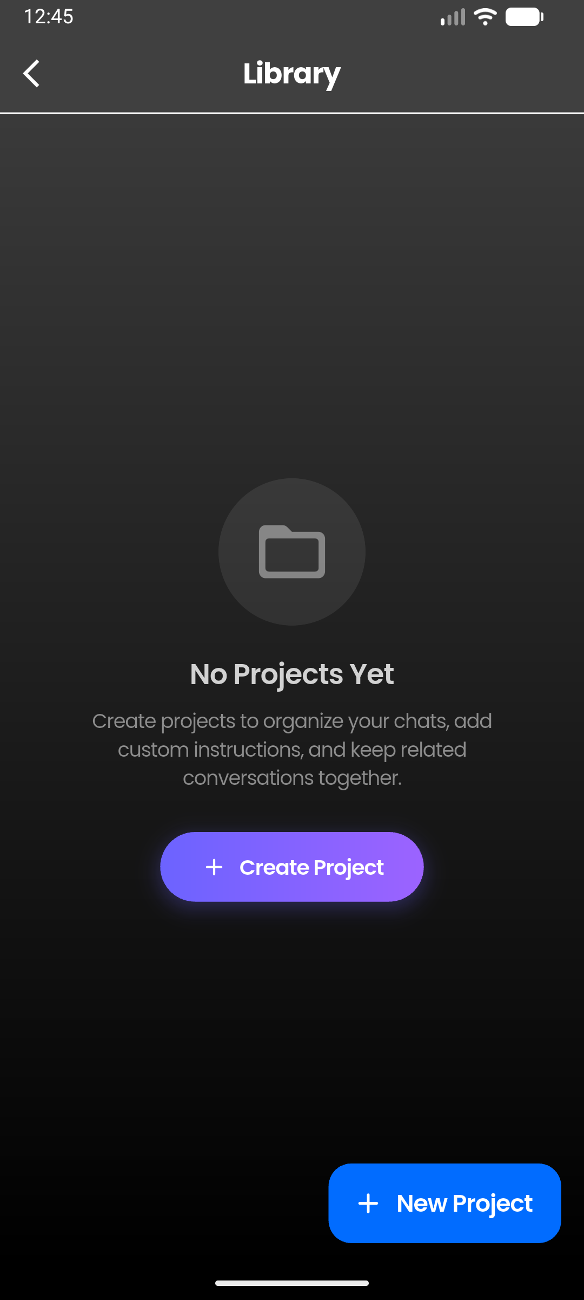]
Paste screenshot here

Constructor Parameters
None.

AppBar Layout
┌────────────────────────────────────────────────────┐
│ [←] Notifications │
└────────────────────────────────────────────────────┘

AppBar Styling
Element | Style
Toolbar height | 56
Background | Transparent
FlexibleSpace gradient | #282828 (top) → #404040 (bottom)
Bottom border | White, 0.5px
Title | "Notifications", Poppins 17px bold white, centered
Leading | arrow_back_ios_new_rounded, size 20, white, left padding 12

Body Background
Gradient: RGBA(64, 64, 64, 1) (top) → RGBA(0, 0, 0, 1) (bottom)

Data Source
- StreamBuilder on notifications collection
- Filter: userId == currentUser.uid
- Limit: 50
- Client-side sort by createdAt desc (avoids composite index)
- Deduplicate by doc.id

Notification Item
Property | Value
Margin | bottom: 8
Padding | horizontal: 12, vertical: 10
Background (unread) | Colors.white alpha 0.12
Background (read) | Colors.white alpha 0.05
Border | White24, width 0.5
Border radius | 14

Notification Icon Container
Property | Value
Padding | 8
Background | Type-color alpha 0.15
Border radius | 10
Icon size | 18, white

Notification Type Colors & Icons
Type | Icon | Color
connection_request | person_add_rounded | Blue
connection_accepted | people_rounded | Green
message | chat_bubble_rounded | #016CFF
post_match | auto_awesome_rounded | Purple
like | favorite_rounded | Red
Default | notifications_rounded | #007AFF

Screen Label Badges
Type | Label
connection_request / connection_accepted | "Networking"
message | "Messages"
post_match / like | "Nearby"
Default | "General"
Badge styling:
- Padding: horizontal 6, vertical 2
- Background: type-color alpha 0.15
- Border: type-color alpha 0.3, width 0.5
- Border radius: 4
- Text: Poppins 12px w600 white

Notification Typography
Element | Style
Sender name (unread) | Poppins, 14px, w600, white
Sender name (read) | Poppins, 14px, w500, white
Time | Poppins, 13px, white 75% opacity (timeago format)
Body | Poppins, 13px, white 75% opacity, maxLines 2 ellipsis

Sender Name Cache
- Map _nameCache stores senderId → name
- Fetched from users collection on first access
- Fallback: "Someone"

Empty State
Property | Value
Icon | notifications_off_outlined, size 72, white 30% opacity
Title | "No notifications yet", Poppins 18px w600 white50
Subtitle | "Your notifications will appear here", Poppins 14px white35

SCREEN 4

Library Screen
File: lib/screens/profile/library_screen.dart
Purpose: Displays user's projects from `projects` Firestore collection. Allows loading chats and creating new chats within projects.
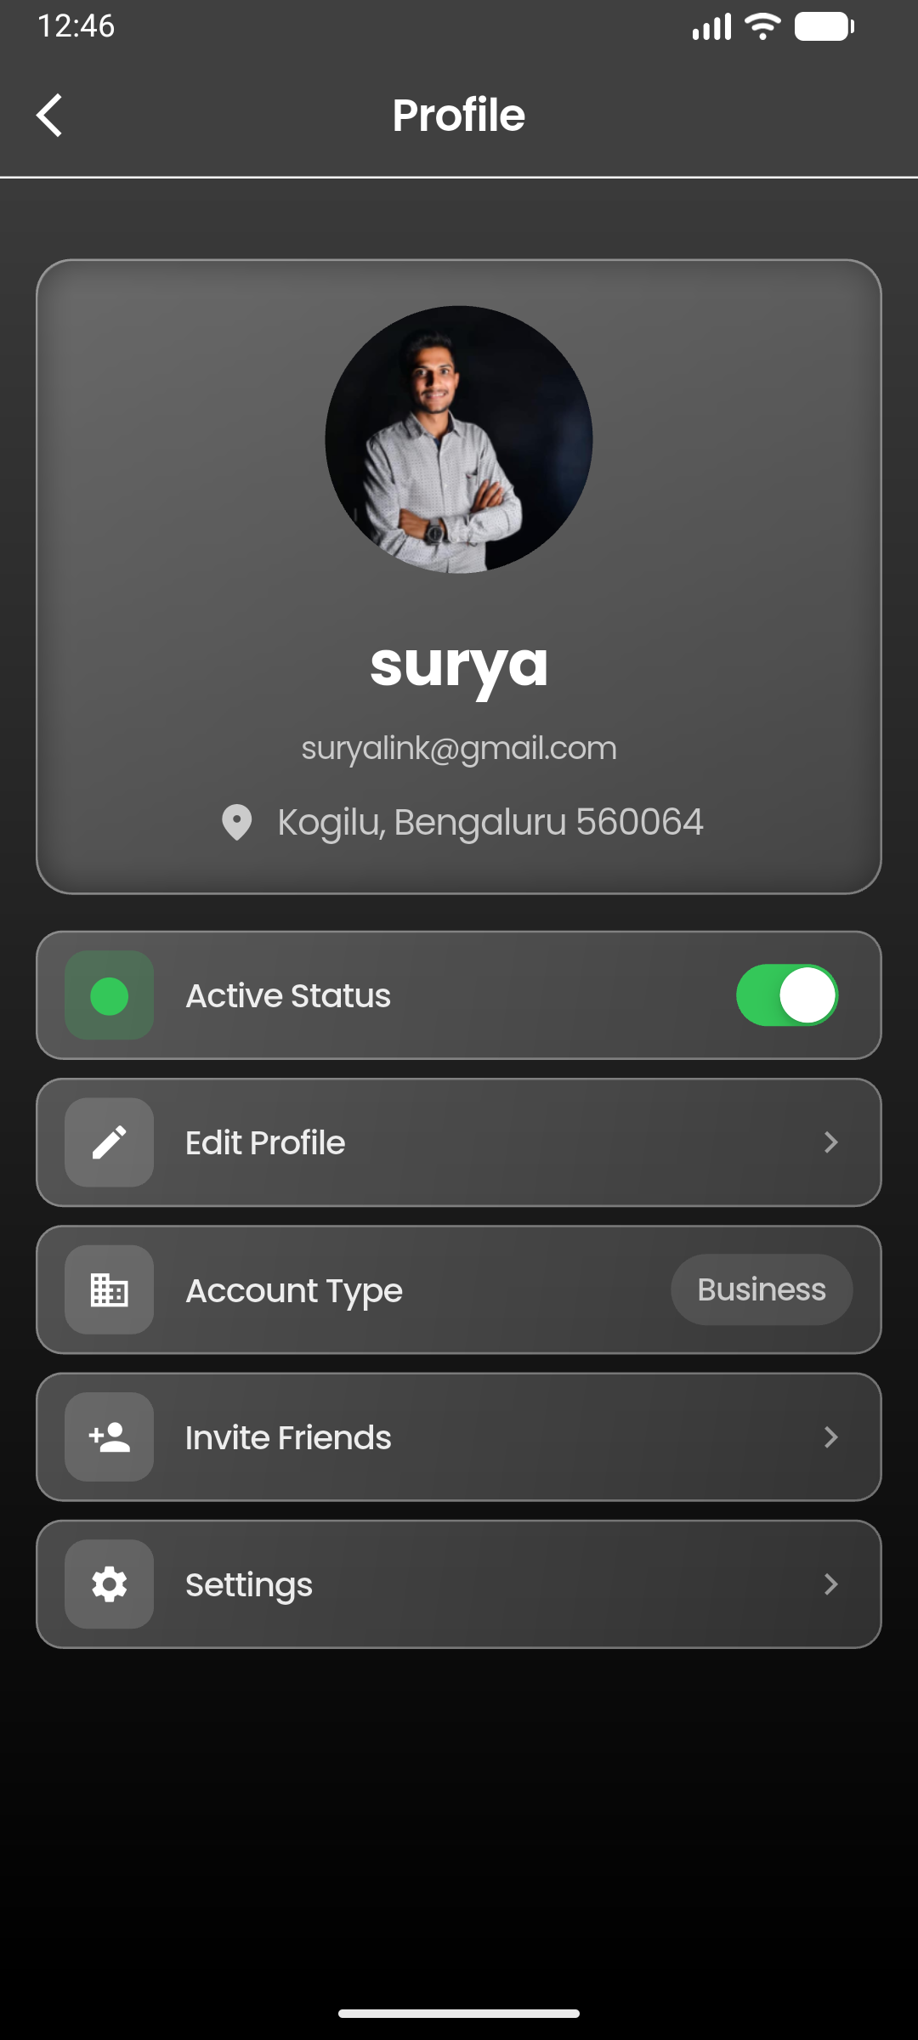
[ Library Screen ]
Paste screenshot here

Constructor Parameters
Parameter | Type | Required | Default | Description
onLoadChat | Function(String chatId)? | No | null | Callback to load specific chat
onNewChatInProject | Function(String projectId)? | No | null | Callback to create new chat in project

Data Source
- projects collection, filter by userId, limit 50
- Deduplicate by doc.id
- Sort: newest first (by createdAt)

SCREEN 5

Profile Screen
File: lib/screens/home/profile_with_history_screen.dart
Purpose: Displays user profile with photo, name, email, location, active status toggle, edit profile, account type, invite friends, and settings access. Uses real-time Firestore listener for profile updates.
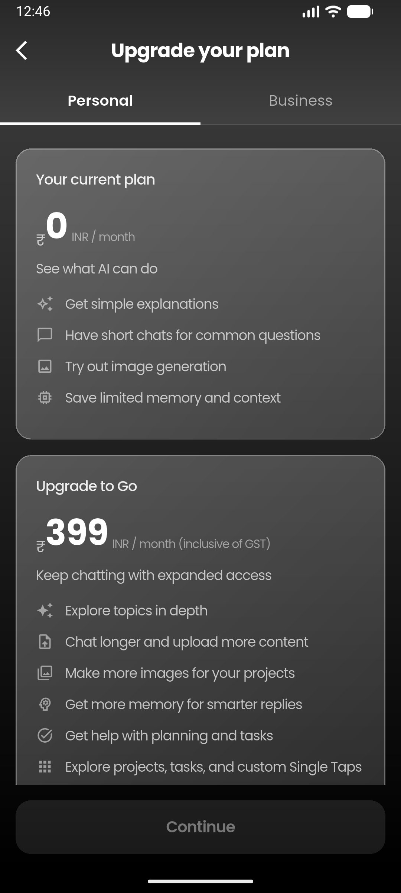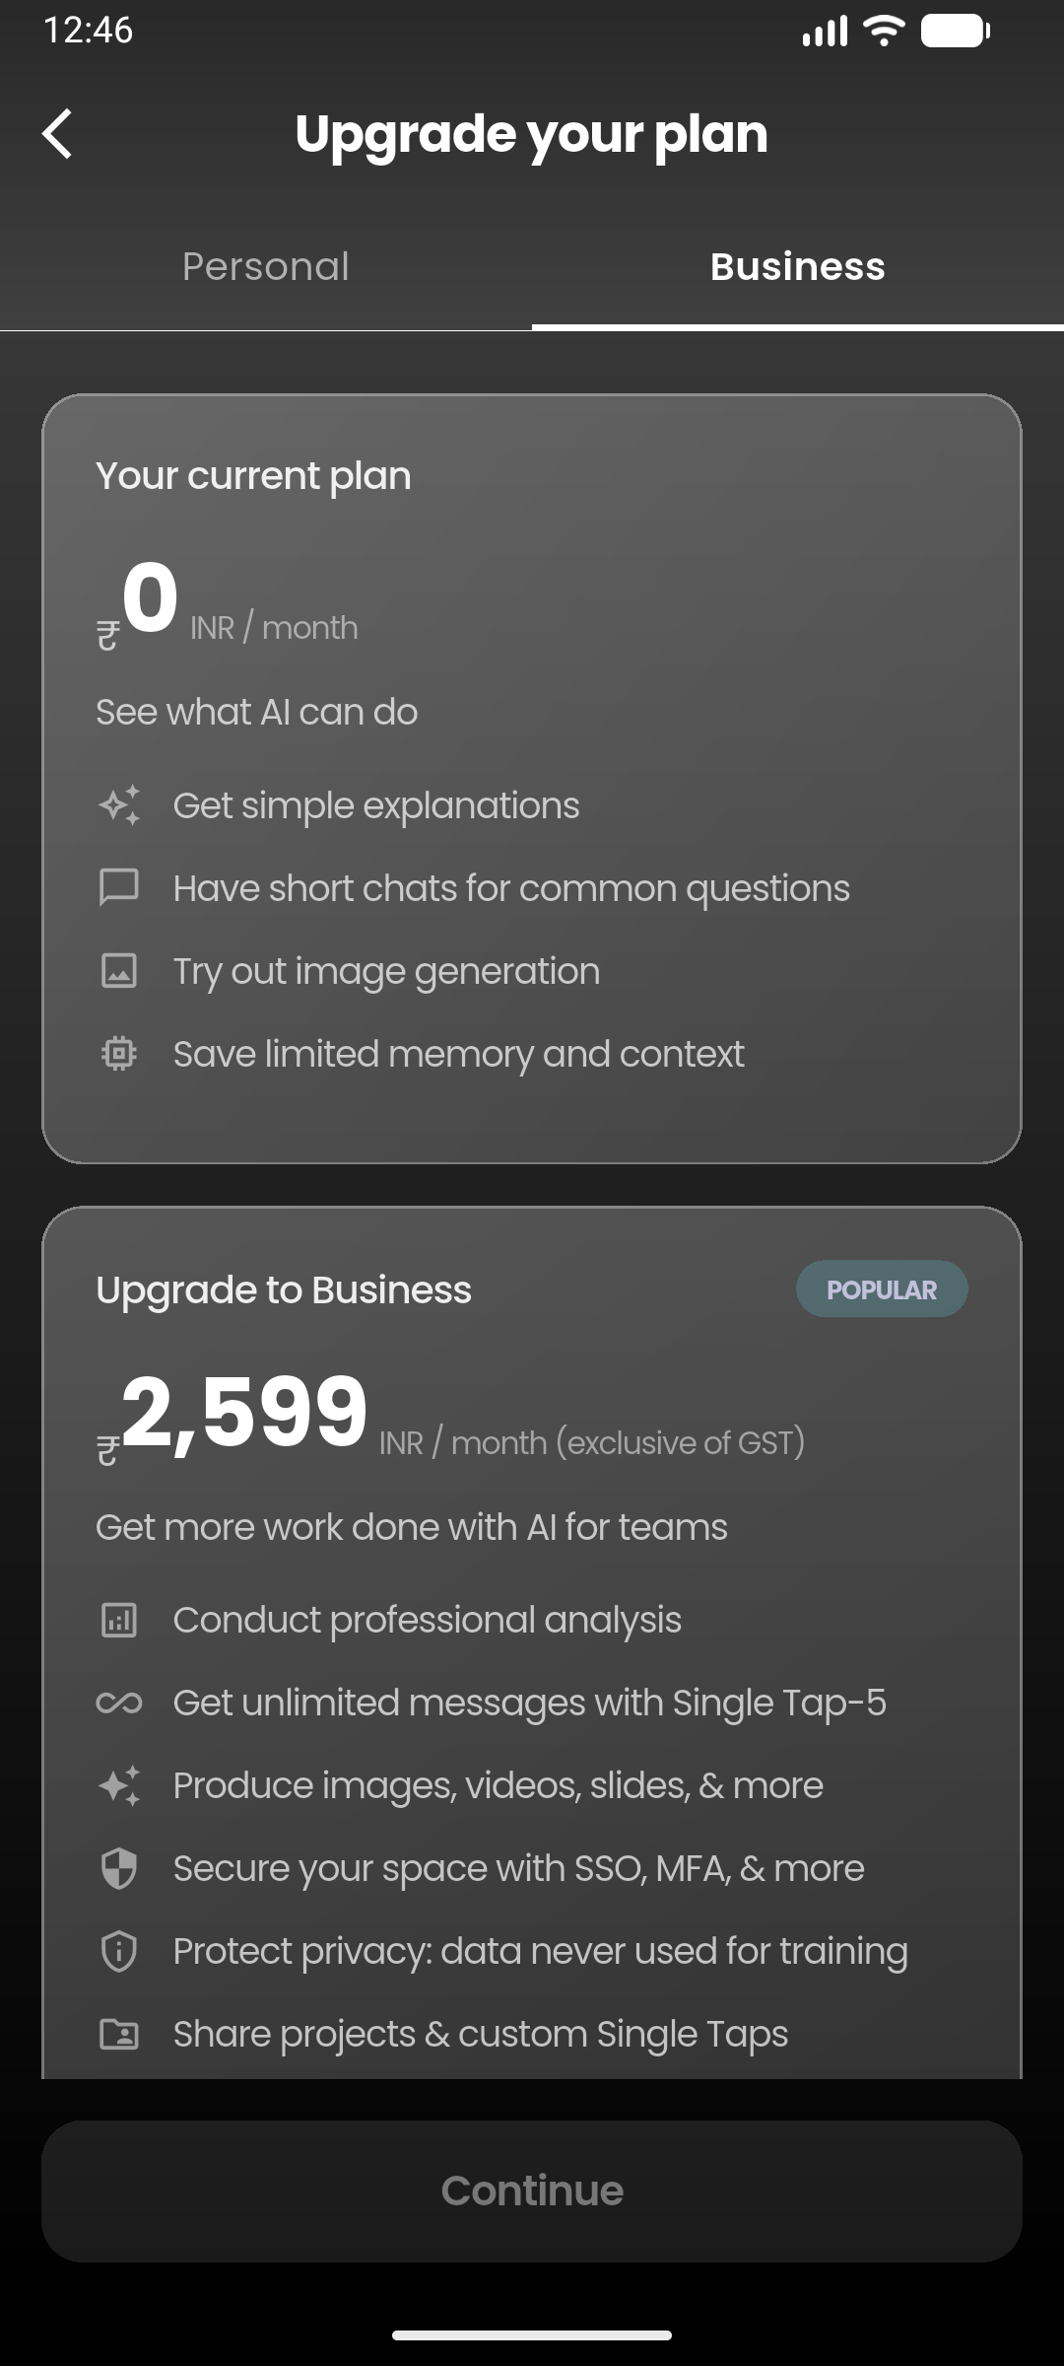
[ Profile Screen ]
Paste screenshot here

AppBar Layout
┌────────────────────────────────────────────────────┐
│ [←] Profile │
└────────────────────────────────────────────────────┘

AppBar Styling
Element | Style
Background | RGBA(64, 64, 64, 1)
Blur | BackdropFilter sigmaX: 15, sigmaY: 15
Bottom border | White, 1px
Title | "Profile", Poppins w600 white, centered
Leading | arrow_back_ios, white

Body Background
Gradient: RGBA(64, 64, 64, 1) (top) → RGBA(0, 0, 0, 1) (bottom)

Profile Header Card
┌──────────────────────────────────┐
│ │
│ (Profile Photo) │ ← UserAvatar, radius 60
│ │
│ User Name │ ← Poppins 28px bold white
│ email@example.com │ ← Poppins 14px white70
│ 📍 City, Area Pincode │ ← Poppins 16px white70
│ │
└──────────────────────────────────┘

Profile Header Card Styling
Property | Value
Margin | fromLTRB(16, 0, 16, 16)
Background gradient | Colors.white alpha 0.25 → 0.15
Border | Colors.white alpha 0.3
Border radius | 16
Blur | BackdropFilter sigmaX: 10, sigmaY: 10
Padding (inner) | 20 all

Profile Header Typography
Element | Family | Size | Weight | Color | Align
Name | Poppins | 28 | bold | white | center
Email | Poppins | 14 | normal | white 70% opacity | center
Location icon | location_on_rounded | 20 | — | white 70% opacity | —
Location text | Poppins | 16 | normal | white 70% opacity | center

Active Status Card
Property | Value
Margin | fromLTRB(16, 0, 16, 8)
Background gradient | Colors.white alpha 0.25 → 0.15
Border | Colors.white alpha 0.3
Border radius | 12
Padding | horizontal: 12, vertical: 8

Active Status — Icon Container
Property | Value (active) | Value (inactive)
Size | 40 × 40 | 40 × 40
Background | AppColors.iosGreen alpha 0.2 | White alpha 0.15
Border radius | 10 | 10

Active Status — Toggle
- Updates showOnlineStatus and isOnline in Firestore
- Shows glassmorphism snackbar with visibility feedback

Action Cards
Card | Icon | Navigation
Edit Profile | edit_outlined | ProfileEditScreen
Account Type | calendar_view_week_rounded | Account type dialog (Personal/Business)
Invite Friends | person_add_alt_1_rounded | Share.share() with app link
Settings | settings_outlined | SettingsScreen

Action Card Styling
Property | Value
Margin | fromLTRB(16, 0, 16, 8)
Background gradient | Colors.white alpha 0.25 → 0.15
Border | Colors.white alpha 0.3
Border radius | 12
Icon container | 40×40, white alpha 0.15, border radius 10
Icon size | 20, white
Title | Poppins 15px w600 white
Chevron | chevron_right, white alpha 0.3

Account Type Dialog
Property | Value
Background | #2A2A2A
Border | White24, 0.5px
Border radius | 16
Title | "Account Type", Poppins w600 white
Options | Personal, Business
Selected border | #007AFF, 1.5px
Check icon | check_circle, #007AFF

Data Lifecycle
- Real-time StreamSubscription on users/{uid} document
- Optimization: Only calls setState when meaningful data changes (city, location, interests)
- Background location update on init (silent, non-blocking)

SCREEN 6

Upgrade Plan Screen
File: lib/screens/profile/upgrade_plan_screen.dart
Purpose: Displays subscription plans in 2 tabs (Personal/Business). No actual payment integration — tapping Continue shows a snackbar with the selected plan.
📱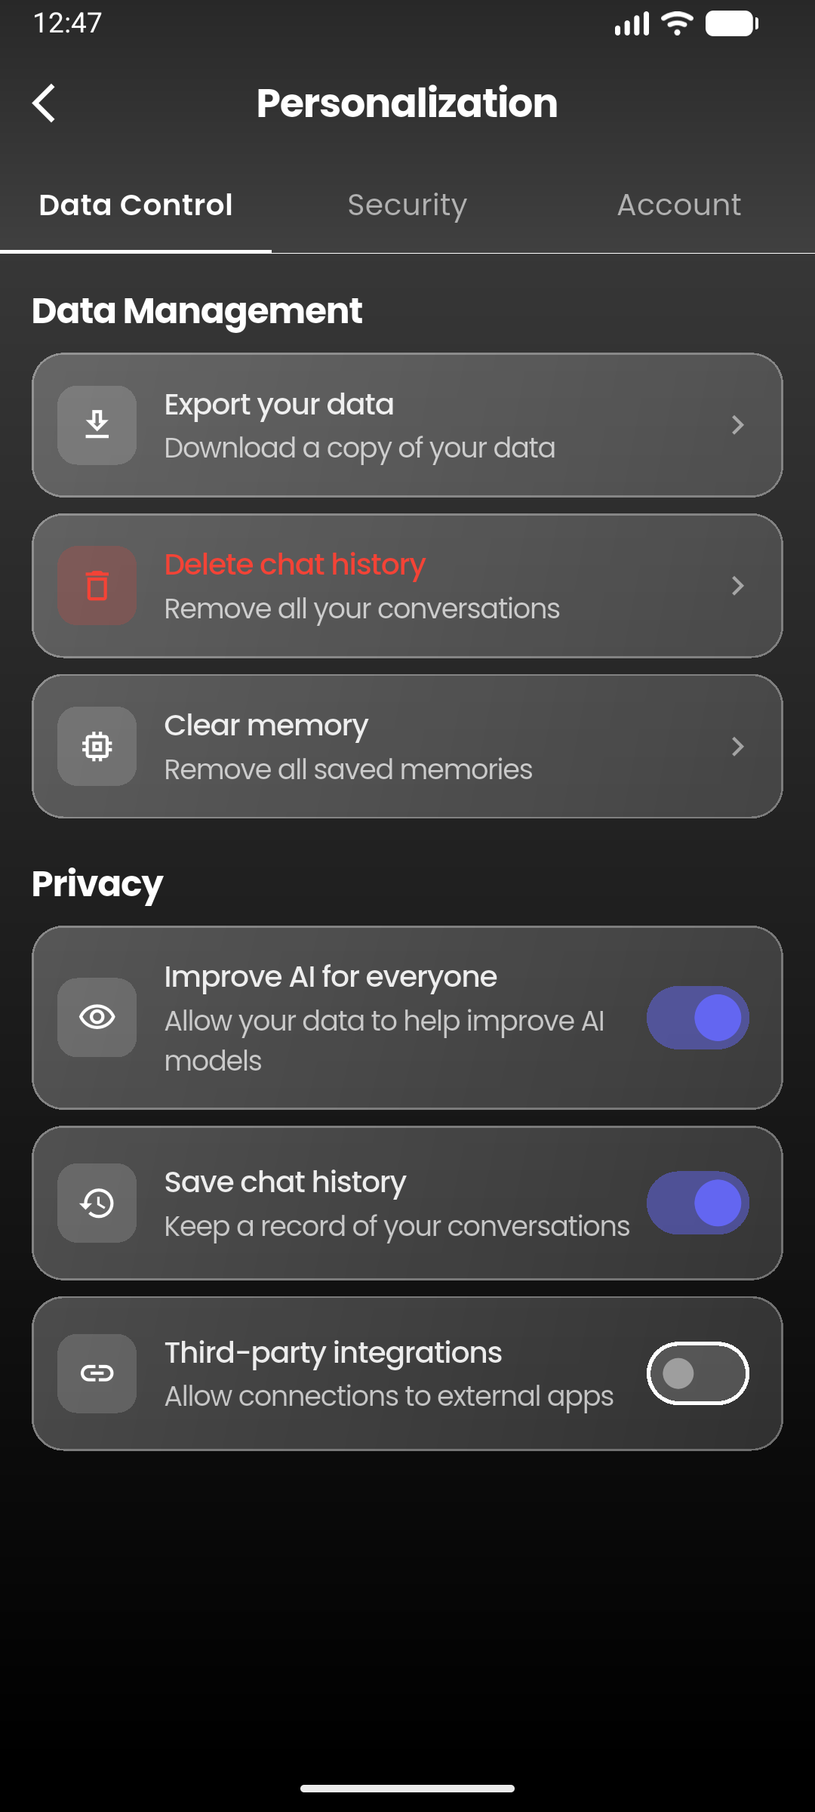
[ Upgrade Plan Screen ]
Paste screenshot here

AppBar Layout
┌────────────────────────────────────────────────────┐
│ [←] Upgrade your plan │
├────────────────────────────────────────────────────┤
│ Personal │ Business │
└────────────────────────────────────────────────────┘

AppBar Styling
Element | Style
Background | Transparent
FlexibleSpace gradient | #282828 (top) → #404040 (bottom)
Bottom border | White, 0.5px
Title | "Upgrade your plan", Poppins 20px bold white, centered
Leading | arrow_back_ios, white

Tab Bar Styling
Property | Value
Indicator size | TabBarIndicatorSize.tab
Indicator color | White
Indicator weight | 2
Divider | Transparent
Label color (selected) | White
Label style (selected) | Poppins, 15px, w600
Label color (unselected) | White 60% opacity
Label style (unselected) | Poppins, 15px, normal

Body Background
AppBackground with showParticles: false

Personal Plans
Plan | Price | Period | Badge
Free | ₹0 | INR / month | —
Go | ₹399 | INR / month (incl. GST) | —
Plus | ₹1,999 | INR / month (incl. GST) | POPULAR
Pro | ₹19,900 | INR / month (incl. GST) | —

Business Plans
Plan | Price | Period | Badge
Free | ₹0 | INR / month | —
Business | ₹2,599 | INR / month (excl. GST) | POPULAR

Plan Card Styling
Property | Value (normal) | Value (selected)
Background gradient | Colors.white 0.25 → 0.15 | #6366f1 0.25 → 0.15
Border color | Colors.white alpha 0.3 | #6366f1 alpha 0.5
Border width | 1 | 1
Border radius | 16 | 16
Padding | 20 all | 20 all

Plan Card Typography
Element | Family | Size | Weight | Color
Button text | Poppins | 15 | w500 | white 90% opacity
Currency (₹) | Poppins | 16 | normal | white70
Price | Poppins | 36 | bold | white
Period | Poppins | 12 | normal | white 50% opacity
Description | Poppins | 14 | normal | white 70% opacity
Feature icon | — | 18 | — | white 50% opacity
Feature text | Poppins | 14 | normal | white 70% opacity
Footer text | Poppins | 11 | normal | white 40% opacity

Popular Badge
Property | Value
Background | RGBA(99,213,241) alpha 0.2
Border radius | 12
Padding | horizontal: 12, vertical: 4
Text | "POPULAR", Poppins 10px bold, RGBA(193,193,218)

Continue Button
Property | Value (active) | Value (inactive)
Background | #007AFF | White alpha 0.1
Text color | White | White 40% opacity
Text | "Continue", Poppins 16px w600
Width | Full
Padding | vertical: 16
Border radius | 16
Margin | 16 all

SCREEN 7

Personalization Screen
File: lib/screens/profile/personalization_screen.dart
Purpose: Data control, security, and account management. 3 tabs with toggle settings, destructive actions (delete chat history, clear memory, deactivate/delete account), and navigation to sub-screens.
📱
[ Personalization Screen 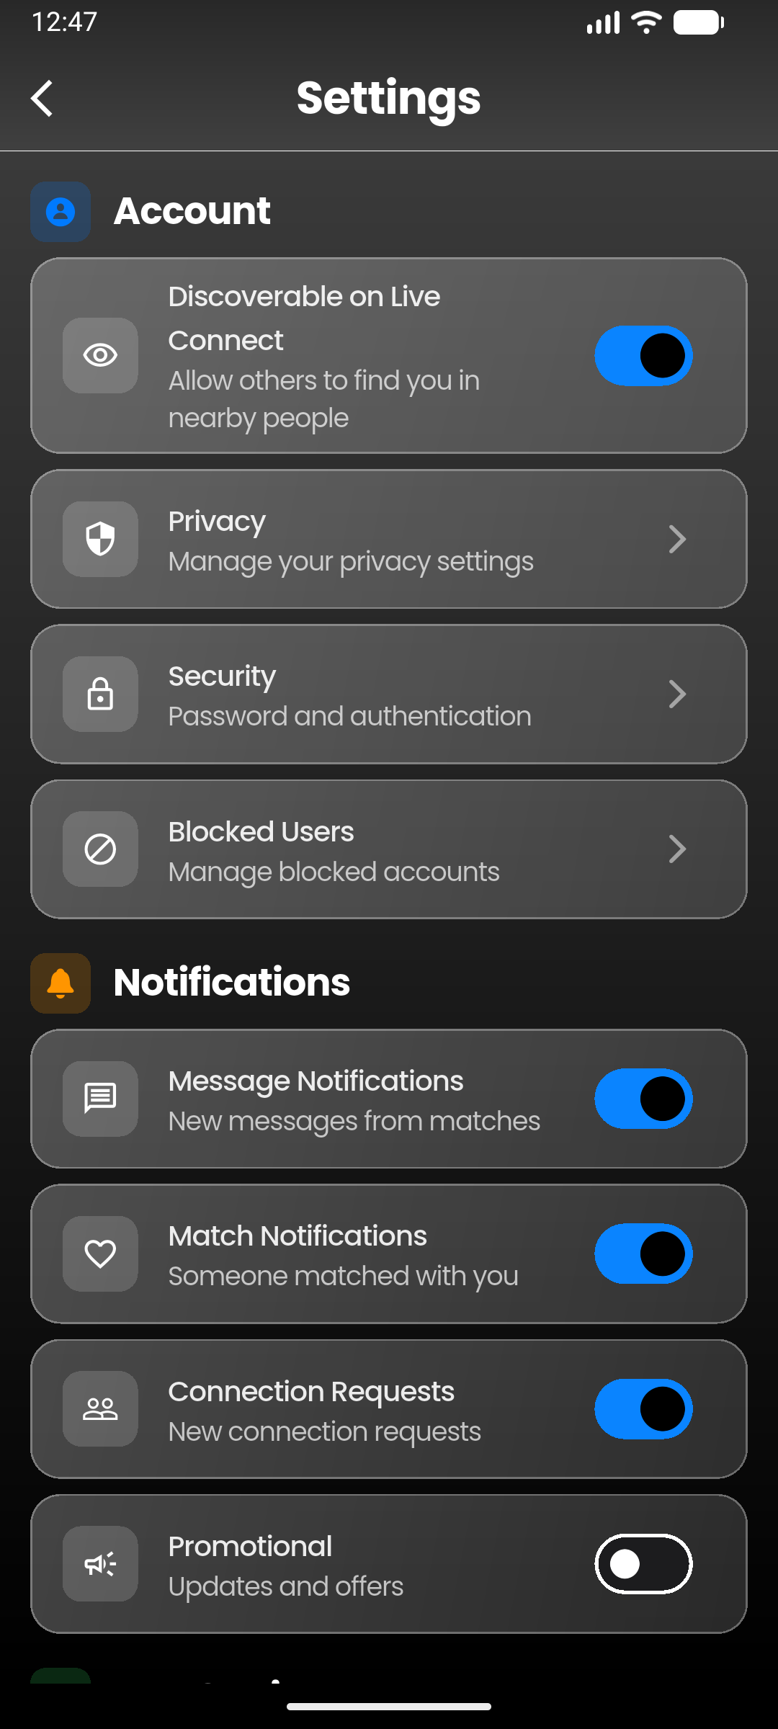]
Paste screenshot here

AppBar Layout
┌────────────────────────────────────────────────────┐
│ [←] Personalization │
├────────────────────────────────────────────────────┤
│ Data Control │ Security │ Account │
└────────────────────────────────────────────────────┘

AppBar Styling
Element | Style
Background | Transparent
FlexibleSpace gradient | #282828 (top) → #404040 (bottom)
Bottom border | White, 0.5px
Title | "Personalization", Poppins 20px bold white, centered

Tab Bar Styling
Same as Upgrade Plan Screen (Poppins 15px, white indicator, weight 2).

Body Background
AppBackground with showParticles: false, overlayOpacity: 0.7

Data Control Tab
Data Management Section:
Item | Icon | Action | Destructive
Export your data | download_outlined | Coming Soon dialog | No
Delete chat history | delete_outline | Deletes all chat_history for user | Yes
Clear memory | memory_outlined | Clears app cache directory | No
Privacy Section:
Toggle | Icon | Default | Firestore Key
Improve AI for everyone | visibility_outlined | true | improveAI
Save chat history | history_outlined | true | saveChatHistory
Third-party integrations | link_outlined | false | thirdPartyIntegrations

Security Tab
Item | Icon | Action | Destructive
Change password | lock_outline | ChangePasswordScreen | No
Active sessions | devices_outlined | Coming Soon dialog | No
Log out all devices | logout | AuthService.logoutFromOtherDevices() | Yes
Login history | history_outlined | Coming Soon dialog | No

Account Tab
Item | Icon | Action | Destructive
Edit profile | person_outline | ProfileEditScreen | No
Deactivate account | pause_circle_outline | Sets accountStatus: deactivated, signs out | Yes
Delete account | delete_forever_outlined | Double confirmation (typed "DELETE"), deletes user/posts/chat/auth | Yes

Setting Item Card Styling
Property | Value
Margin | bottom: 8
Padding | horizontal: 12, vertical: 14
Background gradient | Colors.white 0.25 → 0.15
Border | Colors.white alpha 0.3, width 1
Border radius | 16

Setting Item — Icon Container
Property | Value (normal) | Value (destructive)
Padding | 10 | 10
Background | White alpha 0.15 | Red alpha 0.2
Border radius | 10 | 10
Icon color | White | Red
Icon size | 20 | 20

Setting Item — Typography
Element | Style (normal) | Style (destructive)
Title | Poppins 15px w500 white90 | Poppins 15px w500 red
Subtitle | Poppins 14px white70 | Poppins 14px white70
Chevron | chevron_right, size 20, white50 | same

Toggle Item — Switch
Property | Value
Active thumb | #6366f1
Active track | #6366f1 alpha 0.5
Inactive thumb | Grey
Inactive track | Grey alpha 0.3

Section Header
Property | Value
Font | Poppins, 18px, bold, white

Confirmation Dialogs
Property | Value
Background | #1C1C1E
Border | Colors.white alpha 0.3
Border radius | 20
Title font | Poppins, white
Content font | Poppins, white70
Cancel color | White70
Destructive color | Red
Special input border | Red (for DELETE confirmation)

Loading Overlay
Property | Value
Background | Black alpha 0.5
Indicator | CircularProgressIndicator, color #6366f1

SCREEN 8

Settings Screen
File: lib/screens/profile/settings_screen.dart
Purpose: Comprehensive settings with sections for Account, Notifications, App Settings, Coming Soon features, and Support. Uses Riverpod for state management.
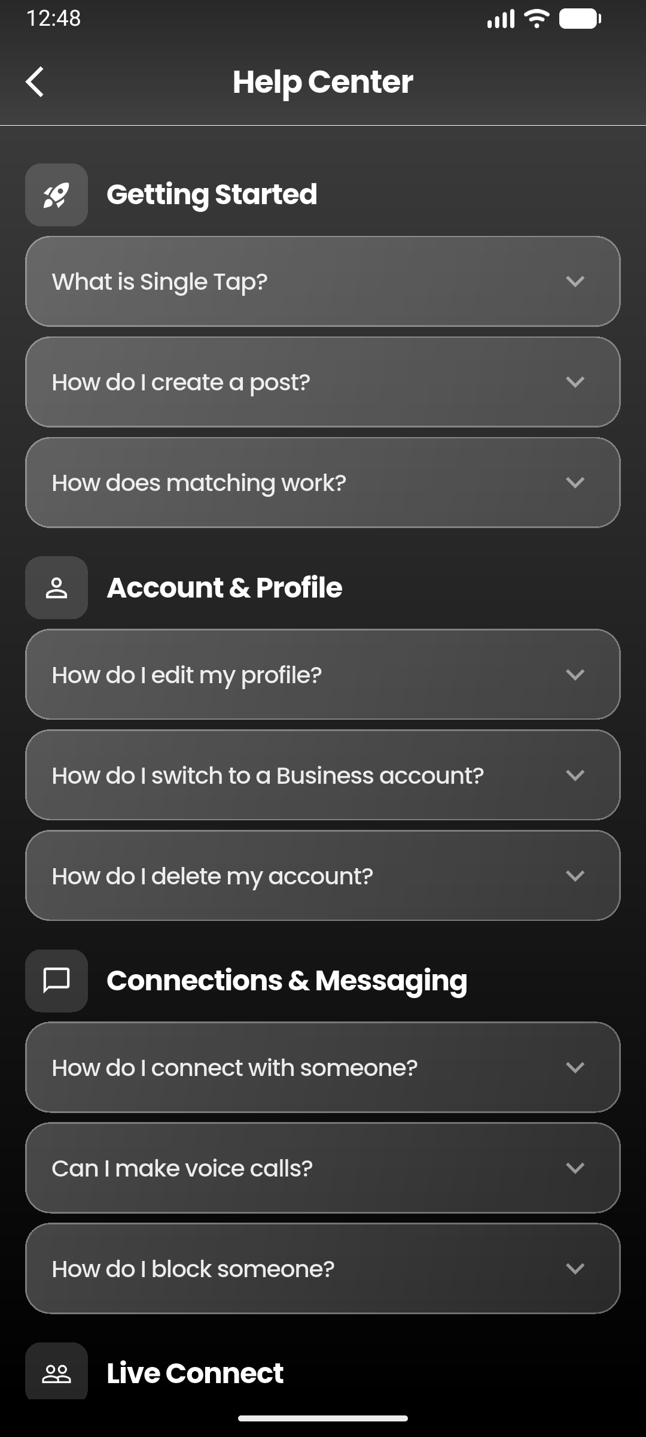
[ Settings Screen ]
Paste screenshot here

AppBar Layout
┌────────────────────────────────────────────────────┐
│ [←] Settings │
└────────────────────────────────────────────────────┘

AppBar Styling
Element | Style
Background | Transparent
FlexibleSpace gradient | #282828 (top) → #404040 (bottom)
Bottom border | White, 0.5px
Title | "Settings", Poppins 24px bold white, centered
Leading | arrow_back_ios, white

Body Background
AppBackground with showParticles: false, overlayOpacity: 0.7

Content Padding
EdgeInsets.only(top: kToolbarHeight + 40, left: 16, right: 16, bottom: 16)

Account Section
Icon | Color | Header
CupertinoIcons.person_circle_fill | AppColors.iosBlue | "Account"
Item | Type | Description
Discoverable on Live Connect | Switch | Toggle discoveryModeEnabled
Privacy | Navigation | → PersonalizationScreen
Security | Navigation | → Security options sheet
Blocked Users | Navigation | → Blocked users screen

Notifications Section
Icon | Color | Header
CupertinoIcons.bell_fill | AppColors.iosOrange | "Notifications"
Item | Firestore Key | Default
Message Notifications | messageNotifications | true
Match Notifications | matchNotifications | true
Connection Requests | connectionRequestNotifications | true
Promotional | promotionalNotifications | false

App Settings Section
Icon | Color | Header
CupertinoIcons.gear_solid | AppColors.iosGreen | "App Settings"
Item | Navigation Target
Location | LocationSettingsScreen
Storage & Data | Storage options dialog
Clear Cache | Clear cache dialog
Performance Debug | PerformanceDebugScreen

Coming Soon Section
Icon | Color | Header
CupertinoIcons.sparkles | AppColors.iosPink | "Coming Soon"
Feature | Icon | Description
Premium | workspace_premium | Unlock exclusive features
Events | event | Discover local events
Groups | groups | Join interest-based groups
Stories | auto_stories | Share your moments

Support Section
Icon | Color | Header
CupertinoIcons.question_circle_fill | AppColors.iosTeal | "Support"
Item | Navigation Target
Safety Tips | SafetyTipsScreen
About | About dialog (version 1.0.0)
Terms of Service | TermsOfServiceScreen
Privacy Policy | PrivacyPolicyScreen
Send Feedback | Feedback dialog
Report a Problem | Report problem dialog

Section Header Styling
Property | Value
Icon container | 32×32, color alpha 0.2, border radius 8
Icon size | 18
Title | Poppins, 20px, bold, white
Gap (icon → title) | 12

Individual Item Card Styling
Property | Value
Margin | bottom: 8
Background gradient | Colors.white 0.25 → 0.15
Border | Colors.white alpha 0.3, width 1
Border radius | 16
Icon container | padding 10, white alpha 0.15, border radius 10
Icon size | 20, white
Title | Poppins 15px w500 white90
Subtitle | Poppins 14px white70
Trailing | CupertinoIcons.chevron_forward, white50

Switch Item Card Styling
Same card styling as Individual Item, but with SwitchListTile instead of ListTile.

Coming Soon Badge
Gradient badge with "COMING SOON" text, shimmer-like appearance.

SCREEN 9

Help Center Screen
File: lib/screens/profile/help_center_screen.dart
Purpose: Static FAQ screen with 6 expandable categories. No API calls — all content is hardcoded.
📱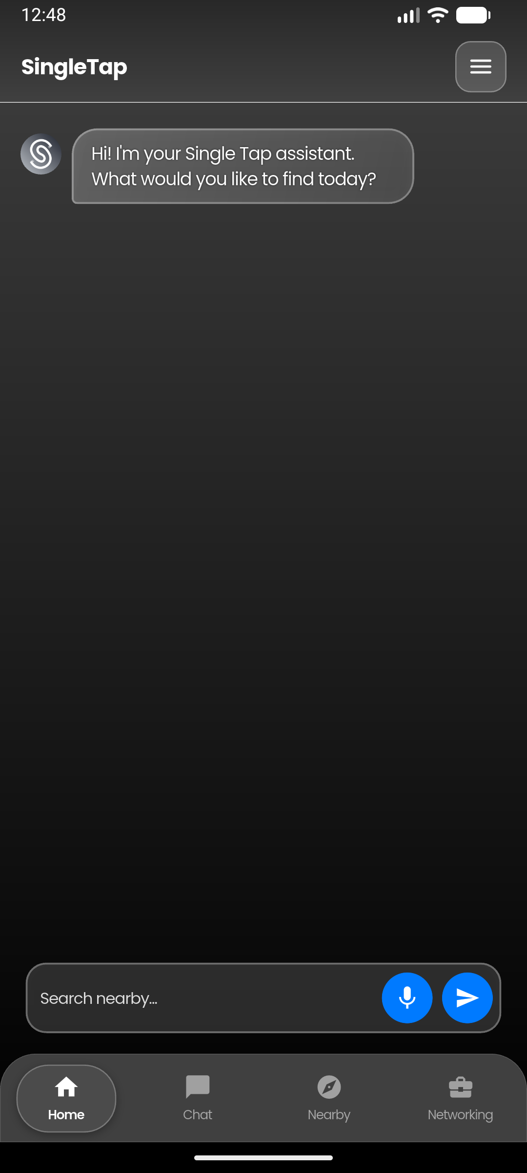
[ Help Center Screen ]
Paste screenshot here

AppBar Layout
┌────────────────────────────────────────────────────┐
│ [←] Help Center │
└────────────────────────────────────────────────────┘

AppBar Styling
Element | Style
Background | Transparent
FlexibleSpace gradient | #282828 (top) → #404040 (bottom)
Bottom border | White, 0.5px
Title | "Help Center", Poppins bold white, centered
Leading | arrow_back_ios, white

Body Background
AppBackground with showParticles: false

Content Padding
EdgeInsets.only(top: kToolbarHeight + 44, left: 16, right: 16, bottom: 16)

FAQ Categories
# | Category | Icon | Color
1 | Getting Started | rocket_launch | Blue
2 | Account & Profile | person_outline | Purple
3 | Connections & Messaging | chat_bubble_outline | Green
4 | Live Connect | people_outline | Orange
5 | Privacy & Safety | shield_outlined | Red
6 | Troubleshooting | build_outlined | Teal

Category Header
Property | Value
Icon container | padding 10, white alpha 0.15, border radius 10
Icon size | 20, white
Title | Poppins, 18px, bold, white
Gap (icon → title) | 12
Padding | top: 4, bottom: 6

FAQ Item (Expandable)
Property | Value
Margin | bottom: 6
Background gradient | Colors.white 0.25 → 0.15
Border | Colors.white alpha 0.3, width 1
Border radius | 16

FAQ Item — Question
Property | Value
Padding | 16 all
Text | Poppins, 15px, w500, white 90% opacity
Chevron (collapsed) | keyboard_arrow_down, white 50% opacity
Chevron (expanded) | keyboard_arrow_up, white 50% opacity

FAQ Item — Answer (shown on expand)
Property | Value
Padding | fromLTRB(16, 0, 16, 16)
Text | Poppins, 14px, normal, white 70% opacity, height 1.5

FAQ Content (3 per category)
Getting Started:
- What is Single Tap?
- How do I create a post?
- How does matching work?
Account & Profile:
- How do I edit my profile?
- How do I switch to a Business account?
- How do I delete my account?
Connections & Messaging:
- How do I connect with someone?
- Can I make voice calls?
- How do I block someone?
Live Connect:
- What is Live Connect?
- How do I appear on Live Connect?
- Why can't I see anyone nearby?
Privacy & Safety:
- Is my location shared with others?
- How do I report inappropriate behavior?
- Are my messages encrypted?
Troubleshooting:
- The app is running slowly
- I'm not receiving notifications
- Voice calls aren't connecting

SCREEN 10

New Chat (Drawer Feature)
File: lib/widgets/common widgets/app_drawer.dart
Purpose: First feature card in the drawer. Saves the current home-screen AI conversation to Firestore, refreshes the chat history list, then closes the drawer so the user lands on a fresh chat.
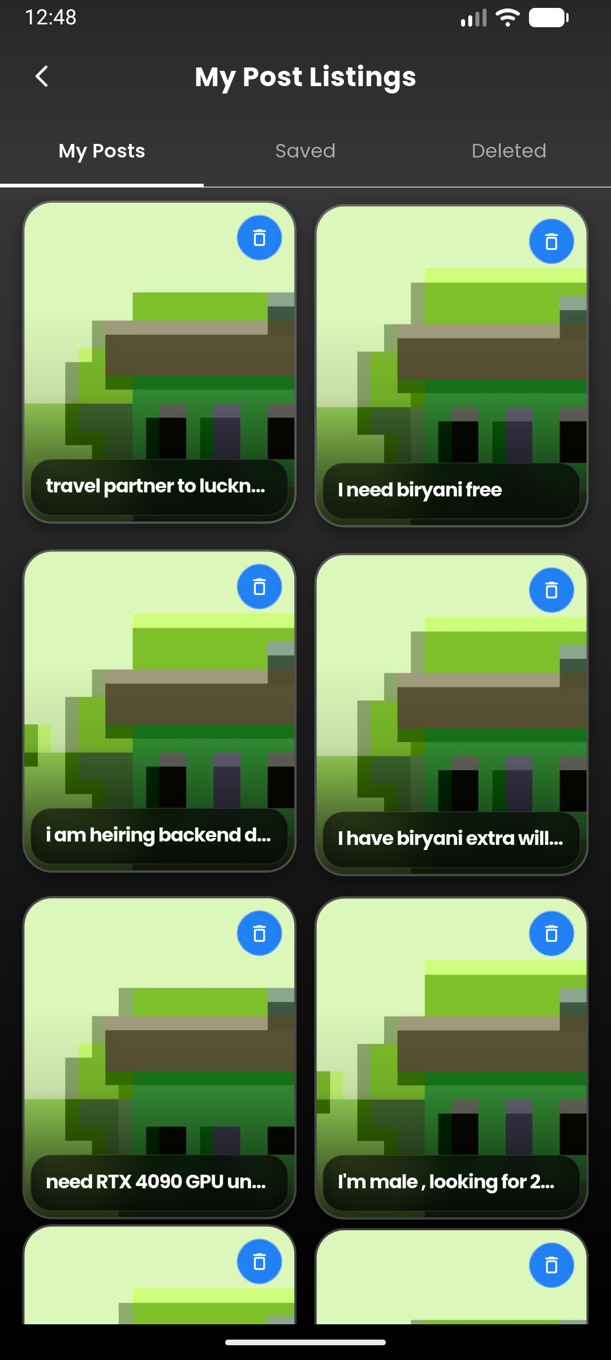
[ New Chat (Drawer Feature) ]
Paste screenshot here

Trigger
Feature card in drawer with blue icon (Icons.edit_outlined):
_buildFeatureCard(
icon: Icons.edit_outlined,
label: 'New Chat',
color: Colors.blue,
onTap: () async {
HapticFeedback.mediumImpact();
await widget.onNewChat?.call();
await _loadRecentChats();
if (context.mounted) Navigator.pop(context);
},
)

Visual Styling
Property | Value
Icon | Icons.edit_outlined
Icon Color | Colors.blue
Card Margin | horizontal 12, vertical 2
Card Padding | vertical 5, horizontal 12
Card Gradient | Colors.white alpha 0.25 → 0.15
Border | Colors.white alpha 0.3, width 1
Border Radius | 16
Label Font | Poppins, 14px, w500, white 90% opacity

Behavior Flow
- User taps "New Chat" card
- HapticFeedback.mediumImpact() fires
- widget.onNewChat?.call() is awaited — this saves the current conversation in the home screen to chat_history collection
- _loadRecentChats() refreshes the chat history list in the drawer
- Drawer closes via Navigator.pop(context)
- User is back on the home screen with a fresh empty chat

Layout Diagram
┌─────────────────────────────────────┐
│ 🔵 ✏️ New Chat │
│ (blue icon, glassmorphism) │
└─────────────────────────────────────┘

SCREEN 11

My Posts Screen
File: lib/screens/home/api_my_posts_screen.dart
Purpose: Displays the current user's post listings in a tabbed interface with 3 tabs: My Posts (active), Saved, and Deleted. Each tab shows posts in a 2-column grid with floating card animations. Supports soft-delete, permanent delete, restore, unsave, and auto-delete of 30-day-old deleted posts.
📱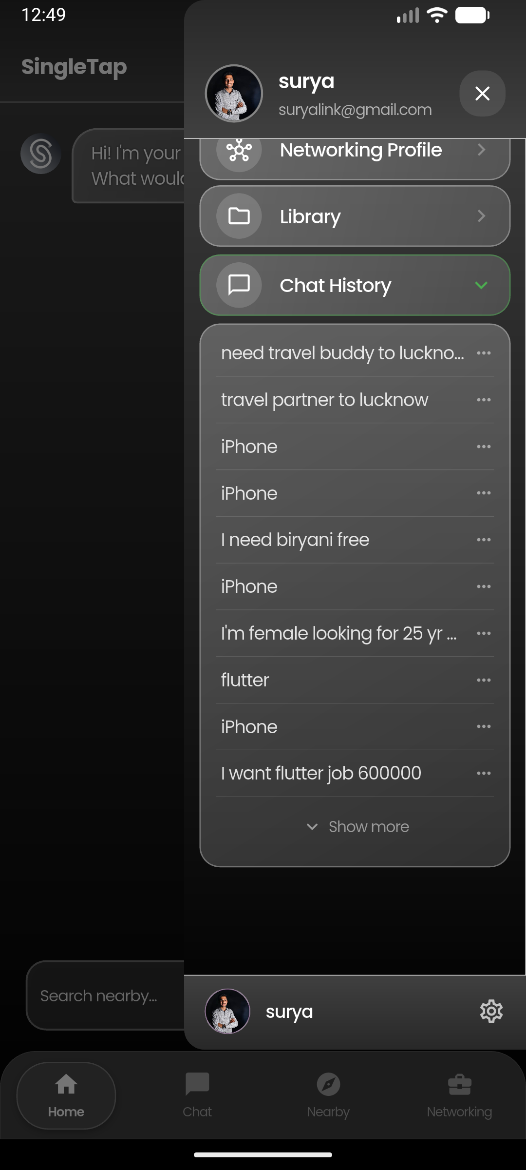
[ My Posts Screen ]
Paste screenshot here

Constructor Parameters
Parameter | Type | Required | Default | Description
key | Key? | No | null | Standard widget key

State Variables
Variable | Type | Description
_tabController | TabController | 3 tabs: My Posts, Saved, Deleted
_currentUserName | String | Logged-in user's display name
_currentUserPhoto | String? | Logged-in user's photo URL
_isAutoDeleting | bool | Prevents duplicate auto-delete operations

Layout Diagram
┌──────────────────────────────────────────┐
│ ← My Post Listings │
│ ─────────────────────────────────────── │
│ [ My Posts ] [ Saved ] [ Deleted ] │
│ ─────────────────────────────────────── │
│ │
│ ┌──────────┐ ┌──────────┐ │
│ │ Image │ │ Image │ │
│ │ │ │ │ │
│ │ ┌──────┐ │ │ ┌──────┐ │ │
│ │ │Title │ │ │ │Title │ │ │
│ │ │Brand │ │ │ │Brand │ │ │
│ │ │₹Price│ │ │ │₹Price│ │ │
│ │ └──────┘ │ │ └──────┘ │ │
│ └──────────┘ └──────────┘ │
│ │
│ ┌──────────┐ ┌──────────┐ │
│ │ Image │ │ Image │ │
│ │ │ │ │ │
│ │ ┌──────┐ │ │ ┌──────┐ │ │
│ │ │Title │ │ │ │Title │ │ │
│ │ │Brand │ │ │ │Brand │ │ │
│ │ │₹Price│ │ │ │₹Price│ │ │
│ │ └──────┘ │ │ └──────┘ │ │
│ └──────────┘ └──────────┘ │
└──────────────────────────────────────────┘

AppBar Styling
Property | Value
Title | "My Post Listings", Poppins 18px w700 white
Back Icon | arrow_back_ios_new_rounded, size 18, white
Background | Transparent
FlexibleSpace Gradient | Colors.black alpha 0.4 → 0.2 → transparent
TabBar Indicator | White, weight 1, tab-size indicator
TabBar Label | Poppins 13px w600 white
TabBar Unselected | Poppins 13px normal, white 60% opacity
Tab Names | "My Posts", "Saved", "Deleted"
Divider below tabs | White, height 0.5

Body Styling
Property | Value
Background Gradient | #404040 → #000000
Grid Columns | 2
Grid Padding | fromLTRB(15, 12, 15, 90)
Cross-axis Spacing | 12
Main-axis Spacing | 12
Child Aspect Ratio | 0.85
Scroll Physics | BouncingScrollPhysics

Floating Card Animation
Each post card is wrapped in _FloatingCard — an animated widget that:
- Uses SingleTickerProviderStateMixin
- Duration: 1600 + (index % 6) * 220 ms per card (staggered)
- Oscillates vertically between -6.0 and +6.0 px
- Curve: Curves.easeInOut, repeats in reverse

Post Card Styling
Property | Value
Border Radius | 20 (outer), 18.5 (ClipRRect inner)
Border | Colors.white alpha 0.25, width 1.5
Box Shadow | black alpha 0.4, blur 8, offset (0, 4)
Bottom Gradient | transparent → black alpha 0.1 → 0.80 (stops 0.35, 0.6, 1.0)
Bottom Info Bar | Glassmorphism — blur(12, 12), black alpha 0.55, radius 14, border white alpha 0.15
Title Font | Poppins, 13px, w700, white
Sub-category Font | Poppins, 11px, normal, white 85% opacity
Price Font | Poppins, 13px, w700, color #00D67D (green)
Price Format | ₹ prefix, comma-separated

Top-Right Action Buttons
Tab | Icon | Action
My Posts | delete_outline_rounded | Soft delete (moves to Deleted tab)
Saved | bookmark_rounded | Unsave (removes from saved_posts)
Deleted | restore_rounded + delete_forever_rounded | Restore or permanently delete
Button styling: #016CFF alpha 0.85 background, white icon (15px), circle shape with blur(8, 8), white alpha 0.4 border.

Badges
- Remaining Days (Deleted tab): Shows "X days left" in red badge when ≤7 days, dark bg otherwise. Timer icon + text, Poppins 10px w600.
- Donation Badge: Orange alpha 0.9 background, "Donation" text, Poppins 10px w700.

Dialogs
Soft Delete Dialog:
- Gradient: #404040 → #0F0F0F
- Icon: delete_outline_rounded in red alpha 0.15 circle
- Title: "Delete Post?" Poppins 17px bold
- Body: Explains 30-day retention
- Buttons: Cancel (glass) + Delete (AppColors.error)
Restore Dialog:
- Same style, green accent (AppColors.success)
- Title: "Restore Post?"
Permanent Delete Dialog:
- Same style, red accent
- Title: "Delete Permanently?"
- Warning: "This action cannot be undone"

Firestore Queries
Tab | Collection | Query
My Posts | posts | where('userId', ==) + orderBy('createdAt', desc) + limit(50)
Saved | users/{uid}/saved_posts | orderBy('savedAt', desc) + limit(50)
Deleted | posts | where('userId', ==) + orderBy('createdAt', desc) + limit(100)
- My Posts tab: Client-side filters isActive != false
- Deleted tab: Client-side filters isActive == false, auto-deletes posts older than 30 days
- All tabs: Client-side deduplication via Set<String> on doc IDs

Navigation
Tapping a post card navigates via custom _ExpandRoute (slide-in from left):
Navigator.push(context, _ExpandRoute(
builder: (_) => ApiListingDetailScreen(
postId: postId,
post: post,
isDeleted: cardType == _CardType.deleted,
showCallButton: false,
),
));
Transition: 500ms forward, 400ms reverse, easeOutQuart / easeInQuart curves, fade from 0.5.

Empty State
- Icon in glass circle (icon color white54, size 64)
- Title: AppTextStyles.titleLarge, white
- Subtitle: AppTextStyles.bodyMedium, white60

SCREEN 12

Chat History (Inline Feature)
File: lib/widgets/common widgets/app_drawer.dart
Purpose: Expandable section inside the drawer that shows recent AI chat conversations from the `chat_history` Firestore collection. Users can tap to load a chat, pin/unpin chats, share, or delete them.
📱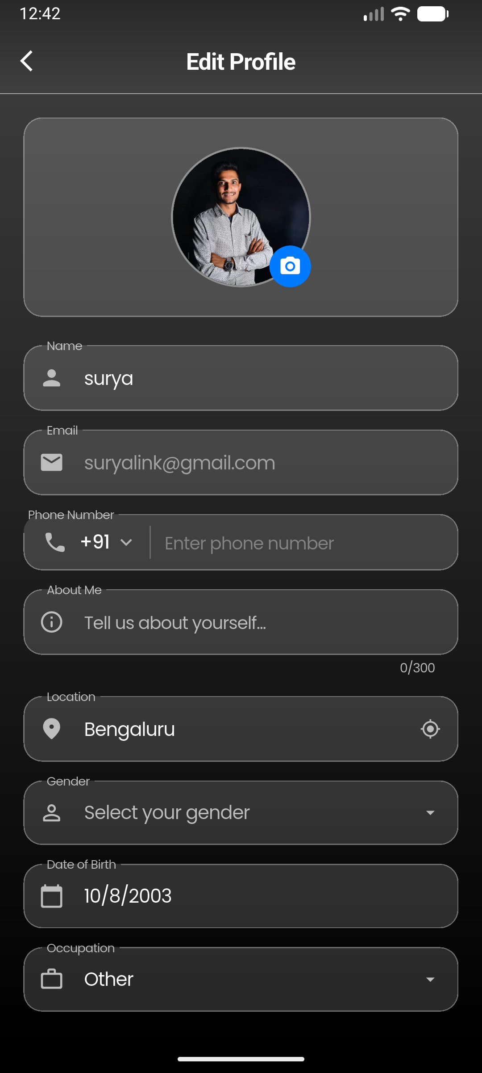
[ Chat History (Inline Feature) ]
Paste screenshot here

Trigger
Expandable feature card in drawer with green icon (Icons.chat_bubble_outline):
_buildExpandableFeatureCard(
icon: Icons.chat_bubble_outline,
label: 'Chat History',
color: Colors.green,
isExpanded: _showChatHistory,
onTap: () {
HapticFeedback.lightImpact();
setState(() => _showChatHistory = !_showChatHistory);
},
)

Visual Styling — Expandable Card
Property | Value
Icon | Icons.chat_bubble_outline
Icon Color | Colors.green
Card Margin | horizontal 12, vertical 2
Card Padding | vertical 5, horizontal 12
Card Gradient | Colors.white alpha 0.25 → 0.15
Border | Colors.white alpha 0.3, width 1
Border Radius | 16
Label Font | Poppins, 14px, w500, white 90% opacity
Expand Indicator | keyboard_arrow_down / keyboard_arrow_up, white 50% opacity

Chat List Container Styling
Property | Value
Margin | left 12, right 12, top 2, bottom 4
Gradient | Colors.white alpha 0.25 → 0.15
Border | Colors.white alpha 0.3, width 1
Border Radius | 16
Empty Text | "No chats yet", Poppins 14px, white 50% opacity

Chat Item Styling
Property | Value
Margin | horizontal 4
Padding | left 12, top 4, bottom 4, right 2
Background (unread) | Colors.white alpha 0.05
Background (read) | Transparent
Border Radius | 6
Chat Name Font | Poppins, 14px, white 85% opacity
Chat Name (unread) | FontWeight.w600
Chat Name (read) | FontWeight.normal
Unread Dot | Blue, 6px circle, margin-right 4
Pin Icon | Icons.push_pin, white alpha 0.4, size 12
Divider | White alpha 0.12, height 0.5, margin horizontal 12

Data Loading
Loads from chat_history collection:
_firestore
.collection('chat_history')
.where('userId', isEqualTo: user.uid)
.limit(50)
.get();
- Filters out archived chats (isArchived == true)
- Filters out project chats (projectId != null, shown in Library instead)
- Deduplicates by document ID
- Sorts: pinned chats first, then by createdAt (newest first)
- Limits display to first 20 chats
- Shows first 10 initially; "Show more" button reveals all 20

Chat Item Context Menu
3-dot menu (Icons.more_horiz) as PopupMenuButton:
Action | Icon | Description
Share | share_outlined | Exports chat messages as text via share_plus
Pin/Unpin | push_pin_outlined / push_pin | Toggles isPinned field in Firestore
Delete | delete_outline | Shows confirmation, then deletes from chat_history
Menu styling: #2D2D2D background, rounded corners (radius 12), items 44px height, Poppins 14px. Delete text is red.

Show More Button
When there are >10 chats, shows at index 10:
- Text: "Show all X chats" or "Show less"
- Font: Poppins 13px w500, white 50% opacity
- Background: transparent

Layout Diagram
┌──────────────────────────────────────┐
│ 🟢 💬 Chat History ▾ │ ← Expandable card
├──────────────────────────────────────┤
│ ┌──────────────────────────────────┐│
│ │ 📌 Pinned Chat Name ••• ││ ← Pinned first
│ │ ──────────────────────────────── ││
│ │ Chat Name ••• ││
│ │ ──────────────────────────────── ││
│ │ Chat Name 🔵 ••• ││ ← Unread dot
│ │ ──────────────────────────────── ││
│ │ ... ││
│ │ ──────────────────────────────── ││
│ │ Show all 15 chats ││ ← Show more
│ └──────────────────────────────────┘│
└──────────────────────────────────────┘

SCREEN 13

Edit Profile Screen
File: lib/screens/profile/profile_edit_screen.dart
Purpose: Full profile editing form accessible from the Profile screen ("Edit Profile" button). Allows users to update their name, phone number (with country code picker), bio, location (with auto-detect), gender, date of birth, occupation, and profile photo (camera or gallery).
📱
[ Edit Profile Screen ]
Paste screenshot here

Constructor Parameters
Parameter | Type | Required | Default | Description
key | Key? | No | null | Standard widget key

State Variables
Variable | Type | Description
_formKey | GlobalKey<FormState> | Form validation key
_nameController | TextEditingController | User's display name
_phoneController | TextEditingController | Phone number (without country code)
_locationController | TextEditingController | City / location text
_bioController | TextEditingController | About me text (max 300 chars)
_currentPhotoUrl | String? | Current profile photo URL
_selectedImage | File? | Locally picked image (camera/gallery)
_selectedGender | String? | Selected gender option
_selectedOccupation | String? | Selected occupation
_selectedDateOfBirth | DateTime? | Picked date of birth
_selectedCountryCode | String | Default '+91' (India)
_isLoading | bool | Initial profile load state
_isUpdating | bool | Save/upload in progress
_isUpdatingLocation | bool | Location detect in progress

Services Used
Service | Usage
AuthService | Get current user
UserManager | Load cached profile, update profile cache
FirebaseFirestore | Read/write to users collection
FirebaseStorage | Upload profile images to profile_images/{uid}.jpg
ImagePicker | Pick from gallery or take photo (quality 95, max 1920px)
IpLocationService | Auto-detect location from IP

Layout Diagram
┌──────────────────────────────────────────┐
│ ← Edit Profile │
│ ─────────────────────────────────────── │
│ │
│ ┌────────────┐ │
│ │ │ │
│ │ Avatar │ 📷 │
│ │ (120x120) │ │
│ └────────────┘ │
│ │
│ ┌──────────────────────────────────┐ │
│ │ 👤 Name │ │
│ └──────────────────────────────────┘ │
│ ┌──────────────────────────────────┐ │
│ │ ✉️ Email (read-only) │ │
│ └──────────────────────────────────┘ │
│ ┌──────────────────────────────────┐ │
│ │ 📞 +91 ▾ │ Phone Number │ │
│ └──────────────────────────────────┘ │
│ ┌──────────────────────────────────┐ │
│ │ ℹ️ About Me (max 300) │ │
│ └──────────────────────────────────┘ │
│ ┌──────────────────────────────────┐ │
│ │ 📍 Location 🎯 │ │
│ └──────────────────────────────────┘ │
│ ┌──────────────────────────────────┐ │
│ │ 👤 Gender ▾ │ │
│ └──────────────────────────────────┘ │
│ ┌──────────────────────────────────┐ │
│ │ 📅 Date of Birth │ │
│ └──────────────────────────────────┘ │
│ ┌──────────────────────────────────┐ │
│ │ 💼 Occupation ▾ │ │
│ └──────────────────────────────────┘ │
│ │
│ ┌──────────────────────────────────┐ │
│ │ Update Profile │ │
│ └──────────────────────────────────┘ │
└──────────────────────────────────────────┘

AppBar Styling
Property | Value
Title | "Edit Profile", 20px bold white
Toolbar Height | 56
Back Icon | Icons.arrow_back_ios, size 22, white
Background | Transparent
FlexibleSpace | Gradient #282828 → #404040, bottom border white 0.5px

Body Styling
Property | Value
Background Gradient | #404040 → #000000
ScrollView Padding | 20 all
Spacing between fields | 16 (SizedBox)

Profile Image Section
Property | Value
Container Width | Full width
Container Padding | vertical 24
Container Border Radius | 16
Container Border | Colors.white alpha 0.3, width 1
Container Background | Colors.white alpha 0.15
Avatar Size | 120 x 120, circle
Avatar Border | Colors.white alpha 0.3, width 2
Camera Button | AppColors.iosBlue circle, camera_alt icon (20px white)
Camera Button Position | Bottom-right of avatar

Image Picker Options
Uses SharedFormWidgets.showImagePickerDialog:
- Pick from Gallery (quality 95, max 1920x1920)
- Take Photo (quality 95, max 1920x1920)
- Remove Photo (if existing photo)

Input Field Styling (Glassmorphism)
All fields use SharedFormWidgets.glassInputDecoration:
Property | Value
Fill Color | Colors.white alpha 0.15
Border Radius | 16
Enabled Border | Colors.white alpha 0.3, width 1
Focused Border | Colors.white alpha 0.5, width 1.5
Label Style | Colors.grey[400], 14px
Floating Label | white70, 14px
Text Style | White, 16px
Hint Style | White alpha 0.35, 15px
Prefix Icon Color | Colors.grey[400], size 22

Form Fields
Field | Type | Prefix Icon | Validation | Extra
Name | TextFormField | person_rounded | Required | —
Email | TextFormField | email_rounded | — | Read-only, disabled, dimmed (50% opacity)
Phone | Custom Row | phone_rounded | — | Country code picker + digits only, max 15
About Me | TextFormField | info_outline_rounded | — | Multiline, max 300 chars
Location | TextFormField | location_on_rounded | — | Auto-detect button (my_location icon)
Gender | GestureDetector | person_outline_rounded | — | Custom dropdown sheet
Date of Birth | GestureDetector | calendar_today_rounded | — | DatePicker dialog, dark theme
Occupation | GestureDetector | work_outline_rounded | — | Custom dropdown sheet

Country Code Picker
- 30 countries pre-loaded (India, USA, UK, Australia, UAE, etc.)
- Shows as bottom sheet (CountryCodePickerSheet)
- Default: +91 (India)
- Divider between code and phone input: white alpha 0.2, 1px wide, 28px tall

Date Picker Dialog
Property | Value
Theme | Dark
Background | #1a1a2e
Primary Color | AppColors.iosBlue
Shape | Rounded, radius 16, white alpha 0.3 border
Cancel Button | White text, white alpha 0.3 border, radius 12
Confirm Button | White text, AppColors.iosBlue background, radius 12
Initial Date | Saved DOB or year 2000
Date Range | 1950 – now

Update Button
Property | Value
Width | Full width
Padding | vertical 16
Background | AppColors.iosBlue
Border Radius | 16
Text | "Update Profile", white 18px bold
Loading State | CircularProgressIndicator (strokeWidth 2, white, 20x20)

Save Flow
- Validates form via _formKey.currentState!.validate()
- Uploads new photo to Firebase Storage if _selectedImage != null
- Updates Firebase Auth profile (displayName, photoURL)
- Writes to Firestore users/{uid} with merge (name, email, photoUrl, phone, location, city, bio, occupation, gender, dateOfBirth, age, lastSeen, isOnline)
- Updates UserManager cache
- Shows success snackbar
- Calls Navigator.pop(context, true) — returns true to signal profile was updated

Screen Navigation Flow
┌─────────────────────────────────────────────────────────────┐
│ APP DRAWER │
│ │
│ Feature Cards: │
│ ├── New Chat ───────→ (callback, stays on Home) │
│ ├── Downloads ──────→ DownloadsScreen │
│ │ └── FullScreenImageViewer │
│ │ └── VideoPlayerScreen │
│ ├── Notification ───→ NotificationsScreen │
│ ├── My Posts ───────→ ApiMyPostsScreen │
│ ├── Networking ─────→ NetworkingProfilesPageScreen │
│ ├── Library ────────→ LibraryScreen │
│ └── Chat History ───→ (expandable inline list) │
│ │
│ Profile Menu (⚙️): │
│ ├── Profile ────────→ ProfileWithHistoryScreen │
│ │ ├── ProfileEditScreen │
│ │ └── SettingsScreen │
│ ├── Upgrade Plan ───→ UpgradePlanScreen │
│ ├── Personalization → PersonalizationScreen │
│ │ ├── ChangePasswordScreen │
│ │ └── ProfileEditScreen │
│ ├── Settings ───────→ SettingsScreen │
│ │ ├── PersonalizationScreen │
│ │ ├── LocationSettingsScreen │
│ │ ├── PerformanceDebugScreen │
│ │ ├── TermsOfServiceScreen │
│ │ ├── PrivacyPolicyScreen │
│ │ └── SafetyTipsScreen │
│ ├── Help ───────────→ HelpCenterScreen │
│ └── Log out ────────→ OnboardingScreen (clears stack) │
└─────────────────────────────────────────────────────────────┘

Shared Design System

Consistent Background Gradients
Location | Start | End
AppBar flexibleSpace | #282828 (RGBA 40,40,40) | #404040 (RGBA 64,64,64)
Body background | #404040 (RGBA 64,64,64) | #000000 (RGBA 0,0,0)
Drawer background | #404040 (RGBA 64,64,64) | #000000 (RGBA 0,0,0)
Profile Menu popup | #323232 (RGBA 50,50,50) | #191919 (RGBA 25,25,25)

Font Family
Poppins — used exclusively across all screens. No other font family is used.

Glassmorphism Card Pattern
All screens use consistent glass-card styling:
- LinearGradient with Colors.white alpha 0.25 (topLeft) → 0.15 (bottomRight)
- Border: Colors.white alpha 0.3, width 1
- Border radius: 16
- Optional BackdropFilter with ImageFilter.blur (sigma 10–15)

Icon Container Pattern
Reused across drawer, settings, personalization, help:
- Padding: 8–10
- Background: Colors.white alpha 0.15
- Shape: Circle (drawer) or rounded rect (settings/personalization, radius 10)
- Icon: size 20, white

Accent Colors
Name | Hex | Usage
Primary Blue | #016CFF | Message notifications, Networking Profile
iOS Blue | #007AFF | Continue button, notification default, bookmarks
Indigo | #6366f1 | Toggle switches, plan selection, loading indicator
Material Blue | #2196F3 | Domain badges
Error Red | Colors.red | Destructive actions, logout, delete
Success Green | Colors.green | Snackbar success, online status

Navigation Back Pattern
All screens from drawer follow this pattern:
onPressed: () {
HapticFeedback.lightImpact();
Navigator.pop(context);
WidgetsBinding.instance.addPostFrameCallback((_) {
MainNavigationScreen.scaffoldKey.currentState?.openEndDrawer();
});
}

Haptic Feedback
- lightImpact — Standard taps, navigation, toggles
- mediumImpact — New chat, delete actions, long-press select

Dependencies
Package | Usage
firebase_auth | User authentication, sign out
cloud_firestore | All data (notifications, chat_history, projects, users)
cached_network_image | Avatar images in drawer and profile
flutter_riverpod | State management (Settings, Profile screens)
share_plus | Chat sharing, invite friends
timeago | Notification time formatting
path_provider | iOS downloads directory, cache clearing
permission_handler | Storage permission for downloads

File Structure
lib/widgets/common widgets/
└── app_drawer.dart ← Drawer widget (main menu + profile popup)
lib/screens/profile/
├── downloads_screen.dart ← Screen 2: Downloaded chat media
├── library_screen.dart ← Screen 4: Projects / Library
├── upgrade_plan_screen.dart ← Screen 6: Subscription plans
├── personalization_screen.dart ← Screen 7: Data/Security/Account
├── settings_screen.dart ← Screen 8: App settings
├── help_center_screen.dart ← Screen 9: FAQ
├── profile_edit_screen.dart ← Screen 13: Edit Profile form
├── terms_of_service_screen.dart ← Sub-screen: Terms of Service
├── privacy_policy_screen.dart ← Sub-screen: Privacy Policy
├── safety_tips_screen.dart ← Sub-screen: Safety Tips
└── saved_posts_screen.dart ← Sub-screen: Saved Posts
lib/screens/home/
├── notifications_screen.dart ← Screen 3: Notifications
├── profile_with_history_screen.dart ← Screen 5: User Profile
├── api_my_posts_screen.dart ← Screen 11: My Posts (3 tabs)
└── main_navigation_screen.dart ← Scaffold that hosts the drawer
lib/screens/login/
├── onboarding_screen.dart ← Logout destination
├── change_password_screen.dart ← From Personalization > Security
└── choose_account_type_screen.dart ← From Settings > Account
lib/screens/location/
└── location_settings_screen.dart ← From Settings > Location
lib/screens/networking/
└── networking_profiles_page_screen.dart ← From drawer > Networking Profile
lib/screens/
└── performance_debug_screen.dart ← From Settings > Performance Debug

