Guideline

1. For the first

User need to login to the system (username admin and password password)

1. When use open the system user don’t see anything, so user need to add moto (click on button create new moto)

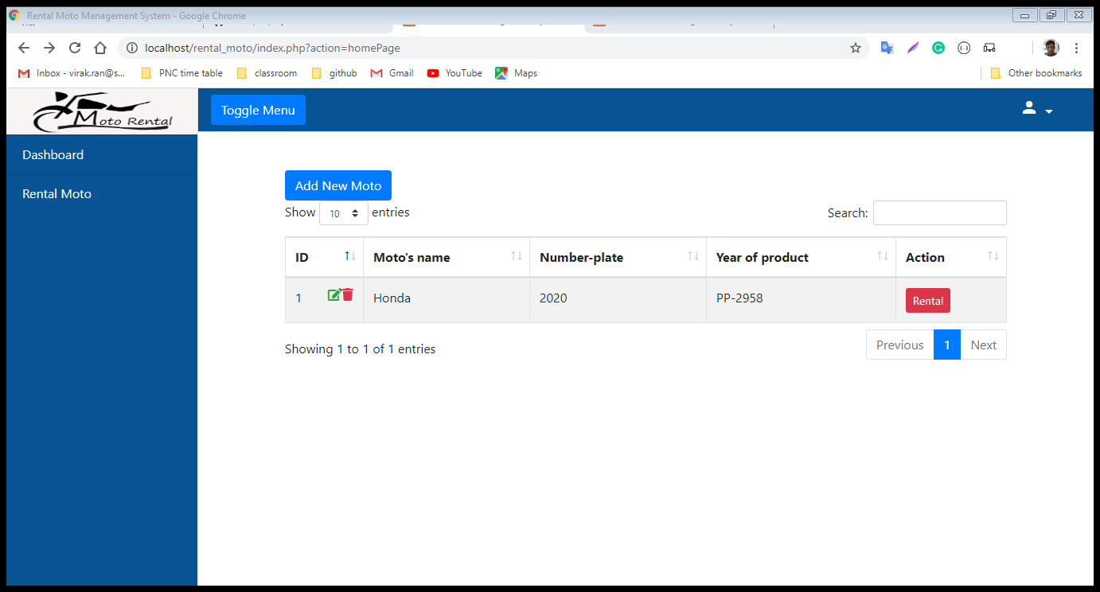

After user add new moto it will display like this.

1. If user want to rent only click on button rental

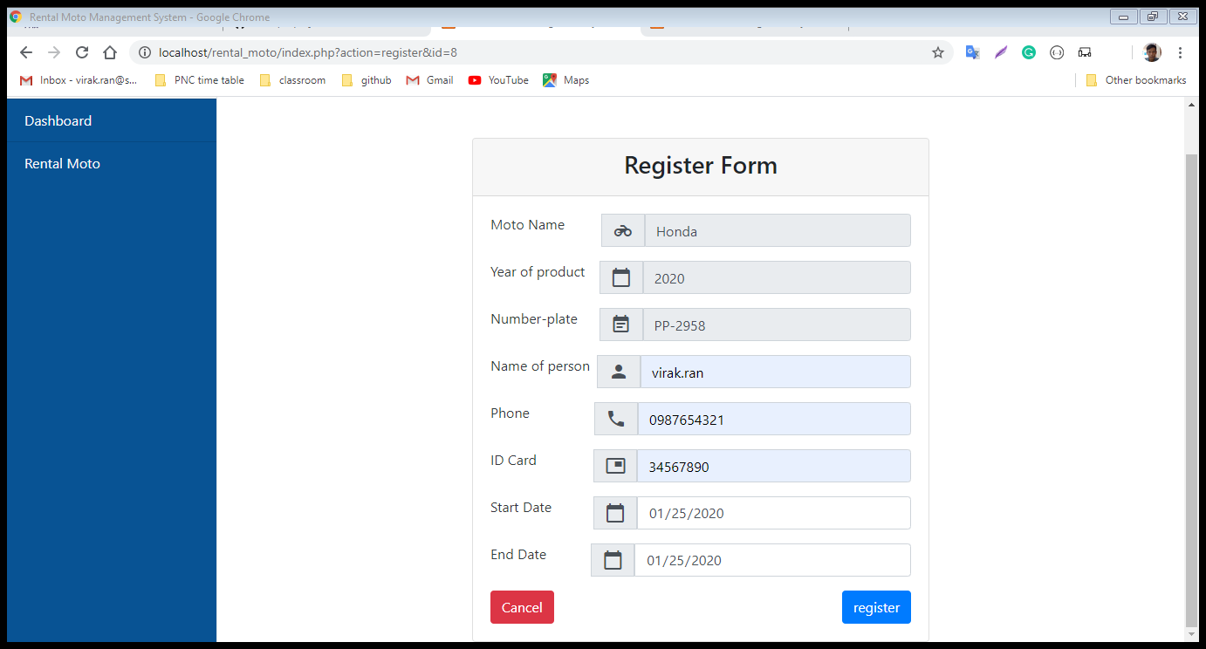

1. After click on register it will go to

