# Smart Logistics Mixed Reality Rapid Prototype

11.12.2022

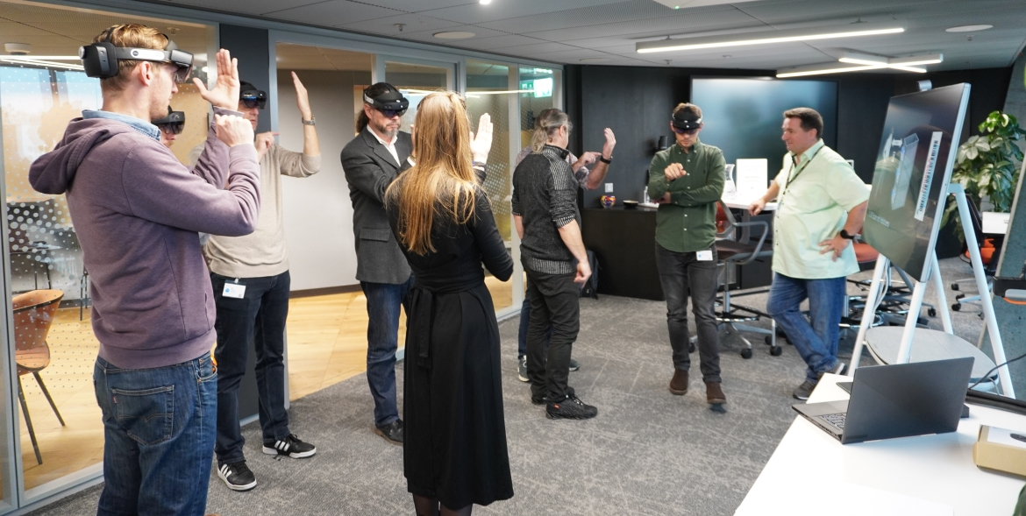

Recently we have had Migros Logistics team together with afca partner engaged in a Rapid Prototype workshop at the Microsoft Technology Center to validate Barcodes capturing from containers to guide frontline workers. The containers are equipped with a barcode (not a 2D QR code) and a RF ID. The containers are stapled on pallets delivered by trucks on the delivery drop point for intake triage. Within larger distribution center a fully automated smart intake triage covers this process. But for smaller distribution centers is the cost to high to establish a similar fully automated system. In this case frontline workers do the intake and triage job for fine distribution based on the “Old” readable Tag.

## Frontline worker scenarios

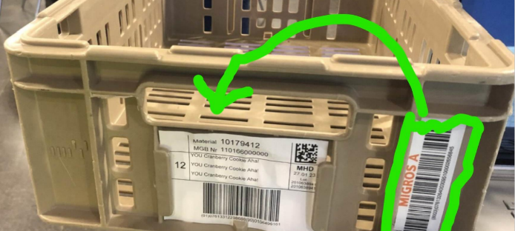Trucks are delivery pallets with stabled various sized containers at the distribution center delivery point. A frontline worker identifies the readable tag to decide where to deliver the containers for later transport. In some cases the “Old” readable Tag is mismatching the containers barcodes ID number or is just missing. In this case the frontline worker needs to read the barcode ID to get the detail logistics information to intake and distribute it.

## Business objectives

* Remove redundancy of the “Old” readable tag to reduce printing and assembly cost, and reduce errors.
* Enable frontline workers with a smart guiding system to increase their productivity.
* Use the existing barcode ID numbers as the single point of true.

## Our challenges

* RF ID does not work in all cases. For examples, if a the RF ID of the top containers didn’t work the scanner will scan the RF ID from the next nearby containers and the frontline worker has no glue if the scanned one is the chosen one.
* The device needs to be mounted in a way to enable the frontline worker to use booth hands to pick one or more containers at the same time.
* The barcode ID number tag needs to be recognized in all environmental conditions. For example the tag can be wet or dirty, if it contains cooled food.
* The barcode ID number recognition needs to scan the container stable, when the frontline worker is walking in front of the stable to get distribution insights about the containers.
* HoloLens does support QR Codes (2D codes) scanning out of the box without big latency. But it does not support barcode scanning at all.

## Art-of-the possible discovery

During the discussion we verified six use cases how to address the challenges and business objectives.

1. **ID-Scan with HoloLens** – Preferred option as it is Hands free and gives the frontline worked guidance within the real world context.
2. Graphical user interface

   Description automatically generated**QR-Code scan with HoloLens** – Best option from a code recognition point of view, but still requires to print out an “Old” readable tag including the QR codes. No business justification.
3. **Scan with Smartphone** – Requires a two step approach to use one hand to scan the container and store the smartphone to pick up the containers with two hands.
4. 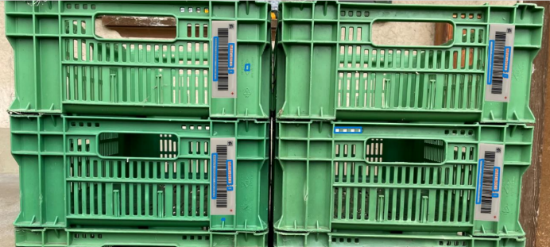**Scan with Smartphone and HoloLens** – Combination of use case 1 and 3 with increase cost.
5. **Scan with Azure Kinect and HoloLens** – Extension of use case 1 to decrease latency to scan all containers barcode ID number and share it in context using HoloLens. Way to go, if use case 1 latency and frontline worker experiences does not decrease efficiency.
6. **Scan with Azure Kinect (Body Tracking and Audio)** – Extension of use case 5 without HoloLens works for distribution center with clear intake lines.

## Validated preferred use case 1

Scanning the barcode didn’t give us a good confident level, as in some cases the barcode image was not recognizable via image recognition (Azure Cognitive Services). But identifying the Migros Logo on the tag to identify the ID number below the barcodes give us a good confident level using image recognition. The team tested this with different pallets and stocked containers.

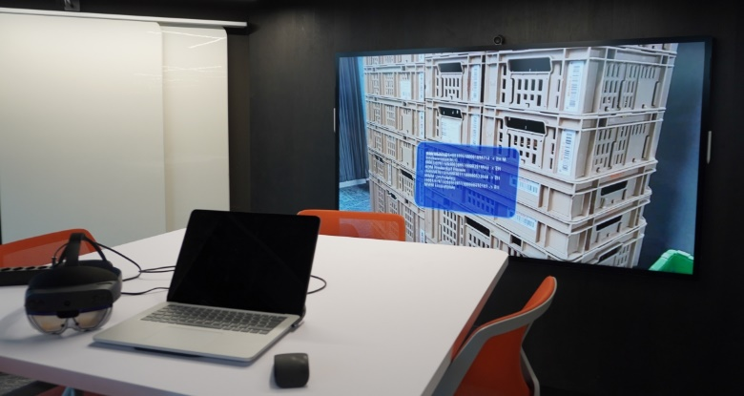The test outcome shows the scanned and recognized ID numbers within the context of the stabled containers. It works!

An MVP should now proof the end-to-end solution by:

1. Bring the image recognition model to the device.
2. Get the distribution data upfront cached on the device based on incoming planned pallets.

To increase speed of recognition and proof it within real environment condition to validate user experiences.

## Conclusion

This was a great team work experience together with a mixed Migros stakeholder team and a partner with deep understanding of mixed reality. Would like to thanks the Migros and afca team for this rapid prototype workshop at the Microsoft Technology Center.