# Swiss Smart Factory powered by Microsoft Cloud

The Swiss Smart Factory (SSF) is the first test and demonstration platform for Industry 4.0 in Switzerland and with the lighthouse project «Drone Production», we intended to show how smart factories can already work today with an entire production ecosystem powered by Microsoft Cloud and our Partner ecosystem.

## Take a virtual tour

To develop smart production and achieve higher added value, technologies are not only used on their own, but also together. Our focus here is not just on the machines, but rather the entire environment – building, infrastructure and machines. Thanks to this comprehensive data consistency of all work steps, information flows from developer to developer; from the developer to the machine; from the machine to the product; from the product to the customer and from customer back to the manufacturer.

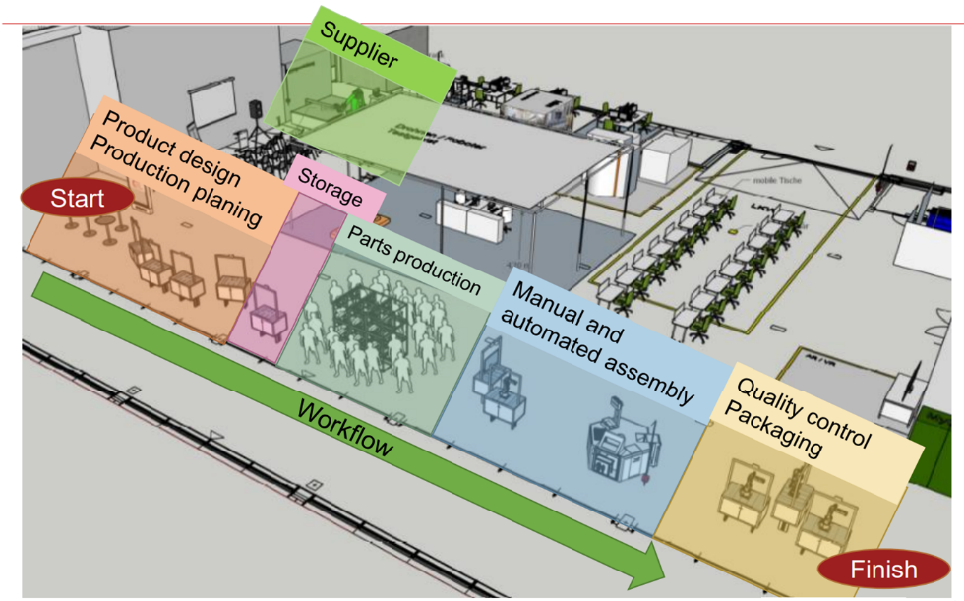

[Factory Floor Pictures]

[Videos Intro and Walk]

### Visitor Welcome and Guide

[Power App Details Incl. Video or Screen Shots]

### Microsoft Cloud powered connected factory

Connected Smart Factory enables organizations to transform the way they operate and service from a costly break-fix model to a proactive and predictive service model through the combination of IoT diagnostics, scheduling, asset maintenance, and inventory on the same platform.

#### Factory

**3D Printer Farm:** The 3D Printer Farm of the Lighthouse project Industry 4.0 is where drone parts are printed on 9 printer modules. The modules are connected over OPC-UA to inform about the process status and allows to retrofitted IO-Links sensors to gather additional information is needed.

**Laser as a Service:** The Laser as a Service is where printed drone parts get their finish.

#### Azure

«We build our lighthouse project on a scalable and secure Microsoft cloud platform to lay the foundation and run the production line to showcase it» Michael Wendling, Head Swiss Smart Factory Lighthouse project.

**Azure IoT Edge:** Internet-connected sensors on 3D Printer Farm and Laser as a Service equipment send data to Azure IoT Hub via secured WLAN or LAN connectivity. A single equipment can have multiple sensors each taking different measurements such as progress status, temperature and pressure. The 3D Printer Farm is a collection of similar 3D Printer Module equipment each with multiple sensors and Azure IoT Edge device is used to organize them, and broker telemetry sent to Azure IoT Hub.

**Azure IoT Hub:** Is the gateway to the cloud, capable of ingesting data on a large scale from any IoT device. Azure IoT Hub is a collection of applications and processes tailored to connected device scenarios that are also customizable. Azure IoT Hub deploys a resource group with a collection of applications and processes.

**Azure Service Bus:** Takes faults and enters them into a queue to systematically keep track of them. The queue is helpful for scenarios where faults fail to get transferred to Dynamics 365 and should be attempted again after some time.

**Azure Stream Analytics and Azure SQL:** Used to store device data for longer time periods to perform data analysis. For example, the Power BI based Connected Factory application enables organizations interested in analyzing large amounts of historical data to predict device failures across their factories. Threshold rules helps to decide if device data is abnormal and beyond acceptable boundaries. Abnormal data is characterized as a Fault to be analyzed and managed by Factory Operator.

**Azure Time Series Insights:** Is designed for ad hoc data exploration and operational analysis allowing operators to uncover hidden trends, spotting anomalies, and conduct root-cause analysis.

**Azure Logic App - Azure to Dynamics:** Connects Azure with Dynamics 365. Serves as a way to apply more logic, map entities, and trigger the appropriate actions in Dynamics 365, such as the creation of an IoT Alert record.

**Azure Logic - Dynamics to Azure:** This adds detail to data and actions that need to be sent to Azure IoT Hub from Dynamics. Azure IoT Hub will then send the data or action to the connected device.

#### Dynamics 365

**Microsoft Dataverse:** Lets you securely store and manage data that's used by user applications: Power Apps, Connected Field Service, Guides, Remote Assist and Power BI Dashboards. In our case we manage Functional Locations, Customer Assets, Device, Alerts, Case, Work Orders and Service Activity.

**Connected Field Service:** A set of entities and processes built on Dynamics 365 Field Service. Connected Field Service allows you to connect IoT devices (sensors) with Field Service customer assets to be served remotely on on-site.

**Alert:** Faults are passed from Azure IoT Hub to Dynamics 365 in the form of IoT alerts, which is an entity in Field Service. An IoT alert is the first part of the process inside Dynamics 365. An IoT alert is a subset of all device data that requires attention and potentially an action from the service operator.

**Registration and Commands:** Processes used in Connected Field Service to interact with and send data back to Azure IoT Hub and finally to the device. Registration allows you to create a new device and register it in Azure IoT Hub. Commands allow you to execute actions on devices such as reboot.

### Applications

#### Power Apps - Visitor Management app

The Visitor Management is a collection of four Power Apps to manage smart factory visitors.

* Visitor Welcome Desk app located at the entry point of the factory floor
* Visitor Self Registration app on a tablet device
* Visitor Management app to manage visits
* Visitor Mixed Reality app to confirm mixed reality competency

We build this apps during a three day Hackathon with the Swiss Smart Factory team.

#### Visitor Self Registration app - Welcome Desk

The Welcome Desk application is a self-service application manage smart factory visitors and their equipment loans, like Tablet or HoloLens during the visit.

New visitors can self register at the Visitor Welcome Desk by check-in and selecting the guest host, entering their contact data and selecting a loan equipment to be used during their visit. After their visit, they can check-out and return loaned equipment.

To ensure safety work rules during their stay, the app captures a photo of the visitor and using Azure Custom Vision model to check, if the visitors is equipped with Hard Hat and Mask.

#### Visitor Self Registration app - Tablet

Similar to the Welcome Desk but optimized on Tablet devices.

#### Visitor Management app

The Visitor Management app is used by the guest hosts to manage visits, visitors and equipment loans.

#### Visitor Mixed Reality experience confirmation app

Visitors who loan a HoloLens device during their visit and experience the mixed reality scenario using Dynamics 365 Guides, can earn after successfully finish a guided scenario, the Swiss Smart Factory Mixed Reality badge.

#### Application deployment

The application is available as Power Platform managed and unmanaged solution or source code under MIT licensing.

##### Prerequisites

The Visitor Management app are built on Power Platform and Azure Custom Vision. And there for the following apps needs to be installed and configured before deploying the app:

* Microsoft Dataverse environment
* Azure Subscription for Azure CustomVision services

##### Installation

To install the VisitorManagement managed solution

1. Open Web Browser and go to <https://github.com/teamruegg/VisitorManagement>
2. Under **Releases** download the Release Package
3. Open a new Tab in the Web Browser and go to <https://make.powerapps.com/>
4. Under **Solutions** choose **Import**
5. Select the solution file “visitormanagement_0_8_0_8_managed.zip”
6. After

##### **Source code**

You find the GitHub repository with the latest version under

* <https://github.com/teamruegg/VisitorManagement>

Any feedback is welcome.

#### Power Apps - Tour Guide

**Power Apps -** Daily Check

**Microsoft Teams:** Collaboration

**Power BI:** Connected Factory

**Dynamics 365 Connected Field Service:** Monitoring Inspection

**Dynamics 365 Remote Assist:** lorem ipsum

**Dynamics 365 Guide:** Daily Check and Inspection

### Devices

HoloLens

Mobile

[Architecture Slide with the cloud foundation]

Business Value overview and Architecture Blueprint

[SFF Video from Youtube]

## Experience use cases in action

[Align topics and use cases to our Microsoft Cloud for Manufacturing reduced to what we show - [Microsoft Cloud for Manufacturing | Microsoft](https://www.microsoft.com/en-us/industry/manufacturing/microsoft-cloud-for-manufacturing)]

Selected manufacturing use cases including released and new capabilities that seamlessly connect people, assets, workflow, and business processes, empowering organizations to be more agile.

### Digitally empower your workforce

Reskill your workers and increase productivity with new digital experiences.

[Teams and Remote Assist] Connect frontline workers, office workers, and service partners with the secure collaboration and information management tools needed to support remote work.

[Power Apps Daily Check] Empower agile factory worker. Build and deploy solutions to monitor intelligently, protect continuously, and augment behavioral insights in days.

[Dynamics 365 Guides Mixed Reality] Overcome skills gaps and boost employee collaboration across the value chain with mixed-reality devices and applications to maximize engagement, gain insights, and enhance productivity.

### Operate safe and agile factories

Build the productive, smart factory of the future with industrial IoT, cloud, AI, digital twins, and mixed reality.

Graphical representation of a complete Azure Digital Twins business environment.

As companies navigate their business transformations, they unlock new use cases.

The need to model the whole enterprise is becoming more evident. Companies can use Azure Digital Twins to create comprehensive models of their complete business that include processes, people, and products. These models give them a true end-to-end view of their enterprise.

Think of a company that's able to model its factories and also its suppliers and resellers. Modeling would allow it to further automate its operations. For example, the company could capture the signals from its users' experiences or in-store demands and tie them in real time to the production line. In this way, the company would have visibility of the production capacity and capability to meet the demand. It could go one step further by closing the loop with the supplier of the raw materials required to meet the demand in the specific timeline. This capability provides better visibility of the product and its traceability.

Azure Digital Twins can help to bridge the gap between the inception and engineering of any product and its operations. With digital twins and simulations, companies can do what-if analysis on their products to test situations before they occur. For example, before ordering an expensive asset, companies could simulate the impact of a change in the configuration or a repair. Along with AI and process automation, companies can get to true self-healing assets and advanced root-cause analysis.

#### Manufacturing use cases

|  |  |
| --- | --- |
| Segments | Use cases |
| * Discrete manufacturing * Process manufacturing * Connected products | * Autonomous operations. * Root-cause analysis to identify root cause of failures by tracing issues through the topology. * What-if analysis, simulations:   + Simulate optimization scenarios, spot bottlenecks in the production, and dynamically adjust operations to meet output.   + Physics-driven product simulation modeling, such as digital verification and validation for product R&D and prototyping.   + Propose new factory design and design changes to existing lines to unlock additional capacity, such as commissioning and efficient operation of a production line via simulation.   + Model, such as predictive equipment maintenance via simulations.   + Advanced digital simulation. * Self-healing assets and augmented maintenance. * Support the real-time factory operations to increase capacity and throughput. * Respond dynamically to real-time changes in supply and demand. * Develop and execute optimized planning strategies. * Monitor and control of factory operations. * Digital twins of manufactured goods. Lifetime tracking from ingredients or parts to product usage monitoring. Examples:   + What machines or product lines was a product or part processed on?   + Where was it stored?   + Who delivered it?   + What are the correlations between customer satisfaction and production line, delivery, and storage? |

#### Swiss Smart Factory powered by Azure Digital Twins

Real-world environments in Azure Digital Twins are modeled as a topology graph. The entities that make up the graph are called twins. Each type of twin is described as a collection of properties, telemetry, commands, relationships, and components. Twin definitions are expressed in DTDL, a language that's based on JSON-LD.

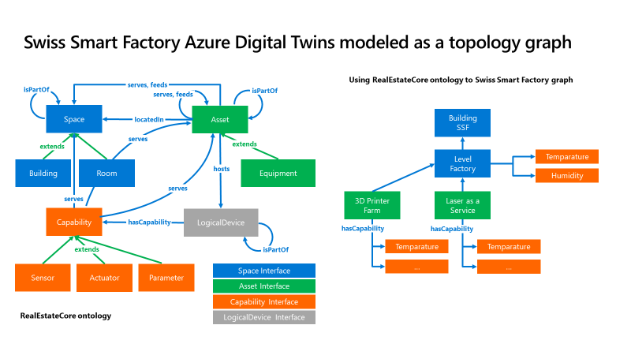

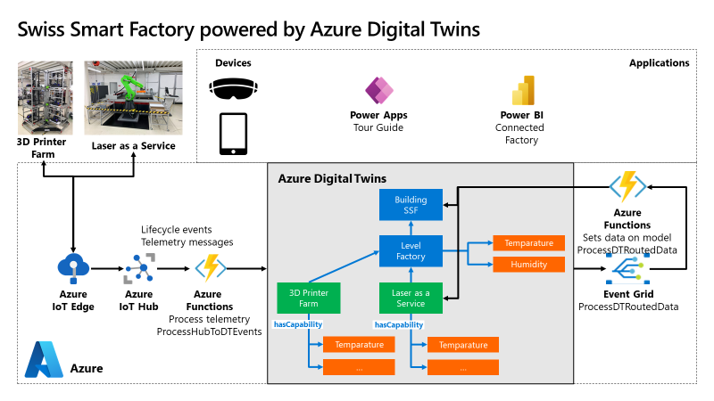

[PWC Smart Factory Reports] Connect people, products, and processes. Provide a 360-degree view of overall plant systems and workflow that allows operators to analyze problems and enhance workflow efficiency.

[IoT Edge Solution with 3D Printer]

[IoT Cencerus Laser as a Services]

[IoT Accenture Machine to Machine Communication]

### Unlock innovation and new services

Accelerate the engineering of new business value using digital feedback loops and digital twins.

[PLM Case Siemens Azure Digital Twins]

[Side Effects 3D Training program CAD/PLM]