Starting with the time-dependent multigroup diffusion equation:

$$\frac{1}{{\overline{v}}_{g}}δ_{t}ϕ_{g}-∇∙D_{g}∇ϕ_{g}+Σ_{rg}ϕ_{g}=\sum_{g^{'}=1,g^{'}≠g}^{G}{Σ_{s,g^{'}→g}}ϕ_{g^{'}}+χ_{g}\sum_{g^{'}=1}^{G}{\overline{ν}Σ_{fg^{'}}ϕ_{g^{'}}}+Q_{g}$$

Grouping and defining the terms first (with multiple regions and forbearing the time term):

Fission Source Time Inscattering

$${Q^{*}}_{g,ijk}^{l,n}=χ_{g}\sum_{g^{'}=1}^{G}{\overline{ν}Σ_{fg^{'},ijk}ϕ_{g^{'},ijk}^{l,n}}+Q_{g,ijk}+\frac{1}{v_{g}Δt}ϕ_{g,ijk}^{l,n}+\sum_{g^{'}=1,g^{'}≠g}^{G}{Σ_{s,g^{'}→g}}ϕ_{g',ijk}^{l,n}$$

n indices added for time (would need to add to previous equations)

Absorb Outscatter Time

$$Σ_{rg,ijk}^{*}=Σ_{ag,ijk}+\sum_{g=1,g≠g^{'}}^{G}{Σ_{s,g→g'}} \left(outscattering\right)+\frac{1}{v_{g}Δt}$$

For a 1 group problem the fission term should be coupled with the removal term (no summation just $\overline{ν}Σ_{fg,ijk}$)

This simplifies our problem to:

$$-∇∙D_{g}∇ϕ_{g}^{l+1}+Σ_{rg,ijk}^{*}ϕ_{g,ijk}^{l+1}={Q^{*}}_{g,ijk}^{l,n}$$

This turns into a matrix solve:

$$Aϕ_{g,ijk}^{l+1}={Q^{*}}_{g,ijk}^{l}\left(ϕ_{g,ijk}^{l}\right)$$

**Finite Difference:**

Discrete equations for a zone away from the boundary (2-D):

$$-\frac{{\hat{D}}_{g,\left(i+\frac{1}{2}\right)jk}\left(ϕ_{g,\left(i+1\right)jk}^{l+1}-ϕ_{g,ijk}^{l+1}\right)-{\hat{D}}_{g,\left(i-\frac{1}{2}\right)jk}\left(ϕ_{g,ijk}^{l+1}-ϕ_{g,\left(i-1\right)jk}^{l+1}\right)}{h_{x}^{2}}-\frac{{\hat{D}}_{g,i\left(j+\frac{1}{2}\right)k}\left(ϕ_{g,i\left(j+1\right)k}^{l+1}-ϕ_{g,ijk}^{l+1}\right)-{\hat{D}}_{g,i\left(j-\frac{1}{2}\right)k}\left(ϕ_{g,ijk}^{l+1}-ϕ_{g,i\left(j-1\right)k}^{l+1}\right)}{h_{y}^{2}}+Σ_{rg,ijk}^{*}ϕ_{g,ijk}^{l+1}={Q^{*}}_{g,ijk}^{l}$$

Where:

$${\hat{D}}_{g,\left(i+\frac{1}{2}\right)jk}=\frac{2D_{g,ijk}D_{g,\left(i+1\right),jk}}{D_{g,ijk}+D_{g,\left(i+1\right),jk}}$$

For left boundary:

$$-\frac{{\hat{D}}_{g,\left(\frac{3}{2}\right)jk}\left(ϕ_{g,\left(2\right)jk}^{l+1}-ϕ_{g,1jk}^{l+1}\right)-h_{x}J_{g,x}(0,y_{j},z_{k})}{h_{x}^{2}}-\frac{{\hat{D}}_{g,1\left(j+\frac{1}{2}\right)k}\left(ϕ_{g,1\left(j+1\right)k}^{l+1}-ϕ_{g,1jk}^{l+1}\right)-{\hat{D}}_{g,1\left(j-\frac{1}{2}\right)k}\left(ϕ_{g,1jk}^{l+1}-ϕ_{g,1\left(j-1\right)k}^{l+1}\right)}{h_{y}^{2}}+Σ_{rg,1jk}^{*}ϕ_{g,1jk}^{l+1}={Q^{*}}_{g,1jk}^{l}$$

Where:

$$J_{g,x}\left(0,y_{j},z_{k}\right)=-\frac{D_{g,ijk}}{B}\left(C-\frac{A}{2}\left(3ϕ_{1jk}-ϕ_{2jk}\right)\right)$$

If B =0

$$J_{g,x}\left(0,y_{j},z_{k}\right)=-\frac{D_{g,ijk}\left(ϕ_{g,1jk}-\frac{C}{A}\right)}{\frac{h_{x}}{2}}$$

Some algebra is needed to figure what goes where in A, but it is the hope of the student that Dr. McClarren’s code already helps with this.

In short the finite difference code settled upon looks like:

import numpy as np

import scipy as sp

import scipy.sparse as sparse

import scipy.sparse.linalg as splinalg

import time

import sys

tart_time = time.time()

#Functions

def coordLookup_l(i, j, k, I, J):

def coordLookup_ijk(l, I, J):

def diffusion_steady_fixed_source(I,J,K,Nx,Ny,Nz,hx,hy,hz,ihx2,ihy2,ihz2,BCs,D,Sigma,Q,L,…):

def lattice2G():

def inner_iteration(G,I,J,K,Nx,Ny,Nz,hx,hy,hz,ihx2,ihy2,ihz2,BCGs,Sigmarg,Sigmasgg,D,Q,L,…):

def kproblem_mg_diffusion(I,J,K,G,Nx,Ny,Nz,hx,hy,hz,ihx2,ihy2,ihz2,BCGs,Sigmarg,Sigmasgg,…):

def Power_find(I,J,K,Power):

def plotting(phig,Powermap):

#Define the Problem

Power,hx,hy,hz,ihx2,ihy2,ihz2,x,y,z,Sigmarg,Sigmasgg,nuSigmafg,nug,chig,D,Q,L,I,J,K,Nx,Ny,Nz,G,BCGs = lattice2G()

#k Convergence

k,iterations,phig = kproblem_mg_diffusion(I,J,K,G,Nx,Ny,Nz,hx,hy,hz,ihx2,ihy2,ihz2,BCGs,Sigmarg,Sigmasgg,nuSigmafg,chig,D,L,…)

#Determine Assembly Power Profile

Powermap=Power_find(I,J,K,Power)

#End the Run Time

print("--- %s ---" % (time.time() - start_time))

#Make the plots

plotting(phig,Powermap)

Step by step this code does the following:

1. Sets up the geometry
   1. The geometry setup is read from a geometry file, which provides the assembly type at each i,j,k location of the problem. This file is generated from an excel file which produces the geometry for a given number of nodes in the problem.
   2. The assembly numbers are read from a power file, which provides the assembly number at each i,j,k location. This file is generated from an excel file which determines which locations are of each assembly for a given number of nodes in the problem.
   3. Subsequently other variables (cross section variables, spacing, length…) are produced either by loops or are read or calculated.
2. Runs through the kproblem diffusion solver
   1. This diffusion solver will start with a random flux for domain if no previous runs for the problem were completed. Otherwise, the program will search for old flux configurations and interpolate flux values for the current geometry and start with that for the initial guess
   2. The diffusion solver runs through an iterative loop to converge the flux and determine k. This loop:
      1. Determines the fission source term
 $${Q^{*}}_{g,ijk}^{l,n}=χ_{g}\sum_{g^{'}=1}^{G}{\overline{ν}Σ_{fg^{'},ijk}ϕ_{g^{'},ijk}^{l,n}}$$

     2. Passes this term, along with the flux to an inner convergence loop which iteratively solves for the flux group by group by iteratively updating the scattering source and solving the system.

$$Aϕ_{g,ijk}^{l+1}={Q^{*}}_{g,ijk}^{l}\left(ϕ_{g,ijk}^{l}\right)$$

Where:

$$A=-∇∙D_{g}∇+Σ_{rg,ijk}^{*}$$

$${Q^{*}}_{g,ijk}^{l,n}={\left[χ_{g}\sum_{g^{'}=1}^{G}{\overline{ν}Σ_{fg^{'},ijk}ϕ_{g^{'},ijk}^{l}}\right]}_{constant}+{\left[\sum_{g^{'}=1,g^{'}≠g}^{G}{Σ_{s,g^{'}→g}}ϕ_{g^{'},ijk}^{l+i}\right]}_{updated}$$

And $-∇∙D_{g}∇$ is given at the top of page two.

* + 1. Once a new $ϕ_{g,ijk}^{l+1}$ is determined, a new k is calculated by
 $$k_{new}=\frac{\left\|ϕ_{g,ijk}^{l+1}\right\|}{\left\|ϕ_{g,ijk}^{l}\right\|}$$

   2. If this new multiplication factor is within 1e-5 of the old one, the iteration stops.
  1. Once the flux has been determined the power in each assembly is determined by the equation

$$P_{assy}=\sum_{g=1}^{2}{\sum_{n}^{N}{dxdydz 200 ϕ_{ijkg}νΣ_{fg}}}$$

This loop looks like:

Powermat=np.zeros(int(Power[1:,:].max()))

for assy in range(int(Power[1:,:].max())):

for k in range(K):

for j in range(J):

for i in range(I):

if(assy+1==int(Power[J-j,i])):

for g in range(G):

if(assy==0):

Powermat[assy] +=4*hx*hy*hz*200*phig[i,j,k,g]*nuSigmafg[i,j,k,g]

elif(i<iswitch):

Powermat[assy] +=2*hx*hy*hz*200*phig[i,j,k,g]*nuSigmafg[i,j,k,g]

elif(j<jswitch):

Powermat[assy] +=2*hx*hy*hz*200*phig[i,j,k,g]*nuSigmafg[i,j,k,g]

else:

Powermat[assy] +=hx*hy*hz*200*phig[i,j,k,g]*nuSigmafg[i,j,k,g]

The assembly in the middle is multiplied by 4 because the code only has ¼ of the assembly shown, the assemblies on the edge are multiplied by 2 because the code has only ½ of the assembly shown.

The first Problem is described below:

The Zion PWR Benchmark (K.S. Smith, NSE, 1986), is a 2-D, two-group, reactor benchmark calculation where a quarter reactor is specified by the following figure:

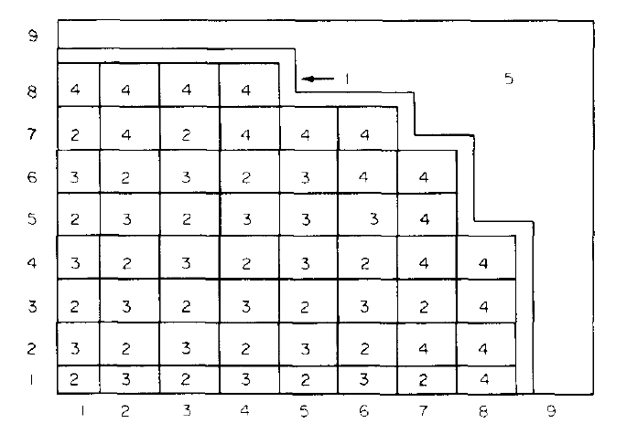

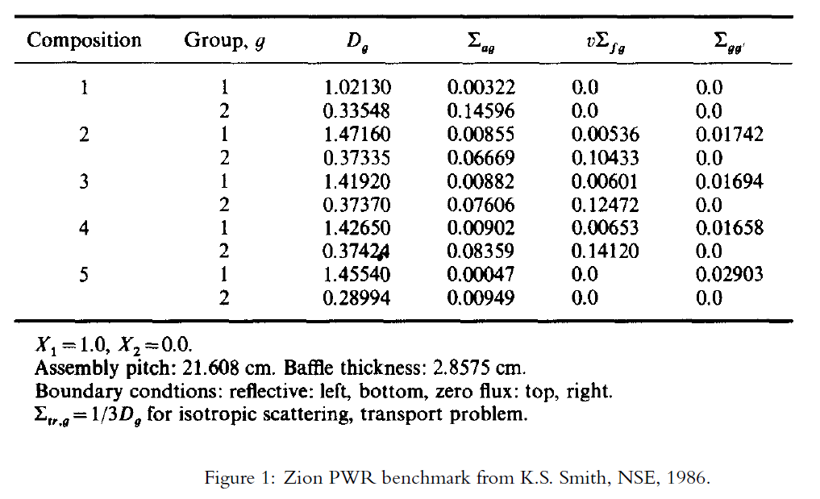

A quarter of the reactor is a square that is divided in the figure into a 9 x 9 grid of 21.608 x 21.608 cm squares (i.e., the quarter reactor size is 194.472 x 194.472 cm). At the midline there are 8 assemblies in the x and y directions. In the problem specification there is only downscattering and what we have called Σrg is called Σag. Also, note that all fission neutrons are born fast.

1. Solve this problem using the finite difference method.
   1. Find $k_{eff}$ and the fission power in each assembly.

|  |  |  |  |  |  |
| --- | --- | --- | --- | --- | --- |
| Number of Nodes | dx (cm) | k effective | time (s) | k iterations | t per iteration |
| 100 | 2.32 | 1.27507 | 53.9 | 7 | 8 |
| 200 | 1.16 | 1.2749 | 204.97 | 6 | 34 |
| 300 | 0.7747 | 1.27484 | 587.62 | 7 | 84 |
| 400 | 0.58104 | 1.27482 | 193.44 | 2 | 97 |

The time includes setting up the geometry but does not include producing the graphs. These times would be longer if old solutions were not used for the more refined mesh, so probably are not indicative of the efficiency of the algorithm.

The power in each assembly, as determined by the above algorithm, is shown below with the different mesh resolutions:

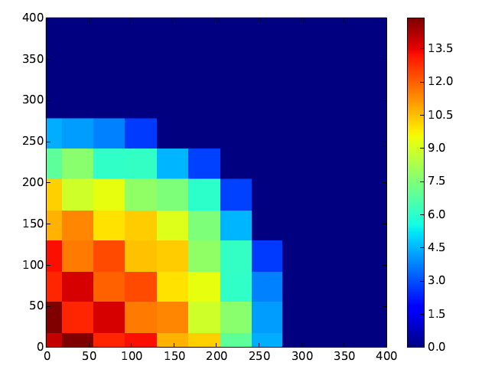

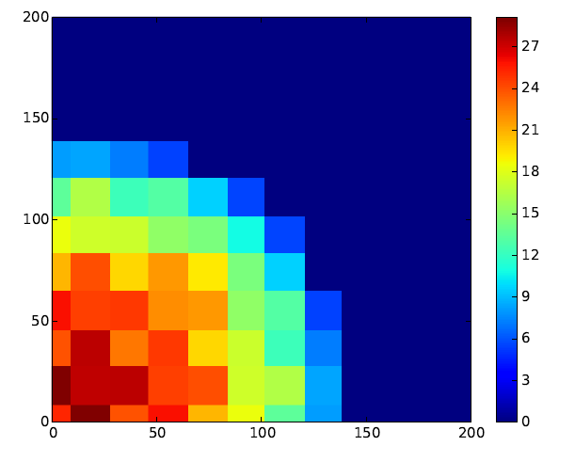

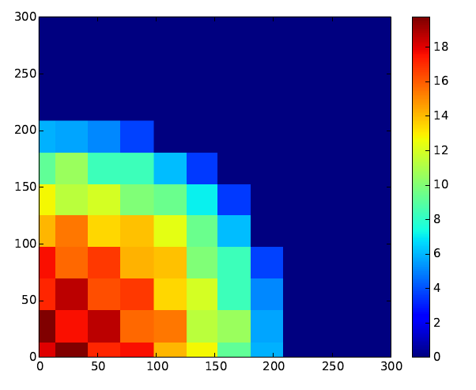

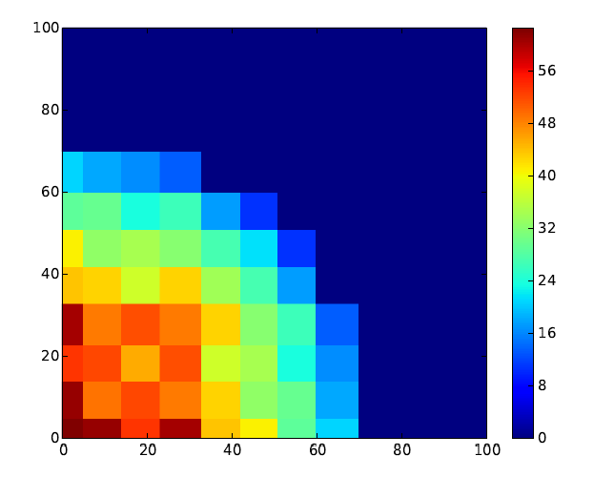

With each refinement of the mesh, specific assemblies with higher fissile material in the center of the core are highlighted as producing more power. The central pin, although seeing the highest fluxes does not produce the most power because it has the lowest enrichment of the assemblies.

The absolute value on each mesh is arbitrary and in order to relate to power the sum total of the flux and percent of fission energy deposited in the reactor should be considered. Along this line of thought, the sum flux for the 300 and 400 cases are provided for the thermal and fast groups.

|  |  |  |  |
| --- | --- | --- | --- |
| Number of Nodes | Flux Fast Group Sum | Flux 1 Group Sum | Total |
| 300 | 139 | 34.9 | 173.9 |
| 400 | 185 | 46.1 | 231.1 |

Please note that the fast flux group sum is larger than the thermal group sum. There should be an explanation for this.

The mesh resolution should be around 0.58104 to resolve the multiplication factor to 1 pcm.

Although the problem does not ask for the following plots, they are pretty and provided below:





