NUEN 629
Homework 2
Due: 10/06/15
Paul Mendoza

- Compute three group cross-sections for a homogeneous mixture of graphite and natural uranium where the ratio of graphite to uranium is 150:1. You can assume the Watt-fission spectrum, and that the groups bounds are { 0, 1ev, 100 keV, 20 MeV }.
Group cross sections are defined by:
$$Σ_{g}\left(\overset{⃑}{r}\right)=\frac{\int_{E_{g}}^{E_{g-1}}{dE Σ\left(\overset{⃑}{r},E\right)ϕ\left(\overset{⃑}{r},E\right)}}{\int_{E_{g}}^{E_{g-1}}{dE ϕ\left(\overset{⃑}{r},E\right)}}$$
Assuming a homogeneous medium with the uranium to graphite ratio described above the group cross section can be defined as:
$$Σ_{g}\left(\overset{⃑}{r}\right)=\frac{\int_{E_{g}}^{E_{g-1}}{dE(at\%_{12}N^{mix}σ_{12}\left(E\right)+at\%_{235}N^{mix}σ_{235}\left(E\right)+at\%_{238}N^{mix}σ_{238}\left(E\right))ϕ\left(\overset{⃑}{r},E\right)}}{\int_{E_{g}}^{E_{g-1}}{dE ϕ\left(\overset{⃑}{r},E\right)}}$$

Where $at\%_{12}=0.993377; at\%_{238}=0.00657; at\%_{235}=4.768e-5$, and $N^{mix}=0.113e24 at/cc$. Rearranging,

$$Σ_{g}\left(\overset{⃑}{r}\right)=N^{mix}\left[\frac{at\%_{12}\int_{E_{g}}^{E_{g-1}}{dEσ_{12}\left(E\right)ϕ\left(\overset{⃑}{r},E\right)}}{\int_{E_{g}}^{E_{g-1}}{dE ϕ\left(\overset{⃑}{r},E\right)}}+\frac{at\%_{238}\int_{E_{g}}^{E_{g-1}}{dEσ_{238}\left(E\right)ϕ\left(\overset{⃑}{r},E\right)}}{\int_{E_{g}}^{E_{g-1}}{dE ϕ\left(\overset{⃑}{r},E\right)}}+\frac{at\%_{235}\int_{E_{g}}^{E_{g-1}}{dEσ_{235}\left(E\right)ϕ\left(\overset{⃑}{r},E\right)}}{\int_{E_{g}}^{E_{g-1}}{dE ϕ\left(\overset{⃑}{r},E\right)}}\right]$$
Using Short hand:
$$Σ_{g}\left(\overset{⃑}{r}\right)=N^{mix}\left[at\%_{12}σ_{g,12}+at\%_{235}σ_{g,235}+at\%_{238}σ_{g,238}\right]$$

Janus was used to produce these group averaged cross sections assuming a fission spectrum and are shown in Table 1. Group 1 is the lowest energy group.
Table 1 Three group cross sections for isotopes in the system
 | σt (b) | σs (b) | σf (b) | σγ (b)
235G1 | 131.5515 | 13.77506 | 101.2921 | 16.4844
235G2 | 13.1442 | 10.52882 | 1.89372 | 0.591047
235G3 | 7.551755 | 4.243951 | 1.215399 | 0.087956
238G1 | 9.890571 | 9.196642 |  | 0.693925
238G2 | 13.09678 | 12.55621 |  | 0.327781
238G3 | 7.706308 | 4.732475 |  | 0.066865
12G1 | 4.75749 | 4.756678
12G2 | 5.539658 | 4.539656
12G3 | 2.353363 | 2.339561

Three groups cross sections were calculated with the scheme described above and are shown in Table 2.
Table 2 Three group cross sections for the system
 | Σt (1/cm) | Σs (1/cm) | Σf (1/cm) | Σγ (1/cm)
Group 1 | 0.542088 | 0.540847 | 0.000546 | 0.000604
Group 2 | 0.631629 | 0.518962 | 1.02E-05 | 0.000247
Group 3 | 0.269931 | 0.266156 | 6.55E-06 | 5.01E-05

The required text file input for Janis is as follows (energies are in eV):
neutron group structure......3 group
1 1e-5 1
2 1 100000
3 100000 2e7

A quick MCNP calculation shows flux distributions for the system described and the system without graphite (the fission spectrum is plotted on the same graph for comparison):
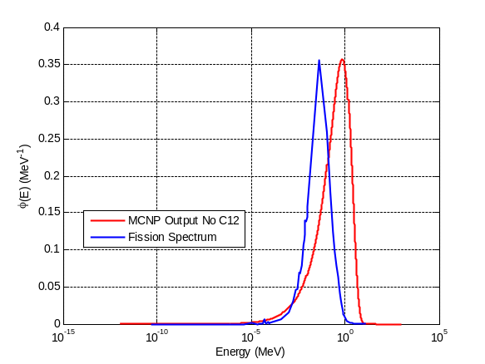
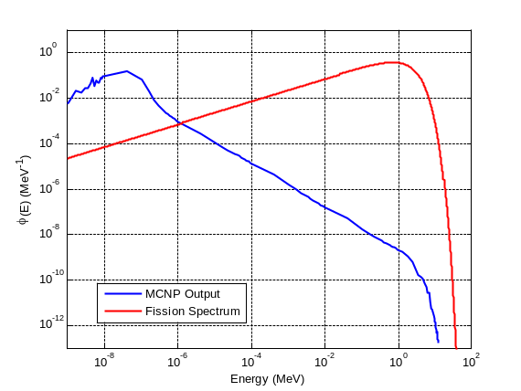

Figure 1. Comparison between MCNP flux distributions and the fission spectrum.

This shows that the Watt-fission spectrum is not the spectrum that this system would have. It should be noted that the MCNP spectrum could be used for this analysis, but JANIS was used instead for speed. Dr. McClarren’s code could also be used, and is described below:
Following the example provided in laboratory 1; starting with the steady-state infinite medium problem given by:
$$\left[\sum_{i=1}^{3}{at\%_{i}*N^{mix}σ_{t}^{i}\left(E\right)}\right]ψ\left(μ,E\right)=\frac{1}{2}\int_{0}^{∞}{dE^{'}\left[\sum_{i=1}^{3}{at\%_{i}*N^{mix}σ_{s}^{i}\left(E_{i}→E_{f}\right)}\right]}ϕ\left(E^{'}\right)+\frac{χ\left(E\right)}{2k}\int_{0}^{∞}{dE^{'}\left[\sum_{i=1}^{3}{at\%_{i}*N^{mix}ν_{f}σ_{f}^{i}\left(E^{'}\right)}\right]}ϕ\left(E^{'}\right)$$

Where $at\%_{12}=0.993377; at\%_{238}=0.00657; at\%_{235}=4.768e-5$. The average downscattering energy exchange for a neutron is assumed to be:

$${\left(\frac{E_{f}}{E_{i}}\right)}_{av}=\frac{A^{2}+1}{{\left(A+1\right)}^{2}}$$

where for the different isotopes:

$${\left(\frac{E_{f}}{E_{i}}\right)}_{av,12}≈0.857988; {\left(\frac{E_{f}}{E_{i}}\right)}_{av,238}≈0.991667; {\left(\frac{E_{f}}{E_{i}}\right)}_{av,235}≈0.99156133.$$

If it is assumed that downscattering is the only type of scattering then the transport equation, integrated over energy (with a normalized fission term) can be written as:
$$ϕ\left(E\right)=\frac{\sum_{i=1}^{3}{at\%_{i}*σ_{s}^{i}\left({\left(\frac{E_{i}}{E_{f}}\right)}_{av,i}E\right)}ϕ\left({\left(\frac{E_{i}}{E_{f}}\right)}_{av,i}E\right)}{\left[\sum_{i=1}^{3}{at\%_{i}*σ_{t}^{i}\left(E\right)}\right]}+\frac{χ\left(E\right)}{\left[\sum_{i=1}^{3}{at\%_{i}*σ_{t}^{i}\left(E\right)}\right]}$$

The cross section data was processed and reproduced below (apologizes for the readability of the graphs):
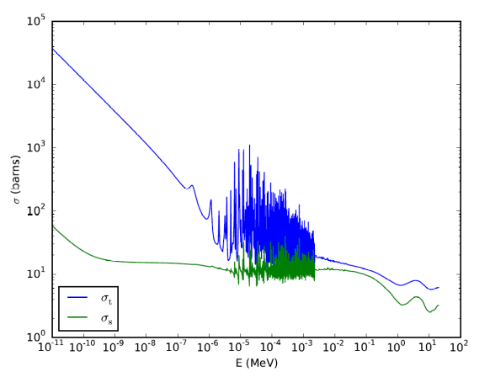
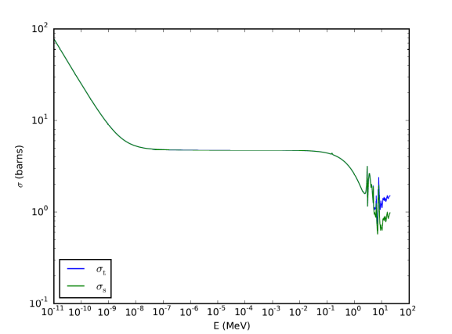
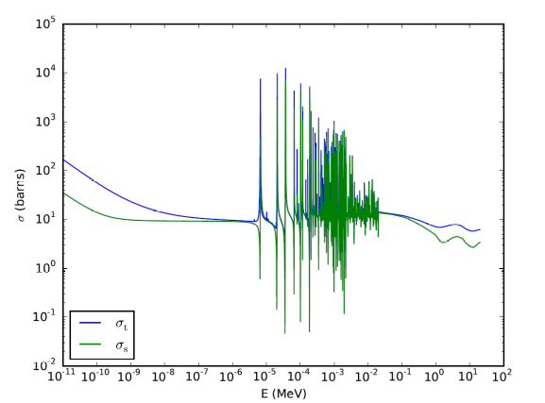
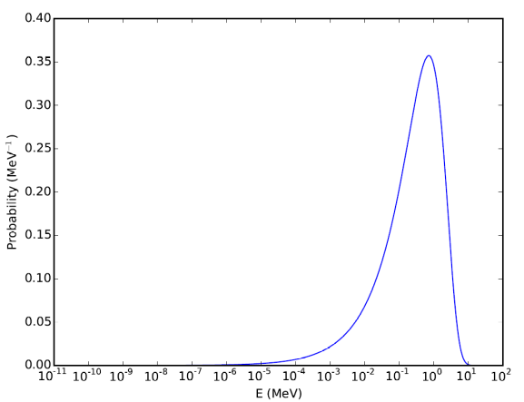
Figure 2: Cross Section data and the fission spectrum for the isotopes in the system.

The spectrum that was used for the averaging:
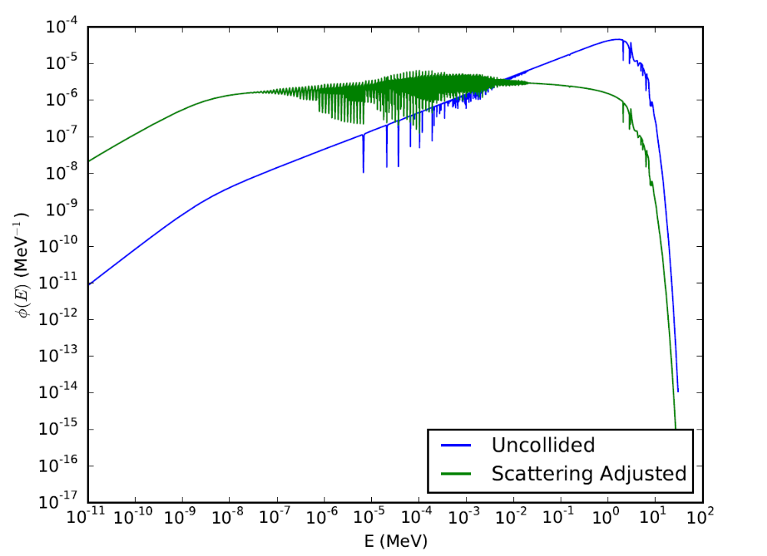
Figure 3. Flux spectrum used for cross section averaging.

The code used for the cross section processing was mostly copied from Dr. McClarren the integration portion I wrote is provided below:
#Perform Integration
from scipy import integrate
from scipy.integrate import trapz
#Make Functions of things I want to integrate.
X_t_235_phi=interpolate.interp1d(energies,phi_iteration(energies)*sig_t_235_interp(energies),fill_value=0,bounds_error=False)
#Perform the integration For Group 1
EE=1e-6
for xx in range(0, len(energies)):
if (energies[xx]<=EE):
index=xx
phi_int_g1=integrate.trapz(phi_iteration(energies[0:index]),energies[0:index])
X_t_235_g1=integrate.trapz(X_t_235_phi(energies[0:index]),energies[0:index])

Cross sections are shown on the next page:
Comparison of cross section data calculated from Janis and the data calculated from the python script is shown in Table 3. The values are similar but different because different spectrum were used.
Table 3 Cross Section Comparison and results from python script
 | Python |  | Janis
 | σt (b) | σs (b) | σt (b) | σs (b)
235G1 | 179.76 | 13.98 | 131.55 | 13.78
235G2 | 13.98 | 10.81 | 13.14 | 10.53
235G3 | 7.78 | 4.49 | 7.55 | 4.24
238G1 | 10.06 | 9.21 | 9.89 | 9.20
238G2 | 13.67 | 13.08 | 13.10 | 12.56
238G3 | 7.95 | 5.24 | 7.71 | 4.73
12G1 | 4.77 | 4.77 | 4.76 | 4.76
12G2 | 4.58 | 4.58 | 5.54 | 4.54
12G3 | 2.59 | 2.58 | 2.35 | 2.34
 | Σt (1/cm) | Σs (1/cm) | Σt (1/cm) | Σs (1/cm)
Group 1 | 0.544 | 0.543 | 0.542 | 0.541
Group 2 | 0.524 | 0.524 | 0.632 | 0.519
Group 3 | 0.296 | 0.294 | 0.270 | 0.266

Note, the set slowing down energy is wrong. Should force a maxwellian and do probabilistic slowing.

