MIAI 2.0 — Job Mode & Artifacts
Facilitation Guide & Input Capture Sheet for the TWF Working Session
Prepared for review by 3 AI super users · Output to be handed to TWF · Confidential

The one-sentence goal
For each media-planning job, we agree (a) the job mode, (b) the primary artifact it produces, and (c) the artifact details TWF needs to build the agent. Where the three of you disagree, we capture the disagreement rather than smoothing it over.

Definitions card — pin these words first
Read this out loud before anything else. Most confusion disappears once these are agreed.
Term | What it means
Job | One discrete task a planner does — e.g. “build audience segments”, “analyze marketing situation”.
Job mode | The type of run you launch (per deck slide 7). It decides which agents activate and which artifacts are produced. Five in the deck: Context Build, Diagnosis, Strategy Development, Storytelling / Presentation, Full End-to-End Run.
Primary artifact | The main output the job / mode produces and hands to the next step.

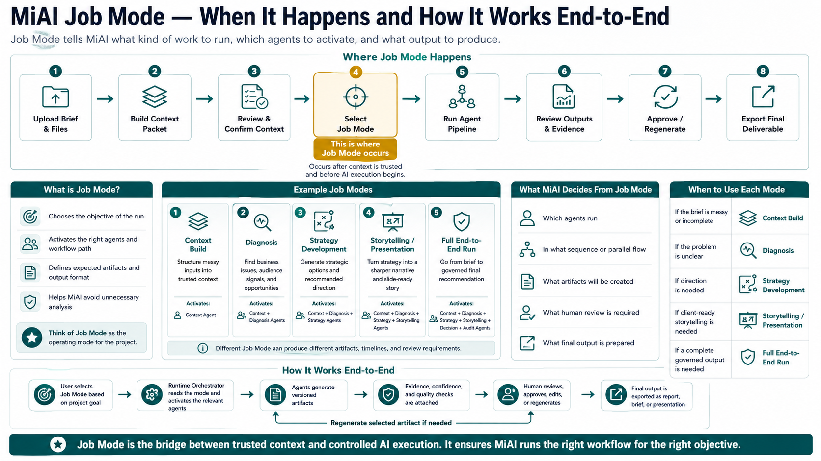

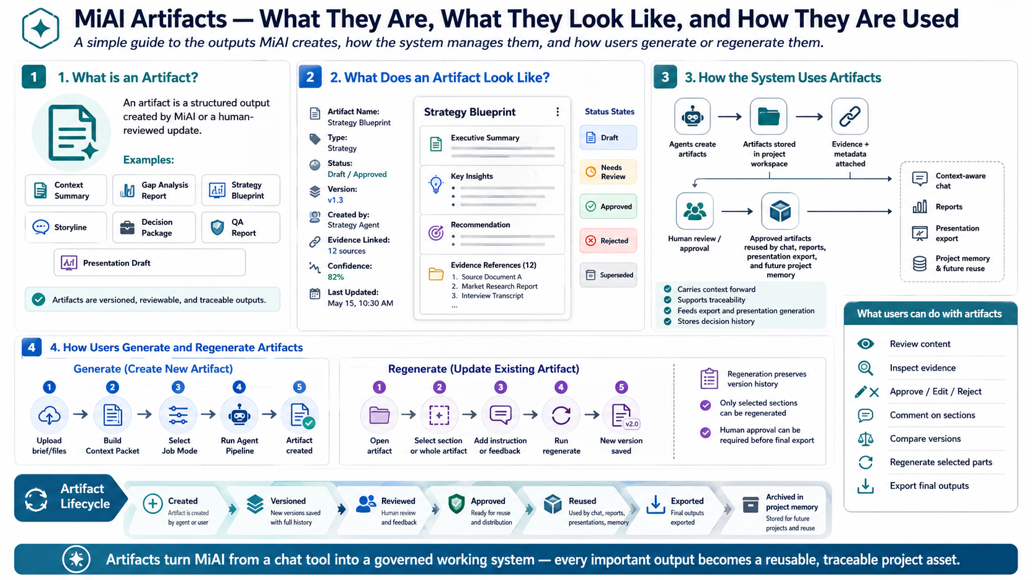

Job — Information for Strategy Lead In
# | Job Modes | What | Primary artifact (output) | Format
1 | Context Builder | - Structure messy input to trusted context  - Create LIVE research | - Context summary  - Context report | .docx  .pdf
2 | Diagnosis | - Analyze business issues, market and consumer trend, opportunity gaps | - Context Summary  - Context report | .docx  .pdf
3 | Strategy Development | - Generate or ideate strategic direction, or recommend the option or idea | - Strategy Blueprint | .docx  .pdf
4 | Storytelling Presentation | - Narrative the content and strategy in to slide | - Storyline  - Ready to use prompt for beautiful.ai  - Presentation Draft | .pptx
Tip: print one grid per reviewer so answers stay independent, then reconcile on a shared copy. Where the three modes disagree on a job, keep the disagreement — that is what TWF needs to see.
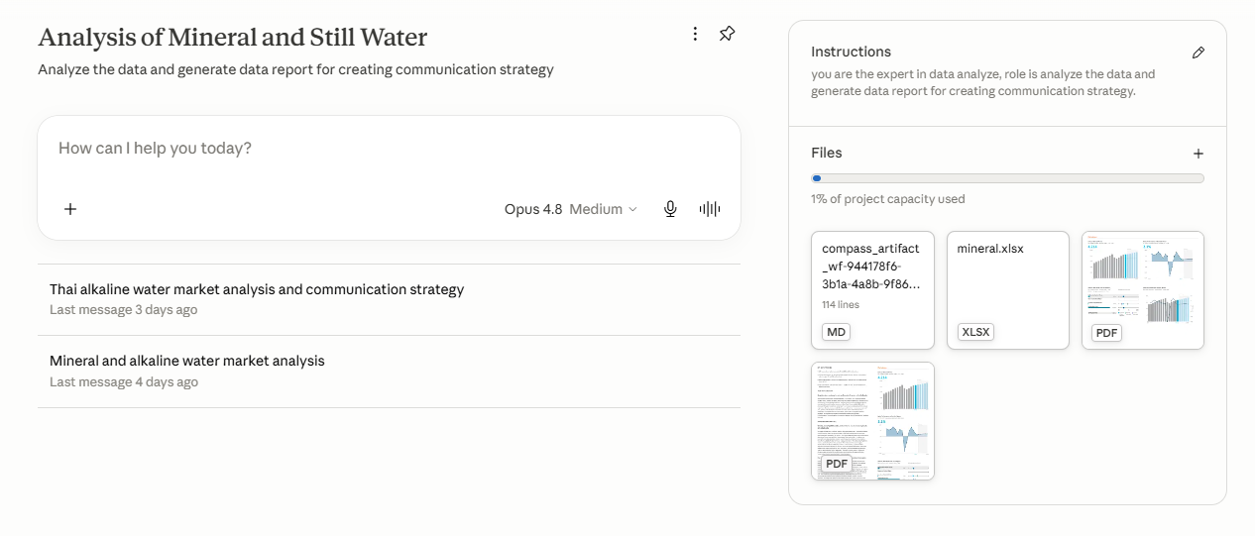

Confusion & open-questions log
Question or point of confusion | Raised by

What you hand TWF afterward
- The filled grid — job → mode → primary artifact + format + inputs + agent extras, with mode disagreements flagged.
- The job-mode → artifacts summary — the worked example above, extended to all five modes.
- The confusion log — consolidated open questions, keyed to slides.

