137 – BOTTOM SECTION IN HOMEPAGE LAYOUT PHP

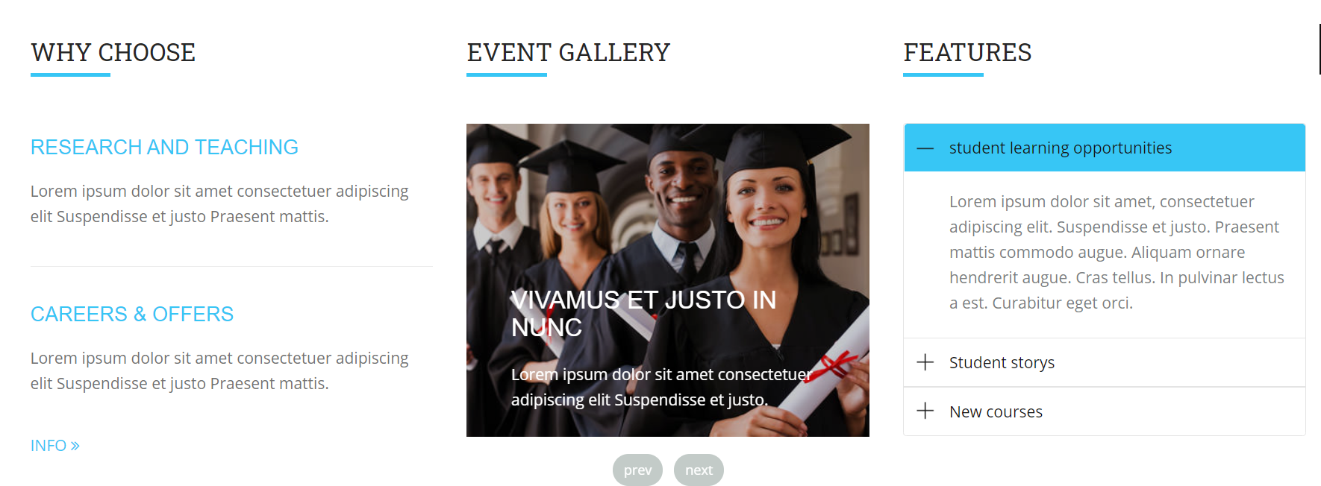

1. **WHY CHOOSE SECTION**  
   **A- Change title ‘WHY CHOOSE’ using the table TRADUCCIONES_MAGAZINE**  
   **Change ‘WHY CHOOSE’ label depending on language  
     
   Use same logic we already have used on rest of labels:** $contactLang=queryAll("SELECT PALABRA,I1,I2,I3,I4,I5,I6,I7,I8,I9,I10,I11,I12,I13,I14,I15 FROM TRADUCCIONES_MAGAZINE WHERE id = 1058","row_array");  
     
   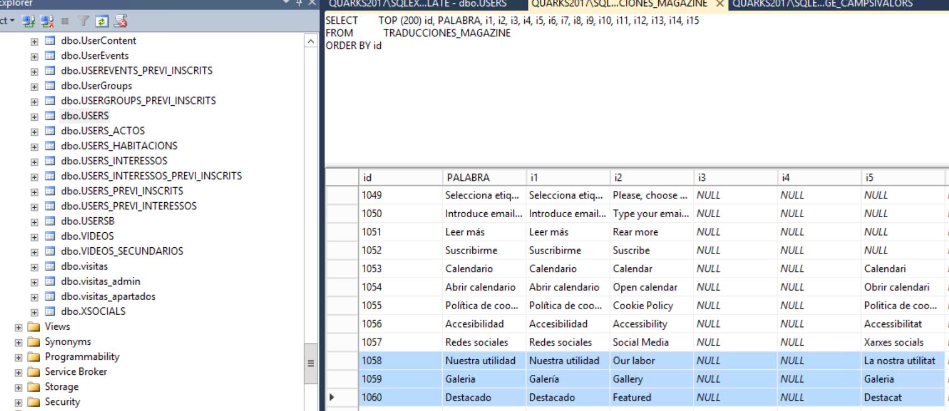

If language we are using in web view is not the default , then we must use the iX correspondant where x is the value for language version. If our language value = default language, then we use the column ‘PALABRA’ for to populate the string.

**B- Select the content to show using the registry where nom=’whychoose’ in table HOMEPAGE_CAMPSIVALORS.**   
With the value stored in column ‘idasociado’ for this record, extract from table CONTENT (and successive CONTENT_Ix for the languages) the values of columns ‘title’ and ‘shortdesc’.

1. We will show title in blue, and shortdesc in grey as now it’s in layout. For the INFO>> link, we open the page h_item-detail.php?contentid=xxxx where xxxx is the value of contentid we are using.  
     
     
   If language we are using in web view is not the default , then we must use the CONTENT_Ix table to get the values for the title and shortdesc values.   
   Example, assuming whe have default language = 1, then if we are showing languageid = 2 contents, we must use table CONTENT_I2 for to get the values of title and shortdesc  
     
   If we are showing languageid=5, then we must use CONTENT_I5 table to get the values of title and shortdesc.  
     
   Video and thumnail values are always readed from table CONTENT, this not changes between languages.   
     
   **HOW TO KNOW WHAT LANGUAGE IS THE DEFAULT:**

Select id_idioma from IDIOMAS where PREDETERMINAT=’S’ ,   
in our example, if language (idioma) we are showing currently is the 2 (Spanish) then we use table CONTENT. For the other languages, que use the table CONTENT_Ix  
  
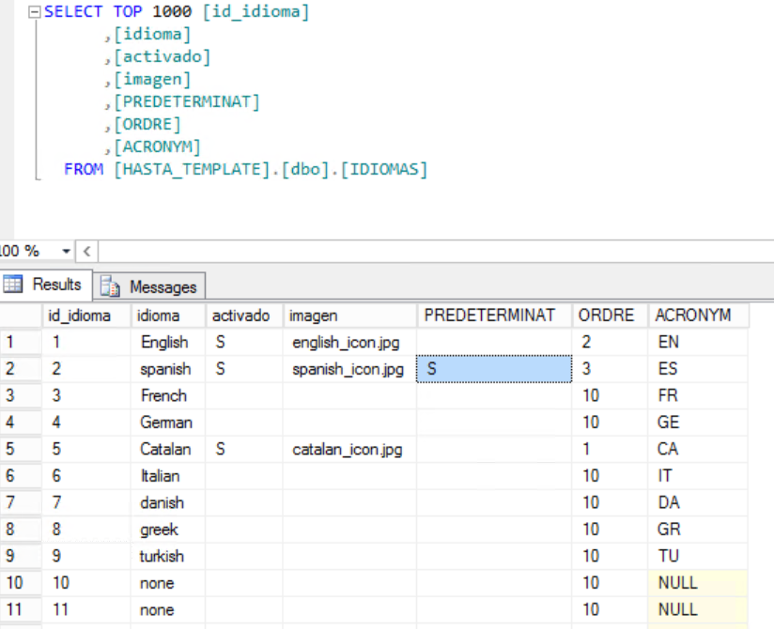

1. **EVENT GALLERY SECTION**  
     
   **A- Change title ‘EVENT GALLERY’ using the table TRADUCCIONES_MAGAZINE**  
   **Change ‘WHY CHOOSE’ label depending on language  
     
   Use same logic we already have used on rest of labels:** $contactLang=queryAll("SELECT PALABRA,I1,I2,I3,I4,I5,I6,I7,I8,I9,I10,I11,I12,I13,I14,I15 FROM TRADUCCIONES_MAGAZINE WHERE id = 1059","row_array");  
     
   

If language we are using in web view is not the default , then we must use the iX correspondant where x is the value for language version. If our language value = default language, then we use the column ‘PALABRA’ for to populate the string.  
  
**B- for to show the images of gallery, we use the table HOMEPAGE_CAMPSIVALORS. We have this registries created:**  
  
fotohasta1,  
fotohasta2,  
fotohasta3,  
fotohasta4,  
fotohasta5  
  
For every registry with column i1 not empty, we show the image stored in this column (see example images)  
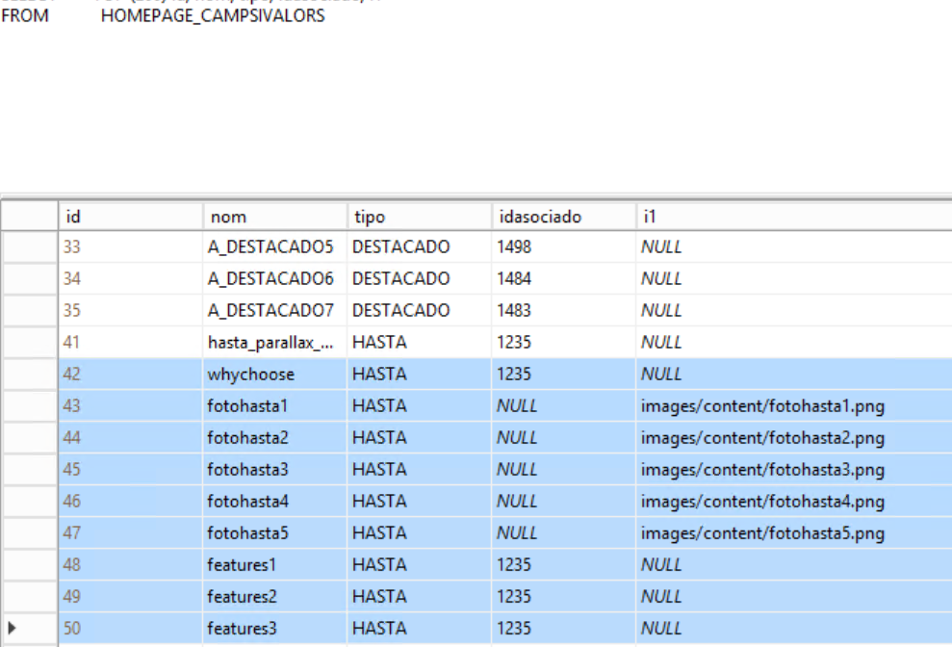  
So we will only show the values not null, this is important to avoid to get an error or a empty image when clicking in next-prev button.

1. **FEATURES SECTION**

**A- Change title ‘FEATURES’ using the table TRADUCCIONES_MAGAZINE**  
**Change ‘WHY CHOOSE’ label depending on language  
  
Use same logic we already have used on rest of labels:** $contactLang=queryAll("SELECT PALABRA,I1,I2,I3,I4,I5,I6,I7,I8,I9,I10,I11,I12,I13,I14,I15 FROM TRADUCCIONES_MAGAZINE WHERE id = 1060","row_array");  
  


If language we are using in web view is not the default , then we must use the iX correspondant where x is the value for language version. If our language value = default language, then we use the column ‘PALABRA’ for to populate the string.

B- For to populate the 3 micro-sections, we use the ‘title’ and ‘shordesc’ values of 3 different registries of table CONTENT.  
For to know what are this 3 elements, we use the table HOMEPAGE_CAMPS I VALORS. We search for the registries ‘featured1’,’featured2’,’featured3’   
  
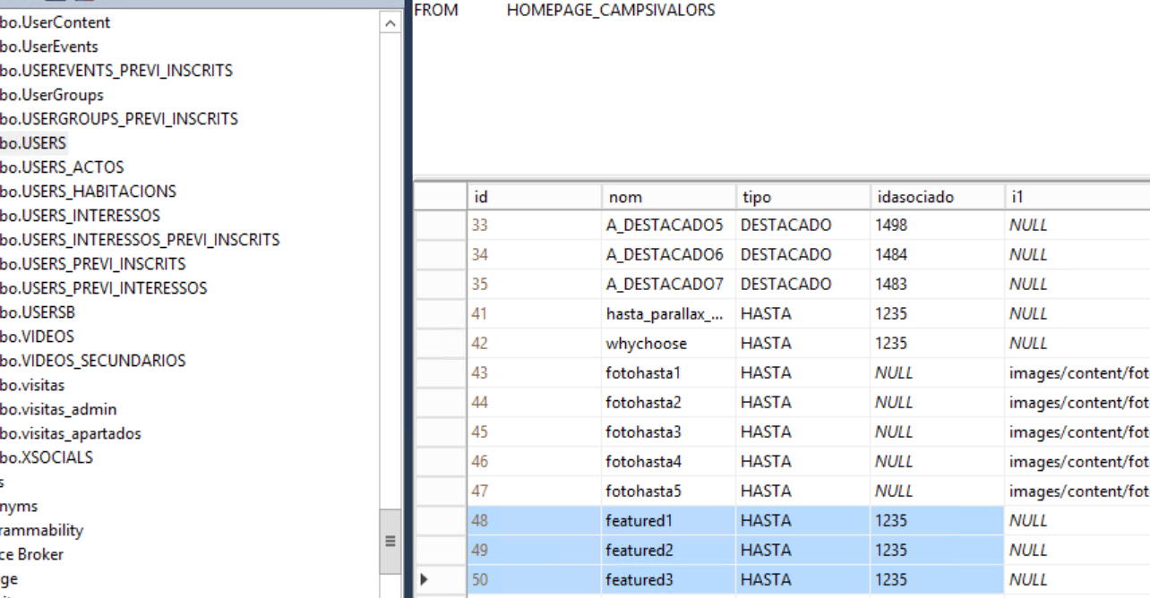

As on the other points to show info, we must control the language. When language variable we are showing to visitor is the same as the default one stored in table IDIOMAS, we use columns ‘title’ and ‘shortdesc’ from table CONTENT.  
If not this case, we use the table CONTENT_IX where X is the language id variable (use equal columns ‘title’ and ‘shortdesc’)