**ECORUGS - MAINTENANCE**

**Ecorugs – washing instructions**

**Machine wash:**

Your Ecorug can be machine washed !

To wash your Ecorug, please follow below instructions:

* Remove the label on the back of your Ecorug, but keep it: you will need it in order to benefit from our ‘Take Back Program’.
* Wash your Ecorug by hand or in a machine with a maximum washing temperature of 30°C, using a gentle or moderate wash program, with reduced spinning (maximum 600 rpm).
* DO NOT tumble dry your Ecorug. Higher drying temperatures can affect its colors.
* Dry your Ecorug by dripping/drying it flat or hanging it indoors to prevent sunlight from altering the colors.
* DO NOT iron your Ecorug. It is not necessary, and the high ironing temperature could damage it.
* DO NOT bleach your Ecorug, as this may alter its colors.

When machine washing, it's possible that the heat-sealed band on your Ecorug may partially detach (see photo below). In this case, you can reattach it by placing it back in position and ironing it at a low temperature (maximum 110°C).

Ironing is only allowed for this purpose, as it is done on the back of the product.

This ironing must be done on an ironing board.

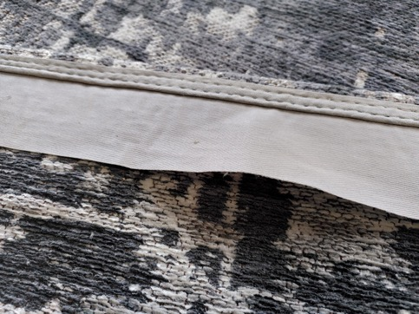

It is also possible to observe slight wear and tear in the back of the product during washing (see photo below): this is entirely normal and has no impact on the visible side or quality of the product.

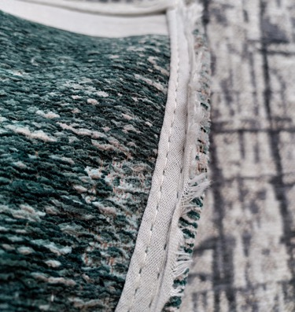

**Professional cleaning:**

f you choose to have your Ecorug professionally cleaned at a dry cleaner, please provide them with the link to this document so that they can follow the washing and maintenance recommendations (see 'Interim maintenance by a professional cleaner' section).

**Ecorugs – maintenance tips**

DAILY MAINTENANCE

**Vacuum Cleaning**

It is important for the lifespan of your Ecorug to vacuum it from the day of purchase at least once per week.

Check at least monthly whether the dust filter should be cleaned or the vacuum cleaner should be replaced.

DO NOT clean your Ecorug with an electrically driven brushing vacuum cleaner, as this may damage the fibers on its surface.

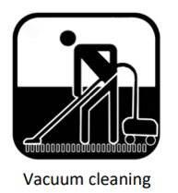 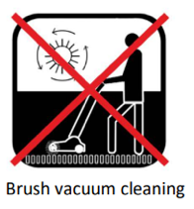

INTERIM MAINTENANCE BY YOURSELF

**Cleaning Manually with James Interior Cleaner**

You can manually clean your Ecorug yourself using a cotton terry towel and the 'James Interior Cleaner' detergent provided by our partner James.

(<https://www.james.eu/en/products/james-interior-cleaner/>)

If, from the day of purchase, you treat your Ecorug regularly with James Interior Cleaner, your Ecorug will stay looking nice longer.

James Interior Cleaner is a surface cleaning solution that effectively maintains your Ecorug’s fibers. It will help keeping your Ecorugs fresh, and prevent it from looking greyish, allowing you to enjoy it for a longer period.

You can decide whether it is necessary to (locally) clean your Ecorug.

Spray James Interior Cleaner on your Ecorug and then rub it dry with a dry white terry towel, using wide sweeping strokes. If you see the soiling coming off the carpet, then you may continue the cleaning.

**Beating the Rug**

If your Ecorug is easy to pick up, shake it outside and then hang it on a clothesline and beat it, preferably on its back. Afterward, bring it back inside and vacuum it following our daily maintenance instructions.

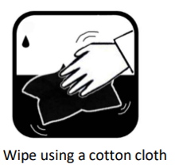

INTERIM MAINTENANCE BY A PROFESSIONAL CLEANER

Your Ecorug is eligible for interim cleaning when the creation of walkways by local soiling becomes so disturbing that vacuum-cleaning does not give a satisfactory result anymore. If you cannot or if you do not wish to clean your Ecorug manually with James Interior Cleaner, it can also be cleaned by a professional cleaning company.

Below, you will find the cleaning methods to apply:

**Pad Cleaning (single disc machine only)**

Pad cleaning (Bonnet system) can be performed on your Ecorug with a single disc machine equipped with a Bonnet Pad and proper detergent.

1. If necessary, first thoroughly clean your Ecorug using a vacuum cleaner with an adjustable floor nozzle.

2. Spray approximately 100 ml/m² of detergent on your Ecorug. We recommend using the 'James Cleanstar' detergent provided by our partner, James.

(<https://www.james.eu/en/products/james-cleanstar-can/>)

3. Then, clean your Ecorug using a single disc machine fitted with appropriate Bonnet pad. To avoid burning of the yarns, the machine should be operated at low speed (between 120 and 180 rpm).

4. To avoid brown stains on your Ecorug, furniture may exclusively be placed back on a dry carpet.

**Spray Extraction**

Cleaning by spray extraction can be performed on your Ecorug.

1. If necessary, first thoroughly clean your Ecorug using a vacuum cleaner with an adjustable floor nozzle.

2. Spray approximately 100 ml/m² of detergent on your Ecorug. We recommend using the 'James Cleanmaster’ detergent provided by our partner, James.

(<https://www.james.eu/en/products/james-cleanmaster/>)

3. Then, clean your Ecorug using a spray extraction machine equipped with a steel bar with nozzles with a flushing power of 12 litres of water per m² maximum.

4. To avoid brown stains on your Ecorug, furniture may exclusively be placed back on a dry carpet.

DO NOT clean your Ecorug using a powder cleaning counter rotating brush machine or a spray extraction machine equipped with rotating nozzles (Rotovac).

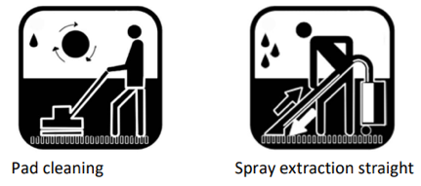 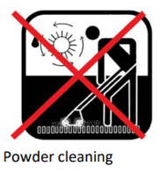 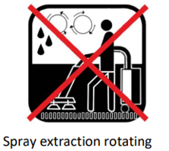

STAIN REMOVAL

Stains should be treated preferably immediately.

**Fresh Stains**

Immediately moisten a cotton cloth with cold water, wring it out and place it on the stain. Leave it on place, without peaking, until it is dry. Do not dab or rub, as this may cause permanent damage to your Ecorug. Never use soap!

**Persistent stains**

Treat as per the instructions on the James Staindisc or the James website (<https://www.james.eu/en/>). Via this link you can find more than 5000 different stain solutions!

James Stainwonder, James Stainspray and James Interior Cleaner have been tested on our Ecorugs.

If you have any doubts about the treatment, do not take any action at all and let the stain dry. Consult the James website (<https://www.james.eu/en/>), mail to james@james.eu or call the James line for more advice (+31 77 327 80 00).

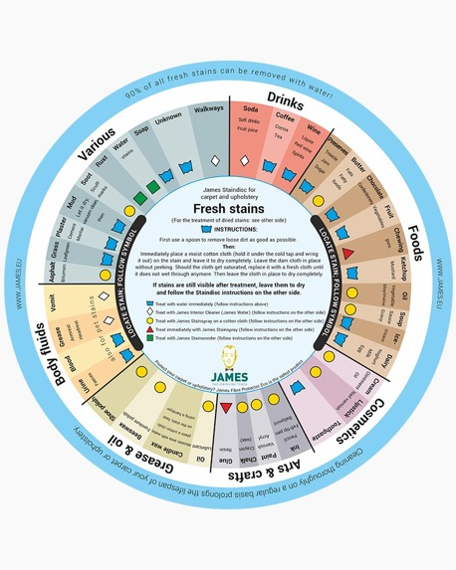 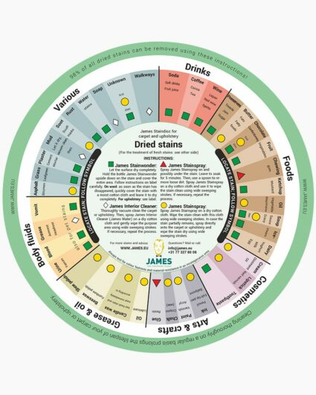

PREVENTION

**Prevention is better**

Place a rug in front of your house's entrance to trap dirt. Change your air filters to reduce suspended dust particles.

Do not install your Ecorug outdoors; its polyester fibers are not treated to withstand prolonged exposure to daylight and rain.

Regularly flip your Ecorug 180° to alternate the side most exposed to foot traffic; this way, your Ecorug will age more evenly.

To store your rug, always roll front-side out, wrapping it in a cloth for optimal protection. Do not fold or store your rug in a tight plastic bag.

In case the floor in your house is partly hard flooring (wood, stone, natural stone), please pay attention to the following: after cleaning the floor with soap, rinse it carefully using clean water. Dried up soap residues off a hard floor can be transported to rugs by shoe soles and the soles of feet. These sticky soap residues cause the carpet to become soiled quicker.

After cleaning the floor, make sure the space under your Ecorugs completely dried up. Any residues can change the characteristics of the Ecorugs top or bottom side. Louis De Poortere is not responsible for the damages on the floor. To make sure your floor is protected, please use a certified underlay

**Maintenance and stain removal**

You can find more information about the maintenance of all our collections, as well as tips for stain removal, on our partner James' website (<https://www.james.eu/en/>).