In the ad that I chose, it is an ad by Nike for weight loss. The main focus of the ad is an obese child around the age of 13 running alone. The ad uses all of the components to communicate its purpose. The ad will always be associated with kairos because obesity will always be a problem. I think it relies mostly on pathos because see this kid actually trying to lose weight is very inspiring and heartwarming because it is his own decision to run and it serves as a great motivator. Because everyone knows who Nike is, it adds ethos to the ad. Also, everyone knows that their commercials usually star athletic people, it impacts the viewers even more because it strikes them with the reality that not all people are as athletic as they are portrayed on TV. The audience for this ad is anyone trying to accomplish the same goal as this little boy.

Ideas for WP2: weight loss, littering, smoking, alcohol abuse, staying green

[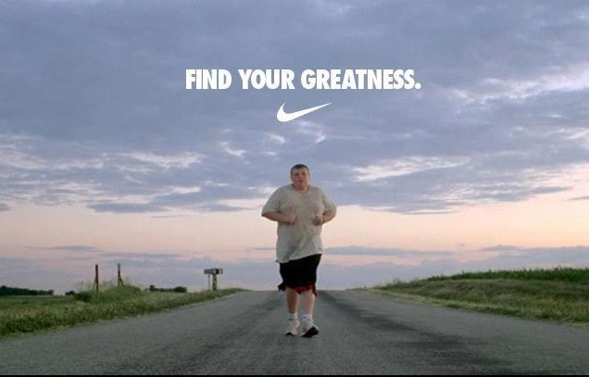](http://www.google.com/url?sa=i&rct=j&q=find%20your%20greatness&source=images&cd=&cad=rja&docid=N14Fnm6PQ7Ae_M&tbnid=iGYKyGv_fLOU4M:&ved=0CAUQjRw&url=http://www.sorrybrosports.com/2012/08/fat-kid-in-nikes-find-your-greatness.html&ei=IrUiUaLHK83RiAL7ioDoCQ&psig=AFQjCNH_v0vNRZbVpLIyXLL_9-XqQTEOsg&ust=1361315468351436)