**Grid (Raster)**

The CSS Grid Layout Module offers a grid-based layout system, with rows and columns, making it easier to design web pages without having to use floats and positioning. We call it a 2-dimensional system.

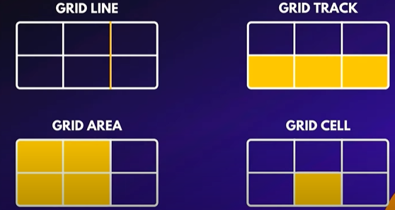

1-Grid Line

2-Grid Track

3-Grid Area

4-Grid Cell

CSS Grid Properties

***Cantainer/Items***

Grid-template

[Grid-template-areas](https://developer.mozilla.org/en-US/docs/Web/CSS/grid-template-areas)

[Grid-template-columns](https://developer.mozilla.org/en-US/docs/Web/CSS/grid-template-columns)

[Grid-template-rows](https://developer.mozilla.org/en-US/docs/Web/CSS/grid-template-rows)

Grid-column-start

Grid-column-end

Grid-row-start

Grid-row-end

Sets up an auto-flow by setting the row tracks explicitly via ***the***[***grid-template-rows***](https://developer.mozilla.org/en-US/docs/Web/CSS/grid-template-rows) property (and the [***grid-template-columns***](https://developer.mozilla.org/en-US/docs/Web/CSS/grid-template-columns)property to none) and specifying how to auto-repeat the column tracks via [***grid-auto-columns***](https://developer.mozilla.org/en-US/docs/Web/CSS/grid-auto-columns)(and setting [grid-auto-rows](https://developer.mozilla.org/en-US/docs/Web/CSS/grid-auto-rows) to auto). [***grid-auto-flow***](https://developer.mozilla.org/en-US/docs/Web/CSS/grid-auto-flow)is also set to column accordingly, with dense if it's specified.

Sets up an auto-flow by setting the column tracks explicitly via the ***[grid-template-columns](https://developer.mozilla.org/en-US/docs/Web/CSS/grid-template-columns)*** property (and ***the [grid-template-rows](https://developer.mozilla.org/en-US/docs/Web/CSS/grid-template-rows)*** property to none) and specifying how to auto-repeat the row tracks via ***[grid-auto-rows](https://developer.mozilla.org/en-US/docs/Web/CSS/grid-auto-rows)***(and setting [grid-auto-columns](https://developer.mozilla.org/en-US/docs/Web/CSS/grid-auto-columns) to auto). ***[grid-auto-flow](https://developer.mozilla.org/en-US/docs/Web/CSS/grid-auto-flow)*** is also set to row accordingly, with dense if it's specified.

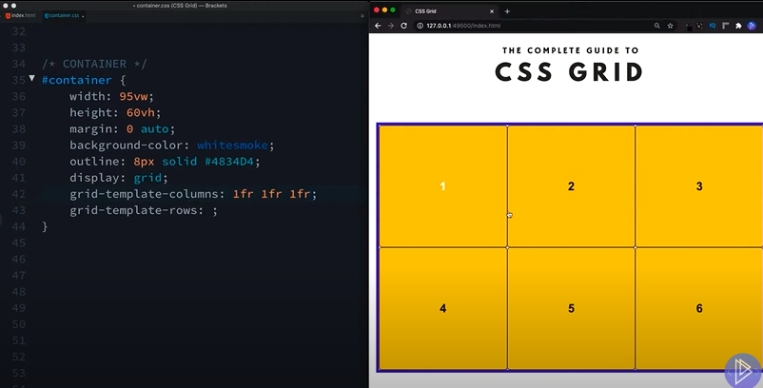

Here we chose “grid-template-colums: 1fr 1fr 1fr; “ and we have three equal width colums of one fr and if we actually expand the viewport, we can see that these will always adhere to that rule.

