WED HMRC MWS data

Quick guide for users

Version 01.00 December 2025

Contents
Contents 1
1. Introduction 1
2. Details of the dataset 2
2.1 The Migrant Workers Scan 2
2.2 MWS linked to ASHE 6
2.3 MWS linked to PAYE (RTI) wage data 8
2.4 MWS linked to self-assessment data 10
3. Further reading 11
Appendix: full variable listing 11

Introduction
The Migrant Workers Scan (MWS) contains information on all overseas nationals who have registered for and have been allocated a National Insurance Number (NINo). The data is held by HM Revenue and Customs (HMRC) and is delivered on an annual basis by the Department for Work and Pensions (DWP) to the Office for National Statistics (ONS). The MWS started recording migration information from 1975, but its current form operates from 2002 (earlier data is compiled from the previous systems); arrivals prior to 1975 are not recorded.
The Wage and Employment Dynamics (WED) team was commissioned by ADRUK to produce a research-ready dataset (RRD). A 1% sample of the data, those who meet the criterion for inclusion in the Annual Survey of Hours and Earnings (ASHE), has now been made available to researchers using the Secure Research Service (SRS), and is linkable to ASHE and to other HMRC data.
The source data file for the 1% sample is provided by ONS from the complete administrative record supplied to them by DWP. All the HMRC files have a reference number (hmrc_id) allowing the same individual to be identified across the different HMRC data files. This should allow direct linkage to the other HMRC files in the SRS (PAYE and Self-Assessment) which cover the same sample of the population. The ASHE files have a different unique person ID reference number (piden). A lookup file between these two references allows the ASHE and HMRC data to be linked together.
This Quick Guide summarises the data files and provides basic statistics. The report “Data Explained: ASHE-MWS” contains more discussion of the data, and can be found on the WED website and the ADRUK website.

Details of the dataset

The Migrant Workers Scan
The MWS consists of a single datafile. It is supplied as a CSV file, and is converted by the WED team into a Stata file “MWS.dta”. The data file undergoes relatively little cleaning but has additional variables which are derived or pulled from other sources.
The full variable list is included in the Appendix but in summary the file contains:
- Date of registration for NINo, and date of arrival in the UK
- Nationality, and country of residence immediately prior to arrival
- Age and marital status (male, female/married, female/non-married)
- Postcode area at registration
- Index fields to link to the ASHE and HMRC data
‘Arrival date’ is completed for all records, but registration date is missing in about 5% of cases. Most of the missing registrations are for arrivals prior to 2000, which is not entirely surprising. ‘Country of residence prior to arrival’ is also missing in a substantial number of cases. Otherwise, original and derived variables are generally well populated with the exception of ‘piden’ and postcode area– see Table 1.

Original Variable | % of valid (non-missing) observations |  |  | Mean
 | All | Arr. 2002 onwards | Reg. 2002 onwards | All | Arr. 2002 onwards | Reg. 2002 onwards
age_at_q1 | 100% | 100% | 100% | 20.96 | 16.38 | 16.74
age_at_q2 | 100% | 100% | 100% | 21.21 | 16.63 | 16.99
age_at_q3 | 100% | 100% | 100% | 21.47 | 16.88 | 17.24
age_at_q4 | 100% | 100% | 100% | 21.72 | 17.13 | 17.49
country_code | 100% | 100% | 100%
date_of_arrival_in_UK | 100% | 100% | 100%
date_of_registration | 95% | 100% | 100%
hmrc_id | 100% | 100% | 100%
Piden | 56% | 57% | 58%
postcode_area | 85% | 88% | 86%
previous residence* | 100% | 100% | 100%
sex_status | 100% | 100% | 100% | 0.81 | 0.83 | 0.83
Total observations: | 156,200 | 119,253 | 123,790
* Note: ‘previous residence’ is always completed but 3/4 of observations are coded as ‘not specified’/’not recorded’/’unused code’
Table 1: Original variables: missingness and mean values, by arrival/registration date
Registration date is available from 1982 onwards. Most registrants post-2007 arrive in the year of registration (Table 2). A small number (1282, or 0.82%) appear to arrive after registration. This is feasible: employees who have given work permits or student intending to carry out work may apply for a NINo from abroad. We assume that the registration year is correct, as this should have been recorded automatically by the system, whereas the arrival date is entered by the registrant. Registered postcode is generally present but missing in 22% of those arriving pre-2002, and in half of those cases where the migrant arrives after registration, as might be expected.
Arrival year | Frequency | Same registration and arrival year | Arrival year after registration year | Mean age on arrival | Arrived as an adult | Male
75-81 | 6,127 | n/a | n/a | 24.8 | 1.5% | 53.5%
82-86 | 4,707 | 46.4% | 0.1% | 26.3 | 1.3% | 52.0%
87-91 | 8,296 | 51.5% | 0.6% | 26.4 | 1.0% | 52.1%
92-96 | 7,694 | 49.3% | 1.5% | 26.7 | 1.2% | 52.2%
97-01 | 10,123 | 28.1% | 1.0% | 27.0 | 2.0% | 50.0%
02-06 | 25,130 | 38.9% | 0.5% | 27.1 | 1.2% | 53.2%
07-11 | 30,801 | 62.5% | 0.8% | 27.4 | 1.0% | 53.6%
12-16 | 35,147 | 72.3% | 1.2% | 28.5 | 0.8% | 53.6%
2017 on | 28,175 | 72.2% | 0.8% | 29.6 | 0.0% | 51.5%
Total | 156,200 | 56.3% | 0.8% | 27.8 | 0.9% | 52.7%
Table 2: Characteristics by arrival year
Age in each quarter in 2002 is recorded, enabling birth year to be generated. The data currently available runs to 2022, and so the last recorded birth date is 2006 (allowing the individual to be 16 in 2022, the minimum age for PAYE employment). As Table 2 shows, the mean age at arrival date increases steadily, although the proportion arriving as a child is more variable.
Table 3 shows the age distribution of registrants by arrival date.
Arrival year | Year of birth
 | pre-1960 | 60-69 | 70-79 | 80-84 | 85-89 | 90-94 | 95-99 | 00-04 | 05 onwards
75-81 | 5,138 | 984 | . | . | . | . | . | .
82-86 | 2,020 | 2,636 | 47 | . | . | . | . | .
87-91 | 1,990 | 4,775 | 1,530 | . | . | . | . | .
92-96 | 1,083 | 2,574 | 3,976 | 61 | . | . | . | .
97-01 | 828 | 1,759 | 5,753 | 1,606 | 173 | . | . | .
02-06 | 1,235 | 2,630 | 9,120 | 8,441 | 3,501 | 203 | . | .
07-11 | 1,082 | 2,156 | 5,818 | 7,549 | 10,012 | 3,996 | 188 | .
12-16 | 673 | 2,023 | 4,897 | 4,554 | 8,027 | 9,971 | 4,742 | 260
2017 on | 255 | 1,312 | 3,206 | 2,681 | 4,172 | 6,366 | 7,005 | 3,114 | 64
.' means numbers less than 10 (including zeros and structural zeros)
NB. Missing numbers can't be replaced in cells from other tables because the year of birth doesn't align with the year of arrival.
Table 3: Birth year distribution by arrival date
The MWS records sex and marital status jointly as [male, female married, female not married]. The WED transformation creates a new binary variable ‘male’. Table 4 shows the share of males arriving is fairly steady. The proportion of married females is falling over time, but this is more a reflection of secular trends. As with all MWS data, marital status is recorded at the time of arrival and not updated.
Arrival year | Number | % Male | % Female
 |  |  | Married | Unmarried
75-81 | 6,127 | 53.5% | 43.0% | 3.4%
82-86 | 4,707 | 52.0% | 44.0% | 4.0%
87-91 | 8,296 | 52.1% | 36.0% | 11.9%
92-96 | 7,694 | 52.2% | 32.7% | 15.1%
97-01 | 10,123 | 50.0% | 42.6% | 7.4%
02-06 | 25,130 | 53.2% | 39.7% | 7.1%
07-11 | 30,801 | 53.6% | 35.8% | 10.6%
12-16 | 35,147 | 53.6% | 15.4% | 30.9%
2017 on | 28,175 | 51.5% | 7.7% | 40.8%
Total | 156,200 | 52.7% | 27.6% | 19.7%
Table 4: Sex and marital status, by arrival year
Table 5 shows nationality by arrival year (arrivals from British nationals born abroad, British Overseas Territories and missing values excluded).
Arrival year | Africa | Asia | Australasia | Europe | Latin America | Canada | US | Caribbean | Total
75-81 | 596 | 1,688 | 813 | 2,252 | 89 | 127 | 252 | 65 | 5,882
82-86 | 485 | 1,049 | 578 | 1,777 | 50 | 106 | 235 | 24 | 4,304
87-91 | 1,008 | 1,523 | 1,001 | 3,455 | 80 | 129 | 338 | 85 | 7,619
92-96 | 1,088 | 1,391 | 893 | 3,243 | 108 | 102 | 267 | 78 | 7,170
97-01 | 1,743 | 2,975 | 720 | 3,528 | 212 | 138 | 262 | 302 | 9,880
02-06 | 3,310 | 6,452 | 1,307 | 12,577 | 500 | 224 | 403 | 241 | 25,014
07-11 | 2,157 | 8,397 | 1,129 | 17,635 | 594 | 254 | 458 | 98 | 30,722
12-16 | 1,430 | 4,854 | 869 | 26,817 | 328 | 225 | 458 | 63 | 35,044
2017 on | 2,129 | 7,658 | 541 | 16,493 | 441 | 190 | 506 | 110 | 28,068
NB omits missing values, British nationality, and British Overseas Territories
Table 5: Registered nationality on arrival, by arrival date
The increase in European migrants after 2004 is notable, as is the drop in recent years after the Brexit vote in 2016. Figure 1 shows this more directly.

Figure 1: Numbers arriving by EU status
Different nationalities are likely to have more varied paths. Table 6 shows whether arrivals are from a region other than their nationality prior to moving to the UK. Arrivals from Latin America, Asia and Europe are relatively more likely to have been living in their home region prior to travel to the UK.
Region | Same region as nationality before move?
 | Yes | No
Africa | 9,990 | 3,956
Asia | 28,662 | 7,325
Australasia | 4,643 | 3,208
Europe | 73,628 | 14,149
Latin America | 2,020 | 382
Canada | 990 | 505
US | 2,040 | 1,139
Caribbean | 718 | 348
NB omits missing values, British nationality, and British overseas territories
Table 6: Region of residency before moving to UK
Figure 2 shows the postcode areas from which registrations are received (areas with less than 300 migrants are omitted). Postcode areas are usually the first two letters and represent and town and its hinterland e.g. AB is the postcode area for Aberdeen and the North-East Grampians. The size of the bubble represents the number of registrations from that postcode area.
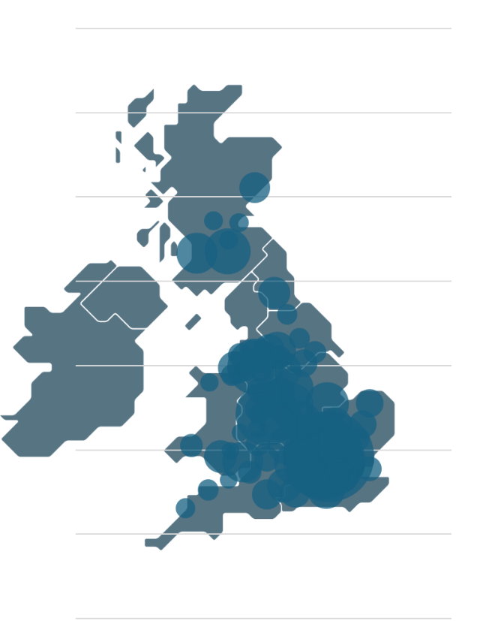
Figure 2: average eastings and northings for postcode district (eg BS16, AB1 etc).
Only districts with over 100 recorded migrants included. UK map Vecteezy.
Registrations are strongly concentrated in existing population centres, particularly in London, the midlands, the north-west and the central belt of Scotland.

MWS linked to ASHE
The Annual Survey of Hours and Earnings (ASHE) is a 1% survey of those in employment, selected as a random draw from National Insurance numbers (NINo). It is completed each year for a specific week in April by the employers of the selected sample . The same 1% of the labour force are always sampled if they are in employment in that week.
The MWS files contain the variable person identifier ‘hmrc_id’. These can be found in a lookup table which provides a link to the ASHE person identifier “piden”, as in Figure 3.
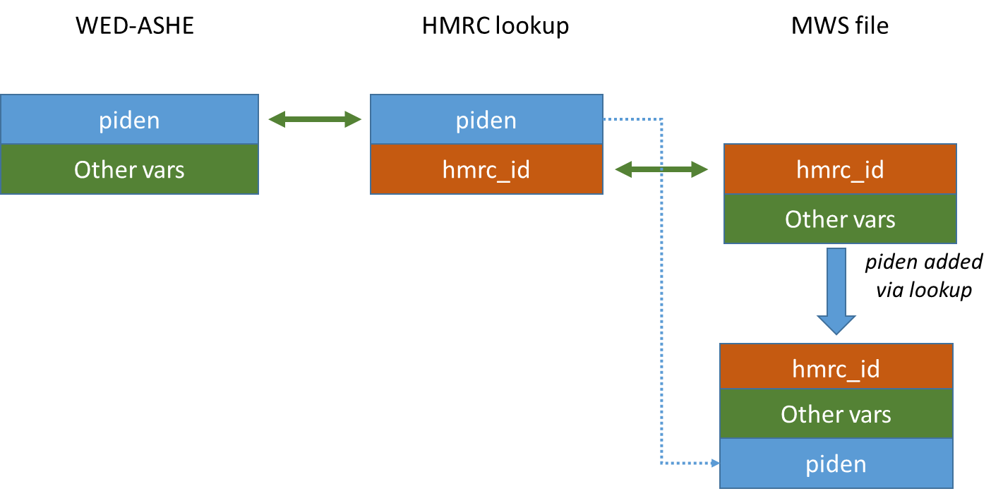
Figure 3: linkage between MWS and ASHE
All MWS records appear in the lookup file, which contains all possible NINOs. However, not all of those have a valid piden; see Table 7.

Does the person have  a link to the ASHE ID? | No | 87,857
 | Yes | 68,343
 | Total | 156,200
Table 7: Linkage rates between MWS, the lookup table and ASHE

Around 68,000 individuals have a corresponding record of piden between 1997 and 2022. There are many reasons why a migrant may not have been recorded in ASHE e.g. granted a NINo but not employed; employed but not during the ASHE survey period in April; employed but leaving the country before employment could be recorded.
Table 8 shows linkage rates for various breakdowns: arrival rate, birth year, region and sex.

 |  | Valid HMRC reference but not found in ASHE | Appears in HMRC link file and ASHE | Total
Arrival year | 75-81 | 4,836 | 1,291 | 6,127
 |  | 78.93 | 21 | 100
 | 82-86 | 3,363 | 1,344 | 4,707
 |  | 71.45 | 29 | 100
 | 87-91 | 5,781 | 2,515 | 8,296
 |  | 69.68 | 30 | 100
 | 92-96 | 4,440 | 3,254 | 7,694
 |  | 57.71 | 42 | 100
 | 97-01 | 4,278 | 5,845 | 10,123
 |  | 42.26 | 58 | 100
 | 02-06 | 9,756 | 15,374 | 25,130
 |  | 38.82 | 61 | 100
 | 07-11 | 14,770 | 16,031 | 30,801
 |  | 47.95 | 52 | 100
 | 12-16 | 18,622 | 16,525 | 35,147
 |  | 52.98 | 47 | 100
 | 2017 on | 22,011 | 6,164 | 28,175
 |  | 78.12 | 22 | 100
 | Total | 87,857 | 68,343 | 156,200
 |  | 56.25 | 44 | 100
Birth year | pre-1960 | 9,955 | 4,349 | 14,304
 |  | 69.6 | 30.4 | 100
 | 60-69 | 12,292 | 8,557 | 20,849
 |  | 58.96 | 41.04 | 100
 | 70-79 | 16,958 | 17,394 | 34,352
 |  | 49.37 | 50.63 | 100
 | 80-84 | 11,985 | 12,908 | 24,893
 |  | 48.15 | 51.85 | 100
 | 85-89 | 13,287 | 12,602 | 25,889
 |  | 51.32 | 48.68 | 100
 | 90-94 | 11,995 | 8,544 | 20,539
 |  | 58.4 | 41.6 | 100
 | 95-99 | 8,432 | 3,504 | 11,936
 |  | 70.64 | 29.36 | 100
 | 00-04 | 2,889 | 485 | 3,374
 |  | 85.63 | 14.37 | 100
 | 05 onwards | 64 | 0 | 64
 |  | 100 | 0 | 100
 | Total | 87,857 | 68,343 | 156,200
 |  | 56.25 | 43.75 | 100
Region | Africa | 6,422 | 7,524 | 13,946
 |  | 46.05 | 53.95 | 100
 | Asia | 20,232 | 15,755 | 35,987
 |  | 56.22 | 43.78 | 100
 | Australasia | 5,488 | 2,363 | 7,851
 |  | 69.9 | 30.1 | 100
 | Europe | 49,625 | 38,152 | 87,777
 |  | 56.54 | 43.46 | 100
 | Latin America | 1,254 | 1,148 | 2,402
 |  | 52.21 | 47.79 | 100
 | Canada | 938 | 557 | 1,495
 |  | 62.74 | 37.26 | 100
 | US | 2,107 | 1,072 | 3,179
 |  | 66.28 | 33.72 | 100
 | Caribbean | 365 | 701 | 1,066
 |  | 34.24 | 65.76 | 100
 | Total | 86,431 | 67,272 | 153,703
 |  | 56.23 | 43.77 | 100
Male | No | 40,829 | 32,999 | 73,828
 | Yes | 47,028 | 35,344 | 82,372
 | Total | 87,857 | 68,343 | 156,200
Table 8: Linkage rates for arrival year group, birth year group, region and sex
Linkage to ASHE, as a proportion of those arriving, peaks for arrival in 2002-2006, dropping off in either direction; the reverse is the case for linkage to the HMRC data but not ASHE. This is as expected as earlier arrivals may have left the labour market or the country, and later arrivals will have had less opportunity to be selected for ASHE. Birth rates show a similar pattern. Linkage rates to countries vary wildly. The share of linkable male migrants does not show obvious systematic variation.
For those who appear in both ASHE and MWS, we can compare recording of age and sex. There is strong agreement between age and sex as recorded in ASHE and the MWS – 99% of individuals appearing in one dataset have recorded age within a year in the other, and have the same sex recorded in both datasets. See Tables 9a and 9b.
Variation | Frequency
No variation | 63,483
+/- 1 year | 4,000
+/- 2-10 years | 596
+/- 10+ years | 264
Table 9a: Age variation in years between ASHE and MWS
 |  | Frequency
 |  | MWS
 |  | Female | Male
ASHE | Female | 32,817 | 183
 | Male | 182 | 35,161
Table 9b: Sex variation between ASHE and MWS

MWS linked to PAYE (RTI) wage data
The MWS can be linked directly to other HMRC data through the variable hmrc_id. Table 10 shows linkage rates between MWS and the ‘PAYE-ASHE supplement’ which is an annualised summary of the PAYE data.
Tax year | MWS only | PAYE only | Both | Total
2015 | 0 | 437,471 | 81,743 | 519,214
2016 | 0 | 435,511 | 81,217 | 516,728
2017 | 0 | 435,077 | 81,219 | 516,296
2018 | 0 | 434,772 | 81,197 | 515,969
2019 | 0 | 374,661 | 56,901 | 431,562
2020 | 0 | 70,130 | 17,475 | 87,605
Unlinked | 73,926 | 0 | 0 | 73,926
Total | 73,926 | 2,187,622 | 399,752 | 2,661,300
Table 10a.MWS individuals linked to payslip data

Tax year | MWS only | PAYE only | Both | Total
2015 |  | 280,061 | 43,758 | 323,819
2016 |  | 279,343 | 47,555 | 326,898
2017 |  | 279,691 | 50,185 | 329,876
2018 |  | 280,284 | 51,826 | 332,110
2019 |  | 280,249 | 53,209 | 333,458
Total |  | 1,399,628 | 246,533 | 1,646,161
Table 10b. MWS Individuals with some paid employment
Tax year | MWS only | PAYE only | Both | Total
2015 |  | 157,410 | 37,985 | 195,395
2016 |  | 156,168 | 33,662 | 189,830
2017 |  | 155,386 | 31,034 | 186,420
2018 |  | 154,488 | 29,371 | 183,859
2019 |  | 94,412 | 3,692 | 98,104
2020 |  | 70,130 | 17,475 | 87,605
Total |  | 787,994 | 153,219 | 941,213
Table 10c. Individuals with pensions only
Table 10a shows that a majority of those in the MWS have also had some form of income registered by the tax system in these years. This does not necessarily imply active pay – occupational pensions account for about 25% of PAYE returns, and about 5% of PAYE returns have an employment record but no associated weekly or monthly payment. Tables 10b and 10c show the linkage rates between those who have some employment in the tax periods, and those who only receive pensions. The number of migrants who receive employment pay is rising over time, while the number receiving occupational pensions appears to be falling. These overall indicate that about 15% of those in paid employment are registered migrants.
Table 11 compares the characteristics of those linked with RTI who are not linked.
 |  | MWS only | MWS and PAYE
Sex | Female | 48% | 47%
 | Male | 52% | 53%
 | Total | 73,926 | 82,274
Birth year | pre-1960 | 13% | 6%
 | 60-69 | 17% | 10%
 | 70-79 | 23% | 21%
 | 80-84 | 15% | 16%
 | 85-89 | 14% | 19%
 | 90-94 | 9% | 17%
 | 95-99 | 6% | 9%
 | 00-04 | 3% | 1%
 | 05 onwards | 0% | Missing - out of scope for PAYE
 | Total | 73,926 | 82,274
Region | Africa | 9% | 9%
 | Asia | 25% | 22%
 | Australasia | 8% | 3%
 | Europe | 52% | 62%
 | Latin America | 2% | 2%
 | Canada | 1% | 1%
 | US | 3% | 2%
 | Caribbean | 0% | 1%
 | Total | 72,852 | 80,851
Table 11: Match rates with PAYE by MWS characteristics
It shows that migrants who appear in the pay records are as likely to be male as those unlinked, are younger on average, and much more likely to have European nationality. Given that the PAYE match is only of the years 2015-2019, these results are as expected.
There is one other difference. The HMRC data incudes a marker for student loan repayment. There is a much lower rate of student loan repayments amongst migrants compared to the general population, suggesting they were more likely to either (a) arrive post student or (b) not be eligible for student loans, or (c) not need them. We have not yet fully explored the meaning and reliability of the student loan variable in the HMRC data, so we leave this as a research question for now.

MWS linked to self-assessment data
The HMRC Self-Assessment (SA) returns are also linkable via hmrc_id. About 15% of migrants are observed in the SA data from 2011-2018:
Tax year | MWS only | SA only | Both | Total
2011 | 0 | 82,653 | 9,409 | 92,062
2012 | 0 | 81,347 | 9,997 | 91,344
2013 | 0 | 86,108 | 11,011 | 97,119
2014 | 0 | 88,648 | 12,175 | 100,823
2015 | 0 | 89,043 | 13,520 | 102,563
2016 | 0 | 89,277 | 14,966 | 104,243
2017 | 0 | 89,987 | 16,106 | 106,093
2018 | 0 | 87,967 | 16,213 | 104,180
Unlinked | 129,899 | 6,510 | 1,865 | 138,274
Total | 129,899 | 701,540 | 105,262 | 936,701
Table 12: Matches MWS vs self-assessment data
In contrast to the PAYE data, there are notable differences between those who match to the SA data and those who do not; see Table 13.
 |  | MWS only | MWS and SA
Sex | Female | 49% | 36%
 | Male | 51% | 64%
 | Total | 73,926 | 82,274
Birth year | pre-1960 | 9% | 9%
 | 60-69 | 13% | 16%
 | 70-79 | 20% | 30%
 | 80-84 | 15% | 20%
 | 85-89 | 17% | 15%
 | 90-94 | 14% | 7%
 | 95-99 | 9% | 2%
 | 00-04 | 3% | 0%
 | 05 onwards | 0% | 0%
 | Total | 73,926 | 82,274
Region | Africa | 9% | 9%
 | Asia | 23% | 25%
 | Australasia | 5% | 4%
 | Europe | 57% | 57%
 | Latin America | 2% | 1%
 | Canada | 1% | 1%
 | US | 2% | 2%
 | Caribbean | 1% | 1%
 | Total | 72,852 | 80,851
Table 13: MWS-SA match by MWS characteristics
Migrants who also appear in only the SA data are much more likely to be male, and to have been born earlier (birth year peaks noticeably in the 1970s for matched migrants, but is much more evenly spread for the unmatched). The birth year likely reflects self-employment being more associated with older workers. Unlike the PAYE data, the nationality of those migrants across both linked and unlinked data does not vary significantly.

Further reading
The WED report MWS-ASHE Data Explained provides a more analytical view of the data, including comparisons to the migrant data in the Annual Population survey.In 2017 ONS produced a quality assurance report on the MWS. This appears to be the most recent official review of the source data.

Appendix: full variable listing
Name | Source | Variable label
age_at_entry | derived | Age at entry
age_at_entry_grp | derived | Age at entry, in categories
age_at_q1 | MWS | Age created at January 1st of the agreed base year 2000.
age_at_q2 | MWS | Age created at April 1st of the agreed base year 2000.
age_at_q3 | MWS | Age created at July 1st of the agreed base year 2000.
age_at_q4 | MWS | Age created at October 1st of the agreed base year 2000.
birth_year | WED | birth year from ASHE
birth_year_MWS | derived | Year of birth in MWS, calculated from age in Q1 2000
birth_year_MWS_grp | derived | Year of birth in MWS, in categories
country_code | MWS | Nationality of the individual (code)
country_name | derived | Nationality
country_region | derived | Nationality, by region
date_of_arrival | derived | Date of arrival in UK (Stata Date format)
date_of_arrival_in_uk | MWS | Date of arrival in UK (number format yyyymmdd)
date_of_death | MWS | The individuals date of death, truncated to year only.
date_of_reg | derived | Date of registration (Stata date)
date_of_registration | MWS | Date of registration (long number yyyymmdd)
dayarrival | derived | Day of arrival
dayreg | derived | Day of registration
eastings | derived | Eastings based on the post code area
EU | derived | Whether home nationality is in the EU
EU_at_entry | derived | Whether home nationality was EU at the time of registration
female_married | derived | Female married recorded in MWS (1/0)
hmrc_id | ONS | hmrc identifier
male | WED | male from ASHE (modal value if inconsistent)
male_mws | derived | Male recorded in MWS (1/0)
mergeashe | WED | Matching result from linking birth year and male from ASHE (ie has this person ever appeared in the ASHE dataset?)
mergepiden | WED | Matching result from linking hmrc_id to piden (ie does this person appear to be within scope for ASHE?)
montharrival | derived | Month of arrival
monthreg | derived | Month of registration
northings | derived | Northings based on the post code area
piden | derived | Person identifiers (used in ASHE)
pidens | ONS | Person identifier (string)
duplications | derived | Flag of duplications from new lookup file (1/0 – Y/N)
dup_ons_solution | derived | Flag of selection of piden (ONS previous lookup) (1/0 – Y/N)
post_code_full_area | MWS | The postcode truncated to postcode area (first 1 or 2 alpha characters in postcode depending on format)
prev_residency_code | MWS | The individuals previous country of residence, recorded as a nationality code. Codes provided in a lookup file.
prev_residency_name | derived | Previous Residency Name
prev_residency_region | derived | Previous Residency Classification
sex_status | MWS | Sex/marital status
yeararrival | derived | Year of arrival
yearreg | derived | Year of registration

www.wagedynamics.com
ASHE comprises 1% of the labour force employed in a week in April each year. As the 1% is based on NINo, the same individuals are recorded each year if they are working, creating a longitudinal sample. See the WED guidance https://www.wagedynamics.com/data-documentation/enriched-ashe-qa/ for details
https://www.wagedynamics.com/hmrc/
https://www.ons.gov.uk/peoplepopulationandcommunity/populationandmigration/populationestimates/methodologies/migrantworkerscanqualityassuranceofadministrativedatausedinpopulationstatisticsjan2017

