Department for Work and Pensions
Registration And Population Interaction Database
(RAPID)

Population Interactions with
Employment, benefits and pensions - UK

Release 8
(2010/11 to 2023/24)
October 2024

Process Documentation &
Record Descriptions
(Secure Research Service (SRS) user version)
Version 2.0 (22/08/25)
Contents

1 Summary of the data 3
2 About this documentation 4
3 The type of analyses the SRS version of RAPID data will support 6
4 Data treatment to avoid disclosure and re-identification 8
5 Gaining Access to RAPID via the ONS Secure Research Service (SRS) 10
6 Getting started with RAPID 11
7 RAPID Executive summary 12
8 RAPID Release 8 – Summary of improvements and updates 13
9 Data Structure and Processing 30
10 Data sources that feed in to RAPID 37
11 Customer Information System (CIS) processing 40
12 Migrant Worker Scan (MWS) processing 45
13 Child Benefit (CHB) processing 52
14 Pay As You Earn (PAYE) processing 63
15 Tax Credit (Working Tax Credits (WTC) & Child Tax Credits (CTC)) processing 75
16 Housing Benefit (SHBE) processing 83
17 DWP Benefit processing (Legacy Benefits excluding UC & PIP) 92
18 Personal Independence Payment (PIP) processing 105
19 Universal Credit (UC) processing 108
20 Adult Disability Payments (ADP) and Child Disability Payments (CDP) processing 115
21 Self Employment (56NZ Self Assessment extract) processing 122
22 Coronavirus Job Retention Scheme (CJRS) & Self-Employment Income Support Scheme (SEISS) 131
23 Geo-coding 135
24 Data linking to create a tax year based file 138
25 Residency 139
26 RAPID Release 8 Record description 144
27 Medical condition codes 144

Summary of the data

The Registration And Population Interactions Database, ‘RAPID: Population interactions with employment, benefits and pensions – UK’ is a population based dataset created from administrative records held by Department for Work and Pensions (DWP) and His Majesty’s Revenue and Customs (HMRC). The data holds records for all people with a National Insurance number (NINO), including children, who were alive on or after 6th April 2010. The data covers the United Kingdom and is based on 100% extracts from DWP and HMRC administrative systems.

For simplification and ease of understanding the data will be referred to as ‘RAPID’ throughout this documentation.

RAPID captures an annual summary of employment, benefit and pension activities, and the income associated with those activities between 2010/11 and 2023/24. The data is created in flat file format and is ‘analysis ready’. The data holds 1 row per person per tax year and columns for each of the activity variables.

The data enables analysis of month on month activities and the transitions between employment and benefit. It includes income measures based on the activities within RAPID and provides the ability to analyse populations to low levels of geography by age, sex and derived economic activity in each month.

About the Data

Data created by: | Department for Work and Pensions
Update frequency | Annual
Timeframe | 2010/11 to 2023/24
Population | United Kingdom & some abroad activities
Coverage | - All people with a National Insurance Number (including children);  - Includes people who may no longer be resident in the UK but who have a National Insurance Number;  - Includes people who have died since 2010. Records are included up to and including the tax year of death.
Size | Between 79 million and 87 million person records per tax year.

About this documentation

About this document:

 | Created | Updated by | Position
RAPD R8 (SRS User Version) V2.0 | 22/08/2025 | Andrew Needham | DWP CASS Data Exploitation Team Lead.
Document owner and contact details

Owner address |  | Data owner contact details
Department for Work and Pensions  Central Analysis & Science Strategy  Data Exploitation Team  BP5301 Benton Park View  Benton Park Road  Newcastle upon Tyne  NE 98 1YX |  | CASS Data Exploitation Team  Cass.dataexploitation@dwp.gov.uk
Your Feedback |  | srs.customer.support@ons.gov.uk  adrcuration@ons.gov.uk
Your feedback is very important to us to help us improve the product and make it more useable and understandable to researchers.

If you would like to provide feedback on the documentation or the underlying data please provide your feedback to the email addresses above.

About this documentation

This documentation is intended for users and prospective users of the RAPID data within the ONS Secure Research Service (SRS).

This document covers the data within RAPID that is available in the ONS SRS and reflects the data that DWP have agreed to share with the ONS. This version of the RAPID data is not linkable to any other data that is already held within the SRS.
The creation of RAPID generates data from the 2008/09 tax year. However, the initial supply of data to the SRS only provides data from 2010/11 onwards. Future ingests of RAPID may include data for 2008/09 & 2009/10. These versions may also be linkable to other data sources within the SRS.

This documentation includes information about the source data used within RAPID, the purpose for its collection, the accuracy and processing stages to create RAPID, along with any cautions and caveats that analysts need to be aware of. The documentation includes processes for 2008/09 and 2009/10, even though these years are not included in the data being supplied to the SRS.

Section 3 gives an overview of the types of analyses that the RAPID data will support, and perhaps more importantly, what it will not support in isolation.

Section 4 provides information on how to become an accredited researcher and the process for gaining access to RAPID in the SRS.

The type of analyses the SRS version of RAPID data will support

The diagram below gives an overview of the types of information that is currently captured in the SRS version of RAPID R8. The RAPID data incudes data from 2008/09 at the point it is created by DWP. However, the initial supply of data to the ONS SRS only includes tax years 2010/11 to 2023/24.

What the RAPID data will support

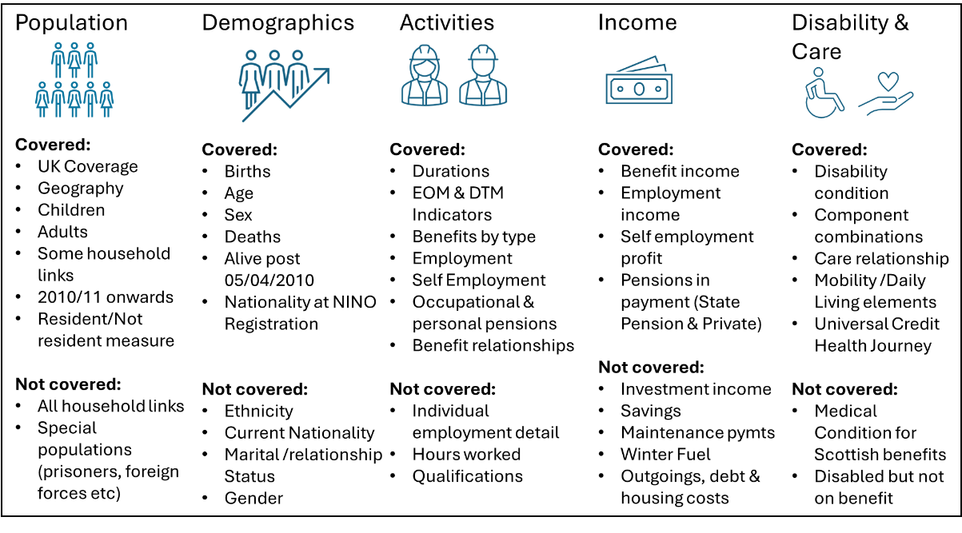
RAPID is a population based database and holds records for all people with a National Insurance Number who were alive on or after the 6th April 2010. The data includes both adults and children (who have been part of a child benefit award since 2010).
People appear in the data until a death date is recorded. These records are included up to (and including) the tax year in which death occurs.

The data is in flat file format and requires no linking to perform analyses within the year. There are tax year datasets and relationship datasets. The tax year datasets hold 1 row per person per tax year, and have columns for each of the activity variables. The tax year data can be linked together by person to give a longitudinal view of their activity history since 2010.
The relationship datasets hold the links between people in a household benefit award. There is a row per relationship, per benefit, per tax year. The relationship datasets can also be linked with the tax year files for each of the individuals in the relationship.

The data includes records for people who are no longer resident, resulting in significant over coverage when compared to ONS population estimates. In RAPID the presence of activities within a tax year populate a ‘resident’ flag to reduce the over coverage and result in a population measure that is very similar to ONS midyear population estimates.

The time series element of the SRS version of the data enable you to look at individual interactions over a 14 year period. It enables analysts to look at specific interactions, e.g. benefits or employment, over time and to assess the income generated from each of these activities. The data also enables analysis of transitions between activities month on month or year on year and combinations of activities over time, e.g. employment combined with an income related benefit, or employment combined with child benefit. The data can be segmented into small populations and low levels of geography, being based on 100% administrative data rather than a sample survey.

While the data is extremely powerful it is not perfect. The current version of the data will not enable comprehensive household analyses for all households. In RAPID households on an income related benefit can be linked together, but a universal household linkage isn’t currently possible.

RAPID captures most regular income streams from benefits, employments, self employments and pensions, but it currently excludes any income from investments, stocks, shares, maintenance payments and some irregular benefit payments, e.g. Winter Fuel Payments, Cold Weather Payments, Social Fund payments and Cost of Living Payments (although eligibility for this later category can be defined).

RAPID also hold no information on debt, housing costs, taxation (beyond that paid via PAYE) or other costs.

Data treatment to avoid disclosure and re-identification
The following measures have been agreed between ONS and the data suppliers, DWP and HMRC, following analysis and discussion:
- Convert month/year of birth to age at quarter
- Apply an age band to everyone 90+
- Set nationality breakdowns as UK/EU/RoW
- Lowest level of geography limited to local authority
- Removal of LA information for families with 8+ children
- Removal of LA information for particularly high earners where they have unusual characteristics and/or are dominant in their groups (distinct combinations of Age, Sex, Geography, place of origin and no. of children)
This proposal relates to a default suite of variables which all researchers would have access to. This will be reviewed following researcher feedback.
Users of the data are required to refrain from attempting to unpick measures (such as age grouping) that have been instituted to prevent accidental re identification of individuals.
RAPID can be held alongside any SRS/external data with correct project approvals in place, due to the lack of personal identifiers making individual linkage not possible. Matching can be achieved at the aggregate LA level to other data, as per SRS guidance researchers should not attempt to reidentify individuals within the data.

If you have any feedback on the mitigations, please reach out to ADRcuration@ons.gov.uk
If you have any questions/comments on the following User Guide, please direct them to ADRcuration@ons.gov.uk

Gaining Access to RAPID via the ONS Secure Research Service (SRS)

Below are some useful links that provide you with guidance on becoming an accredited researcher and how to access the RAPID data within the ONS Secure Research Service.

Becoming an accredited researcher: https://www.ons.gov.uk/aboutus/whatwedo/statistics/requestingstatistics/secureresearchservice/becomeanaccreditedresearcher

Applying for an SRS Project: https://www.ons.gov.uk/aboutus/whatwedo/statistics/requestingstatistics/secureresearchservice/becomeanaccreditedresearcher

How to get support:
SRS Customer Support: srs.customer.support@ons.gov.uk

Getting started with RAPID

This documentation is intended to support users of RAPID Release 8 in the SRS. Below are few things you need to know and need to consider to enable you to get started.

RAPID is created on fully masked data that has already been made available to the DWP Analytical Community;

RAPID brigades these released and published datasets into a single coherent view of citizen interactions with DWP and HMRC within the tax year. The data is formatted to provide a single data row per person per tax year, with columns for all the activity and income variables. The RAPID processing will create a row for anyone who is alive in the year, regardless of whether there are any activities within the data;

RAPID Release 8 has a single dataset for each tax year. These datasets are called ‘RAPID_R8_taxyear_2010’, ‘RAPID_R8_taxyear_2011’ etc. and are 100% datasets based on the various data extracts that DWP hold. The data includes both DWP and non-DWP customer records and includes anyone with a National Insurance Number (NINO).

In addition, RAPID holds relationship datasets for Child Benefit, Housing Benefit, Child Tax Credits, Work Tax Credits, Universal Credit, Pension Credit, State Pension, Carers Allowance and Income Support. The relationship datasets hold the duration of each claimant/partner pairing in the year and information about the months which the pairings cover in each year.

The SRS version of RAPID Release 8 covers tax years 2010/11 to 2023/24. Self Employment data for 2023/24 will not be available until summer 2025 so Release 8 use the 2022/23 self employment data as a proxy for 2023/24.

This documentation provides users with an overview of the methodology used to create RAPID, the caveats and cautions about the data, known issues with some data aspects and a comprehensive guide on all the variables in the dataset.

RAPID Executive summary

The Registration And Population Interaction Database (RAPID) has been developed by Central Analysis And Science Strategy Unit (CASS) to utilise existing data extracts and bringing selected information together into a coherent view of what citizens who interact with DWP, HMRC or Local Authorities (via Housing Benefit) systems are doing during the tax year.

This data provides a valuable asset in understanding the journeys and interactions between employment, self employment and benefit accrual and receipt. This data will generate insight that will enable DWP to formulate employment and benefit policies. RAPID helps DWP assess the impacts of new policy initiatives on the UK economy, labour force trends, impacts of the cost of living crisis and any future accrued benefit liabilities as well as helping answer numerous Evidence Strategy questions.

RAPID is based on 100% extracts of various Department for Work & Pensions (DWP) benefit systems and is supplemented with 100% data extracts from HMRC systems. The data extracts capture 100% of the ‘people’ but only a limited selection of the variables within each database. RAPID holds records for anyone who has ever had a National Insurance Number (NINO), including both resident and non-resident people. Records with a date of death which is prior to the 2010/11 tax year are dropped.

RAPID collates information on individual activities (and the income generated from those activities) within each tax year to enable a judgement to be made about whether a person is resident in the UK in that year. It does this by assessing their activities and interactions with the source systems within each tax year up to and including 2023/24 to provide a ‘foot print’ measure of the resident population¹, their activities and income (from those activities) in each year.

It is worth keeping in mind that RAPID is not perfect. It utilises administrative data, which in itself is sometimes flawed and sometimes has some ‘quirks’ that enable the various administrative systems to function. RAPID utilises these data and processes them in a consistent way where possible, but ultimately some imperfections remain, partly because RAPID is created on fully anonymised data and partly because some of the data extracts used in RAPID do not hold all the variables required to make accurate judgements.
RAPID is not perfect and it pushes the boundaries of what is possible with administrative data, accepting that the data was not originally collected for the statistical purposes RAPID was created for. Having said that, the outputs largely match published data and we believe the majority of data to be robust and of a high quality.

RAPID Release 8 – Summary of improvements and updates

Release 8 incorporates a number of changes and improvements over Release 7 .

A brief overview of the changes are listed below. More detailed information is included in the sections dealing with each specific data source.

R8 changes at a glance….

Data / subject | 2008/09 to 2022/23 | 2023/24 | Notes
Customer Information System (CIS) | Complete refresh | New data | R8 now uses ‘re-bulked’ and refreshed CIS extract.  Current nationality now included. See Section 9.
Migrant Worker Scan (MWS) | Complete refresh | New data
Child Benefit (CHB) | Complete refresh | New data | R8 uses the historic CHB extracts from 2008/09 to 2020/21, which only included families and children where CHB was in payment.  From 2021/22 R8 now utilises the new Future Child Benefit (FCHB) extract. This new extract includes families and children that are subject to the High Income Cap (HIC) and where CHB is not being paid.  All years now have new End of Month (EOM) & During the Month (DTM) values that differentiate between ‘Paid’,’ Zero rate’ and ‘HIC’ cases.  R8 now holds During The Month (DTM) and End Of Month (EOM) values for CHB relationships.
Guardians Allowance (GA) | New data from 2021/22 | New data | R8 now captures Guardians Allowance from the new Future Child Benefit extract. A Guardian’s Allowance amount is now calculated.
Pay As You Earn (PAYE) employment and Occupational pensions | Complete refresh | New data | R8 now uses employment start and end dates sourced from the ‘Spells’ data within the Employment Characteristics Data (ECD). This data provides the best measures of PAYE start and end dates. Now includes 1 day spells.
Tax Credits (NTC) | Complete refresh | New data | R8 now holds During The Month (DTM) and End Of Month (EOM) values for Tax Credit relationships.
Housing Benefit (HB) | Complete refresh | New data | No relationship data is available before October 2009.  R8 now holds During The Month (DTM) and End Of Month (EOM) values for Tax Credit relationships.
Attendance Allowance (AA) & Disability Living Allowance (DLA) | Complete refresh | New data | R8 now includes medical condition codes. The last condition code in the year is retained.
Personal Independence Payments (PIP) | Complete refresh | New data | R8 now includes medical condition codes. The last condition code in the year is retained.
Universal Credit (UC) | Complete refresh | New data | Corrects an issue for Northern Ireland where some cases were excluded from R7.1 between 2015 and 2021. These cases are now included in R8.  R8 now includes a ‘Health Journey’ flag showing the persons medical condition is being taken into account in the UC award.  R8 now holds During The Month (DTM) and End Of Month (EOM) values for UC relationships.
Employment Support Allowance (ESA) | Complete refresh | New data | R8 now includes medical condition codes. The last condition code in the year is retained.
Income Support (IS) | Same as R7.1 | New data
Job Seekers Allowance (JSA) | Same as R7.1 | New data
Pension Credit (PC) | Complete refresh | New data | R8 now holds During The Month (DTM) and End Of Month (EOM) values for Pension Credit relationships.
Invalid Care Allowance (ICA) | Same as R7.1 | New data | R8 now holds During The Month (DTM) and End Of Month (EOM) values for Care relationships.
Industrial Injuries (II) | Same as R7.1 | New data
Incapacity Benefit (IB) | Same as R7.1 | New data
Widows Benefit (WB) | Same as R7.1 | New data
Passported Incapacity Benefit (PIB) | Same as R7.1 | New data
Bereavement Benefit (BB) | Same as R7.1 | New data
State Pension (SP) | Same as R7.1 | New data | New relationship EOM & DTM variables to be added in a future release.
Severe Disablement Allowance (SDA) | Same as R7.1 | New data
Maternity Allowance (MA) | Same as R7.1 | New data
Bereavement Support Payment (BSP) | Same as R7.1 | New data
Industrial Death Benefit (IDB) | Same as R7.1 | New data
Self Employment | Same as R7.1 to 2021/22 | Refreshed 2022/23 and new data for 2023/24 | R8 refreshes the 2022/23 data (to replace the proxy year in R7.1) and adds 2023/24 data (the new proxy year)
Coronavirus Job Retention Scheme (CJRS) | Same as R7.1 & R6 | N/A | Uses R6 data for 2019/20 to 2021/22
Self Employment Income Support Scheme (SEISS) | Same as R7.1 & R6 | N/A | Uses R6 data for 2019/20 to 2021/22
Child Disability Payment (CDP) | Complete refresh | New data
Adult Disability Payment (ADP) | Complete refresh | New data
Geography | Complete refresh | New data | New COA 2021 variables.
Residency | Complete refresh | Complete refresh

Refreshed Tax years:

R8 adds the 2023/24 tax year data bringing the time series available in the SRS up to 14 years.

All employment and occupational pension data has been refreshed for all years to utilise the new spell based data within the DWP derived Employment Characteristics Database. This new spell based data captures the best measure of PAYE start and end dates and these have been brought into the PAYE processing of R8. The new spells based data may alter some durations and End of Month (EOM)/ During the Month (DTM) derivations.

Self employment data for 2023/24 is not expected to be complete until summer 2025, so proxy rules have been used to populate self employment records, (like in previous releases). R8 also refreshes all the self employment data for all years.

The following benefit data has also been refreshed for all years to capture the medical condition or relationship and End of Month (EOM)/ During the Month (DTM)information:

- Attendance Allowance, Disability Living Allowance, Personal Independence Payments, Employment Support Allowance – refreshed to capture medical conditions data;
- Universal Credit – refreshed to capture Health Journey flag and relationship EOM/DTM data;
- Pension Credit, Income Support, Tax Credits, Carers Allowance, Child Benefit, Housing Benefit – refreshed to derive EOM/DTM variables in the relationship data;
- Geography – Refreshed to capture Census Output Area 2021 codes.

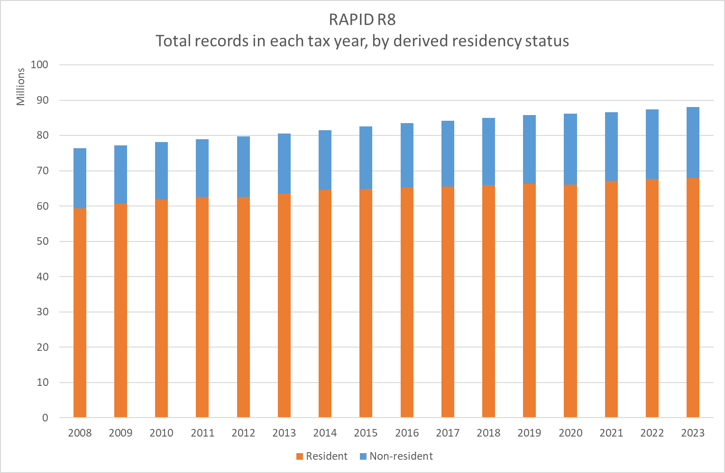

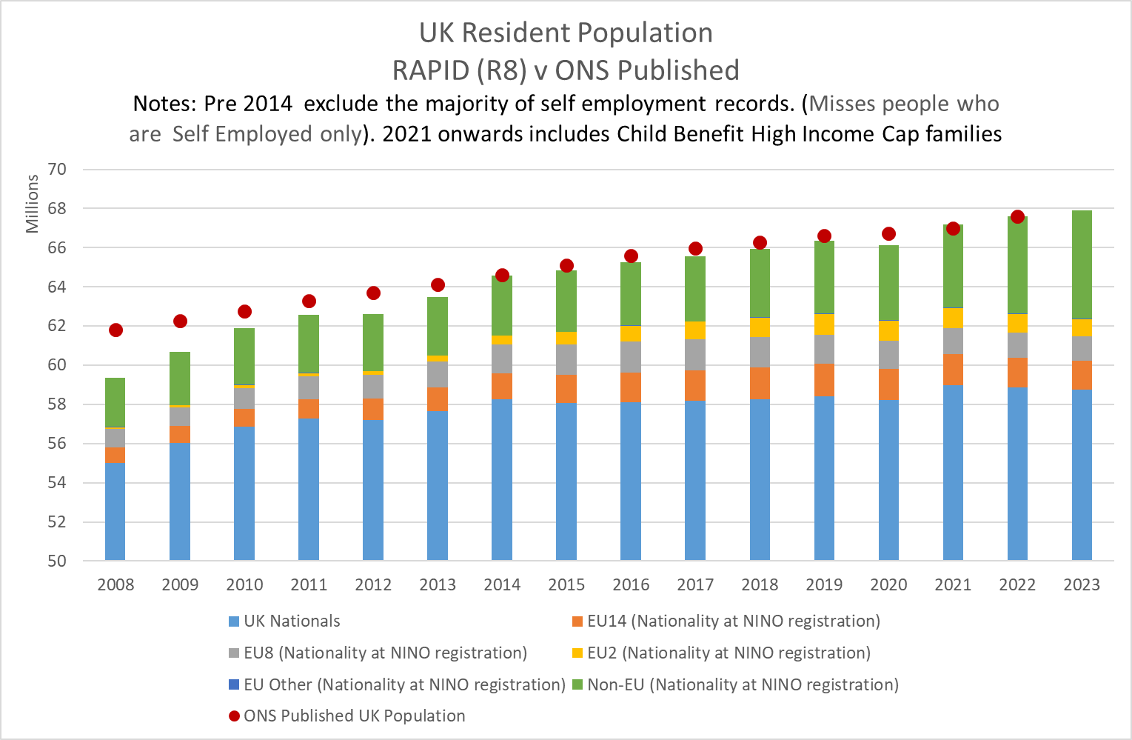

New Child Benefit data:

R8 utilises the new Future Child Benefit (FCHB) extract from HMRC. This new extract was supplied in June 2023 and included a complete ‘set’ of Child Benefit records back to February 2021.

The new FCHB data now includes records for families and children where the High Income Cap (HIC) is in place, meaning the family have decided to stop getting the CHB payment rather than paying it back via self assessment.
A National Insurance Credit will still be applicable if the main payee needs the Credits for a qualifying year for benefit/state pension accrual purposes.

The new FCHB data has been used in R8 from 2021/22 onwards and new End Of Month (EOM) and During The Month (DTM) values have been applied to differentiate between ‘paid’ (P), ‘zero rate’ (Z) and ‘high income cap’ (H) cases.

The historic data was only included cases that were ‘in payment’, i.e. High Income Cap cases where not part of the historic extract. The EOM/DTM values for the historic cases have also been changed to provide a consistent series. All cases where Child Benefit is in payment will hold ‘P’ in the EOM/DTM variables.

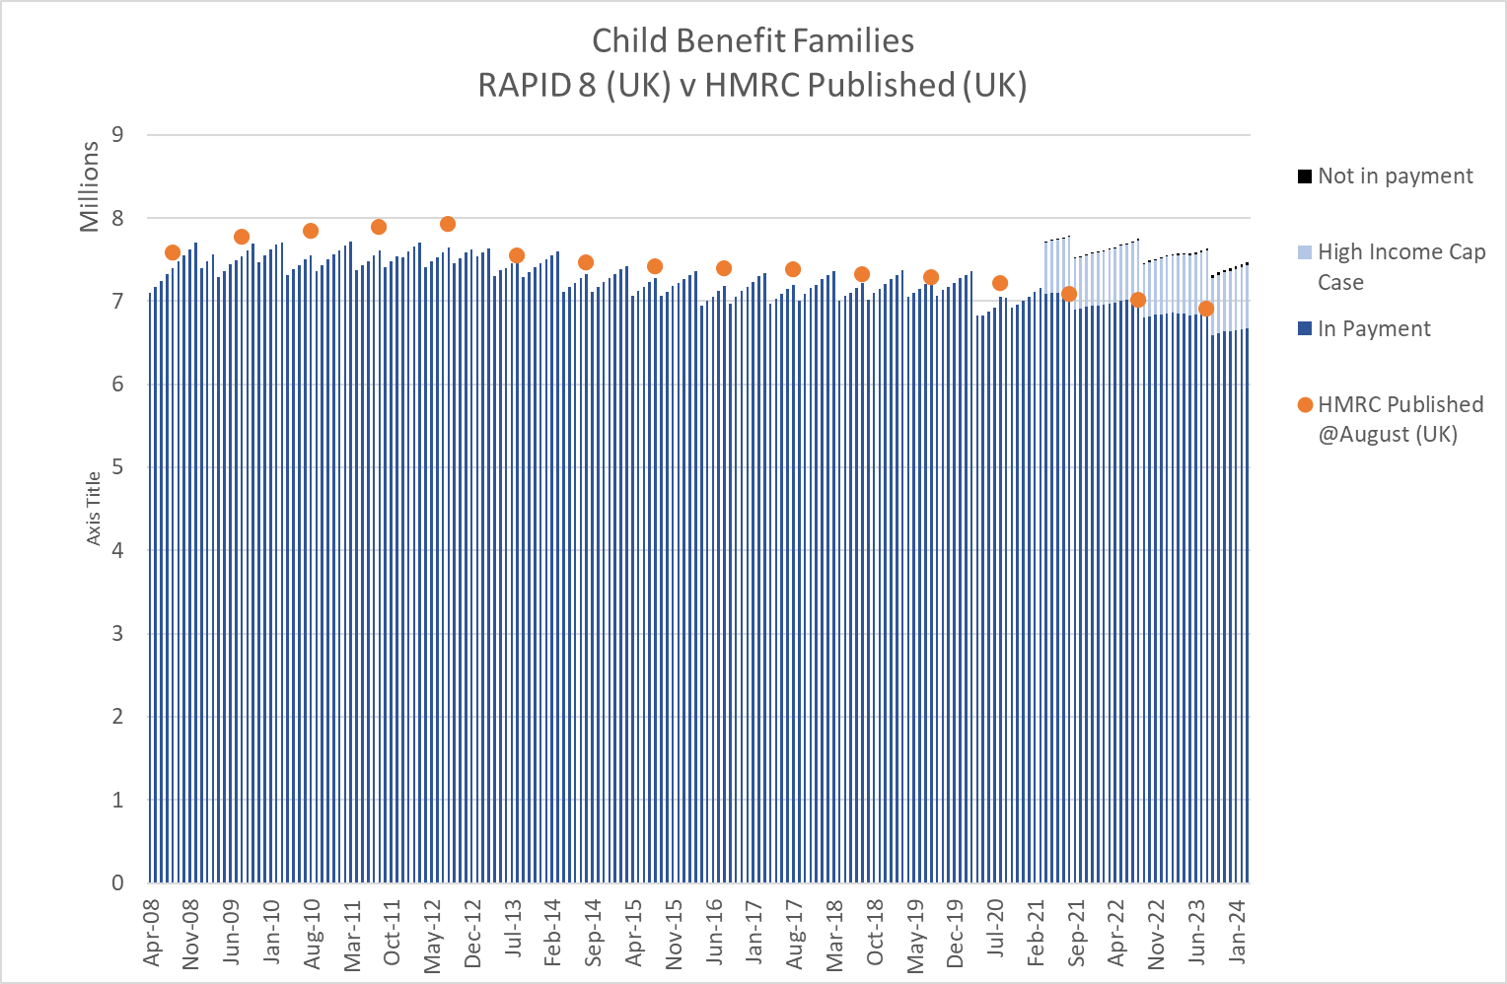

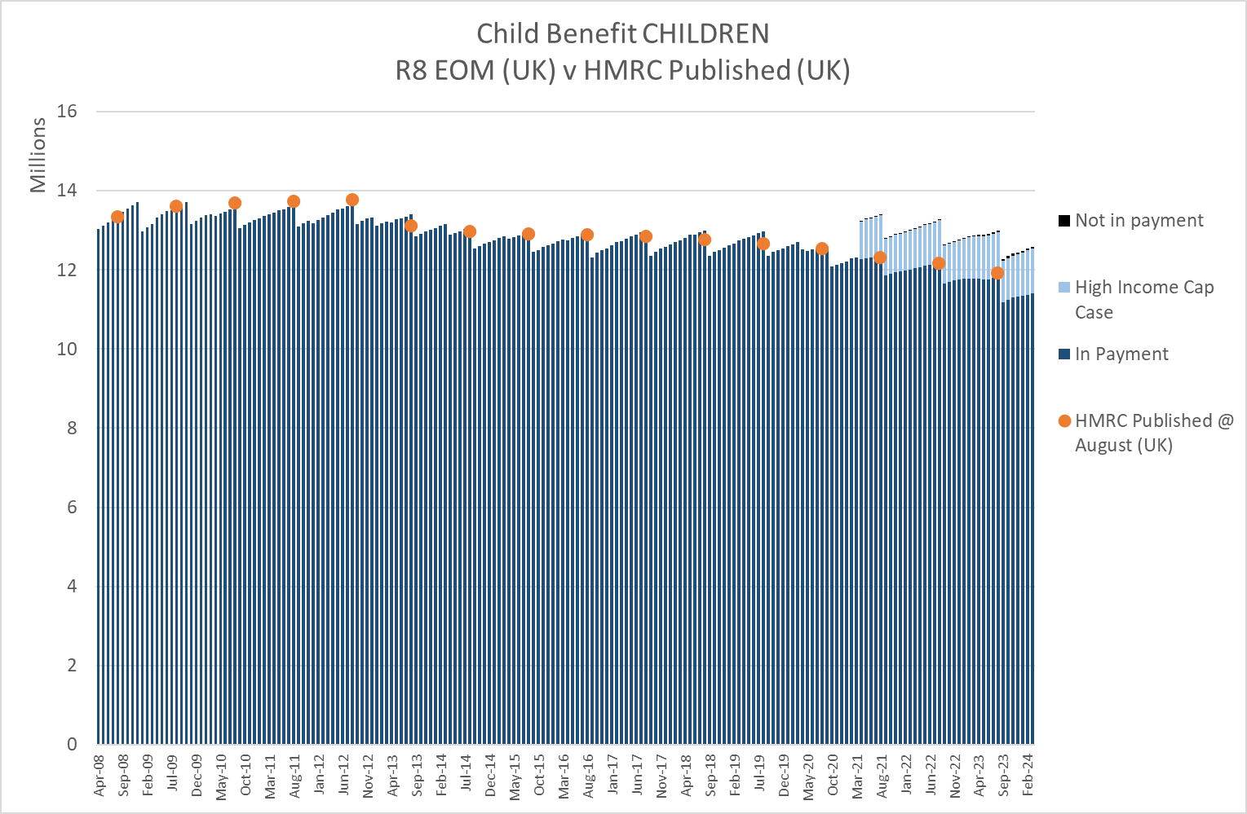

In addition, R8 now holds EOM and DTM indicators for Child Benefit relationships.

The new FCHB data also includes an indicator showing whether Guardians Allowance is payable with the Child Benefit, and how many children it is payable for.

R8 now calculates the Guardians Allowance amount and populates it against the payee/adult record in a separate variable.

New medical condition data:

R8 now brings medical condition code variables for the main disability benefits, i.e. Personal Independence Payments, Employment Support Allowance, Disability Living Allowance and Attendance Allowance.

As part of the processing of these benefits the last medical condition code that is observed in the year is retained and made available. The data is available throughout the time series of the benefit within RAPID.

It is worth noting that some of the medical codes change (or are expanded) over time. Some codes are no longer used for new cases or have been replaced by expanded codes. Some cases that are still current may still hold the old medical condition code and have not been updated to the new code on the source system, meaning a combination of old and new codes may be needed, depending on the analysis, and/or the benefit being analysed.

For Universal Credit the ‘Health Journey’ flag has been captured from 2017 onwards. Individual medical condition codes are not available on the UC system so the health journey flag has been brought in to RAPID to indicate that there is a health condition that is being taken into the assessment of the UC award.

A list of the medical condition decodes is available in section 24

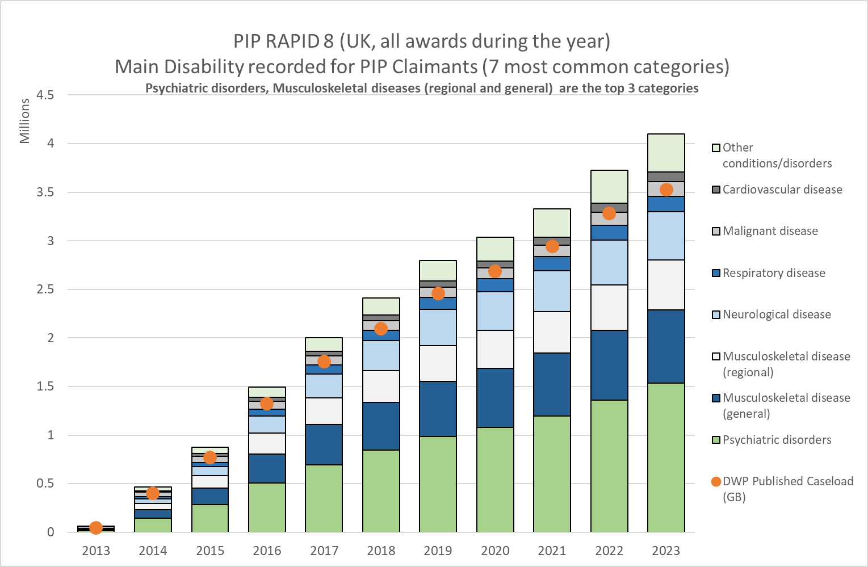

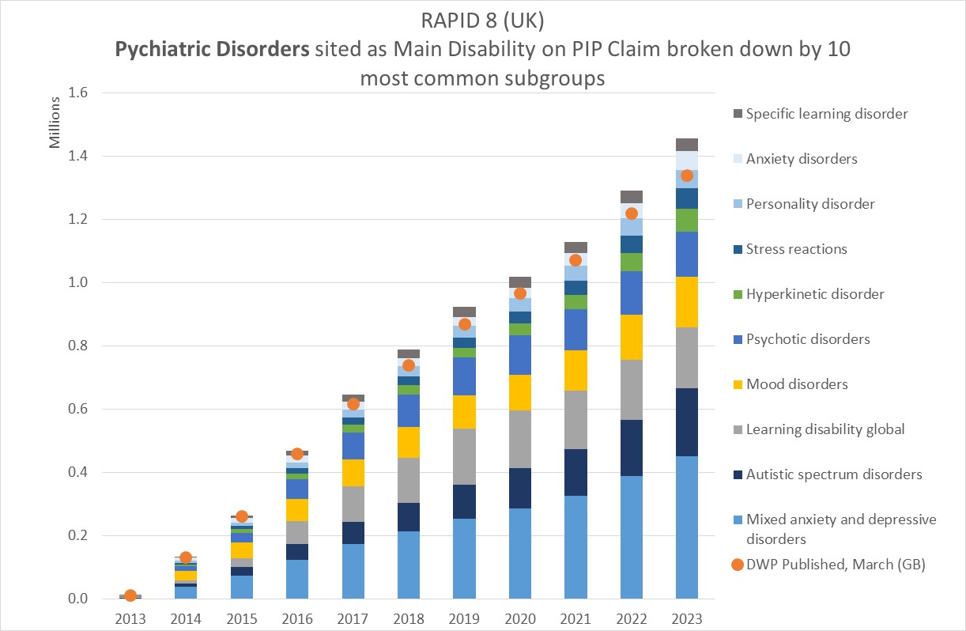

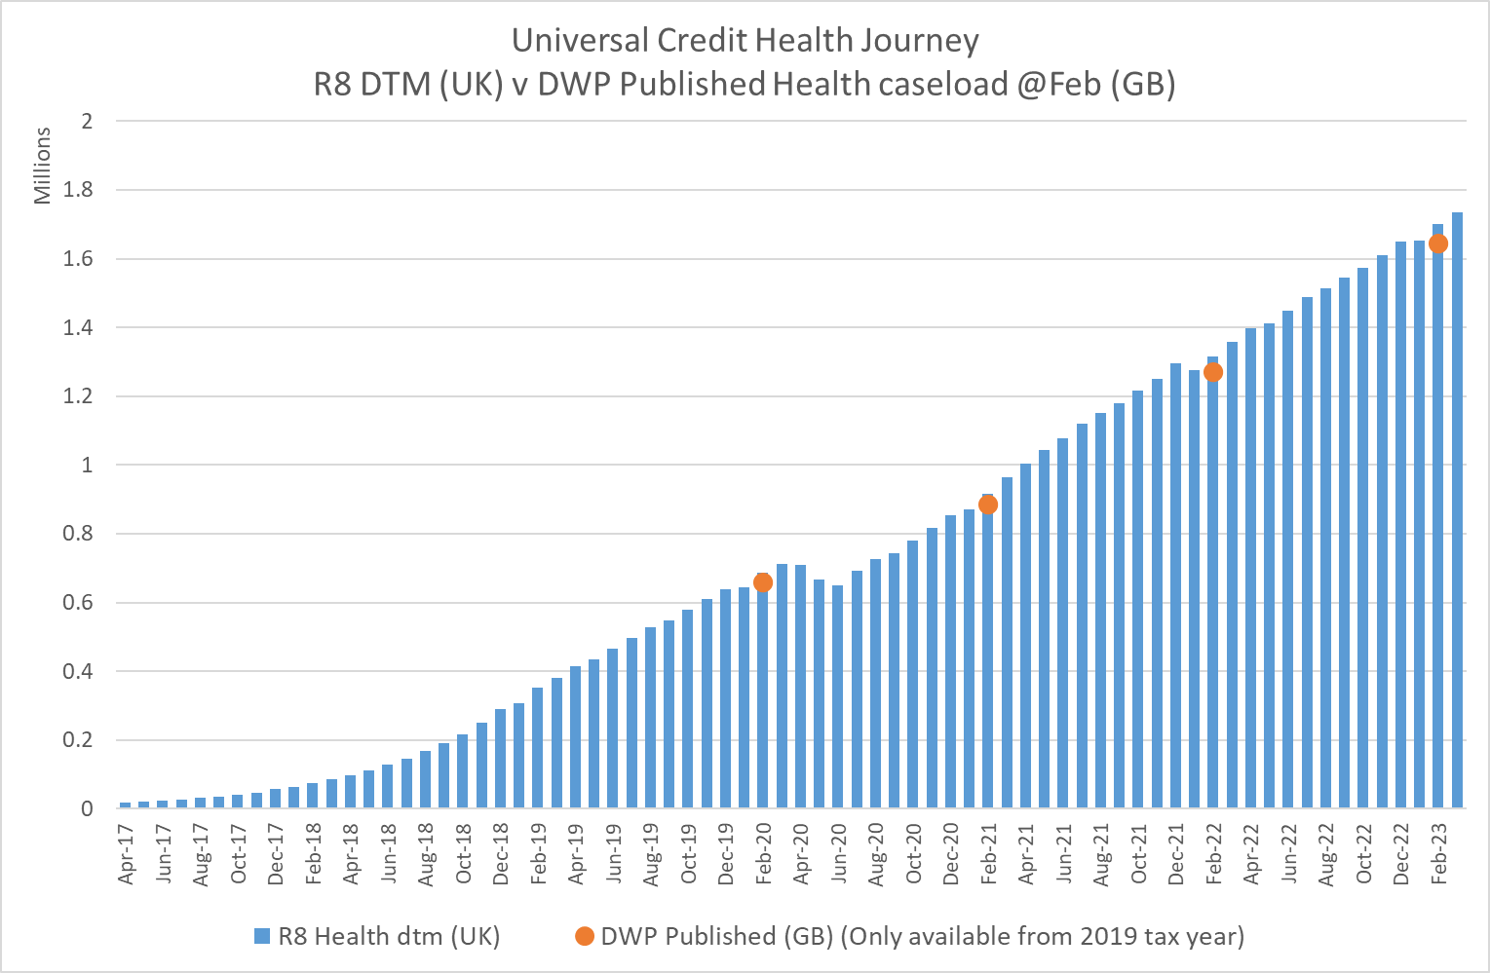

New End of Month (EOM) and During the Month (DTM) values for Relationship datasets:

R8 now includes EOM and DTM variables for most of the relationship dataset, the exception being State Pension relationships. The new variables hold the months of the relationship ‘pairing’. New relationship EOM/DTM variables are available for the following relationship datasets:

- Income Support
- Housing Benefit (from December 2009)
- Working Tax Credits (from 2010)
- Child Tax Credits (from 2010)
- Child Benefit
- Pension Credit
- Carers Allowance (from 2010)
- Universal Credit (from 2015)

More work is required on the State Pension relationships as this data is limited in a number of ways:

- Data coming via Get Your State Pension (currently sourced from Central Payments Data) does not include any partner information, so all these relationships are missing from the SP relationship data;

- New State Pension awards do not require partner details as there is no longer any interaction between partners within an award. This means that pensions awarded after 2016 are less likely to have partner details completed, and hence the relationship data is not well populated for these awards;

- Pre-2016 awards. These records are not necessarily maintained. In some parings one party has the partner recorded while the other does not, making the generation of relationship data extremely complicated.

It is worth noting that the SP relationship data is not as robust as the other relationship datasets, and should be used with extreme caution.

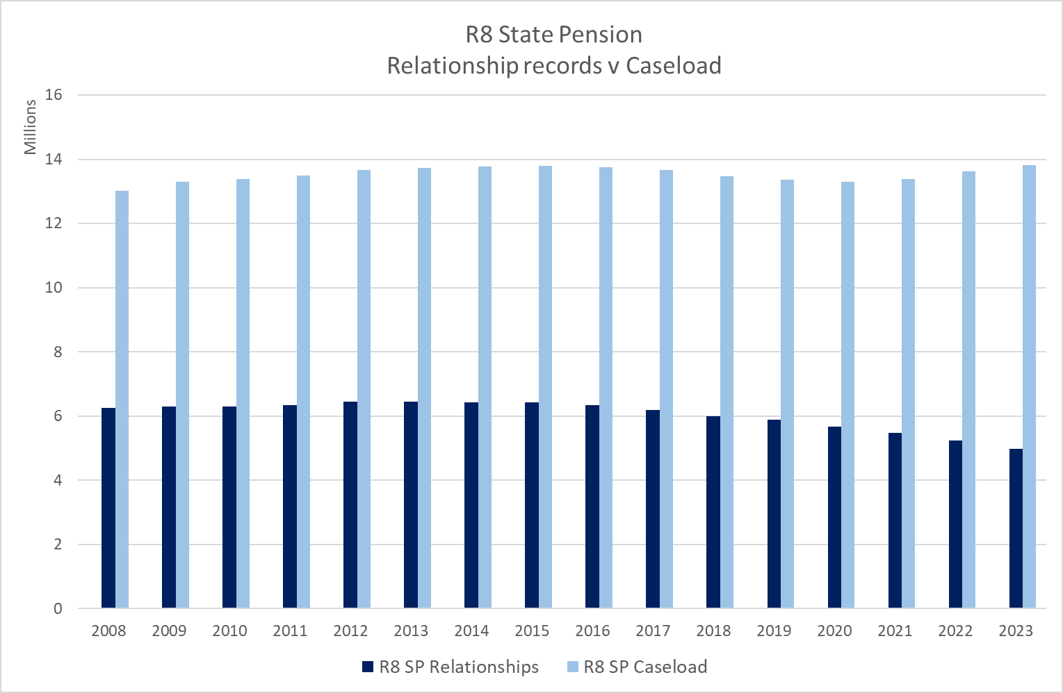

New Census Output Area 2021 (COA2021) codes

R8 now includes COA 2021 variables, in addition to COA 2011 and COA 2001.

Universal Credit data for Northern Ireland

An error was found in R7 & R7.1 impacting the coverage of Northern Ireland UC awards before June 2020. This data was previously available in R6.

The file used to capture UC awards for Northern Ireland was redeveloped by the team supplying the data in early 2023. Unfortunately the redeveloped data that was used in R7 and R7.1 only captured the UC household history from June 2020 onwards, which we were unaware of at the time of R7 creation.

The RAPID team raised the issue with the team that supplies the data and a new file was provided, including the history pre June 2020. This data has now been used in R8.
However, due to ongoing supply issue the UC data for Northern Ireland in 2023/24 excludes data for February and March 2024. This will impact the Northern Ireland duration and UC amount calculations as well as the population of the EOM and DTM indicators for 2023/24.

The RAPID team will be redeveloping the UC data for R9 (October 2025) to capture data directly from the UC system tables.

Processing of PAYE data used in duration, EOM & DTM methodology

R8 now utilises the new version of the DWP derived Employment Characteristics Database (ECD) to capture PAYE start and end dates for each employment and occupational pension spell.

R7.1 used a combination of P14 and P45 dates to generate start and end dates, which were then used in the derivation of duration and End of Month (EOM)/ During the Month (DTM)indicators. The old methodology excluded spells of 1 day.

The new Spell Based data within the new ECD captures the best measure of start and end date for every employment, including spells that only last 1 day.
The ECD methodology captures all spells with some ‘pay’.

The new Spell Based data is linked to the PAYE data within RAPID and appends the start and end dates. The inclusion of 1 day spells and improved start and end date capture may increase the number of employments counted, and may change the duration and EOM/DTM calculations for some records.

The data now includes durations of 1 day, which were excluded from previous releases of RAPID. This has increased the number of records within any given month when compared to R7.1 as can be seen in the During the Month (DTM) analysis in the chart below. There is also a slight impact on weekly pay estimates.

For employments analysis has shown that a high proportion of the 1 day spells are in connection with agency, hospitality, retail, education and care sectors. For pensions the 1 day spells are likely to be one-off pension payments where the pension has been taken as a lump sum with no ongoing pension payments.

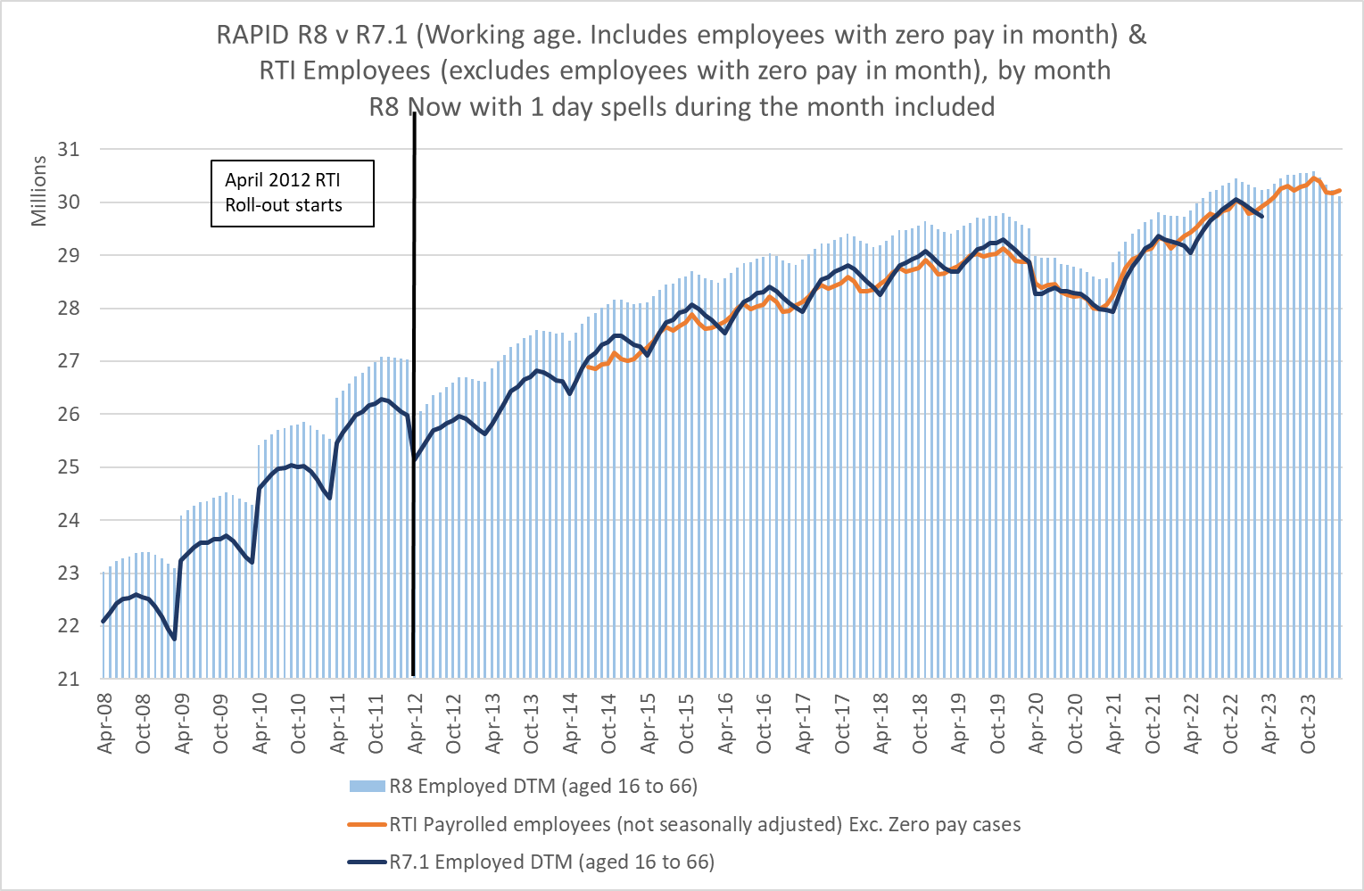

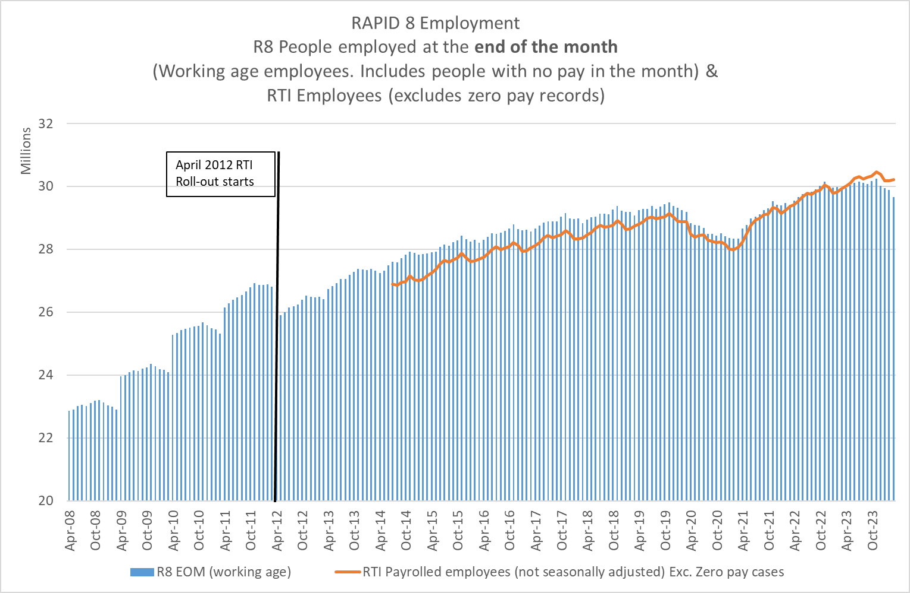
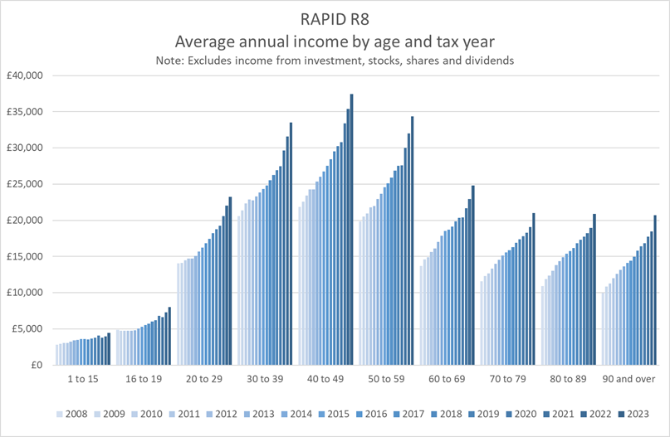

RAPID R8 Comparisons with published outputs

Please find relevant PowerPoint which includes comparisons between RAPID Release 8 and published outputs on external RAPID documentation

GLOSSARY of Acronyms

Acronym | Definition | Notes
AC | Analytical Community | Analysts within DWP
ADP | Adult Disability Payment | Devolved Scottish benefit replacing DLA & PIP in Scotland
CASS | Central Analysis and Science Strategy Unit | DWP department
CCAPINID | Tax Credit Application Instance ID
CCNINO | Claimant National Insurance Number
CDP | Child Disability Payment | Devolved Scottish benefit replacing Child DLA in Scotland
CHBDOB | Child Benefit Date of Birth
CIS | Customer Information System | Data extracts for rapid are entered into this system
COA | Census Output Area
CPS | Central Payment System | The system that manages payments to all benefits claimants
CRJS | Coronavirus Job Retention Scheme | April 2020 to Sept 2021
D&A | Data and Analytics | DWP department
DB2 | Database 2 | NINO records identified as current or past DWP customers
DB3 | Database 3 | NINO records that have never been DWP customers
DTM | During the month
ECD | Employer Characteristics Dataset
EMPREFNO | Employer’s PAYE Reference Number
EOM | End of month
FCHB | Future Child Benefit Extract | Introduced in February 2021
FRY | Final Relevant Year | The year before a person is eligible for state pension
GMS | Generalised Matching Service
GOR | Government Office Region
GSS | Government Statistical Service
GYSP | Get Your State Pension
HBref | Housing Benefit reference number
HIC | High Income Cases | In relation to CHB.
IDBR | Inter-Departmental Business Register | Industry classifications for each business within the UK
L2 | Lifetime Labour Market Database | 2nd version of the LLMDB (L2) data
LA | Local Authorities
LCLASER | Local Authority Serial Number
LCHBREF | Housing Benefit Reference Number
MWS | Migrant Worker Scan
NEET | Not in Education, Employment or Training
NI | National Insurance
NINO | National Insurance Number
NPS | National Insurance and PAYE service | HMRC system for recording PAYE data
NSPL | National Statistics Postcode Lookup
NTC | New Tax Credits
OCCPEN | Occupational Pension Indicator
ONS | Office for National Statistics
OPLu | Occupational Pension Look Up Data | Dataset created using word strings within PAYE systems to identify PAYE schemes that have ‘pension’ related words in the scheme name.
PAYE | Pay as You Earn | HMRC’s system to collecting National Insurance and Income Tax from employment and pensions.
PCNINO | Partner’s (of a claimants) National Insurance Number
PSCS | Pension Strategy Computer System
QSE | Quarterly Statistical Enquiry
RTI | Real Time Information | A key government programme (2013) which aims to improve the way in which employers submit Pay As You Earn (PAYE) information about their employees to HM Revenue & Customs (HMRC).
SA | Self Assessment | A system HMRC uses to collect tax from those self-employed or a partner in a business partnership.
SHBE | Single Housing Benefit Extract | Copy of information captured in the payment system used to pay Housing Benefit
SPA | State Pension Age | Currently at age 66
SEISS | Self-Employment Income Support Scheme | Payments made by the government to eligible businesses which had been adversely affected by the coronavirus pandemic. The grants are subject to income tax and self-employed National Insurance contributions (NIC)
SIC | Standard Industry Classification
UCAD | Universal Credit Analyst Division | DWP Department
UCFS | Universal Credit Full Service | Current UC benefit which replaced UCLS
UCLS | Universal Credit Live Service | Original UC benefit which was replaced by UCFS
WPLS | Work and Pension Longitudinal Study

Benefits Acronyms
AA | Attendance Allowance
ADP | Adult Disability Payment | Replaces DLA & PIP in Scotland
BB | Bereavement Benefit
CDP | Child Disability Payment | Replaces Child DLA in Scotland
CHB | Child Benefit | Being replaced with UC
CTC | Child Tax Credits | Being replaced with UC
DLA | Disability Living Allowance
ESA | Employment Support Allowance | Being replaced with UC
HB | Housing Benefit | Being replaced with UC
IB | Incapacity Benefit
ICA/CA | Invalid Care Allowance
IDB | Industrial Death Benefit
II | Industrial Injuries Disablement Benefit
IS | Income Support | Being replaced with ESA (and in turn UC)
JSA | Job Seekers Allowance | Income-based is being replaced with UC
MA | Maternity Allowance
PC | Pension Credit
PIB | Passported Incapacity Benefit
PIP | Personal Independence Payments
SDA | Severe Disablement Allowance | Being replaced with ESA (and in turn UC)
SP | State Pension
UC | Universal Credit | Introduced in January in 2013 to replace the following benefits:  - Child Tax Credit  - Housing Benefit  - Income Support  - Income-based Jobseeker’s Allowance (JSA)  - Income-related Employment and Support Allowance (ESA)  - Working Tax Credit
WB | Widows Benefit
WTC | Working Tax Credit | Being replaced with UC

Data Structure and Processing
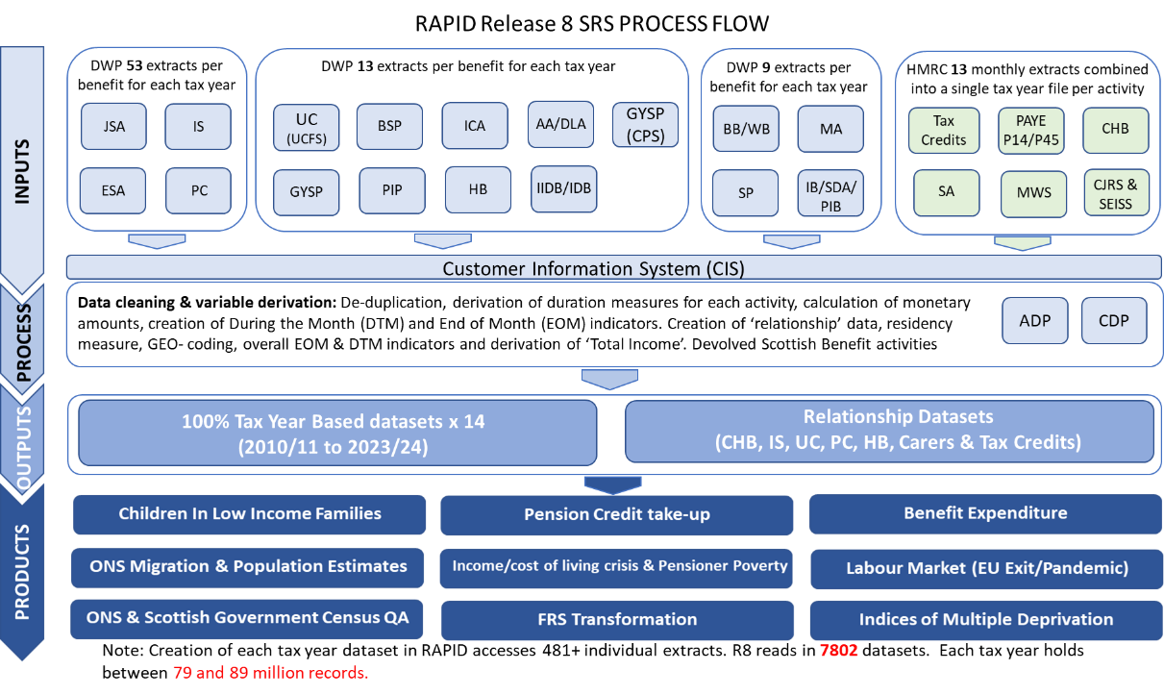

The production of RAPID R8 processes over 7,800 individual data extracts to generate the whole time series. To make the data more manageable and for efficiency of processing, the data is processed into tax years. Each final tax year file hold between 79 million and 88 million person records.

RAPID uses the DWP Customer Information System (CIS) to generate a NINO based ‘person spine’, to which all the other data extracts are linked. The CIS data holds one row per person and is NINO based. The RAPID data has been structured in the same way as the CIS data, i.e. one record per person, per tax year with column variables for each activity within the year. The tax years being processed within SRS version of RAPID Release 8 cover 2010/11 to 2023/24. The CIS data includes records for children who have been issued a Child Reference Number as part of a child benefit award. This number becomes their NINO when they reach age 16.

Only CIS records with no date of death present or a date of death after 5 April 2010 are selected for the SRS version of RAPID Release 8. Pre-2010 the data is of variable quality. Self Employment analytical data is not present at all (from any source) for 2008/09 and 2009/10, and is not fully complete until 2014/15.

Various variables are derived from the CIS data for analytical purposes, for example: the age the person reaches State Pension Age, (taking into account the new pension rules and pension age equalisation bringing women’s retirement age in line with men), the tax year in which someone reaches that age that they start to have National Insurance liability, and the Final Relevant Year (FRY) for State Pension purposes.

The post 2010 CIS data is linked to the 100% Migrant Worker Scan (MWS), sourced from HMRC’s National Insurance & PAYE Service (NPS). This linkage provides the NINO registration details for non-British Nationals registering for National Insurance purposes.

Any non-British NINO registrations notified after 1975 are appended to the CIS data used in RAPID, providing an indication of nationality, country of origin, first arrival dates and registration details – all of which are based on the information provided at the point of registration. No subsequent changes of nationality are captured.

The RAPID processing sets a default nationality and country of origin to ‘UK National’ for anyone not found on the MWS or in the CIS data as a migrant registration. This will include people who registered from abroad but who did so prior to 1975 and any non-British nationals who have never previously been in the UK but who registered with British documentation due to having dual nationality with another country.

RAPID also holds the current nationality as held on CIS as well as the nationality when the record was created. Current nationality is not routinely updated and so is not well populated. However, for some benefit awards DWP now ask about nationality and this will generate an update to the CIS data. Nationality may also be updated on CIS by other sources but this variable should be used with extreme caution. This variable is only really useful for ‘fine-tuning’ analyses of migration – it is not updated for everyone and a high proportion of the records do not hold anything. Current nationality should be used with extreme caution due to its poor population coverage.

Activities on benefit receipt, employment, self-employment and pensions are sourced from the 100% DWP and HMRC extracts and are formatted into a tax year view of each activity.

The durations from each activity spell within each tax year are calculated, along with the income elements generated from those activities. These are aggregated into a tax year view. For example, 3 employment spells each of 2 weeks would result in an aggregated tax year view of 6 weeks employment. RAPID processing caters for overlapping employments, and caps the duration measure based on the number of times the persons’ ‘Employment during the month (DTM)’ indicators are set (see DTM & EOM section below). The income generated from overlapping employments is still correct and reflect the total from all employments in the year.

The tax year aggregated activities are amalgamated and linked with the CIS/MWS data to provide a single row per person per tax year, with columns for each of the activities and their associated incomes. Each tax year row provides an overview of all the activities and incomes throughout the year for each person in the data. All activities are capped at 52 weeks.

For UK Nationals there will be a tax year row for every year from the first year in which they appear on the Child Benefit data or 2010. For migrants there will be a tax year row for every year from the tax year of first arrival in the UK.
Tax years will be present up to the tax year of death, or the latest tax year being processed (2023/24). Tax years with no observable activity have a blank tax year row created, this ensures that all the people that are alive are in the data for every year.

Residency is determined by the activity and address information. The RESIDENT variable is a derived variable that has been designed to make it easier to identify the population that are ‘likely’ to be resident in the year. It is not a perfect measure and may classify people as ‘non-resident’ when they are actually resident, and vice-versa. Analysts may want to derive different measures of residency on different criteria, using different tests. See section 25.3 for more detail on the methodology.

Creation of End of Month (EOM) and During the Month (DTM) indicators – all years:

RAPID holds two 12 character variables for every activity and relationship in RAPID showing whether the activity was current ‘during the month’ (DTM) and ‘current at the end of the month’ (EOM). These variables are available for every year within RAPID.

These DTM and EOM variables are 12 character variables that indicate whether the activity is current during the month (DTM) or on the last day of the month (EOM). The 1st character represents April, the last represents March etc. These DTM and EOM indicators are set using the actual start and end date of the activities.

These DTM indicators have been used to constrain the activity durations in some circumstances to provide a better measure of the activity in total.

For example, if someone had two employments both with a duration of 26 weeks that ran concurrently, previous versions of RAPID would show 2 employments and would have added these two employments together creating a duration of 52 weeks. There would also be a knock on impact on average weekly pay, dividing the annual pay by 52 rather than 26.

From RAPID R5 onwards the DTM indicators (which are based on real start and end dates) are used to generate a ‘maximum’ number of weeks the person could be employed, i.e. we generate a count of the number of times the DTM indicator is set and multiply it by the average number of weeks in a month (4.33). This maximum number is then used to constrain the number of weeks employed.

In RAPID this constraining methodology using the DTM indicators is used in the following processing:
- Employment
- Occupational and Private Pensions
- Get Your State Pension (GYSP)
- Self Employment
- Child Tax Credits
- Working Tax Credits
- Child Benefit

RAPID also generates OVERALL_DTM_IND & OVERALL_EOM_IND variables. These are generated from all the individual DTM and EOM indicators for each activity. The overall indicator shows whether there was any activity within each month.

In addition, the overall DTM indicators are used to generate a LAST_INTERACTION variable which shows the last month within the year that had any activity.

Note: The DTM indicator is set for activities between April and March of the tax year. Someone with an activity between 1st and 5th April (the end of the tax year) will not necessarily show in the DTM indicator. While the activity duration caters for this period and calculates the duration in the whole tax year, the activity may show 1 week but the DTM may equal ‘000000000000’ – this scenario indicates that the activity was in the last few days of the tax year and was actually in April.

New EOM & DTM values from R7 & R7.1

R7 & R7.1 re-purpose the EOM and DTM indicators for some benefit records. In previous releases the EOM and DTM variables were simple binary measures, indicating whether someone had a particular activity in each month of the year.

R7 & R7.1 add extra richness to these variables for certain benefit activities. Rather than being a simple ‘0 or 1’ measure the positive values have been replaced to reflect the Universal Credit conditionality or disability benefit payment combination for each month.

This additional detail enables analysts to assess the conditionality for Universal Credit, the contributory/income based splits for JSA and ESA and the disability component combinations for PIP, AA, DLA, Child Disability Payments (CDP (Scotland)) and Adult Disability Payment (ADP (Scotland)). From R7.1 Carers Allowance shows whether the benefit is ‘In Payment’ or ‘Zero Rate’ (with underlying entitlement).

From R8 new EOM and DTM values appear in the Child Benefit data. This is because from 2021 the data now includes High Income Cap cases, whereas the data pre-2021 only included cases that were being paid. The new values for CHB are as follows: P = Paid, Z = Zero rate & H = High Income Cap.

These new EOM and DTM values allow analysts to see the change in conditionality/payment combination in every month of the year, and now enable more accurate identification of cases that meet certain criteria for support. For example, the new EOM and DTM values allow analysts to assess eligibility for Cost of Living payments, or cold weather payments.

As part of the refresh of the EOM and DTM variables some additional records have been brought into the data. Some benefit records now include people who have underlying entitlement to the benefit, but where nothing is in payment.

The EOM and DTM values for non-benefit activities remain binary as in previous releases of RAPID.

Example 1 – Employment:

Someone who was employed between February and June, not employed between July and October, but then has another employment spell between November and March would have the following Employment_DTM_IND= ‘111000011111’, Employment_EOM_ind= ‘110000011111’(See diagram below).

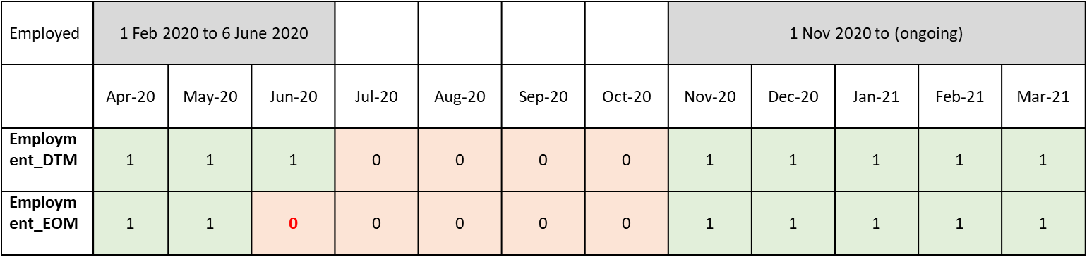

Example 2 – Universal Credit Conditionality:

Someone with 2 spells of UC. Each EOM/DTM value holds the conditionality that was applicable in the month.

The conditionality values are as follows:

'A'='Searching for work'
'B'='Working - with requirements'
'C'='No work requirements'
'D'='Working - no requirements'
'E'='Preparing for work'
'F'='Planning for work'
'N'='Not Applicable'
'Z'='Not known

In the example below the UC_DTM_IND = ‘AAB0000EAABB’ and the UC_EOM_IND = ‘AA00000EAABB’.

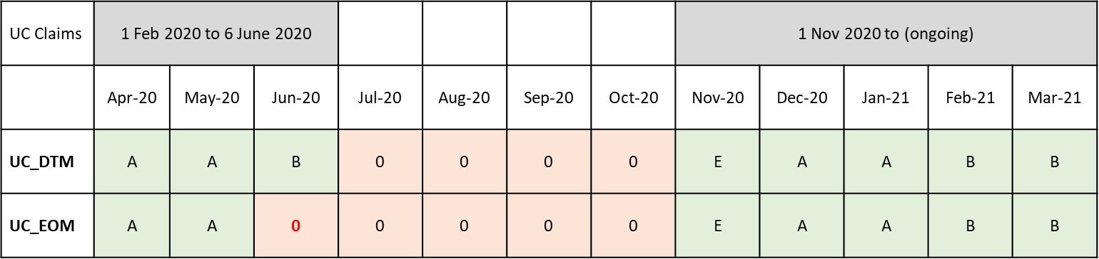

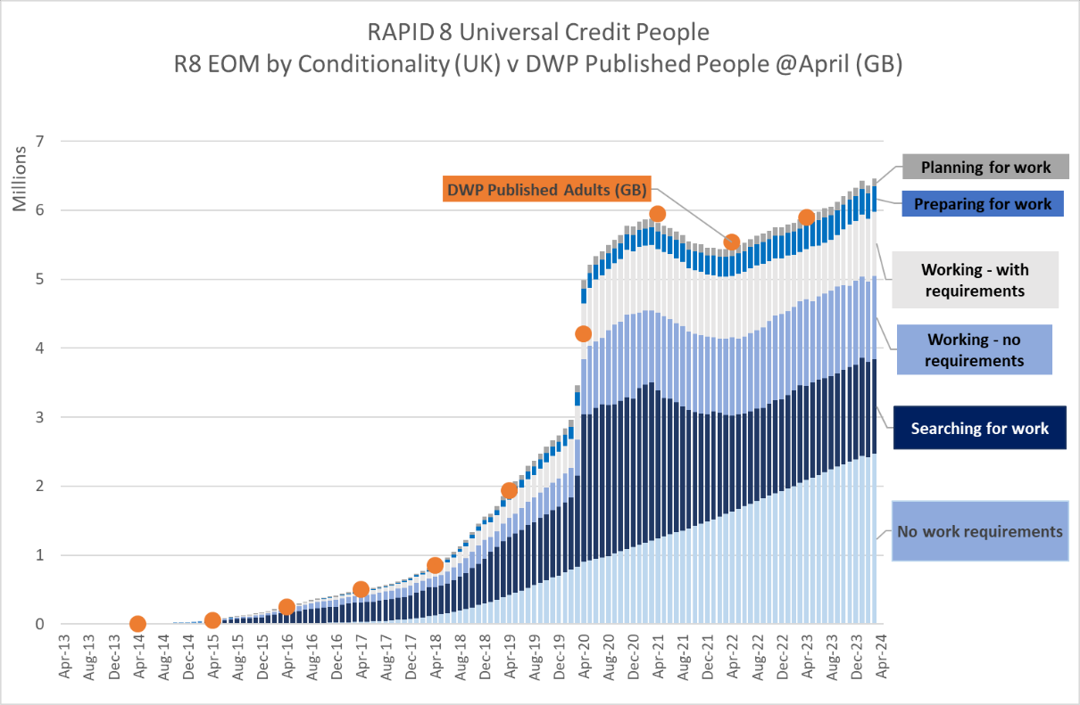

Example 3 – Personal Independence Payment (PIP) with Payment/Rate combination:

Someone with 1 spells of PIP. Each EOM/DTM value holds the payment combinations that was applicable in the month.

The payment combinations/rate values are as follows:

'A'="Daily living Enhanced only"
'B'="Daily Living Enhanced and Mobility Enhanced"
'C'="Daily Living Enhanced and Mobility Standard"
'D'="Daily Living standard and Mobility Enhanced"
'E'="Daily Living standard and Mobility Standard"
'F'="Mobility Enhanced only"
'G'="Mobility Standard only"
'H'="Daily living Standard only"
'N'="pip extract amount > 0 but no component allocated"
'X'="Miscellaneous"
'Z'="Zero Payment Cases"

In the example below the PIP_DTM_IND = ‘0000AACCDDDD’ and the PIP_EOM_IND = ‘0000AACCDDD0’.
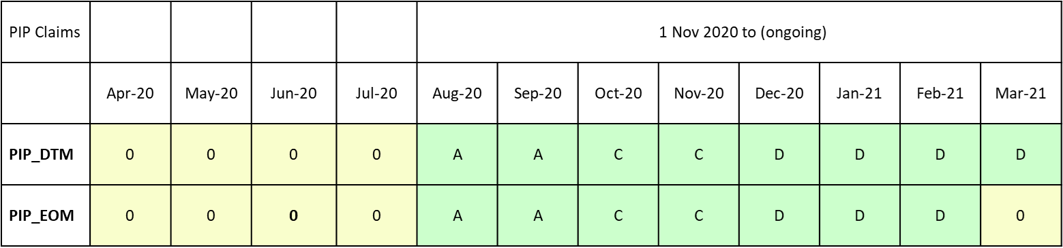

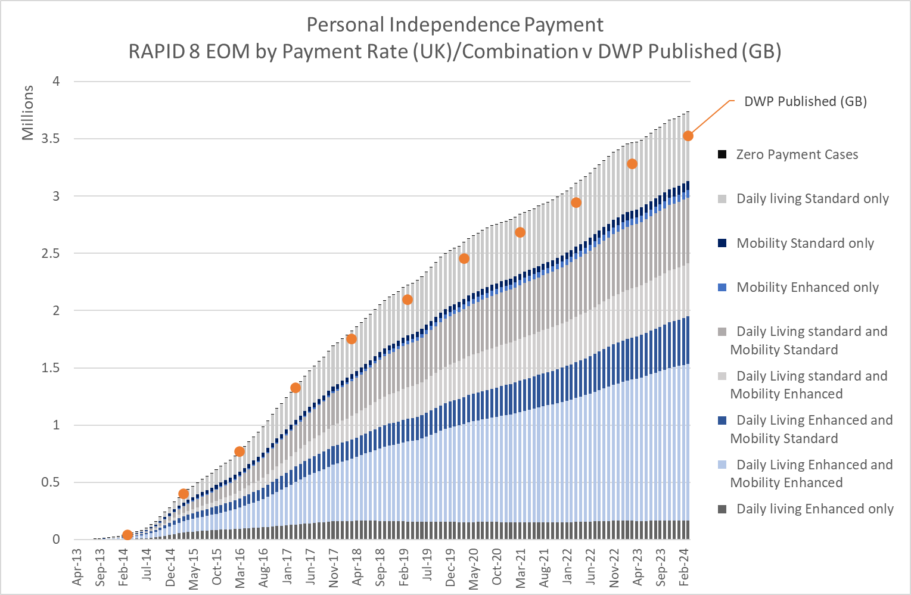

These EOM and DTM variables enable analysts to assess:

  - Activities within each month;
  - Activities that are current at the end of each month, providing the ability to look at various ‘points in time’ – thus allowing easier comparisons with published data;
  - Transitions between activities month on month;
  - Activities that overlap or run consecutively – benefit combinations, combinations between employment and benefits etc.;

Data sources that feed in to RAPID

The table below shows the data sources that have been used in the creation of RAPID, the frequency of the extract and the source of the data:

Data | Source | Extract frequency | Notes
Customer Information System | DWP (CIS) | Daily | United Kingdom.  From R7 CIS is also the source for data on the devolved Scottish Benefits (ADP & CDP). Data is sourced from the CIS BENCAP data table.
Migrant Worker Scan | HMRC (MWS) | Quarterly | United Kingdom. Holds all historic registrations up to the date of extract
Child Benefit | HMRC (CHB) | Monthly | United Kingdom. Analytical dataset derived from raw extract used in RAPID. From 2021 data is updated daily and RAPID uses the new Future Child Benefit (FCHB) extract.
Pay As You Earn (PAYE) | HMRC (56NZ) | Monthly | United Kingdom. Employment and Occupational/Personal Pension records.
Tax Credits | HMRC (WPLS NTC extract) | Monthly | United Kingdom. Working Tax Credit & Child Tax Credit records. Derived analytical WPLS 100% NTC records used in RAPID. Used in the Tax Credit activity and income measures.
Self Assessment | HMRC (SA) | Monthly | United Kingdom. Self-employment only, (not all self-assessment)
Housing Benefit | DWP (SHBE) | Monthly (from June 2019) | United Kingdom. Prior to June 2019 data is taken from a historic NI dataset. The format is slightly different.  Pre-October 2009 HB data was supplied in individual extracts from each LA rather than via SHBE.
Tax Credits | DWP (GMS) | Monthly | United Kingdom. GMS data is only used in the derivation of the self employment measures, as the self employment income is not available from the WPLS NTC extract. Data for 2008 & 2009 is not available.
Attendance Allowance | DWP (GMS) | Monthly | United Kingdom
Disability Living Allowance | DWP (GMS) | Monthly | United Kingdom
Invalid Care Allowance | DWP (GMS) | Monthly | United Kingdom
Industrial Injuries Disablement Benefit | DWP (GMS) | Monthly | United Kingdom
Industrial Death Benefit | DWP (GMS) | Monthly | United Kingdom
Income Support | DWP (GMS) | Weekly | United Kingdom
Pension Credit | DWP (GMS) | Weekly | United Kingdom
Job Seekers Allowance | DWP (GMS) | Weekly | United Kingdom. Extract refreshes 50% of the cases on a weekly bases, meaning extract takes 2 weeks to reflect all changes
Employment Support Allowance | DWP (GMS) | Weekly | United Kingdom. Extract refreshes 50% of the cases on a weekly bases, meaning extract takes 2 weeks to reflect all changes
Incapacity Benefit | DWP (GMS) | 6 Weekly | United Kingdom.
Severe Disablement Benefit | DWP (GMS) | 6 Weekly | United Kingdom.
Passported Incapacity Benefit | DWP (GMS) | 6 Weekly | United Kingdom.
Maternity Allowance | DWP (GMS) | 6 Weekly | United Kingdom.
Bereavement Benefit | DWP (GMS) | 6 Weekly | United Kingdom. Includes: Bereavement Payment, Bereavement Allowance & Widowed Parent Allowance. Paid to men and women widowed April 2001 to April 2017 (replaced by BSP).
Widows Benefits | DWP (GMS) | 6 Weekly | United Kingdom. Includes: Widows Pension, Widows Pension (age-related) & Widowed Mothers Allowance. Only paid to women widowed before April 2001. Excludes initial one-off ‘Widows Payment’
State Pension | DWP (GMS) | 6 Weekly | United Kingdom.
Universal Credit | DWP (UC) | Monthly | United Kingdom. RAPID uses published derived datasets  From R8 ‘Health Journey’ datasets from the UC system are also brought into RAPID processing
Personal Independence Payments | DWP (PIP) | Monthly | United Kingdom. RAPID uses GB & NI published derived datasets
Bereavement Support Payments | DWP (BSP) | Monthly | Great Britain only. Paid to Men and Women widowed from April 2017 onwards.
Get Your State Pension | DWP (CPS) | Monthly | UK. GYSP data sourced from the Central Payment System, which identifies payments of New State Pension.

The following sections highlight the assumptions that have been made during the processing of each data source, the ‘caveats’ around the data or definitions used, and where there are known issues. It also highlights areas that are in scope for further development in future versions, or where processing could be improved with access to more or unmasked data. These are also included in the record description section and populated against each impacted variable.

Customer Information System (CIS) processing

Customer Information System (CIS)

Information | Notes
Data administration | - Data owned and maintained by DWP;  - Interacts with other legacy systems, both in DWP and HMRC.
Data purpose | - Holds a single record of each person with a National Insurance Number and is used to maintain the latest details of the customer information;  - Data recorded in legacy systems is broadcast to CIS to maintain a central record of changes in personal circumstances. These changes once recorded on CIS then broadcast out to all other systems that CIS interacts with to ensure that DWP uses the most current customer information;  - Maintains changes in name, address, marriage (where necessary), dates of birth and death and NINO registration details;
Completeness | - Holds a record for anyone who has ever held a National Insurance Number;  - Includes people who are no longer alive, people who are no longer resident in the UK and includes the records of children who are part of a child benefit award;  - Once the NINO has been issued the record remains on CIS in perpetuity.
Coverage | - 100% of all NINO’s on the system;  - Excludes people who have not registered for NINO purposes, e.g. People who have never been part of a Child Benefit award (impacts awards post 2012 mainly), newly arrived migrants who have not yet needed to register for NI purposes, foreign students who do not intend to work or claim benefit and people who are working and living in the UK but who are retaining rights to pay NI and tax in their home territory (e.g. embassy staff, people working in the UK for a foreign company etc).  - RAPID only uses NINO’s where the person is alive in 2010 or later.
Accuracy | - Details held in CIS are good for people who are claiming a DWP benefit, or who interact with DWP/HMRC systems in some way;  Records for Non-DWP customers are generally good in terms of dates of birth, dates of death and gender. Changes in address are not as accurate as for DWP customers as there is no need for these customers to inform DWP of changes in circumstances. These people tend to be in employment and with no benefit, tax credit or child benefit interactions. Students also fall into this category as they often have no interaction with benefits but are more mobile in terms of address information  - CIS BENCAP data holds data relating to the devolved Scottish Benefits. The BENCAP data is the source of the Adult Disability Payment (ADP) and Child Disability Payment (CDP) data used in RAPID. See ADP/CDP processing section
Outliers | - Some records on CIS appear to be unfeasibly old, i.e. they have an early date of birth and no date of death. Dates of death are only recorded once a death certificate has been seen or when a death has been notified to the Department. In some circumstances someone with a NINO may die whilst abroad, and if the person has not been resident for a number of years, and has no reason to interact with DWP the death may never get recorded on the CIS. RAPID makes no adjustment for these records and they remain within the data. Analysts can then decide what actions they want to take for these outliers. As a general rule RAPID marks people over the age of 110 as ‘RESIDENT’= NO

CIS selection criteria & processing

Only records that are alive on or after 6th April 2010 are selected for inclusion in RAPID. The CIS records include child records where the child is part of a Child Benefit award. These child NINOs are usually referred to as Child Reference Numbers, but become NINO’s once the child has reached age 16. Only selected variables from the CIS data are carried forward.

For each record selected from CIS the following information is captured or derived:

  - Date of birth, Date of death & sex;

  - Calculates tax year of birth and the tax year of death. These variables are used in subsequent derivations so that processing is only performed for tax years where the person is ‘alive’ on the system;

  - Calculates the date of entitlement to State Pension, taking in to account the changing State Pension age rules, equalization and New State Pension. The Final Relevant Year (FRY) is also calculated based on the State Pension entitlement date. The FRY is the last full tax year prior to the year in which someone reaches State Pension Age or the last full tax year prior to the year in which a person dies (if it is before SPA);

  - Calculates the tax year of entry for National Insurance purposes. This is generally the tax year in which someone reaches age 16, and the age from which National Insurance becomes payable on employments and when National Insurance Credits are awarded for periods on certain benefits;

  - Calculates the age at the 30 June of each tax year being processed based on full date of birth;

  - Once the full date of birth has been used in the derivation of additional variables the full date is truncated to MMM/YYYY format. Analysts wanting to create new or different age measures will have to apply a ‘day’ element to the truncated date. This measure has been applied to cater for disclosivity concerns about full dates of birth.

  - The date of first appearance in the CIS extract is also captured from R6 onwards. This is a reasonable proxy for the date of registration for migrants. In addition the nationality at the point the record is recorded on CIS is retained from R6 onwards. This data is only reliable for migrant populations and reflects the nationality at the point the CIS record was created.

  - From R7 RAPID holds the current nationality held on CIS as well as the nationality when the record was created. Current nationality is not routinely updated and so is not well populated. However, for some benefit awards DWP now ask about nationality and this will generate an update to the CIS data. Nationality may also be updated on CIS by other sources but this variable should be used with extreme caution. This variable is only really useful for ‘fine-tuning’ analyses of migration – it is not updated for everyone and a high proportion of the records do not hold anything.



CIS cautions & caveats

- Anyone with a tax year of birth or death that would result in a value of 1900 or earlier has these variables set to ‘null’;

- Since the changes to Child Benefit came in to force in 2012 restricting access to the benefit for families over a certain income level, not all children appear in the Child Benefit data, and hence will not appear in the CIS data either. Whereas take up of Child Benefit was almost universal prior to this policy change, take up is now restricted by income. This has various analytical and coverage impacts and biases. See Annex 1 in the Record Description (Section 26) for more details of the impacts.

- There are records on the CIS data where no date of death is recorded but where the person looks ’unfeasibly’ old when looking at the tax year being processed.
CIS only records a date of death where a death has been notified to HMRC, DWP or the Registrar General. In some circumstances people who have been issued a NINO for legitimate purposes may emigrate and die whilst abroad. Where there is no ongoing contact prior to death and where a death occurs abroad there is no mechanism to record this event on UK systems. Hence the record remains ‘alive’ and the record continues to age. This will impact all records where death occurs abroad (unless we are informed by family etc), but as mortality rates for people of working age are reasonably low there is minimal impact on working age records. However, as the age cohorts increase the data will include people who appear to be alive, but who have died abroad. The activity data within RAPID helps to alleviate this issue to some degree, but caution is needed when examining older records and records with no activities.

Migrant Worker Scan (MWS) processing

Migrant Workers Scan (MWS)

Information | Notes
Data administration | - Data owned and maintained by HMRC and sourced from the National Insurance and PAYE Service (NPS) database;  - People registering for National Insurance Numbers issued in extraordinary circumstances, (i.e. where a NINO has not been allocated as part of a Child Benefit award or at age 16) are administered by DWP but recorded on the HMRC NPS system.
Data purpose | - Holds registration details for people who register for National Insurance purposes via extraordinary circumstances, or who have applied for a UK visa via Home Office and their visa gives them the right to work. Students needing a NINO have to apply for a NINO once they arrive in the country and are not issued a NINO as part of the visa application process;  - Records the registration date for NI purposes, the self-reported date of arrival in to the UK (for migrants), the nationality and previous country of residence, along with the address at the point of registration;  - Since 2020 proof of arrival date is required as part of the VISA application and NINO registration process.
Completeness | - Only holds registration details for people who register via the extraordinary registration process or via the Home Office visa application route;  - The extract includes all registrations back to 1975. Caution is needed about registration data between 1997 and 1998 as the data for this period is deficient due to HMRC system changes;  - Only includes people who present themselves at the point of registration with a non-British nationality. It therefore excludes people who have never been in the UK previously but who have dual nationality and present themselves at registration with British documentation.  - Historically excludes migrant registrations after State Pension Age (age 60+ for women 65+ for men – even when SPA was raised to age 66). From November 2022 these registrations are captured.  - Excludes child registrations.
Coverage | - 100% of all NINO’s registering as non-British via the extraordinary registration process or via the Home Office visa route, i.e. not as a consequence of being part of a Child Benefit award or being allocated routinely at age 16;  - Registration details for migrants arriving during 1997 and 1998 are deficient due to system changes within HMRC. These records are present on HMRC and DWP systems but not identifiable as migrants specifically, i.e. they have no non-British nationality or country of last residence, and as such are not captured by the Migrant Worker Scan and appear as UK Nationals within the data.
Accuracy | - Details held in the MWS reflect the details at registration. They do not track subsequent changes in nationality post registration;  - Date of entry to the UK is self-reported and may not be accurate;  - Date of entry can be updated if a person leaves the UK and returns and informs HMRC or DWP that this has happened. It does not reflect all movements, departures and arrivals for everyone on the extract;  - Not all cases have Nationality and or Country of birth populated. RAPID uses a combination of nationality and country of birth to allocate a ‘Country of origin’ variable for all records.  - The MWS is not a complete measure of migration and should not be used for that purpose in isolation.
Outliers | - Some cases on the extract have inconsistent dates of registration and dates of entry.

MWS selection criteria, data cleaning & processing

This section collects details of migrant NINO registrations, captured on the HMRC National Insurance and PAYE Service (NPS). The data used in RAPID is the same as is published in ‘National Insurance Number Allocations to Overseas Nationals’, but is manipulated slightly differently and linked to other data sources used in RAPID.

MWS selection criteria

The Migrant Worker Scan only captures NINO registrations for people who present themselves as ‘non-British’. This means that the scan excludes some people who have never been in the UK before, but for whatever reason, hold a British passport (dual nationality registrations for example).

While the MWS is correct as defined by the National Statistics definition some analyses was done to investigate the characteristics of those who were being excluded.
The main findings showed that those excluded from the MWS were:

- People with dual nationality but who present themselves with British documents for NINO registration purposes;
- People who previously resided in ex-UK colonies (Hong Kong for example) who were eligible for British Overseas passports;
- People who previously resided in countries where UK Nationals tend to emigrate to (Australia, New Zealand, Canada, Spain) and who gain a British passport by virtue of their parents or grandparents;
- People who registered after State Pension Age;
- Child registrations.

MWS data cleaning

During analyses of migrants to adjust ONS migrant inflow estimates an extraction issue with the Migrant Worker Scan (MWS) became evident. RAPID Release 4 catered for this extraction issue which has been carried forward to subsequent releases.

The MWS extraction process selects the latest arrival information which can result in the first arrival date being over-written, making it appear that the person arrived after registration, and results in the arrival dates being different on different extracts.

The MWS processing within RAPID creates a ‘master’ file which analyses all the MWS extracts back to 2011. The data is sorted by first arrival date and the first record is then selected and is used as the record from which all further processing is done. Previous methodology only looked at the latest MWS which could result in a later arrival date being selected, i.e. not the first arrival that is relevant to the registration.

The derived MWS ‘Master file’ used in RAPID analyses all MWS extracts from 2011 to July 2024. It captures migrant arrivals from April 1975 up to April 2024, this only includes those migrants who register for a National Insurance Number – therefore it is not a total migration estimate.

From R6 onwards the first date of appearance on CIS and the nationality at the point the CIS record is created are captured and used in the identification of migrant registrations. The date that the person is first seen on CIS is used as a proxy for the registration date, which is comparable in over 98% of records when the CIS and MWS are compared. Similarly the nationality on CIS and the MWS are over 99% comparable.

Where the registration details are present in the MWS these details are used in RAPID. A new variable ‘MIGRANT_DATA’ indicates that the information has come from the ‘MWS’.
Where a non-British record appears in CIS and is not on the MWS the migrant registration data is taken from CIS and the ‘MIGRANT_DATA’ variable is set to CIS.

It is worth noting that NINOs that are issued via Home Office as part of the visa application may have an arrival date that is the same as the registration date or after registration. The visa may be issued and needed before arrival in the UK.
This historically impacts non-EU more than EU registrations (as EU arrivals didn’t need a visa historically). From January 2021 EU nationals also need a visa to come to the UK for work purposes.

MWS Processing

The migrant registration records are processed as follows:

Collects the variables from the MWS and CIS (for those where the data is sourced from the CIS data) and renames them to make them consistent with the NPS/MWS data. This includes changing the following variable names:

- CCNATCODE renamed to CCNATIONALITY - Nationality at NINO registration;
- CCPRCTRY renamed to PREVIOUS_COUNTRY_OF_ORIGIN – Country of birth at point of registration;
- CDUKARRV renamed to DATE_OF_ARRIVAL - The self-reported first date of arrival in UK & ‘Date of Entry’ recorded on NPS system for National Insurance purposes;
- CDREGIST renamed to REGISTRATION_DATE - Date of registration for National Insurance purposes;
- The county codes in CIS are not the same as those used in the MWS. Where a record is sourced from CIS the country codes are ‘mapped’ to be the same as those on the MWS. Some country codes on the MWS do not exist in CIS so these are coded as ‘Not Known’, this includes:
  - Hong Kong
  - Yemen
  - Cambodia
  - Kosovo
  - Serbia
  - Montenegro

Records sourced from the MWS and CIS are combined and processed in exactly the same way.

The tax year of first arrival in the UK is derived from the arrival date (or date of registration for CIS sourced records). This is self-reported and is populated on all migrant records. This date is also what is recorded on the NPS system as the ‘Date of Entry’, which is the date that the person starts to have National Insurance liabilities.

The tax year of registration is derived from the registration date. This is not populated on all records, but is largely complete post 2000/01. Prior to this date the information was recorded differently and is not quite so robust. However, arrival date is completed for everyone and can be used as a very loose proxy.

There are 2 fields in the MWS holding country codes, either field may hold a foreign country code, and the values may be different in each variable. In addition, one field may be 'not known' and the other may have a valid value. Therefore, a hierarchy is applied to ensure that all the available information is used to pick up the best estimate of 'country of origin'.
The ‘COUNTRY_CODE’ variable is derived, based on a hierarchy between PREVIOUS_COUNTRY_OF_ORIGIN (country of birth) and CCNATIONALITY, holding the numeric value of the derived country. The hierarchy is set as follows, based on the premise that nationality is more likely to be populated than previous country of origin:

- Where the PREVIOUS_COUNTRY_OF_ORIGIN is ‘Not Known’ and CCNATIONALITY is a valid code, COUNTRY_CODE equals the CCNATIONALITY code;

- Where the PREVIOUS_COUNTRY_OF_ORIGIN is a valid code and CCNATIONALITY is ‘Not known’, COUNTRY_CODE equals the PREVIOUS_COUNTRY_OF_ORIGIN code;

- Where the PREVIOUS_COUNTRY_OF_ORIGIN is a valid code but holds different value to that held in CCNATIONALITY and where the value is also a valid code, COUNTRY_CODE equals the CCNATIONALITY code;

- Where both values are equal COUNTRY_CODE equals the CCNATIONALITY code.

While COUNTRY_CODE holds the numeric decode of the country, based on the hierarchy (See Annex 2 of the record description (Section 26) for the list of countries), an additional variable (COUNTRY_OF_ORIGIN) is derived holding the text version of the country.

A SUBCONTINENT variable is derived which groups the countries in to sub-continent areas. The country groupings are shown in Annex 3 – see record description (Section 26):

The tax year of registration is derived and corrects some arrival years where registration year is before arrival year - this is due to the way the MWS extract is selected (taking the latest arrival information recorded);

The processed MWS data is then linked to the CIS data by NINO, appending the information derived above. For cases that are not present on the MWS the country of origin and subcontinent variables are set to ‘UK National’.

A year of entry for NI purposes is derived based on 16th birthday (for UK Nationals) or date of first arrival in the UK for Migrants. This attempts to replicate the DoE variable held on the National Insurance and PAYE Service (NPS) data.

MWS cautions & caveats

- The identification of migrants in RAPID is only reliable back to 1975. Anyone arriving from abroad prior to 1975 will appear as a UK National in the data;

- During the transition from HMRC’s NIRS1 to NIRS2 system there was no system on which to record new NINO registrations and they were backlogged and processed in bulk. Hence there are hardly any migrant registrations in 1998 and registrations for 1997 also look low.
All these registrations were processed in bulk during 1999 and 2000. However, the bulk processing also missed the country of origin and nationality details for a high proportion of migrant. These missing migrants largely impact 1997, 1998 and 2004 migrant arrivals and registrations. The RAPID dataset and code does NOT attempt to identify the missing migrants, and they are classed by default as ‘UK National’ – as they are presented in HMRC’s live systems.

- While the new processing of the MWS using the new ‘Master file’ now caters for records that previously had their original arrival date over-written by a later arrival, there are still some anomalies with the data that users need to be aware of.

  - Some records that appear in the MWS appear to have been previously resident prior to registration and as such appear as UK Nationals in years prior to registration. This can happen when a person is part of a child benefit award (as a child) and therefore is allocated a NINO for the purposes of child benefit. If the person then leaves the UK as a child the RAPID processing would create a tax year record for each year, including those after they have departed. If the same person subsequently returns to the UK and registers with non-British details, they will then be captured by the MWS and be classified from the first-arrival year as a migrant.

It is worth noting that the person may not have been a UK National whilst on child benefit, but as children do not go through the same registration process as adults they would not be captured by the MWS.

Child Benefit (CHB) processing

Child Benefit (CHB)

Information | Notes
Data administration | - Data owned and maintained by HMRC and sourced from the Child Benefit computer system;
Data purpose | - Holds Child Benefit awards and includes details of the main payee (claimant) and the inclusion/exclusion dates of any children in the child benefit award;
Completeness | - The HMRC CHB system retains records for 18 months after the whole child benefit award has finished;  - The extract used in RAPID for data up to 2020/21 is based on a derived analytical dataset that takes the monthly CHB extracts and builds and retains a history of the award, and is not subject to the same archiving routine as the live system. This data only incudes cases that are in payment (i.e. excludes High Income Cap (HIC) cases);  - Processing of CHB data from 2021/22 onwards uses the new Future Child Benefit (FCHB) system. This new extract is based on relational data tables that are updated daily. This new data also includes information on cases that are not in payment due to the High Income Cap (HIC);  - Processing of the pre 2020/21 CHB data has highlighted some anomalies in the extracts for certain tax years. These anomalies have been catered for in the processing of RAPID and are explained below.
Coverage | - Up to December 2012 the coverage and take-up of Child Benefit records was thought to be over 98%. However, in January 2013 Child Benefit was restricted for higher income families;  - This change in January 2013 resulted in a reduction in the number of CHB awards that were in payment.  - The number of new births on CHB and CIS reduces since January 2013. There is also likely to be a geographic bias to the ‘missing’ cases focusing on areas where incomes are higher;  - Children already in receipt of Child Benefit at January 2013 will already be in CIS and therefore even though the payment of CHB may cease the record still appears on the CIS data;
Accuracy | - For the records that appear in the data the quality of data is thought to be good, with the exception of the years where some records have been corrected (see notes below).
Outliers | - A small number of records appear to be in receipt of Child Benefit beyond the maximum age. No correction has been made to these records in RAPID.

CHB selection criteria, data cleaning & processing

Part 1 – Processing of 2010/11 to 2020/21 (in payment cases only)

This section collects details of Child Benefit activities within the tax year and generates activities for both the child and parent (main payee only) in the CHB award.

New from R6:

R5.1 showed an increase in the number of children and families for the 2020/21 tax year. This increase was unexpected and contrary to what was being published by HMRC.

A lengthy Investigation identified that records were being supplied in a new ‘tactical’ CHB extract that hadn’t been seen for many years. These re-appearing records were identified as High Income Cap (HIC) cases that were no longer in payment, but where underlying entitlement still existed.

Investigations for R6 found that there was no indicator on the tactical data that definitively identified HIC cases, so methodology was developed to identify those children who re-appeared on CHB at ages greater than zero, and that re-appeared in the data on dates that coincided with the new tactical extract.

These records were flagged and removed for both the child and the parent for the 2020/21 tax year. They will also not appear in the CHB Relationship data.

There are some limitations with this approach that need to be considered.

New from R8:

R8 still uses the CHB ‘tactical’ feed for the 2020/21 tax year data.

As a result cases that stop being HIC and start being paid will not be identified by this methodology and will therefore be excluded from the data. Similarly, cases that become HIC and stop being paid will still appear in the data and RAPID will allocate them CHB activities and money incorrectly. This is a limitation of the information available on the tactical CHB data extract.

CHB selection criteria

The inclusion dates for each child are used to assess whether the child in part of the award in the tax year being processed and the duration in weeks is calculated.

From Release 4.2 there are changes the way durations on Child Benefit are calculated for the parent/main payee. In previous releases the duration of the parent activity has been generated from the duration of the child. For the vast majority of cases this was fine, but for cases where the parent or main payee changed during the year both main payees got the full duration of the child, inflating the CHB activity for both payees.

From Release 4.2 durations are calculated for each child/main payee pairing and populates the duration of each pairing against the main payee record. For example a child who is on child benefit for 52 weeks, but is split between 2 payees (10 and 42 weeks), the child shows activity of 52 weeks, but each payee shows 10 & 42 weeks respectively. The updated methodology also caters for a maximum duration for each payee when there are multiple children in the year.

CHB parent durations will be reduced from previous releases where there has been a change of payee in the year.

The CHB Relationship data has also been updated and now includes the duration of each child/payee pairing in the year and the number of payees the child has had in the year.

CHB data cleaning

Testing of the aggregation of the activity weeks within the tax year by NINO highlighted some data anomalies and missing data in certain tax years. This was particularly evident when looking at clustering of start and end dates which are generated as part of the extract processing rather than a problem with the live CHB systems. The tests highlighted the following:

- An unusually high number of children with 2 week durations in 2010/11, 2014/15 & 2015/16;
- A high number of durations of 24 & 38 weeks in 2011/12;
- A high number of durations of 10 & 13 weeks in 2012/13.

The tests show that all the 2 week duration cases had a single end date for at least 1 CHB spell. Some cases have more than one spell, and hence will have an aggregated total that is more than 2 weeks in the tax year, but for those who have an aggregated total of 2 weeks there is only 1 CHB spell present.
The following end date is populated in each year:

2010/11 = 23 April 2010
2014/15 = 24 April 2014
2015/16 = 23 April 2015

This suggested that the cluster of end dates was due to a processing issue with the handling of the CHB extract within DWP, i.e. they were not real CHB system generated dates.
It suggested cases had been excluded in subsequent extracts or the extract has not been received at all and as a consequence the extract processing in DWP had generated an end date based on the last extract that they appeared in rather than keeping the CHB spell open. This is a known issue and DWP documentation held in Statistical Services confirms historical extract issues.

Tests on the 24 and 38 week duration cases show that they are only a feature of the 2011/12 tax year, suggesting a specific extract problem affecting only that year. Distributions in all other years look normal. The same is true for 10 and 13 week durations in 2012/13.

The tests showed that there was a connection between the records with 34 and 38 weeks spells in 2011/12 and the cases with 10 and 13 week durations in 2012/13. It appeared that a large number of the cases with 34-38 week durations in 2011/12 also had 10-13 week durations in 2012/13. There are also similarities with start and end dates, with the majority of cases in the 34-38 group appearing to end spells on 30 December 2011, and then restart spells between 30 Dec 2012 and 26 Jan 2013. This would give them activities in both the 2011/12 and 2012/13 tax years. This is due to extract issues in these tax years.

Having identified a problem with certain extracts being missing from the processing the RAPID code attempts to correct the anomaly and fill the gap left by the missing extracts, utilising the information from extracts at either side of the missing period.

The correction code creates first and last observations for each NINO in the period 2010/11 to 2016/17. The correction works on the basis that the first and last year CHB aggregate totals will not be amended as they may be the legitimate start or end of a CHB spell and may legitimately be less than 52 weeks.
Any tax year between the first and last observations with an aggregate spell of less than 52 weeks will be automatically populated with a 52 week spell in that year. So, for example, if the raw data suggests the following durations:

2010=52 wks @ age 11
2011=38 wks @ age 12
2012=11 wks @ age 13
2013=52 wks @ age 14
2014=52 wks @ age 15
2015=22 wks @ age 16
After correction the data looks like this:

2010=52 wks @ age 11
2011=52 wks @ age 12 (changed from 38 wks)
2012=52 wks @ age 13 (changed from 11 wks)
2013=52 wks @ age 14
2014=52 wks @ age 15
2015=22 wks @ age 16 (unchanged as last observation)

NOTE: This code will not generate tax years that have no CHB period at all. For example: 2011 = 52 weeks and 2013 = 52 weeks. A record for 2012 will NOT be created by this correction code.
Further testing after the correction was applied suggested the aggregate totals were much improved and in line with what was expected. The drop in total caseload from 2013 onwards is expected and likely to be a consequence of the new CHB entitlement rules that came into effect in Jan 2013 for high earners.

From R5 onwards children records are linked with CIS before processing and captures any dates of death. Where there is an open CHB spell and a date of death the spell is closed at the date of death.

A small number of records (1164 across all years) appear with open spells in the CHB data but have a date of death present in the CIS data.

While the children never made it to the RAPID tax year datasets as the death date excluded them, they were being included in the CHB relationship data, as this was created using CHB data in isolation. This new process stops the creation of the relationships.

From R6 High Income Cap cases started to appear in a new tactical extract. Attempts have been made to remove these cases to show just those records ‘in payment’.

From R6 RAPID CHB processing using the ‘CHBDOBs’ dataset also caters for odd durations in 2020/21.
Analyses showed that there are some specific dates where cases suddenly disappear and re-appear within a few weeks - suggesting there was a problem with some of the extracts prior to the hand over of processing to HMRC in February 2021 or a problem with the processing of CHBDOBS dataset within DWP.

The issue appears to impact most months in 2020/21. There was a 4 weekly cycle suggesting this is an extract/CHBDOBs processing issue rather than real CHB changes.

Analyses showed that:

April 2020 - 38,787 children had an end date of 16/4/20, of which 23,914 had a new spell starting between 16/4/20 and 16/6/20;

May 2020 - 21,061 children had an end date of 14/5/20, of which 14,867 had a new spell starting between 14/5/20 and 14/7/20;

June 2020 - 18,549 children had an end date of 11/6/20, of which 13,499 had a new spell starting between 11/6/20 and 11/8/20;

July 2020 - 17,340 children had an end date of 09/07/20, of which 13,157 had a new spell starting between 09/07/20 and 09/09/20;

August 2020 - 410,413 children had an end date of 6/8/20, of which 398,584 had a new spell starting between 6/8/20 and 6/10/20;

Sept 2020: - 40,098 children had an end date of 3/9/20, of which 31,425 had a new start date starting between 3/9/20 and 3/11/20;

Oct 2020 - 79,062 children had an end date of 1/10/20, 64,264 of which had a new start date starting between 1/10/20 and 1/12/20;

Oct 2020 - 15,964 children had an end date of 29/10/20, 13,362 of which had a new start date starting between 29/10/20 and 29/12/20;

Nov 2020 15,279 children had an end date of 26/11/20, 13,828 of which had a new start date starting between 26/11/20 and 1/02/21 (pre tactical extract);

Dec 2020 10,311 children had an end date of 24/12/20, 8893 of which have a new start date starting between 24/12/20 and 1/02/21 (pre tactical extract);

These end dates look odd and suggested there was a data problem during this period. The gap between the spells reduces the CHB weeks being calculated in this code and distorts the distribution for the 2020/21 tax year.

Data cleaning rules were derived that changed the start date on the new spell to be the same day as the end date on the closing spell. This generated a continuous duration split over 2 spells - correcting the data and the distribution.

Example:

Before correction:

Start date End date
Spell 1 12AUG2019 06AUG2020
Spell 2 16AUG2020 .

Missing 10 days

After correction:

Start date End date
Spell 1 12AUG2019 06AUG2020
Spell 2 06AUG2020 .

Missing 0 days

CHB data processing

RAPID links the children and main payee together. The duration of each child/main payee pairing is calculated.
The number of children variable and is also derived and used in the derivation of the annual CHB amount, populated against the main payee/parent only.
A weekly CHB rate is be populated for the main payee that is dependent upon how many children are in the award in the tax year. The rates are derived based on 1st and subsequent child rates appropriate to the tax year being processed.
Activity durations are calculated for each child (CHB_WKS_CHILD) and the parent (CHB_WKS_PARENT).

Parts 2 & 3 – Processing of 2021/22 onwards

R8 utilises the new Future Child Benefit (FCHB) extract from HMRC. This new extract was supplied in June 2023 and included a complete ‘set’ of Child Benefit records back to February 2021.

The data is held in 5 relational data tables that are linked together using system generated linking keys and identifiers. The 5 tables are:

- ADULT – details of the payee
- AWARD – details of the award to the payee
- CHILD – Details of the children with the award
- POI – Dates showing the Periods of inclusion of each child within the award
- POA – Dates sowing he periods of adjustment for the award

The data is updated daily via Change Data Capture processes. Each change that is notified generates a new data row with new award and inclusion/exclusion dates.

This constant updating of the data and generation of new awards and new periods of inclusion or exclusion make the data very difficult to interpret longitudinally from a single extract.

The complexities of the data, especially the replacement of award information with every change in the number of children, has led us to a decision that for the purposes of RAPID a ‘snapshot’ approach is the best solution.

From each of the 5 relational data tables the AWARD/CHILD/POI/POA START and END dates and the EFFECTIVE_FROM and EFFECTIVE_TO dates are assessed, and only the award data that is current/effective on the last day of each month is selected.
This removes the audit trail of changes in award data and selects a single record that is effective on the last day of the month. In some snapshots there may be a small number of duplicates or multiple records (especially in the POA tables). Only the last record is selected to ensure that there is a one-2-one match.

The new FCHB data now includes records for families and children where the High Income Cap (HIC) is in place, meaning the family have decided to stop getting the CHB payment rather than paying it back via self assessment.

A National Insurance Credit will still be applicable if the main payee needs the Credits for a qualifying year for benefit/state pension accrual purposes.

The new FCHB data has been used in R8 from 2021/22 onwards and new End Of Month (EOM) and During The Month (DTM) values have been applied to differentiate between ‘paid’ (P), ‘zero rate’ (Z) and ‘high income cap’ (H) cases.

The new FCHB data also includes an indicator showing whether Guardians Allowance is payable with the Child Benefit, and how many children it is payable for.

R8 now calculates the Guardians Allowance amount and populates it against the payee/adult record in a separate variable. GA is payable at a standard rate per child. The number of children where GA is payable can be derived by dividing the GA amount by the GA rate. The number of GA children may be different to the total number of children in the award.

Part 3 of the process puts pre and post 2021/22 data together and creates consistent EOM and DTM indicators across both sets of data.
The historic data only included cases that were ‘in payment’, i.e. High Income Cap cases where not part of the historic extract. The EOM/DTM values for the historic cases have also been changed to provide a consistent series. All cases where Child Benefit is in payment will hold ‘P’ in the EOM/DTM variables.

CHB cautions & caveats

- In a year where the number of included children reduces from 2 (or more) to a single included child the derived annual amount payable may not reflect the change in rate to the higher rate, and so may under estimate the CHB amount by the difference between the 1st child rate and the subsequent child rate. For example, if there are 2 children in the award and the first child is only current for 44 weeks, but the second child is current for 52 weeks the rate is calculated based on 44 weeks x higher rate, and 52 weeks x lower rate. The 52 week period will always be calculated at the lower rate, even though 8 weeks should be at the higher rate. Hence the total amount is deficient in that year by the difference in the 2 rates for that 8 week period.

- People arriving from Non-EU countries have no access to Child Benefit for the first 5 years or until they have acquired indefinite leave to remain. From January 2021 this will also apply to newly arriving migrants from the EU. This may have an impact on certain people’s ‘footprint’ on which residency is derived within RAPID.

- There are some record within the data where the child looks too old to be part of a current child benefit award, and in some circumstances these children can appear to be older than their parent.

It has come to light that in some circumstances the process to allocate new Child Reference Numbers (which become NINO’s) has been circumvented resulting in a small number of cases being allocated Child Reference Numbers (NINOs) that already exist.
RAPID doesn’t correct this situation, as the child still exists and the parent is still being paid, but the linked NINO in the relationship data is not the child NINO – it refers to another person.
From a parent point of view the amounts paid are likely to be correct, but the relationship pairings look odd, and the child will appear to be too old for CHB – treat these records with caution. The actual NINO pairing in RAPID (and the raw CHB data) will be incorrect, but there will be a real child associated with the parent – we just can’t identify them as they have someone else’s NINO.

- The cleaning of data pre-2014 has an impact on the effectiveness of the EOM and DTM indicators. For cases where the duration has been corrected the start and end dates are not changed and as such the DTM and EOM indicators will not reflect the activity in the missing months.

- Removal of HIC cases for 2020/21. Cases that stop being HIC once removed from the data and become paid will not be identified by the HIC removal methodology. Similarly, cases that become HIC and stop being paid will still appear in the data. This is a limitation of the information available on the existing CHB data extract.

- Children generally leave Child Benefit at the end of the school year or school term in which they become too old for CHB. As a result a large proportion of children leaving CHB are observed leaving in the first week of September (the end of the academic year). Further leavers are seen at Christmas and Easter. The data shows that in 2020 and 2022 the leaving date was not the beginning of September (as usual), but the end of September. This has the result of inflating 25 and 26 week durations in those years. The reason for the later end dates in these years is not known.

- Partner NINO is not available from the data. There is no requirement for a Child Benefit claimant to provide their partners NINO when submitting a claim unless their partner is in receipt of Child Benefit. Where the partner is receiving Child Benefit, HMRC ask for their NINO in order to set up a family unit and pay the higher rate to the correct claimant in the household. The NINO is only captured on the claim in this specific scenario.





Child Benefit Relationships

CHB Relationships within the tax year are captured in a separate dataset. This dataset holds the NINO links between the Child Benefit main payee and the children. The dataset holds 9 variables,
CCNINO = Parent NINO
CCNINO_CHILD = Child NINO
CNTAXYEAR = Tax Year
CHB_PAIRING_WKS = Duration of child/payee pairing in the year
CHB_TOT_WKS_CHILD = Total duration of the child (from all pairings)
NUMBER_OF_PAYEES = Number of payees the child has had
AMENDED_CHB_WKS = CHB duration amended (pre 2016)
RELATIONSHIP_DTM_IND = Relationship During the Month
RELATIONSHIP_EOM_IND = Relationship End of Month

Pay As You Earn (PAYE) processing

Pay As You Earn (PAYE) – 56NZ P14 Extract

Information | Notes
Data administration | - Data owned and maintained by HMRC and sourced from the National Insurance & PAYE Service computer system;
Data purpose | - Data collected for the administration of Tax and National Insurance;
Completeness | - The PAYE data extract includes both employment and pension records, and some benefit records (although these are believed to have been removed as part of the ingest process into DWP). In the processing for RAPID an attempt is made to split these records into Employments and pensions;  - RAPID processing is performed on fully masked data so the split between employments and pensions is based on several criteria, and while it is largely robust, some very small employer PAYE schemes may be classified as employment when they should be pensions and vice-versa.
Coverage | - The PAYE data includes all employment and pension records that are submitted via employers PAYE Payroll processes;  - The data will not include records for people who are not paid via PAYE payroll processes, e.g. people who are paid ‘cash in hand’  - Data provided by employers before the introduction of Real Time Information (RTI) (Pre 2012) may exclude employments where the person works for a small or medium sized employer and where there was no tax or national insurance liability at all throughout the year. Before the introduction of HMRC’s RTI system there was no requirement for employers to submit annual PAYE records where there was no tax or national insurance liability. However employers operating electronic payroll systems were likely to have included these records to be able to pay their employee and these would then be provided to HMRC
Accuracy | - The measures of ‘Pay’ and ‘Tax’ in RAPID take in to account all records within the year, including adjustments that may result in negative amounts;  - The ‘Pay’ elements are Taxable Pay, i.e. ‘Gross pay’ net of any pension and non-taxable deductions. This is also the amount of pay on which NI liability is based.
Outliers | - No adjustment is made for outliers. A relatively small number of records have very large amounts of pay, which may distort averages. Analysts may want to remove or restrict outliers.

PAYE selection criteria, data cleaning & processing

Improvements have been made to the methodology used in RAPID for cleaning and splitting PAYE records into ‘pensions’ and ‘employments’, and these changes have been applied for all years within the data.

R8 now utilises the new version of the DWP derived Employment Characteristics Database (ECD) to capture PAYE start and end dates for each employment and occupational pension spell.

R7.1 used a combination of P14 and P45 dates to generate start and end dates, which were then used in the derivation of duration and EOM/DTM indicators. The old methodology excluded spells of 1 day.

The new Spell Based data within the new ECD captures the best measure of start and end date for every employment, including spells that only last 1 day.
The ECD methodology captures all spells with some ‘pay’.

The new Spell Based data is linked to the PAYE data within RAPID and appends the start and end dates. The inclusion of 1 day spells and improved start and end date capture may increase the number of employments counted, and may change the duration and EOM/DTM calculations for some records.

The data now includes durations of 1 day, which were excluded from previous releases of RAPID. This has increased the number of records within any given month when compared to R7.1 as can be seen in the During the Month (DTM) analysis in the chart below. There is also a slight impact on weekly pay estimates.

For employments analysis has shown that a high proportion of the 1 day spells are in connection with agency, hospitality, retail, education and care sectors. For pensions the 1 day spells are likely to be one-off pension payments where the pension has been taken as a lump sum with no ongoing pension payments.

PAYE Selection criteria

RAPID uses all PAYE records and has been created with the permission of HMRC data gatekeepers, and is covered in the joint data sharing MoU between HMRC and DWP. The current agreement allows for the detail of each employment / pension record to be accessed in the derivation of the RAPID data, but that only a summarised annual view of the data will be carried through to the RAPID data.

Because HMRC have permitted use of the detailed employment and pension records in the derivation of RAPID nothing has been lost and the data is presented in the same format as all the other data in the RAPID dataset. RAPID is one of the few datasets that holds all employment and pension records going back to 2010/11. It is therefore one of the most complete datasets on employment and pensions.

The ability to access all the PAYE records has greatly increased the coverage and usefulness of the RAPID data as it provides information about all the employed population with a PAYE record, i.e. employees. The PAYE data does not include the self-employment elements of employment. These records are documented later in this paper.

This RAPID creation code takes all the HMRC ‘56NZ’ PAYE extracts supplied by HMRC to DWP each month and these generate PAYE activities back to 2010/11 tax year.

The ‘56NZ’ PAYE data is an annual view of all the PAYE records submitted by employers. Before 2012/13 employers submitted employment pay and tax data to HMRC annually, usually at the end of the tax year.

From 2012/13 employers started to migrate to the new Real Time Information (RTI) method of submitting data to HMRC. As employers migrated to the new system they moved away from submitting data at the end of the tax year to supplying data each time they ran their payroll system.
The roll-out of RTI was not completed until all PAYE schemes had moved to the RTI system in 2016/17. This change required employers to submit data for each pay period to enable a more accurate assessment of earnings/income for the purposes of awarding Universal Credit (UC). However, the 56NZ PAYE data continued to provide an annual view of the data, based on the annual rollup of all the RTI payroll records submitted throughout the tax year, presented in the same format as pay and tax data pre-2012.

The data also includes PAYE records for people who are in receipt of an occupational or personal pensions paid via the PAYE system.

PAYE Data cleaning

New procedures have been deployed to clean records within the PAYE data extracts, these broadly do the following:

- Re-name NINO to make it compatible with other data (CCNINO);
- Re-name and re-bases tax year to make it compatible with other data i.e. 2011 in the raw data = 2010/11. This code re-maps it to 2010 and renames it CNTAXYEAR;
- Select tax years 2010/11 to 2023/24;
- Remove records in the extract that have no NINO populated;
- Remove records with no monetary values in the data, i.e. records that look like administrative records where there are no pay or tax elements showing activity;
- Utilises the DWP derived Employment Characteristics Datasets, specifically the Employment & Pension Spells datasets to populate employment and pension start and end dates against each PAYE record;
- De-duplicate records that are identical;

PAYE data processing

Splitting of employment and pension records:

From R6 there were improvements to the splitting of employment and pension PAYE records. The splitting of PAYE records into employment and pension records is not an exact science and is made more difficult when working with fully anonymised data where the name of the PAYE scheme is not visible and where the data extract is limited by the variables that are supplied.

In previous versions the Occupational Pension (OCCPEN) indicator on the source data has been used in combination with derived characteristics data about the PAYE scheme to make a judgement about which records are employment and which are pensions. R8 builds on this methodology and utilises an updated version of the Employment Characteristics Database to help split employment and pension records.

The creation of the Employment Characteristics Dataset uses a derived Occupational Pension Look-up (OPLu) file and the ‘56NZ’ OCCPEN indicator in combination with the PAYE Scheme name to try and differentiate between pension schemes and employment schemes by looking for word strings within the PAYE scheme name, e.g. Pension Scheme, Retirement Fund, Pensioners, Annuity, death benefit etc. Creation of the OPLu data uses unmasked data held in DWP Data & Analytics. A flag is set indicating that the scheme name contains one of these word strings. The variable that is used to identify the scheme is then masked to enable linking and the flag is retained for analytical use.

The new ECD processing utilises a new ‘Occupational Pension Look-Up table’ which is used in the splitting of PAYE records. Previous versions of ECD (and thus RAPID) used a look-up table that only interrogated the PAYE Scheme Name back to 2018/19. The new look-up table removes the tax year restriction and looks at all PAYE scheme names, regardless of the tax year. The result is that more pension schemes are identified.

The main impact from RAPID R6 onwards was that some records were swapped from being ‘employment’ to being ‘pensions’ because they were now found in either the new Occupational Pension Look-up table or being captured by the new RAPID employment/pension splitting methodology

From Release 6 further improvements were made to the previous ‘PAYE splitting’ methodology and uses the more accurate start dates of the employment/pension record in combination with the date at which the person reaches State Pension Age to establish whether it is likely to be a pension or an employment record.
For each PAYE record the start date of the record is assessed to see if the person started on, after, or within 6 months of reaching State Pension Age. Any PAYE record that started on, after or within 6 months of the person reaching SPA is classed as a ‘potential’ occupational pension record. This is used in processing later in the methodology.

To assess whether the record is an employment or pension the ECD is used in combination with the data within the individual record. In previous versions of RAPID if the whole PAYE Scheme was classified as a ‘Pension’ all the individual records within the scheme would also be classified as pensions. Previous versions excluded ‘Mixed pension/employment’ schemes from this element of processing. R6 onwards brings ‘Mixed’ PAYE schemes into the processing and then uses a combination of individual pension indicators and ‘potential’ pension indicators to assess whether the individual record within the scheme is likely to be a pension or an employment record.

The new methodology from R6 onwards improves the split, but it is still not 100% perfect. Applying age criteria to any employment analyses help to mitigate this problem, although some may be legitimate employment records for people working over State Pension Age (SPA).

The resulting figures now put the measure of employment in line with the Labour Force Survey and RTI.
It is also worth noting that data provided by employers before the introduction of Real Time Information (RTI) (Pre 2012) may exclude employments where the person works for a small or medium sized employer and where there was no tax or national insurance liability at all throughout the year. Before the introduction of HMRC’s RTI system there was no requirement for employers to submit annual PAYE records where there was no tax or national insurance liability. However employers operating large electronic payroll systems were likely to have included these records to be able to pay their employee and these would then be provided to HMRC.

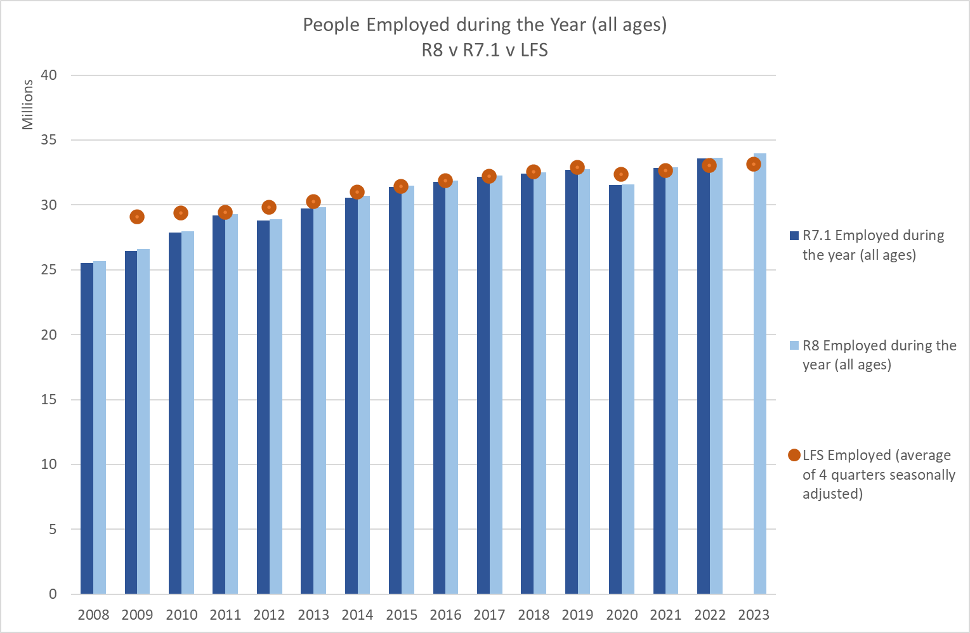
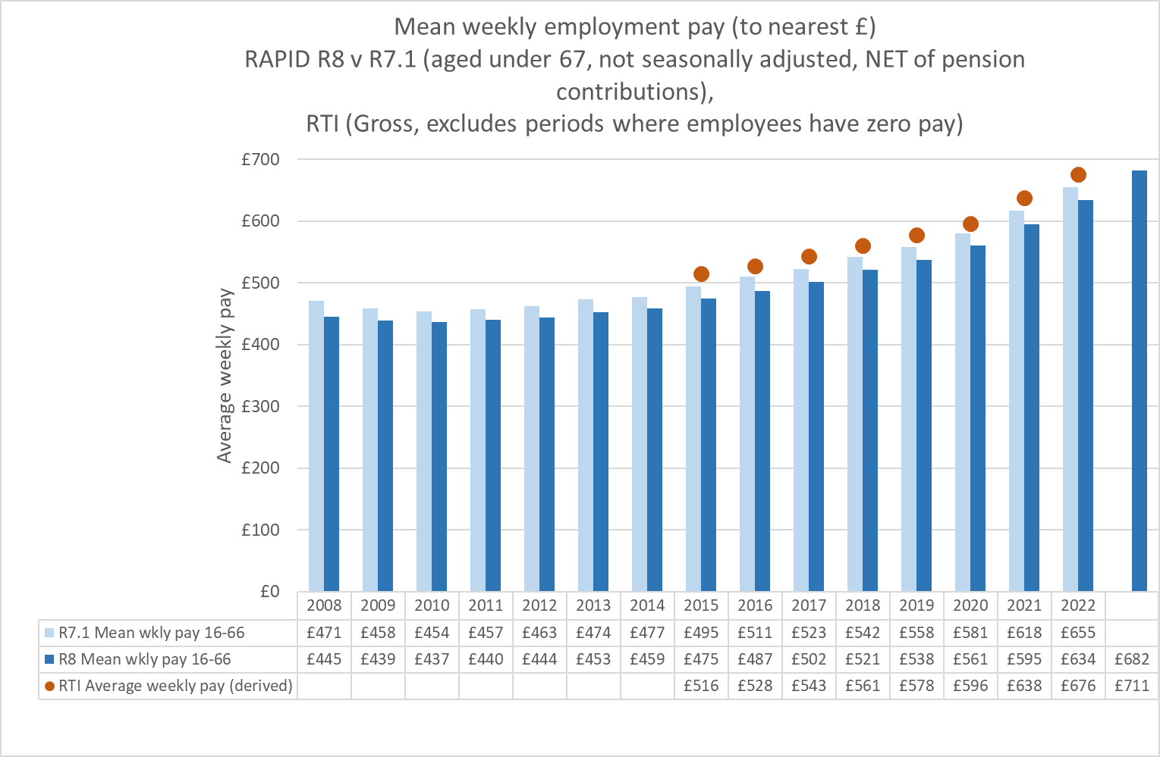

Pension records look sensible when compared to the Occupational Pension Scheme Survey, for the records the OPSS include in their survey. The PAYE data includes pension records for personal pensions, drawdown schemes which are not included in the OPSS figures. OPSS figures are not available beyond 2019.

The chart below shows the records that are classified as ‘employments during the month’ and those where the current criteria have not been met to classify them as pensions (aged 67+). The RTI figures are ‘current at the end of the month’. These 67+ records may also be legitimate employment records for people working beyond State Pension Age.

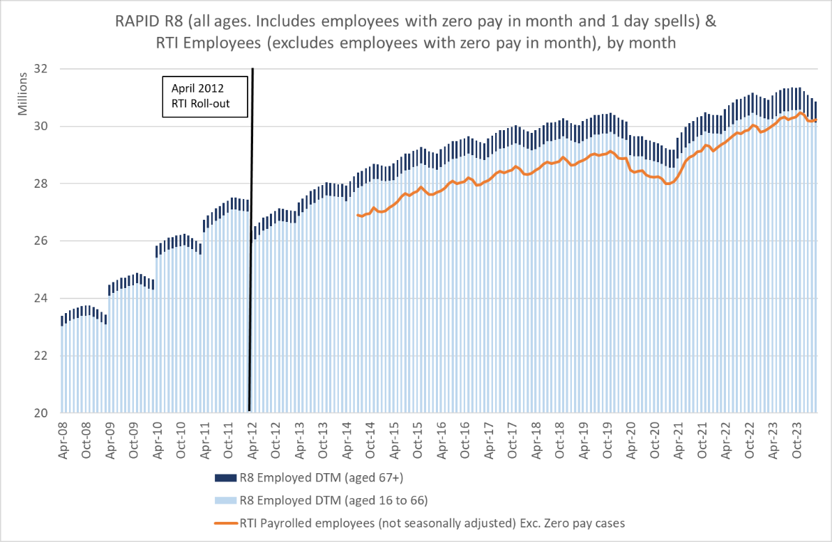

These potential pension records that are still classified as employments have certain characteristics. It is also worth keeping in mind that some of these records could be legitimate employments for people who continue to work beyond State Pension Age. The characteristics are as follows:

- They are all aged over 66;

- They have not been identified from the Occupational Pension Look-up table, i.e. the PAYE scheme ‘name’ does not include anything that identifies the scheme as being a pension scheme, and there are more than 100 members and the average age is over 66 or;

- They are part of a PAYE scheme where the average age of all the members is under age 67 and they are not identified from (2), or;

- They are part of a PAYE scheme that has fewer than 100 members, i.e. small PAYE schemes. The RAPID Employment/Pension splitting criteria is only applied to larger schemes;

- The individual employment record is not identified as a pension on the raw data, and they are classified in (1), (2), (3) and (4);

- The individual characteristics show that this group of records remain reasonably steady over time, but when looked at on a monthly basis the pattern is slightly different to working age employment records.

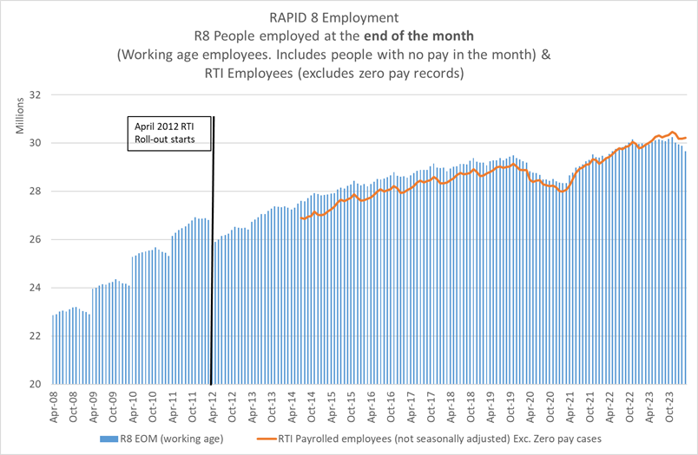

In light of the employment/pension splitting rules we recommend any analyses of employment records also applies age criteria to exclude potential misclassified pension records.

PAYE Employment record processing:

The following processing is performed:

- Totals the annual amount of employment pay (Pay in this employment) and tax (tax in this employment) from all employment records per person per tax year. The amount is ‘taxable pay ‘ , i.e. gross pay minus non-taxable deductions. Hence ‘Gross Pay’ is under estimated for some records;

- Employment duration is derived based on start and end dates. It is worth keeping in mind that while someone may be contractually employed for a full year, they do not necessarily ‘earn’ in every week, which impacts any derived weekly pay amount. People falling into this category will be people on zero hour contracts (who remain fully contractually employed), people working part-year and people who have other unusual working patterns but who remain contractually fully employed;

- A weekly amount of employment pay is derived based on the total amount divided by the duration weeks (see note above);

- The total number of different employments is calculated, based on the number of different PAYE reference numbers that are on the persons’ employment record in the tax year;

RAPID holds two 12 character variables for every activity in RAPID (including employments and pensions) showing whether the activity was current at any point ‘during the month’ (DTM) and current at the ‘end of the month’ (EOM). These variables are available for every year within RAPID.

These DTM and EOM variables are 12 character binary variables that toggle between 0 and 1 depending on whether the activity meets the criteria. The 1st character represents April, the last represents March. These DTM and EOM indicators are based on the actual start and end date of the activities.

These DTM indicators have been used to constrain the activity durations in some circumstances to provide a better measure of the activity in total.

For example, if someone had two employments both with a duration of 26 weeks that ran concurrently, previous versions of RAPID would show 2 employments and would have added these two employments together creating a duration of 52 weeks. There would also be a knock on impact on average weekly pay, dividing the annual pay by 52 rather than 26.

In RAPID the DTM indicators (which are based on real start and end dates) are used to generate a ‘maximum’ number of weeks the person could be employed, i.e. we generate a count of the number of times the DTM indicator is set and multiply it by the average number of weeks in a month (4.33). This maximum number is then used to constrain the number of weeks employed .

This methodology has improved the activity measures (where applied) and increased the accuracy of any derived average weekly amounts.

PAYE Pension record processing:

- Totals the annual amount of pension and tax from all pension records is totalled per person per tax year. The amount is gross but is net of non-taxable deductions;

- An overall annual type of pension/s in payment in the tax year is derived from all the pension records identified. This shows the combination of pensions that are in payment during the year. For the pensions that have been identified through the Occupational Pension Look-up data processing the type of pension is set to ‘not known’. These not known elements are catered for in the type definitions;

- Occupational pension duration is derived based on start and end dates on the ECD Spell Based datasets. This will default to 52 weeks where no dates are held as pensions generally stay in payment once awarded (up to death);

- A weekly amount of Occupational Pension in payment (from all pensions) is derived based on the total amount divided by the duration weeks.

- DTM & EOM indicators are set (as per employments – see above), and the pension durations may be adjusted based on the number of DTM indicators that are set in the year.

RAPID also includes 4 variables that count up the number of pensions being paid by type, which is then used to set a pension combination variable (PENSION_COMBO) showing what type of pension are paid to a person within the year. The pension type totals are as follows:

- DB_PENSION_TOT = Total number of Defined Benefit (salary related) pension in payment;
- DC_PENSION_TOT = Total number of Defined Contribution (Money Purchase) pension in payment;
- MIXED_DB_DC_TOT = Total number of mixed Defined Benefit and Defined Contribution (sometimes called Mixed Benefit schemes);
- UNKOWN_PENSION_TOT = The total number of ‘unknown’ or undefined pension schemes. This includes personal pensions, drawdown scheme and occupational pensions not categorised by the OCCPEN variable.

The chart below shows the occupational and personal pensions in payment by type compared to the ONS Occupational Pension Scheme Survey.

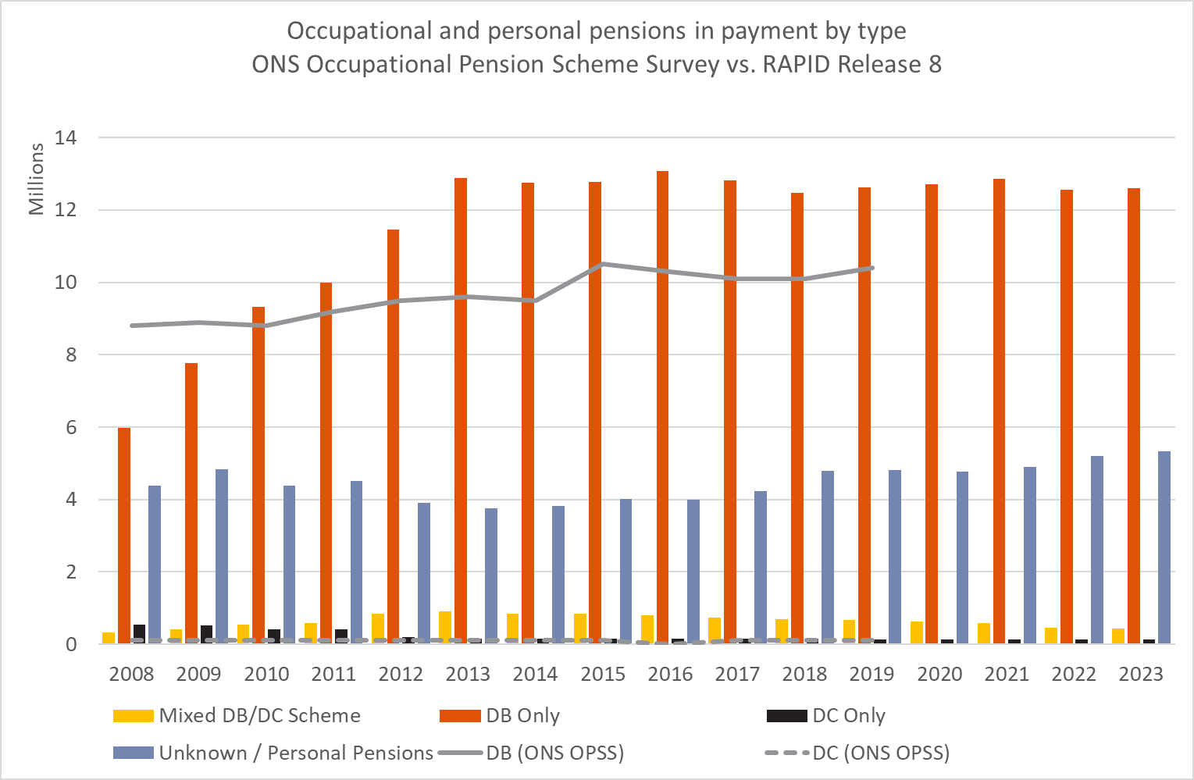
Notes:
- OPSS does not cover state pensions or personal pensions, the latter being based on individuals entering into a contract with a pension provider. These cases are classed as ‘Unknown’ in the RAPID data;
- The OPSS estimates of pension scheme membership are not counts of individuals as an individual may have more than one type of occupational pension scheme membership;
- OPSS estimates that there are approximately 44,000 occupational pension schemes in the population. The OPSS sample consists of approximately 1,600 occupational pension schemes, of which 1,400 are in the private sector and 200 in the public sector.

PAYE cautions & caveats

- The splitting of employment and pension records is not an exact science and there may be records that have been misclassified in both directions. It is worth remembering that occupational pensions can be paid as survivor pensions to partners and children so some people may have pensions where you wouldn’t expect a record.

- In the RAPID splitting of pensions and employments the type of pension has been derived from the OCCPEN indicator, which gives a broad indication of the type of scheme. For schemes identified through other methods the type is recorded as ‘unknown’, this will include personal pensions, drawdown schemes, and occupational pensions that have not been classified in the OCCPEN variable.

- The amount of weekly pay or pension is a derived variable, which relies on the start and end dates of employment. It is worth noting that someone could be employed for a full 52 weeks, but only earn in 26 weeks if they have unusual working patterns, (term-time workers, student workers, zero hours contracts etc.) – hence their weekly ‘pay / pension’ would be artificially deflated by the duration measure, so treat these variables with caution.

- Any Gross Pay measure that analysts derive from this data is likely to be under estimated as it is the ‘Taxable Pay’ (excluding superannuation and pension payments) that is brought through to RAPID. Therefore, any ‘gross pay’ estimate is likely to be an under estimate for anyone who is part of a pension scheme and has deductions made from their salary into the scheme. This is likely to include all people who auto-enrol into the new pension provision. It is likely that the ‘Gross Pay’ will be deficient by between 1% and 10%, depending on the type of scheme.

- Pay estimates include pay from both full time and part time employments. Unfortunately, there is no way of splitting records into part-time and full-time within the RAPID data.

- Data published from HMRC’s RTI system suggest that there was a drop in the numbers in employment in 2020/21, due to the COVID pandemic, and these impacts are also observed in RAPID.
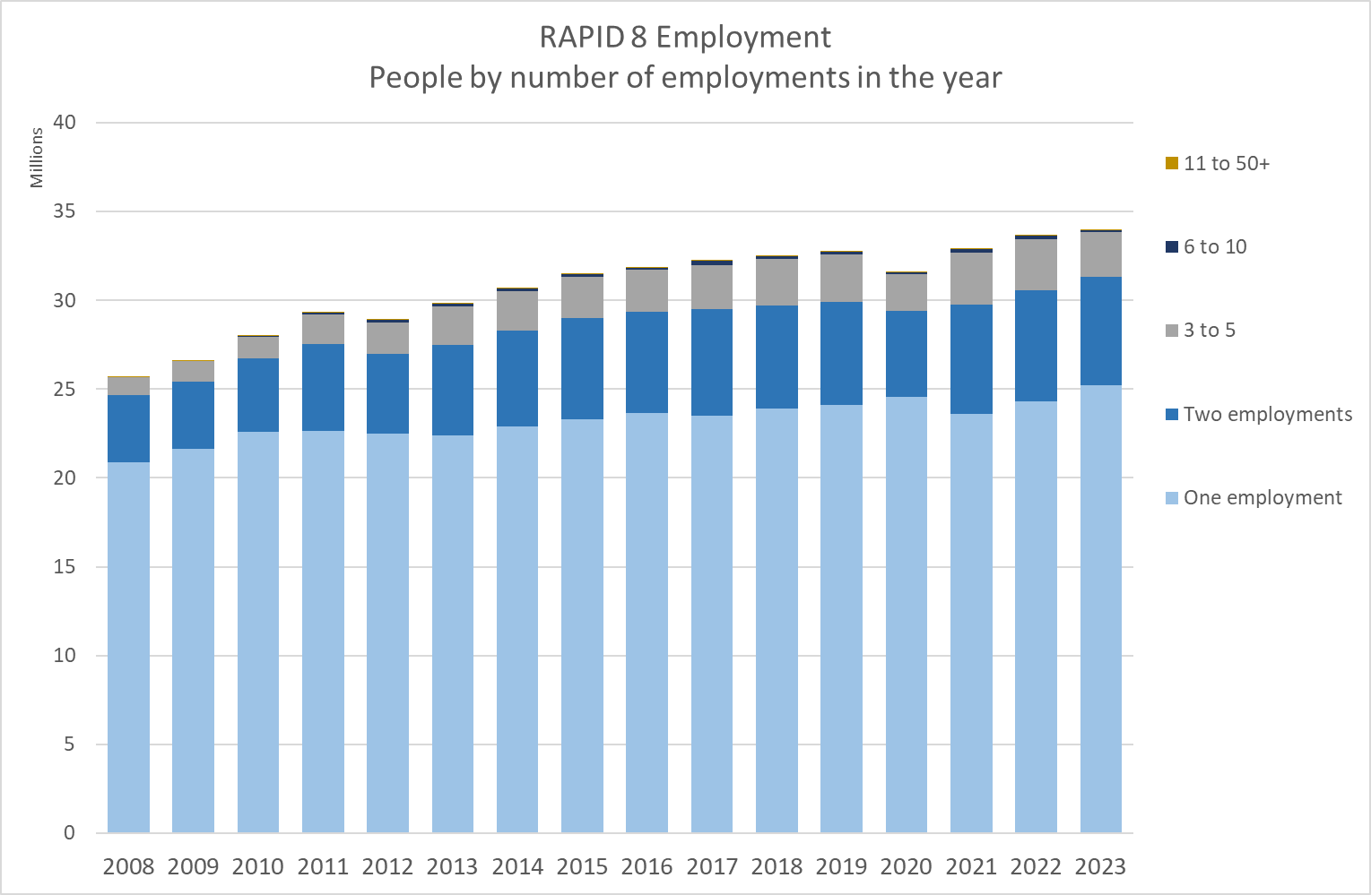

Tax Credit (Working Tax Credits (WTC) & Child Tax Credits (CTC)) processing

New Tax Credit (WTC & CTC) – Work and Pension Longitudinal Study (WPLS)
100% Extract

Information | Notes
Data administration | - Data owned and maintained by HMRC and sourced from the Tax Credit computer system;
Data purpose | - Data collected and maintained by HMRC for the administration and payment of Working Tax Credit and Child Tax Credits
Completeness | - Includes records for DWP Customers and non-DWP customers;
Coverage | - Includes all adults that are part of each tax credit award;  - Includes people who are entitled to Tax Credits and have a Tax Credit spell within the year. For RAPID only cases with a positive daily tapered rate are brought forward, i.e. cases in payment;
Accuracy | - The bespoke WPLS Tax Credit extract supplied by HMRC has a ‘lag’ of a couple of months to take account of provisional awards and adjustments;  - Personal amounts are derived from the household payment, based on the total payment divided by the adults included in each award;  - NOTE: Child Tax Credit policy changes in 2016 (income disregard lowering), and 2017 (2 child limit) reducing the income measure for some families.
Outliers | - Outliers not catered for.

Tax Credit selection criteria, data cleaning & processing

Tax Credit selection criteria and data cleaning

In RAPID Child Tax Credits (CTC) and Working Tax Credits (WTC) are created separately and populate their own activity measures.

This process collects child tax credit and working tax credit payments for each household award and each type of award (CTC or WTC). The customer records are split into different UNIX areas depending on whether there are DWP customers in the household, or whether there are only non-DWP customers in the household. Customers either appear in a one data area or the other and there should be no duplication across the various datasets.

For example:

Example 1, DWP household: CCAPINID=23. The claimant is ENCNINO ‘XXX’ and is in the DWP customer dataset. While there is a second row for CCAPINID=23 in the DWP dataset the ENCNINO is blank as this NINO is not a DWP customer, so the partner NINO has to be collected from the non-DWP customer dataset, linked by CCAPINID. Partner NINO = ‘YYY’

Example 2, NON-DWP Household: CCAPINID=63 is only found in the NON-DWP dataset. ENCNINO's = ‘AAA’, 'BBB'. In order to produce the complete tax credit data these datasets need pulling together and linking by CCAPINID.

The first part of the processing generates a record for each household claim to Tax Credits, and captures the adults within that award. Durations are calculated for each award based on award start and end dates, and the duration is populated against every adult in the award.

Any household that has an element of Child Tax Credits (CTC) in payment will have the following variables generated:
- CTC_TOT_WKS – Total weeks covered by CTC
- CTC_TOT_AMT – Total amount paid in CTC
- CTC_DTM_IND – DTM indicator showing which months CTC was present
- CTC_EOM_IND – EOM indicator showing which month-ends CTC was present in
- Only awards with CTC amounts greater than zero are retained
- In addition, there is a CTC Relationship dataset showing all the relationships that were part of the CTC awards. Within the relationship data there is a duration of the adult pairings, the CCAPINID and new relationship EOM and DTM indicators showing which months the pairings were present in.

Any household that has an element of Working Tax Credits (WTC) in payment will have the following variables generated:
- WTC_TOT_WKS – Total weeks covered by WTC
- WTC_TOT_AMT – Total amount paid in WTC
- WTC_DTM_IND – DTM indicator showing which months WTC was present
- WTC_EOM_IND – EOM indicator showing which month-ends WTC was present in
- Only awards with WTC amounts greater than zero are retained
- In addition, there is a WTC Relationship dataset showing all the relationships that were part of the WTC awards. Within the relationship data there is a duration of the adult pairings, the CCAPINID and new relationship EOM and DTM indicators showing which months the pairings were present in.

To generate a combined Tax Credit amount the CTC & WTC can be added in the final RAPID dataset.

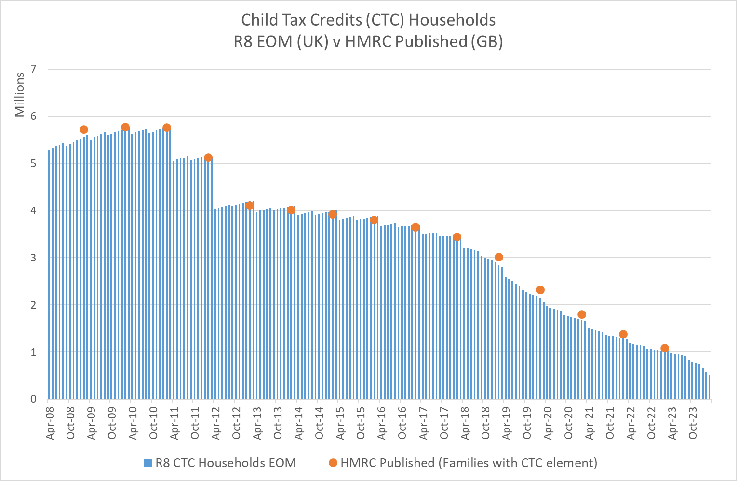

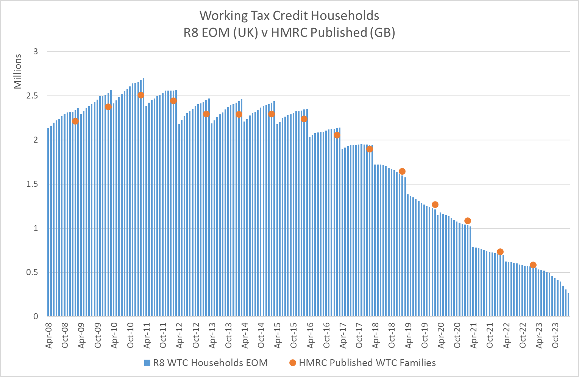

Households with both CTC & WTC have the same Tax Credit Application Instance ID (CCAPINID), and a separate data row for each award type. In this processing each adult within that household will have the household weekly amount calculated for each award type, and a ‘personal child tax credit amount’ is derived, i.e. total household amount in each award divided by the number of adults in the award. This is to enable the calculation of a personal income measure from the sources being looked at in the RAPID suite of programs.

At a NINO/Person level there can be a number of Tax Credit awards within the year, as people have complicated lives and move in and out of households.
For example, when a person leaves a household and either starts a new award as a claimant or if they become part of a new/different household as a partner. In these circumstances a new CCAPINID is created for the new award, or the individual may start to appear on the existing award of the household they are entering.

At a person level this person may appear a number of times, for example as a claimant in one award, partner in another, or have multiple combinations. The number of relationships during the year for each individual is calculated. The processing keeps the relationship links and household ID's for each person and retains them in the relationship table. RAPID makes 2 relationship datasets available, one for CTC and one for WTC, and keeps these links and application ID’s to enable linkage back to the source data and see the NINO’s that go together in the year.

At a NINO level the durations on CTC and WTC are calculated and the derived personal tax credit amount and duration within each award and each tax credit type are totalled to give an annual aggregate.

Example 1: NINO 'A' appears as a claimant in CTC award 1, and NINO 'B' appears as the partner record. Total weekly Child Tax Credits paid to the household = £100 per week. The derived personal Tax Credit amount = £50 each. Duration= 26 weeks.
NINO 'A' then moves to a new award as a single person, with a new household award of £75 with a duration of 10 weeks. The derived personal child tax credit amount = £75. Duration = 10 weeks.

In this scenario NINO 'A' would have an annual total personal Child Tax Credit amount = £125 (£50+£75), and duration = 36 weeks (26 +10). NINO 'B' would have total personal Child Tax Credit = £50, and duration=26 weeks.

The same methodology if applied to WTC and a dataset for each type of Tax Credit is created.

Tax Credit processing

- Processing is split into CTC and WTC, but the processing is the same for both types of Tax Credit;

- The DWP and Non-DWP customer records are brought together and linked by Tax Credit Application Instance ID (CCAPINID), and the number of adults within each award are counted;

- The Tax Credit award start and end dates are analysed and any awards that are outside the period being covered by the RAPID dataset are dropped;

- The award start and end dates are used to set the duration within the tax year and a tax year variable is also derived;

- The number of Tax Credit ‘spell’ days in the tax year is calculated based on the start and end dates. Some spells with a zero rate have spells exceeding the maximum possible for the tax year. This is due to ongoing entitlement but where there is nothing payable due to the tapering of the benefit. These spells are capped at 365 days;

- The ‘Tapered daily rate’ (held as a whole pence value), is divided by 100 to generate a pound and pence measure. This also includes cases where the daily tapered rate has been reduced to zero but where the award is still open and appears current. This is then multiplied by the number of days in the Tax Credit spell to generate an annual amount for each component of the award, i.e. if there are Working Tax Credits and Child Tax Credits in the same award the duration and amount from each element is calculated separately;

- Within each award (CCAPINID) each record in the tax year is processed in turn and the following variables are derived for use in further processing;
1. Generates a Tax Credit type id;
2. Sums the Child Tax Credit and Working Tax Credit amounts by type;
3. Totals the Child Tax Credit and Working Tax Credit days;
4. Converts the days to weeks (where the days are between 1 & 6 the number of weeks defaults to 1 week;

- Generates a total Tax Credit weeks (CTC & WTC separately);

- The WTC and CTC amounts are calculated. At this stage the data is still household and award based;

- The next stage appends the payment and duration data at a household level to the all the adults within the Tax Credit award;

- The ‘personal’ amounts of each element of tax credits are then derived by dividing the household amounts by the number of adults within the award;

- The annual totals are then derived by adding the personal amounts and durations for each individual NINO within the tax year and also counts the number of household awards the person has been part of in the year.

- A household weighting factor is derived that enable household level statistics from the person level data. Where there is only one adult in the award the statistical weighting = 1, but where there are 2 adults in the award the statistical weighting = 0.5. These values are carried forward and totalled at a person level and retained in the final dataset. Once the person has been in a household of 2 at any point their weighting remains at 0.5 for the whole tax year regardless of any subsequent awards. Where a person has been part of a number of household awards in the year this can generate ‘half values’ when aggregated and using the weighting variable.

- DTM & EOM indicators are set and in some circumstances, these are used to adjust the duration of the overall Tax Credit award. Some cases in the data appear in 2 (or more) different households concurrently (which in theory shouldn’t happen), which inflates the overall duration if they were added together.

- Relationship data is derived capturing the adult pairings within the award. This data also holds the DTM and EOM’s for each pairing.

Tax Credit cautions & caveats

- The weighting variable must be used as a 'var statement' in any tabling statements to generate something comparable to household level statistics. It should only be used in tabling non-amount variables (total expenditure can be generated by totalling the personal amounts). The weighting variable can generate ‘half values’ in aggregate where records have been members of multiple households in the year.

Pairing | Record level rating value
Person A & Person B | 0.5 each  (Person A & Person B = 1.0 in aggregate)
Person A & Person C | 0.5  (Person C only, Person A is already 0.5 based on previous pairing)
Total aggregated weighing | 1.5

- RAPID excludes people who have zero in payment. These cases are also excluded from HMRC published outputs.

- From 2016/17 the income disregard for Tax Credits was reduced from £5000 to £2500. This has the result in removing some people from Tax Credit eligibility and potentially reduces the tax credit income for those that are eligible.

- From 2017/18 the ‘2 child limit’ and the removal of the ‘Family Element’ of Child Tax Credits were introduced. This has the impact of reducing entitlement and the amounts paid. More information can be found in the link below.
2 child limit policy
From 6 April 2017, the child element was no longer be available for third and subsequent children born on or after 6 April 2017 unless an exception applies.
Removal of the family element
The family element was previously paid to all families. From 6 April 2017, it was only paid where the claimant is responsible for a child or qualifying young person born before 6 April 2017.
https://revenuebenefits.org.uk/tax-credits/policy/current-policy/

- People arriving from Non-EU countries have no access to Tax Credits for the first 5 years or until they have acquired indefinite leave to remain. From January 2021 this will also apply to newly arriving migrants from the EU. This may have an impact on certain people’s ‘footprint’ on which residency is derived within RAPID.

Tax Credit Relationships

In RAPID two relationship datasets are created – CTC Relationships and WTC relationships. Both datasets are structured in the same way and are the same as in previous releases.

The Tax Credit Relationship dataset captures all the relationships between claimant and partner within each Tax Credit award within the tax year.

For each ‘pairing’ the duration and EOM/DTM of the pairing on Tax Credits is captured and the NINO’s are captured. CCNINO = Claimant NINO and PCNINO= Partner NINO.

The relationship data is structured in a way that the pairing appears twice for each award, with claimant being CCNINO and Partner being PCNINO and then vice versa Partner being CCNINO and Claimant being PCNINO. This is because within RAPID both parties have a record, and hence both appear with CCNINO in the main data.

The Tax Credit relationship data also includes people with no partners. As such it would be possible to analyse the relationship data in isolation to get a total number of awards in the year (once the data has been de-duplicated by CCAPINID to remove the pairing duplicates mentioned above).

Housing Benefit (SHBE) processing

Single Housing Benefit Extract (SHBE)

Information | Notes
Data administration | - Data owned by DWP and maintained by Local Authorities (LA) and sourced from LA Housing Benefit computer systems;
Data purpose | - Source data retained on LA systems for the administration and payment of Housing Benefit;  - SHBE Extract provided by LA’s to DWP for the purposes of statistical analyses, expenditure forecasting, Fraud and Error and policy development. SHBE is not an extract of the live systems used to pay Housing Benefit, but is a derived copy of the information captured in the payment systems;
Completeness | - The data is supplied from over 400 different LA’s, generally on a monthly basis;  - Data for before October 2009 is not sourced from SHBE but is sourced from individual extracts supplied by LA’s. Pre-October 2009 no partner information is supplied, therefore for 2008/09 and the first 6 months of 2009/10 the relationship data cannot be generated, and the ‘people’ estimates are undercounted;  - On rare occasions data from certain LA’s can be corrupt or not supplied, which results in a gap in the information for that LA for that month. Where this happens DWP investigate and seek to get the data re-submitted by the LA, but if these issues remain unresolved it can generate gaps in the data;  - Some partner details within the SHBE extract are not correctly populated and have default values in the identifiers to enable partner incomes to be recorded on the LA systems. These default NINO’s are dropped from the RAPID processing as it is impossible to link them to the correct accounts in RAPID.
Coverage | - RAPID includes Housing Benefit data for Northern Ireland. The format of the HB data for Northern Ireland is different to GB records prior to June 2019. As such some measures are derived differently for NI cases prior to June 2019 and some values are not available at all, for example, there are no monetary amounts for NI HB in payment prior to June 2019. This means the total income measures exclude HB NI in payment prior to 2019/20, and the measure for 2019/20 is incomplete only capturing the amount in payment from June 2019.
Accuracy | - The SHBE data is not from the LA’s live systems, therefore it may not be as up to date as the systems used to pay benefit.  - The Housing Benefit amounts reflect ‘entitlement’ amounts once the award has been finalised. The actual amounts paid may be different if there are arrears, recoveries or sanctions etc.
Outliers | - Outliers not catered for in RAPID;  - Some records in RAPID have high numbers of HB awards in the year. As the RAPID data is created on fully masked data it is not possible to assess whether the high number of awards is due to genuine movements of address or whether they are a consequence of administrative changes. RAPID caps the number of different households to 13 in any one year.

Processing of Great Britain and Northern Ireland Housing Benefit record

From Release 5 the processing brings in Housing Benefit data for Northern Ireland (NI). The NI data is in a different format to the GB data and so the processing of GB and NI records is done differently. Different processes are used for NI records.

The Northern Ireland HB data is split into a 'current' format extract (similar to the GB monthly extract but with fewer variables), and a 'historic' file. Both of these data have limitations:

- 'Current' format file - this holds fewer variables than the GB data (no start and end dates or Housing Benefit reference number (LCHBREF) or Local Authority Serial Number (LCLASER). RAPID derives proxy references for both variables but it results in relationship data that may be less reliable. However, the ‘current format’ data does provide information on partners and amounts of HB in payment.

The ‘current format’ data is monthly and available from June 2019 (so is not complete for the whole of the 2019/20 tax year - missing April & May 19);

- 'History' format file. Holds historic HB data up to May 2019 (where the format changes to the 'current' format). Within the ‘history’ file there are also some limitations that impact the way RAPID processes the NI records, and records between 2008 and 2012 are processed differently to the records between 2013 and 2018.

There are no amounts of HB in payment on this NI file so RAPID will not be able to populate the HB amounts from 2008 to 2018.

  - 2008 to 2012 processing. Durations on HB are derived from the start and end dates of the HB award. Changes within the award are not captured and the ‘partner’ NINO is taken to be the partner throughout the period.

  - 2013 to 2018 processing. Durations on HB are calculated using the ‘Valid From Date’ and Valid To Date’ variables. These dates capture the changes within the award and durations are calculated for each change within the year. These durations are then totalled into a tax year view.

Housing Benefit selection criteria, data cleaning & processing

The RAPID code uses the Single Housing Benefit Extract (SHBE) from October 2009 to derive activities for Housing Benefit customers. Pre-October 2009 individual extracts supplied by LA’s are used and these extracts do not hold as many variables. Crucially they do not include partner details. This impacts both the household and ‘people’ estimates for 2008/09 and 2009/10 as can be seen below:

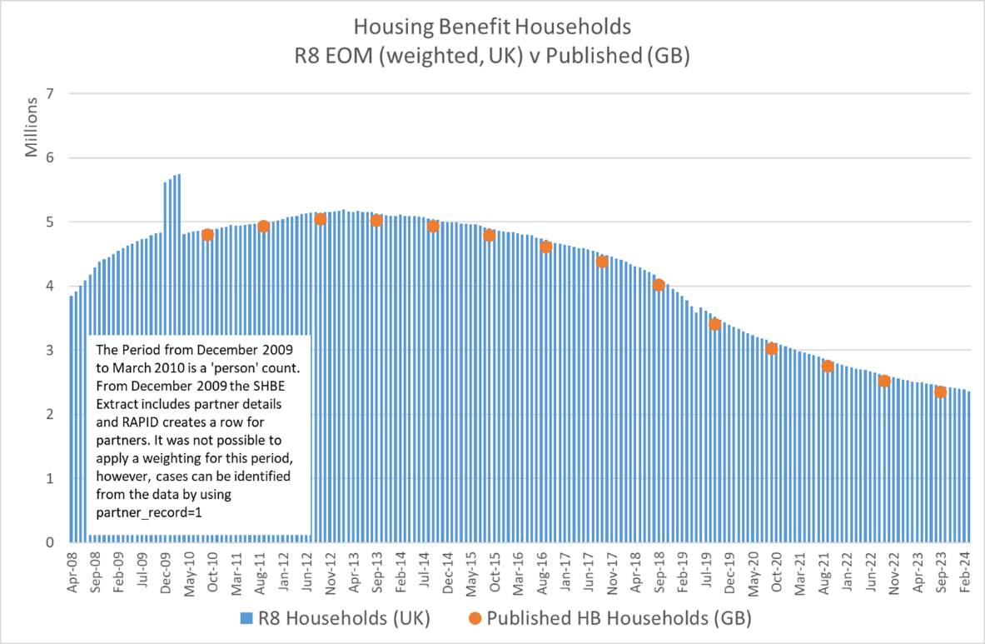

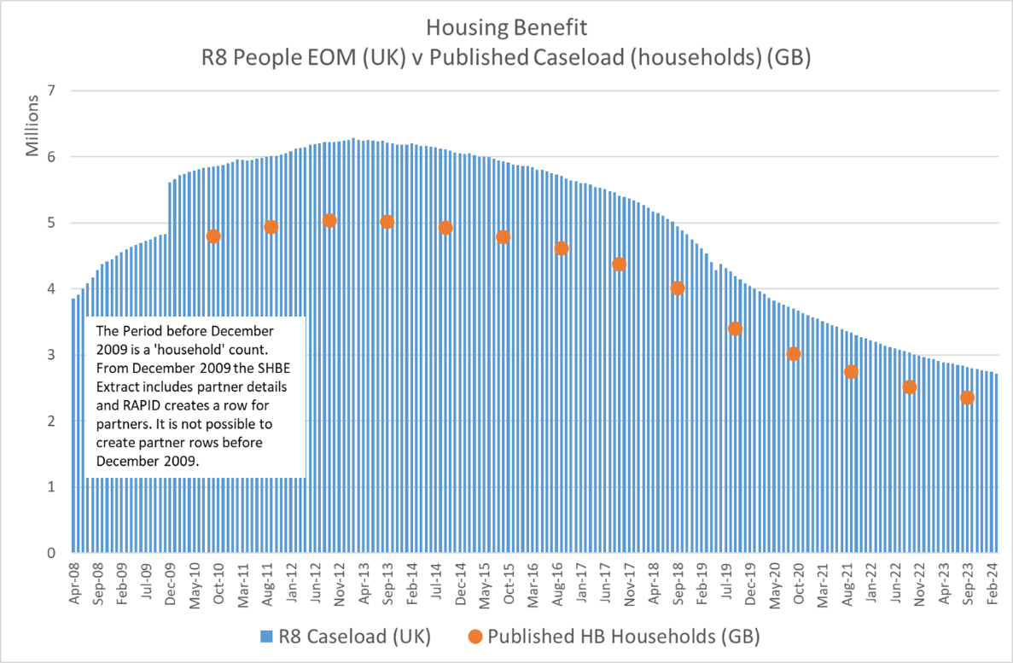
The SHBE data is generated on an 'award' bases. If a person moves accommodation within a Local Authority very often the HB reference number doesn't change, although the amount of HB in payment might. If a person moves outside the LA a new HB reference number is created by the new LA area.

Where partner details are available (from October 2009) these will be included in a HB relationship table. The RAPID_HB_RELATIONSHIPS data holds the NINOs associated with each Housing Benefit Number within the year being processed.

Housing Benefit selection criteria and data cleaning

The RAPID creation routine will process each award by HB ref (LCHBREF) and NINO. Partner NINO is also included as a column variable within each record (rather than having a row for the partner). This code will create a new row for each partner within each award and will generate a 'personal HB amount' for each person within the award. The LCHBREF variable is also used in the relationship data to link people together within the award.

The Northern Ireland data does not hold HB ref. The processing of the data in RAPID generates a proxy HB ref (LCHBREF). Between 2008 and 2018 when the historic file is used the LCHBREF is generated from the ‘SPELL_KEY’ variable. This is a unique identifier that works in a similar way to LCHBREF within the GB data.

From June 2019 when the ‘current’ monthly data is used neither the SPELL_KEY or LCHBREF variables are available. The LCHBREF variable is populated with a derived reference which is a concatenation of the nino and pcnino to give a unique reference for each Northern Ireland coupling within each monthly extract.

There are some anomalies with the GB partner NINO field which this code attempts to cater for.

Some of the HB systems operated by LA's will only allow partner elements to be added if there is something in the partner NINO field (PCNINO). As such, some values within the PCNINO field are default values rather than real NINO's. As RAPID processing works on masked NINO data it is impossible to identify NINO's that are default values. Hence, a count of the occurrences of each PCNINO within each year is performed and where there are more than 30 occurrences of the PCNINO within the year these partner NINO's are hard coded and excluded from the process that creates a row for the partner NINO.

Housing Benefit processing:

- All the cases on the SHBE extract within a given tax year are extracted. A macro is used to process all monthly SHBE extracts within each tax year. Only extracts from April 2010 onwards are included in the processing. Hence this code only creates tax year views from the 2010/11 tax year onwards. The monthly extracts are then brought together into a tax year file;

- The processing looks at all the extracts within the year by NINO and HBref (Housing benefit reference number) to create a key (dupkey) to identify duplicates and to enable aggregation within each award. The code does the following:

- Sorts the data by dupkey;

- In some circumstances a claimant can also appear as a partner in another award in the same month. The process to create partners will also create a partner row. Similarly, a new award may start in the month and the existing award is also still on the extract with no end date. This looks like both awards are current at the same time and so a duration for each is generated, and when summed they generate a duration that is longer than the month in question.
The processing code only keeps one record. In the event that there is more than one record in the month the data is sorted by NINO tax year and the number of weeks for each spell is calculated. The spell with the largest number of weeks in the extract is retained to avoid double counting. If there is only 1 record for the NINO in the extract it will still be kept.

NOTE: This methodology may drop a record with a partner, and as such a partner record will not be created for that extract month either.

- From R5 onwards if the real start date is populated it will be used moving away from the methodology that allocated everyone with the same duration in the month. From R5 if the start date is missing then the extract start date is used. This new methodology uses the dates if they are populated and only uses the extract dates where nothing else exists - it will generate a duration of the maximum dates covered by the extract.

- The processing generates a running total of the weekly amount (HHOLD_ANN_AMT) and an average weekly amount based on the total amount divided by the number of weeks;

- Collects the extract_id and mid-month date that the person last appears in the tax year. For ongoing claims this should be the last extract in the tax year. For cases with a properly recorded end date this may not be the last extract in the year.

- For cases that disappear from the extracts before the end of the tax year, and where no end date is populated the code populates the end date with the mid-month date from the last observed extract they appear in but only if the last observed extract is before the last extract in the tax year, suggesting that they have terminated the HB claim (otherwise they would be present at the end of the year)

- Sets a count of the number of adults in the household based on whether PCNINO (partner NINO) is populated

- Derives personal HB amount based on rate payable and number of adults in award

- The process sets PCNINO to 'NOT KNOWN' for NINO records that have 30+ occurrences in any year. This action prevents partner records being created in the following stages;

- Creates a row for any partner within a claim. Essentially duplicates the award details for the partner and swaps PCNINO and CCNINO, thus generating an award row for the partner. The following actions are applied:

- Selects HB awards that have a partner NINO (excluding those who have been set to NOT KNOWN in the previous data step). Creates a partner copy of the claimant record;

- Puts the original claimant row and newly derived partner row together into a single dataset. The number of adults in the household award is derived, and then the ‘personal’ element of the household amount is derived by taking the household amount and dividing it by the adults within the award;

- The award totals are then aggregated into an annual view of all the awards the person has been part of. The personal annual amounts and durations for each individual NINO are totalled, and a count of the number of household awards the person has been part of in the year is generated;

- A household weighting factor is derived that enable household level statistics from the person level data. Where there is only one adult in the award the statistical weighting = 1, but where there are 2 adults in the award the statistical weighting = 0.5. These values are carried forward and totalled at a person level and retained in the final dataset. Once the person has been in a household of 2 at any point their weighting remains at 0.5 for the whole tax year regardless of any subsequent awards. The weighting is only possible from 2010/11 onwards. The weighting variable can generate ‘half values’ in aggregate where records have been members of multiple households in the year.

Pairing | Record level rating value
Person A & Person B | 0.5 each  (Person A & Person B = 1.0 in aggregate)
Person A & Person C | 0.5  (Person C only, Person A is already 0.5 based on previous pairing)
Total aggregated weighing | 1.5

- DTM & EOM indicators are set and in some circumstances these are used to adjust the duration of the overall Housing Benefit award. Some cases in the data appear in 2 (or more) different households concurrently (which in theory shouldn’t happen), which inflates the overall duration if they were added together.

- A HB relationship dataset is also created for each year.

Housing Benefit cautions & caveats

- Looking at the cases in the SHBE extracts before any annual aggregation of awards can be confusing, especially when you look at the person based dataset. NINOs can appear a number of times, with exactly the same money but with a different HB Ref numbers.
For example, in the household dataset that is used in the derivation a person only appears once. The NINO is a partner in one award and a claimant in another. Hence it looks like a duplicate based on the money once the new row for the partner has been created. However, the code is doing exactly what is expected. This person was part of 2 different awards in the year and the two awards were for the same amount of money. At a person level though the personal amounts are different as in one claim only half the household amount goes to the person (as a partner) and in the other the person gets the whole amount (as a single claimant).

- The weighting variable must be used as a 'var statement' in any tabling statements to generate household level statistics. It should only be used in tabling non-amount variables (total expenditure can be generated by totalling the personal amounts)

- The Housing Benefit amounts reflect ‘entitlement’ amounts once the award has been finalised. The actual amounts paid may be different if there are arrears, recoveries or sanctions etc.

- People arriving from Non-EU countries have no access to Housing Benefit for the first 5 years or until they have acquired indefinite leave to remain. From January 2021 this will also apply to newly arriving migrants from the EU. This may have an impact on certain peoples’ ‘footprint’ on which residency is derived within RAPID.

- Northern Ireland records have no HB monetary amounts populated from 2008 to 2018. The NI HB amount measure for 2019 is only partial from June 2019 to 5th April 2020.

Housing Benefit Relationships

The Housing Benefit Relationship dataset captures all the relationships between claimant and partner within each Housing Benefit award within the tax year. Relationships will only be created from October 2009 onwards.
There will be a pairing record for each HB award in the year. This means that a person may appear more than once if they have been in a number of awards in the year, i.e. it is not the total number of weeks for the person, but is the total weeks for each award. The data is structured this way to enable linkage back to the raw HB data if needed. If you require a total HB duration for the person you can collect this from the RAPID tax year based data, or do a total of the ‘total weeks’ variable within the relationship data – the total should be the same either way.

For each ‘pairing’ the duration and EOM/DTM indicators of the pairing on Housing Benefit is captured and the NINO’s are captured. CCNINO = Claimant NINO and PCNINO= Partner NINO.

The relationship data is structured in a way that the pairing appears twice for each award, with claimant being CCNINO and Partner being PCNINO and then vice versa Partner being CCNINO and Claimant being PCNINO. This is because within RAPID both parties have a record, and hence both appear with CCNINO in the main data.

The HB relationship data also includes people with no partners. As such it would be possible to analyse the relationship data in isolation to get a total number of awards in the year (once the data has been de-duplicated by LCHBREF and LCLASER to remove the pairing duplicates mentioned above).

DWP Benefit processing (Legacy Benefits excluding UC & PIP)

Generalised Matching Service Benefit Data (GMS)

Information | Notes
Data administration | - Data owned and maintained by DWP and sourced from the various DWP Legacy Benefit computer systems;
Data purpose | - Information about benefit claims and awards are captured on DWP benefit systems to enable the payment of benefit to individuals and households;  - Data also used in the prevention of benefit fraud;
Completeness | - General Matching Service (GMS) data extracts from the legacy systems are taken regularly. The frequency of the extract depends on the legacy system being used. A full list of extract schedules if shown in Section 10;  - The GMS extracts generally capture the cases that are ‘live’ at the point the extract is taken. This means that information about benefit terminations is not generally captured and has to be inferred;  - Benefit terminations are inferred when the person ceases to appear on the ‘live’ extract. This has an impact on the duration and income measures in RAPID. For example, in a weekly extract the duration might be over-estimated by up to 6 days (if they terminated the benefit the day after the extract was taken, i.e. live in one extract, but not present in the following extract). In a 6 weekly extract the duration and income measure might be over-estimated by up to 5 weeks and 6 days. Fortunately, the benefits that are on a longer extraction schedule tend to be benefits where people claim and remain on benefit for long periods or until death, e.g. State Pension;
Coverage | - Coverage is generally good in the GMS data. However, on extracts that have a longer extraction schedule some short spells may be missed. For example, in a 6 weekly scan schedule a claim to benefit that starts and ends within that 6 week window, and is not current at the extraction date will be missed from the extract, and thus also missing from RAPID. Fortunately, the benefits that tend to be on longer extraction schedules tend to be benefits that also have longer benefit durations;  - RAPID interrogates every GMS extract that is available within the year. For example, for benefit extracts that are supplied weekly, 53 different extracts are examined to generate the duration and income measures.  - In 2016 certain disability and carer benefits were devolved to Scotland. From 2020 Children on DLA who were living in Scotland started to migrate to the new Scottish Child Disability Payment (CDP). Adults on Personal Independence Payments (PIP) who lived in Scotland started to be migrated to the new Adult Disability Payment (ADP). See section 20 for more details.
Accuracy | - The data in the GMS extracts accurately reflects the start dates and entitlement amounts at the point of extract;  - The duration measures in RAPID are calculated based on the number of days the person has been in receipt of benefit within the extract period, so in a weekly extract the maximum duration would be 7 days;  - The weekly benefit rate is also captured in each extract. A daily rate is calculated by taking the weekly rate and dividing it by 7 days. The amount payable within each extract is then calculated by multiplying the derived daily date by the number of days the person has been in receipt within the extract;  - RAPID processing captures this information from each individual extract and aggregates the amounts and durations to provide an annual measure. It therefore captures all changes in benefit rates throughout the year;  - The benefit amounts reflect ‘entitlement’ amounts once the award has been finalised. The actual amounts paid may be different if there are arrears, recoveries, suspensions or sanctions etc.  - Benefit amounts are usually uprated annually in April. The level of uprating is usually determined by the Customer Prices Index (CPI) in the September preceding the April. Due to the ‘triple lock’ Pension benefits may be uprated by more than this amount.
Outliers | - No adjustment is made for outliers;  - Duration measures are capped at 52 weeks;  - No adjustment is made for overlapping benefits. There are some benefit combinations that should not be possible at the same time. RAPID does not adjust any of the GMS data for these scenarios.

Benefit data methodology, selection criteria, data cleaning & processing

Benefit data methodology

This section deals with the legacy benefits supplied via GMS extracts. The benefits processed here are:

- State Pension (including new awards made via the Get Your State Pension system) (SP);
- Pension Credit (PC);
- Widows Benefit (WB) (Includes: Widows Pension, Widows Pension (age-related) & Widowed Mothers Allowance. Only paid to women widowed before April 2001.);
- Bereavement Benefit (BB) Includes: Bereavement Payment, Bereavement Allowance & Widowed Parent Allowance. Paid to men and women widowed April 2001 to April 2017 (replaced by BSP);
- Bereavement Support Payments (BSP) Great Britain only. Paid to Men and Women widowed from April 2017 onwards;
- Attendance Allowance (AA);
- Disability Living Allowance (DLA);
- Incapacity Benefit (IB);
- Passported Incapacity Benefit (PIB);
- Severe Disablement Allowance (SDA);
- Industrial Injuries Disablement Benefit (II);
- Industrial Death Benefit (IDB);
- Employment Support Allowance (ESA);
- Invalid Care Allowance (ICA & CA);
- Income Support (IS);
- Job Seekers Allowance (JSA);
- Maternity Allowance (MA);

The methodology review of Release 1 highlighted an issue with the data being used in RAPID to calculate benefit durations and benefit amounts. The issue impacted all DWP benefits with the exception of Universal Credit (UC) and Personal Independence Payments (PIP).

The methodology used in Release 1 calculated the duration on each benefit from the ‘frozen’ quarterly published datasets and amalgamated 5 quarters into a tax year view.

While the methodology for calculating durations and amounts was robust, the ‘Frozen’ datasets that were being used meant that some spells were missed completely, and the durations and amounts for cases not current at the end of the quarter were being excluded from the calculation. The frozen datasets only include cases that are current at the end of the quarter, and as such any award that started and finished within the quarter were not being captured at all.
Similarly, cases that terminated during the quarter excluded the element of the duration and amount from the end of the last quarter (where present) to the date of termination. This potentially resulted in an under count of durations and amounts and was particularly noticeable for benefits that typically have shorter durations, like Job Seekers Allowance (JSA) for example.

The methodology from Release 2 onwards reverted to the raw Generalised Matching Service (GMS) 100% extracts and performs the calculation on each extract for each benefit. So, for example, where the GMS extract is weekly 53 extracts were analysed and the duration and amount from each extract was calculated and then totalled to provide an annualised view.

Some GMS extracts are weekly, some are fortnightly, some are 4 weekly and some are 6 weekly. The same methodology has been employed for each type of extract. However, these less frequent extracts also have an impact on the duration and amount calculations.

The GMS extracts only capture ‘live/current cases’ at the point of extract, and few data extracts hold a real date of termination. This means that in a 6 weekly GMS extract you generate terminations once every 6 weeks, and as such the duration calculation has a 6 weekly flow pattern. The same applies to fortnightly and 4 weekly extract. However, this is only particularly noticeable where benefit has a short spell aspect to it. State Pensions for example come on a 6 weekly extract, but the benefit spells are such that they remain on for life generally, so the 6 weekly cycle isn’t observed. The impacts can be seen in the charts below. JSA benefit spells tend to be short, hence the fortnightly extract schedule takes 2 weeks of terminations off at once, whereas State Pension spells tend to be lifelong once awarded and only impact the duration at death.

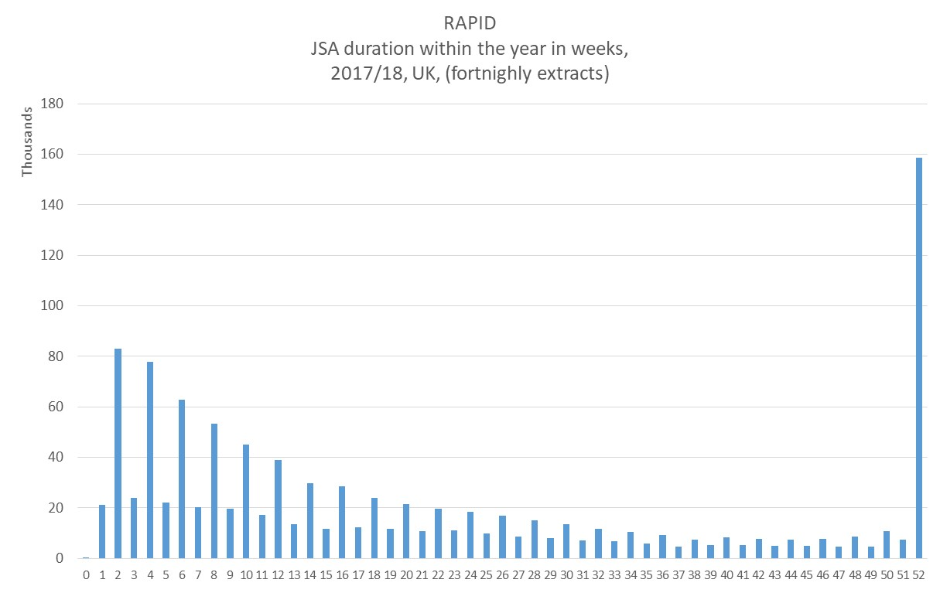

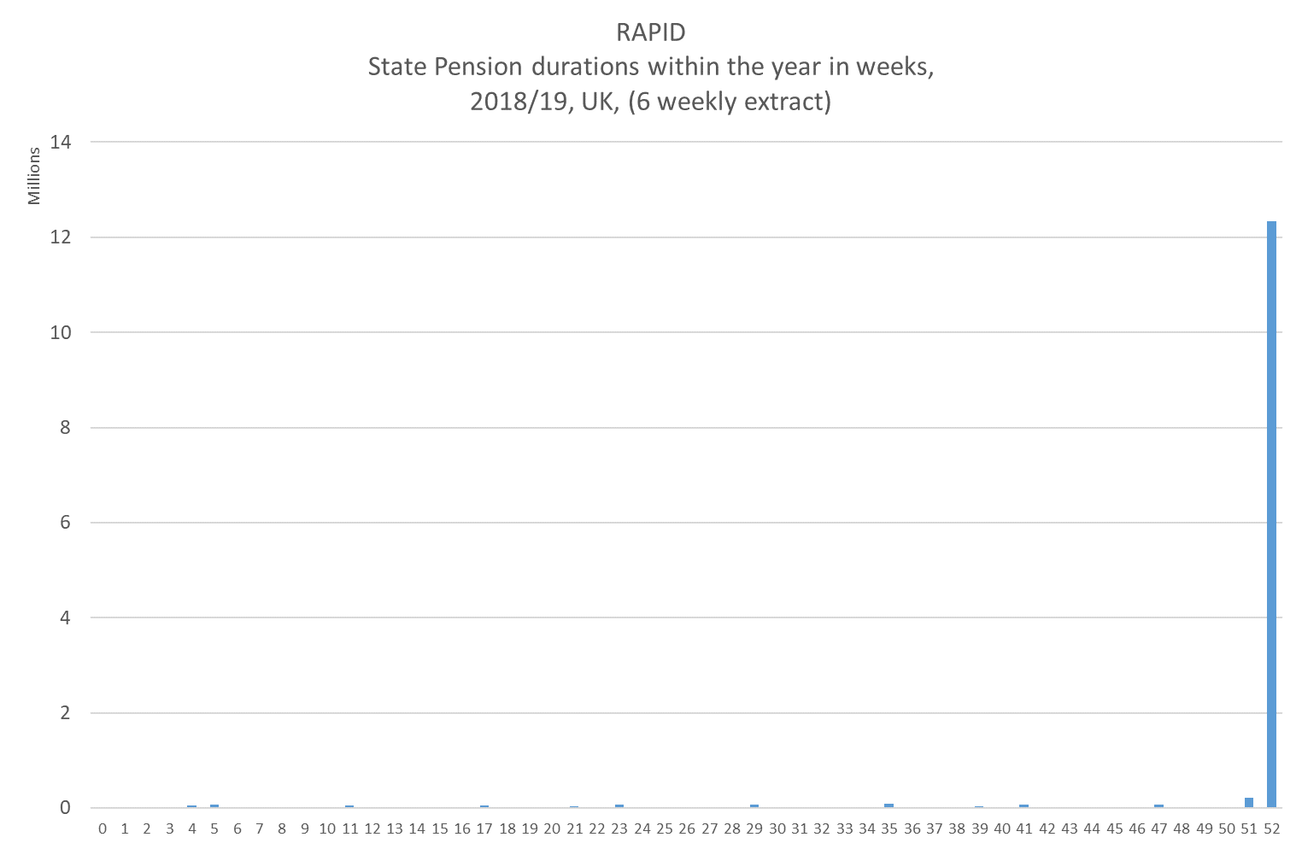

Impacts of the methodology change:

- Using the GMS extracts has generated a more robust and accurate measure of durations and amounts, especially for the benefits that come on a weekly extract;

- For benefits that come on a less frequent extract there may be an element of over counting of both duration and amounts. For example in a 6 weekly extract it may be possible to over-estimate durations (and amounts) by up to 5 weeks and 6 days. This impacts certain benefits more than others;

- No estimation, imputation or correction is made to benefit end dates, so durations for benefits that do not come on a weekly GMS extract cycle reflect a duration cycle that follows the cycle of the extract;

- The extracts that span the period covering the tax year start and tax year end are used twice, once capturing durations up to the end of the tax year, (5th April), and again capturing durations from 6th April in the following tax year.

Benefit data selection criteria & data cleaning

The RAPID data uses the GMS datasets for each of the DWP benefits to derive durations on each benefit type throughout the year. Universal Credit (UC) and Personal Independence Payment (PIP) data is processed in further sections. The benefits processed in this section relate to United Kingdom

Benefit data processing

All the benefits in this section are processed in exactly the same way and the same derived variables are kept, with the exception of BB, SP, and WB where additional variables about whether the benefit is payable in a Frozen Rate country are also kept. The additional variables enable these records to be excluded from the ‘resident’ measure later in the processing.

The DWP Benefit records are processed as follows:

- The DWP GMS benefit data is United Kingdom.

- Records are de-duplicated. Where ‘Alias’ and ‘Real’ records exist within the same extract only the ‘Real’ record is taken and the ‘Alias’ (or any other records (‘dead’ for example, or additional duplicated ‘Real’ records) are dropped;

- Any records where the benefit spell ended before the extract date of the extract being processed will be dropped;

- Each extract is processed in turn and by individual benefit. The start and end dates of the award are analysed to generate the number of days a person has had an open/current benefit spell within the extract being processed. For example, in a weekly extract the maximum spell would be 7 days;

- The benefit payment for each duration is generated by taking the weekly benefit rate in payment and deriving a ‘daily rate’, dividing the weekly rate by 7 days. The amount of money that each duration generates is then derived by multiplying the daily rate by the number of days the duration covers within the extract. This caters for changes in the benefit rates that happen during the year;

- The total number of days and amount of money within each extract are then totalled by NINO for each extract used in the tax year;

- Once each extract has been processed they are aggregated to generate tax year total view. The maximum duration within the tax year is capped at 52 weeks;

- For some State Pension (SP) awards that are paid in combination with Pension Credit there is a payment end date within the SP GMS scan. For these cases the duration and amount of SP in payment is captured from the SP combined payment information within the Pension Credit GMS scan. A flag is set (SP_VIA_PC_FLAG) is set to show that the SP duration and amount has been derived from the Pension Credit scan. From 2020 cases paid via the Get Your State Pension system are captured from the Central Payments System. These records are then added to the other pension caseload datasets to complete the State Pension coverage.

- Similarly, some SDA awards they are combined with Income Support payments. In this circumstance the SDA duration and award amount is captured form the SDA combined payment information within the IS GMS scan. A flag is set (SDA_VIA_PC_FLAG) is set to show that the SDA duration and amount has been derived from the Income Support scan.

- DTM & EOM indicators are derived using the benefit start dates and the data extract dates. For household benefits from R8 the EOM and DTM indicators are generated in the relationship tables showing the months of the adult pairings.

Benefit Specific data cautions & caveats

There are some specific processes to the way some benefits are processed that users need to be aware of:

- Uprating of benefits. Benefit amounts are usually uprated annually in April. The level of uprating is usually determined by the Customer Prices Index (CPI) in the September preceding the April. Due to the ‘triple lock’ Pension benefits may be uprated by more than this amount. This uprating will be reflected in the Total Income measures in RAPID. Some years the uprating may be much higher than normal, which helps explain sudden increases in pensioner income particularly.

Bereavement Support Payments (BSP) (GB only). RAPID includes BSP records. The data is populated back to 2017 when the benefit was introduced and RAPID creates durations, amounts, EOM and DTM variables. It is worth noting that the payment information is derived and includes the first lump sum payment at the beginning of the award.

The BSP extract is Great Britain only, so excludes all Northern Ireland award.

State Pension (SP): New SP cases that have been awarded via the Get Your State Pension (GYSP) process are included in the SP measures.

Pensions from 2020/21 onwards awarded via the GYSP system have been captured from the Central Payment System (CPS), (the system that manages payments to all benefit claimants).

From the payment information the duration and amounts paid via GYSP have been calculated and a new variable has been added that identifies that the record was awarded via the GYSP system. The GYSP data is UK based.

- Attendance Allowance (AA). From 2018 there are a larger number of records with ‘zero’ weeks. The DLA/AA extract dates have an impact on durations. For example, from 2018 onwards the April extract date has been very close to the start of the tax year. Durations using the April extract may only generate 1 to 3 days, which would round to zero in the calculation of weeks.
If the person then dies between the April and May extract they would not appear in the monthly May extract (not live on the extract day), and therefore the duration for the year would only be very short based on the April extract only. All deaths would come off on a single day (the day of the last extract +1). Pre 2018 where the April extract is further away from the start of the tax year the number of days would be 4+ which would generate a full week. This can be seen in the outputs with higher numbers of 1 week durations, although the impacts of deaths being removed on mass with each extract can be seen in the 4 week cycle of the extracts.

From R7 the rate of AA in payment in each month is available from the EOM and DTM indicators.

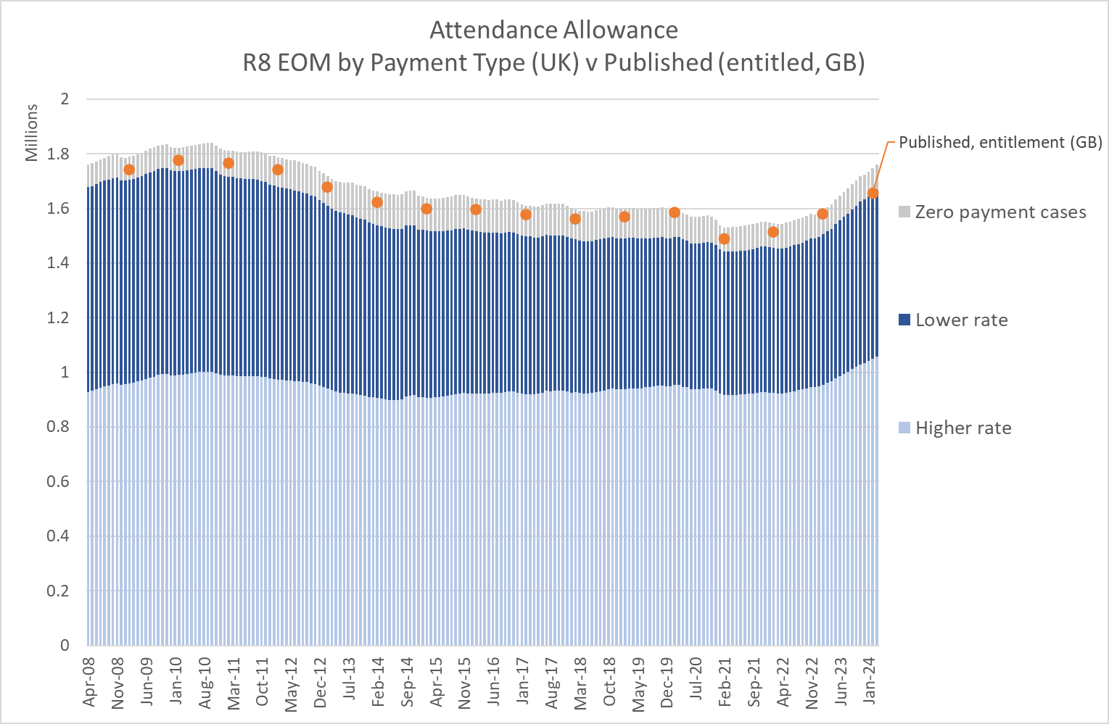

- Disability Living Allowance (DLA): See note for AA. DLA is supplied in the same extract as AA so the same caveats apply.

However a further impact for DLA is the movement of caseload from DLA to PIP in the April of each year from 2018 onwards. Of the cases with zero weeks (due to extract dates above) 67% of the cases with zero weeks in 2018 moved to PIP, 72% of the zero weeks cases in 2019 moved to PIP. The remaining cases either died or ceased to be eligible for DLA as part of the reassessment for PIP.

From R7 the EOM and DTM indicators have been updated to reflect the rates in payment in each month. DLA now includes zero payment cases.

In 2016 certain disability and carer benefits were devolved to Scotland. From 2022 Children on DLA who were living in Scotland started to migrate to the new Scottish Child Disability Payment (CDP). See section 20 for more details.

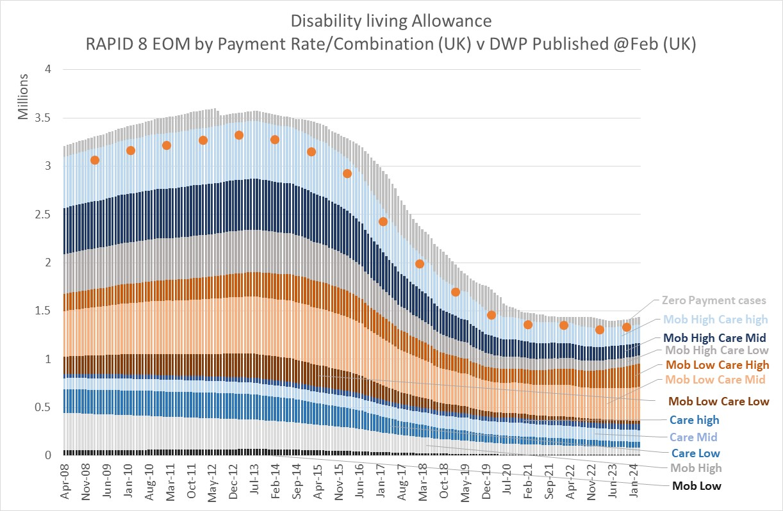

- Job Seekers Allowance (JSA): From R6 the split between Contributory and Income based JSA is included. JSA Contributory is paid for the first 6 months of the award and is based having paid sufficient National Insurance contributions. JSA Income Based is paid when an income top up is needed. This can be paid in addition to contributory JSA during the first 6 months. After 6 months the contributory element ceases to be paid and people remain on income based if they need the income top-up.
The processing of JSA in RAPID does not use the ‘claim type’ variable in the raw data, as this is not often updated to reflect the current type of benefit in payment – it more reflects the status at the point the award was made. Instead, RAPID uses the contributory and income based amounts to decide the type of award in payment at each extract.

From R7, zero payment (credit only) cases are included in the data. The EOM and DTM variables now hold the combination of payment in each month.

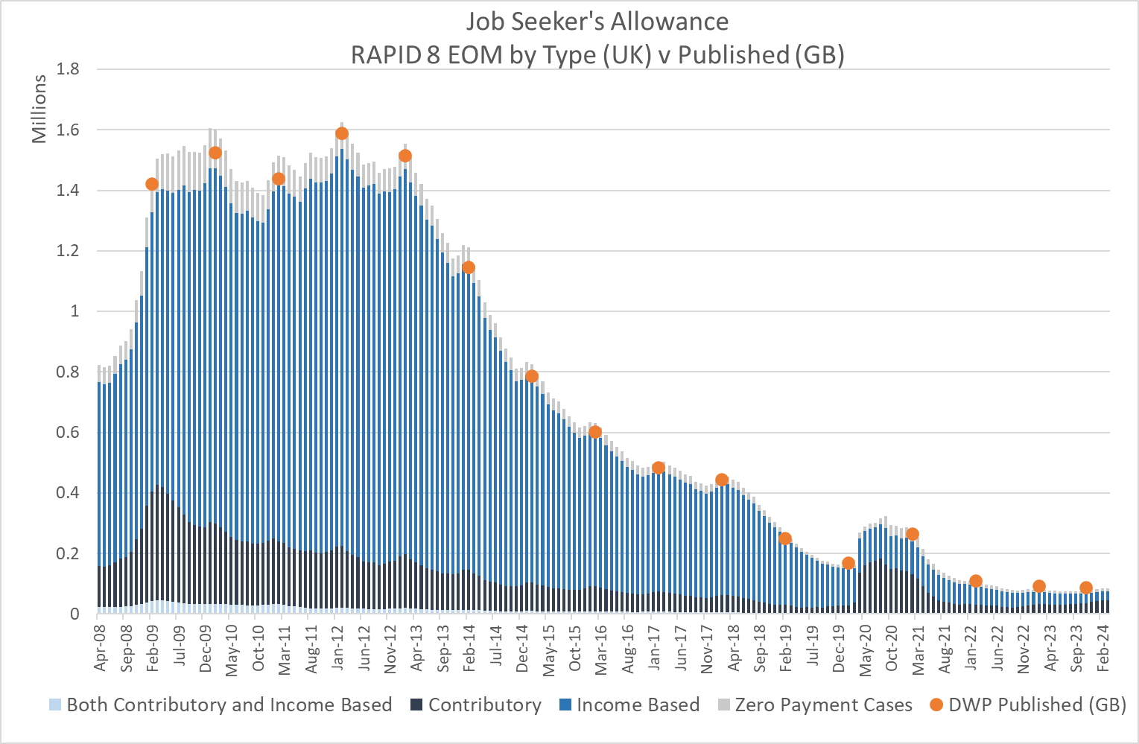

- Employment Support Allowance (ESA): From R6 the split between Contributory and Income based ESA is included.
The processing of ESA in RAPID does not use the ‘claim type’ variable in the raw data, as this is not often updated to reflect the current type of benefit in payment – it more reflects the status at the point the award was made. Instead, RAPID uses the contributory and income-based amounts to decide the type of award in payment for each extract. The split between Contributory, Income-Based and Both is the same throughout the series covering both old style and new style ESA. Which grouping cases fall into will depend on the rules that apply at the point of the extract.
From R7 zero payment cases are included in the data. The EOM and DTM variables now hold the combination of payment in each month.

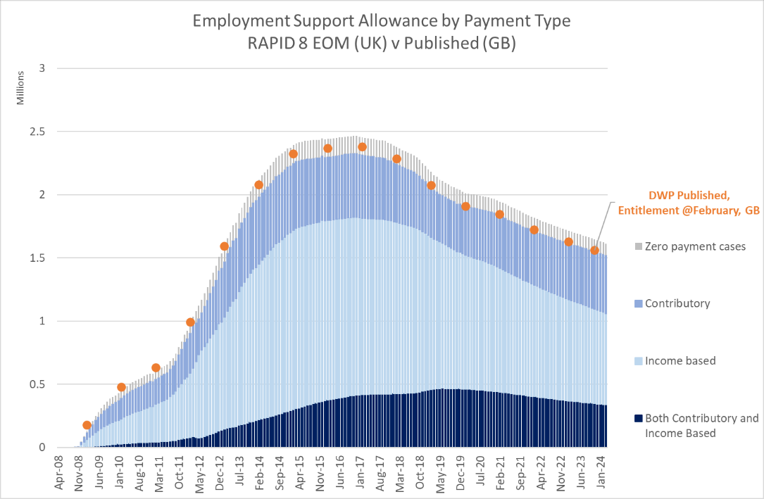

- Medical condition data: R8 includes medical condition code variables for the main disability benefits, i.e. Personal Independence Payments, Employment Support Allowance, Disability Living Allowance and Attendance Allowance.

As part of the processing of these benefits the last medical condition code that is observed in the year is retained and made available. The data is available throughout the time series of the benefit within RAPID.

It is worth noting that some of the medical codes change (or are expanded) over time. Some codes are no longer used for new cases or have been replaced by expanded codes. Some cases that are still current may still hold the old medical condition code and have not been updated to the new code on the source system, meaning a combination of old and new codes may be needed, depending on the analysis, and/or the benefit being analysed.
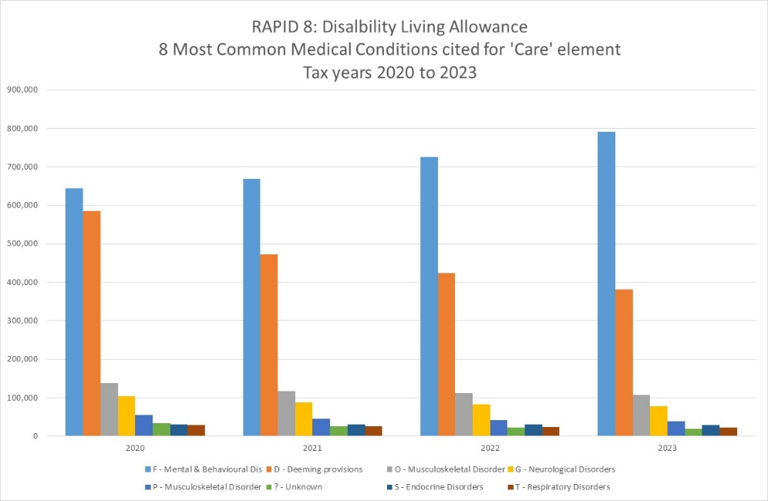
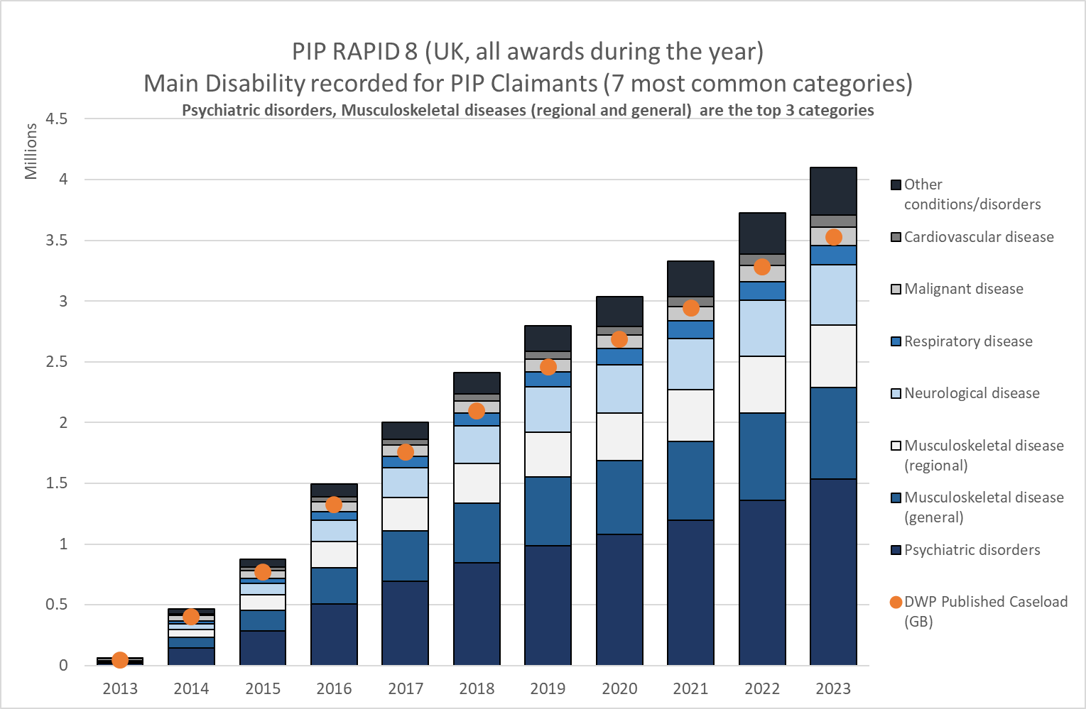

New End of Month (EOM) and During the Month (DTM) values for Relationship datasets:

R8 includes EOM and DTM variables for most of the relationship dataset, the exception being State Pension relationships. The new variables hold the months of the relationship ‘pairing’. New relationship EOM/DTM variables are available for the following relationship datasets:

  - Income Support
  - Housing Benefit (from December 2009)
  - Working Tax Credits (from 2010)
  - Child Tax Credits (from 2010)
  - Child Benefit
  - Pension Credit
  - Carers Allowance (from 2010)
  - Universal Credit (from 2015)

- Overlapping Benefits: No adjustment is made for overlapping benefits. There are some benefit combinations that should not be possible at the same time. RAPID does not adjust any of the GMS data for these scenarios;

- Benefit Amounts: The benefit amounts reflect ‘entitlement’ amounts once the award has been finalised. The actual amounts paid may be different if there are arrears, recoveries, suspensions or sanctions etc. In most cases the entitlement amount will be what is actually paid.

- Weighting for household benefits: For household benefits where the activity is generated for both adults within the award the weighting variable can generate ‘half values’ in aggregate where records have been members of multiple households in the year.

Pairing | Record level rating value
Person A & Person B | 0.5 each  (Person A & Person B = 1.0 in aggregate)
Person A & Person C | 0.5  (Person C only, Person A is already 0.5 based on previous pairing)
Total aggregated weighing | 1.5

- Migrant Access to Benefits: People arriving from Non-EU countries have no access to income-related benefits for the first 5 years or until they have acquired indefinite leave to remain. From January 2021 this will also apply to newly arriving migrants from the EU. This may have an impact on certain people’s ‘footprint’ on which residency is derived within RAPID.

Personal Independence Payment (PIP) processing

Personal Independence Payments (PIP)

Information | Notes
Data administration | - Data owned and maintained by DWP and sourced from the Personal Independence Payments computer system;
Data purpose | - Information about PIP claims and awards are captured on DWP systems to enable the payment of benefit to individuals;  - Data also used in the prevention of benefit fraud;
Completeness | - The data used in RAPID is created by the Analytical Community and is a ‘cleaned’ and formatted version of the source system that makes the data easy for analysts to interpret;  - Data is only available from April 2013 onwards;  - The PIP dataset that is used in the creation of RAPID does not contain the actual start and end dates of the benefit award (at the time of RAPID’s creation at least). The durations on PIP are therefore calculated form the extract dates and use these dates as a proxy for the duration in each monthly extract.
Coverage | - The datasets used in RAPID are the same datasets that are used to publish the National Statistics on PIP caseload. As such, the data covers all PIP caseload within each extract;  - Data is for United Kingdom;  - In 2016 certain disability and carer benefits were devolved to Scotland. From 2022 Adults on PIP who were living in Scotland started to migrate to the new Scottish Adult Disability Payment (ADP). See section 20 for more details.
Accuracy | - The way durations are calculated in RAPID may result in an over estimate of the activity within a year as the extract dates are used to calculate duration rather than the start and end dates of the award. However, this will only be an issue at the beginning or end of an award and the profile of PIP cases means that then numbers with short spells or terminating spells will be small. In the year that a new PIP award starts the duration is likely to be over estimates, possibly by up to 3 weeks and 6 days.  - The PIP amounts reflect ‘entitlement’ amounts once the award has been finalised. The actual amounts paid may be different if there are arrears, recoveries, suspensions or sanctions etc. In most cases the entitlement amount will be what is actually paid.
Outliers | - No adjustment is made for outlier in RAPID.

PIP Processing

The RAPID creation code processes all the PIP monthly data extracts from April 2013 onwards.

RAPID uses the ‘on-flow’ date and extract dates (the period covered by each extract) to calculates, the duration of each PIP spell within each quarter, ensuring that there is no overlap or double counting of days on adjacent extracts. Start and end date for the periods of PIP are not currently held in the analytical PIP datasets, but on-flow date is held. This date is used as a proxy for start date;

In some records a new award may start in the month and the existing award is also still on the extract with no end date. This looks like both awards are current at the same time and so a duration for each is generated, and when summed they generate a duration that is longer than the month in question.

RAPID processing only keeps one record. In the event there is more than one record in the month, the data is sorted by NINO tax year and the
number of weeks for each spell. The spell with the largest number of weeks in the extract is retained to avoid double counting. If there is only 1 record for the NINO in the extract it will still be kept. From R7 zero payment cases are included.

The PIP records are then processed as follows:

- The RAPID code uses the ‘caseload’ analytical datasets, which is an amalgamation of all the PIP extracts for each month. The RAPID data takes this amalgamated data but processes each monthly extract in turn;

- For each extract the following information is derived:

  - The tax year that the extract is relevant to;
  - The number of days in the extract being processed, based on a calendar days measure, taking into account any leap years;
  - The Daily Living Award type, which is then used to generate the daily living rate in payment. This is hard coded based on the type and weekly rate applicable in the tax year;
  - The Mobility Award type, which is used to generate the mobility rate in payment. This is hard coded based on the type and weekly rate applicable in the tax year;
  - A derived ‘total’ rate in payment is calculated for that month, by adding the Daily Living and Mobility components together;
  - A Daily Rate is calculated based on the Total rate payable divided by 7 days, which is then multiplied by the number of days that the extract covers, (calendar days). This generates a total in payment and duration for each extract;
  - The last medical condition that is observed in the tax year is retained and brought forward to the RAPID data.

- Once all the months within the tax year have been processed they are aggregated to provide an annual estimate of the PIP durations and amounts in payment;

- From R7 new EOM and DTM values are used to identify what payment combinations were present in each month.



PIP cautions & caveats

- The rates in payment are derived based on the award component types, rather than the system generated amounts. Hence there may be some discrepancy between what the derived rate and what is actually paid, and no account is taken of things like arrears or adjustments etc.

- Prior to April 2013 all the variables relating to PIP will be blank;

- In 2016 certain disability and carer benefits were devolved to Scotland. From 2022 Adults on PIP who were living in Scotland started to migrate to the new Scottish Adult Disability Payment (ADP). See section 20 for more details.

Universal Credit (UC) processing

Universal Credit

Information | Notes
Data administration | - Data owned and maintained by DWP and sourced from the Universal Credit computer system;
Data purpose | - Information about UC claims and awards are captured on DWP systems to enable the payment of benefit to individuals and households;  - Data also used in the prevention of benefit fraud;
Completeness | - The data used in RAPID is created by the Analytical Community and is a ‘cleaned’ and formatted version of the source system that makes the data easy for analysts to interpret;  - Data is only available from January 2013 onwards;  - The household data holding the amounts in payment is only available from August 2015, hence there are no monetary amounts populated prior to this date, although the activity is captured. It will not be possible to derive the various components of the award.  - The issue identified at above also means that any partners in the award cannot be identified before August 2015, and hence their activities and components cannot be derived or captured.
Coverage | - The datasets used in RAPID are the same datasets that are used to publish the National Statistics on UC caseload. As such, the data covers all UC caseload within each extract.  - Coverage restricted to claimant only prior to August 2015;  - Data is for United Kingdom. UC was only introduced to Northern Ireland in 2017, hence before this the data represents the UK whilst on other benefits
Accuracy | - The UC data used in RAPID is sourced from the same data that is used for UC publications;  - The UC amounts in RAPID relate to what is ‘paid’ rather than what the entitlement is, which may be higher.
Outliers | - No adjustment is made for outlier in RAPID.

UC Methodology & processing

UC Methodology

The RAPID creation code processes utilises all the UC full service data extracts and captures UC start dates from 1 Jan 2013 (currently the earliest start date on the caseload datasets);

The RAPID processing uses the analytical datasets that are created by Client Statistics, which utilise the monthly UC Full Service extracts. At September 2024 there are 2 main analytical datasets, 'UC Caseload', which holds that start and end dates of the award/assessment, and 'UC Household' (or benefit unit), which holds the amounts of money being paid. The same datasets exist for Northern Ireland which are added to the Great Britain data to provide a United Kingdom measure;

Some records appear in caseload and not in household and vice-versa. The cases with no household record present have nothing in payment.
From Release 5 cases in the CASELOAD data with no supporting payment data in the HOUSEHOLD data, i.e. not in payment, have been dropped for extracts beyond August 2015. Extracts before August 2015 only have CASELOAD data (and no payment information) and so have been retained.
This change has been made to stop duplication of records (and inflation of the duration measures) where a record appears in the CASELOAD data with no supporting HOUSEHOLD record AND where a partner record is created by the RAPID process creating a duplicate spell.

To capture activities for all UC cases both caseload and household datasets need to be looked at;

The total amount in payment is held in the HN_TOTAL_PAYMENT variable, and this is used to derive the annual amounts of UC in payment. The UC Total amount in payment (HN_TOTAL_PAYMENT) doesn’t include the housing amount if there is a Managed Payment in place (where the housing element is paid directly to the landlord). For the creation of RAPID the process looks to see if there is a managed payment indicator set in the months being processed. If the indicator is set the housing entitlement amount is added to the HN_TOTAL_PAYMENT amount.

The household dataset shows the maximum entitlement for each component that is part of the award, e.g. standard entitlement, child entitlement, disability and housing entitlements. THESE ARE NOT NECESSARILY THE AMOUNTS BEING PAID.
The component entitlement variables (while not useable for deriving payable amounts of each element) are used to set indicators showing the entitlement elements that are part of the actual payment. The total being paid is what is being paid monthly - it can be reduced to zero but is still classed as a UC customer in this methodology.

While there is no direct mapping from the old legacy system definitions these derived indicators utilise the data within the UC award to set various legacy system equivalents, for example:

(a) The caseload data holds an employment indicator, (1 = employed). This shows that someone in the award is getting an earnings top-up (like tax credits). A SAS retain statement is used to set an annual indicator;

(b) The Caseload data holds the conditionality regime, e.g. 'looking for work' this is used to identify those who would have previously been on JSA in the legacy systems. This methodology is used in ONS unemployment measures and can be used as a proxy for legacy JSA - A SAS retain statement is used to set an annual indicator;

(c) Housing entitlement greater than zero in the Household dataset will be used to identify people who would previously appeared in the HB data. A SAS retain statement is used to set an annual indicator;

(d) Child entitlement greater than zero in the Household dataset will be used to identify people who would previously appeared in the Child Tax Credit data.

A SAS retain statement is used to set an annual indicator of the components. Any partners included in the award will have their details captured. A personal amount will be derived (diving the amount by the number of adults in the household) and an activity row for partner is be created.

Any partner details and duration of partnership with links are output to a relationship dataset, showing all the partnership NINO links within the year.

Each monthly extract will be analysed and the duration of each UC award within the extract period will be calculated. The duration within each month uses the exact extract dates, and is calculated based on the start date of the UC award and the start date of the extract, i.e. previous extract date +1 day. The May 2013 extract (the first) will collect all start dates from 1 Jan 2013;

In some records a new award may start in the month and the existing award is also still on the extract with no end date. This looks like both awards are current at the same time and so a duration for each is generated, and when summed they generate a duration that is longer than the month in question.

From R5 only one record is kept per extract. In the event that there is more than one record in the month, the data is sorted by NINO tax year and the number of weeks for each spell. The spell with the largest number of weeks in the extract is retained to avoid double counting. If there is only 1 record for the NINO in the extract it will still be kept

From R7 the conditionality rules that the person is subject to in each month is retained in the EOM and DTM indicators. The conditionality is set for each adult in the award separately as each person may be under different conditionality rules.

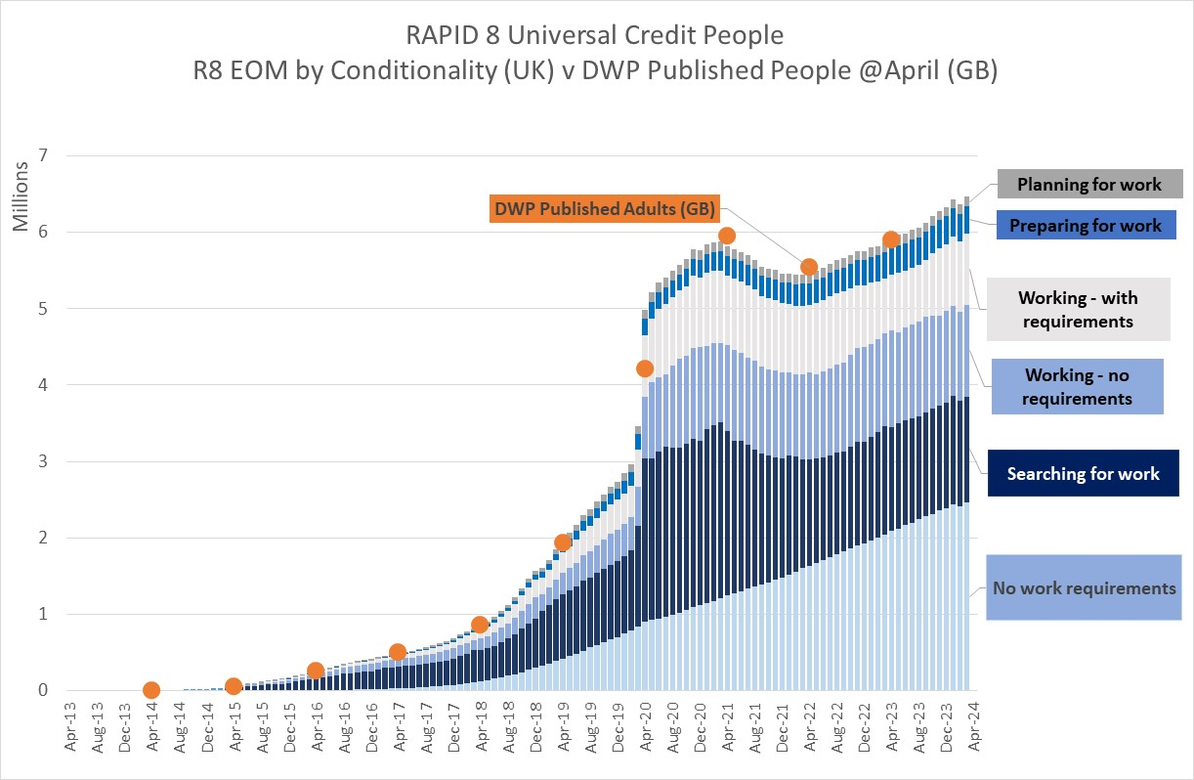

For Universal Credit the ‘Health Journey’ flag has been captured from 2017 onwards. Individual medical condition codes are not available on the UC system so the health journey flag has been brought in to RAPID to indicate that there is a health condition that is being taken into the assessment of the UC award.


UC Processing

- Uses the monthly extract ID and sets tax year being processed;

- Calculates the number of days the UC has been awarded in the month using combination of extract dates and start dates and sets an indicator to identify that the case appears in the caseload data;

- Restricts processing to the months covered by the analysis – otherwise it creates problems further down the code as the household dataset includes spells beyond the last extract being processed;

- Drops cases with no NINO present;

- Sets indicators for each component that makes up the award. The components are as follows:

  - Personal
  - Dependent child/children
  - Childcare
  - Dependant disabled children
  - Housing
  - Limited Capacity to work
  - Carer

- Derives a personal element of the payment, based on the total household amount divided by the number of adults included in the award, and sets an indicator to show whether the cases also appear in the household dataset;

- Where the component indicator is set, showing the component is part of the award in that month, the component weeks is populated with the number of weeks of the UC award in that month i.e.it assumes that the component has been present for the whole period within the monthly extract;

- Where there is a partner NINO within the monthly extract, a duplicate of the claimant record is created and populated against the partner, creating an activity for both claimant and partner. Both records will have the same derived ‘personal’ entitlement amount populated and the same durations within that month. NOTE: Some partners already appear in the data at caseload level, but not at household level. The merge is done on NINO and start date so that where the start date is the same only one record is created (the persons caseload record, but with the household data appended). Where the start dates are different a new record is created, i.e. this person now has a record on the caseload data of his/her own and a record in the household data with different start dates - assumed to be different claims or spells within the month

- The monthly totals from each extract are then aggregated into an annual view.

- A household weighting factor is derived that enable household level statistics from the person level data. Where there is only one adult in the award the statistical weighting = 1, but where there are 2 adults in the award the statistical weighting = 0.5. These values are carried forward and totalled at a person level and retained in the final dataset. Once the person has been in a household of 2 at any point their weighting remains at 0.5 for the whole tax year regardless of any subsequent awards. For UC household benefits where the activity is generated for both adults within the award the weighting variable can generate ‘half values’ in aggregate where records have been members of multiple households in the year.

Pairing | Record level rating value
Person A & Person B | 0.5 each  (Person A & Person B = 1.0 in aggregate)
Person A & Person C | 0.5  (Person C only, Person A is already 0.5 based on previous pairing)
Total aggregated weighing | 1.5

- DTM & EOM indicators are derived. From R7 the EOM and DTM indicators hold the conditionality rules that apply to the person in the award. They are derived for claimant and partner separately. The conditionality EOM and DTM values are as follows:

'A'='Searching for work'
'B'='Working - with requirements'
'C'='No work requirements'
'D'='Working - no requirements'
'E'='Preparing for work'
'F'='Planning for work'
'N'='Not Applicable'
'Z'='Not known'

- From R8 the UC Health Journey data is assessed. This data indicates that the person has a medical condition that is being catered for in the UC award. R8 generates a flag for the person if they are on the health journey.
In addition a health journey DTM variable is derived to show the months that the health journey refers to.

UC cautions & caveats

- The household data holding the amounts in payment is only available from August 2015, hence there are no monetary amounts populated prior to this date, although the activity is captured. It will not be possible to derive the various components of the award. It may be possible to populate the monetary amounts for the period from 2013 to July 2015 in the future is further work is done by the UC analysis team. Essentially it looks like missing UC amounts for approx 85k people by July 15, building from a very small starting base in 2013.

- The issue identified above also means that any partners in the award cannot be identified before August 2015, and hence their activities and components cannot be derived or captured.

- UC data from Release 4.1 onwards relates to United Kingdom.

- People arriving from Non-EU countries have no access to Tax Credits for the first 5 years or until they have acquired indefinite leave to remain. From January 2021 this will also apply to newly arriving migrants from the EU. This may have an impact on certain peoples ‘footprint’ on which residency is derived within RAPID.

- Data for Northern Ireland for February and March 2024 are excluded from the data due to a data supply issue. Therefore the caseload, durations and amounts for Northern Ireland in 2023/24 are not a complete measure for the whole year and will look lower than expected.

Universal Credit Relationships

The Universal Credit Relationship dataset captures all the relationships between claimant and partner within each Universal Credit award within the tax year. Relationships can only be captured from August 2015 onwards.
For each ‘pairing’ the duration of the pairing on Universal Credit is captured and the NINO’s are captured. CCNINO = Claimant NINO and PCNINO= Partner NINO.
The relationship data is structured in a way that the pairing appears twice for each award, with claimant being CCNINO and Partner being PCNINO and then vice versa Partner being CCNINO and Claimant being PCNINO. This is because within RAPID both parties have a record, and hence both appear with CCNINO in the main data.
The Universal Credit relationship data also includes people with no partners. As such it would be possible to analyse the relationship data in isolation to get a total number of awards in the year (once the data has been de-duplicated to remove the pairing duplicates mentioned above).

From R8 EOM and DTM relationship variables are available for each adult pairing.

Adult Disability Payments (ADP) and Child Disability Payments (CDP) processing

Adult Disability Payments (ADP) & Child Disability Payments (CDP)

Information | Notes
Data administration | - Data owned and maintained by Scottish Government (SG) and sourced from the new Scottish Benefit computer systems;
Data purpose | - Data collected by SG for the purposes of paying benefits.
Completeness | - Data on ADP & CDP is captured by the DWP Customer Information System (CIS) in the BENCAP data table. The data is provided by SG to DWP to enable the correct administration of non-devolved benefits;  - The data holds all award decisions made by Social Security Scotland, the date of decision, the dates of award, the components payable and the amounts paid.
Coverage | - Only includes people who live and claim ADP and/or CDP in Scotland;  - Includes all new awards and cases that have migrated from DWP benefits, e.g. Child DLA, PIP and adult DLA.
Accuracy | - The data obtained from CIS is provided by SG in ‘real time’ which is updated in the daily ingest of CIS in to the D&A Data Warehouse;  - During migration from DWP to SG systems awards were subject to a review. This has resulted in the published figures being significantly revised retrospectively to reflect what the revised award position would have been;  - This retrospection has made the data difficult to process in a way that is consistent with a changing publication estimate. The processing in RAPID has used the same methodology as adopted by the benefits provided in GMS extracts. It generates a snapshot of the decision that was in payment on the Friday of each week, i.e. what the customer would have been paid in that week. It does not take into account retrospective awards. As such, during the migration period the RAPID derived figures are lower than the revised published figures (that include retrospection).
Outliers | - No records have been adjusted for outliers.

Background to Adult Disability Payments and Child Disability Payments

The Scotland Act 2016 gave Scottish Government new powers relating to social security, including responsibility over certain benefits.
Under those powers new Scottish Benefits were introduced for the disabled and carers that replaced the benefits that were available in England and Wales.
Initially there were two new benefits, Adult Disability Payments (ADP), that replace Personal Independence Payments (PIP) and Disability Living Allowance (DLA), and Child Disability Payments (CDP) that replace Child DLA.
Under the new powers claimants of PIP, DLA & Child DLA started to be migrated to the new Scottish Benefits and any new claimants in Scotland went directly on to the new benefits.
Adults Disability Payments (ADP)
Adult Disability Payment is a benefit for disabled working-age adults who live in Scotland. It's to help with the extra costs of being disabled or having a long-term health condition. It's paid by Social Security Scotland.
Adult Disability Payment replaces Personal Independence Payment (PIP) in Scotland. Existing Scottish PIP claimants started to be migrated to ADP in March 2022.
Existing Scottish DLA claimants will move to ADP from August 2022 onwards if they were born on or after 8 April 1948 and:
- they tell the Department for Work and Pensions (DWP) about a change in circumstances
- they ask to move to Adult Disability Payment, or
- their DLA is ending or coming up for renewal.
Claimants continue getting their regular DLA payments until the benefit moves. If the claimant was born before 8 April 1948, their benefit will migrate to ADP at a later date.
At the point a claimant is migrated from PIP/DLA to ADP the ADP award rate remained the same as was paid on PIP or DLA. However, all migrated cases will be reviewed and reassessed under ADP rules after migration. This will happen sooner if there has been a change of circumstances, a change in the medical condition, or the existing DLA/PIP assessment has come to and end. The ADP rules and rates payable may be different to those used by PIP & DLA benefits.

Child Disability Payments (CDP)

Child Disability Payment is a benefit for disabled children and young people who live in Scotland. It’s a payment to help with the extra costs of being disabled or having a long-term health condition. It’s paid by Social Security Scotland.
Child Disability Payment is replacing the Disability Living Allowance (DLA) for children and young people who live in Scotland.
Existing Scottish Child DLA claimants started to be migrated to CDP in spring 2022.
At the point a claimant is migrated from Child DLA to CDP the CDP award rate remained the same as was paid on Child DLA. However, all migrated cases will be reviewed and reassessed under CDP rules after migration. This will happen sooner if there has been a change of circumstances, a change in the medical condition, or the existing Child DLA assessment has come to an end. The CDP rules and rates payable are different to the Child DLA benefits.

ADP & CDP data

The data is ingested by D&A as part of the Customer Information System (CIS) extract which is updated daily. The ADP and CDP data is held within the BENCAP data table in CIS.

The data from CIS is supplied by Scottish Government and utilises an interface that keeps CIS updated with benefit awards in Scotland to ensure GB based benefit payments take into account the devolved Scottish benefit awards.

The data that is retained in CIS BENCAP is loaded by D&A. It captures all records that are supplied to CIS, this includes initial awards, change of circumstances, changes of decisions and benefit uprating decisions.

Decision dates:

All dates in the data are held in date/time format, so need to be reformatted for certain analyses.

Each new decision (award, change of circumstances, award review or uprating) generates a new row within the data. The awards (in the data so far at least) appear to have new spells for each uprating period and the dates appear to run from uprating date to uprating date (after the initial award start date), for example:

NINO Decisions date Start date end date
QQ111111 01/01/22 01/01/22 09/04/22
QQ111111 04/03/22 10/04/22 08/04/23
QQ111111 16/03/23 09/04/23 09/04/24

It is also worth noting that some decisions are ‘future’ decisions and generate future start and end dates. It is also worth knowing that there can be a number of decision records on the same day for the same benefit award, all with differing start and end dates or payment amounts.

Cases started being handled by Scotland in March 2022 and existing Child DLA cases started to migrate after this period.

The raw data includes a high proportion of retrospective decisions, especially for cases that have transferred over from Child DLA to CDP - the rules and eligibility are slightly different and there was a decision to review cases as the current decisions come to an end or soon after migration to the new benefit.

ADP cases were also reviewed after being migrated and can be subject to further review after award.

These retrospective decisions, in conjunction with the way D&A are generating the 'Current Row' variable mean the data is more complicated than it should be. It also means it is almost impossible to replicate published figures from the raw data as it is presented to analysts.

The following sections highlights the investigation into the data that were undertaken and the approach that has been adopted for including the data in RAPID. Other analysts may choose to analyse the data differently.

Component variables:

Both ADP and CDP are held in the same CIS BENCAP data table.

ADP is identified by BENEFIT_TYPE = 770.
CDP is identified by BENEFIT_TYPE = 739.

The data holds 2 sets of component variables, Component_1_type & Component_1_amount, and component_2_type and component_2_amount.

ADP Mobility is identified by component type = 483;
ADP Daily Living is identified by component type = 482;

CDP Mobility is identified by component type = 480;
CDP Care is identified by component type = 481.

There is no consistency around which variables (type 1 or type 2) will hold which component. For example, the mobility component could be held in Type_1 or Type 2 variables. This means that both component types need to be assessed to work out the composition of the award.

ADP components:

ADP has 3 component types for both Mobility and Daily Living:
S = Standard Rate
U = Enhance Rate
Z = ‘Nil rate’

We found a small number of cases with a value = ‘L’. It should be noted here that adults whose awards transfer from Disability Living Allowance who were in receipt of the lowest rate of the Care component will continue to receive payments for the Daily Living component at the same rate as the legacy payment (the “transitional rate”) until their Adult Disability Payment award is reviewed.
A handful of records had missing values.

CDP components:

CDP has two components (Care & Mobility) with 3 rates for Care (Low, Middle, High)
and 2 rates for Mobility (low or High).

For CDP the expected values are:
L = Low
M = Medium
H = High
Z = ‘Nil rate’

Analytical approach & data processing

The initial approach was to extract cases based on the ‘Current Row’ variable, which is derived by D&A when the data is loaded. However, we quickly came to the conclusion that this methodology would not be possible as there were a number of ‘Current Row’s per award, some with completely overlapping award start and end dates, and some with future award dates.

We have fed our findings back to our data ingest team but our thinking here is that ‘current row’ is not suitable for historic or time series analyses. The ‘current row’ is only valid if you are interested in ‘today’. If a new decision comes in tomorrow that new decision will become the current row, meaning the data is constantly changing and is not suitable for time series analyses.

Having looked at the data we decided to adopt a ‘snapshot’ approach using purely business generated decisions date keys, i.e. ignoring all variables derived on ingest.

This decision to generate a ‘snapshot’ was partly a consequence of the way the business is presenting data to CIS – the data being presented is generating lots of retrospective decisions (because of the migration from legacy benefits and the reassessment commitments) that change start and end dates of award, or award components.

Our methodology has been to generate a weekly ‘snapshot’ from all the awards and decisions that are present in the data.
We look for awards that are current and in payment on a particular date (we’ve chosen the last Friday of each week in the year).

The snapshot extract identifies awards that were:

- Current on the snapshot date, i.e started before or on the snapshot date and were either still open or closed on or after the snapshot date;
- Had money in payment (AWARD_AMOUNT greater than zero and CLAIM_STATUS=32 (in Payment));
- Where the start date did not equal the end date;
- The decision was before the snapshot date.

Where a number of awards meet the criteria on the last day of the month, the latest decision was taken. This latest decision uses the DWP_DECISION_DATE which includes the date and time stamp of the decision.

This represents the information that was current on that date and what would have been paid to the customer on that day. Using this methodology we exclude decisions that would impact the award start and end dates or amounts retrospectively.

The reasoning here is simple – if the data was sourced from GMS we would take what was in payment at the extract date, and later changes that were applied retrospectively would not be captured in that extract, but would be reflected in later extracts. The extract reflects what was being paid to the claimant AT THE TIME. Our approach with CDP/ADP applies the same principle.

RAPID now includes ADP and CDP data from 2022/23, using the snapshot methodology capturing decisions up to the snapshot date only as this most closely aligns with the GMS extract methodology.

The RAPID data will include the total amounts paid annually and the End of Month (EOM) and During the month (DTM) indicators. These indicators show the component combinations applicable to each month.

The charts below show the RAPID estimates (without retrospection) compared to the revised Scottish Government published figures (including retrospective awards).

It is worth noting that the published caseload figures are derived from different data extracts, taken directly from the ADP/CDP system. The methodology for producing the published figures is also slightly different and provides additional data on which to base a caseload count. For example the published caseload count includes cases that have been approved for a payment in the caseload period, even if they have not been paid yet and will be paid in arrears, whereas the RAPID estimates are only taking cases that are shown in payment on CIS.

The RAPID estimates show the component combinations that are available from the EOM and DTM indicators.
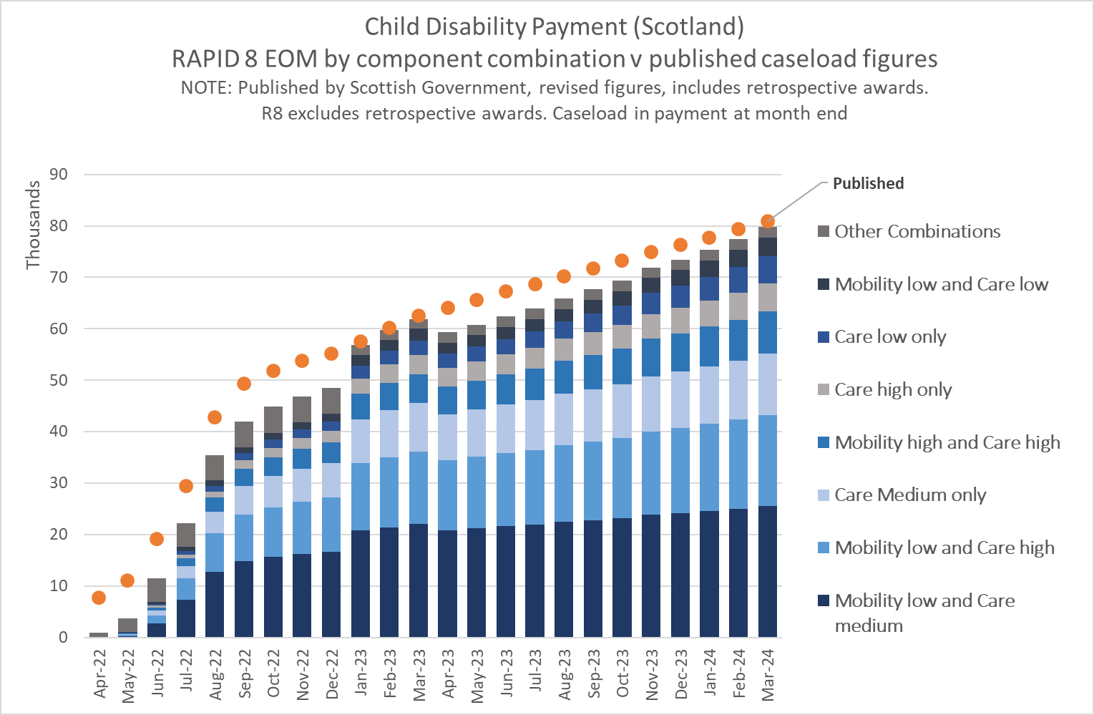
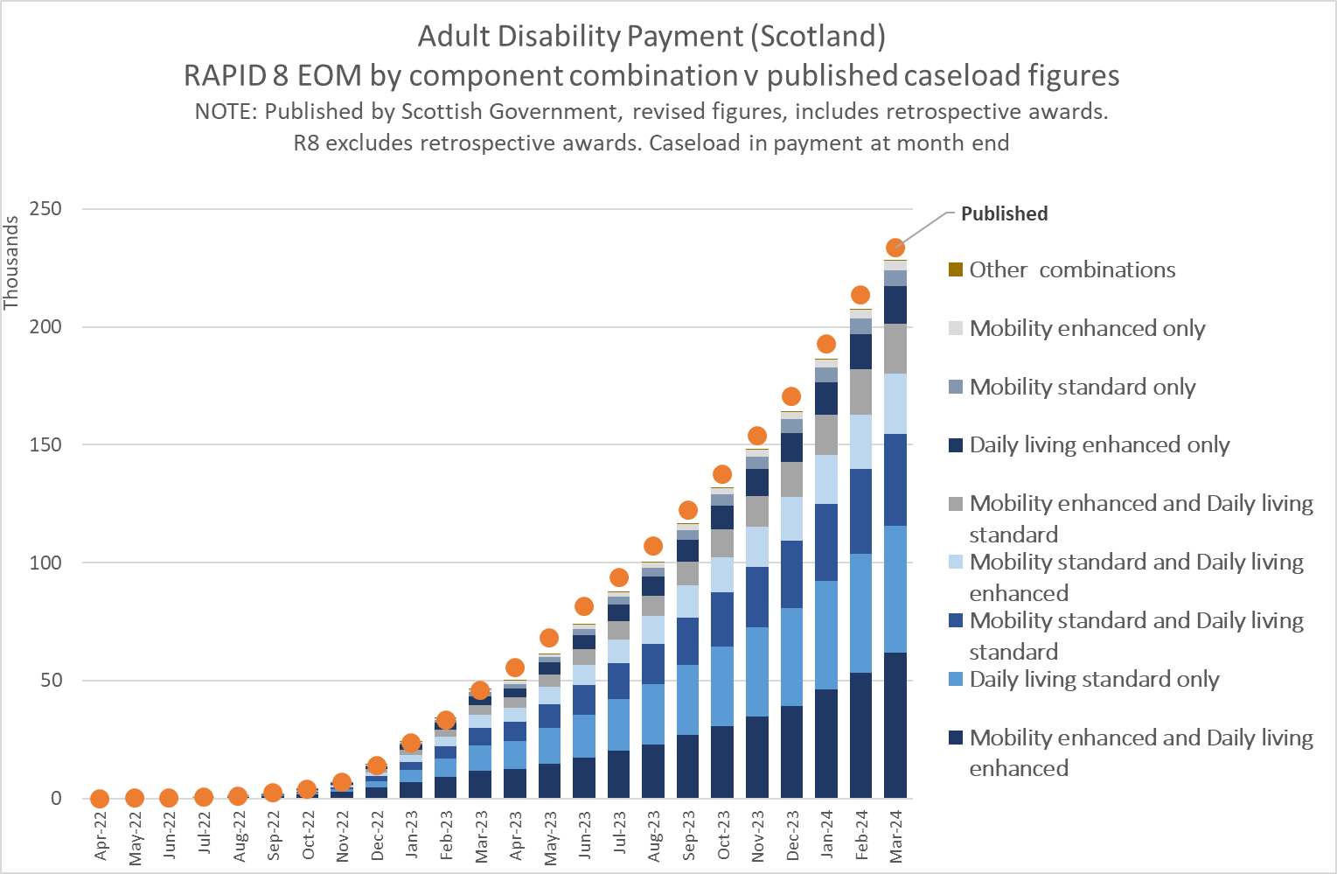

ADP & CDP Cautions and caveats

  - Data relating to ADP and CDP remain the responsibility of Scottish Government.
  - Outputs from RAPID will not match published figures due to award retrospection, particularly during the period where benefit claimants have been migrated from DWP systems.

Self Employment (56NZ Self Assessment extract) processing

Self Employment (SA) – Self Assessment extract (56NZ)

Information | Notes
Data administration | - Data owned and maintained by HMRC and sourced from the Self-Assessment computer system.
Data purpose | - Data collected by HMRC for the purposes of assessing tax liabilities for the self-employed, people with multiple employments where pay is above the higher tax threshold, and for people with investment income that is not captured by the PAYE system.
Completeness | - DWP receive a copy of certain records from the SA database via the 56NZ extract;  - The 56NZ extract excludes investment SA returns, and as such is not a complete measure of self assessed income that is submitted to HMRC;  - The extract is not complete historically and does not provide a complete picture of self employment income for the whole period covered by the RAPID database. Currently, the extract is deficient for tax years prior to 2014/15. The latest tax year in Release 8 is 2023/24, which is also incomplete as the deadline for submitting self assessment returns is not due until January 2025.  - In the RAPID processing people on Tax Credits with some self employment information are analysed to supplement the SA records. So, where there is evidence of self employment on Tax Credits, but there is no SA record present, the Tax Credit data is used to populate the self employment activity and income. This data is only available from 2010/11 onwards.  - From R5 the self employment measure also includes people who do not appear in the SA data, but who have declared self employment income in the UC award, and the UC award is in payment and take account of that element of income.  - R6 identified missing data for the 2016/17 tax year. R8 applies proxy rules to populate self employment activities in 2016/17 for 245,000 records.
Coverage | - In the RAPID processing records without a NINO on the SA extract are dropped. In the SA system NINO is not the primary key (although the majority of records have NINO), hence any records without NINO are dropped as they cannot be linked to the other data within RAPID;  - The SA data may also exclude people who are self employed but who do not self assess for whatever reason. These cases are likely to be biased towards the lower earning self employed. However, these cases are likely to be captured via the Tax Credit and UC processing to add self employment data for those that are not on the SA feed.
Accuracy | - The SA extract is received monthly, and as a consequence it captures any changes that are made to the self assessment records throughout the year. This can create duplicate records, especially if information has been supplied a number of times throughout the year. However, the current extract does not contain any variables that enable the accurate/simple removal of replacement records;  - The RAPID processing makes an attempt at correcting the SA data by removing true duplicates and duplicates across extracts, i.e. where all the details are the same, and uses HMRC protocols to reduce the risk of double counting records.  - The income measures from the SA feed for the self employed are based on the taxable ‘profit’. It is therefore not a complete measure of income if some income has been offset as part of business costs and deductions. As such there are some records with zero or negative money associated with them. Excludes income derived from dividends.  - In Release 8 the self employment measures (both durations and SA income) for 2023/24 are largely missing from the SA feed. Release 8 uses the SA data in 2022/23 as a ‘proxy’ for 2023/24 and rolls forward the duration and income measures. No adjustment is made for inflation and only the SA derived elements are rolled forward – any tax credit or UC elements are captured from the 2023/24 tax credit/UC data correctly without the use proxy data.  Comparisons of proxy values with real values 12 months later suggests this is a reasonable assumption to make in most cases, and while it may not be perfect it helps to improve the resident population and income measures for 2023/24.
Outliers | - No records have been adjusted for outliers.

Self Employment selection criteria, data cleaning & processing

The self employment processing is split in 5 different processes, Self Assessment processing, Tax Credit Processing, Universal Credit processing, SEISS processing and amalgamation and ‘Proxy’ processing.

Self employment identified from Self Assessment:

The Self Assessment data supplied in the 56NZ extract from HMRC has the following record types, referred to as ‘schedule flags’ in HMRC systems. (definitions supplied by Ann White in HMRC KAI):

- SCHEDULE_FLAGS:

  - Schedule_Flag = P (Employment Short Tax Return) Individual should only have one live/current record with flag = P, but could also have record with flag = T;

  - Schedule_Flag = T (Self Employment Short Tax Return) Records with gross profits or losses from a business (self-employment) income. Individual should only have one live/current record with flag = T, but could also have record with flag=P;

  - Schedule_Flag = E (Employment Long tax Return) Individual with > 1 source of employment income in the tax year will have multiple live/current records with flag = E could also have records with flag=M and/or S;

  - Schedule_Flag = M (Ministers of Religion) Individual with > 1 source of income in the tax year will have multiple live/current records with flag = M, could also have records with flag=E and/or S;

  - Schedule_Flag = S (Self Employed Long Tax Return) Individual with > 1 business in the tax year will have multiple live/current records with flag = S, could also have records with flag=M and/or E.

TAX YEAR: In the SA data extract tax year = 2015 = 2014/15 tax year. This is the same as how the data is held in other data from 56NZ. The RAPID processing reformats the tax year to make it consistent with previous processing for this project (and consistent with the L2 extract). Tax year will be reformatted to tax year-1, i.e. 2014 = 2014/15.

Only people with a schedule flag of 'Self Employment' will be captured by RAPID processing. ‘Employment’ schedules are captured via the PAYE feed. Ministers of Religion records (of which there were under 20,000 in 2015/16) could be either self employed or already captured in the employment data - hence to avoid double counting they have been excluded from this Self Employment measure.

This processing attempts to generate activities for people that are self employed and that have submitted information via the self assessment system, and where possible will also collect information on self employment earnings.

The self employment records identified from the SA extract are processed as follows:

- Records with a Schedule Flag of 'S' (Self Employment Long Tax Return) or 'T' (Self Employment Short Tax Return) are selected where tax year is 2013/14 or later;

- Tax year is reformatted to be consistent with other data in RAPID, i.e. tax year-1;

- De-duplication. Exact duplicates within and across extracts are removed. For schedule T records the last record within the tax year is selected;

- Self employment durations are derived based on start and end dates. Where no start or end date is recorded the period is assumed to be 52 weeks;

- DTM and EOM indicators are set;

- Durations from each schedule type, per person, per tax year are totalled. The DTM indicators are used to adjust the duration measures. In previous releases two 26 week periods would generate 52 weeks in aggregate. From R5 the actual dates are used for each spell and the DTM indicators are used to adjust the overall annual measure – so if the two spells ran concurrently for 26 weeks the overall measure would be restrained at 26 weeks, rather than 52 as in previous versions;

- Earned Income (EARNED_INCOME) from each record is totalled per person, per tax year. This is the ‘profit’ from self employment net of business expenses. The amount can be negative if a profit has not been made.

- Durations and monetary amounts will include schedules that have no monetary values recorded. These records could be people below the Lower Profit Threshold or who have no earning after allowances and expenses have been taken in to account. However, the fact that there is a SA record should rightly generate an activity that will count towards the residency measure in RAPID.

- RAPID includes self employed trade classification for cases that are sourced from the self assessment data extract. The ‘SELFEMP_TRADE_CLASS’ variable is derived from the HMRC trade classification that is captured when the SA details are submitted to HMRC. Subsequent changes in trade may not be reflected. A list of HMRC trade Classification decodes can be found in Annex 5.

Correction of Self-Employment data for 2016/17

Analysis using Self Employment data highlighted an issue with the data begin supplied via the 56NZ Self-Assessment data feed. Investigation identified that the SA extract for May 2017 was missing records for 2016/17.

These missing records cannot be resupplied, so a ‘proxy’ rule has been developed to populate records where the information is thought to be missing.

The proxy rule looks for records where there was a self assessment record covering March 2016 (so, current at the end of the 2015/16 tax year), and the person has evidence of self assessment in April 2017 (so, current at the beginning of the 2017/18 tax year), and there is no self assessment record at all in 2016/17.

Where these criteria are met the person is given a proxy self employment activity, i.e. 52 weeks activity and EOM/DTM = 111111111111. The self employed earnings are derived as the average of 2015/16 and 2017/18. This methodology generates an additional 245,000 self employment records.

Self employment identified from Tax Credits:

The self employment records identified from the GMS Tax Credit data extracts are processed as follows:

- The weekly GMS Tax Credit data extracts are interrogated and the extracts spells (and annual earnings) for people who have declared themselves as self employed on the tax credit claim are captured. The tax credit data for self employment is largely (but not exclusively) replicated within each weekly data feed, i.e. the information around self employment is not updated or changed unless there is a new or updated award. In addition, while the start date of self employment is captured (in most cases) there are no end dates. For the purposes of RAPID the last Tax Credit GMS extract within the tax year is used to populate the self employment data. The GMS Tax Credit is not available for 2008/09 or 2009/10, meaning there are no self employment measures for these years.

- The processing and identification of self employment records within the GMS Tax Credit data is done as follows, for both customer and non-customer records:

- Only cases were either WTC or CTC are in payment (amounts greater than zero) are retained. This is because the feed includes cases that are no longer in payment and therefore may not have up to date information;

- Only cases with self employment earnings (annual) populated are captured to be included in the self employment measures;

- Only the extract covering the last week of the tax year will be assessed (rather than each weekly extract). This is to reduce processing but is believed to capture most if not all TC spells as they largely run for the whole year. The last extract of the tax year is chosen as it is most likely to reflect the final position for the year;

- Some extracts don't have all the monetary amounts populated and have data quality issues. Hence the nearest complete extract to the end of the tax year is used. As a consequence, the end date of the spell is populated with the last day of the tax year to ensure that durations are calculated correctly and are not deficient.

- Self employment duration is captured from the self employment start date. Where this is not populated, but where the self employment earnings or self employment indicator are set, a duration of 52 weeks will be populated;

- Self employment (annual) earnings is captured from the Tax Year week being processed;

Self employment identified from Universal Credit

In some records a new award may start in the month and the existing award is also still on the extract with no end date. This looks like both awards are current at the same time and so a duration for each is generated, and when summed they generate a duration that is longer than the month in question.

From R5 only one record is kept. In the event that there is more than one record in the month, the data is sorted by NINO tax year and the number of weeks for each spell. The spell with the largest number of weeks in the extract is retained to avoid double counting. If there is only 1 record for the NINO in the extract it will still be kept.

Self employed cases identified from the monthly UC extract are identified as follows:

- Collects the linking keys and NINO from the UCFS Claimant Master file;

- Renames NINO to CCNINO and only selects the latest record for each NINO;

- Collects self employed records from the UCFS Claimant_ap_se_master file where:
(a) Self employment flag is 'true' and;
(b) UC has been awarded.

- Merges the claimant master and claimant_ap_se_master together by claimant key to put CCNINO against each record;

- Sets duration within each AP_Date/Extract and collects self employment earnings that have been declared from that period;

- Generates EOM and DTM indicators;

Self employment amalgamation processing

The final section of self employment processing is to bring together all the data from the 3 sources together.

The income and duration estimates will only look at one source for the combined variables (SELFEMP_TOT_AMT and SELFEMP_TOT_WKS). In reality people may have income in SA and another source but if they appear in the SA data only that element of income / duration will be carried forward to SELFEMP_TOT_AMT and SELFEMP_TOT_WKS.

While each element of the self employment measures are available separately in the final data, combined SELFEMP_TOT_AMT and SELFEMP_TOT_WKS are derived. These variables use all 3 sources and are populated using the following hierarchy:

- Where there are monetary amounts on the SA data, both duration and money will be sourced from the SA data, else;

- Where there are monetary amounts on the TC data and nothing on the SA data, both duration and money will be sourced from the TC data, else;

- Where there are monetary amounts (or weeks durations) on UC and nothing in SA or TC both the duration and money will be sourced from the UC data, else;

- Sets a variable to show whether data has come from SA, TC or UC.

The final stage of the processing is to generate a proxy year to populate self employment records the most recent tax year in the data (2023/24).

In Release 8 the self employment measures (both durations and SA income) for 2023/24 are largely missing from the SA feed because the data for 2023/24 is not scheduled to be submitted to HMRC until January 2025.

Release 8 uses the SA data in 2022/23 as a ‘proxy’ for 2023/24 and rolls forward the duration and income measures, i.e. the SA measures for 2023/24 are identical to those in 2022/23. The ‘SELFEMP_SOURCE’ variable is set to ‘PY’ (Proxy Year) for these cases.

No adjustment is made for inflation and only the SA derived elements are rolled forward. The proxy is only applied where there is SA data in the 2022/23 tax year. Anyone who is classed as self employed in 2022/23 via the Tax Credit or UC records route will not have the proxy applied, as these real elements are already available for the 2023/24 tax year.
Comparisons of proxy values with real values 12 months later suggests this is a reasonable assumption to make in most cases, and while it may not be perfect it helps to improve the resident population and income measures for 2023/24.

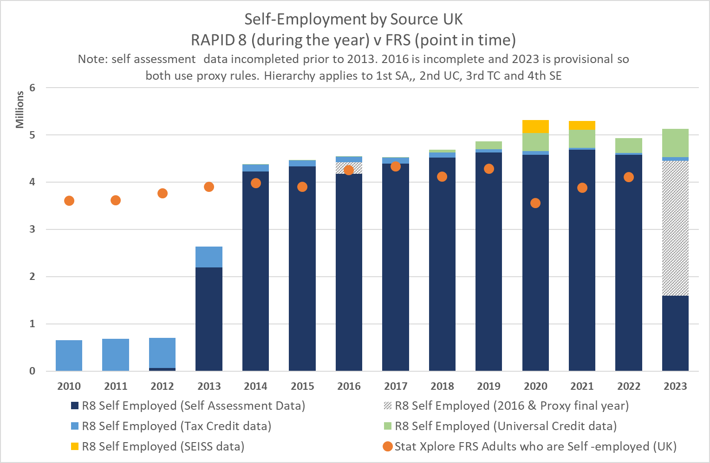

Self Employment cautions & caveats

- SA data is only completed for tax years 2013/14 onwards. It may be possible to analyse earlier years if a new extract is secured by D&A. Data for 2013/14 is incomplete, data for 2014/15 through to 2022/23 is thought to be more robust, but may be subject to change as late self assessment returns are processed;

- For the very latest tax year on the data the data will not be complete until the self assessment deadline of 30 January (in the following tax year) has passed and all SA records have been processed and entered onto HMRC systems. Therefore, the data for 2023/24 will not be complete until March 2025 at the earliest.

- Between 2010/11 and 2013/14 the self employment income is only sourced from tax credit data - hence it is not a complete measure of those who are self employed due to the lack of historic SA data.
The self employment records that are identified via the Tax Credit data also excludes any people who have now migrated to Universal Credit and as such, people who are self employed and on UC are only identified from 2013 onwards.

- The ‘proxy’ methodology used in the latest year does not capture all the self employed. It excludes those people who are newly self employed in the latest year and those that didn’t self-assess in the penultimate tax year.

- Self Employment income in RAPID is defined as ‘Profit’ after all business expenses and may be defined differently to other sources of data on ‘earnings’. Excludes earnings paid as dividends.

Coronavirus Job Retention Scheme (CJRS) & Self-Employment Income Support Scheme (SEISS)

CJRS & SEISS data

Information | Notes
Data administration | - CJRS & SEISS data owned and maintained by HMRC.
Data purpose | - CJRS scheme put in place in March 2020 to protect employees from the impacts of the Coronavirus Pandemic;  - CJRS scheme finished on 30 September 2021;  - SEISS Scheme introduced in May 2020 to protect the Self Employed during the pandemic;  - SEISS finished on 30 September 2021.
Completeness | - The CJRS data covers all people that were part of the furlough scheme;  - The SEISS grant data is provided for all those people who were eligible and applied for the SEISS scheme. The scheme ran over 5 tranches (load periods).  - RAPID R8 uses all available data on the SEISS grant;  - Not all the self employed were eligible for the scheme, and not all the self employed needed the help of the scheme, therefore the SEISS data is not a full measure of the self employed.
Coverage | - CJRS data captures all people who were part of the scheme in the United Kingdom;  - SEISS data captures all the self employed people who were eligible and applied for the SEISS scheme in the United Kingdom. People may be part of just 1 grant period or all 5. No all the self employed were eligible for the scheme, depending on how long they had been self employed and how much interaction with the Self Assessment Scheme they’d had in the past.  - R8 data is taken directly from R7 as there is no change in the data.
Accuracy | - In the raw data we found that many individuals had short gaps between their spells (such as weekends or single weeks off of furlough). This may be because the person actually worked during this period or was not contracted to work. In the processing of this data we have not amalgamated spells that have a gap and have only counted the days of actual furlough;  - A small number of records (approx. 0.15%) appear more than once in a single SEISS grant period. The data does not indicate whether these additional records are replacements for existing records or supplementary records. In the RAPID processing all records are totalled.
Outliers | - No adjustment is made for outliers in RAPID.

All data in R8 is taken directly from R7, unchanged.

There are EOM and DTM variables for both CJRS and SEISS. In addition, the total SEISS loan amount paid during 2020/21 is also included.

CJRS processing

The CJRS durations and EOM and DTM indicators are generated from the CJRS data that is supplied by HMRC. The CJRS data holds the spell of each furlough period within each employment. These have been used to generate measures of the overall duration on furlough, as well as the EOM and DTM indicators. The DTM indicators have been used to cap some durations, for example where someone was furloughed in 2 employments at the same time. All CJRS payments are paid via the PAYE system as part of weekly/monthly earnings, so CJRS earnings are already part of the RAPID data.

In the raw data we found that many individuals had short gaps between their spells (such as weekends or single weeks not furloughed). This may be because the person actually worked during this period or was not contracted to work.
In the processing of this data we have not amalgamated spells that have a gap and have only counted the days of actual furlough.

The CJRS indicators will help analysts understand the type of people who were part of the furlough scheme, what impact it had on their earnings (and explain drops in income), and assess how many people moved from furlough into unemployment.

The data is processed as follows:

  - All CJRS data extracts are used up to the end of the scheme in September 2021. These extracts are appended and hold all the spells of furlough from the beginning of the scheme in March 2020;
  - The spells are de-duplicated to remove true duplicates (records that are completely identical). De-duplication uses NINO, employer reference number, PAYE reference number, furlough start and end dates;
  - Processes the CJRS spells by tax year and selects awards that are current in the tax year;
  - Generates the number of days covered by the spell in the year and converts it to a number of weeks;
  - Sets variables for end of month (EOM) and during the month (DTM);
  - As a person could be furloughed in more than 1 job at any one time, the duration is capped at the DTM Maximum, i.e. the start and end dates of each spell are analysed and if the overall duration is more than the maximum number of weeks populated in the DTM indicator the duration is reduced. An indicator is set to say the duration has been capped.
  - Retains the annual total of all spell durations and the EOM & DTM indicators

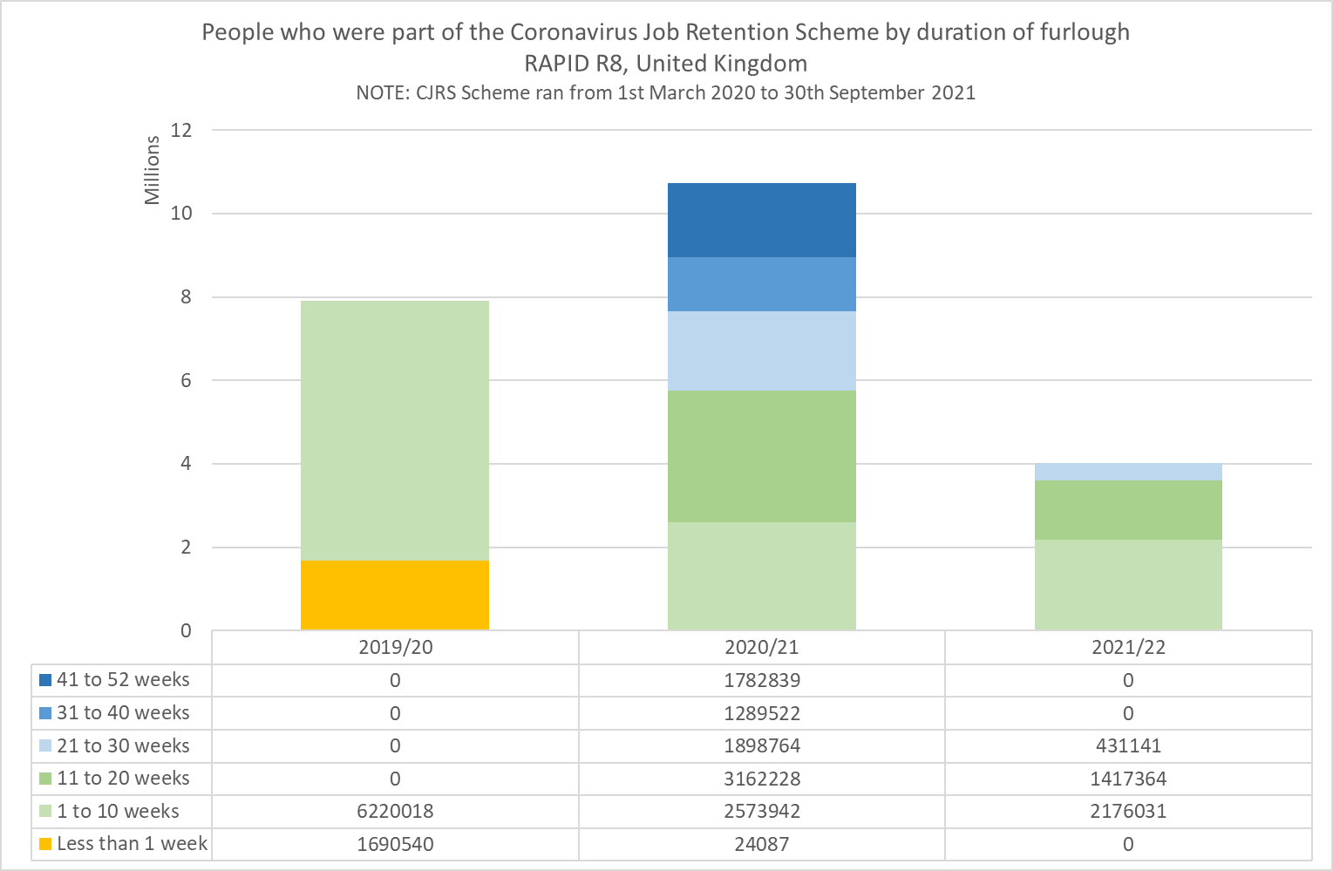

SEISS processing

The SEISS data is generated from the data HMRC has supplied on all tranches of SEISS grant that were payable during the 2020/21 and 2021/22 tax years. The SEISS data is used to generate EOM and DTM indicators and these show the duration of each grant period.

The total SEISS amount is also captured as a new variable. This is the total SEISS amount that has been paid to enable business to survive during the pandemic.

The SEISS amount has not been used in the derivation of the ‘Proxy’ measures for the self employed for the 2021/22 tax year. This is because the SEISS amount is generated on a different basis to the Self Assessment. The grant amount is paid on the basis that it will help businesses survive, whereas the SA amounts (used in the RAPID income measures) is based on ‘profit’ net of any business expenses.

In theory, all those people who were part of the SEISS scheme will also self assess for the 2020/21 and 2021/22 tax years, so will form part of the usual data update for the next release of RAPID.

The data is processed as follows:

- Start date and end date of the period covered under each tranche of the scheme;
- The total amount of SEISS grant paid from each tranche is totalled. Some people appear to have more than 1 grant in a single tranche period. HMRC have informed us these may be additional supplementary payments, and such none of the records have been removed in the RAPID processing;
- Set current at End Of Month (EOM) and During the Month (DTM) indicators
- Aggregate all data to provide an annual view.
- Constrains the total duration to the DTM max. Where there are multiple payments within a single tranche this could artificially inflate the duration. The maximum number of weeks is calculated using the start and end dates of the payment and the DTM indicators and where the duration is higher than the maximum possible the duration is capped.
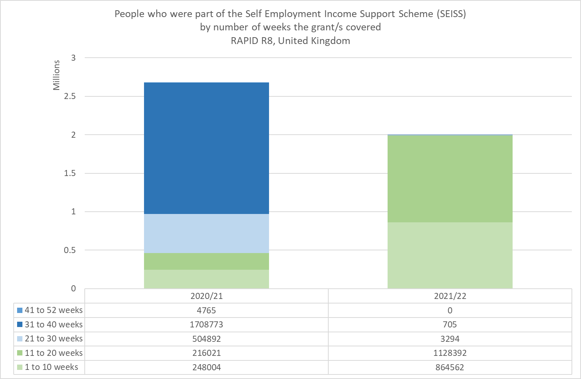

Geo-coding

Geo-coding using the Customer Information System (CIS)

Information | Notes
Data administration | - Address data is owned and maintained by DWP and sourced from the Customer Information System (CIS);
Data purpose | - The CIS data is the main customer contact system that maintains the most up to date and accurate information about a persons, name, address and dates of birth and death;  - CIS is the main system that DWP uses for contacting customers about benefit entitlements and claims;  - Information about changes in circumstances and address are captured by various methods;  - From updates to legacy benefit, UC & PIP systems that update CIS and then broadcast to all other systems;  - Individual’s corresponding with DWP;  - Some updates from HMRC systems (but not all);
Completeness | - The data on name and address are captured for everyone with a NINO. However, the data may not be up to date for some records, particularly if the person has no interaction with DWP for some time;  - Name and address details are verified and updated when the person has contact with DWP (and/or HMRC in some circumstances). Contact could be through a claim to benefit, pension forecast, payment of National Insurance (NI), registration for NI, being part of a household who claims benefit, change of name though marriage etc, interactions with the Government Gateway services.  - Records that are less likely to be up to date are:  - People who work and have no recent benefit, tax credit or child benefit activities;  - Students who do not necessarily change their address during term time;  - People who have left the country. There is no mechanism or requirement to notify DWP or HMRC when someone leaves the UK. Hence there are a large number of ‘open’ non-terminated address spells for people who left the UK some time ago;  - In RAPID some records may have no address data because they registered for NI purposes after the final year being processed in RAPID, but where they report that they arrived during the period covered by RAPID. Essentially they will only have an address from the period when they registered. These people are kept resident within RAPID by a residency rule, but will have no geo-coding for that period;
Coverage | - Most cases on CIS will have some address data, how up to date it is dependent upon the criteria highlighted above;  - Addresses may be ‘abroad’, where someone has notified that they are residing abroad – for payment of pension abroad for example;  - Addresses with a UK postcode are then linked with AddressBase to have Census Output Area reference codes allocated to them. Only the COA is made available to analysts. These COA’s are then brought through to RAPID to generate an address measure at the beginning and end of the tax year being processed;
Accuracy | - Dependent upon the type of record and time since the last interaction with DWP/HMRC
Outliers | - No adjustment is made for outliers in RAPID.

Geo-Coding processing

R8 now includes COA 2021 variables, in addition to COA 2011 and COA 2001.

  - Three measures of geocoding are created based on the full address:

1. First address in the tax year (e.g. FIRST_COA2011)
2. Last address in the tax year (e.g. LAST_COA2011)
3. Address with the longest duration in the tax year (e.g. LONGEST_COA2011)

  - All addresses are collected from the CIS address history file, and the following actions are applied:

- Merges CIS address histories with the cases that are in RAPID, based on NINO. Reduces the number of records and only keeps the address records for the cases that are part of RAPID.
- Selects variables needed in RAPID
- Renames variables
- Formats the address data into tax years. Only selects the last occurrence of each address in the tax year (ensures only 1 version of each address per tax year is kept).
- Based on the start and end dates of the address the first, last and longest address in the year are captured.
- The 2001, 2011 and 2021 COA's associated with these addresses are retained. These COA's can then be linked to geocoded lookup tables to identify geographies down to Census Output Area.

  - ONS are still deciding what level of geography will be available in the Secure Research Service. Whatever level of geography is chosen the data will be based on the COA information recorded in RAPID and on the CIS.

Data linking to create a tax year based file

This section documents how the activities and income measures derived from each of the extracts are linked together to generate an annual overview of the activities citizens undertake each year, and how a residency measure is derived;

The CIS records included in the RAPID dataset may or may not have activities in the years being looked at, either because they are performing activities that are not covered in this process, or because they have left the country.

To enable all the ‘live’ records to be included for each tax year being processed ‘dummy’ years are created. For example, someone with observable activities in 2011 and 2013, but no activities in 2012 would have a dummy year created for the 2012 tax year. This ensures that all the records are present for every year. Dummy years are only created where necessary up to and including the year of death;

The summary activities created from all the extract processing, including the dummy years, are then linked to the merged Customer Information System (CIS)/ Migrant Worker Scan (MWS) file by tax year and NINO. This presents a tax year based dataset that has all the CIS and Migrant Worker Scan data on the same row as all the activities that have been undertaken in the year.
The resulting merged data creates 1 row per person per tax year, with columns for each activity and income variable. In RAPID each tax year dataset is held separately.

Each tax year based dataset has significant over-coverage in terms of the number of ‘live’ records when compared to population estimates. This is because once a NINO is issued it is never removed from the CIS system. This is because while the person is active they may have accrued benefit or pension entitlement through employment or National Insurance contributions, and that entitlement (particularly Pension entitlement) has to be retained for the duration of the working life. People may emigrate from the UK but have accrued pension rights from activities whilst here and these records remain on the system.

Similarly, if someone returns to the UK they may start using their NINO again, rather than being issued with a new number. Hence a residency measure is needed for analyses purposes to exclude records that are thought to be no longer resident in the UK;

Residency

Residency methodology

The residency methodology in RAPID is fairly simplistic and is based on a number of activity based rules. Analysts may choose to deviate from this measure of residency and create stricter/less strict versions depending on their requirements.

Residency is derived as follows:

  - RESIDENT = ‘Yes’ if:

    - There is at least 1 week of activity, in any of the activity measures, and;

    - If one of the 3 GEO_FLAG measures is UK (i.e. at least one of the geo-flags is UK in the year, indicating that the person has been resident at some point), and;

    - FROZEN RATE indicators for State Pension, Bereavement Benefit or Widows Benefit are set to ‘No’, showing that the benefit is paid not abroad in a frozen rate country (where the benefit rate uprating is not applied), or;

    - If the person is a migrant who has registered after the last tax year being processed in RAPID, but their date of arrival is within the period covered by RAPID these cases are classified as resident via a rule. (Note, these people may not have any address data for this period), or;

    - Similarly, all migrants will be kept resident between arrival and registration (and may have no address data for this period);

  - Anyone who does not meet the above criteria will have RESIDENT=’No’ in the tax year.

Residency cautions & caveats

- The residency methodology in RAPID counts people with no activities as non-resident, and this can impact certain types of record, and hence the population estimates generated from RAPID. Currently the types of people we would class as non-resident include:

- People in full time education who do not work or claim benefits;

- People who are part of a household that are not part of a HB, Tax Credit or benefit award and where the person does not work – this might include people who provide ‘care’ on an unpaid basis, people who are out of work and do not claim benefit. Comparisons with census suggest that these records are likely to be women;

- People who have not yet registered for National Insurance purposes, and are therefore not yet on the data.

- The lack of complete self-employment data also has an impact on the residency measure between 2008 and 2013. As people who are only self-employed will potentially miss being picked up due to the lack of self-employment data. The population of ‘proxy’ self-employment data for the latest year largely corrects the residency measures, but as a proxy measure residency cannot be guaranteed and should be regarded as provisional.

- People who are employed between 2010/11 and the introduction of RTI in 2012 may appear as non-resident if their employment had not generated any tax or National Insurance liability over the whole year. Pre-RTI employers did not need to submit PAYE records for employees who did not pay tax or National Insurance. These people are more likely to have worked for small or medium sized employers who did not submit electronic payroll submissions to HMRC. People working for medium or large employers who submitted PAYE data electronically are more likely to be included in the data.

- RAPID will enable the derivation of different residency rules that would keep certain people resident regardless of whether there is an activity or not. For example if a child is on Child Benefit at age 16 but is then ‘inactive’ at age 17, it is likely that the person has just stopped getting CHB rather than leaving the country. A derived residency rule might keep this record ‘resident’ for a number of years afterwards.

- People arriving from Non-EU countries have no access to income related benefits (including Tax Credits and Child Benefit) for the first 5 years or until they have acquired indefinite leave to remain. From January 2021 this will also apply to newly arriving migrants from the EU. This may have an impact on certain peoples ‘footprint’ on which residency is derived within RAPID. As a consequence some migrants with a NINO may be resident but not have any identifiable activity, and will therefore be classed as ‘not resident’.

The initial figures from the residency measures applied in RAPID look encouraging, especially if you consider the issues highlighted above.





Records likely to be missed from the resident population

The following types of case may not be classed as resident in the RAPID data.

Category / Person type | People RAPID may not class as resident
Students | Some students may not be classed as resident if they do not interact with anything observable within RAPID. This will include people who finish full time education and who continue to reside with parents and who are not in employment, education or training (NEETS) and who are not eligible for benefits in their own right.
Spouses of migrants | Some spouses of migrants may not yet have registered for NI purposes, either because they have not interacted with anything that requires a NINO, or because their culture means that they are not expected to interact with any financial aspects of life.
Migrant pensioners getting pension paid from home state | If person is resident in the UK and not registered for NI or benefit purposes they will not be on the DWP or HMRC extract.
Prisoners | Prisoners may appear in the RAPID data but depending on how long they have been in prison will determine whether they are classed as resident in the year. People who are in prison for 12 months or more may have no activities to verify residency
Self-employed post State Pension Age | May not be classed as resident if they have not claimed State Pension, but as long as they self assess for tax purposes they will be classed as resident. Some self employed may not claim State Pension to avoid higher tax rates.
Wealthy not on state pension | May be on RAPID, but not classed as resident in the year if there is no income generating activity and state pension not claimed.  RAPID will not count people as resident if their only activity and income is derived from investment income, as this is not included in the self assessment data extract.
Spouses living on partners income | These records may be on RAPID, but not classed as resident in the year if there is no income generating activity and state pension has not been claimed in own right.
Asylum Seekers | Not included in RAPID until asylum granted, NINO allocated and benefits or employment interaction
Migrants with no recourse to public funds | These records may be in RAPID if they have been issued a NINO either for employment purposes or via the visa application process. People arriving from Non-EU countries have no access to income related benefits (including Tax Credits and Child Benefit) for the first 5 years or until they have acquired indefinite leave to remain. From January 2021 this will also apply to newly arriving migrants from the EU. This may have an impact on certain people’s ‘footprint’ on which residency is derived within RAPID.
People who only have investment activities | The Self-Assessment extract that DWP currently receive from HMRC does not accurately show or include people whose only income is derived from investments. As such people who gain their income from investments AND who do not declare that income as self-employment income may appear to be non-resident (if that was their only activity in the year). This might include people who derive income from property letting or stocks/shares if they do not declare that income as self-employment.
Some people in secure or sensitive employments | Some people working in secure and/or sensitive employments may not have an employment record in the RAPID data. These are not supplied to DWP or HMRC analysts for security reasons.

In this dataset a person is assumed to be ‘resident’ if they have any observable activity at some point during the year. Release 8 also use residential address data in the methodology.

