Azure Databricks workshop – TO Dos

# Validate access to Azure

Ensure you can access your Azure pass, and connect to the Azure subscription provided to you for the workshop. Note: There is just enough credit to do the workshop.

# Use the storage account already created previously

Resource group: <your-rg>  
Name: <your-sa-name>

# Create storage containers in the storage account

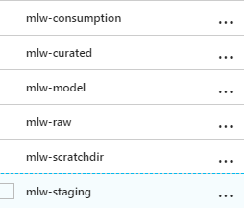

# Download the workshop data to your machine

<https://flightdelayprediction.blob.core.windows.net/workshop-data/WorkshopData.zip>

Unzip the downloaded datasets

1. Install Azure storage explorer in your machine

<https://azure.microsoft.com/en-us/features/storage-explorer/>

Connect to the Azure subscription and navigate to the storage account container, mlw-staging

# Upload the workshop data to the storage container mlw-staging

Using storage explorer, copy the 4 directories to the storage container.

Should look like this..  
