The reference of build process

<https://wenku.baidu.com/view/eada0db33186bceb19e8bb80.html>

1. The following is the actual process I set up

1). configuration java environment

reference:

main ：<http://blog.csdn.net/xb12369/article/details/40788491>

<http://blog.csdn.net/lyl_lyf/article/details/48767143> secondary

（1.1） Check your system is 32-bit or 64-bit

you can use the command "getconf LONG_BIT" to view,

If the result returned 32, then it is 32-bit. if the result returned 64 then it is 64-bit.

In addition you can use the command "uname-a" to view,

in The output of result, if there is a x86_64 then it is 64-bit, no is 32-bit.

1.2) On the basis of 1 download JDK

<http://www.oracle.com/technetwork/java/javasebusiness/downloads/java-archive-downloads-javase6-419409.html>

1.3）install JDK

A. Create a new folder of java under user: #mkdir /usr/java

b. # chmod 777 jdk-6u45-linux-x64.bin

c. # ./jdk-6u45-linux-x64.bin

1.4) Configure environment variables

a. # vi /etc/profile

b. add the following lines at the end：

export JAVA_HOME=/usr/java/jdk1.6.0_45

export JAVA_BIN=/usr/java/jdk1.6.0_45/bin

export PATH=$PATH:$JAVA_HOME/bin

export CLASSPATH=.:$JAVA_HOME/lib/dt.jar:$JAVA_HOME/lib/tools.jar

export JAVA_HOME JAVA_BIN PATH CLASSPATH

d. Press Esc first, enter the control mode, then#:wq （ Save and exit ）

e. #. /etc/profile Make configuration file effective (restart)

f. #java -version The version information appear means successful

2.) install maven

reference:

<http://www.linuxidc.com/Linux/2013-05/84489.htm> mainly

<https://www.cnblogs.com/clicli/p/5866390.html> secondly

2.1) download zip

apache-maven-3.0.5-bin.zip

<http://maven.apache.org/download.cgi>

* 1. Unzip

Right-click to select extract to / user

* 1. reference

a. execute # vi /etc/profile

b. add the following lines at the end

export MAVEN_HOME=/home/homer/Apache-maven/apache-maven-3.0.5 //you own menu export PATH=${MAVEN_HOME}/bin:${PATH}

c. Press Esc first, enter the control mode，then #:wq （save and exit）

d. #source /etc/profile OR #. /etc/profile

Let the configuration take effect (restart)

* 1. verification

Enter the command: mvn -v

The output version information indicates that the installation was successful.

* 1. Error handling

IF OUTPUT IS Picked up _JAVA_OPTIONS: -Dawt.useSystemAAFontSettings=gasp

<http://blog.csdn.net/qq_23191031/article/details/51049684>

IF OUTPUT IS Exception in thread "main" java.lang.UnsupportedClassVersionError: org/apac he/maven/cli/MavenCli : Unsupported major.minor version 51.0

<https://jingyan.baidu.com/article/75ab0bcbce5c27d6864db2ef.html>

OR

<https://zhidao.baidu.com/question/262059006101736125.html>

1. install Miniment

<http://mininet.org/download/#option-1-mininet-vm-installation-easy-recommended>

1. install Controller, openflowplugin and openflowjava

<https://www.cnblogs.com/liwei33/p/5940366.html>

Originally, our system JDK is 1.6, maven is 3.0.5 。It cannot meet the requirements of OpenDaylight, so in order to successfully install OpenDaylight, we choose to build programming environment from 0.

Result:

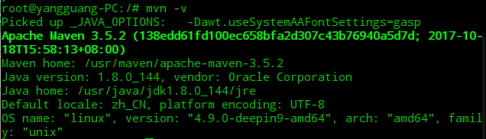

Jdk：1.8.0_144

Maven: 3.5.2

Linux：4.9.0-deepin9-amd64