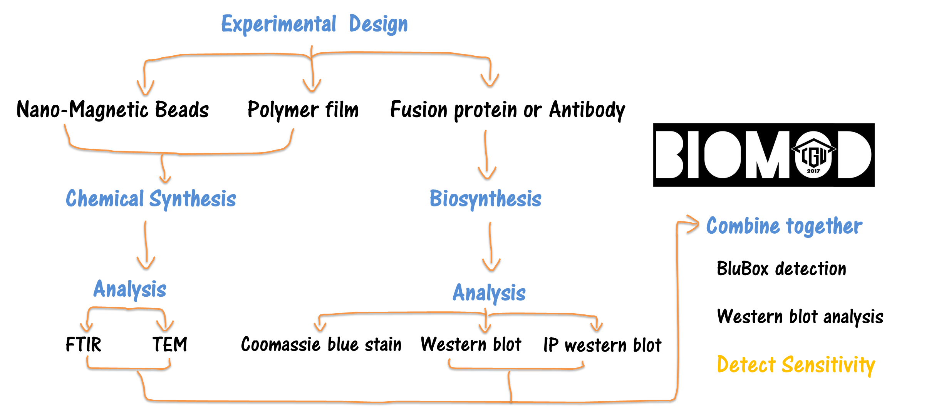

流程圖 在project或 first page

系統圖 在design page

Home page

We are the CGUnion team, a group of undergraduates from Taiwan Chang Gung University attending to the annual biomolecular design competition, BIOMOD.

The link you see above is a 3 minute video explaining our project which we spare no effort over the last three and half months in different labs. We aimed to establish a platform by detection of platelet integrin $α$ IIb $β$ 3 as a model, and further expanded for exosome containing cancer markers detection.

* Nano-Magnetic Beads synthesis
* Antibodies or recombinant proteins conjugated on Nano-Magnetic Beads
* Sensitivity comparison between BluBox and western blot analysis

For detail explanation about our project, please click the links below. Enjoy your visit and don’t hesitate to contact us and leave us your questions and comments.