Sponsors:

 Bluesense diagnostics

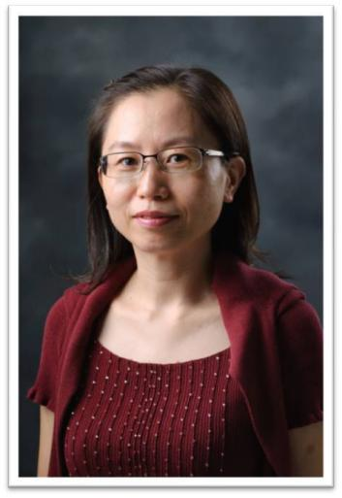Ph.D. Professor Li-Man Hung

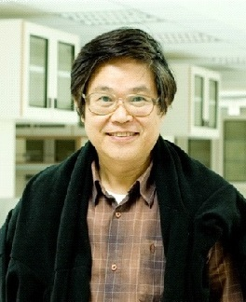Ph.D. Professor Sze-Cheng John Lo

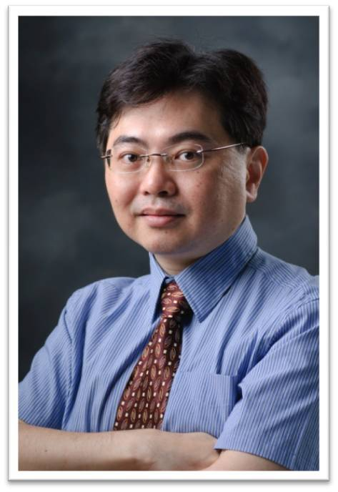Ph.D. Assistant Professor Sheng-Chieh Hsu

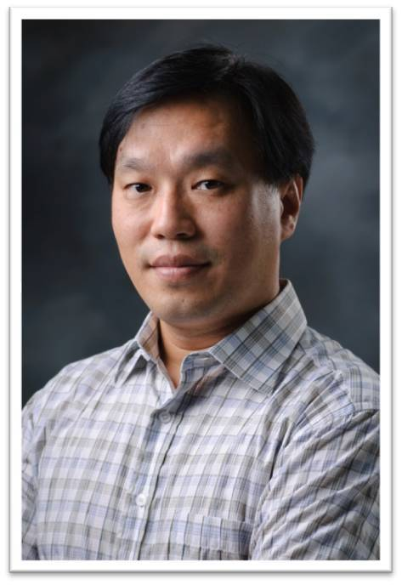Ph.D. Associate Professor Robert Y.-L. Wang

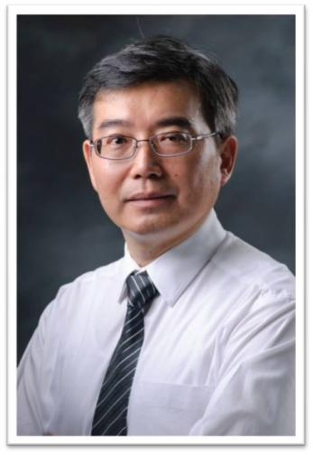Ph.D. Assistant Professor Yaa-Jyuhu Meir

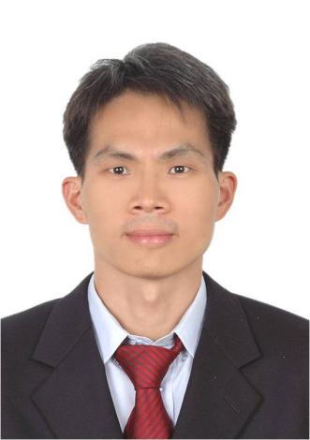Ph.D. Assistant Professor Ming-Chih Lai

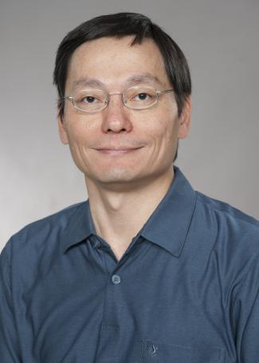Ph.D. Professor Chao-Lan Yu

 Department of Biomedical Sciences

Professor Mu-Yi Hua

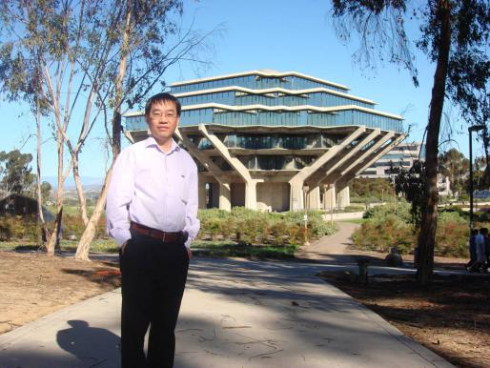Professor Ching-Ping Tseng