#!/usr/bin/env python3

import sys
# import this

if sys.version_info.major == 2:
print("You are running Python 2, which is no longer supported. Please update to Python 3.")

ords = [81, 64, 75, 66, 70, 93, 73, 72, 1, 92, 109, 2, 84, 109, 66, 75, 70, 90, 2, 92, 79]

print("Here is your flag:")
print("".join(chr(o ^ 0x32) for o in ords))

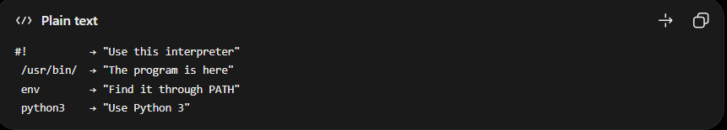
sys gives you access to information about the Python interpreter and the system.
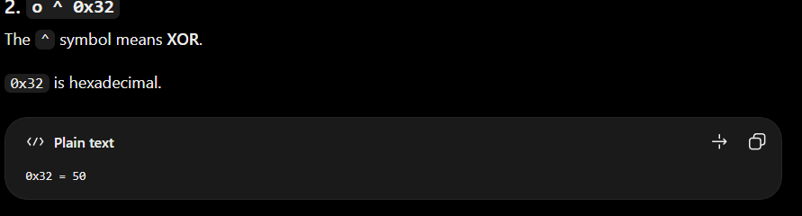
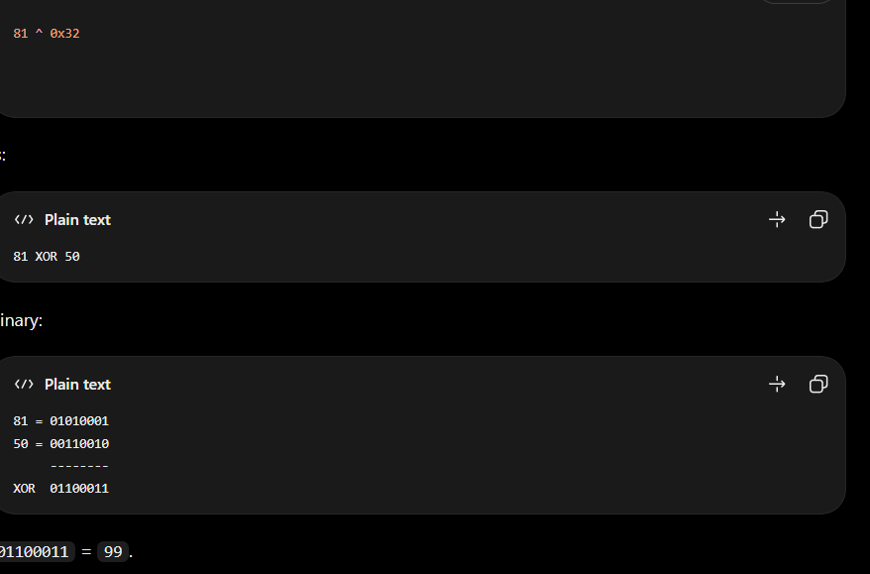
After performing the XOR now we need to convert to the char/ASCII of the Xor value
Let suppose if the xor is 99 then the char value will be ‘ c’
“” this is used for keeping no space between them
. is the way Python lets you access methods/attributes of an object.
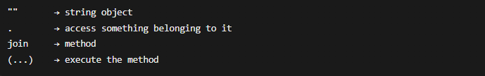
if sys.version_info.major == 2:
print("You are running Python 2, which is no longer supported. Please update to Python 3.")
this check whether the system version of the python is 2 or not if yes then it will not run on it will say “ You are running Python 2, which is no longer supported. Please update to Python 3”
Flag : crypto{z3n_0f_pyth0n}

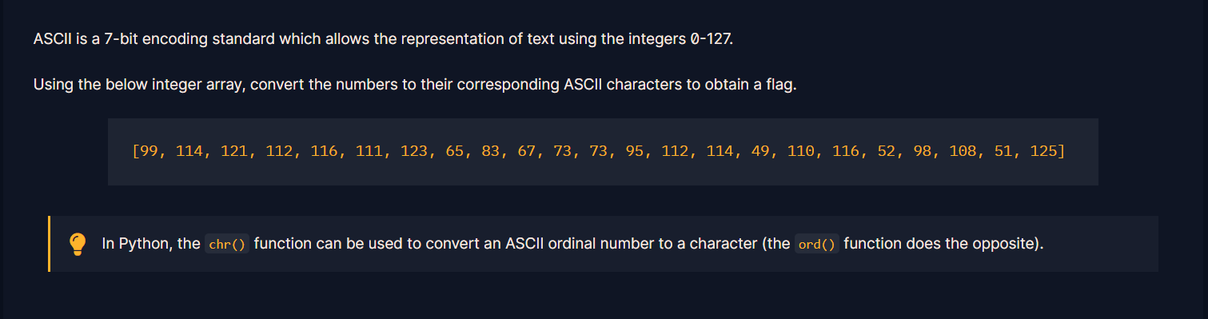
this is the .py for this challenge
#!/usr/bin/env python3
ords = [99, 114, 121, 112, 116, 111, 123, 65, 83, 67, 73, 73, 95, 112, 114, 49, 110, 116, 52, 98, 108, 51, 125]
print("flag:")
print("".join(chr(o) for o in ords))
Flag: crypto{ASCII_pr1nt4bl3}
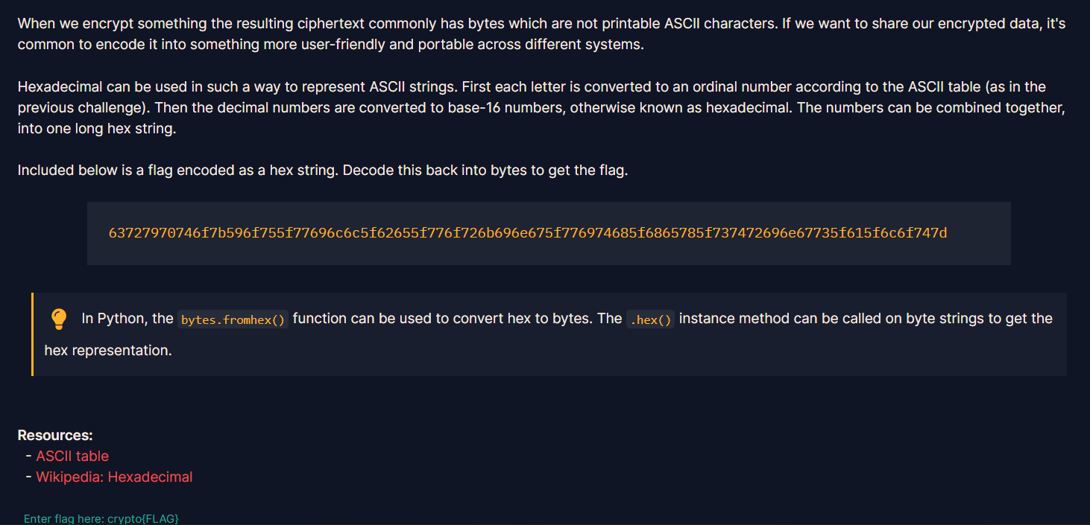
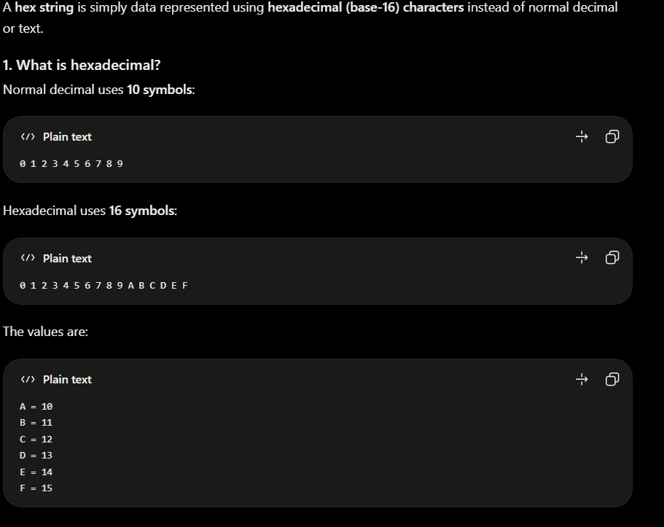
Character | Decimal | Hex
A | 65 | 41
B | 66 | 42
C | 67 | 43
D | 68 | 44
E | 69 | 45
F | 70 | 46
G | 71 | 47
H | 72 | 48
I | 73 | 49
J | 74 | 4A
K | 75 | 4B
L | 76 | 4C
M | 77 | 4D
N | 78 | 4E
O | 79 | 4F
P | 80 | 50
Q | 81 | 51
R | 82 | 52
S | 83 | 53
T | 84 | 54
U | 85 | 55
V | 86 | 56
W | 87 | 57
X | 88 | 58
Y | 89 | 59
Z | 90 | 5A

Character | Decimal | Hex
a | 97 | 61
b | 98 | 62
c | 99 | 63
d | 100 | 64
e | 101 | 65
f | 102 | 66
g | 103 | 67
h | 104 | 68
i | 105 | 69
j | 106 | 6A
k | 107 | 6B
l | 108 | 6C
m | 109 | 6D
n | 110 | 6E
o | 111 | 6F
p | 112 | 70
q | 113 | 71
r | 114 | 72
s | 115 | 73
t | 116 | 74
u | 117 | 75
v | 118 | 76
w | 119 | 77
x | 120 | 78
y | 121 | 79
z | 122 | 7A

hex_string = "63727970746f7b596f755f77696c6c5f62655f776f726b696e675f776974685f6865785f737472696e67735f615f6c6f747d"
data = bytes.fromhex(hex_string)
print(data)
bytes.fromhex : this function is used to convert hexadecimal string and convert it into bytes
text.encode().hex() : this is used for the converting the plaintext into hexstrings
Flag: crypto{You_will_be_working_with_hex_strings_a_lot}

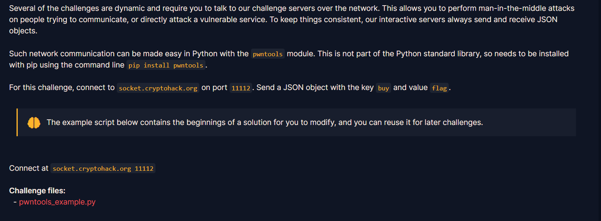

This is the given py file
“ 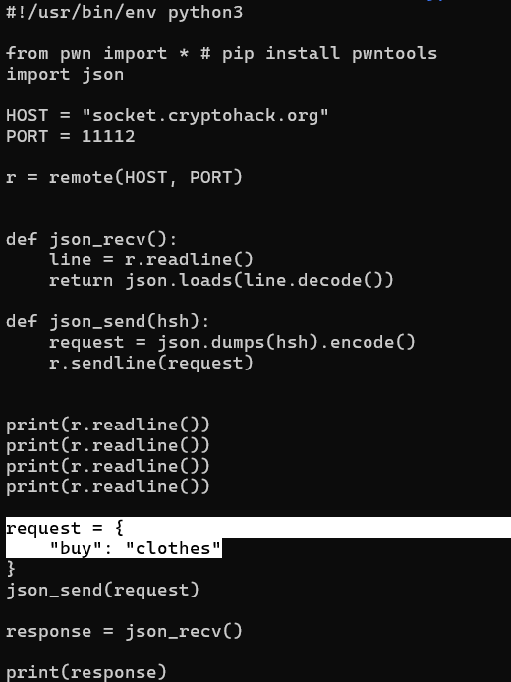
This is given in the question “Send a JSON object with the key buy and value flag”
So the value of the buy will be replaced by clothesflag
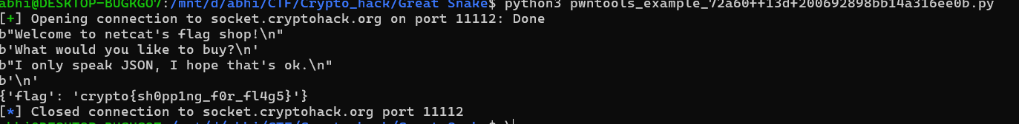
Flag: crypto{sh0pp1ng_f0r_fl4g5}

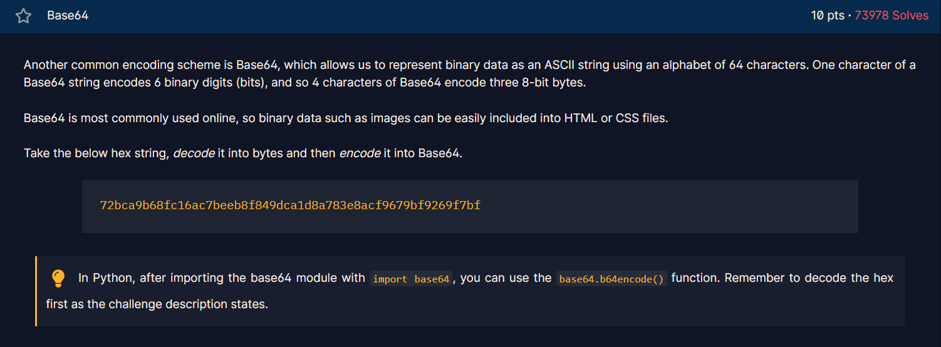
Base64 is a binary-to-text encoding scheme that converts binary data into a set of 64 printable ASCII characters
Import base64 : In Python it has a built-in library called base64.It contains functions for working with Base64 encoding and decoding.
This is the solving program
“ import base64
b = "72bca9b68fc16ac7beeb8f849dca1d8a783e8acf9679bf9269f7bf"
data = bytes.fromhex(b)
flag = base64.b64encode(data)
print(flag)”

Flag: crypto/Base+64+Encoding+is+Web+Safe/
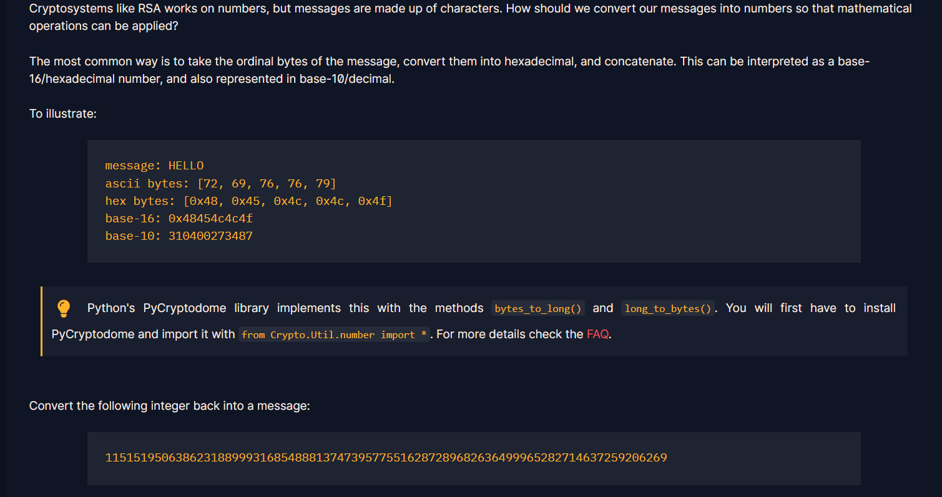
PyCryptodrome library : It gives Python the tools needed to encrypt, decrypt, hash, sign, and perform other cryptographic operations.
bytes_to_long() : This function convert the message into some integers value
long_to_bytes() : This function convert the integer into some message

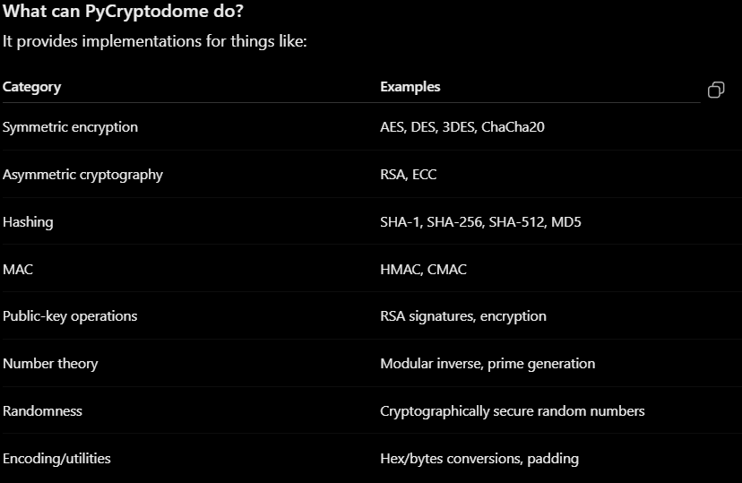
This is my solving program :
from Crypto.Util.number import *
key = 11515195063862318899931685488813747395775516287289682636499965282714637259206269
Flag = long_to_bytes(key)
print(Flag)
Flag: b'crypto{3nc0d1n6_4ll_7h3_w4y_d0wn}’
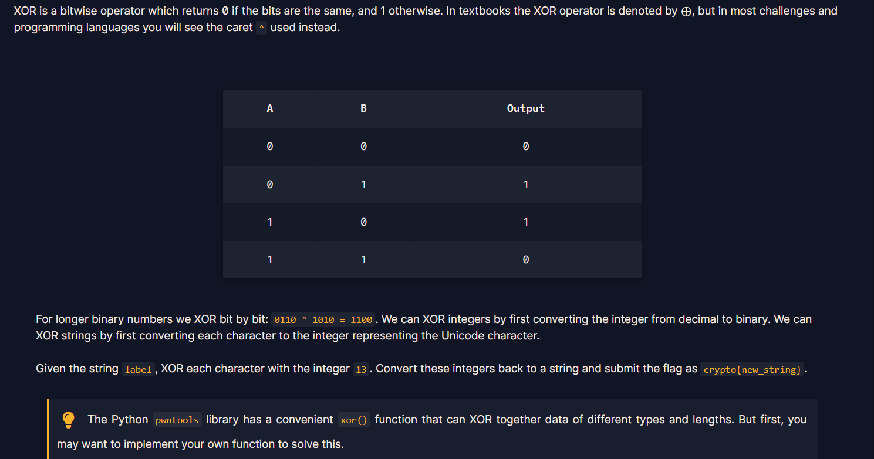
XOR : Here the input must me 1 for the output 1 if not then it will return 0
Solver.py
string = "label"
result = "".join(chr(ord(c) ^ 13) for c in string) [ Character → number → XOR with 13 → character]
print(result)
Ord : converts a character into its integer/Unicode value.
for c in string : Take each character from string one by one and store it temporarily in c

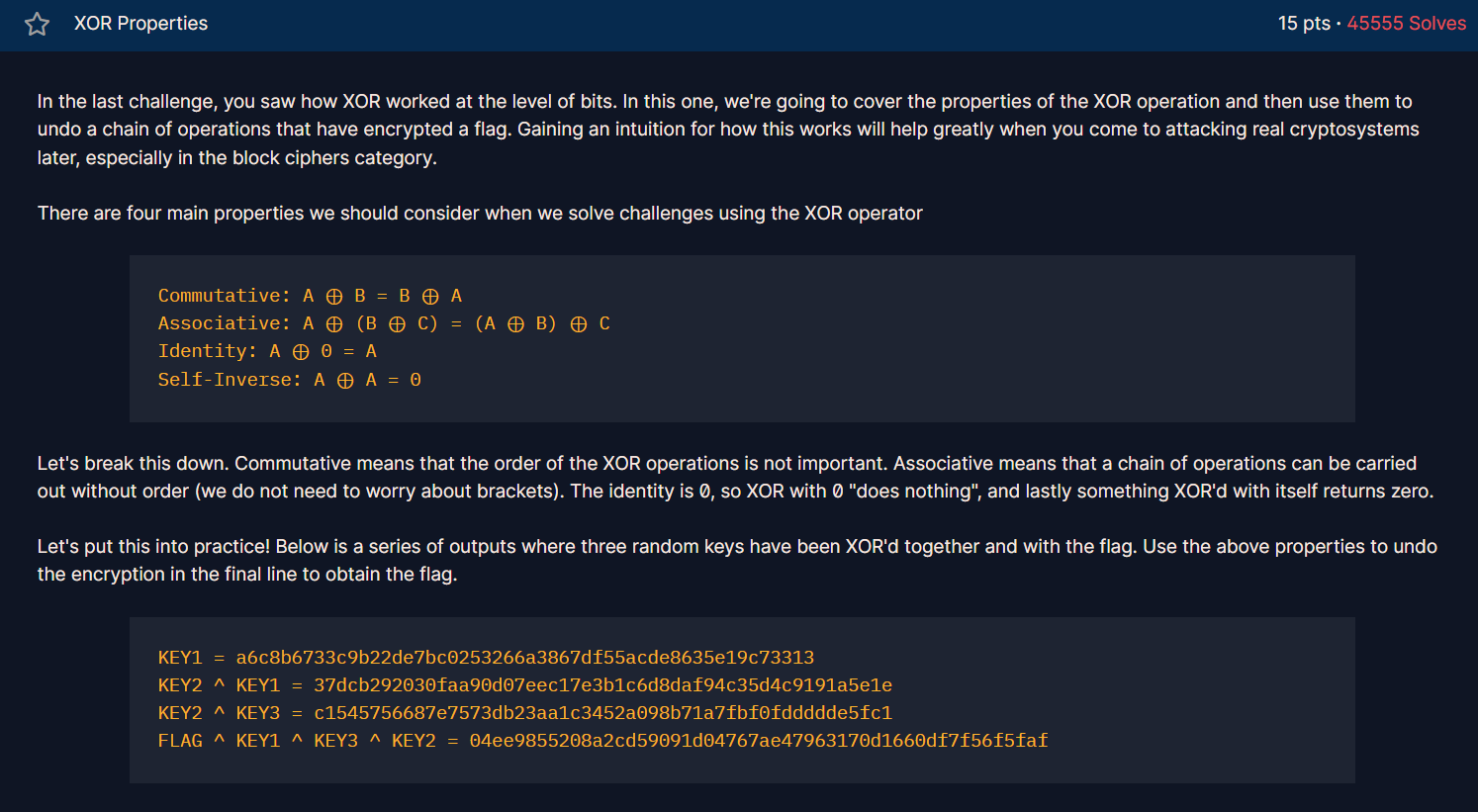
Let’s understand this with the help of an example
a = 12
K = 5
C = a ^ K [ a XOR K]
Print(C)
Output: 12 = 1100 [ both the number must first convert into the binary]
5 = 0101 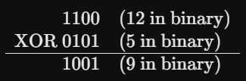
After XOR the value is 1001 which is 9
In the same program if we do the C ^ K it will print the orginal value that is a
9 Xor 5 = 12 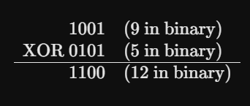
Notice the pattern? Since $12⊕5=9$, then $9⊕5=12$. This illustrates the self-inverse property of XOR ($A⊕B=C⟹C⊕B=A$), which is a fundamental concept used in cryptography to undo or decrypt XOR operations!

Now for solving the question we know that the key1 is given and and key2 xor key3 is also given
If we rearrange the last equation i,e FLAG ^ KEY1 ^ KEY3 ^ KEY2 = 04ee9855208a2cd59091d04767ae47963170d1660df7f56f5faf
FLAG ^ KEY1 ^ KEY2^ KEY3 = 04ee9855208a2cd59091d04767ae47963170d1660df7f56f5faf [ Associative law]
FLAG ^ a6c8b6733c9b22de7bc0253266a3867df55acde8635e19c73313 ^ c1545756687e7573db23aa1c3452a098b71a7fbf0fddddde5fc1 = 04ee9855208a2cd59091d04767ae47963170d1660df7f56f5faf
FLAG = a6c8b6733c9b22de7bc0253266a3867df55acde8635e19c73313 ^ c1545756687e7573db23aa1c3452a098b71a7fbf0fddddde5fc1 ^ 04ee9855208a2cd59091d04767ae47963170d1660df7f56f5faf
this is solving script
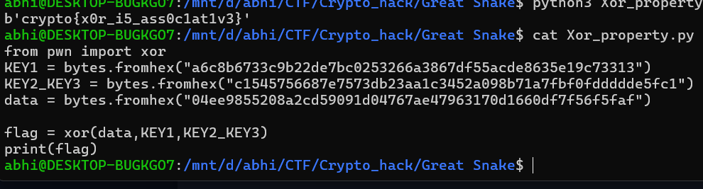

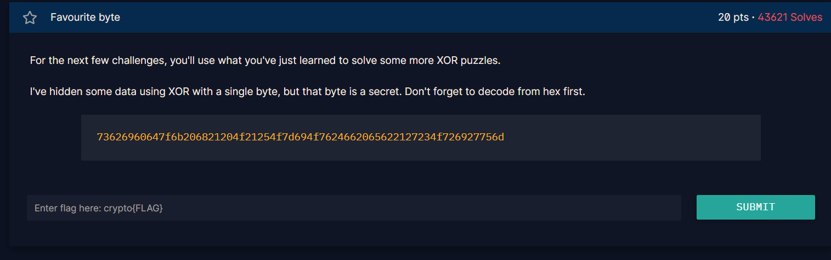
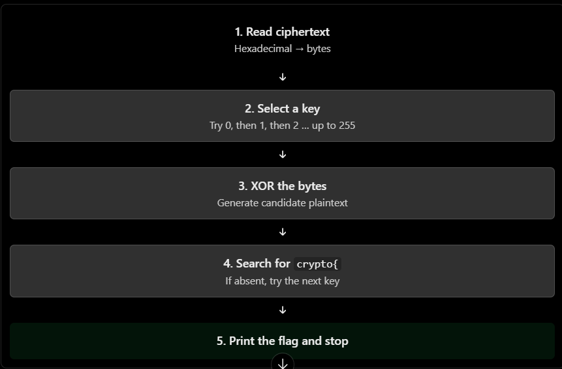
This Is the solving script for this challenge ;
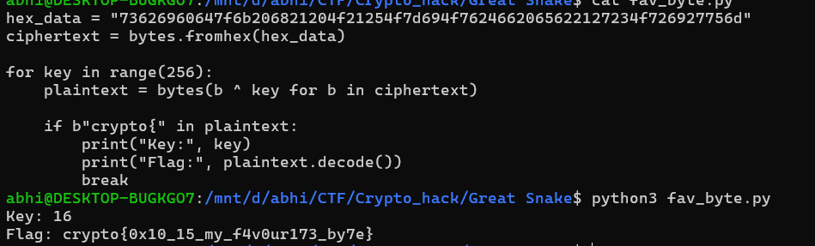
crypto{0x10_15_my_f4v0ur173_by7e}

