Remote365 Host
Setup Guide
How to turn a phone into an unattended remote-support device — one time, about a minute.
Remote365 Host lets a phone be viewed and controlled remotely by an authorised operator — even when nobody is holding it, and it comes back on its own after a reboot. You set it up once on each phone by following the on-screen steps below. The app does the hard part (pairing) itself — you only flip two Android switches.

What you need
- The phone you want to set up (Android 8 or newer).
- About one minute, and the phone in your hand for the setup.
- That’s it — no computer or cable is required.
Good to know: Each screen advances on its own the moment you finish it — you rarely need to tap "next". Just do what the screen asks and it moves forward.

Step 1 · Open the app
Tap the Remote365 Host icon. You’ll see the splash screen for a second while it starts, then it goes to the Welcome screen automatically.
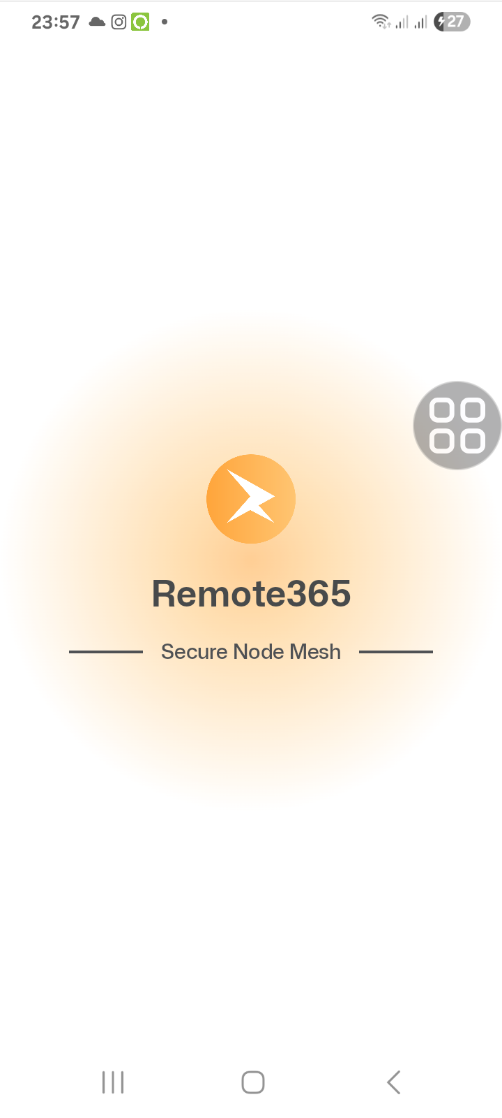

Step 2 · Welcome
This screen explains what the app does. When you’re ready, tap the orange Get started button.
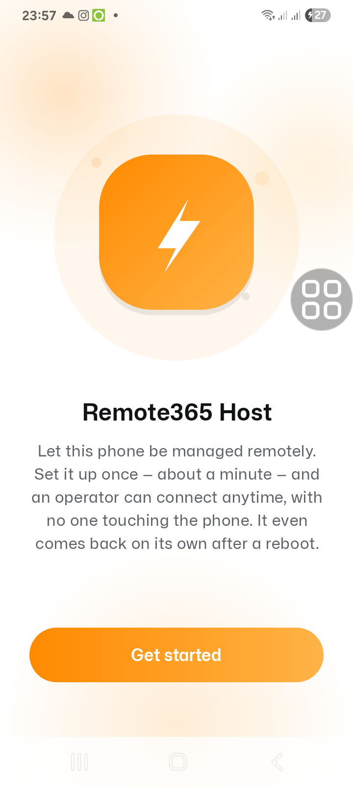

Step 3 · Before you start (consent)
This explains that an authorised operator will be able to view and control the device during sessions you or your administrator approve, and that the device’s ID and password live on the home screen. Tap I agree & continue.
Android will ask: "Allow Remote365 Host to send you notifications?" — tap Allow so the app can show its status.
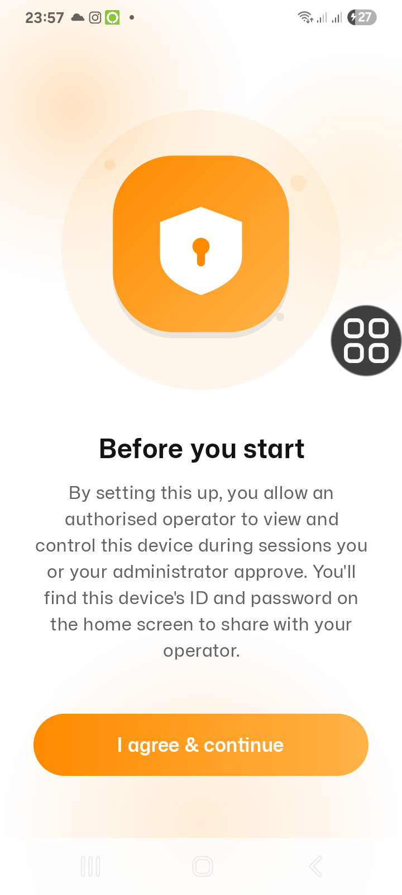

Step 4 · Turn on remote input (Accessibility)
This lets an operator tap and type on the phone — and lets the app read the pairing code for you in the next steps.
- Tap Open Accessibility settings.
- Find Remote365 Input in the list and turn it on. Confirm on the Samsung prompt.
- If Samsung says the setting is restricted, choose Allow restricted settings first, then turn it on.
- Tap Back to return to the app — it moves to the next step by itself.
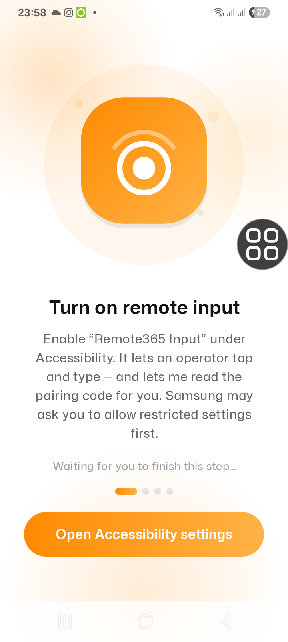

Step 5 · Unlock Developer options (only if needed)
If Developer options is not already turned on, the app shows this step. Open About phone → Software information, then tap Build number seven times until it says developer mode is on. Come back to the app.
You might skip this: If Developer options is already enabled on the phone, you won’t see this screen — the app jumps straight to the next step.
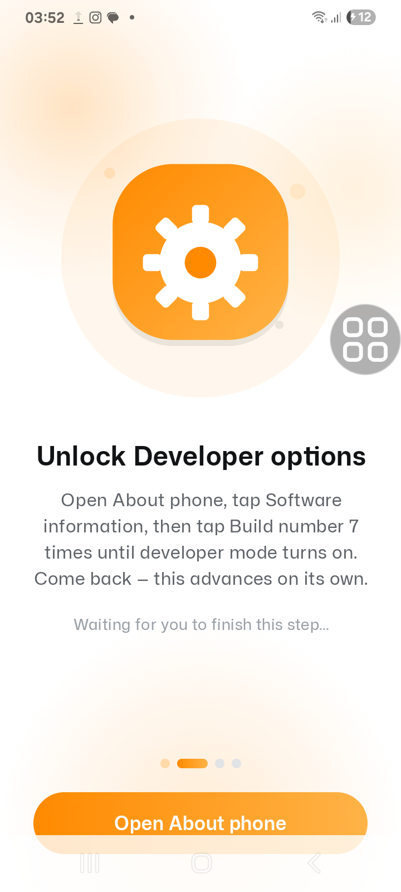

Step 6 · Turn on Wireless debugging
This is the only switch you flip yourself — Android won’t let an app turn it on for you.
- Tap Open Developer options.
- Scroll to Wireless debugging and switch it on.
- Accept the "Allow wireless debugging on this network?" prompt.
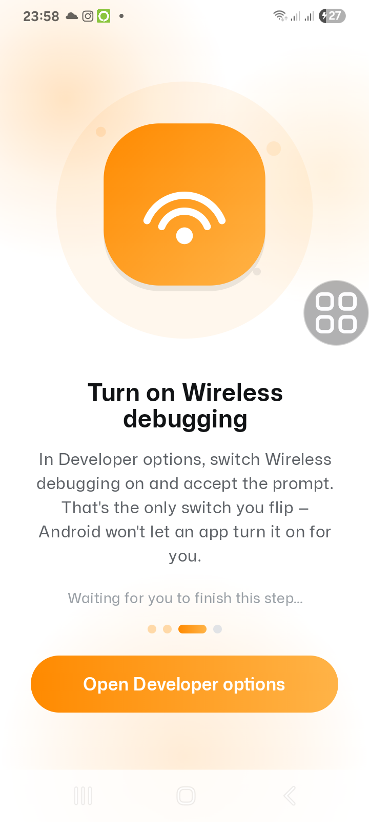

Step 7 · Pair this phone
Now the app pairs itself — you don’t type anything.
- On the Wireless debugging screen, tap Pair device with pairing code.
- A dialog with a 6-digit code appears. Leave it open — the app reads the code and finishes on its own.
- You’ll see "Waiting for the pairing dialog…", then it pairs automatically in a few seconds.
On Android 15, the pairing dialog may look black in a screen share — that’s an Android security feature, and it does not stop the app from pairing.
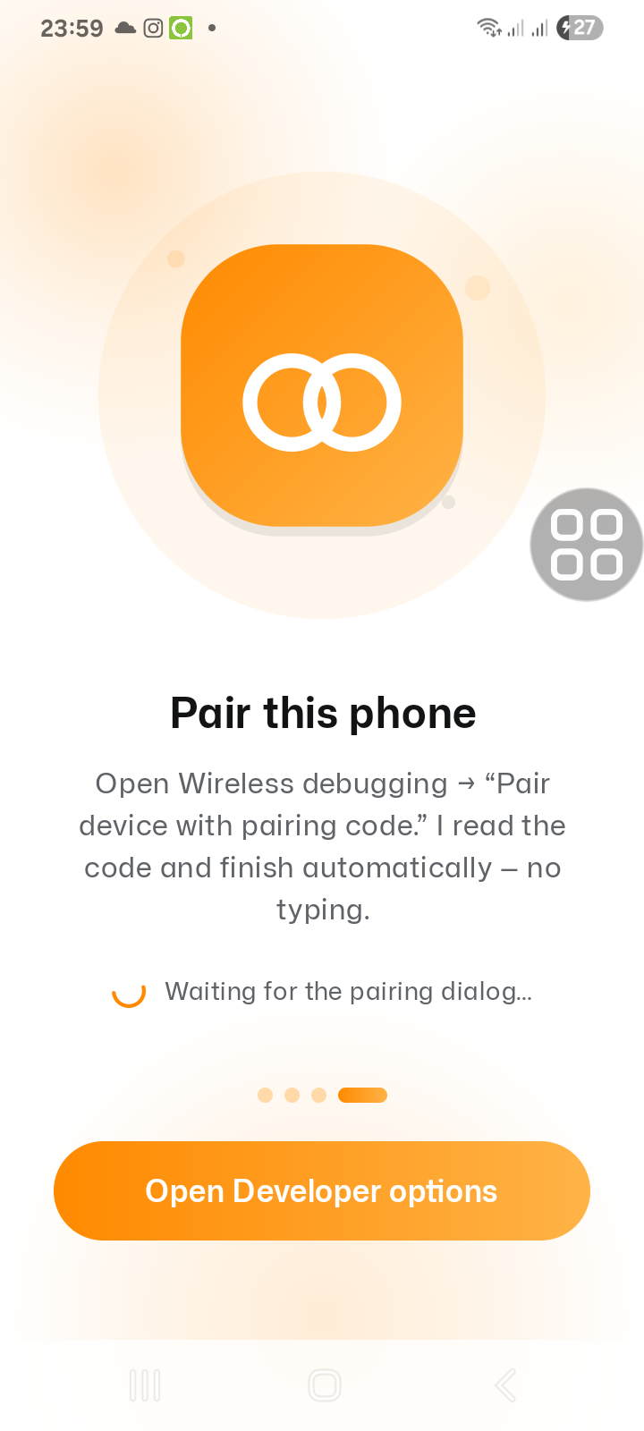

Step 8 · You’re all set
When pairing finishes, this confirmation appears. The phone is now unattended: an operator can connect anytime — even after a reboot — with nobody at the phone. It moves to the home screen on its own.
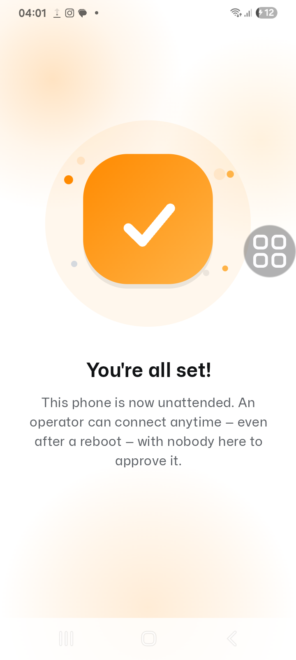

Step 9 · Host Access — your ID & password
This is the home screen. Share the Device ID and Password with whoever will connect to this phone.
- Your ID and Password — tap Copy on either, or Copy ID & password to copy both at once.
- Show reveals the password; Change password sets a new one (anyone already connected will need to re-enter it).
- Easy grant access (optional): turn this on to let anyone with the ID connect without the password.
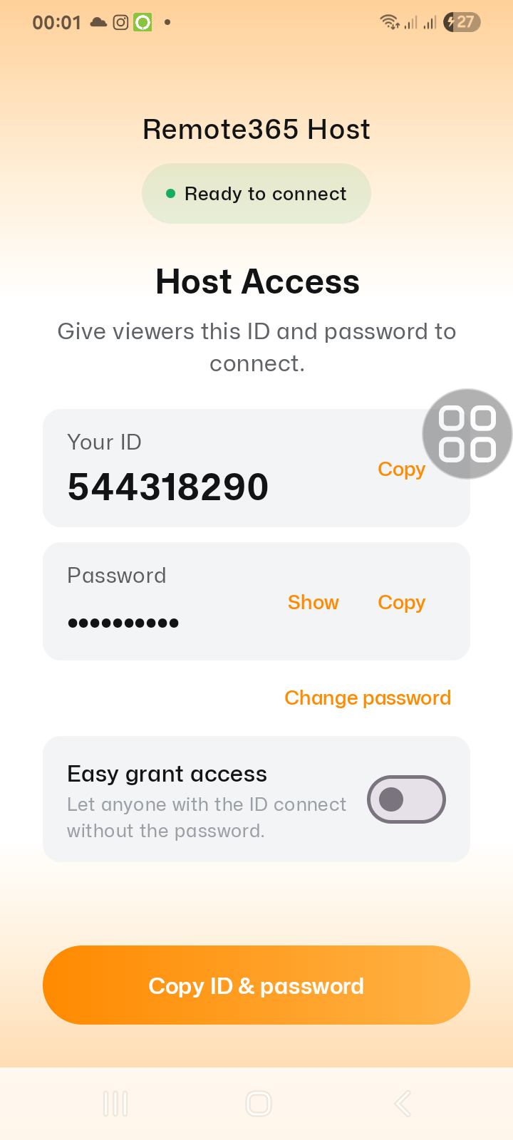

After setup
- The phone stays online on its own and reconnects automatically after a reboot — no one needs to touch it again.
- To connect from the viewer app, enter this phone’s Device ID and Password (or just the ID, if Easy grant access is on).
- You can reopen Remote365 Host anytime to see the ID and password or change the password.
Repeat per phone: Do these same steps once on each phone you want to manage.

