练习题需要的数据如下：

Student 表格

Course表：

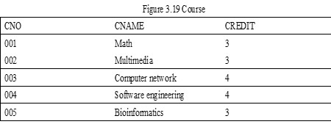
SC表：
学号： 姓名：

- Select the number and the total grade of the students whose total grade is more than 200.

Select sno, sum(grade) from sc
group by sno
having sum(grade)>200

- Select the courses that were selected by none students. List the courses’ NO. and names.

先写出关系代数的表达式， 再写出SQL表达式

Π_{cno}, _{Cname}(σ_{SC.cno=NULL}(Course SC )

Select c.cno,cname
from course c left join sc on c.cno=sc.cno where sc.cno is null



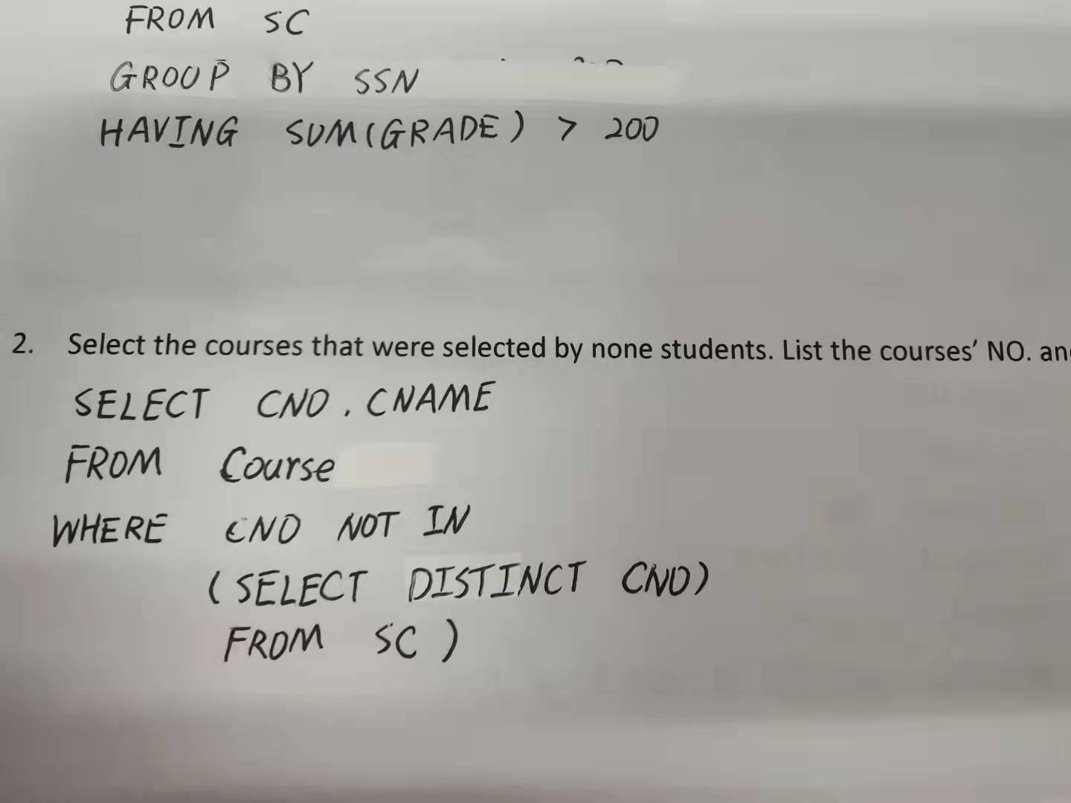

- Find the names and age of students in other departments that have smaller age than any a student in the department 33.

SELECT Sname，Sage
FROM Student
WHERE Sage < ANY (SELECT Sage
FROM Student
WHERE deptid= ' 33 ')
AND deptid <> ' 33 ' ;

- Find all the students who take all courses

先写出关系代数的表达式， 再写出SQL表达式

select * from Student s
where not exists
(select * from Course c
where not exists
(select * from sc
where ssn= s.ssn
and Cno = c.Cno))
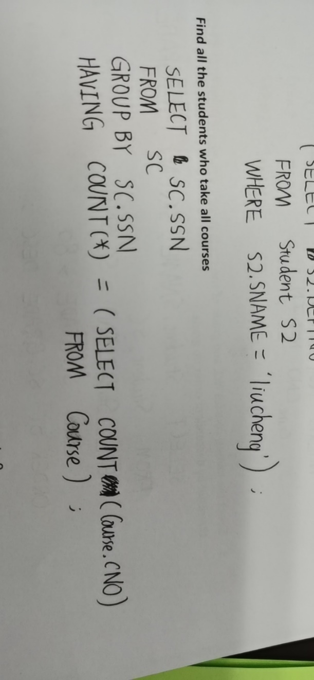
- For students in department 33, please set the grades of their courses to 0.
Update SC
Set Grade=0
Where SSN In
(Select SSN
From Student
Where DEPTNO=33)
