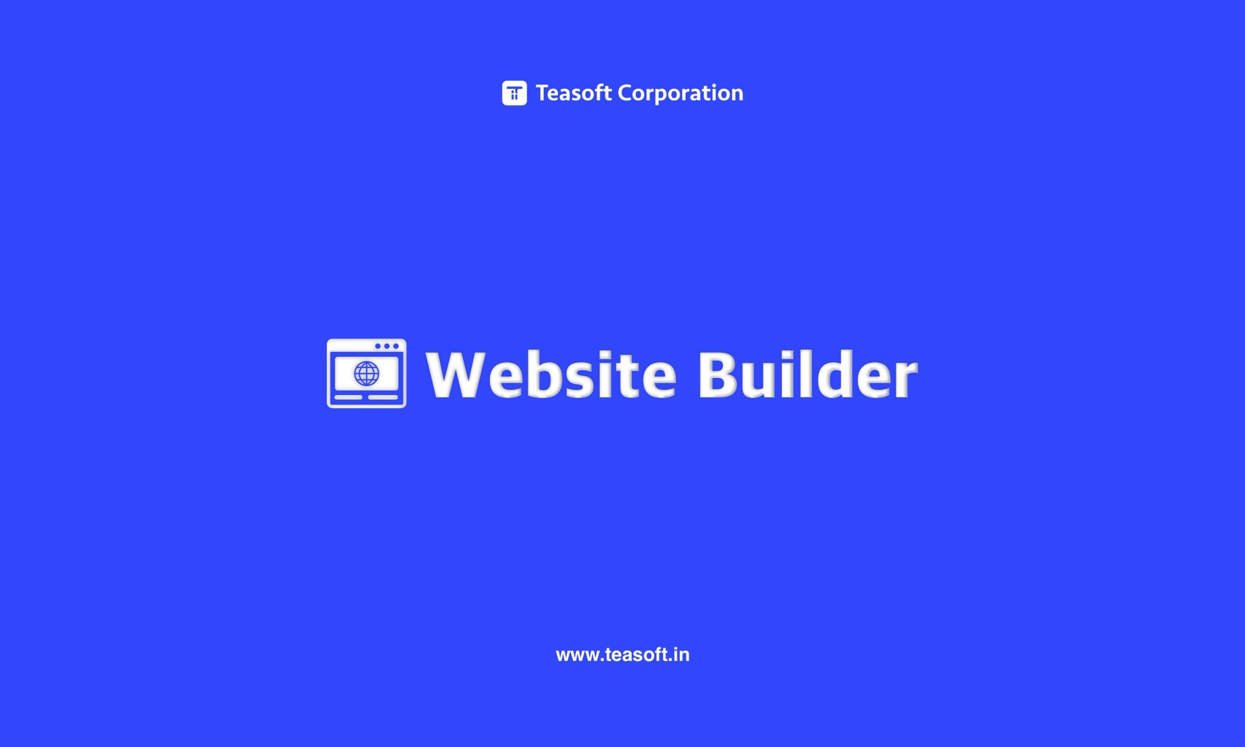

**Create Stunning Websites Effortlessly with Teasoft Free Website Builder**

Welcome to Teasoft Free Website Builder, your ultimate solution for creating dynamic and professional websites with ease. Whether you're a seasoned developer or a beginner, our intuitive platform offers a variety of templates and tools to help you build stunning websites without any coding knowledge.

**Benefits:**

**1. User-Friendly Interface:** Our website builder is designed with simplicity in mind. The drag-and-drop functionality makes it easy for anyone to create a website, regardless of technical expertise.

**2. Wide Range of Templates:** Choose from a vast selection of professionally designed templates that cater to various industries and purposes. Customize them to suit your brand and style.

**3. Responsive Design:** Ensure your website looks great on any device. Our templates are fully responsive, adapting to different screen sizes and resolutions.

**4. SEO-Friendly:** Optimize your website for search engines with built-in SEO tools. Improve your visibility and reach a wider audience.

**5. Integrated Tools:** Enhance your website with a range of integrated tools, including image converters, text formatters, and code enhancers. All available within the Teasoft platform.

**6. Cost-Effective Solution:** Save money on web development and design services. Our free website builder offers all the features you need to create a professional website at no cost.

Ready to start building your website? Visit Teasoft Free Website Builder <https://www.teasoft.in/misc-tool/website-builder> today and explore the endless possibilities. Discover how our user-friendly platform, with its extensive range of templates and tools, can help you bring your vision to life with ease. Visit our website to learn more about how Teasoft can empower your web development journey.